Report on the Armidale petrol market
November 2016
ISBN 978 1 922145 97 0
Australian Competition and Consumer Commission
23 Marcus Clarke Street, Canberra, Australian Capital Territory, 2601
© Commonwealth of Australia 2016
This work is copyright. In addition to any use permitted under the Copyright Act 1968, all material contained within this work is provided under a Creative Commons Attribution 3.0 Australia licence, with the exception of:
• the Commonwealth Coat of Arms
• the ACCC and AER logos
• any illustration, diagram, photograph or graphic over which the Australian Competition and Consumer Commission does not hold copyright, but which may be part of or contained within this publication.
The details of the relevant licence conditions are available on the Creative Commons website, as is the full legal code for the CC BY 3.0 AU licence.
Requests and inquiries concerning reproduction and rights should be addressed to the Director, Corporate Communications, ACCC, GPO Box 3131, Canberra ACT 2601, or publishing.unit@accc.gov.au.
Important notice
The information in this publication is for general guidance only. It does not constitute legal or other professional advice, and should not be relied on as a statement of the law in any jurisdiction. Because it is intended only as a general guide, it may contain generalisations. You should obtain professional advice if you have any specific concern.
The ACCC has made every reasonable effort to provide current and accurate information, but it does not make any guarantees regarding the accuracy, currency or completeness of that information.
Parties who wish to republish or otherwise use the information in this publication must check this information for currency and accuracy prior to publication. This should be done prior to each publication edition, as ACCC guidance and relevant transitional legislation frequently change. Any queries parties have should be addressed to the Director, Corporate Communications, ACCC, GPO Box 3131, Canberra ACT 2601, or publishing.unit@accc.gov.au.
ACCC 10/16_1133
www.accc.gov.au

Summary
Petrol prices in Armidale were significantly higher than those in the five largest cities in Australia from 2012–13. The main reasons for this were: higher transport costs; higher retail operating costs per litre; and higher retail margins and profits.
Relatively weak retail competition in Armidale, reflected by a lack of price discounting, contributed to the increase in retail margins and profits in recent years. The Armidale market is small and relatively concentrated, and until recently did not have an active price discounter.
However, in June 2016 a Liberty-branded independently operated retail site commenced in Armidale, with consistently lower prices than its competitors. Around the same time the NSW Government launched FuelCheck, an online tool providing consumers with real-time fuel price information covering every retail site across NSW.
The presence of an active discounter, as well as greater price transparency, has led to average petrol prices in Armidale decreasing relative to those in the five largest cities and Glen Innes in the September quarter 2016. Glen Innes is around 100 kilometres north of Armidale on the New England Highway and is the closest regional location to Armidale that is part of the ACCC’s fuel price monitoring program. Historically it has had lower prices than Armidale.

Key points

Historically petrol prices in Armidale were significantly higher than in the five largest cities in Australia and this difference increased in recent years
Between 2012–13 and 2014–15 Armidale motorists paid on average around 8 cents per litre (cpl) more for E10 (i.e. regular unleaded petrol (RULP) with up to 10 per cent ethanol) than motorists in the five largest cities (i.e. Sydney, Melbourne, Brisbane, Adelaide and Perth) paid for RULP.
This was almost three times the price differential in the previous three years: E10 prices in Armidale between 2009–10 and 2011–12 were on average around 3 cpl more than RULP prices in the five largest cities. A similar differential, and increase over time, occurred with premium unleaded petrol (PULP) 95 prices in Armidale and the five largest cities.
In 2015–16 the differential between E10 prices in Armidale and RULP prices in the five largest cities decreased to around 6 cpl, and for PULP 95 the differential decreased to around 8 cpl.
This report examines E10 and PULP 95 prices in Armidale as motorists in New South Wales (NSW) use significantly more E10 and PULP, and less RULP, than the rest of Australia. This is a result of the ethanol mandate introduced by the state government in October 2007.
In 2014–15, sales of E10 made up around 36 per cent of total petrol sales in both Armidale and Sydney. In comparison, E10 sales as a proportion of total petrol sales in the rest of Australia excluding NSW were only around 4 per cent. Sales of PULP made up around 45 per cent of total petrol sales in Armidale in 2014–15 and around 54 per cent in Sydney, compared with around 23 per cent in the rest of Australia excluding NSW.

E10 prices in Armidale were also higher than surrounding locations
Over the last seven years, annual average E10 prices in Armidale have moved broadly in line with prices in Glen Innes, Inverell and Tamworth (which are all within 130 kilometres of Armidale). However, Armidale E10 prices have consistently been higher than prices in Glen Innes and generally higher than prices in Tamworth and Inverell.

There are three main influences which explain the higher prices in Armidale in recent years
In 2014–15, the average retail E10 price in Armidale was 143.0 cpl compared with an average retail E10 price of 132.6 cpl in Sydney—a difference of 10.4 cpl. In the same year, the average retail PULP 95 price in Armidale was 155.9 cpl compared with 145.9 cpl in Sydney—a difference of 10 cpl.
Sydney was chosen as a comparator location because, like Armidale, its retail sites operate under the NSW ethanol mandate, and sell significant volumes of E10 and PULP. Other capital cities are not as suitable as Sydney because RULP is the predominant fuel sold in those cities.
Wholesale prices for E10 and PULP 95 in 2014–15, as calculated by the relevant terminal gate prices (TGPs), were broadly the same in Armidale and Sydney, which indicated that the difference in retail prices was due to factors at the retail level.
The three main influences on higher E10 and PULP 95 prices in Armidale are:
- higher transport costs (around 3 cpl)
- higher retail operating costs (around 2 to 3 cpl)
- higher retail margins and profits (around 3 to 4 cpl).
These influences are explained in more detail below.

It costs more to get petrol to Armidale
Petrol in Armidale is sourced from terminals in Sydney, Newcastle and Brisbane, which are all a considerable distance away. Armidale is around 480 kilometres from Sydney, around 460 kilometres from Brisbane, and around 340 kilometres from Newcastle.
The large distances between Armidale and the terminals it obtains its petrol from contribute to the high freight costs to Armidale. In Sydney freight costs are low as petrol only needs to travel relatively short distances from the terminals to retail sites. The cost of transporting petrol to Armidale in 2014–15 is estimated to be around 4 cpl. This compares with an estimated freight cost of around 1 cpl in Sydney.

Retail operating costs per litre are higher in Armidale
Fuel retailers incur a range of operating expenses including staff costs, energy costs, site rental costs and cleaning and maintenance. The margins fuel retailers make on the sale of fuel and other products (such as convenience store products) must cover these costs, as well as provide a return on capital invested.
Retail operating costs per litre of E10 sold in Armidale in 2014–15 were around 7 cpl, compared with around 4 cpl in Sydney. Retail operating costs per litre of PULP 95 sold in Armidale in 2014–15 were around 6 cpl, compared with around 4 cpl in Sydney.
Retailers in Armidale had to pass on a greater share of their operating costs for each litre of fuel sold for two reasons: retailers in Armidale sold significantly lower volumes of fuel per site than those in Sydney, resulting in a greater share of operating costs for each litre sold; and convenience store revenue per site was significantly lower in Armidale than in Sydney.

Retail margins are higher in Armidale
Retailers in Armidale achieved an average net retail margin of around 6 cents on every litre of E10 sold, after accounting for retail operating costs, freight and taxes. For PULP 95 the average net retail margin was around 9 cents on every litre of PULP 95 sold. Net retail margins for E10 in Armidale were around 3 cpl higher than in Sydney, and for PULP 95 they were around 4 cpl higher.
The relatively high retail margins for E10 and PULP 95 in Armidale compared with Sydney are likely to be the result of limited retail price competition in Armidale.

The higher retail margins are reflected in higher GIRDs and profits over time
Gross indicative retail differences (GIRDs) are the difference between retail prices and published wholesale prices (or TGPs). They are a broad indicator of gross retail margins. However, they should not be confused with actual retail profits as they also include retail costs, which vary through time.
Between 2010–11 and 2014–15 the overall trends in the movements of E10 and PULP 95 GIRDs in Armidale are broadly reflected in the movement of net retail margins on E10 and PULP 95:
- E10 GIRDs increased by around 7 cpl over this period to around 19 cpl, compared with an increase of around 3 cpl in net retail margin on E10 to around 6 cpl.
- PULP 95 GIRDs increased by around 11 cpl over this period to around 21 cpl, compared with an increase of around 8 cpl in net retail margin on PULP 95 to around 13 cpl.
The increase in GIRDs is higher than the increase in net retail margins over the period due to increasing freight and operating costs.
Net profit per site in Armidale also increased, but not by the same extent as the increase in GIRDs and net retail margins for E10 and PULP 95. This smaller increase was due to a decrease in total fuel volumes per site and an increase in operating costs and freight costs.

Profits per site were higher in Armidale than Glen Innes
Average net profit per site in Armidale over the period 2010–11 to 2014–15 ranged between $225 000 and $297 000, with an average net profit per site over the period of around $265 000. However, profits made by individual sites varied greatly. Armidale sites had significantly higher average net profits compared with Glen Innes sites due to higher retail prices and net retail margins on fuel, lower operating costs, and substantially higher non-fuel profits in Armidale.
Armidale sites had significantly lower average net profits compared with Sydney sites due to the significantly higher volumes of total fuel sold in Sydney and higher non-fuel profits in Sydney.
In general, the high profits in Sydney reflect relatively high profits from PULP sales (around 30 per cent of total net profit per site) and significant convenience store profits.

Until very recently retailers in Armidale achieved higher margins and profits because of weak retail competition
Relatively weak retail competition in Armidale reflected by a lack of active price discounting, contributed to an increase in retail margins and profits in recent years.
Between October 2011 and October 2014 retail E10 prices in Armidale were very ‘sticky’ (i.e. not responsive to change), with only partial pass-through, both up and down, of changes in TGPs to retail E10 prices. Over this three-year period only 29 per cent of the total increase in TGPs was passed through as higher retail E10 prices. However, they were even more ‘sticky’ when TGPs were decreasing. Over the same period just 12 per cent of the total decrease in TGPs was passed on to motorists. As a result, GIRDs increased by around 15 cpl between October 2011 and October 2014.
Retailers in Armidale were more responsive to very large falls in TGPs in subsequent years. Between October 2014 and June 2016 there were two occasions when TGPs decreased significantly. In response, retail E10 prices in Armidale decreased by a greater amount than TGPs and consequently there was a decrease in GIRDs. On these occasions there was no clear leader of retail price decreases, although retailers each tended to reduce their prices quickly once one of their competitors had moved.

The differential between prices in Armidale and the five largest cities has narrowed in recent months following competitive pressure from a Liberty-branded site
Compared with Armidale, Glen Innes has for many years had an independent price setter (United), which competes more actively on price. This has led to lower retail petrol prices in Glen Innes compared with Armidale over time. This is highlighted by the fact that both Caltex and Woolworths almost always set lower retail prices at their site(s) in Glen Innes than at their site(s) in Armidale.
In June 2016 a Liberty-branded independently operated retail site selling RULP commenced in Armidale. Since this site commenced operations it has consistently had lower RULP prices than the price of RULP or E10 at any other site in Armidale. Most motorists can substitute RULP and E10.
The presence of an independent operator in a market is not in itself a contributor to more competition in a market. What is important is an independent operator which prices competitively.
The recent presence of an active discounter in Armidale, as well as greater price transparency, has led to average petrol prices decreasing in Armidale relative to those in Glen Innes and the five largest cities in the September quarter 2016.

Increased transparency and promotion of effective price competition can lead to lower prices
Easy access to information about current retail petrol prices enables motorists to shop around and purchase fuel at relatively lower priced retail sites. This may promote competitive market behaviour and reward discounters, as more consumers will see which petrol retailers are discounting. Furthermore, if there is close scrutiny of their pricing behaviour, petrol retailers may have less incentive to increase and maintain high prices. Ongoing monitoring and publication of prices and margins can shine a light on what is happening in the market.
On 24 August 2016, the NSW Government launched FuelCheck, an online tool providing consumers with real-time fuel price information covering every retail site across NSW. Motorists can use this tool to identify those sites in Armidale with the lowest petrol prices. Armidale is relatively small which means that motorists can easily travel to those retail sites offering the cheapest petrol.
There are other apps available to consumers, such as the NRMA app and the MotorMouth app, which provide comprehensive site-specific data in Armidale, and other locations in NSW. Motorists can also obtain information about retail prices using the apps of the petrol retailers (such as Woolworths) as well as more general apps (such as GasBuddy).
The provision of retail price information to consumers and third parties on a near real-time basis will improve the functioning of retail petrol markets in a number of ways:
- it will enable motorists to more easily compare prices across retail sites
- it will reward more those companies that discount, particularly the Liberty site if it keeps offering attractive prices to consumers
- it will enable greater public scrutiny of the behaviour of petrol retailers.
The more information on petrol prices which is available to the public, the better informed motorists will be about when to buy petrol and from whom.
NSW Government agencies, motoring organisations, media establishments and academics can use the publicly available retail and wholesale price data to analyse, and comment on, retail petrol prices and GIRDs. This could include commentary and analysis about retail petrol prices by location and by brand over time, and regular publication of charts such as the one below: this shows daily average prices for E10 and RULP by brand in Armidale in August and September 2016 and can inform consumers about the historical pricing practices of retail sites.
Daily retail E10 and RULP prices by retailer in Armidale: 1 August to 30 September 2016
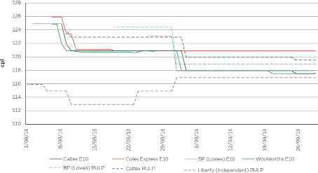
Source: ACCC calculations based on FuelCheck data.
This chart indicates the favourable prices at the Liberty site which, while they continue, should be highlighted and supported by consumers.

The ethanol mandate in NSW has led to less choice and higher prices for motorists
While recognising possible environmental and other benefits that may be associated with the use of E10, since its introduction in October 2007 the ethanol mandate in NSW has had a significant impact on competition and consumers in NSW.
It has affected the competitive dynamic among retailers by reducing the availability of RULP from many retail sites and reduced consumer choice. Some motorists who could not, or chose not to, use E10 in their vehicles used PULP due to the reduced availability of RULP. This is reflected in the fact that between 2007−08 and 2015−16 sales of PULP in NSW increased by 147 per cent, whereas in the rest of Australia the increase over the same period was only 42 per cent.
Furthermore, as PULP retails at a higher price than RULP, it has meant that these motorists have been paying significantly higher prices than if they had continued to purchase RULP and that retailers have been making higher margins. In 2015−16 annual average PULP 95 prices in Armidale were 11.1 cpl higher than RULP prices and PULP 98 prices were 17.9 cpl higher.
The ACCC has calculated that if motorists in Armidale in 2014–15 had purchased the various types of petrol in the same proportions as the rest of Australia excluding NSW, instead of the actual proportions they purchased, they would have spent around 2.1 cpl less on petrol.

Background
In December 2014 the then Minister for Small Business, the Hon. Bruce Billson MP, gave the ACCC a new direction to monitor the prices, costs and profits of unleaded petroleum products in Australia for a period of three years. The new monitoring arrangements introduced by the ACCC include the preparation of regional market studies. These aim to explain why petrol prices are higher in certain regional locations and explain where money is being made in the petrol supply value chain.
The ACCC collects retail petrol prices for all capital cities and over 190 regional locations across Australia. Following extensive assessment of price and other data for these locations the ACCC announced:
- in March 2015 that Darwin would be the first of its regional market studies (the report was released in November 2015)
- in May 2015 that Launceston would be the second regional market study (the report was released in July 2016)
- in August 2015 that Armidale would be the third regional market study
- in April 2016 that Cairns would be the fourth regional market study.
On conclusion of the Cairns market study the ACCC will review the overall lessons learned from the four regional market studies and how these may apply in other regional locations.

High prices and margins do not necessarily indicate a breach of the Competition and Consumer Act
Without anticompetitive agreements or misuse of market power, ‘profiteering’ or ‘price gouging’ are not illegal. The ACCC does not set prices or profit margins in petrol markets, and it is not able to restructure petrol markets or make them operate more efficiently. Its role is to promote effective competition in petrol markets where it can, so that resources are used efficiently and markets work in the interests of consumers.
Higher prices and margins can occur in competitive markets resulting from factors such as increasing demand, supply constraints, or cost savings from operational efficiencies or technological investment.
Markets where competition is weak or ineffective will usually result in higher prices and profits at the expense of consumers. This may be the result of illegal conduct or could also be the result of structural or market dynamics which are not a breach of the Competition and Consumer Act 2010 (Cth). In such circumstances the operation of the market can often improve over time through the competitive process or with policy or other changes to the business environment.
The ACCC takes action to enforce compliance with competition law which prohibits anticompetitive behaviour. This includes cartel conduct, misuse of market power and anticompetitive agreements. These behaviours can all affect prices.
Certain types of agreements can adversely affect the competitive process. Competition law prohibits agreements between competitors about price, customers, outputs and market shares, as well as supply agreements that substantially lessen competition.
By itself, having market power or a significant market share is not illegal. Concerns arise where substantial market power is used to interfere with the process of competition such as eliminating or substantially damaging a competitor, preventing the entry of a person into a market, or deterring or preventing a person from engaging in competitive conduct in a market.
It is the ACCC’s role not only to discover breaches of the Competition and Consumer Act 2010 and take action accordingly, but also to highlight where there is a need for more effective competition.

- Petrol prices in Armidale have been significantly higher than in the five largest cities and surrounding locations
In this report ‘petrol’ means all types of petrol, including regular unleaded petrol (RULP), E10 (RULP with up to 10 per cent ethanol), premium unleaded petrol (PULP) 95 and PULP 98, and ‘PULP’ means PULP 95 and PULP 98.
  - Prices in Armidale were consistently above prices in Sydney and Australia’s five largest cities, and the differential increased in 2012–13
Annual average retail E10 prices in Armidale were consistently higher than in Sydney over the last seven years (see chart 1.1). Between 2009–10 and 2011–12 Armidale motorists paid on average 4.9 cents per litre (cpl) more for E10 than motorists in Sydney. Over the period 2012–13 to 2014–15 the differential increased to 9.5 cpl; this period is shaded in the chart. In 2015–16 the differential decreased to 7.1 cpl.
Chart 1.1: Annual average retail E10 prices in Armidale and Sydney and the difference: 2009–10 to 2015–16
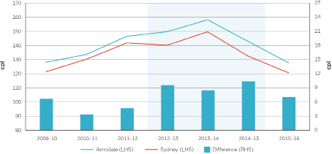
Source: ACCC calculations based on data from Informed Sources and FUELtrac.
A similar pattern is seen when comparing Armidale retail E10 prices with retail RULP prices in the five largest cities (i.e. Sydney, Melbourne, Brisbane, Adelaide, and Perth) over the last seven years (see chart 1.2).
The average retail RULP price in the five largest cities is used for comparison purposes because the ACCC has historically tracked these movements over time in the annual and quarterly petrol reports. An additional reason for using this benchmark is that, of the five largest cities, retail E10 prices are only available for Sydney, Melbourne and Brisbane.
Chart 1.2 shows that between 2009–10 and 2011–12 Armidale motorists paid on average 3.3 cpl more for E10 than motorists in the five largest cities paid for RULP. Over the period 2012–13 to 2014–15 the differential increased to 8.4 cpl; this period is shaded in the chart. In 2015–16 the differential decreased to 6.2 cpl.
Chart 1.2: Annual average retail E10 prices in Armidale and retail RULP prices in the five largest cities and the difference: 2009–10 to 2015–16
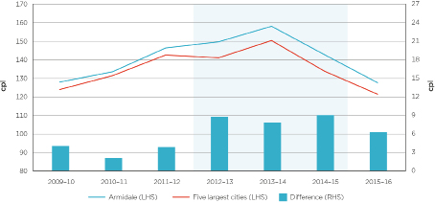
Source: ACCC calculations based on data from Informed Sources and FUELtrac.
The price differential between Armidale and the five largest cities began increasing in mid-2012 (see chart 1.3). While the average monthly differential has fluctuated, it increased significantly overall until January 2015, when it reached a peak of 18.5 cpl. In September 2016 the differential was 1.8 cpl.
Chart 1.3: Monthly average difference between retail E10 prices in Armidale and RULP prices in the five largest cities: January 2010 to September 2016
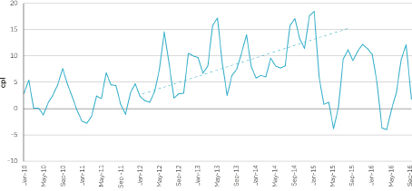
Source: ACCC calculations based on data from Informed Sources and FUELtrac.
The fluctuation in the differential in prices between Armidale and the five largest cities is largely explained by the tendency for Armidale prices to be less volatile than those in the five largest cities, and less responsive to movements in international petrol prices and wholesale prices. However, the differential has trended upwards—this is discussed further in chapter 5.
  - PULP 95 prices were also higher in Armidale
The trends and price differentials observed for retail E10 prices in Armidale since 2009–10 were also observed for retail PULP 95 prices in Armidale (see chart 1.4).
Chart 1.4: Annual average retail PULP 95 prices in Armidale and the five largest cities and the difference: 2009–10 to 2015–16
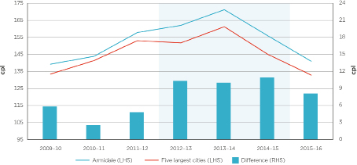
Source: ACCC calculations based on data from Informed Sources and FUELrac.
Over the period 2009–10 to 2011–12 Armidale motorists paid on average 4.4 cpl more for PULP 95 than motorists in the five largest cities. Between 2012–13 and 2014–15 the differential increased to 10.4 cpl; this period is shaded in the chart. In 2015–16 the differential decreased to 8.1 cpl.
Interestingly, the trends and price differentials for retail E10 and PULP 95 prices in Armidale were not observed for diesel. Between 2009–10 and 2015–16 the annual average retail diesel price differential between Armidale and the five largest cities remained in the range of around 6 cpl to 8 cpl.
  - The high proportion of E10 and PULP sold in Armidale has been driven by the ethanol mandate in NSW
The majority of petrol sold in Armidale is either E10 or PULP. In 2014–15 sales of E10 represented 36 per cent of total petrol sold in Armidale, PULP represented 45 per cent, and RULP represented 19 per cent. Data on how these sales proportions have changed over time in Armidale is provided in chapter 2.
This high proportion of E10 and PULP sales has been driven by the ethanol mandate in NSW. Since the introduction of the mandate, the availability of RULP has been limited and the majority of motorists are using E10 and PULP instead.
The NSW ethanol mandate was introduced in 2007 and required that from 1 October 2007, 2 per cent of the total volume of petrol sold in NSW should be ethanol. On 1 January 2010 the mandated level increased to 4 per cent and on 1 October 2011 it increased again to 6 per cent.
  - The difference in GIRDs between Armidale and the five largest cities has increased in recent years
Gross indicative retail differences (GIRDs) are the difference between retail prices and published terminal gate prices (TGPs). TGPs are the prices at which petrol can be purchased from wholesalers in the spot market and are posted on a regular basis on the websites of the major wholesalers. While many wholesale transactions do not occur at the terminal gate, TGPs can be regarded as indicative wholesale prices.
As a result, GIRDs can be treated only as a useful approximate benchmark of the retail gross margin on petrol. They should not be confused with actual retail profits as they also include retail costs, which vary through time.
In 2015–16 average E10 GIRDs in Armidale were 18.5 cpl, which was 7.3 cpl higher than average RULP GIRDs in the five largest cities (see chart 1.5).
Chart 1.5 Annual average E10 GIRDs in Armidale and RULP GIRDs in the five largest cities and the difference: 2009–10 to 2015–16
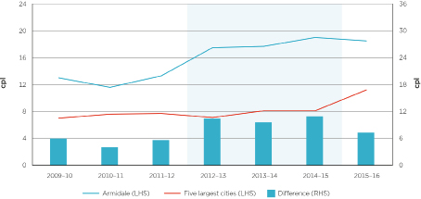
Source: ACCC calculations based on data from BP, Caltex, FUELtrac, Informed Sources, Mobil, Viva Energy and WA Fuelwatch.
Between 2009–10 and 2014–15 RULP GIRDs increased slightly in the five largest cities, but E10 GIRDs increased by a greater amount in Armidale. From 2009–10 to 2011–12 GIRDs in Armidale were on average 5.2 cpl higher than those in the five largest cities. They then increased substantially to be on average 10.3 cpl above those in the five largest cities over the period 2012–13 to 2014–15. In 2015–16 E10 GIRDs decreased marginally in Armidale and RULP GIRDs in the five largest cities increased substantially.
In 2015–16 average PULP 95 GIRDs in Armidale were 20.9 cpl, which was 8.0 cpl higher than average PULP 95 GIRDs in the five largest cities (see chart 1.6).
Chart 1.6 Annual average PULP 95 GIRDs in Armidale and the five largest cities and the difference: 2009–10 to 2015–16
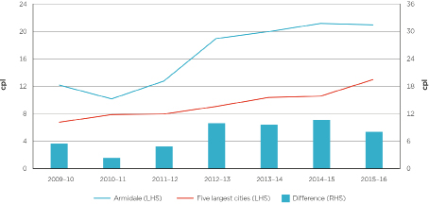
Source: ACCC calculations based on data from BP, Caltex, FUELtrac, Informed Sources, Mobil, Viva Energy and WA Fuelwatch.
Between 2009–10 and 2014–15 PULP 95 GIRDs increased in the five largest cities, but they increased by a greater amount in Armidale. From 2009–10 to 2011–12 GIRDs in Armidale were on average 4.2 cpl higher than those in the five largest cities. They then increased substantially to be on average 10.0 cpl above those in the five largest cities over the period 2012–13 to 2014–15.
  - E10 prices in Armidale have also been significantly higher than in nearby regional locations
Three of the regional locations included in the ACCC’s fuel monitoring program are situated within 130 kilometres of Armidale. These are: Glen Innes, Inverell and Tamworth.
Over the last seven years, annual average retail E10 prices in Armidale moved broadly in line with prices in these three locations (see chart 1.7). However, Armidale E10 prices were consistently higher than prices in Glen Innes and generally higher than prices in Tamworth and Inverell. Since 2012–13 annual average E10 prices in Armidale were on average 7.4 cpl higher than prices in Glen Innes, 5.0 cpl higher than in Inverell, and 3.6 cpl higher than in Tamworth.
Chart 1.7: Annual average retail E10 prices in Armidale and nearby regional locations: 2009–10 to 2015–16
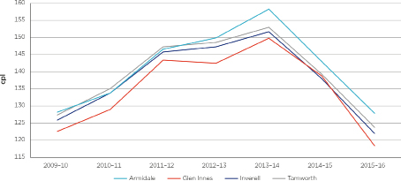
Source: ACCC calculations based on data from Informed Sources and FUELtrac.
  - The differential between Armidale prices and those in the five largest cities, and Glen Innes, has narrowed in recent months
Since February 2016 the monthly average differential between retail E10 prices in Armidale and retail RULP prices in the five largest cities has narrowed (see chart 1.8). In the period July 2015 to January 2016, the monthly average differential was 10.6 cpl. In the subsequent eight months the average difference was 2.9 cpl. Some of the decrease in the differential is likely to be due to the lag in changes in prices in regional locations relative to prices in the five largest cities.
Chart 1.8: Monthly average retail E10 prices in Armidale and retail RULP prices in the five largest cities: July 2015 to September 2016
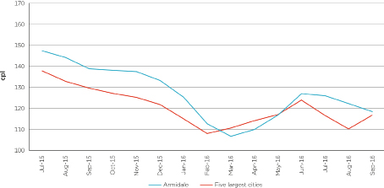
Source: ACCC calculations based on data from FUELtrac.
The differential between retail E10 prices in Armidale and Glen Innes has also decreased in recent months (see chart 1.9). In the September quarter 2016 the quarterly average differential was 3.4 cpl, which was the lowest quarterly average differential since the June quarter 2015.
The relative decrease in Armidale retail E10 prices may have been influenced by the emergence of a discount retailer in Armidale (a Liberty-branded site) from June 2016. This is discussed further in chapter 5.
Chart 1.9: Monthly average retail E10 prices in Armidale and Glen Innes: July 2015 to September 2016
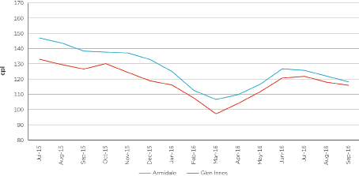
Source: ACCC calculations based on data from FUELtrac.
  - ACCC investigation in 2014 about high petrol prices in Armidale found no evidence of cartel conduct
In September 2014 concerns were raised with the ACCC about the consistently high cost of fuel in Armidale, compared with surrounding towns. Petrol prices in Armidale were very stable during the first 40 weeks of 2014. As this type of market behaviour may be an indication of underlying cartel conduct, the ACCC undertook an investigation of Armidale’s retail fuel sites.
In May 2015 the ACCC announced that it had not found evidence of cartel conduct and decided to end its investigation. The ACCC requires evidence of anti-competitive activity before it can take action in the courts.
  - The announcement of both the ACCC’s investigation and the market study in Armidale appear to have had some downward effect on retail prices
Soon after the ACCC announced that it was undertaking a fuel market study in Darwin there was a fall in retail petrol prices. The ACCC’s Darwin report noted that retail petrol prices in Darwin decreased significantly from October 2014 and commented that:
This decrease, and its size relative to the five largest cities, appears to have been significantly influenced by the increased scrutiny of Darwin prices by the Northern Territory Government (including through the Northern Territory Fuel Summit), the ACCC and the wider community.
The ACCC’s investigation into alleged cartel conduct in Armidale was made public on 23 October 2014 in a media release by Senator John Williams. At that time retail E10 prices in Armidale were around 155 cpl, having been around 160 cpl for a long period (see chart 1.10).
Prior to the announcement, retail E10 prices in Armidale were very stable but TGPs trended downwards from July 2014. Following the announcement, retail E10 prices decreased to around 121 cpl in late January 2015, a decrease of around 34 cpl from the peak. The decrease in Armidale prices occurred during a period when TGPs were also decreasing. They decreased by 31 cpl from the time of announcement to their trough in late January 2015.
Chart 1.10 Daily average retail E10 prices and TGPs in Armidale: 1 January 2014 to 31 January 2015
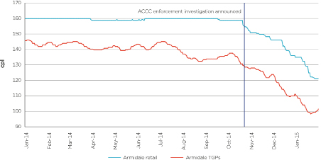
Source: ACCC calculations based on data from BP, Caltex, FUELtrac, Informed Sources and Viva Energy.
On 3 August 2015 the ACCC announced Armidale as the location for its third regional market study. This was based on analysis of petrol price data for all regional locations monitored by the ACCC across Australia.
At the time of the announcement, retail E10 prices in Armidale were around 147 cpl (see chart 1.11). Following the announcement, prices decreased for the rest of 2015, finishing the year at around 129 cpl, a decrease of around 18 cpl. This decrease also occurred during a period when TGPs were decreasing; they decreased by around 17 cpl from the time of announcement to the end of the year.
Chart 1.11 Daily average retail E10 prices and TGPs in Armidale: 1 January 2015 to 31 December 2015
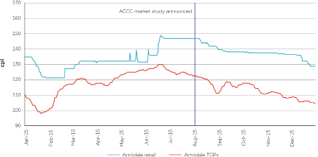
Source: ACCC calculations based on data from BP, Caltex, FUELtrac, and Viva Energy.
- The Armidale market is small and concentrated
  - There are a small number of participants at all levels of the Armidale petrol market
For the purposes of this study, the ACCC has defined Armidale as the area of Armidale and its surrounds to a 20 kilometre radius.
Three companies either refine or import fuel into NSW and Queensland for sale in the Armidale retail market. These are BP, Caltex and Viva Energy. They obtain their fuel from Australian refineries and overseas (from locations such as Singapore and South Korea). Fuel sold in the Armidale market is transported from terminals in Brisbane, Sydney and Newcastle to Armidale. The three refiner-importers also supply the Armidale market as wholesalers. Another company, Lowes, operates in the region as a wholesaler and retailer.
There are currently nine retail sites in Armidale, eight of which sell petrol and one which sells diesel only. This is a small number of retail sites relative to Armidale’s population. In comparison, the nearby town of Glen Innes has six retail sites but is only about a quarter of the size of Armidale in terms of population.
  - Caltex and the supermarket chains set prices at the majority of retail sites
Caltex, Coles Express and Woolworths operate, and set prices at, six of the eight retail petrol sites in Armidale (see table 2.1). The remaining two retail sites are independently operated.
Table 2.1 Armidale retail petrol sites by brand, price setter and type of petrol sold as at August 2016
Brand | Address | Price setter | Type of petrol sold
Brand | Address | Price setter | E10 | RULP | PULP 95 | PULP 98
Caltex | 6–8 Queen Elizabeth Drive | Caltex | ✓ | ▪ | ✓ | ✓
Caltex | New England Highway | Caltex | ✓ | ▪ | ✓ | ✓
Caltex | 2-4 Marsh Street | Caltex | ✓ | ▪ | ✓ | ✓
Caltexa | 142–144 Marsh Street | Caltex | ▪ | ✓ | ✓ | ✓
Woolworths | 244A Beardy Street | Woolworths | ✓ | ▪ | ✓ | ✓
Coles Express | 89-93 Marsh Street | Coles Express | ✓ | ▪ | ✓ | ✓
BPb | 84 Marsh Street | Lowes | ✓ | ✓ | ▪ | ✓
Liberty | 351 Beardy Street | Independent | ▪ | ✓ | ✓ | ▪

Source: ACCC calculations based on data from the companies.
Notes: a. This site was a Woolworths site until 20 November 2014. It sold E10 until 2013.
b. From 1 September 2015 this site has been operated by Ocwen Energy, a joint venture between BP Australia and Lowes Petroleum Service. Prior to this, it was operated by Chippen Holdings Pty Ltd.
Caltex is the most common petrol retail brand in Armidale with four Caltex-branded retail sites. All of these are operated on a commission agency basis, and Caltex determines the retail prices at these sites. No other company sets retail prices at more than one retail site in Armidale: there is one priced by Coles Express, one priced by Woolworths, one by the independent operator Lowes (BP-branded) and one by another independent (Liberty-branded). In contrast to the markets in Darwin and Launceston (the ACCC’s previous petrol market studies), the price setter for most retail sites in Armidale is the same as their banner brand.
  - The Armidale market has been relatively stable over the last 10 years
Chart 2.1 shows that since 2009, the number of retail sites in Armidale has been relatively stable, ranging between 8 and 9. The decrease between 2008 and 2009 was due to the closure of two Shell sites and one Mobil site. Since 2011, the number of retail sites in Armidale has remained constant at 9 sites. The ACCC is not aware of any new retail petrol sites in the Armidale market in the past 12 months, or of any plans for future sites. However, in June 2016 there was a change of ownership at the retail site at 351 Beardy Street. It was formerly a Neumann-branded independent site and commenced operating under the Liberty brand.
Chart 2.1 Armidale retail sites by brand: 2007 to 2016
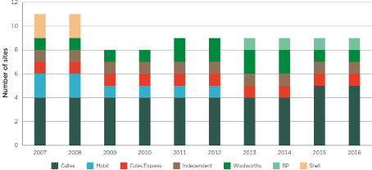
Source: ACCC calculations based on Informed Sources Netwatch data.
Note: The chart includes all fuel retail sites in Armidale—including sites that sell diesel only. Therefore there is one more site in 2016 included in this chart (a Caltex site) than in table 2.1.
  - Independents are a small portion of the Armidale market
The major petrol retailers in Armidale—Caltex, Coles Express and Woolworths—dominate the market. In 2014–15 these retailers combined had an 86 per cent market share by volume of petrol (i.e. E10, RULP and PULP) sold in Armidale (see chart 2.2). BP (Lowes) held the remaining 14 per cent market share.
Chart 2.2 shows that the dominant market share of the major retailers has remained largely unchanged since 2010–11. Although Caltex sets the price at half the retail sites in Armidale, it sells only 39 per cent of the total petrol sold. In contrast, the supermarket chains operate only a quarter of the retail sites in Armidale, but sell almost half the volume of petrol. Chart 2.2 does not include data for the Liberty site (because it was not available) and therefore understates the share of the independents in Armidale.
From late-November 2014 a Woolworths site changed to a Caltex site. This largely accounts for the significant change in the market share of Caltex and Woolworths between 2013–14 and 2014–15.
Chart 2.2 Armidale retail petrol volumes by brand: 2010–11 to 2014–15
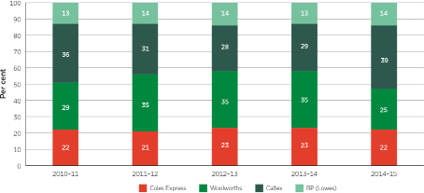
Source: ACCC calculations based on data from the companies.
Note: This chart excludes the Liberty-branded site because the current owner did not own the site until June 2016.
The market share for Caltex and Woolworths in 2014–15 includes a pro-rata allocation of the former Woolworths site that became a Caltex site from late-November 2014.
  - E10 and PULP are the most widely sold types of petrol
Due to the ethanol mandate in NSW, many sites in the state do not sell RULP. Table 2.1 shows that this is the case in Armidale, where only three out of eight retail sites sell RULP. The remaining retail sites sell E10. There is only one retail site (BP-branded Lowes) which sells both E10 and RULP. All eight retail sites sell at least one of PULP 95 and PULP 98, with six selling both.
  - The NSW ethanol mandate has led to a change in the type of petrol sold
    - The ethanol mandate was introduced in 2007
The NSW ethanol mandate was introduced in 2007 and was designed to encourage broader use of ethanol and other biofuels in NSW. It required that from 1 October 2007, 2 per cent of the total volume of petrol sold in NSW should be ethanol. On 1 January 2010 the mandated level increased to 4 per cent and on 1 October 2011 it increased to 6 per cent, which is the current level.
However, the NSW Independent Pricing and Regulatory Tribunal (IPART) has noted that, to date, the ethanol mandate has not been met, and ethanol sold as a proportion of total petrol sold in NSW is currently around 2.5 per cent.
In December 2015, the NSW Government announced a range of reforms to the state’s ethanol mandate, which aimed to ‘…. put downward pressure on E10 prices, increase compliance among fuel companies and boost transparency in the market.’ The reforms included amending the Biofuels Act 2007 to extend the ethanol mandate to a wider range of fuel retailers and to provide for IPART to determine the maximum price of wholesale ethanol. They are expected to take effect by the end of 2016.
While recognising environmental and other benefits that may be associated with the use of E10, the ACCC in the past has commented that the NSW ethanol mandate has had a significant impact on competition and consumers:
- it affected the competitive dynamic between retailers by reducing the availability of RULP at many retail sites
- it reduced consumer choice; some motorists who could not (or chose not to) use E10 in their vehicles, because of the reduced availability of RULP, used PULP, which has higher profit margins than RULP
- since PULP retails at a significantly higher price than RULP, it meant that these motorists have been paying significantly higher prices than if they had continued to purchase RULP.
The impact of the ethanol mandate can be seen in chart 2.3. In 2014–15, PULP made up 45 per cent of total petrol sales in Armidale and this figure was even higher in Sydney (54 per cent). In comparison, in the same year, PULP sales as a proportion of total petrol sales in Australia excluding NSW were 23 per cent. The previous locations for regional petrol market studies (Darwin and Launceston) had proportions of only 16 per cent and 17 per cent respectively.
Chart 2.3 Type of petrol sold in Armidale, Sydney, Australia excluding NSW, Launceston and Darwin
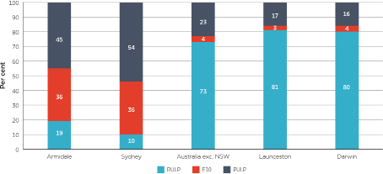
Source: ACCC calculations based on data from the companies, and Department of Industry, Innovation and Science, Australian Petroleum Statistics, Issue 238, May 2016, (for Australia exc. NSW).
Notes: Data for Armidale, Sydney and Australia exc. NSW is for 2014–15, data for Launceston and Darwin is for 2013–14.
Proportions may not sum to 100 due to rounding.
    - The ethanol mandate led to a large decrease in RULP sales in NSW
Chart 2.4 shows the impact over time of the NSW ethanol mandate on the type of petrol sold in Armidale. RULP sales as a proportion of total petrol sold decreased from 49 per cent in 2010–11 to 16 per cent in 2011–12. Over the same period, E10 sales increased from 31 per cent to 49 per cent, and PULP sales increased from 20 per cent to 35 per cent.
Between 2011–12 and 2014–15, the proportion of PULP further increased from 35 per cent to 45 per cent, and the proportion of E10 decreased from 49 per cent to 36 per cent. The proportion of RULP remained fairly steady, slightly increasing from 16 per cent to 19 per cent.
Chart 2.4 Armidale petrol sales by type: 2010–11 to 2014–15
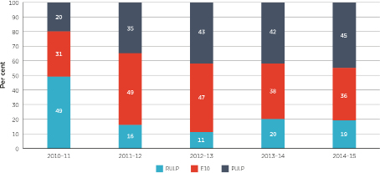
Source: ACCC calculations based on data from the companies.
Note: Proportions may not sum to 100 due to rounding.
    - The ethanol mandate also led to a large increase in PULP sales in NSW
The impact of the ethanol mandate on PULP sales in NSW can also be seen in chart 2.5, which shows annual PULP sales as a proportion of petrol sold in NSW, Victoria and Queensland between 2005–06 and 2015–16. While there has been a gradual increase in PULP sales in Victoria and Queensland, there has been a rapid increase in NSW from 2010–11 coinciding with developments in the ethanol mandate.
Chart 2.5 PULP sales as a proportion of total petrol sales in NSW, Victoria and Queensland: 2005–06 to 2015–16
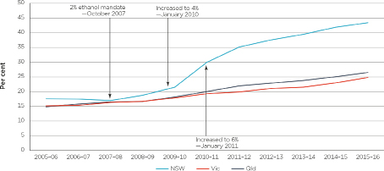
Source: ACCC calculations based on Australian Petroleum Statistics, various issues.
In 2011 the ACCC commented that the major influences on the demand for PULP include: an increasing proportion of vehicle manufacturers either recommending or requiring that PULP be used; and consumer perceptions and marketing about the quality of PULP and the associated benefits. It is unlikely that these influences would be significantly different in NSW from the rest of Australia. IPART, in commenting on the difference in PULP sales in NSW compared with the rest of Australia stated: ‘The evidence suggests NSW consumers are averse to ethanol blended petrol.’
- Retail margins, operating costs and freight contribute equally to the higher retail prices in Armidale
Retail petrol prices are influenced by a large number of factors. These include the international price of refined petrol and the AUD–USD exchange rate, transport costs, operating costs, and profits made by wholesalers and retailers. The international price of refined petrol and the AUD–USD exchange rate are the same anywhere in Australia, but other components of the retail price will vary from one location to the next.
The analysis in chapters 3 and 4 is based on retail site-specific data provided by retailers operating in Armidale and Glen Innes, and aggregate data in Sydney. There are some methodological issues associated with this data, which are described in more detail in appendix F. The key points to note are:
- Data obtained from the sites of individual companies have been averaged across the locations, and therefore the aggregate data represents an average only and should not be attributed to any individual retail site or company.
- Various types of retail sites operate in the petrol industry which have different operating and financial arrangements. These include company-owned and company-operated sites, franchise sites and commission agency sites.
- As companies allocate head office costs in different ways, these have been excluded in the profit calculations in these chapters.
  - Value chains in Armidale
The ACCC has examined the components of the value chains for E10 and PULP 95 in Armidale for 2014–15 and compared them with those in Sydney. The value chains show, in broad terms, the elements of the price of a litre of E10 and PULP 95 from the imported refined petrol price through to the pump (tables 3.1 and 3.2).
E10 and PULP 95 value chains are examined for Armidale and Sydney because both cities sell significantly more E10 and PULP than RULP. Of the total volume of fuel sold in Armidale in 2014–15, around 24 per cent was E10 and around 30 per cent was PULP, compared with around 13 per cent for RULP. In the same year in Sydney, around 27 per cent of the total volume of fuel sold was E10, and around 40 per cent was PULP, compared with around 7 per cent for RULP.
Sydney was chosen as a comparator location because, like Armidale, its retail sites operate under the NSW ethanol mandate, and sell significant volumes of E10 and PULP. Other capital cities are not as suitable as Sydney because RULP is the predominant fuel sold in those cities.
    - Components of the value chain
The value chain analysis comprises three fundamental elements: the import parity price (IPP), the wholesale price, and the retail price.
Petrol is delivered into Armidale from refineries and terminals in Sydney, Brisbane and Newcastle. It may have been produced domestically or imported from overseas. Regardless of the source, the price of refined petrol in Australia is based on the IPP. Pricing according to import parity is the setting of wholesale prices of petrol at a price comparable with the cost of importing fuel into a given location in Australia. This is because Australia is a net importer of refined petrol and domestic prices must reflect international prices to attract sufficient petrol into the Australian market.
The IPP price has four components: the benchmark price of petrol (which is generally the same anywhere in Australia); international shipping costs; a quality premium; and other import costs (such as wharfage and other incidental costs). Because E10 consists of up to 10 per cent ethanol and 90 per cent RULP, an indicative IPP for E10 in Armidale and Sydney was calculated using the actual costs paid by wholesalers for ethanol (and associated freight) for 10 per cent of the IPP for E10, and the IPP for RULP for the remaining 90 per cent of the IPP for E10.
The wholesale price is based on TGPs. These are the prices at which petrol can be purchased from wholesalers in the spot market and are posted on a regular basis on the websites of the major wholesalers. As fuel in Armidale is sourced from terminals in Brisbane, Newcastle and Sydney, the average of E10 and PULP 95 TGPs in those locations was used for the TGPs in Armidale.
The retail price is the average headline price paid by motorists at the bowser. It does not take into account any discounts from that price, such as shopper docket discounts.
    - E10 value chain
In 2014–15 the average retail E10 price was 143.0 cpl in Armidale and 132.6 cpl in Sydney—a difference of 10.4 cpl. The value chain in table 3.1 shows the components of these prices.
Table 3.1 E10 value chain in Armidale and Sydney: 2014–15 (cpl)
 |  | Armidale |  | Sydney |  | Difference
Retail price |  | 143.0 |  | 132.6 |  | 10.4
Net margin |  | 6 |  | 3 |  | 3
Operating costs |  | 7 |  | 4 |  | 3
Freighta |  | 4 |  | 1 |  | 3
GST–retailb |  | 2 |  | 1 |  | 1
Terminal gate price |  | 124.0 |  | 124.1 |  | -0.1
Wholesale GST and excise |  | 51 |  | 51 |  | 0
Costs and margins |  | 4 |  | 5 |  | -1
Indicative import parity price |  | 68.8 |  | 68.1 |  | 0.7
Ethanol cost |  | 5 |  | 4 |  | 1
Refined petrol |  | 60 |  | 60 |  | 0
Freight |  | 3 |  | 3 |  | 0
Costs and margins |  | 1 |  | 1 |  | 0
Quality premium |  | 0 |  | 0 |  | 0

Source: ACCC calculations based on data from the companies. Retail components in Armidale are based on data from Caltex, Coles Express, Lowes and Woolworths. Retail components in Sydney are based on data from Caltex, Coles Express and Woolworths. IPP, TGPs and ethanol costs in Armidale are based on data from BP, Caltex and Viva Energy. IPP, TGPs and ethanol costs in Sydney are based on data from BP, Caltex, Mobil and Viva Energy.
Notes: The components of each price level for each location have been rounded. As a result, they may not sum to the totals.
a. The retail freight costs are from the FUELtrac Freight Index.
b. GST–retail is one-eleventh of the difference between the retail price and the TGP.
The value chain shows that in 2014–15 the factors contributing to higher retail E10 prices in Armidale compared with Sydney were at the retail rather than the wholesale level. On average:
- retail freight costs were higher in Armidale by around 3 cpl
- retail operating costs were higher in Armidale by around 3 cpl
- net retail margin was higher in Armidale by around 3 cpl.
The other contributor was the impact of the GST at the retail level (around 1 cpl).
At the wholesale level, the cost of ethanol in the indicative IPP in Armidale was around 1 cpl higher than in Sydney. However, wholesale costs and margins in Armidale were around 1 cpl less than in Sydney. As a result, these differences offset each other leading to E10 TGPs in Armidale and Sydney being essentially the same.
    - PULP 95 value chain
In 2014–15 the average retail PULP 95 price was 155.9 cpl in Armidale and 145.9 cpl in Sydney—a difference of 10.0 cpl. The value chain in table 3.2 shows the broad components of these prices.
Table 3.2 PULP 95 value chain in Armidale and Sydney: 2014–15 (cpl)
 |  |  | Armidale |  | Sydney |  | Difference
Retail price |  |  | 155.9 |  | 145.9 |  | 10.0
Net margin |  |  | 9 |  | 5 |  | 4
Operating costs |  |  | 6 |  | 4 |  | 2
Freighta |  |  | 4 |  | 1 |  | 3
GST–retailb |  |  | 2 |  | 1 |  | 1
Terminal gate price |  |  | 134.8 |  | 134.5 |  | 0.3
Wholesale GST and excise |  |  | 52 |  | 52 |  | 0
Costs and margins |  |  | 8 |  | 7 |  | 1
Import parity price |  |  | 74.4 |  | 75.0 |  | -0.6
Refined petrol |  |  | 67 |  | 67 |  | 0
Freight |  |  | 3 |  | 3 |  | 0
Costs and margins |  |  | 1 |  | 1 |  | 0
Quality premium |  |  | 3 |  | 4 |  | -1

Source: ACCC calculations based on data from the companies. Retail components in Armidale and Sydney are based on data from Caltex, Coles Express and Woolworths. IPP and TGPs in Armidale are based on data from BP, Caltex and Viva Energy. IPP and TGPs in Sydney are based on data from BP, Caltex, Mobil and Viva Energy.
Notes: The components of each price level for each location have been rounded. As a result, they may not sum to the totals.
a. The retail freight costs are from the FUELtrac Freight Index.
b. GST–retail is one-eleventh of the difference between the retail price and the TGP.
As with E10 prices, the value chain shows that in 2014–15 the factors contributing to higher retail PULP 95 prices in Armidale compared with Sydney were at the retail level. On average:
- retail freight costs were higher in Armidale by around 3 cpl
- retail operating costs per litre were higher in Armidale by around 2 cpl
- net retail margin was higher in Armidale by around 4 cpl.
The other contributor was the impact of the GST at the retail level (around 1 cpl).
At the wholesale level, as with E10, the PULP 95 TGPs in Armidale and Sydney were essentially the same. The lower quality premium component of the IPP in Armidale was offset by higher wholesale costs and margins in Armidale.
The PULP 95 value chain shows that in both Armidale and Sydney, retailers on average achieved higher profit margins on PULP 95 sales than on E10 sales in 2014–15.
  - It costs more to transport petrol to Armidale
Petrol in Armidale is sourced from terminals in Sydney, Newcastle and Brisbane, which are all a considerable distance away. Armidale is around 480 kilometres from Sydney, around 460 kilometres from Brisbane, and around 340 kilometres from Newcastle.
The large distances between Armidale and the terminals it obtains its petrol from contribute to the high freight costs in Armidale. In Sydney freight costs are low as petrol only needs to travel relatively short distances from the terminals to retail sites. The average cost of transporting petrol to Armidale in 2014–15 was around 4 cpl. This compares with an average freight cost of around 1 cpl in Sydney.
A comparison of the freight costs in Armidale with those of nearby locations indicates that they appear reasonable and not out of line with other locations.
  - Retail operating costs per litre are higher in Armidale
Fuel retailers incur a range of operating expenses including staff costs, energy costs, site rental costs and cleaning and maintenance. The margins fuel retailers make on the sale of fuel and other products (such as convenience store products) must cover these costs.
Retail allocated operating costs per litre of E10 sold in Armidale in 2014–15 were around 7 cpl, compared with around 4 cpl in Sydney. Retail allocated operating costs per litre of PULP 95 sold in Armidale in 2014–15 were around 6 cpl, compared with around 4 cpl in Sydney.
The allocated operating costs per litre for E10 in Armidale are different from those for PULP 95 because not all of the sites in Armidale that sell E10 also sell PULP 95, and vice versa. Therefore, total operating costs were allocated across different sites for E10 and PULP 95. The methodology for the allocation of operating costs is outlined in appendix F.
Overall in Armidale in 2014–15, average retail operating costs per site that sold E10 were around $365 000, and average retail operating costs per site that sold PULP 95 were around $267 000. Both were lower than in Sydney where operating costs per site were on average around $472 000. Operating costs were lower in Armidale mainly due to lower wages and rent costs.
However, retailers in Armidale had to pass on a greater share of their operating costs for each litre of fuel sold for two reasons:
- retailers in Armidale sold significantly lower volumes of fuel per site than Sydney, resulting in a greater share of operating costs for each litre sold
- information about sale volumes in Armidale and Sydney is presented in section 4.5
- convenience store revenue per site was significantly lower in Armidale than in Sydney (by around $500 000 for E10 sites and around $650 000 for PULP 95 sites in 2014–15), which meant gross margins for non-fuel sales were lower in Armidale
- therefore, a lower share of operating costs could be apportioned to non-fuel sales.
  - Retail margins are higher in Armidale
Retailers in Armidale achieved an average net retail margin of around 6 cents on every litre of E10 sold, after accounting for retail operating costs, freight and taxes. For PULP 95 the average net retail margin on the same basis was around 9 cents on every litre of PULP 95 sold. Net retail margins on E10 in Armidale were around 3 cpl higher than in Sydney, and net retail margins on PULP 95 were around 4 cpl higher.
The relatively high retail margins for E10 and PULP 95 in Armidale compared with Sydney are likely to be the result of limited retail price competition in Armidale. This is discussed in chapter 5.
  - Wholesale prices for E10 and PULP 95 are the same in Armidale and Sydney
In 2015–16 average E10 and PULP TGPs in Armidale and Sydney were broadly the same:
- annual average E10 TGPs in Armidale were 0.1 cpl higher
- annual average PULP 95 TGPs in Armidale were 0.2 cpl higher.
Chart 3.1 shows that annual average E10 TGPs in Armidale and Sydney were broadly the same over the last six years.
Chart 3.1: Annual average E10 TGPs in Armidale and Sydney and the difference: 2009–10 to 2015–16
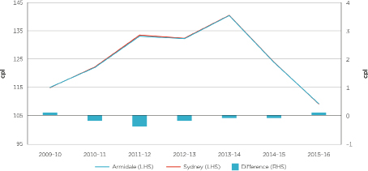
Source: ACCC calculations based on data from BP, Caltex, Mobil and Viva Energy.
Chart 3.2 shows that the difference between annual average PULP 95 TGPs in Armidale and Sydney decreased from 1.6 cpl in 2009–10 to be broadly the same over the last five years.
Chart 3.2: Annual average PULP 95 TGPs in Armidale and Sydney and the difference: 2009–10 to 2015–16
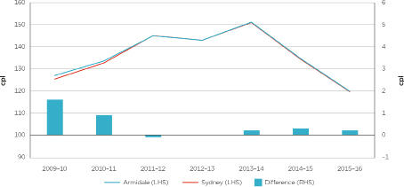
Source: ACCC calculations based on data from BP, Caltex, Mobil and Viva Energy.
  - The E10 value chain in Glen Innes
The Armidale E10 value chain in 2014–15 was also compared with the value chain in Glen Innes.
Glen Innes is around 100 kilometres north of Armidale on the New England Highway. It is the closest regional location to Armidale that is part of the ACCC’s fuel monitoring program. Glen Innes has six retail sites, four of which sell E10. The population of Glen Innes is around one quarter of Armidale.
In 2014–15 the average retail E10 price was 143.0 cpl in Armidale and 138.8 cpl in Glen Innes—a difference of 4.2 cpl. The value chain in table 3.3 shows the broad components of these prices. It assumes that TGPs in Armidale and Glen Innes are the same.
Table 3.3 E10 value chain in Armidale and Glen Innes: 2014–15 (cpl)
 |  | Armidale |  | Glen Innes |  | Difference
Retail price |  | 143.0 |  | 138.8 |  | 4.2
Net margin |  | 6 |  | 2 |  | 4
Operating costs |  | 7 |  | 7 |  | 0
Freighta |  | 4 |  | 5 |  | -1
GST–retailb |  | 2 |  | 1 |  | 1
Terminal gate price |  | 124.0 |  | 124.0 |  | 0.0
Wholesale GST and excise |  | 51 |  | 51 |  | 0
Costs and margins |  | 4 |  | 4 |  | 0
Indicative import parity price |  | 68.8 |  | 68.8 |  | 0.0
Ethanol cost |  | 5 |  | 5 |  | 0
Refined petrol |  | 60 |  | 60 |  | 0
Freight |  | 3 |  | 3 |  | 0
Costs and margins |  | 1 |  | 1 |  | 0
Quality premium |  | 0 |  | 0 |  | 0

Source: ACCC calculations based on data from the companies. Retail components in Armidale are based on data from Caltex, Coles Express, Lowes and Woolworths. Retail components in Glen Innes are based on data from Caltex, United and Woolworths. IPP and TGPs in Armidale are based on data from BP, Caltex and Viva Energy. IPP and TGPs in Glen Innes are assumed to be the same as Armidale.
Notes: The components of each price level for each location have been rounded. As a result, they may not sum to the totals.
a. The retail freight costs are from the FUELtrac Freight Index.
b. GST–retail is one-eleventh of the difference between the retail price and the TGP.
The value chain shows that in 2014–15 the main contributor to higher E10 prices in Armidale compared with Glen Innes was the net retail margin: it was 6 cpl in Armidale, 4 cpl higher than in Glen Innes (2 cpl).
Freight costs were around 1 cpl higher in Glen Innes than in Armidale. The impact of the GST at the retail level was around 1 cpl lower in Glen Innes.
The higher net retail margin on E10 in Armidale in 2014–15 contributed to higher overall net profits per site compared with Glen Innes (see chapter 4).
- Retail profits in Armidale were underpinned by increasing margins on petrol sold
This chapter presents the analysis of retail site profitability in Armidale, and compares this with Glen Innes, Sydney, and Australia as a whole.
  - Increases in net retail margins on petrol sold supported retail profits in Armidale
Over the period 2010–11 to 2014–15, the annual average net profit per site in Armidale ranged from $225 000 to $297 000. Over the five-year period the annual average net profit per site was $265 000. While site profits varied from year to year there was little difference between profits in 2010–11 and 2014–15 (see chart 4.1).
Chart 4.1 Net profit per site in Armidale: 2010–11 to 2014–15
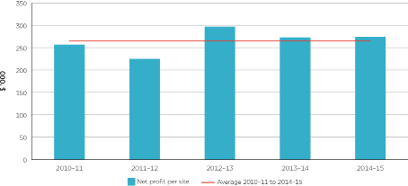
Source: ACCC calculations based on data obtained from Caltex, Coles Express, Lowes and Woolworths.
Notes: The net profit figures are based on profit and loss statements and financial templates provided by the companies. Net profit per site is broadly equal to earnings before interest and tax.
Two factors played a role in supporting net profits per site in Armidale over the period. The first was increasing retail net margins on petrol sold. The second was a change in the mix of petrol sales towards PULP, which typically has higher retail margins than E10 and RULP. These factors were offset by a decline in the volume of fuel sales per site (partly due to an additional retail site in Armidale from 2011–12).
Net retail margins on E10 and PULP 95 are a measure of the profits that retailers make on each litre of petrol sold. They are calculated by subtracting operating costs, freight and retail GST (per litre of petrol sold) from GIRDs.
Chart 4.2 shows annual average net retail margin on E10, E10 GIRDs and average net profit per site in Armidale from 2010–11 to 2014–15. Chart 4.3 shows similar data for PULP 95.
Chart 4.2 Annual average E10 net retail margin, E10 GIRDs, and net profit per site in Armidale: 2010–11 to 2014–15
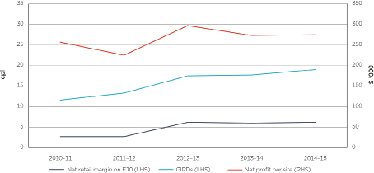
Source: ACCC calculations based on data from BP, Caltex, Coles Express, FUELtrac, Informed Sources, Lowes, Viva Energy and Woolworths.
Chart 4.3 Annual average PULP 95 net retail margin, PULP 95 GIRDs, and net profit per site in Armidale: 2010–11 to 2014–15
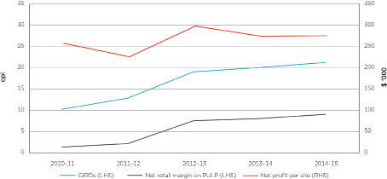
Source: ACCC calculations based on data from BP, Caltex, Coles Express, FUELtrac, Informed Sources, Viva Energy and Woolworths.
Between 2010–11 and 2014–15 the overall trends in GIRDs in Armidale were broadly reflected in the movement of net retail margins on E10 and PULP 95:
- E10 GIRDs increased by around 7 cpl over this period, compared with an increase of around 3 cpl in net retail margin on E10
- PULP GIRDs increased by around 11 cpl over this period, compared with an increase of around 8 cpl in net retail margin on PULP 95.
The increase in GIRDs was higher than the increase in net retail margins over the period due to increasing freight and operating costs.
The increase in net retail margins on petrol sold added to site profits in Armidale, as did the change in the mix of petrol sales to PULP. As shown in chart 2.4, PULP as a proportion of petrol sales in Armidale increased from 20 per cent in 2010–11 to 45 per cent in 2014–15. The margins retailers in Armidale make on PULP sales are larger than those on E10 and RULP sales. As a result, this change in mix added to site profits.
The positive effect that the increase in net retail margins on petrol sales and the change in the petrol mix had on site profits was offset by the reduction in the volumes of fuel sold on a per site basis (partly due to an additional retail site in Armidale from 2011–12). While total fuel sold in Armidale remained relatively stable between 2010–11 and 2014–15, total average fuel sales per site in Armidale decreased by around 16 per cent.
  - Net profit per site in Armidale was substantially higher than in Glen Innes
In 2014–15 average net profit per site in Armidale was around $270 000 per site, around the same as in 2013–14. This was substantially higher than the average net profit per site in Glen Innes, which was around $90 000 per site in 2013–14 and around $160 000 per site in 2014–15 (see chart 4.4).
Chart 4.4 Net profit per site in Armidale and Glen Innes: 2013–14 and
2014–15
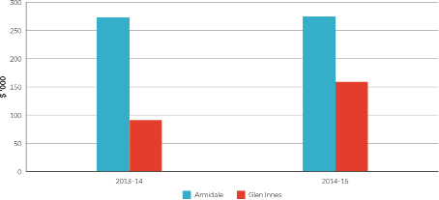
Source: ACCC calculations based on data obtained from the companies.
Notes: Armidale estimates are based on data from Caltex, Coles Express, Lowes and Woolworths. Glen Innes estimates are based on data from Caltex, Woolworths and United.
The net profit figures are based on profit and loss statements and financial templates provided by the companies. Net profit per site is broadly equal to earnings before interest and tax.
Factors contributing to higher net profit per site in Armidale compared with Glen Innes were: higher retail prices and net retail margins on fuel; lower operating costs; and substantially higher non-fuel profits in Armidale.
  - Retail unit net profit in Armidale is higher than the Australian
average
Retail unit net profit measures the overall profitability of retail sites in relation to total volume of fuel sold at those sites. It is defined as the overall net profit earned at retail sites (including profit made on convenience sales) per litre of fuel sold. This includes all grades of petrol, diesel and automotive LPG. This measure allows comparison of the profitability of sites in Armidale with the average across Australia.
Annual average retail unit net profit in Armidale and Australia for the period 2010–11 to 2014–15 is shown in chart 4.5. Australia-wide data for 2014–15 is not yet available.
In 2013–14, retail unit net profit in Armidale was around 7 cpl, compared with around 5 cpl across Australia.
Chart 4.5 Annual average retail unit net profit in Armidale and Australia: 2010–11 to 2014–15*
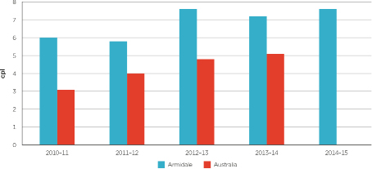
Source: ACCC calculations based on data from the companies.
Notes: Armidale estimates are based on data from Caltex, Coles Express, Lowes and Woolworths.
The Australia-wide estimates in this chart are based on data published in the ACCC’s 2014 petrol monitoring report, adjusted to remove the impact of head office costs.
* Australia-wide average retail unit net profit for 2014–15 is not yet available.
Retail unit net profit in Armidale was higher than the Australian average in all years between 2010–11 and 2013–14. Retail unit net profit in Armidale increased by 1.8 cpl (around 30 per cent) from 2011–12 to 2012–13, which was partly due to higher gross margins and broadly unchanged operating costs per litre on both fuel and non-fuel sales. Retail unit net profit across Australia increased from around 3 cpl in 2010–11 to around 5 cpl in 2013–14.
  - Net profit per site in Armidale is substantially lower than in Sydney
Chart 4.6 indicates that net profit per retail site in Armidale was significantly lower than in Sydney, which was around $470 000 per site in 2013–14 and around $480 000 per site in 2014–15. These are very high profit levels.
Chart 4.6 Net profit per site in Armidale and Sydney: 2013–14 to 2014–15
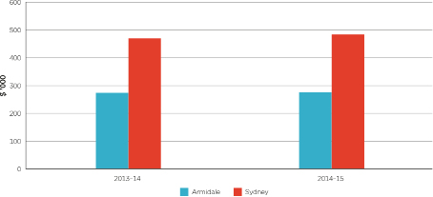
Source: ACCC calculations based on data obtained from the companies.
Notes: Armidale estimates are based on data from Caltex, Coles Express, Lowes and Woolworths. Sydney estimates are based on data from Caltex, Coles Express and Woolworths.
The net profit figures are based on profit and loss statements and financial templates provided by the companies. Net profit per site is broadly equal to earnings before interest and tax.
Net profit per site in Sydney was higher than in Armidale as a result of a number of factors:
- Sydney sites sold higher volumes of petrol than Armidale sites, and in particular higher volumes of PULP, which has higher margins compared with other types of petrol. Sydney sites sold on average three times as much PULP as Armidale sites (see section 4.5).
- Sydney sites also had 63 per cent higher non-fuel profits compared with Armidale sites. A significant proportion of this relates to convenience store sales.
- Higher operating costs at Sydney sites were offset by higher fuel and non-fuel revenue. Higher fuel sales meant that operating costs in Sydney were much lower than in Armidale on a per litre basis.
In general, the high profits in Sydney reflect relatively high profits from PULP sales (around one third of total net profit per site) and significant convenience store profits.
  - Retail sites in Armidale sell lower volumes of fuel
Retail sites in Armidale on average sell much lower volumes of fuel, including E10 and PULP, than sites in Sydney. In 2014–15, retail sites in Armidale sold around half the volume of E10 as sites in Sydney (around 1 million litres compared with 2 million litres—see chart 4.7), and around one-third of the volume of PULP as sites in Sydney (around 1 million litres compared with 3 million litres).
Chart 4.7 Average volume of fuel sold per site in Armidale and Sydney: 2014–15
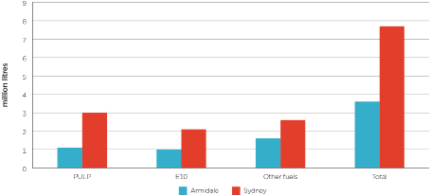
Source: ACCC calculations based on data from the companies.
Notes: Armidale estimates are based on data from Caltex, Coles Express, Lowes and Woolworths. Sydney estimates are based on data from Caltex, Coles Express and Woolworths.
Overall, average fuel sales per site were around 3.6 million litres in Armidale in 2014–15. This was less than half the volume of fuel sold in Sydney (around 7.7 million litres).
Generally speaking, retail sites selling higher volumes of fuel will have lower operating costs per litre of fuel sold, and the revenue from the higher sales volumes will more than offset any increases in operating costs (such as wages and energy costs).
- Lack of discounting in Armidale led to higher retail margins and higher prices
Competition among petrol retailers has an important influence on petrol prices and retail profit margins. The high degree of transparency of petrol prices enables consumers to shop around for petrol. This can encourage some petrol retailers to ‘chase volumes’ through discounting. However, the absence of retailers with a strategy to ‘chase volumes’ can result in situations where petrol prices remain stubbornly high, even when wholesale prices are falling.
  - Retail prices in Armidale only decreased when TGPs fell significantly, leading to higher retail margins over time
There have been significant swings in international crude oil and refined petrol prices over the last five years, which have been reflected in wholesale prices (i.e. TGPs). For example, TGPs in Armidale fell by around 47 cpl between July 2014 and January 2015. They subsequently increased by over 30 cpl to June 2015, before again decreasing by more than 30 cpl over the following eight months.
Competition among retailers plays a key role in how retail prices react to changes in TGPs. In the larger capital cities (and allowing for the price cycles that occur in those cities) retail prices tend to be largely responsive to movements in TGPs, both up and down. However, in Armidale retail prices typically only decrease when wholesale prices fall substantially.
To investigate the reaction of retail E10 prices in Armidale to changes in TGPs, eight time periods between June 2011 and June 2016 were identified. Each time period was split into two sub-periods:
- during the first sub-period TGPs were decreasing
- during the second sub-period TGPs were generally increasing.
Table 5.1 identifies the periods and chart 5.1 shows daily median retail E10 prices and daily average E10 TGPs for each period.
Table 5.2 separates each period into the two sub-periods described in table 5.1. The changes in daily median retail E10 prices, daily average TGPs and GIRDs are shown for each sub-period and for each period as a whole. The column ‘Retail/TGP’ shows the percentage of the change in TGPs that was passed through to retail E10 prices during each sub-period.
Table 5.1: Time periods used to assess the reaction of retail E10 prices in Armidale
Period | Dates | Number of days
Period | Dates | Sub-period when  TGPs were decreasing | Sub-period when TGPs were increasing
1 | 16 October 2011 to 12 April 2012 | 56 | 123
2 | 12 April 2012 to 17 October 2012 | 80 | 108
3 | 17 October 2012 to 21 February 2013 | 98 | 29
4 | 21 February 2013 to 8 September 2013 | 61 | 138
5 | 8 September 2013 to 5 January 2014 | 53 | 66
6 | 5 January 2014 to 4 October 2014 | 231 | 41
7 | 4 October 2014 to 19 June 2015 | 109 | 149
8 | 19 June 2015 to 1 June 2016 | 242 | 106

Source: ACCC calculations based on data provided by one of the companies and BP, Caltex and Viva Energy.
Chart 5.1: Daily median retail E10 prices and daily average TGPs in Armidale: 1 June 2011 to 30 June 2016
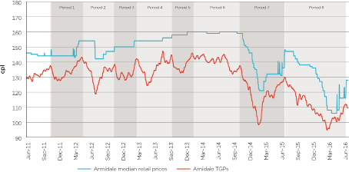
Source: ACCC calculations based on data provided by one of the companies and BP, Caltex and Viva Energy.
Table 5.2: Changes in daily median retail E10 prices and daily average TGPs in Armidale, by time period
 | Sub–period when TGPs were decreasing |  |  |  | Sub–period when TGPs were increasing |  |  |  | Whole period
Change in: | Retail prices | TGPs | GIRDs | Retail/TGP | Retail prices | TGPs | GIRDs | Retail/TGP | Retail prices | TGPs | GIRDs | Retail/TGP
 | cpl | cpl | cpl | % | cpl | cpl | cpl | % | cpl | cpl | cpl | %
Period
1 | 0 | –9.8 | 9.8 | 0 | 10.0 | 15.6 | –5.6 | 64 | 10.0 | 5.8 | 4.2 | 172
2 | –12.0 | –24.6 | 12.6 | 49 | 8.0 | 19.7 | –11.7 | 41 | –4.0 | –4.9 | 0.9 | 82
3 | 0 | –8.4 | 8.4 | 0 | 4.0 | 12.0 | –8.0 | 33 | 4.0 | 3.6 | 0.4 | 111
4 | 0 | –17.7 | 17.7 | 0 | 2.0 | 20.3 | –18.3 | 10 | 2.0 | 2.6 | –0.6 | 77
5 | 2.0 | –12.0 | 14.0 | –17 | 2.0 | 13.3 | –11.3 | 15 | 4.0 | 1.3 | 2.7 | 308
6 | 0 | –13.9 | 13.9 | 0 | –1.0 | 5.4 | –6.4 | –19 | –1.0 | –8.5 | 7.5 | 12
7 | –37.0 | –39.2 | 2.2 | 94 | 26.0 | 31.6 | –5.6 | 82 | –11.0 | –7.6 | –3.4 | 145
8 | –37.0 | –35.1 | –1.9 | 105 | 5.0 | 17.3 | –12.3 | 29 | –32.0 | –17.8 | –14.2 | 180

Source: ACCC calculations based on data provided by one of the companies and BP, Caltex and Viva Energy.
The relationship between wholesale and retail E10 prices in Armidale between June 2011 and June 2016 can be divided into two distinct phases.
The first phase covered the first six periods (from 16 October 2011 to 4 October 2014). During this phase, TGPs were largely unchanged overall, while retail E10 prices increased. This led to a very large increase in GIRDs:
- TGPs decreased by 0.1 cpl
- retail E10 prices increased by 15.0 cpl
- GIRDs increased by 15.1 cpl.
The second phase covered the seventh and eighth periods (from 4 October 2014 to 1 June 2016). During this phase there were two periods of significant falls in TGPs, as well of one period of significant, and rapid, increases in TGPs.
During this time retail E10 prices decreased by a very large amount, and more so than TGPs:
- TGPs decreased by 25.4 cpl
- retail E10 prices decreased by 43.0 cpl
- GIRDs decreased by 17.6 cpl.
At the end of March 2016, daily GIRDs were 2.4 cpl, which was the lowest over the entire eight periods. However, retail prices increased again in June, and daily GIRDs were around 20 cpl at 30 June 2016.
    - Retail E10 prices in Armidale were very unresponsive to movements in wholesale prices between October 2011 and October 2014, and retail E10 margins increased significantly over this time
From period 1 to period 6 (16 October 2011 to 4 October 2014) retail E10 prices in Armidale were very ‘sticky’, with only partial pass-through, both up and down, of changes in TGPs to retail E10 prices. In period 4, for example, TGPs decreased by 17.7 cpl while retail E10 prices did not change. Subsequently TGPs increased by 20.3 cpl with only a 2.0 cpl increase in retail E10 prices.
While retail E10 prices in Armidale have been ‘sticky’ on the way up, they have been more ‘sticky’ on the way down (see table 5.2). From period 1 to period 6 only 29 per cent of the total increase in TGPs was passed through as higher retail E10 prices. In aggregate, TGPs increased by 88.8 cpl and retail E10 prices increased by 31.2 cpl. Over the same period, only 12 per cent of the total decrease in TGPs was passed on to motorists. In aggregate, TGPs decreased by 86.4 cpl and retail E10 prices decreased by 10.0 cpl.
Between period 1 and period 6 retail E10 prices increased by 15.0 cpl in aggregate, compared with a decrease in TGPs of 0.1 cpl. Apart from one instance in June 2012, retail E10 prices in Armidale did not substantially decrease at any time over these periods. In contrast, retail E10 prices increased a number of times between period 3 and period 6, resulting in an increase in GIRDs from around 12 cpl to around 22 cpl.
The asymmetry in pass-through of wholesale price changes led to a large increase in GIRDs. In 2010–11 annual average GIRDs in Armidale were 11.6 cpl, and they increased to 19.0 cpl in 2014–15 (see table B3 in appendix B). The asymmetry in pass-through of wholesale price changes is consistent with a lack of active price competition in the Armidale retail market.
    - Retail E10 prices appear to be more responsive to very large changes in wholesale prices
There was a change in retail E10 pricing outcomes in Armidale in periods 7 and 8 (4 October 2014 to 1 June 2016). TGPs decreased substantially in both periods, and all of the decrease was passed through to retail E10 prices. In these periods the minimum retail price was reached at around the same time that the minimum TGP occurred. Furthermore, in periods 7 and 8 less than two-thirds of the increase in TGPs were passed through to retail E10 prices.
One possible reason for this significant pass-through is the very large size of the decrease in TGPs compared with the first six periods. Large and rapid falls in TGPs can cause substantial increases in retail margins. GIRDs in the first half of period 8 were higher than at any time during the previous seven periods. During periods when retail margins are high, it can become more attractive for retailers to chase higher sales volumes (as the margin on each additional sale is high). This in turn creates a competitive impetus whereby many retailers bring down their prices to match their competitors.
  - Armidale has lacked a price discounter for many years
    - There are a small number of participants in the Armidale retail market and few independents
As noted in chapter 2, there are eight retail sites in Armidale selling petrol: four Caltex, one Woolworths, one Coles Express, one BP-branded operated by Lowes, and one Liberty-branded independent. Apart from the last two sites, retail prices in Armidale are determined by the head offices of the major retailers (Caltex, Coles Express and Woolworths). In sum, there are a small number of independent sites and independent price setters in Armidale.
    - Between July 2011 and August 2014 retail prices were relatively ‘sticky’ in Armidale
The ACCC has analysed price data for seven retail sites operated by four petrol retailers in Armidale—Caltex, Coles Express, Woolworths and BP (Lowes)—for the six years between July 2010 and June 2016. During this period there were four (three prior to late-November 2014) Caltex sites, two (one prior to June 2011 and from late-November 2014) Woolworths sites, one Coles Express site and one BP (Lowes) site. Retail price data was not available for the site currently branded as Liberty. Both E10 and RULP prices were analysed because most motorists can substitute one type of petrol for the other.
Between July 2011 and August 2014 retail prices were typically the same across all retail sites in Armidale at any given time. There were few price movements compared with movements in TGPs, during what appeared to be a period of weak price competition. On average, retail E10 prices in Armidale only changed around once every seven weeks during this period.
Chart 5.2 shows daily retail E10 prices of the retailers in Armidale between 1 April 2012 and 30 June 2013. It indicates that retailers generally matched each other’s prices during this time. Apart from a single decrease in June 2012, average retail E10 prices in Armidale incrementally increased, despite TGPs moving both up and down over the period (see chart 5.1).
Chart 5.2 Daily retail E10 prices by retailer in Armidale: 1 April 2012 to 30 June 2013
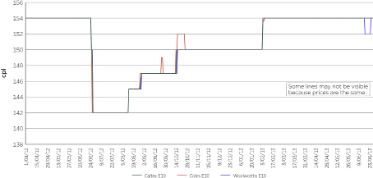
Source: ACCC calculations based on data provided by one of the companies.
Note: E10 prices for BP (Lowes) are not available until June 2014.
    - When retail prices decreased in Armidale there was no clear price leader
After September 2014 there were a number of occasions when retail prices fell significantly in Armidale. During these times, there was no clear leader of retail price decreases. The number of times each retail operator led prices down was shared relatively evenly between them. The retailers each tended to reduce their retail prices quickly once one of their competitors had moved. This is shown in chart 5.3 when retail prices decreased by almost 40 cpl in around three months between mid-October 2014 and mid-January 2015.
Chart 5.3 Daily retail E10 and RULP prices by retailer in Armidale: 1 September 2014 to 31 January 2015
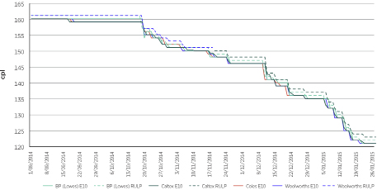
Source: ACCC calculations based on data provided by one of the companies.
Note: The Woolworths site selling RULP became a Caltex site in late November 2014.
    - When retail prices increased in Armidale this was often led by BP (Lowes)
In the periods after September 2014 when retail prices in Armidale increased significantly, BP (Lowes) appear to have been the retailer to most frequently lead prices up, with the other retailers typically following after a delay. This is shown in chart 5.4 which shows retail E10 and RULP prices for the five month period between February and June 2015, when prices increased by over 25 cpl.
The chart also highlights a number of occasions when Caltex significantly increased prices (the large spikes in the charts) at all of their Armidale sites, only for other sites not to have followed. After one to two days Caltex dropped their prices back. These retail price spikes often occurred in line with increases in TGPs, but were much larger than the TGP increases.
Chart 5.4 Daily retail E10 and RULP prices by retailer in Armidale: 1 February 2015 to 30 June 2015
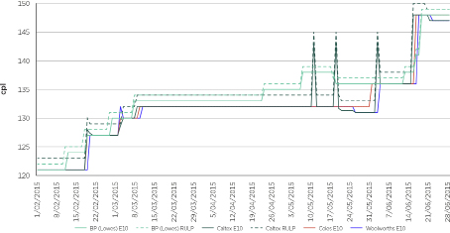
Source: ACCC calculations based on data provided by one of the companies.
  - A stronger discounter in Glen Innes led to price competition and lower prices
Glen Innes has consistently had lower retail prices than Armidale (see appendix E). In
2015–16 average retail E10 prices in Glen Innes were 9.5 cpl lower than in Armidale.
Like Armidale, Glen Innes has relatively few retail sites. There are currently six retail petrol sites in Glen Innes: one Caltex, one Woolworths, one United, one Shell, and two small independents (Fossicker and Jamesies). As in Armidale, these sites sell E10 or RULP, or a combination of the two.
The ACCC has analysed retail E10 price data for three petrol retailers in Glen Innes (Caltex, Woolworths and United (with limited observations)) for the six years between July 2010 and June 2016.
In examining the market structure of Glen Innes, a noticeable difference between Armidale is the presence of a United site, a retailer which typically competes strongly on price.
For those days on which United pricing data was available, United prices were, in the vast majority of cases, lower than or equal to prices at the Caltex and Woolworths sites. Overall, United prices were on average around 2–3 cpl lower than those at the Caltex and Woolworths sites.
This analysis, in combination with the data in chart 5.8 (which shows retail prices in Glen Innes in August and September 2016), supports the observation that United is a strong price competitor.
Caltex and Woolworths have retail sites in both Armidale and Glen Innes. A comparison of their daily average retail E10 prices in both towns (see charts 5.5 and 5.6) shows that:
- prices were generally lower (and sometimes by significant amounts) in Glen Innes
- over the six-year period July 2010 to June 2016, Caltex E10 prices in Glen Innes were on average 6.2 cpl lower than Caltex E10 prices in Armidale
- over the four-year period July 2012 to June 2016 Woolworths E10 prices in Glen Innes were on average 7.3 cpl lower than Woolworths E10 prices in Armidale
- prices were more volatile in Glen Innes, with a number of short price spikes evident.
The lower prices in Glen Innes and the greater volatility may indicate strong price competition in the market.
Chart 5.5 Daily average Caltex retail E10 prices in Armidale and Glen Innes: 1 July 2010 to 30 June 2016
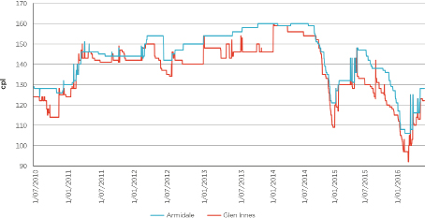
Source: ACCC calculations based on data from one of the companies.
Chart 5.6 Daily average Woolworths retail E10 prices in Armidale and Glen Innes: 1 July 2012 to 30 June 2016
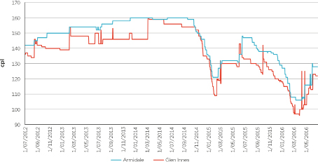
Source: ACCC calculations based on data supplied by one of the companies.
Note: The chart excludes the former Woolworths site at 142–144 Marsh Street Armidale as this site primarily sold RULP.
  - Since June 2016 Armidale has had a price discounter
In June 2016 a Liberty-branded independently operated retail site commenced operations in Armidale. It sells RULP but not E10. This was formerly a Neumann-branded independent site.
Since this Liberty site commenced operations the differential between Armidale and Glen Innes prices has narrowed. In the September quarter 2016 the differential between Armidale and Glen Innes retail E10 prices was 3.4 cpl, significantly below the annual average differential in 2015–16 of 9.5 cpl.
That the Liberty site is a low priced site is evident from the FuelCheck data which has been available since mid-August 2016. Chart 5.7 shows daily retail E10 and RULP prices by retailer in Armidale in August and September 2016 and the Liberty site is clearly the lowest priced site in the market.
In September the average E10 price in Armidale was 118.7 cpl and the average RULP price was 118.6 cpl. The average RULP price at the Liberty site was 116.9 cpl.
Chart 5.7 Daily retail E10 and RULP prices by retailer in Armidale: 1 August to 30 September 2016
Source: ACCC calculations based on FuelCheck data.
FuelCheck also provides fuel prices in real-time in Glen Innes. Chart 5.8 shows daily retail E10 and RULP prices by retailer in Glen Innes in August and September 2016. In September 2016 United had the lowest average RULP and E10 prices in the market. Prices at the other retailers were broadly similar for E10.
Chart 5.8 Daily retail E10 and RULP prices by retailer in Glen Innes: 1 August to 30 September 2016
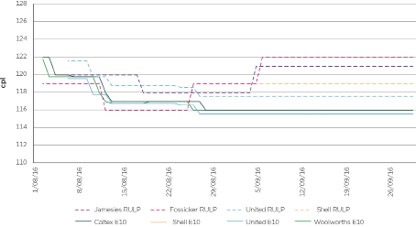
Source: ACCC calculations based on FuelCheck data.
- Increased transparency and promotion of effective price competition can lead to lower prices
  - Increase transparency of retail prices and GIRDs
Easy access to information about current retail petrol prices enables motorists to shop around and purchase fuel at relatively lower priced retail sites. This may promote competitive market behaviour and reward discounters, as more consumers will see which petrol retailers are discounting.
Furthermore, if there is close scrutiny of their pricing behaviour, petrol retailers may have less incentive to increase and maintain high prices. Ongoing monitoring and publication of prices and margins can shine a light on what is happening in the market.
    - Providing near real-time retail prices to motorists
Price sensitive motorists will often shop around for the cheapest prices, which can be facilitated by access to petrol pricing information.
On 24 August 2016, the NSW Government launched FuelCheck, an online tool providing consumers with real-time fuel price information covering every retail site across NSW. It is accessible on any device connected to the internet, including smartphones, tablets, desktop computers and laptops.
FuelCheck enables NSW motorists to: find the cheapest fuel being sold anywhere in NSW; get directions to any retail site in NSW; search for fuel by type or brand; and submit a complaint to NSW Fair Trading if the price at the pump does not match what is shown on FuelCheck.
Retail site operators need to ensure that the price of a fuel in FuelCheck matches the standard price of the fuel at their site. The standard price is the price per litre at which the fuel is available to retail customers without any discounts or special offers (such as shopper docket discounts). Penalty notices of $550 can be issued for each offence.
Motorists can use this tool to identify those sites in Armidale with the lowest E10 and RULP prices. Armidale is relatively small which means that motorists can easily travel to those retail sites offering the cheapest petrol.
Examples of information from the FuelCheck website are shown in charts 6.1 and 6.2.
Chart 6.1: Retail E10 prices by site in Armidale: 10 am on 13 October 2016
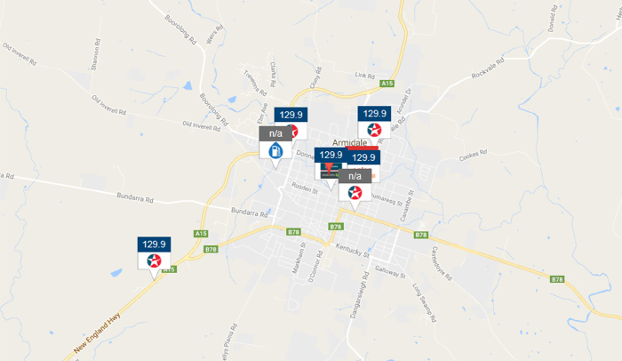
Source: NSW FuelCheck
Note: Screenshot taken at 10 am on 13 October 2016.
Chart 6.2: Retail RULP prices by site in Armidale: 10 am on 13 October 2016
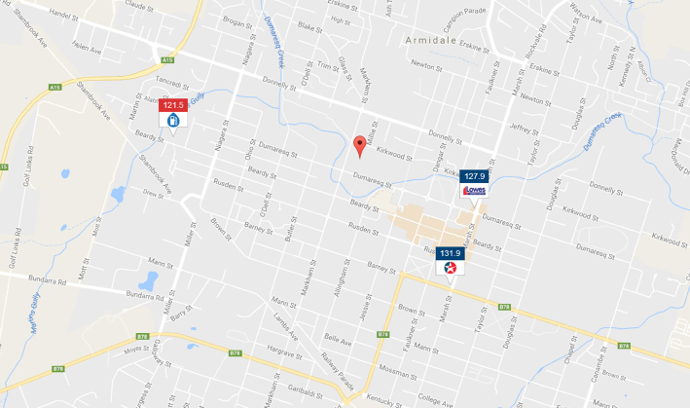
Source: NSW FuelCheck
Note: Screenshot taken 10 am on 13 October 2016.
There are other apps available to consumers, such as the NRMA app and the MotorMouth app, which provide comprehensive site-specific data in Armidale, and other locations in NSW. Motorists can also obtain information about retail prices using the apps of the petrol retailers (such as Woolworths) as well as more general apps (such as GasBuddy).
Making retail price information available to consumers and third parties on a near real-time basis will improve the functioning of retail petrol markets in a number of ways:
- it will enable motorists to more easily compare prices across retail sites
- it will reward more those companies that discount, particularly the Liberty site if it keeps offering attractive prices to consumers
- it will enable greater public scrutiny of the behaviour of petrol retailers.
The more information on petrol prices which is available to the public, the better informed motorists will be about when to buy petrol and from whom.
There may be scope for media outlets to more actively disseminate retail pricing information to help consumers find the cheapest price.
    - Regular publication of retail prices and GIRDs and benchmarking against other locations
NSW government agencies, motoring organisations, media establishments and academics can use the publicly available retail price data (from the sources noted in section 6.1.1) and wholesale price data (from the websites of the wholesalers and the Australian Institute of Petroleum) to analyse, and comment on, retail prices and GIRDs.
This could include:
- commentary and analysis about retail petrol prices by location and by brand over time
- regular publication of charts (such as charts 5.7 and 5.8 based on data from FuelCheck), which inform consumers about the historical pricing practices of retail sites
- monthly average retail price comparisons, such as for Armidale and Glen Innes, as shown in charts 6.3 and 6.4
Chart 6.3: Monthly average retail E10 prices in Armidale and Glen Innes: July 2015 to September 2016
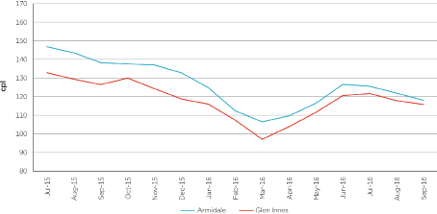
Source: ACCC calculations based on FUELtrac data.
Chart 6.4: Monthly average difference between retail E10 prices in Armidale and Glen Innes: July 2015 to September 2016
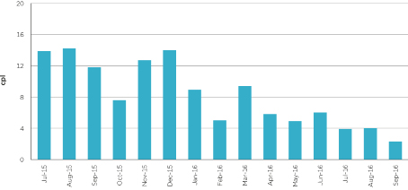
Source: ACCC calculations based on FUELtrac data.
GIRDs are a broad indicator of profitability and can be compared across locations and over time. When GIRDs in one location are significantly higher than in nearby locations it may indicate a lack of price competition among petrol retailers. GIRDs in the Armidale market, relative to other locations, could be monitored and information published on GIRDs for consumers and industry participants. This could include information such as:
- chart 6.5, which shows monthly average E10 GIRDs in Armidale and RULP GIRDs in the five largest cities between July 2015 and September 2016
- chart 6.6, which shows the monthly average difference between the two.
Chart 6.5: Monthly average E10 GIRDs in Armidale and RULP GIRDs in the five largest cities: July 2015 to September 2016
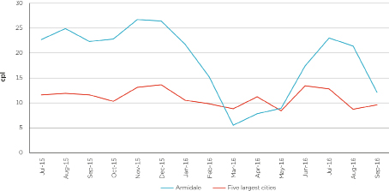
Source: ACCC calculations based on BP, Caltex, FUELtrac, Mobil, Viva Energy and WA Fuelwatch.
Chart 6.6: Difference between monthly average E10 GIRDs in Armidale and RULP GIRDs in the five largest cities: July 2015 to September 2016
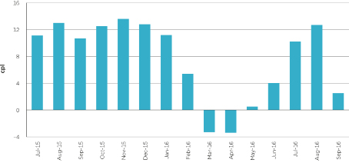
Source: ACCC calculations based on BP, Caltex, FUELtrac, Mobil, Viva Energy and WA Fuelwatch.
By making this information widely available, the monitoring organisations and consumers can make companies accountable when GIRDs become significantly higher than usual.
  - Promote effective entrants into the market
The Armidale petrol market is relatively concentrated, and the introduction of new players into the market—particularly discounters—may lead to increased competition.
The entry of the Liberty-branded site in the Armidale market in June 2016 seems to be having a downward effect on prices in Armidale. Monthly average prices in Armidale relative to Glen Innes have been relatively low in the September quarter 2016. Chart 6.2 shows that at 10 am on 13 October 2016 the retail RULP price at the Liberty-branded site was over 10 cpl lower than the Caltex site and over 6 cpl lower than the BP (Lowes) site.
For a discounter to remain successful it is important that motorists support their business. Motoring organisations and the media can play a role in this regard.
  - ACCC to closely monitor future merger activity, as well as retail prices and GIRDs, in the Armidale market
The ACCC will closely monitor and assess future acquisitions in Armidale and assess whether any acquisitions are likely to substantially lessen competition.
The Armidale market is relatively concentrated and any changes to the ownership structure could have a significant impact on competition and prices.
The ACCC will also continue to monitor retail prices and GIRDs in Armidale, and report on them in the quarterly petrol reports.
  - The ethanol mandate in NSW has led to less choice and higher prices for motorists
As noted in chapter 2, since its introduction in October 2007 the ethanol mandate in NSW has had a significant impact on competition and consumers in NSW.
It has affected the competitive dynamic among retailers by reducing the availability of RULP from many retail sites. However, consumers have been able to source RULP from those retail sites excluded from the requirements of the legislation. Retail sites are excluded from the ethanol mandate if they are part of an operation of 20 or fewer sites. However, this will change with the reforms announced by the NSW Government in December 2015.
The ethanol mandate has reduced consumer choice. Some motorists who could not, or chose not to, use E10 in their vehicles used PULP due to the reduced availability of RULP. This is reflected in the fact that between 2007−08 and 2015−16 sales of PULP in NSW increased by 147 per cent, whereas in the rest of Australia the increase over the same period was only 42 per cent. A similar trend occurred in Armidale.
Furthermore, as PULP retails at a higher price than RULP, it has meant that these motorists have been paying significantly higher prices than if they had continued to purchase RULP. In 2015−16 average PULP 95 prices in Armidale were 11.1 cpl higher than RULP prices, and PULP 98 prices were 17.9 cpl higher.
  - Armidale motorists may have spent around 2 cents per litre more on petrol in 2014–15
The ACCC has calculated the difference between what motorists in Armidale spent on the various types of petrol in 2014–15 and what they would have spent if they had bought the same proportions of these types of petrol as in the rest of Australia excluding NSW (which does not currently have an ethanol mandate). The analysis found that Armidale motorists may have spent around 2.1 cpl more on petrol in 2014–15.
The proportions of the types of fuel purchased by motorists in Armidale and the rest of Australia excluding NSW are shown in chart 2.3 in chapter 2. It shows that motorists in Armidale purchased significantly higher volumes of PULP and E10 and much lower volumes of RULP than motorists in other states.
The analysis estimated total sales of petrol in Armidale in 2014–15 based on data provided by the companies. Multiplying the volumes sold for each petrol type by its annual average retail price provides an estimate of the total amount spent on petrol in Armidale in 2014–15. Keeping the total volume of petrol sold constant, but changing the proportion of the various types of petrol sold to that of the rest of Australia excluding NSW provides an estimate of what motorists in Armidale would have spent in the absence of the ethanol mandate.
It is important to note that this estimate is based only on the change in petrol type and does not take account of other factors such as differences in the types of vehicles owned in Armidale, or motorists’ preferences, which may influence the type of petrol purchased in Armidale. It also does not take account of the possible costs or benefits from using one type of petrol instead of another, such as environmental benefits, differences in energy content, and engine cleaning properties.

Appendix A: Background and process

Background to the ACCC petrol monitoring arrangements
On 9 December 2014 the then Minister for Small Business, the Hon. Bruce Billson MP, gave the ACCC a new direction to monitor the prices, costs and profits of unleaded petroleum products in Australia for a period of three years.
Instead of providing an annual report to the Minister, as occurred under the previous direction, the ACCC provides reports at least quarterly. The new arrangements enable the ACCC to undertake more timely and targeted monitoring and analysis of particular topics and fuel markets that are of concern to consumers.
Under these arrangements the ACCC produces two types of reports:
- quarterly ‘macro’ reports on petrol price movements and the overall drivers of Australian fuel prices
- seven of these reports have already been released
- market studies that look at ‘micro’ issues in considerable depth, including an analysis of the drivers of petrol prices in specific regional markets
- the first market study on Darwin was released in November 2015
- the second market study on Launceston was released in July 2016.

Regional market studies and what they aim to achieve
The aims of the regional market studies are to:
- get to the bottom of why prices are higher in certain regional locations
- identify and explain each component of the prices paid at the bowser
- explain where money is being made in the petrol price value chain.
These studies rely on compulsory information gathering powers under Section 95ZK of the Competition and Consumer Act 2010 (Cth).
While only a small number of regional market studies are likely to be conducted in each year, each of these studies will have wider implications. The ACCC will be able to draw lessons of wider relevance to other regional markets.

Choice of Armidale
The ACCC undertook extensive assessment of relevant data to select the possible regional locations.
The ACCC collects retail petrol prices for around 190 regional locations across Australia. Two types of analyses were undertaken on this data:
- a regression analysis, which estimated prices for each regional location and then compared these with the actual prices in each location
- a ranking analysis, which ranked the regional locations against a number of criteria, including:
- the difference in price in each location compared with the average price in the five largest cities
- the GIRD in each location
- the GIRD in each location relative to population size
- the GIRD in each location relative to nearby location
- the variance of prices in each location.
The regression and ranking analyses were each undertaken for two time periods—one year (2013–14) and three years (2011–12 to 2013–14).
The results of the four analyses were compiled and assessed. On the basis that Armidale ranked very high overall, it was chosen as the location for the third regional market study.
On 3 August 2015 the ACCC announced Armidale as the location of the third regional market study.

How the study was conducted
Data collection and analysis
Between August 2015 and July 2016, the ACCC issued Section 95ZK notices to BP, Caltex, Coles Express, Lowes Petroleum, Mobil, United, Viva Energy, Woolworths, and four independent retail site operators (including two commission agents for Caltex) to obtain information and documents relating to the supply of petroleum products in Armidale, Glen Innes and Sydney.
The data requested included financial and operational information about each company.
Consultation
The ACCC established a consultation hub on the ACCC website for any stakeholder or interested party to provide information to the market study.
ACCC staff visited retail site operators in Armidale.

Appendix B: E10 prices, TGPs and GIRDs in Armidale
This appendix provides data on retail E10 prices, TGPs and GIRDs in Armidale and Sydney. For comparison purposes it also includes RULP data for the five largest cities.

Retail E10 and RULP prices: 2009–10 to 2015–16
Table B1: Annual average retail E10 prices in Armidale and Sydney, and retail RULP prices in the five largest cities: 2009–10 to 2015–16—cents per litre

Year | Armidale  (E10) | Five largest cities  (RULP) | Diff | Sydney  (E10) | Diff
2009–10 | 128.2 | 124.2 | 4.0 | 121.5 | 6.7
2010–11 | 133.8 | 131.7 | 2.1 | 130.4 | 3.4
2011–12 | 146.6 | 142.8 | 3.8 | 141.9 | 4.7
2012–13 | 149.9 | 141.3 | 8.6 | 140.3 | 9.6
2013–14 | 158.3 | 150.6 | 7.7 | 149.8 | 8.5
2014–15 | 143.0 | 134.1 | 8.9 | 132.6 | 10.4
2015–16 | 127.9 | 121.7 | 6.2 | 120.8 | 7.1

Chart B1: Annual average retail E10 prices in Armidale and retail RULP prices in the five largest cities:
2009–10 to 2015–16
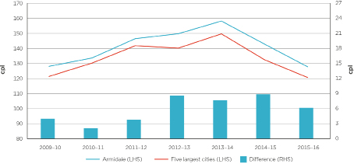
Chart B2: Annual average retail E10 prices in Armidale and Sydney: 2009–10 to 2015–16
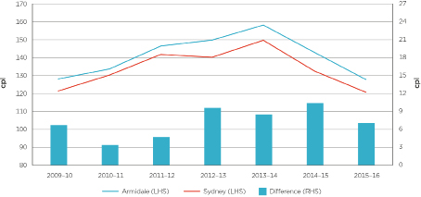

E10 and RULP TGPs: 2009–10 to 2015–16
Table B2: Annual average E10 TGPs in Armidale and Sydney, and RULP TGPs in the five largest cities: 2009–10 to 2015–16—cents per litre
Year | Armidale  (E10) | Five largest cities  (RULP) | Diff | Sydney  (E10) | Diff
2009–10 | 115.2 | 117.2 | –2.0 | 115.1 | 0.1
2010–11 | 122.2 | 124.1 | –1.9 | 122.4 | –0.2
2011–12 | 133.3 | 135.1 | –1.8 | 133.7 | –0.4
2012–13 | 132.4 | 134.2 | –1.8 | 132.6 | –0.2
2013–14 | 140.6 | 142.5 | –1.9 | 140.7 | –0.1
2014–15 | 124.0 | 125.5 | –1.5 | 124.1 | –0.1
2015–16 | 109.4 | 110.5 | –1.1 | 109.3 | 0.1

Chart B3: Annual average E10 TGPs in Armidale and RULP TGPs in the five largest cities: 2009–10 to 2015–16
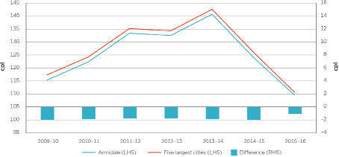
Chart B4: Annual average E10 TGPs in Armidale and Sydney: 2009–10 to 2015–16
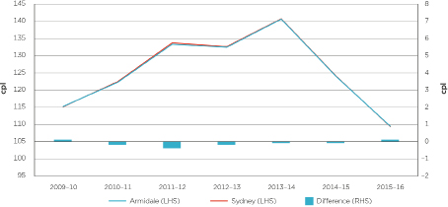

E10 and RULP GIRDs: 2009–10 to 2015–16
Table B3: Annual average retail prices, TGPs and GIRDs: 2009–10 to
2015–16—cents per litre
Year | Retail prices | TGPs | GIRDs | GIRDs difference
Armidale (E10)
2009–10 | 128.2 | 115.2 | 13.0 | –
2010–11 | 133.8 | 122.2 | 11.6 | –
2011–12 | 146.6 | 133.3 | 13.3 | –
2012–13 | 149.9 | 132.4 | 17.5 | –
2013–14 | 158.3 | 140.6 | 17.7 | –
2014–15 | 143.0 | 124.0 | 19.0 | –
2015–16 | 127.9 | 109.4 | 18.5 | –
Five largest cities (RULP)
2009–10 | 124.2 | 117.2 | 7.0 | 6.0
2010–11 | 131.7 | 124.1 | 7.6 | 4.0
2011–12 | 142.8 | 135.1 | 7.7 | 5.6
2012–13 | 141.3 | 134.2 | 7.1 | 10.4
2013–14 | 150.6 | 142.5 | 8.1 | 9.6
2014–15 | 134.1 | 125.5 | 8.6 | 10.9
2015–16 | 121.7 | 110.5 | 11.2 | 7.3
Sydney (E10)
2009–10 | 121.5 | 115.1 | 6.4 | 6.6
2010–11 | 130.4 | 122.4 | 8.0 | 3.6
2011–12 | 141.9 | 133.7 | 8.2 | 5.1
2012–13 | 140.3 | 132.6 | 7.7 | 9.8
2013–14 | 149.8 | 140.7 | 9.1 | 8.6
2014–15 | 132.6 | 124.1 | 8.5 | 10.5
2015–16 | 120.8 | 109.3 | 11.5 | 7.0

Chart B5: Annual average E10 GIRDs in Armidale and RULP GIRDs in the five largest cities: 2009–10 to 2015–16
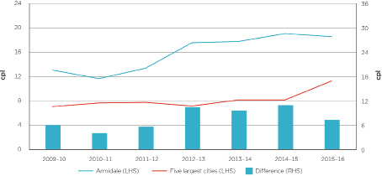
Chart B6: Annual average E10 GIRDs in Armidale and Sydney: 2009–10 to 2015–16
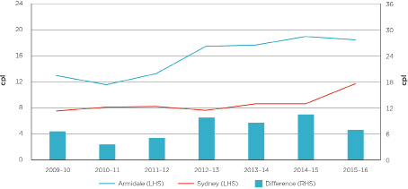

Appendix C: PULP 95 prices, TGPs and GIRDs in Armidale
This appendix provides data on retail PULP 95 prices, TGPs and GIRDs in Armidale, the five largest cities and Sydney.

Retail PULP 95 prices: 2009–10 to 2015–16
Table C1: Annual average retail PULP 95 prices in Armidale, Sydney and the five largest cities: 2009–10 to 2015–16—cents per litre
Year | Armidale | Five largest cities | Diff | Sydney | Diff
2009–10 | 139.2 | 133.4 | 5.8 | 133.1 | 6.1
2010–11 | 143.8 | 141.3 | 2.5 | 141.9 | 1.9
2011–12 | 157.8 | 153.0 | 4.8 | 153.5 | 4.3
2012–13 | 162.0 | 151.7 | 10.3 | 152.0 | 10.0
2013–14 | 171.2 | 161.2 | 10.0 | 161.4 | 9.8
2014–15 | 155.9 | 145.0 | 10.9 | 145.9 | 10.0
2015–16 | 140.9 | 132.8 | 8.1 | 134.3 | 6.6

Chart C1: Annual average retail PULP 95 prices in Armidale and the five largest cities: 2009–10 to 2015–16
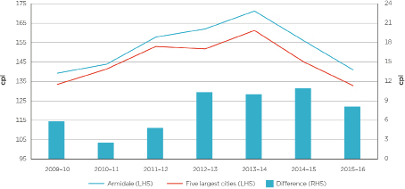
Chart C2: Annual average retail PULP 95 prices in Armidale and Sydney: 2009–10 to 2015–16
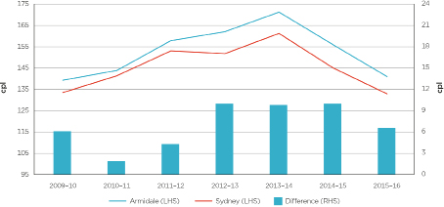

PULP 95 TGPs: 2009–10 to 2015–16
Table C2: Annual average PULP 95 TGPs in Armidale, Sydney and the five largest cities: 2009–10 to 2015–16—cents per litre
Year | Armidale | Five largest cities | Diff | Sydney | Diff
2009–10 | 127.1 | 126.7 | 0.4 | 125.5 | 1.6
2010–11 | 133.7 | 133.5 | 0.2 | 132.8 | 0.9
2011–12 | 145.1 | 145.1 | 0.0 | 145.2 | -0.1
2012–13 | 143.1 | 142.7 | 0.4 | 143.1 | 0.0
2013–14 | 151.3 | 150.9 | 0.4 | 151.1 | 0.2
2014–15 | 134.8 | 134.5 | 0.3 | 134.5 | 0.3
2015–16 | 120.0 | 119.9 | 0.1 | 119.8 | 0.2

Chart C3: Annual average PULP 95 TGPs in Armidale and the five largest cities: 2009–10 to 2015–16
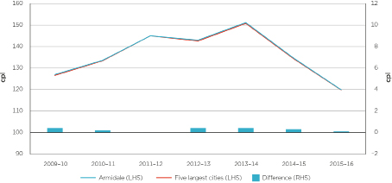
Chart C4: Annual average PULP 95 TGPs in Armidale and Sydney: 2009–10 to 2015–16
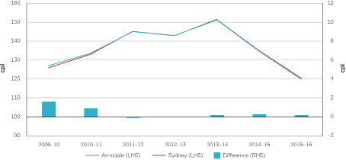

PULP 95 GIRDs: 2009–10 to 2015–16
Table C3: Annual average retail PULP 95 prices, TGPs and GIRDs: 2009–10 to 2015–16—cents per litre
Year | Retail prices | TGPs | GIRDs | GIRDs  Difference
Armidale
2009–10 | 139.2 | 127.1 | 12.1 | –
2010–11 | 143.8 | 133.7 | 10.1 | –
2011–12 | 157.8 | 145.1 | 12.7 | –
2012–13 | 162.0 | 143.1 | 18.9 | –
2013–14 | 171.2 | 151.3 | 19.9 | –
2014–15 | 155.9 | 134.8 | 21.1 | –
2015–16 | 140.9 | 120.0 | 20.9 | –
Five largest cities
2009–10 | 133.4 | 126.7 | 6.7 | 5.4
2010–11 | 141.3 | 133.5 | 7.8 | 2.3
2011–12 | 153.0 | 145.1 | 7.9 | 4.8
2012–13 | 151.7 | 142.7 | 9.0 | 9.9
2013–14 | 161.2 | 150.9 | 10.3 | 9.6
2014–15 | 145.0 | 134.5 | 10.5 | 10.6
2015–16 | 132.8 | 119.9 | 12.9 | 8.0
Sydney
2009–10 | 133.1 | 125.5 | 7.6 | 4.5
2010–11 | 141.9 | 132.8 | 9.1 | 1.0
2011–12 | 153.5 | 145.2 | 8.3 | 4.4
2012–13 | 152.0 | 143.1 | 8.9 | 10.0
2013–14 | 161.4 | 151.1 | 10.3 | 9.6
2014–15 | 145.9 | 134.5 | 11.4 | 9.7
2015–16 | 134.3 | 119.8 | 14.5 | 6.4

Chart C5: Annual average PULP 95 GIRDs in Armidale and the five largest cities: 2009–10 to 2015–16
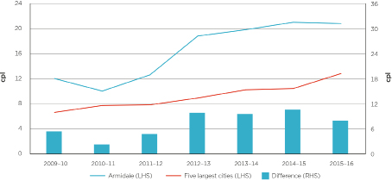
Chart C6: Annual average PULP 95 GIRDs in Armidale and Sydney: 2009–10 to 2015–16
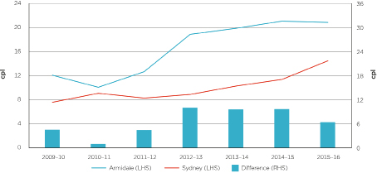

Appendix D: Diesel prices, TGPs and GIRDs in Armidale
This appendix provides data on retail diesel prices, TGPs and GIRDs in Armidale, the five largest cities and Sydney.

Retail diesel prices: 2009–10 to 2015–16
Table D1: Annual average retail diesel prices in Armidale, Sydney and the five largest cities: 2009–10 to 2015–16—cents per litre
Year | Armidale | Five largest cities | Diff | Sydney | Diff
2009–10 | 131.8 | 124.5 | 7.3 | 124.3 | 7.5
2010–11 | 142.8 | 136.3 | 6.5 | 136.3 | 6.5
2011–12 | 155.9 | 147.9 | 8.0 | 147.5 | 8.4
2012–13 | 153.6 | 147.4 | 6.2 | 146.6 | 7.0
2013–14 | 165.6 | 157.8 | 7.8 | 156.6 | 9.0
2014–15 | 148.5 | 140.4 | 8.1 | 140.1 | 8.4
2015–16 | 128.5 | 121.0 | 7.5 | 120.7 | 7.8

Chart D1: Annual average retail diesel prices in Armidale and the five largest cities: 2009–10 to 2015–16
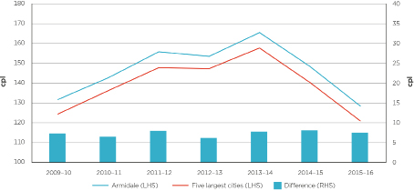
Chart D2: Annual average retail diesel prices in Armidale and Sydney:
2009–10 to 2015–16
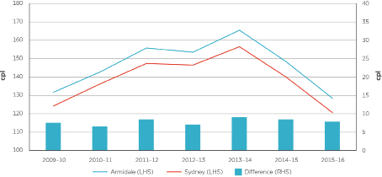
Diesel TGPs: 2009–10 to 2015–16
Table D2: Annual average diesel TGPs: 2009–10 to 2015–16—cents per litre
Year | Armidale | Five largest  cities | Diff | Sydney | Diff
2009–10 | 116.4 | 116.2 | 0.2 | 116.2 | 0.2
2010–11 | 127.7 | 127.4 | 0.3 | 127.8 | –0.1
2011–12 | 138.2 | 138.0 | 0.2 | 138.3 | –0.1
2012–13 | 137.2 | 136.9 | 0.3 | 137.3 | –0.1
2013–14 | 146.6 | 146.4 | 0.2 | 146.7 | –0.1
2014–15 | 126.9 | 126.7 | 0.2 | 127.0 | –0.1
2015–16 | 106.0 | 105.8 | 0.2 | 106.1 | –0.1

Chart D3: Annual average diesel TGPs in Armidale and the five largest cities: 2009–10 to 2015–16
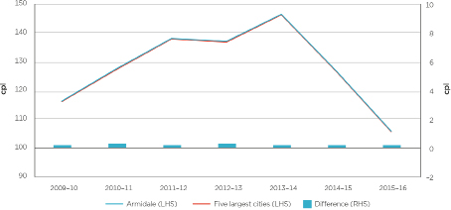
Chart D4: Annual average diesel TGPs in Armidale and Sydney: 2009–10 to 2015–16
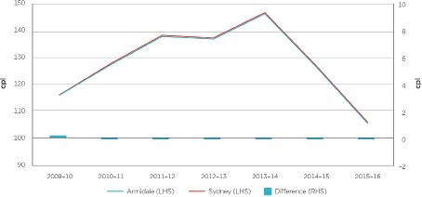

Diesel GIRDs: 2009–10 to 2015–16
Table D3: Annual average retail diesel prices, TGPs and GIRDs: 2009–10 to 2015–16—cents per litre
Year | Retail prices | TGPs | GIRDs | GIRDs  Difference
Armidale
2009–10 | 131.8 | 116.4 | 15.4 | –
2010–11 | 142.8 | 127.7 | 15.1 | –
2011–12 | 155.9 | 138.2 | 17.7 | –
2012–13 | 153.6 | 137.2 | 16.4 | –
2013–14 | 165.6 | 146.6 | 19.0 | –
2014–15 | 148.5 | 126.9 | 21.6 | –
2015–16 | 128.5 | 106.0 | 22.5 | –
Five largest cities
2009–10 | 124.5 | 116.2 | 8.3 | 7.1
2010–11 | 136.3 | 127.4 | 8.9 | 6.2
2011–12 | 147.9 | 138.0 | 9.9 | 7.8
2012–13 | 147.4 | 136.9 | 10.5 | 5.9
2013–14 | 157.8 | 146.4 | 11.4 | 7.6
2014–15 | 140.4 | 126.7 | 13.7 | 7.9
2015–16 | 121.0 | 105.8 | 15.2 | 7.3
Sydney
2009–10 | 124.3 | 116.2 | 8.1 | 7.3
2010–11 | 136.3 | 127.8 | 8.5 | 6.6
2011–12 | 147.5 | 138.3 | 9.2 | 8.5
2012–13 | 146.6 | 137.3 | 9.3 | 7.1
2013–14 | 156.6 | 146.7 | 9.9 | 9.1
2014–15 | 140.1 | 127.0 | 13.1 | 8.5
2015–16 | 120.7 | 106.1 | 14.6 | 7.9

Chart D5: Annual average diesel GIRDs in Armidale and the five largest cities: 2009–10 to 2015–16
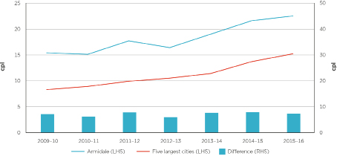
Chart D6: Annual average diesel GIRDs in Armidale and Sydney: 2009–10 to 2015–16
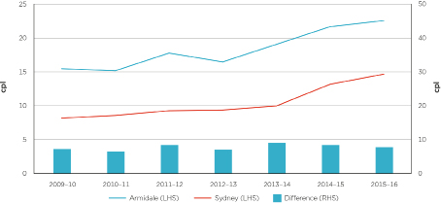

Appendix E: E10 and PULP 95 prices in Armidale and nearby locations
There are three locations within 130 kilometres of Armidale which are included in the ACCC’s fuel price monitoring program. These are Glen Innes, Inverell and Tamworth.
This appendix compares annual average E10 and PULP 95 retail prices in Armidale and these nearby locations during the period 2009–10 to 2015–16.
ACCC petrol monitoring has found that retail petrol prices in regional locations in Australia are typically higher than those in the capital cities, although they generally tend to follow the same overall price movements. Prices in regional locations are generally higher for a number of reasons, including:
- a lower level of local competition, often reflecting the lower number of retail sites
- lower volumes of fuel sold
- distance/location factors
- lower convenience store sales.
These factors also explain differences in petrol prices between regional locations.

Retail E10 prices
Table E1: Annual average retail E10 prices in Armidale and nearby locations:
2009–10 to 2015–16—cents per litre
Year | Armidale | Glen Innes | Diff | Inverell | Diff | Tamworth | Diff
2009–10 | 128.2 | 122.6 | 5.6 | 125.9 | 2.3 | 127.4 | 0.8
2010–11 | 133.8 | 129.0 | 4.8 | 133.8 | 0.0 | 135.1 | –1.3
2011–12 | 146.6 | 143.4 | 3.2 | 145.8 | 0.8 | 147.3 | –0.7
2012–13 | 149.9 | 142.5 | 7.4 | 147.3 | 2.6 | 148.6 | 1.3
2013–14 | 158.3 | 149.8 | 8.5 | 151.7 | 6.6 | 153.0 | 5.3
2014–15 | 143.0 | 138.8 | 4.2 | 138.0 | 5.0 | 139.3 | 3.7
2015–16 | 127.9 | 118.4 | 9.5 | 122.0 | 5.9 | 123.8 | 4.1

Chart E1: Annual average retail E10 prices in Armidale and nearby locations: 2009–10 to 2015–16
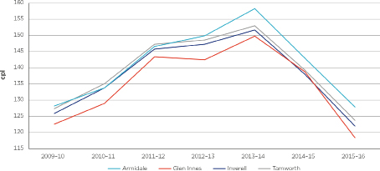
The annual average retail E10 price in Armidale was similar to that in Inverell and Tamworth between 2009–10 and 2012–13. It increased significantly relative to these locations in 2013–14, and remained relatively higher into 2015–16. Over the period 2009–10 to 2015–16, the E10 price in Armidale was always higher than Glen Innes.

Retail PULP 95 prices
Table E2: Annual average retail PULP 95 prices in Armidale and nearby locations: 2009–10 to 2015–16—cents per litre
Year | Armidale | Glen Innes | Diff | Inverell | Diff | Tamworth | Diff
2009–10 | 139.2 | 134.5 | 4.7 | n/a | n/a | n/a | n/a
2010–11 | 143.8 | 138.9 | 4.9 | n/a | n/a | n/a | n/a
2011–12 | 157.8 | 156.0 | 1.8 | n/a | n/a | n/a | n/a
2012–13 | 162.0 | 155.3 | 6.7 | n/a | n/a | n/a | n/a
2013–14 | 171.2 | 162.8 | 8.4 | n/a | n/a | n/a | n/a
2014–15 | 155.9 | 151.7 | 4.2 | 150.5 | 5.4 | 152.6 | 3.3
2015–16 | 140.9 | 131.1 | 9.8 | 134.7 | 6.2 | 136.9 | 4.0

Chart E2: Annual average retail PULP 95 prices in Armidale and Glen Innes: 2009–10 to 2015–16
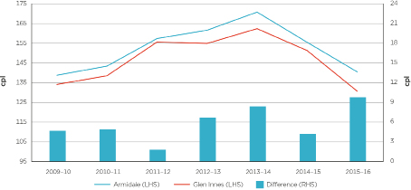
The annual average retail PULP 95 price in Armidale was always higher than in Glen Innes from 2009–10 to 2015–16. The price difference varied significantly over this period ranging from a low of 1.8 cpl in 2011–12 to a high of 9.8 cpl in 2015–16—an increase of 8.0 cpl over four years.

Appendix F: Financial data collection and methodology
This appendix outlines the process of collection and analysis of data for the Armidale market study and the methodology for the processing of retail financial data.

Collection
The ACCC sought detailed financial information from fuel retailers operating in Armidale. These companies included Caltex, Coles Express, Lowes Petroleum, Woolworths, and two commission agents of Caltex.
In addition, information was sought from Caltex, Woolworths and United and two small independent retail site operators in Glen Innes, and from the major retailers about their retail sites in Sydney, to make comparisons with the Armidale market.
Information collected under the ACCC’s petrol monitoring program was also used to compare Australia-wide retail profitability with Armidale.

Confidentiality
The information provided to the ACCC is mostly commercially sensitive and has been provided on a confidential basis. To protect confidentiality, this report presents primarily aggregated analysis of retail costs and profits.

Financial assessment methodology
Data presented in this report was collected from the fuel retailers through financial data templates and profit and loss statements for individual retail sites in Armidale and Glen Innes provided by the companies. Fuel retailers also submitted financial data templates for Sydney in aggregate. The templates were broadly similar to those used under the ACCC’s petrol monitoring program.

Coverage
The analysis focuses on E10 and PULP sold at retail sites in Armidale, Glen Innes and Sydney. To fully examine the retail fuel market, revenue and costs of other fuels and non-fuel products were also analysed, as well as the overall profitability of each retail site.
When calculating the average costs and profits per site in Armidale, only those sites that operated for the full financial year were included.
Head office costs are costs incurred by larger retail operators in the operation of retail sites. These costs may relate to marketing, training, IT services, support office costs, and other administrative costs, which may not easily be attributed to individual sites. Head office costs are generally not included in the profit and loss statements for individual retail sites but are reported separately in the balance sheets across the overall business. As the retail operators used different methods to allocate their head office costs, they have been excluded from the profitability analysis in this report.

Cost allocation
Costs associated with the operation of a retail site cannot be directly attributed to a particular product or service. Petrol is sold jointly with other automotive fuels as well as non-fuel products, such as convenience store goods. Therefore, many costs are common to the retailing of both fuel and convenience store products, as they are generally sold from the same premises and by the same staff.
The existence of common and joint costs means that costs must be allocated to individual products. However, as the monitored companies do not generally measure net profit by product or service, they do not allocate costs to individual products or services.
The methodology the ACCC has used to allocate common costs in this report in the retail sector is consistent with that used in previous years in the ACCC’s annual petrol monitoring reports.
Firstly, gross profit by convenience store and fuel sales were used to prorate costs between these two broad activities. Secondly, costs were then split by petroleum product on the basis of the relative product volumes sold.
While the ACCC has used well accepted cost allocation rules and conventions such as using sales volumes, revenue and costs, care should be taken when interpreting data presented in this report as there is no exact way of allocating common costs.

Petrol value chain
The petrol value chain describes each component contributing to the price of petrol at the bowser in Armidale, and compares this with the components of Sydney and Glen Innes petrol prices. The value chain includes costs and margins associated with importing, storage, wholesaling, transporting and retailing petrol.
Note that the value chain components are based on the average across companies and do not reflect the costs or profits of any individual company.
The value chain uses the average TGP as a proxy for the wholesale price, and uses the average retail petrol price for each location obtained from FUELtrac.

Retail business models in Armidale
In the fuel industry, as with other industries, different companies operate under different business models and organisational structures. Types of retail businesses in Armidale include company owned and operated sites and commission agents.
The differences in business models and their effect on operating costs reported by the companies need to be borne in mind when considering the average costs and profits of the retail fuel market in Armidale, Sydney and Glen Innes.

Profit and loss data
Companies operating retail sites in Armidale and Glen Innes were asked to provide profit and loss statements for each of their retail sites in Armidale for the period 1 July 2010 to 30 June 2015. This information was used to assess the profitability of retail sites in Armidale and Glen Innes. Profit and loss information was used to calculate net profit per site and retail unit net profit—these concepts are described below.

Financial template
Companies operating retail sites in Armidale and Glen Innes were asked to complete financial templates for each of their retail sites covering the period 1 July 2010 to 30 June 2015. Companies were also asked to provide this information in aggregate across all of their retail sites in Sydney. The templates sought information specific to petrol, including costs, revenue and sales volumes that was not available from the profit and loss statements. This information was used to calculate retail unit net profit and net retail margins on petrol—these concepts are described below. The templates were also used to allocate retail operating costs to petrol, as outlined above.

Key financial indicators for assessing the Armidale retail market
Net profit per site
Net profit in chapter 4 is as reported in companies’ profit and loss statements or financial data templates for each site in Armidale, Sydney and Glen Innes. While there may be some small differences in how net profit was calculated between companies, in general net profit broadly equates to net earnings before interest and tax.
Retail unit net profit
The net profit made by fuel retailers for each litre of fuel sold. That is, the overall net profit reported by companies divided by the total volume of fuel sold. This includes profits made on non-fuel products such as convenience store sales.
Net retail margin on E10
The net profit earned by companies from the sales of E10 only, i.e. revenue earned from sales of E10 less purchases of E10 less allocated operating costs. In this report this was calculated as the average retail E10 price less the average TGP, the average operating costs allocated to E10 sales (as described earlier), freight and retail GST.
Net retail margin was also calculated for PULP 95 on the same basis.

In this report ‘petrol’ means all types of petrol, including regular unleaded petrol (RULP), E10, premium unleaded petrol (PULP) 95 and PULP 98, and ‘PULP’ means PULP 95 and PULP 98. All prices used in this report are board prices and do not take account of discount arrangements (such as shopper docket discount schemes). For the purposes of this study, the ACCC has defined Armidale as the area of Armidale and its surrounds to a 20 kilometre radius.
This study compares E10 prices in Armidale with RULP prices in the five largest cities. The average retail RULP price in the five largest cities is used for comparison purposes because the ACCC has historically tracked these movements over time in the annual and quarterly petrol reports (note that from July 2014 the five largest city average uses E10 prices for Sydney because E10 sales are greater than RULP sales there). An additional reason for using this benchmark is that, of the five largest cities, retail E10 prices are only available for Sydney, Melbourne and Brisbane.
These are the closest regional locations to Armidale which are included in the ACCC’s fuel price monitoring program.
More detail on the background to the regional studies and how Armidale was chosen is included in appendix A.
From July 2014 the five largest cities average uses E10 prices for Sydney because E10 sales are greater than RULP sales there.
Appendix B provides more details on E10 prices in Armidale.
Appendix C provides more data on PULP 95 prices in Armidale.
Appendix D provides more data on diesel prices in Armidale.
See chapter 2 for more information on the NSW ethanol mandate and its effects.
As fuel in Armidale is sourced from terminals in Sydney, Brisbane and Newcastle, the average of the TGPs reported by the relevant companies have been used for Armidale. Data on Armidale E10 and PULP 95 GIRDs is provided in appendices B and C.
Australian Competition and Consumer Commission (ACCC), ACCC concludes investigation into Armidale fuel prices, media release, 18 May 2015, at:http://www.accc.gov.au/media-release/accc-concludes-investigation-into-armidale-fuel-prices.
ACCC, Report on the Darwin petrol market, November 2015, at: https://www.accc.gov.au/publications/petrol-market-studies/report-on-the-darwin-petrol-market.
Senator John Williams, ACCC to investigate Armidale fuel prices, media release, 23 October 2014, at: http://www.senatorjohnwilliams.com/news-room/media-releases/682-accc-to-investigate-armidale-fuel-prices, accessed on 19 October 2016.
ACCC, ACCC announces third regional petrol market study in Armidale, media release, 3 August 2015, at: http://www.accc.gov.au/media-release/accc-announces-third-regional-petrol-market-study-in-armidale.
See appendix A.
This is a Caltex-branded unmanned retail site.
Armidale has a population of around 20,000 people and Glen Innes has a population of around 5,000 people. See: Australian Bureau of Statistics, Census of Population and Housing, 2011, http://www.censusdata.abs.gov.au/census_services/getproduct/census/2011/quickstat/0, accessed on 19 October 2016.
A commission agent is someone who operates but does not own the retail site, and receives a commission for selling fuel owned by the site owner, usually a petrol refiner or wholesaler. The retail prices are determined by the owner.
The Queensland government has announced that it will introduce an ethanol mandate commencing on 1 January 2017. See: The Honourable Mark Bailey, Minister for Main Roads, Road Safety and Ports and Minister for Energy, Biofuels and Water Supply, Palaszczuk Government’s biofuels mandate on track, media release, 1 September 2016, at: http://statements.qld.gov.au/Statement/2016/9/1/palaszczuk-governments-biofuels-mandate-on-track, accessed on 27 October 2016.
Independent Pricing and Regulatory Tribunal (IPART), Review of a maximum price for wholesale ethanol in automotive fuel blends, Other—Draft Report, October 2016, page 2, at: https://www.ipart.nsw.gov.au/files/sharedassets/website/shared-files/pricing-reviews-section-12a-publications-review-of-a-maximum-price-for-wholesale-ethanol/draft-report-maximum-price-for-wholesale-ethanol-in-automotive-blends-october-2016.pdf, accessed on 27 October 2016.
Victor Dominello MP, NSW Minister for Innovation and Better Regulation, Reforms To Biofuels Mandate To Boost Competition And Transparency, media release, 20 December 2015, https://www.finance.nsw.gov.au/about-us/media-releases/reforms-to-ethanol-mandate-to-boost-competition-and-transparency, accessed on 19 October 2016.
IPART, op.cit, page 5. IPART comments that in previous years, enforcement of the ethanol mandate reduced the fuel choices available to motorists in NSW but notes that, at present, consumers have a relatively high degree of choice between RULP, PULP and E10 at most service stations.
These figures were for 2013–14—the most recent year for which the ACCC has data.
ACCC, Monitoring of the Australian Petroleum Industry: Report of the ACCC into the prices, costs and profits of unleaded petrol in Australia, December 2011, page 113, at: https://www.accc.gov.au/publications/annual-monitoring-of-the-australian-petroleum-industry/monitoring-of-the-australian-petroleum-industry-2011-report.
IPART, Ethanol mandate: Options to increase the uptake of ethanol blended petrol—Final Report, May 2015, page 30, at: https://www.ipart.nsw.gov.au/Home/Industries/Special-Reviews/Reviews/Ethanol/Assessment-of-options-to-increase-the-uptake-of-ethanol-blended-petrol/29-May-2015-Final-Report/Final-Report-Ethanol-mandate-Options-to-increase-the-uptake-of-ethanol-blended-petrol-May-2015, accessed on 19 October 2016.
Head office costs are costs incurred by larger retail operators in the operation of retail sites. These costs may relate to marketing, training, IT services, support office costs, and other administrative costs, which may not easily be attributed to individual sites. Head office costs are generally not included in the profit and loss statements for individual retail sites but are reported separately in the profit and loss statements across the overall business. As the retail operators used different methods to allocate their head office costs, they have been excluded from the profitability analysis in this report.
The quality premium is a component in the IPP formula which reflects the fact that Australian specifications for petrol are more stringent than the specifications associated with the Singapore benchmarks for petrol. It consists of two components. The first reflects the quality difference, which represents the difference in price between the appropriate benchmark and the product required to meet the appropriate Australian specifications. The second reflects a number of local elements (such as the relative bargaining positions of the parties). The overall quality premium represents a negotiated settlement between the buyer and seller which takes both of these elements into account.
The consistency issues mentioned in chapter 3 and appendix F are applicable to this chapter. Profitability data in this chapter does not take account of head office costs.
Retail unit net profit is different to the net retail margin calculated in section 3.1 as part of the value chain.
Retail unit net profit is used to compare the profitability of Armidale sites and sites across Australia because Australia-wide net profit per site data are not available.
Armidale E10 TGPs were calculated from BP, Caltex and Viva Energy data from the relevant terminals in Brisbane, Newcastle and Sydney.
Retail E10 prices were obtained for seven sites in Armidale.
In charts 5.2 to 5.4 and chart 5.7 Caltex E10 prices are the average of all Caltex sites in Armidale.
Woolworths E10 data in both Armidale and Glen Innes was only available from July 2012.
The FuelCheck arrangements are outlined in chapter 6.
Victor Dominello MP, NSW Minister for Innovation and Better Regulation, Real-time fuel price website to empower motorists, media release, 24 August 2016, at: https://www.finance.nsw.gov.au/about-us/media-releases/real-time-fuel-price-website-empower-motorists, accessed on 19 October 2016.
The website is at: https://www.fuelcheck.nsw.gov.au/app.
The Minister’s letter and direction are available from the ACCC website at: https://www.accc.gov.au/system/files/Ministerial%20direction%20%26%20letter%202014.pdf.
ACCC, ACCC’s new petrol price reports, media release, 15 January 2015, at https://www.accc.gov.au/media-release/acccs-new-petrol-price-reports.
These are available from the ACCC website at: https://www.accc.gov.au/publications/quarterly-report-on-the-australian-petroleum-industry.
These are available from the ACCC website at: https://www.accc.gov.au/regulated-infrastructure/fuel/acccs-fuel-monitoring-role
The source of all retail prices in this appendix is ACCC calculations based on data from FUELtrac and Informed Sources. The sources of TGP data are BP, Caltex, Mobil, Viva Energy and WA Fuelwatch. From 2014–15, the five largest cities average uses the E10 price for Sydney.
As fuel in Armidale is sourced from terminals in Sydney, Brisbane and Newcastle, the average of the TGPs reported by the relevant companies have been used for Armidale.
The source for all retail prices in this appendix is ACCC calculations based on data from FUELtrac and Informed Sources. The sources for TGP data are: BP, Caltex, Mobil, Viva Energy, and WA Fuelwatch.
The source for all retail prices in this appendix is ACCC calculations based on data from FUELtrac and Informed Sources. The sources for TGP data are: BP, Caltex, Mobil, Viva Energy, and WA Fuelwatch.
All retail prices in this appendix are ACCC calculations based on data from FUELtrac.

