

ACCC Draft Decision on
State Water Pricing Application:
2014–15 — 2016–17

March 2014

© Commonwealth of Australia 2014
This work is copyright. Apart from any use permitted by the Copyright Act 1968, no part may be reproduced without permission of the Australian Competition and Consumer Commission. Requests and inquiries concerning reproduction and rights should be addressed to the Director Publishing, Australian Competition and Consumer Commission, GPO Box 3131, Canberra ACT 2601.
Inquiries about this document should be addressed to:
Australian Competition and Consumer Commission
GPO Box 520
Melbourne Vic 3001
Tel: (03) 9290 1800
Fax: (03) 9663 3699
Email: statewaterreview@accc.gov.au

ACCC reference: 48904, D13/75484

Contents
1 State Water 2014-17 pricing application 4
2 Total revenue requirement 10
3 Charges for regulated infrastructure (excluding metering) 13
4 Metering charges 20
5 Forecast water extraction and entitlement volumes 23
6 Operating expenditure 24
7 Capital Expenditure 28
8 Regulatory asset base 31
9 Rate of return 34
10 Regulatory depreciation 36

Appendix A – Valley summaries

State Water 2014-17 pricing application
The Australian Competition and Consumer Commission is reviewing State Water’s 2014-17 pricing application. The review will set regulated charges for customers of State Water’s bulk water infrastructure in the Murray Darling Basin for the three year period from 1 July 2014 to 30 June 2017. Future pricing reviews will cover a four year period. This document is the ACCC’s draft decision. A final decision will be issued following a period of consultation on the draft and further analysis.

The Australian Competition and Consumer Commission
The ACCC is an independent Commonwealth statutory authority whose role is to enforce the Competition and Consumer Act 2010 and a range of additional legislation, promoting competition, fair trading and regulating national infrastructure. Further details about the ACCC are available on our website at www.accc.gov.au.
The ACCC is the body responsible for assessing State Water’s pricing applications in the Murray Darling Basin, in accordance with the Water Charge (Infrastructure) Rules 2010 (WCIR). This function had previously been carried out by the NSW Independent Pricing and Regulatory Tribunal (IPART). IPART has responsibility for State Water’s pricing reviews outside of the Murray Darling Basin.

State Water
State Water is the rural bulk water infrastructure operator in New South Wales. State Water owns, maintains, manages and operates major infrastructure to store and deliver bulk water to approximately 6300 licensed water users. Historically, this has involved the delivery of an average 5500 GL of water annually. Water users range from individual irrigators to large irrigation infrastructure operators, council town water suppliers, electricity generators and environmental water holders.
State Water’s bulk water delivery services in the NSW Murray-Darling Basin (MDB) are provided in the Fish River water supply area, the Lowbidgee Flood Control and Irrigation District and in the following eight valleys: Border, Gwydir, Namoi, Peel, Lachlan, Macquarie, Murrumbidgee and Murray.
State Water was corporatised in 2004 by the State Water Corporation Act 2004 (NSW) and is owned by the NSW Government. In accordance with the State Water Corporation Act 2004, the principal objectives of State Water are to capture, store and release water in an efficient, effective, safe and financially responsible manner. Further details about State Water are available in its application and on its website at www.statewater.com.au.

Draft decision
This document is the ACCC’s draft decision on State Water’s pricing proposal. The ACCC will conduct a further consultation process with State Water and interested parties before finalising its position.
The ACCC’s draft decision is to determine charges for State Water for the period 2014–17. The reasons for this decision are summarised in this document and explained in detail in attachments.
The ACCC’s analysis has shown that State Water’s efficient costs are likely to be lower than those presented in its application. The regulated charges determined by the ACCC reflect the lower forecast of efficient cost and are generally lower than the charges currently levied by State Water.
As a consequence, prices for bulk water supplied by State Water will be relatively stable over the next three years based on this draft decision. This is in contrast to the path of bulk water pricing over the past decade when prices have been increasing to achieve full cost recovery.
The ACCC’s analysis has shown that for the 2014-17 regulatory period, most holders of general security entitlements will have reduced bills for bulk water. Holders of high security entitlements will generally see only moderate increases in their bills.

Key issues in the draft decision
State Water’s proposed expenditure and total revenue
The ACCC’s draft decision is that State Water’s total revenue forecast for the 2014-17 regulatory period is higher than required to meet the efficient cost of offering bulk water infrastructure services. The ACCC formed this view after carrying out a comprehensive assessment of State Water’s costs in the regulatory period. The ACCC’s draft assessment is that State Water’s proposed operating and capital costs are higher than required to meet prudent and efficient costs. The ACCC considered that State Water’s expenditure forecast for the next three years was too high, as was its estimation of the required rate of return on capital, and has reduced State Water’s forecast of efficient cost. This was offset to some extent by the likely rate of depreciation of assets, which the ACCC considered to be higher than State Water’s forecast. Overall however, the ACCC’s draft decision forecast costs are lower than those proposed by State Water. The ACCC’s draft decision is to determine charges that reflect an efficient level of cost.
The ACCC’s draft decision on revenue is largely in line with the previous decision made by IPART for the 2010-14 regulatory period. The ACCC’s draft decision is on average around 1 per cent higher per annum than IPART’s decision (in real terms). The draft decision will lead to small decreases in bulk water bills for most customers. Any price increases are, for the most part, likely to be modest.
Impact on customers in each regulated valley
Appendix A provides a summary of how this draft decision affects charges in each Murray Darling Basin valley regulated by the ACCC. The snapshots for each valley include information on the factors that are driving water charges and the split of government and user shares.
While the overall revenue requirement is largely in line with the last decision made by IPART, other factors such as the rate of asset depreciation, the forecast of water extracted and changes in opex and capex will cause the charges in each valley to vary somewhat from their current level. Consequently, charges in some valleys will fall, while others will be higher. Charges in most valleys are relatively stable, and the revenue recovered from charges in all valleys is lower than that proposed by State Water.
How bulk water charges are determined and varied
State Water proposed recovering 80 per cent of its costs through entitlement charges and 20 per cent through usage charges (80:20 split between fixed and variable charges). It also proposed lowering the cost of high security entitlements.
The ACCC considers that the 80:20 split proposed by State Water does not promote the Basin water charging objectives and principles (BWCOP). Among other things, State Water’s proposal transfers volume related risk onto its customers. The ACCC’s draft decision is to maintain the 40:60 ratio currently used by State Water.
At the same time the ACCC recognises that State Water faces significant revenue volatility given changes in rainfall and water usage from year to year. For example, if water usage falls by 20%, State Water’s revenue can fall by 12%. Such volatility makes revenue recovery uncertain and investment planning more difficult.
The draft decision addresses revenue volatility by establishing an ‘unders’ and ‘overs’ account. An ‘unders’ and ‘overs’ account will allow State Water to adjust its charges annually to recover a portion of the revenue not recovered because water usage is lower than forecast, or to return a portion of revenue to customers if water usage is higher than forecast. The ACCC considers that the unders and overs account, combined with:
- the ACCC’s determination to maintain a 40:60 tariff structure (see attachment 8), and
- approval of a 20 year rolling average method to forecast demand (see attachment 7)
will allow State Water to recover its revenue over time and provide for better price stability and relative certainty for customers.
Charges for Peel Valley
IPART applied valley specific charges from its first determination of bulk water prices in 1996. Charges reflect valley specific costs of providing services with one exception, the Peel Valley. Charges in the Peel Valley only recover around 88 per cent of State Water’s cost of providing services in that valley.
In principle, the ACCC supports valley based cost reflective pricing. However, irrigators in the Peel would face a price shock if the ACCC moved to full cost recovery immediately, with an increase in usage charges of around 70 per cent over the 2014-17 regulatory period. The ACCC has addressed this perverse outcome by capping the price increase over the regulatory period at 10% annually.
The ACCC considers that the NSW Government should give consideration to the continuation of a subsidy for the Peel Valley in the 2014-17 regulatory period. Such a subsidy would be consistent with the BWCOP’s recognition of the need for community service obligations (subsidies) where full cost recovery is unlikely to be achieved. Should the NSW Government decide to continue a subsidy for the Peel Valley, the ACCC will reflect this outcome when determining State Water’s revenue allowance in the final decision.

The ACCC’s timeline and consultation process
The ACCC carried out a comprehensive process of consultation with a variety of interested parties including State Water, customers of State Water’s regulated services, various government bodies and other stakeholders. The ACCC has also considered the advice of its expert consultant Deloitte Access Economics (Deloitte). In undertaking the review Deloitte sub-contracted some aspects of the review to specialist engineers Aurecon and Bird Consulting Group.
The ACCC received 29 public submissions and subsequently met with around 50 stakeholders, including representatives of State Water Customer Service Committees and the NSW Irrigators’ Council, before issuing the draft decision. Copies of submissions are available at www.accc.gov.au. The following timeline shows the ACCC’s review process and upcoming milestones. Further details about consultation on the draft decision are included in appendix C.
Pricing review – timeline and milestones
30 July 2013 | Receive State Water’s application and call for submissions
13 September 2013 | Closing date to receive submissions on State Water’s application
5 March 2014 | ACCC Draft Decision and call for submissions
17 April 2014 | Closing date to receive submissions on ACCC Draft Decision
June 2014 | ACCC Final Decision

Submissions on the draft decision
The ACCC is seeking submissions from interested parties on the draft decision. Interested parties are invited to provide written submissions to the ACCC by close of business Thursday 17 April 2014. Submissions are preferred by email, in Microsoft Word or other text readable document form and can be sent to StateWater.Submissions@accc.gov.au.
Alternatively, submissions can be mailed to:
Mr Sebastian Roberts
General Manager - Water Branch
ACCC
GPO Box 520
MELBOURNE VIC 3001

The ACCC prefers that all submissions be in an electronic format and publicly available, to facilitate an informed, transparent and robust consultation process. Accordingly, submissions will be treated as public documents and posted on the ACCC’s website, www.accc.gov.au, except and unless prior arrangements are made with the ACCC to treat the submission, or portions of it, as confidential. Parties wishing to submit confidential information are requested to:
- clearly identify the information that is the subject of the confidentiality claim; and
- provide a non-confidential version of the submission.

Next steps
After consulting on the draft decision, the ACCC will consider any issues raised by State Water and interested parties, then issue a final decision. The ACCC intends to issue its final decision in June 2014.

The ACCC’s assessment approach
Charges for the use of State Water’s regulated services must be set at a level that allows it the opportunity to earn sufficient revenue to cover the efficient cost of providing these services. The ACCC’s assessment process can be broadly split into two categories:
- how much revenue State Water requires to meet the efficient cost of offering its regulated infrastructure services
- how much State Water needs to charge customers of its regulated services to collect the user share of this revenue.
The ACCC assesses State Water’s proposed charges by reference to its total revenue requirement and the likely usage of its regulated services over the regulatory period. The ACCC will accept State Water’s proposed charges if they meet the requirements set out in the WCIR. If the ACCC does not consider State Water’s proposal is in accordance with the appropriate rules, the ACCC will determine charges for the regulatory period. The ACCC uses the building block approach to determine the efficient level of costs to provide State Water’s regulated services and therefore the amount of revenue required by State Water. The building block approach includes the following capital and operating costs of providing regulated services:
- operating expenditure (chapter 6)
- a return on the projected regulatory asset base incorporating:
- the regulatory asset base (RAB) at the start of the regulatory period (chapter 8)
- capital expenditure to be added to the RAB during the regulatory period (chapter 7)
- a rate of return on the projected RAB (chapter 9)
- an allowance for depreciation of the projected RAB (chapter 10).
These building block costs are used to establish State Water’s efficient costs for the three year regulatory period, and consequently, the total amount of revenue it requires. They form the basis for the ACCC either accepting State Water’s revenue proposal or determining the efficient total revenue requirement. The process is used to establish the total revenue requirement for each individual valley that is covered by the ACCC’s decision.
The ACCC must also consider the likely usage of State Water’s regulated services to determine the appropriate charge (or suite of charges). To do this, the ACCC forecasts the demand for regulated services over the regulatory period. Charges are then set at a level that will allow State Water the opportunity to collect its total revenue requirement. The ACCC must also consider how these charges can be varied during the regulatory period as part of an annual price review, as required by the WCIR.
The attachments to this draft decision explain the ACCC’s assessment process in detail and how charges will be set for the 2014-17 period.

Government and user allocations
The cost of State Water’s infrastructure services is shared between the users of the service and a government share. The ACCC’s decision relates to the total revenue requirement and the charges that will apply to users. The user and government shares of total revenue are detailed throughout this document. The NSW Government has informed the ACCC that it will pay the Government’s share of the efficient costs calculated using the same cost sharing ratios as determined by IPART in 2010.

Murray Darling Basin Authority and Border Rivers Commission costs
Unlike previous regulatory periods, State Water’s proposed charges for 2014-17 did not include the pass-through of costs associated with the Murray-Darling Basin Authority (MDBA) and Dumaresq-Barwon Borders River Commission (BRC). Currently the NSW Government pays its share of these costs to the MDBA and the BRC, and the portion attributed to regulated river operations and maintenance in NSW is recovered through State Water charges regulated by IPART.
State Water’s 2014-17 pricing application stated that the pass through of the NSW Government’s contribution to MDBA and BRC costs was not considered to be a bulk water charge under the Water Act 2007. Consequently, State Water excluded these contributions from its proposed revenue requirements for 2014-17, which reduced revenue requirements for a number of valleys, in particular the Murray and Murrumbidgee valleys.
The NSW Government informed the ACCC in February 2014 that its contribution to MDBA and BRC costs would be recovered from users through State Water charges in the 2014-17 regulatory period and that State Water will be required by the NSW Government to recover these costs.
The ACCC considers that the recovery of MDBA and BRC costs through State Water’s bulk water charges is a regulated water charge under the Water Act 2007. At the time of this draft decision the ACCC has not been advised of the amount of MDBA and BRC costs to be recovered from users through State Water charges in the 2014-17 period.
To enable the pass-through of these costs the ACCC has included in the form of control for State Water’s bulk water charges a mechanism to allow for these costs to be recovered through charges in the 2014-17 period. This mechanism is set out in attachment 10 of this draft decision and will enable State Water to levy separate bulk water charges for the recovery of MDBA and BRC costs.
The ACCC anticipates that the amount of MDBA and BRC costs to be recovered from users through State Water charges in 2014-15 will be confirmed prior to its final decision on regulated water charges in June 2014.

Total revenue requirement
The total revenue requirement is a forecast of State Water’s cost of providing water infrastructure services to users. The ACCC must not approve the charges set out in State Water’s pricing application unless it is satisfied that the total revenue is likely to meet the prudent and efficient cost of providing infrastructure services. As noted in the previous chapter, the ACCC uses the building block model to determine the total revenue requirement.

Draft decision
The ACCC does not accept State Water’s proposed total forecast revenue requirement, as it does not consider it reflects the prudent and efficient cost of providing infrastructure services. The ACCC has calculated a total revenue requirement of $283 million ($, nominal) over the 2014–17 regulatory period for all of State Water’s regulated valleys. This includes a user share of $167.1 million and a government share of $115.9 million.
This revenue requirement is 16.8 per cent lower that State Water's proposed revenue over the 2014-17 regulatory period. Figure 2-1 compares the ACCC’s draft decision to State Water’s proposal in the 2014-17 regulatory period. Figure 2-2 compares the ACCC’s draft decision on total revenue with the decision made by IPART for 2010-14, State Water’s actual revenue over the 2010-14 regulatory period and State Water’s forecast revenue requirement for 2014-17.
Figure 2-1 Comparison of the ACCC’s draft decision and State Water’s proposal
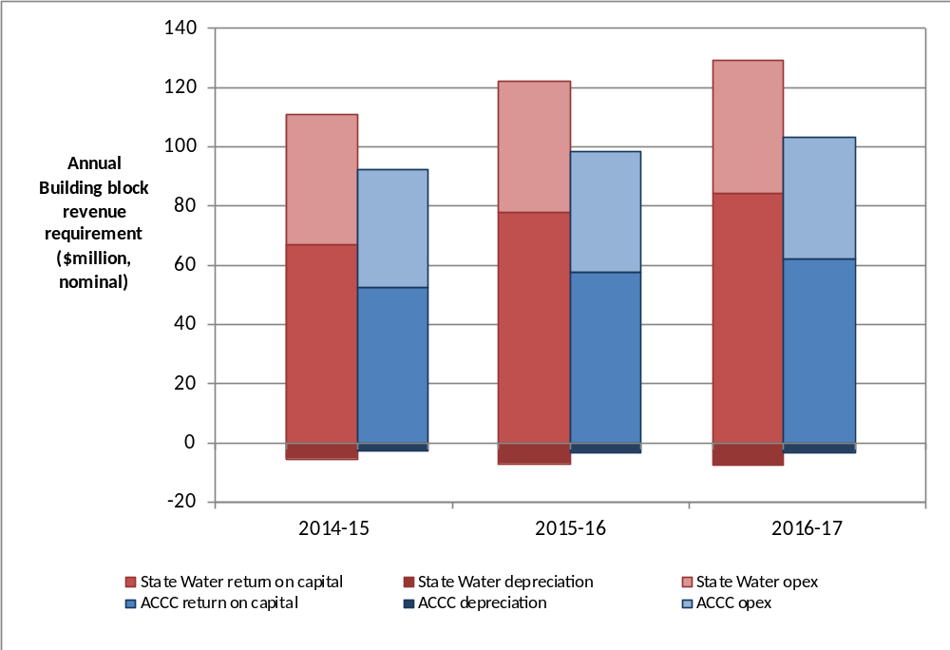
Source: ACCC analysis
Figure 2-2 ACCC’s draft decision compared to State Water’s proposal revenue requirement (user share) and IPART approved revenue for 2009–10 to 2013–14 ($m, nominal)
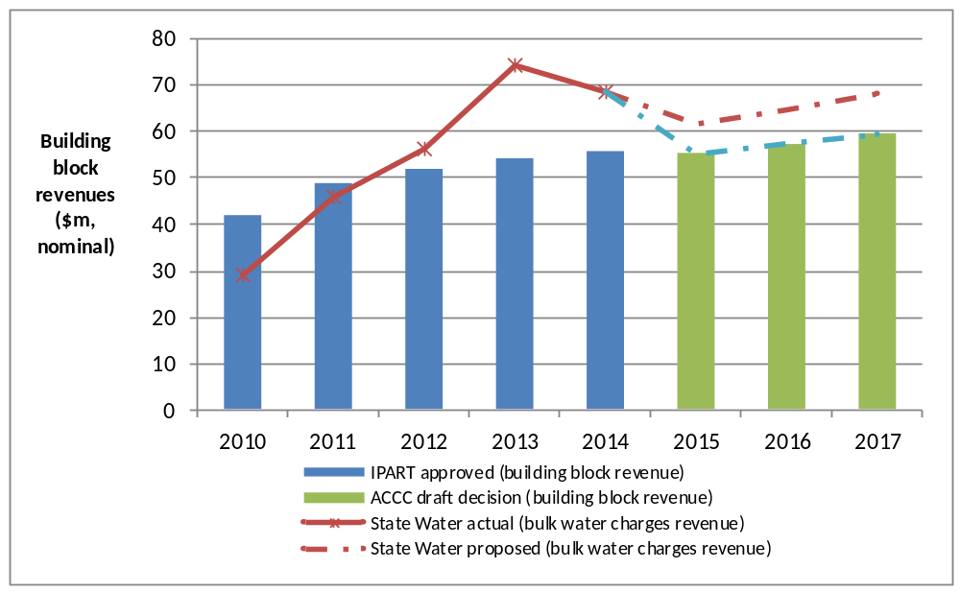
Source: ACCC analysis.
IPART, Review of bulk Water charges for State Water, June 2010, p. 46.
Notes: IPART approved revenues from 2009–2014 are calculated net of MDBA and BRC costs and excludes revenue from the North Coast, Hunter and South Coast valleys not regulated by the ACCC
State Water’s 2013–14 revenue is a forecast based on estimated building blocks.
The bulk water charges revenue refers to the summation of revenue recovered from regulated user charges for each of State Water’s valleys regulated by the ACCC.
The ACCC’s draft decision on State Water’s total revenue is arrived at by summing the building block costs.
The main elements of the ACCC’s draft determination that reduce State Water’s total revenue relative to the proposal are:
- A cost of capital of 7.44 per cent, compared with State Water’s proposed 8.96 per cent.
- Forecast capital expenditure of $151.8 million (real 2013–14), compared with State Water’s proposed $204.1 million ($2013–14), a reduction of 21.5 per cent.
- Forecast operating expenditure of $115.5 million ($2013–14), compared with State Water’s proposed $127.5 million ($2013–14), a reduction of 8.7 per cent.
shows the ACCC’s draft decision total revenue by building block for each year of the regulatory period. The costs are discussed in greater detail in this draft decision and its attachments.
Table 2-1 ACCC draft decision – State Water’s total building block revenue requirement for 2014–17 ($m, nominal)
 | 2014-15 | 2015-16 | 2016-17 | Total
Return on capital | 52.2 | 57.7 | 62.2 | 172.0
Regulatory depreciation | -3.2 | -3.5 | -3.6 | -10.4
Operating expenditure | 39.8 | 40.6 | 41.0 | 121.4
Annual building block revenue requirement (unsmoothed) | 88.8 | 94.7 | 99.5 | 283.0
Plus: Large irrigator rebates | 1.6 | 1.6 | 1.6 | 4.8
Net building block revenue | 90.4 | 96.3 | 101.0 | 287.8
Source: ACCC analysis.
Note: Numbers may not sum due to rounding.
A further breakdown of the total revenue requirement is provided in attachment 1. This includes detailed information on the government and user shares of total revenue and separate revenue requirements for each valley.

Charges for regulated infrastructure (excluding metering)
State Water collects revenue by charging users to access its regulated infrastructure and through contributions from the NSW government. The ACCC assessed State Water’s proposed charges to determine whether they would provide it the opportunity to recover its efficient costs (represented by the user component of total revenue) and whether the charges contribute to the Basin water charging objectives and principles (BWCOP) set out in Schedule 2 of the Water Act. This chapter covers:
- bulk water entitlement and usage charges
- the method for changing prices for bulk water (form of price control)
- other charging issues.

Bulk water charges
Bulk water charges are made up of two components: an entitlement charge to allow access to an allocation of water (fixed charge); and a usage charge based on the amount of water actually supplied (variable charge). The entitlement charge itself is split into two categories, high security entitlements (entitlements that gives a customer preferential access to their water allocation) and general security entitlements that do not receive special preference.
State Water has proposed setting charges so that it collects 80 per cent of its revenue from entitlement charges and 20 per cent from usage charges. State Water has also proposed changes to the calculation of the charge for high security entitlements from their current form. These changes would result in a reduction in high security entitlement charges and relative increases in general security entitlement charges compared to current charges.

Draft decision
The ACCC’s draft decision is to maintain State Water’s current tariff structure so that 40 per cent of its revenue is recovered through entitlement charges (fixed charges) and 60 per cent is recovered through usage charges (variable charges) over the 2014-17 regulatory period. The ACCC considers this tariff structure best contributes to the BWCOP.
The ACCC’s draft decision is to maintain the calculation of high security entitlement charges that applies in the current regulatory period.
Table 3-2 ACCC draft decision on high security entitlement charges by valley for 2014–15 ($ Real 2013-14) ($/ML)
Valley | 2014-15 | 2015-16  Indicative price | 2016-17  Indicative price
Border | 6.59 | 6.54 | 6.50
Gwydir | 13.57 | 14.12 | 14.69
Namoi | 17.07 | 17.20 | 17.33
Peel* | 27.58 | 30.34 | 33.38
Lachlan | 12.89 | 13.44 | 14.01
Macquarie | 12.82 | 13.16 | 13.50
Murray | 1.76 | 1.72 | 1.69
Murrumbidgee | 2.79 | 2.78 | 2.78
Lowbidgee
Source: ACCC analysis.
Note: Peel Valley prices are capped at 10 per cent real price increases per annum.
Table 3-3 ACCC draft decision on general security entitlement charges by valley for 2014–15 ($ Real 2013-14) ($/ML)
Valley | 2014-15 | 2015-16  Indicative price | 2016-17  Indicative price
Border | 2.22 | 2.20 | 2.19
Gwydir | 3.34 | 3.47 | 3.61
Namoi | 7.94 | 8.00 | 8.06
Peel* | 3.03 | 3.34 | 3.67
Lachlan | 3.20 | 3.33 | 3.48
Macquarie | 3.48 | 3.57 | 3.66
Murray | 1.00 | 0.98 | 0.96
Murrumbidgee | 1.21 | 1.21 | 1.21
Lowbidgee | 0.71 | 0.75 | 0.80
Source: ACCC analysis.
Table 3-4 ACCC draft decision on usage charges by valley for 2014–15 ($ Real 2013-14) ($/ML delivered)
Valley | 2014-15 | 2015-16  Indicative price | 2016-17  Indicative price
Border | 6.45 | 6.41 | 6.37
Gwydir | 12.16 | 12.65 | 13.16
Namoi | 20.61 | 20.77 | 20.92
Peel | 45.56 | 50.12 | 55.13
Lachlan | 18.49 | 19.28 | 20.10
Macquarie | 14.71 | 15.10 | 15.50
Murray | 2.60 | 2.55 | 2.49
Murrumbidgee | 3.38 | 3.37 | 3.36
Lowbidgee | 3.38 | 3.37 | 3.36
Source: ACCC analysis.
Note: Peel Valley prices are capped at 10 per cent real price increases per annum.

Summary of reasons
In approving or determining State Water’s regulated charges, the ACCC must have regard to whether the proposed charges would contribute to the BWCOP set out in Schedule 2 of the Water Act. The ACCC considers that State Water’s proposed 80:20 fixed to variable tariff structure would not contribute to the BWCOP. In having regard to the BWCOP, the ACCC considered the following aspects of the BWCOP to be particularly significant:
- to avoid perverse or unintended pricing outcomes
- to ensure sufficient revenue streams to allow efficient delivery of the required services
- to promote the economically efficient and sustainable use of water resources.
The ACCC placed more weight on these aspects of the BWCOP as it considered them to be the most relevant to determining water charges for MDB valleys.
Avoid perverse or unintended pricing outcomes
The ACCC considers State Water’s proposed 80:20 fixed to variable pricing structure may lead to perverse or unintended pricing outcomes. The ACCC considers the 80:20 tariff structure would increase the financial risk to State Water’s customers. During dry periods, customers, particularly those holding general security entitlements, are less likely to receive their full allocation of water. A high entitlement cost means that these users would pay relatively more for their water during dry periods when they are also likely to have less ability (due to reduced crop yields) to pay for the water.
The ACCC is concerned that State Water’s proposal will reduce the cash-flow of water users in dry periods, which may limit their ability to finance their activities, with potentially detrimental economic impacts. This could give rise to perverse or unintended pricing outcomes. The ACCC does not consider that this transfer of risk to customers through an 80:20 tariff structure would contribute to the BWCOP.
Ensure sufficient revenue streams to allow efficient delivery of the required services
The 80:20 tariff structure proposed by State Water weights charges in favour of a fixed cost component. Under this structure, State Water’s revenue is less sensitive to the volume of water extracted than it is under the current 40:60 tariff structure. However, the ACCC considers that a 40:60 tariff structure with an appropriate form of price control will also allow State Water the opportunity to recover its efficient costs. An appropriate form of price control will allow State Water to adjust its prices to account for a proportion of the difference between its actual and target revenue. This structure avoids the detriments associated with transferring volume related risk to customers, while allowing State Water to earn sufficient revenue to efficiently deliver its services.
Promote the economically efficient and sustainable use of water resources
The ACCC has considered whether State Water’s proposal would have a significant impact on the sustainable and efficient use of water resources. The ACCC considers that in comparing the current 40:60 tariff structure with State Water’s proposal, neither are likely to have a significant impact on the efficiency of water use. Further analysis regarding this issue is set out in attachment 8.
The ACCC also considers that the 40:60 tariff structure contributes to the objective of the BWCOP to include a consumption based component and is transparent in that customers understand this tariff structure and can relate their volume of water use to the level of charges they pay.
High security entitlements
State Water’s proposal would bring the cost of high security entitlements down relative to the cost of general entitlements. The ACCC does not consider State Water’s proposed charges adequately reflect the additional value high security entitlements represent compared to general security entitlements.
The ACCC considers that the current method of determining the value of high security entitlements provides a better estimate of the value to customers. This contributes to the objective of the BWCOP to reflect user pays in respect of water storage and delivery in irrigation systems.

Form of price control for bulk water
The form of price control sets out how State Water’s charges can be varied over time. Price controls can take the form of a revenue cap, a price cap or a hybrid of the two. Each of these present a different risk to the customer and the regulated entity.
Revenue cap – the goal of a revenue cap is to ensure that a regulated entity receives its total revenue allowance for a regulatory period, irrespective of the volume of regulated services provided. Under a revenue cap, customers bear any volume related risk through increases or decreases in price over the regulatory period.
Price cap – under a price cap, prices are determined at the commencement of the regulatory period, and adjusted each year for inflation. This results in stable pricing for customers, but does not allow them to be reimbursed for over collection of revenue, nor does it allow the regulated entity to be compensated for the under collection of revenue. Under a price cap, the regulated entity bears any volume related risk.
State Water has proposed a revenue cap for the 2014-17 regulatory period.
The ACCC may choose any form of price control subject to meeting the requirements of the WCIR. Rule 37 of the WCIR requires the ACCC to consider an annual revision of State Water’s maximum charges in the second and third years of the regulatory period, in light of any updated information on demand or consumption forecasts, considering also price stability for each year of the regulatory period.

Draft decision
The ACCC does not approve the revenue cap proposed by State Water. The ACCC is not satisfied that the revenue cap best achieves both revenue stability for State Water and price stability for customers. Further, the ACCC considers State Water’s proposed revenue cap effectively transfers volume related risk to customers. It would result in increases in prices during dry times, which could have detrimental economic implications for customers. The ACCC does not consider that this would contribute to the BWCOP.
The ACCC considers a hybrid form of control should apply to State Water’s bulk water charges for the 2014-17 regulatory period. Specifically, the hybrid form of price control adopted is a price cap that can be adjusted for under or over collection of revenue.
The hybrid form of control will allow for a partial rather than full adjustment to prices to account for the difference between actual and target revenue. Under this form of control, any under or over collection of revenue will be added into a rolling ‘unders’ and ‘overs’ account. The value of this account will be multiplied by the weighted average cost of capital (WACC) to determine the amount by which charges can be adjusted in the next year.
The ‘unders’ and ‘overs’ account is a running balance of annual differences between actual and target revenues. As the adjustment to total revenue is equivalent to the WACC multiplied by the balance in the unders and overs account, and not the full difference between actual and forecast revenues, annual price changes will not be as significant compared to State Water’s proposed revenue cap.
This form of control is symmetrical, as it will reduce charges if State Water has over collected revenue, and increase them if it has under collected.
The ACCC considers the hybrid form of control will maintain price stability for customers while also providing State Water with greater revenue certainty. If there are dry periods, State Water will receive a return on the balance in the ‘unders’ and ‘overs’ account, thereby recognising any additional borrowing costs needed to help manage its cash flows.

Other charging issues

Fish River charges
In the Fish River water supply area, which is part of the MDB, the ACCC has responsibility for regulating water charges for electricity generators and approximately 278 smaller customers that use water for domestic purposes.
The ACCC notes that charges levied for Lithgow and Oberon councils and Sydney Catchment Authority in the Fish River water supply area are not regulated charges under Section 91(3) of the Water Act 2007. Accordingly the ACCC cannot determine charges for these customers, which will be regulated by IPART. The ACCC has agreed with IPART to include all Fish River charges in the ACCC’s review. The ACCC’s view on charges not covered by the Water Act 2007 is set out in the ACCC’s decision on Fish River charges in attachment 8.
IPART will review the charges levied for Lithgow and Oberon councils and Sydney Catchment Authority in 2014-15 and intends to use information from the ACCC’s review in its review process.

Peel valley
Charges for the Peel Valley would be notably high compared to other MDB valleys, and give rise to a perverse outcome without the 10 per cent cap on annual price increases in the Peel Valley determined by the ACCC.
The ACCC considered whether it would be possible to reduce charges in the Peel Valley by applying an alternative methodology for forecasting water extractions based on the potential for the Chaffey Dam extension to positively impact on water extractions in the 2014-17 regulatory period. However, further analysis shows that this is unlikely to have a material effect on charges in the 2014-17 regulatory period.
Other options involving cross-subsidies from other valleys, such as combining the Peel and Namoi valleys for pricing purposes, would result in price increases in other valleys and charges being less cost reflective and transparent at the valley level.
The ACCC considers that the NSW Government should give consideration to the continuation of a subsidy for the Peel Valley in the 2014-17 regulatory period. Such a subsidy would be consistent with the BWCOP’s recognition of the need for community service obligations (subsidies) where full cost recovery is unlikely to be achieved.
Charges for the Peel Valley in this draft decision reflect a 10 per cent cap on annual price increases determined by the ACCC. Charges in the absence of a 10 per cent cap are also set out in attachment 8 for comparative purposes. Should the NSW Government decide to continue a subsidy for the Peel Valley, the ACCC will reflect this outcome when determining State Water’s revenue allowance in the final decision.

Rebates to Irrigation Corporations and Districts
Irrigation Corporations and Districts (ICDs) provide services to a large group of customers in the MDB. ICDs aggregate water orders (i.e. extraction of water from water courses) on behalf of their customers and undertake real-time monitoring of extractions along with billing, metering and compliance functions. This reduces the need for State Water to perform these functions. ICDs receive a rebate from State Water for providing these services.
The ACCC’s draft decision is to continue rebates to ICDs in the 2014-17 regulatory period. The ACCC does not approve the amount of rebates to ICDs proposed by State Water and has maintained the approach to calculating rebates adopted by IPART with updated cost and other inputs to reflect current circumstances. The rebates calculated for this draft decision and the methodology are set out in attachment 8.

Metering charges
The ACCC is responsible for regulating certain water metering charges levied by State Water for the MDB. These are in addition to the bulk water charges and other charges discussed in Chapter 3. The ACCC will approve or determine State Water’s metering charges for:
- extractive customers using a State Water owned meter in a river regulated by the ACCC (meter service charge)
- non-extractive customers (environmental customers) gauging stations (environmental gauging station charge).
The ACCC considers that the following charges are not regulated charges that are subject to Part 6 of the WCIR:
- metering charges for State Water-owned meters, where the charge is imposed for unregulated river and groundwater meters
- metering charges for customer-owned unregulated river and groundwater meters.
The ACCC considers that these charges are not for services provided in relation to water service storage or delivery infrastructure. Therefore, the ACCC does not have a role in approving or determining these charges.

Metering service charge
Metering service charges are levied for users of State Water owned meters on regulated rivers. Metering service charges cover the cost of operating, maintaining, and reading the State Water-owned meters as well as the provision, maintenance, and operation of information systems to process water meter data.
Customers may choose whether their State Water owned meter is funded by a government subsidy. If customers decide not to use a subsidised meter, they will pay an additional charge to State Water to cover the cost of the meter. This additional charge is necessary as the capital cost of the meters is not covered by the government.
Additionally, customers may choose not to receive a State Water owned meter. These customers will retain their existing customer-owned meters. They do not pay the metering service charge, but may pay other charges that cover the costs of State Water reading these customer-owned meters for billing and compliance purposes (maintenance costs remain the responsibility of customer that owns the meter).

Draft decision – metering service charge
The ACCC does not approve State Water’s proposed meter service charges. The ACCC does not consider State Water’s proposed charges represent the prudent and efficient cost of providing infrastructure services. The ACCC’s draft decision is to determine State Water’s metering service charges based on our forecast of prudent and efficient costs.
Meter operating and maintenance costs
Meter operating and maintenance costs apply to all customers that use a State Water owned meter. The ACCC considers the cost forecast by State Water does not reflect the prudent and efficient cost of providing the service. In particular, the forecast costs proposed by State Water are higher than the actual costs observed in its pilot meter program.
In 2011-12 State Water established a pilot metering program in advance of a broader roll out. The ACCC considers that State Water should be able to operate and maintain meters at a similar level of cost to that experienced in the pilot program. The ACCC notes that State Water’s current charges, which were determined by IPART ahead of the pilot program, are sufficient to recover operating and maintenance costs for State Water owned meters.
Meter capital costs
There are two categories of capital expenditure that apply to State Water’s customers:
- the cost of meters purchased, which is only recovered from customers that use State Water owned meters but do not participate in the NSW metering scheme
- the cost of replacing failing meters, which is recovered from all customers that use State Water owned meters.
State Water used a building block approach to calculate depreciation and return on investment for these meters.
The ACCC considers that the initial input cost assumptions used for capital expenditure are prudent and efficient on the basis that they were developed through a detailed and transparent cost build-up that took into account the relevant activities, were based on appropriate data sources, and were independently verified.
However, the ACCC does not consider that State Water’s approach to modelling capital expenditure and calculating depreciation and a return on investment is appropriate, and contains a number of errors.
The ACCC considers that it is more appropriate to calculate capital cost components using an annuity approach. The annuity will determine the annual charge required to recover the capital cost of an asset over its expected life. An annuity can be determined that allows a flat real charge for a single asset across its expected life. The ACCC considers that this has advantages in transparency and certainty for customers. Consequently, the ACCC’s draft decision is to determine the capital cost component of metering based on an annuity approach.

Environmental gauging station charges
State Water has proposed to introduce new charges for metering at in-river gauging stations. These charges will be payable by holders of water access entitlements that have gauging stations as their nominated works. These costs were previously shared between all users as part of the bulk water charge.

Draft decision – gauging stations
The ACCC accepts State Water’s proposed metering charge for environmental gauging stations as prudent and efficient on the basis that:
- the identified gauging stations only benefit the customers using those gauging stations
- the costs of metering at the gauging stations are efficient given State Water’s hydrometric monitoring obligations.
The ACCC considers that it is prudent and efficient to introduce a separate metering charge for environmental gauging stations as the upgrading of the gauging stations benefit only particular customers. Introducing the charge aligns State Water’s charges more closely with the principle of user-pays. The efficient use of water storage and delivery infrastructure and the efficient functioning of water markets are promoted by ensuring that users pay for the services they use.

Forecast water extraction and entitlement volumes
In order to set charges for bulk water services, the ACCC must approve or determine a forecast of water extraction and entitlement volumes for the regulatory period. This forecast is used in conjunction with the forecast of total revenue to determine charges that will allow State Water the opportunity to recover the efficient cost of providing the regulated services.
State Water has previously forecast extraction volumes by taking the average annual volumes for the 20 years prior to the commencement of the regulatory period. State Water proposes maintaining a 20 year average, but adopting a “moving average” that is updated annually at the ACCC’s price review, rather than using a static number determined before the start of the regulatory period.

Draft decision
The ACCC approves the forecast of water extractions for the first year of the next regulatory period, 2014–15, as proposed by State Water for all valleys, except Fish River. The ACCC also approves forecast and entitlement volumes for the next regulatory period as proposed by State Water for all valleys. The ACCC is satisfied that the proposed forecasts of water extractions and entitlement volumes for each valley:
- have been developed using an appropriate forecasting methodology
- are based on reasonable assumptions about key drivers of demand
- utilise the best available information; and
- take into account current demand and economic conditions.
For Fish River, the ACCC has adjusted the proposed forecast minimum annual quantity (MAQ) to reflect the current water sharing plan for Fish River to ensure that forecasts be based on the best information available.
The ACCC approves the use of the 20 year moving average to forecast water extraction volumes. However, the ACCC does not approve the inputs proposed by State Water. This is because the proposed date range includes data that will not be available to the ACCC at the time of its annual price review. For example, State Water proposes using data from 1995–96 to 2014–15 in setting the forecast for the 2015–16 price review. However, actual data from 2014–15 will not be available at this time, as the price review will take place before the end of the financial year.
The ACCC has amended the inputs to the 20 year moving average so that they start and end one year earlier. The ACCC considers this is consistent with its pricing principles, which require that a forecasting approach utilise the best information available.

Operating expenditure
Operating expenditure (opex) is the operating, maintenance and other non-capital costs that are incurred by State Water in providing water storage and delivery services. The ACCC has assessed whether State Water’s proposed opex is consistent with the prudent and efficient costs of providing infrastructure services in the 2014-17 regulatory period. Its findings and draft decision are set out in this chapter and in attachment 2.

Draft decision
State Water has forecast opex of $127.5 million (real $2013-14) over the regulatory period. This includes a user share of $117.6 million (real $2013-14).
The ACCC does not consider State Water’s forecast of opex to be prudent and efficient. The ACCC considers that $115.6 million (real $2013–14) of opex is prudent and efficient for the regulatory period. The user component of forecast opex is $106.1 million (real $2013-14). Figure 2-1 shows the ACCC’s draft decision on opex, and compares it with State Water’s proposal and IPART’s decision for the previous regulatory period.
Figure 6-3 Opex for bulk water charges (millions, real $2013–14)
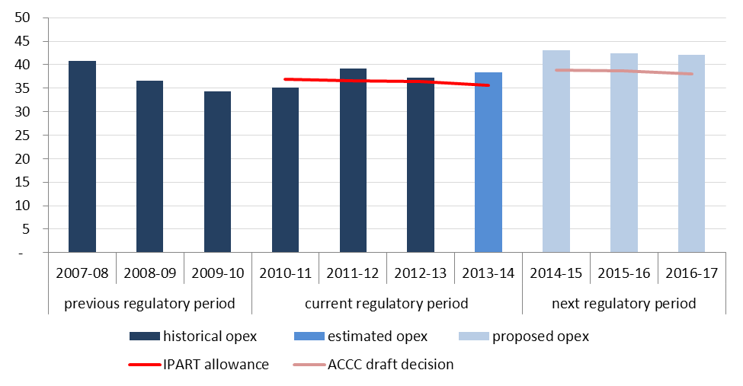

Summary of reasons
To assess State Water’s opex proposal the ACCC developed a forecast of efficient opex. This forecast was then compared with State Water’s proposal. Where inefficiencies were identified the ACCC substituted its own estimates.
The ACCC’s used a ‘base-and-step’ methodology to develop its forecast of efficient opex for each valley. Under this approach, the ACCC used actual opex from a previous regulatory year as a base opex amount (in this case the financial year 2012-13). The ACCC assessed this base opex amount to determine whether it represented the opex required by State Water to provide its bulk water services in an efficient manner. The ACCC then considered whether an additional opex allowance was required to allow State Water to undertake expenditure that was not incorporated in the base year (step increases).

Base opex amount
The ACCC considers base opex should be derived from actual opex incurred in the most recently completed financial year, which in this case is 2012–13. Setting base opex in this way ensures that it reflects the obligations and circumstances faced by State Water in the most recent year in which actual expenditure data is available.
The ACCC then assessed the opex incurred in 2012–13 to determine whether it was likely to reflect an efficient level of opex. To do this, the ACCC examined the incentives to achieve cost savings in the last regulatory period, and whether State Water responded to these incentives. The ACCC considered that State Water had incentives to reduce cost, and that while not consistently outperforming the regulatory allowances set by IPART, it demonstrated that it has been responding to these incentives.
The ACCC also undertook a detailed engineering review of State Water’s base opex, and benchmarked it with other Australian water utilities. The ACCC found that State Water’s asset management practices were in line with good industry practice and that it compared positively to other Australian water utilities.
On this basis, the ACCC considers it reasonable to include opex for the financial year 2012-13 as the base opex amount, with some small adjustments that are detailed at attachment 2.

Step increases
Step increases allow State Water to obtain additional funding to allow for new obligations or changes in circumstance that were not accounted for in base opex. Examples of a change in circumstances that may result in a step increase in forecast opex include: the imposition of new safety regulations or other new legislative requirements, changes in the price of inputs such as labour and materials or gains in productivity (which would reduce the required amount of opex).
The ACCC assessed the step increases proposed by State Water to determine if they were prudent and efficient. In general, the ACCC considers that State Water’s proposed step increases are in excess of the amount required by a prudent and efficient operator. The ACCC considers that:
- State Water’s opex for changes in regulatory obligations is too high. A number of obligations do not represent a material change in circumstances. In some areas a lower cost solution is available.
- A number of proposed step increases in opex to address non-recurrent expenditure are not justified. The ACCC considers that in many instances the base opex already includes amounts sufficient to recover non-recurrent expenditure.
- Some of State Water’s proposed discretionary projects are not justified by the benefits they are expected to produce.
- State Water’s forecast changes in input prices are not realistic.
- Past performance indicates that State Water is likely to achieve a larger productivity gain than it has proposed.
Figure 6-4 sets out the main reasons why the ACCC’s forecast of efficient step increases differs from State Water’s forecast.
Figure 6-4 ACCC adjustments to step increase categories ($million, real $2013–14)
Step increase | State Water’s proposal | ACCC draft decision | Reason for difference
regulatory obligations | 2.94 | 1.39 | The ACCC accepts the additional costs for environmental management, drinking water monitoring, and hydrometric monitoring, but considers that hydrometric monitoring could be done at a lower cost. The ACCC considers that crop statistics and basin plan obligations are already funded through base opex.
non-recurrent expenditure | 18.61 | 0.70 | Non-recurrent expenditure refers to one-off expenses that do not present an ongoing cost to State Water. The base year opex will include some non-recurrent expenditure as well as recurrent expenditure. Consequently, a step increase to opex is not always necessary to fund non-recurrent opex, as the base year opex already includes an allowance for this in the next period. The ACCC considers that a number of State Water’s proposed step increases are for non-recurrent business-as-usual activities and are already funded through the base opex. The ACCC accepts some periodic routine maintenance and investigations into cold water pollution were delayed and would not be included in base year opex. The ACCC has accepted a small step increase for these items.
business transformation | 0.40 | (0.97) | The ACCC accepts there is a need for IT refurbishment but considers that these projects could be delivered at a lower cost. The ACCC also accepts the NSW meter upgrade scheme, which will result in cost savings, as efficient. This cost saving has resulted in a negative step change overall for the business transformation program.
customer requested projects | 1.32 | 1.32 | The ACCC accepts these step changes as they are endorsed by customers.
output growth | 0.78 | 0.67 | The ACCC accepts the additional costs of monitoring more fish passages and delivering more water in Fish River.
input price changes | 3.21 | 0.40 | The ACCC forecasts that productivity adjusted input prices for labour, energy, or chlorine will not increase above CPI, but acknowledges that State Water's insurance premiums have increased.
efficiency gains | - | (1.15) | The ACCC considers that State Water is capable of achieving an ongoing efficiency gain of 1 per cent per year.
Source: ACCC analysis

Comparison of State Water proposal with ACCC forecast
State Water’s proposal of $127.5m (real $2013–14) is significantly higher than the ACCC’s forecast. The ACCC considers State Water’s proposal is not prudent and efficient. The ACCC’s draft decision is to determine opex for the regulatory period at $115.6m (real $2013–14).

Capital Expenditure
Capital expenditure (capex) is incurred when a business spends money either to buy assets or to add to the value of an existing asset. The ACCC has assessed whether State Water’s proposed capital expenditure reflects the prudent and efficient costs of providing infrastructure services in the 2014-17 regulatory period.

Draft decision
The ACCC does not approve State Water’s total capex forecast of $204.1 million (gross, real 2013-14) for the 2014–17 regulatory period. This is because the ACCC is not satisfied that State Water’s proposal reflects the prudent and efficient costs of providing infrastructure services in the regulatory period. The ACCC considers that a capex allowance of $151.8 million (gross, real 2013-14) reflects the prudent and efficient costs of providing infrastructure services. The government share of capex is $99.3 million while the user share is $52.5 million.
Table 7-1 compares the ACCC’s draft decision with State Water’s proposal. It outlines the various components of the ACCC’s draft decision and shows where adjustments have been made, and the government and user shares of the components.
Table 7-5 ACCC draft decision on State Water's approved capital expenditure ($ ‘000, real $2013-14)
 | ACCC draft decision - User Share | ACCC draft decision - Government Share | ACCC draft decision - Total | State Water proposal | Difference between proposal and draft | Percentage difference
Dam Safety Compliance - Pre 1997 Construction | 8,488 | 75,458 | 83,945 | 100,067 | -16,122 | -16.1%
Renewal & Replacement | 14,330 | 1,177 | 15,507 | 19,921 | -4,413 | -22.2%
Corporate Systems | 6,639 | - | 6,639 | 9,155 | -2,516 | -27.5%
EP&P - Fish Passage Works | 22,677 | 22,677 | 45,355 | 57,254 | -11,899 | -20.8%
Water Delivery and other operations | 351 | - | 351 | 17,720 | -17,369 | -98.0%
Gross Capex | 52,486 | 99,312 | 151,798 | 204,117 | -52,320 | -25.6%
Capital Contributions | - | 8,237 | 8,237 | 8,237 | - | 0.0%
Net Capex | 52,486 | 91,075 | 143,561 | 195,880 | -52,320 | -26.7%
Source: ACCC Analysis

Summary of reasons

Overheads allocation
The ACCC considered that State Water’s allocation of labour and overheads cost to its capex program was high when compared to the allocation in previous regulatory periods. State Water did not provide information on its labour and overheads cost for all capital projects. The ACCC calculated an estimate of State Water’s total labour and overheads cost embedded in its capex programs, using the information available to it. The ACCC’s estimate is that State Water had incorporated $32.9 million, or 18.4% of overall capex. State Water had historically spent about 7.0% of its overall capex on labour and overheads costs. The ACCC considered this historical allocation provided the best estimate of efficient labour and overheads costs over the 2014-17 regulatory period. Consequently, the ACCC’s draft decision is to determine $10.7 million for capitalised labour and overheads. The ACCC will consider any further information provided to it prior to reaching its final decision.

Contingencies
State Water proposed including additional capex in its projects as a contingency against cost overruns. The ACCC examined the methods used by State Water to forecast its costs, and whether there was a sufficient risk of overspend to justify additional capex. Where the forecasting method used by State Water already accounted for the risk of a cost overrun (Environmental planning and protection), the ACCC did not accept the 10 per cent contingency allowance proposed. Where the method did not sufficiently account for the risk of a cost overrun (Dam safety), the ACCC accepted that the proposed 10 per cent contingency allowance was prudent and efficient. This resulted in the ACCC approving contingency capex of $7 million, approximately $6 million lower than State Water’s proposal.

Dam Safety Compliance – Pre 1997 Construction
The ACCC accepts the majority of State Water’s dam safety compliance projects as being prudent and efficient, subject to the adjustment to capitalised labour and overheads discussed above. This resulted in the ACCC approving $83.9 million of capex for dam safety compliance, approximately $16 million lower than State Water’s proposal.
However, the ACCC does not consider that it is prudent and efficient for State Water to undertake Dam Safety Compliance works at the Oberon Dam in the 2014-17 regulatory period. The ACCC understands that State Water is not required to complete this work until 2034. State Water proposed to bring forward the safety works for the Oberon Dam to the current period on the basis that it is efficient to undertake these works concurrently with the Rydal Dam safety works. The ACCC does not consider State Water’s efficiency gains outweigh the costs of bringing compliance forward 18 years.

Environmental planning and protection
The ACCC’s draft decision is not to accept State Water’s proposed $57.3 million in Environmental Planning and Protection (EPP) expenditure. The ACCC considers that $45.4 million reflects prudent and efficient expenditure. This reduction is a result of the ACCC’s decision on the contingency allowance and capitalised labour and overheads discussed above.
State Water has concentrated its EPP expenditure heavily in the first year of the regulatory period. The ACCC considers that State Water may not be able to deliver these projects in the timeframe proposed. The ACCC has therefore adjusted the timing of expenditures by moving $20 million from 2014-15 and spreading it equally across 2015-16 and 2016-17.

Renewal and replacement
The ACCC has adjusted State Water’s proposed renewal and replacement allowance to reflect the reduction in capitalised labour and overheads discussed above. Having made these adjustments, the ACCC considers that State Water’s renewal replacement program is prudent and efficient. The ACCC’s draft decision is to approve $15.5 million of capex for renewal and replacement, approximately $4.4 million lower than State Water’s proposal.
The ACCC considers the outlet works at Rydal Dam are more correctly classified as dam safety expenditure as the main driver for the works is to mitigate an existing safety issue. As such, the ACCC has re-allocated this project to the Dam safety category.

Water delivery and other operations
The ACCC does not accept State Water’s proposal for $17.7 million in expenditure on its water delivery and other operations program. The ACCC considers that $0.4 million in expenditure reflects the prudent and efficient cost of this program in the 2014-17 regulatory period.
The ACCC does not consider that a member of the proposed water delivery and operations projects are prudent and efficient, and has not approved capex for the following projects:
- Computer Aided River Management System (CARMS) (a State-wide project) ($13.6 million)
- CO WMAWAS water accounting system ($0.2 million)
- Crooked Creek water efficiency project, in Macquarie valley ($3.5 million).
The major reduction in this category relates to the CARMS project. The ACCC notes that State Water has not completed a detailed business plan, has not obtained external funding or robustly identified the cost and benefits which may result from this project. As such, the ACCC does not consider a prudent and efficient service provider would undertake this expenditure in the 2014-17 regulatory period.

Corporate systems
The ACCC considers that the majority of State Water’s proposed corporate systems capex is prudent and efficient, and is justified by the need to replace ageing systems and avoid risk of failure of business and operating systems. The ACCC’s draft decision is to approve $6.6 million of corporate systems capex as prudent and efficient. This is a reduction of $2.5 million from State Water’s proposal. State Water’s business transformation program (BTP) is expected to result in some savings in opex during the regulatory period. However, the ACCC expects the bulk of the savings will be reflected in forecasts for the following regulatory period from 2017-18. The ACCC has accepted the majority of State Water’s proposal for corporate systems, but has made some reductions to capex for aspects of the project that were not justified by gains in efficiency.

Regulatory asset base
The regulatory asset base (RAB) is the value of the assets that State Water uses to provide it regulated infrastructure services. The assets in State Water’s RAB include its dams, IT systems, plant and machinery, vehicles and buildings. The value of the RAB is used to determine the return on capital and regulatory depreciation components of total revenue.
The methodology for establishing the opening RAB is set out in the WCIR. This involves:
- confirming the value of the opening RAB as at 1 July 2010 (the first year of the 2010–14 regulatory period).
- rolling forward the opening RAB from 1 July 2010 to determine the closing RAB as at 30 June 2014.
- using the ACCC's draft decision on depreciation, capex, disposals and inflation forecasts for the 2014–17 regulatory period to roll forward State Water's projected RAB for each year of that regulatory period.

Draft decision
The ACCC does not approve State Water's total proposed opening RAB as at 1 July 2014 of $726.1 million (nominal) for its ACCC regulated valleys. The ACCC has determined a total opening RAB as at 1 July 2014 of $702 million (nominal). The user share of the opening RAB as at 1 July 2014 is $237.6 million (nominal). The ACCC’s changes to State Water’s proposed inputs to the RAB roll forward model (RFM) are required under Schedule 2 of the WCIR and include:
- Correcting State Water's estimates of forecast capex, depreciation and associated user share inputs for 2009–10. The ACCC considers these to be in error and has amended the amounts to be consistent with those approved by IPART.
- Using forecast depreciation (adjusted for actual inflation) to roll forward the RAB instead of actual depreciation as proposed by State Water. The ACCC considers the forecast depreciation allowance as approved previously by IPART (adjusted for actual inflation) should be used in the roll forward.
- Updating 2012–13 forecast CPI with actual CPI.
shows the ACCC’s draft decision on the roll forward of State Water’s RAB from 2009–10 (the last year of the 2006–10 regulatory period) through to the 2010–14 regulatory period.

Table 8-6 ACCC’s draft decision on State Water's opening RAB roll forward for 2009–10 to 2013–14 ($million, nominal)
 | 2009–10 | 2010–11 | 2011–12 | 2012–13 | 2013–14
Opening value | 354.4 | 434.6 | 519.2 | 583.5 | 614.1
CPI indexation | 8.6 | 12.7 | 16.9 | 9.5 | 15.4
Net capex | 72.3 | 76.4 | 53.4 | 28.3 | 83.2
Less: straight-line depreciation | 0.7 | 4.5 | 5.9 | 7.3 | 8.2
Difference in actual and forecast 2009–10 net capex | 0.0 | 0.0 | 0.0 | 0.0 | -1.9
Return on difference | 0.0 | 0.0 | 0.0 | 0.0 | -0.6
Closing value (Govt + user) | 434.6 | 519.2 | 583.5 | 614.1 | 702.0
Closing value (User) | 173.8 | 189.4 | 207.2 | 213.6 | 237.6
Closing value (Govt) | 260.8 | 329.8 | 376.3 | 400.4 | 464.3
Note: Net capex figures are based on gross capex less any capital contributions from customers or third parties.
Disposals not presented as there were no asset disposals recorded by State Water.
Source: ACCC analysis.
The ACCC has determined a total projected closing RAB as at 30 June 2017 of $865.6 million (nominal) for State Water’s ACCC regulated valleys.
This is based on:
- a total opening RAB as at 1 July 2014 of $702 million (nominal)
- a forecast inflation rate of 2.5 per cent per annum
- forecast net capex of $153.3 million (nominal), discussed further in attachment 4
- a total straight-line depreciation of -$47.4 million (nominal) and total inflation indexation to the opening RAB of $57.8 million, discussed further in attachment 6.
The user share of the projected closing RAB at 30 June 2017 is $295.9 million (nominal). Table 8-7 sets out the projected roll forward of State Water’s RAB during the 2014–17 regulatory period.

Table 8-7 ACCC's draft decision on State Water’s projected RAB roll forward during the 2014–17 regulatory period ($million, nominal)
 | 2014–15 | 2015–16 | 2016–17
Opening value | 702.0 | 775.4 | 836.0
Inflation indexation | 17.5 | 19.4 | 20.9
Net capex | 70.3 | 57.1 | 26.0
Less: straight-line depreciation | 14.3 | 15.9 | 17.3
Closing value (Govt + user) | 775.4 | 836.0 | 865.6
Closing value (User) | 254.7 | 275.9 | 295.9
Closing value (Govt) | 520.8 | 560.2 | 569.7

Note: Disposals not presented as no asset disposals were proposed by State Water.
Source: ACCC analysis.

Rate of return
The rate of return compensates a regulated business for servicing the interest on its loans and providing a return on equity to its investors. The cost of capital building block is calculated by multiplying the rate of return with the value of the regulatory asset base.
The ACCC has adopted the nominal vanilla weighted average cost of capital (WACC) formulation to estimate the rate of return. This is consistent with State Water's pricing application and the ACCC’s pricing principles.
The pricing principles state:
In determining the WACC, it will be necessary to ensure the rate of return is commensurate with the commercial risk associated with the business’ regulated activities such that the business recovers its efficient costs.
The ACCC does not approve State Water’s proposed (indicative) rate of return of 8.96 per cent. The draft decision is to determine State Water's rate of return at 7.44 per cent (subject to updating). The ACCC considers this figure is commensurate with the commercial risk associated with State Water's regulated activities such that it recovers its efficient costs.
For the rate of return, the draft decision applies the ACCC’s pricing principles to State Water. Consequently, the ACCC agrees with the following aspects of State Water's proposed rate of return method:
- Adopting the Sharpe–Lintner capital asset pricing model (CAPM) to estimate the return on equity.
- Adopting the yield on 10 year Commonwealth Government Securities (CGS) as the proxy for the risk free rate.
- Adopting a market risk premium (MRP) of 6.0 per cent.
- Specifying the return on debt as the debt risk premium (DRP) over the risk free rate.
- Using corporate bonds with a BBB credit rating band to estimate the DRP. We define the benchmark bond as a 10 year Australian corporate bond with a BBB+ credit rating. However, due to data limitations, the DRP can be calculated using BBB rated bonds in practice.
- Adopting a 60 per cent gearing ratio.
In its pricing proposal, State Water has decided to depart from the ACCC’s pricing principles on several parameters. The draft decision does not adopt these proposed departures, which include:
- Adopting a long term historical average risk free rate in estimating the return on equity. Rather, the draft decision adopts a short term averaging period as close as practicably possible to the start of the regulatory period.
- Adopting an equity beta of 0.9, based on a combination of estimates of equity betas from Australian energy networks and water networks in the UK and US. Rather, the draft decision adopts an equity beta of 0.7. This is consistent with the ACCC’s pricing principles and is based on evidence from comparative businesses and regulatory decisions for Australian water businesses.
- Using a DRP based on a 10 year historical average. Rather, the draft decision uses an estimate of the prevailing 10 year forward looking DRP.
Table 6.1 sets out the individual WACC parameters and the indicative rate of return determined by the ACCC.
Table 6.1 ACCC's draft decision on State Water's rate of return (nominal)
Parameter | State Water proposal | ACCC draft decision
Nominal risk free rate | 5.26% | 4.28% ª
Equity beta | 0.9 | 0.7
MRP | 6.0% | 6.0%
DRP | 2.55% | 2.46% ª
Gearing level | 60% | 60%
Nominal post-tax return on equity | 10.66% | 8.48%
Nominal pre-tax return on debt | 7.82% | 6.74%
Nominal vanilla WACC | 8.96% | 7.44%
Source: State Water, Pricing application to the ACCC, June 2013, p. 99; ACCC analysis.
Note: (a) We have based the nominal risk free rate and DRP on a 20 business day indicative averaging period from 16 December 2013 to 15 January 2014. We will update these estimates for our final decision to reflect an averaging period as close as practically possible to the start of the regulatory period.

Table 6.1 indicates our proposed rate of return of 7.44 per cent (subject to updating) is lower than State Water's proposed rate of return of 8.96 per cent.
Detailed reasons for the draft decision are in attachment 5.

Regulatory depreciation
Regulatory depreciation is used to determine the value of State Water’s capital assets for each year of that asset’s economic life. An allowance for regulatory depreciation is used as a building block to determine State Water’s total revenue requirement. The allowance is provided so that capital investors can receive a return of their invested capital over the economic life of the asset (return of capital). The value of the regulatory depreciation allowance is also subtracted from the regulatory asset base so that the value of the asset is only collected once.
Various factors determine the regulatory depreciation allowance for the 2014–17 regulatory period. Two key factors include:
- the remaining economic lives for depreciating existing assets in the opening RAB
- the standard economic lives for depreciating new assets associated with forecast net capex.
The approved capex allowance and the opening regulatory asset base also affect the regulatory depreciation allowance.

Draft decision
The ACCC approves State Water's proposal to use the straight-line method to calculate the regulatory depreciation allowance. However, the ACCC does not approve State Water's total proposed regulatory depreciation allowance of –$22.1 million (nominal) for its regulated valleys over the regulatory period.
The ACCC considers that the economic lives of State Water’s assets are, in general, shorter than State Water has proposed. The ACCC considers that the shorter asset lives better reflect the actual economic lives of the assets and the cost of the assets over time. In forming this view, the ACCC accepted the recommendations of Deloitte on asset lives. Shorter lived assets depreciate at a faster rate, which, other things being equal, increases the regulatory depreciation building block and reduces the RAB. The ACCC has adjusted State Water’s asset lives so they better reflect their expected useful life. Applying economic lives that reflect an asset’s expected useful life better reflects the cost of the asset over time and assists in efficient use of assets and planning for their replacement.
The ACCC’s decision on capital expenditure for the 2014-17 regulatory period has also affected the proposed regulatory depreciation allowance (see chapter 7). The ACCC’s draft decision reduces the capital expenditure allowance, which offsets somewhat the increase in the regulatory depreciation building block due to the shorter asset lives.
The ACCC's draft decision is to determine State Water's total regulatory depreciation allowance over the 2014–17 regulatory period at -$10.4 million (nominal). This represents an increase of $11.7 million (nominal) or 52.2 per cent compared to State Water's proposal. The total amount is negative because State Water’s asset base is depreciating at a slower rate than inflation. Table 10-8 shows the calculation of this figure. Given the relatively long lives of some assets, the regulatory depreciation allowance across all ACCC regulated valleys is negative overall, as the indexation (inflation) adjustment to the regulatory asset base outweighs the straight-line depreciation component of regulatory depreciation. This is discussed in more detail in attachment 6.
Table 10-8 ACCC's draft decision on State Water's depreciation allowance ($million, nominal)
 | 2014–15 | 2015–16 | 2016–17 | Total
Straight-line depreciation | 17.5 | 19.4 | 20.9 | 57.8
Less: indexation on opening RAB | 14.3 | 15.9 | 17.3 | 47.4
Regulatory depreciation | -3.2 | -3.5 | -3.6 | -10.4
Source: ACCC analysis.

Appendix A – Valley summaries

Border valley
The Border valley includes the Dumaresq, Severn and Macintyre Rivers in Northern NSW and Southern Queensland. The major dam in the NSW portion of the catchment is Pindari Dam with a capacity of 312,000 ML. The dam supplies water for irrigation, stock and domestic, town water supply, and industrial purposes.
As shown in Table A1, the ACCC’s draft decision will lead to lower high security bulk water entitlement charges in the Border valley in the next regulatory period compared to 2013-14 levels. The general security entitlement charge and usage charge will be slightly higher.
The ACCC has formed the view that State Water’s cost forecast for the regulatory period is higher than required. State Water proposed collecting total revenue of $5.8 million (in $2013–14) over the regulatory period to cover the costs of its services in the Border valley. Following an assessment of efficient costs, the ACCC’s considers that State Water’s total revenue for Border valley should be set at $5.0 million, $0.8 million lower than State Water’s proposal.
Table A1 ACCC Draft Decision – High Security, General Security and usage bulk water charges 2014-15 to 2016-17 ($ Real, 2013-14)*
 | 2013-14 | 2014-15 | 2015-16 | 2016-17
High security ($/ML) | 7.38 | 6.59 | 6.54 | 6.50
General security ($/ML) | 2.07 | 2.22 | 2.20 | 2.19
Usage ($/ML delivered) | 6.08 | 6.45 | 6.41 | 6.37
* Current 2013-14 charges do not include MDBA/BRC costs for comparative purposes.

Figure A1 State Water proposed and ACCC Draft Decision total revenue
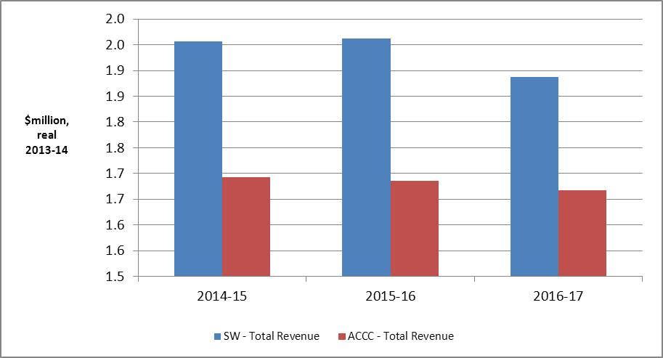
Source: ACCC analysis
Figure A2 ACCC draft decision – Revenue requirement by user and government share and component
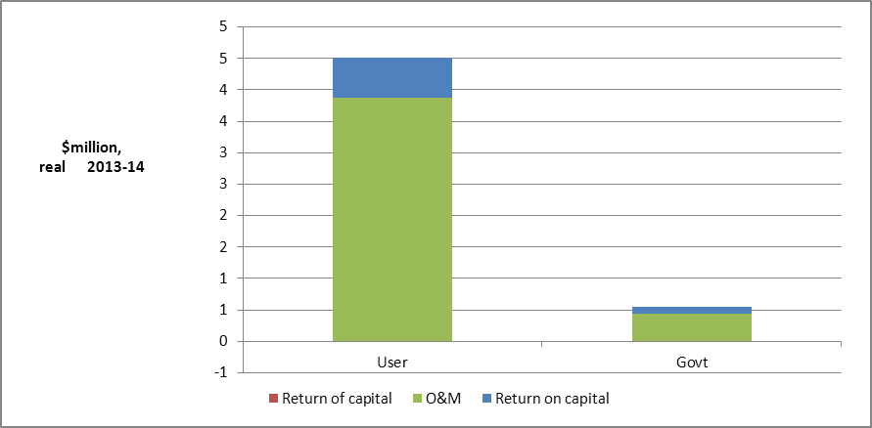
Source: ACCC analysis
What is driving State Water’s costs and charges?
The key drivers of the price change in the ACCC draft decision compared to the 2013-14 prices set by IPART (disregarding MDBA/BRC cost) are:
- operating and maintenance expenditure
- capital expenditure
- lower demand than forecast by IPART.
Why is the ACCC’s draft decision lower than State Water’s proposal?
The ACCC made a number of reductions to State Water’s proposal to arrive at its draft decision on Border valley total revenue. Some of the larger adjustments are:
- non-approval of $0.65 million of State Water’s proposed step increases above base opex. Major step increases that were not approved were staff vacancy rate costs ($0.35 million), routine maintenance tasks at Pindari Dam ($0.13 million) and additional data analysis ($0.05 million) (see chapter 6)
- a reduction of $0.18 million to State Water’s proposed step increases above base opex, mainly related to scheduled routine maintenance tasks (see chapter 6)
- a reduction of $0.67 million in capital expenditure through cuts to labour and overheads, and cuts to State Water-wide projects such as the Computer Aided River Management System (CARMS) (see chapter 7)
- determining a weighted average cost of capital of 7.44 per cent compared to State Water’s proposal of 8.96 per cent (see chapter 9).

Gwydir valley
The Gwydir valley is located in north-western NSW and includes the Gwydir River and its tributaries: the Horton River and Copes, Moredun, Georges and Laura Creeks. Copeton Dam is the major storage within the Gwydir catchment with a total capacity of 1,364,000 ML.
As shown in Table A2, bulk water entitlement and usage charges will remain relatively unchanged over the 2014–17 period compared to 2013-14, though the general security entitlement charge will be slightly lower.
The ACCC has formed the view that State Water’s cost forecast for the regulatory period is higher than required. State Water proposed collecting total revenue of $44.1 million (in $2013–14) over the regulatory period to cover the costs of its services in the Gwydir valley. Following an assessment of efficient costs, the ACCC’s considers that State Water’s total revenue for Gwydir valley should be set at $35.8 million, $8.3 million lower than State Water’s proposal.
Table A2 ACCC Draft Decision – High Security, General Security and usage bulk water charges 2014-15 to 2016-17 ($ Real, 2013-14)
 | 2013-14* | 2014-15 | 2015-16 | 2016-17
High security ($/ML) | 14.39 | 13.57 | 14.12 | 14.69
General security ($/ML) | 4.02 | 3.34 | 3.47 | 3.61
Usage ($/ML delivered) | 12.83 | 12.16 | 12.65 | 13.16
* Current 2013-14 charges do not include MDBA costs for comparative purposes.
Figure A3 State Water proposed and ACCC Draft Decision total revenue
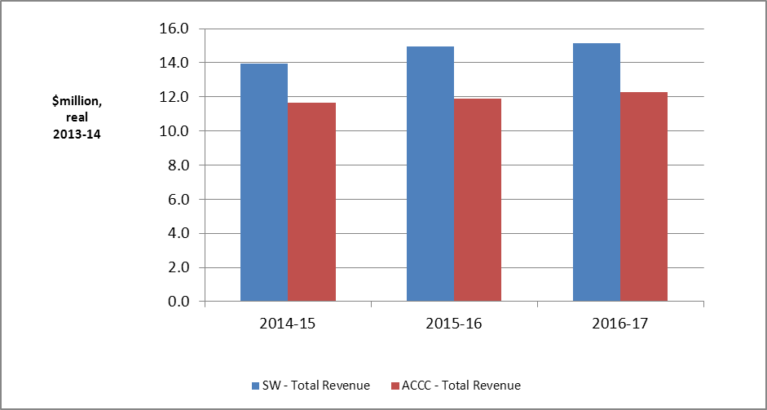
Source: ACCC analysis

Figure A4 ACCC draft decision – Revenue requirement by user and government share and component
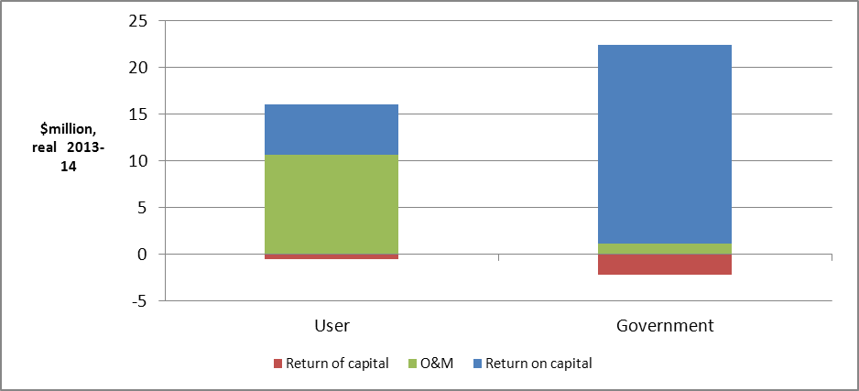Source: ACCC analysis
What is driving State Water’s costs and charges?
The key drivers of the price reduction in the ACCC draft decision compared to the 2013-14 prices set by IPART (disregarding MDBA costs) are:
- reduction in the weighted average cost of capital (WACC)
- removal of revenue volatility allowance.
These outweigh the effect of increases in:
- capital expenditure
- depreciation (return of capital) due to reduction in regulatory asset lives.
Why is the ACCC’s draft decision lower than State Water’s proposal?
The ACCC made a number of reductions to State Water’s proposal to arrive at its draft decision on Gwydir valley total revenue. Some of the larger adjustments are:
- non-approval of $1.65 million of State Water’s proposed step increases above base opex. Major step increases that were not approved were staff vacancy rate costs ($0.94 million) and updating of flood manuals ($0.14 million) (see chapter 6)
- a reduction of $0.47 million to State Water’s proposed step increases above base opex, mainly relating to the hydrometric monitoring agreement with the NSW Office of Water (see chapter 6)
- a reduction of $5.8 million (25.9 per cent) in capital expenditure through cuts to labour and overheads, contingencies on fish passages, and cuts to State Water-wide projects such as the Computer Aided River Management System (CARMS) (see chapter 7)
- determining a weighted average cost of capital of 7.44 per cent compared to State Water’s proposal of 8.96 per cent (see chapter 9).

Namoi valley
The Namoi valley is located in north-western NSW and includes the Namoi River with its major regulated tributary being the Peel River and Manilla River. Smaller tributaries include the Cox, Pian, Narrabri, Baradine and Bohena creeks. Major tributaries of the Peel River are Goonoo Goonoo Creek, Cockburn River and Dungowan Creek. Keepit Dam (capacity of 426,000 ML) is the major storage for the Namoi catchment. Split Rock Dam (397,000 ML) augments the supply from Keepit Dam while Chaffey Dam (62,000 ML) regulates the flow of the Peel River.
As shown in Table A3, the general security bulk water entitlement charge will be lower in the 2014-17 regulatory period compared to 2013-14. The high security entitlement charge and usage charge will increase slightly.
The ACCC has formed the view that State Water’s cost forecast for the regulatory period is higher than required. State Water proposed collecting total revenue of $58.8 million (in $2013–14) over the regulatory period to cover the costs of its services in the Namoi valley. Following an assessment of efficient costs, the ACCC considers that State Water’s total revenue for Namoi valley should be set at $47.7 million, $11.1 million lower than State Water’s proposal.
Table A3 ACCC Draft Decision – High Security, General Security and usage bulk water charges 2014-15 to 2016-17 ($ Real, 2013-14)
 | 2013-14* | 2014-15 | 2015-16 | 2016-17
High security ($/ML) | 16.02 | 17.07 | 17.20 | 17.33
General security ($/ML) | 8.98 | 7.94 | 8.00 | 8.06
Usage ($/ML delivered) | 19.73 | 20.61 | 20.77 | 20.92
* Current 2013-14 charges do not include MDBA costs for comparative purposes
Figure A5 State Water proposed and ACCC Draft Decision total revenue
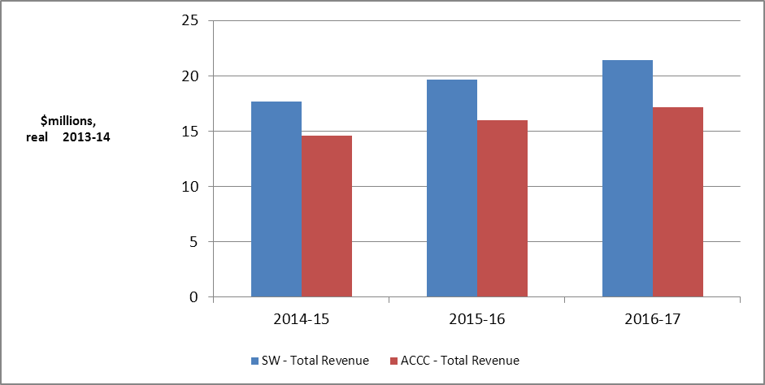
Source: ACCC analysis
Figure A6 ACCC draft decision – Revenue requirement by user and government share and component
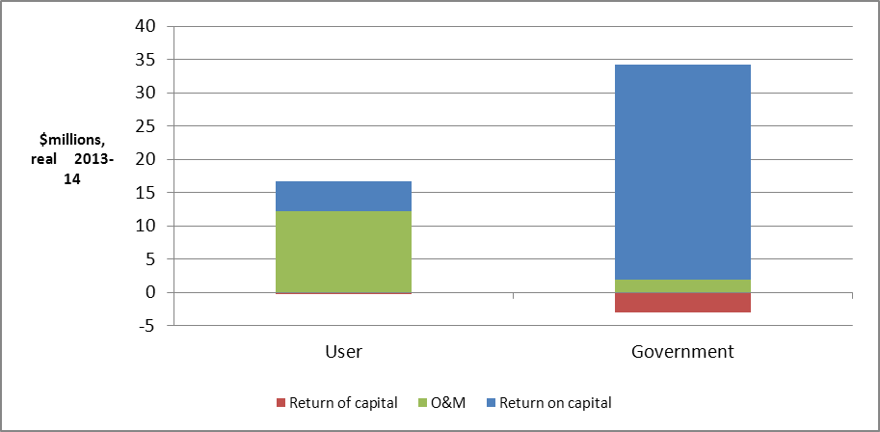
Source: ACCC analysis
What is driving State Water’s costs and charges?
The key drivers of the price reduction in the ACCC draft decision compared to the 2013-14 prices set by IPART (disregarding MDBA costs) are:
- reduction in weighted average cost of capital (WACC)
- removal of revenue volatility allowance.
These outweigh the effect of increases in:
- depreciation (return of capital) due to reduction in regulatory asset lives
- operating and maintenance expenditure.
Why is the ACCC’s draft decision lower than State Water’s proposal?
The ACCC made a number of reductions to State Water’s proposal to arrive at its draft decision on Namoi valley total revenue. Some of the larger adjustments are:
- non-approval of $1.91 million of State Water’s proposed step increases above base opex. Major step increases that were not approved were staff vacancy rate costs ($1.08 million) and updating of flood manuals ($0.16 million) (see chapter 6)
- a reduction of $0.63 million to State Water’s proposed step increases above base opex, mainly relating to the cold water pollution reduction scheme (see chapter 6)
- a reduction of $8.06 million in capital expenditure, through cuts to labour and overheads, contingencies on fish passages, and State-wide projects such as the Computer Aided River Management System (CARMS) (see chapter 7)
- determining a weighted average cost of capital of 7.44 per cent compared to State Water’s proposal of 8.96 per cent (see chapter 9).

Peel valley
The Peel valley is located in north-western NSW and includes the Peel River. The major tributaries of the Peel River are Goonoo Goonoo Creek, Cockburn River and Dungowan Creek. Chaffey Dam (62,000 ML) is the main storage in the Peel valley.
The ACCC has formed the view that State Water’s cost forecast for the regulatory period is higher than required. State Water proposed collecting total revenue of $15.5 million (in $2013–14) over the regulatory period to cover the costs of its services in the Peel valley. Following an assessment of efficient costs, the ACCC considers that State Water’s total revenue requirement for Peel valley is $11.5 million, $3.9 million lower than State Water’s proposal.
In principle, the ACCC supports valley based cost reflective pricing. However, irrigators in the Peel would face a significant price shock if prices increase to full cost recovery immediately. The ACCC has addressed this by capping price increases over the regulatory period at 10% per annum. IPART adopted a similar approach for the current regulatory period.
The ACCC considers that the NSW Government should give consideration to the continuation of a subsidy for the Peel Valley in the 2014-17 regulatory period. Such a subsidy would be consistent with the recognition in the Water Act of the need for community service obligations (subsidies) where full cost recovery is unlikely to be achieved.
The charges in table A4 below reflect a 10 per cent cap on annual price increases as in the ACCC’s draft decision.
Table A4 ACCC Draft Decision – High Security, General Security and usage bulk water charges 2014-15 to 2016-17
 | 2013-14* |  | 2014-15 | 2015-16 | 2016-17
High security ($/ML) |  | 25.08 | 27.58 | 30.34 | 33.38
General security ($/ML) |  | 2.76 | 3.03 | 3.34 | 3.67
Usage ($/ML delivered) |  | 41.42 | 45.56 | 50.12 | 55.13
* Current 2013-14 charges do not include MDBA costs for comparative purposes

Figure A7 State Water proposed and ACCC Draft Decision total revenue
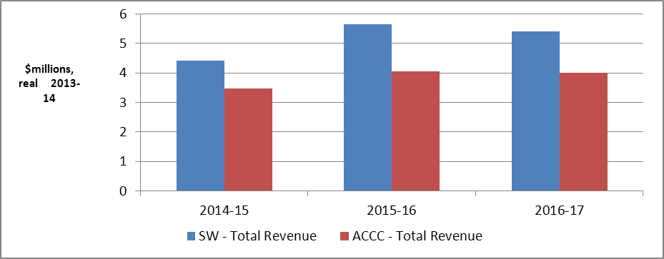
Source: ACCC analysis
Figure A8 ACCC draft decision – Revenue requirement by user and government share by component
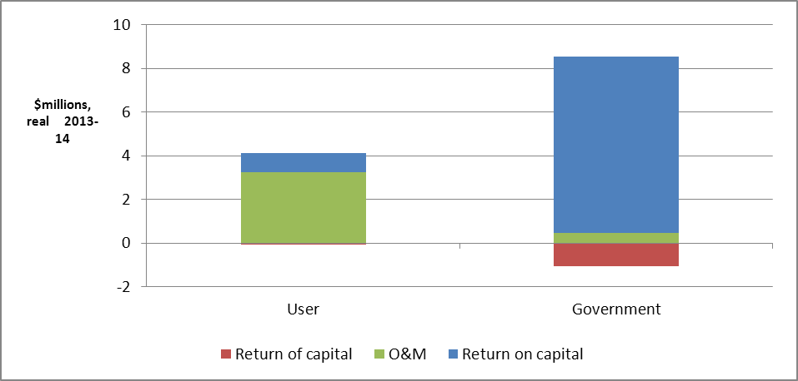
Source: ACCC analysis
What is driving State Water’s costs and charges?
The key drivers of the increase in the full-cost recovery level of prices for Peel valley compared to the 2013-14 prices set by IPART (disregarding MDBA costs) are:
- increased operating expenditure in the current regulatory period above the IPART-approved revenue requirement
- increases in operating and capital expenditure in the next period
- reduction in the rolling average of water usage below the level forecast by IPART.
These factors outweigh the effects of the reduction in the weighted average cost of capital and removal of revenue volatility allowance.
Why is the ACCC’s draft decision lower than State Water’s proposal?
The ACCC made a number of reductions to State Water’s proposal to arrive at its draft decision on Peel valley total revenue. Some of the larger adjustments are:
- non-approval of $0.69 million of State Water’s proposed step increases above base opex. Major step increases that were not approved were staff vacancy rate costs ($0.37 million) (see chapter 6)
- a reduction of $0.35 million to State Water proposed step increases above base opex, mainly relating to scheduled routine maintenance tasks (see chapter 6)
- a reduction of $3.15 million in capital expenditure, mainly due to a cut in the internal labour and overhead component of capex and State-wide projects such as the Computer Aided River Management System (CARMS) (see chapter 7)
- determining a weighted average cost of capital of 7.44 per cent compared to State Water’s proposal (see chapter 9).

Lachlan valley
The Lachlan valley is located in central NSW with its main river being the Lachlan. The Belubula River is also located within the Lachlan valley. The Wyangala Dam is the main storage with a capacity of 1,220,000 ML. A number of natural lakes have also been modified for use as storages, such as Lake Cargelligo at 36,000 ML and Lake Brewster at 154,000 ML. Carcoar Dam (35,800 ML) supplies water within the Belubula valley.
As shown in Table A5, the general security bulk water entitlement charge will be lower in the 2014-17 period compared to 2013-14. The high security entitlement charge and usage charge will increase slightly.
The ACCC has formed the view that State Water’s cost forecast for the regulatory period is higher than required. State Water proposed collecting total revenue of $43.8 million (in $2013–14) over the regulatory period to cover the costs of its services in the Lachlan valley. Following an assessment of efficient costs, the ACCC’s considers that State Water’s total revenue for the Lachlan valley should be set at $37.5 million, $6.3 million lower than State Water’s proposal.
Table A5 ACCC Draft Decision – High Security, General Security and usage bulk water charges 2014-15 to 2016-17 ($ Real, 2013-14)
 | 2013-14 | 2014-15 | 2015-16 | 2016-17
High security ($/ML) | 12.36 | 12.89 | 13.44 | 14.01
General security ($/ML) | 4.42 | 3.20 | 3.33 | 3.48
Usage ($/ML delivered) | 18.04 | 18.49 | 19.28 | 20.10

Figure A9 State Water proposed and ACCC Draft Decision total revenue
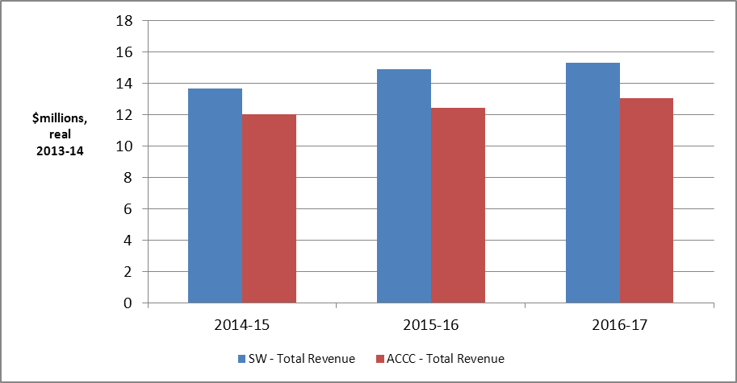
Source: ACCC analysis

Figure A10 ACCC draft decision – Revenue requirement by user and government share by component
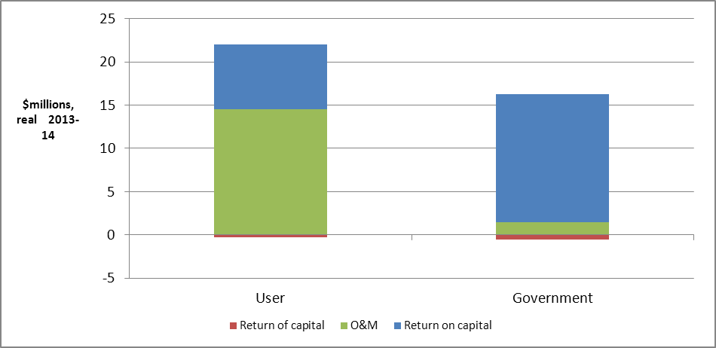
Source: ACCC analysis
What is driving State Water’s costs and charges?
The key drivers of the price reduction in the ACCC draft decision compared to the 2013-14 prices set by IPART are:
- reduction in weighted average cost of capital (WACC)
- removal of revenue volatility allowance
- reduction in operating and maintenance expenditure.
These outweigh the effect of increases in:
- capital expenditure
- depreciation (return of capital) due to reduction in regulatory asset lives
- lower demand than forecast by IPART.
Why is the ACCC’s draft decision lower than State Water’s proposal?
The ACCC made a number of reductions to State Water’s proposal to arrive at its draft decision on Lachlan valley total revenue. Some of the larger adjustments are:
- non-approval of $2.36 million of State Water’s proposed step increases above base opex. Major step increases that were not approved were staff vacancy rate costs ($1.33 million) and updating of flood manuals ($0.19 million) and changes to State Water’s water quality monitoring methodology ($0.18 million) (see chapter 6)
- a reduction of $0.39 million to State Water’s proposed step increases above base opex, mainly related to routine maintenance and cold water pollution projects (see chapter 6)
- a reduction of $8.11 million (24.8 per cent) in capital expenditure, through cuts to labour and overheads, contingencies on fish passages, and State-wide projects such as the Computer Aided River Management System (CARMS) (see chapter 7)
- determining a weighted average cost of capital of 7.44 per cent compared to State Water’s proposal of 8.96 per cent (see chapter 9).

Macquarie valley
The Macquarie valley is in the central-west of NSW with its main river being the Macquarie. Burrendong Dam (capacity of 1,190,110 ML) and Windemere Dam (353,000 ML) are the main storages in the catchment. In addition, there are a number of smaller dams in the catchment providing town water supplies.
As shown in Table A6, the general security bulk water entitlement charge will be lower in the next regulatory period compared to the 2013-14. The high security entitlement charge and usage charge will increase slightly.
The ACCC has formed the view that State Water’s cost forecast for the regulatory period is higher than required. State Water proposed collecting total revenue of $42.9 million (in $2013–14) over 2014-17 to cover the costs of its services in the Macquarie valley. Following an assessment of efficient costs, the ACCC considers that State Water’s total revenue for the Macquarie valley should be set at $34.6 million, $8.3 million lower than State Water’s proposal.
Table A6 ACCC Draft Decision – High Security, General Security and usage bulk water charges 2014-15 to 2016-17 ($ Real, 2013-14)
 | 2013-14* | 2014-15 | 2015-16 | 2016-17
High security ($/ML) | $11.35 | $12.82 | $13.16 | $13.50
General security ($/ML) | $4.22 | $3.48 | $3.57 | $3.66
Usage ($/ML delivered) | $13.90 | $14.71 | $15.10 | $15.50
* Current 2013-14 charges do not include MDBA costs for comparative purposes.
Figure A11 State Water proposed and ACCC Draft Decision total revenue
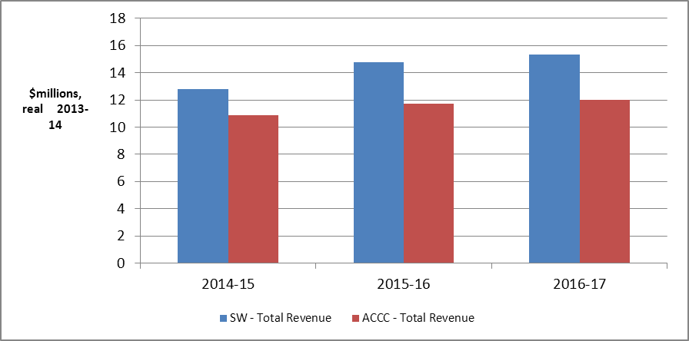
Source: ACCC analysis

Figure A12 ACCC draft decision – Revenue requirement by user and government share by component
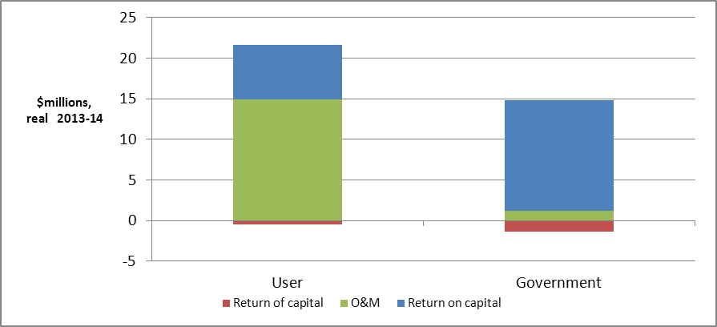
Source: ACCC analysis
What is driving State Water’s costs and charges?
The key drivers affecting prices in the ACCC draft decision compared to the 2013-14 prices set by IPART (disregarding MDBA costs) are:
- reduction in the weighted average cost of capital
- removal of revenue volatility allowance
- increases in capital expenditure and operating expenditure
- increase in depreciation (return of capital) due to reduction in regulatory asset lives
- lower demand than forecast by IPART.
Why is the ACCC’s draft decision lower than State Water’s proposal?
The ACCC made a number of reductions to State Water’s proposal to arrive at its draft decision on Macquarie valley total revenue. Some of the larger adjustments are:
- non-approval of $2.41 million of State Water’s proposed step increases above base opex. Major step increases that were not approved were staff vacancy rate costs ($1.38 million) and updating of flood manuals ($0.2 million) (see chapter 6)
- a reduction of $0.66 million to State Water’s proposed step increases above base opex, mainly relating to scheduled routine maintenance tasks (see chapter 6)
- a reduction of $9.69 million in capital expenditure through cuts to labour and overheads, contingencies on fish passages, State-wide projects such as the Computer Aided River Management System (CARMS), and the Crooked Creek water efficiency project (see chapter 7)
- determining a weighted average cost of capital of 7.44 per cent compared to State Water’s proposal of 8.96 per cent (see chapter 9).

Murray valley
The Murray valley is located in Southern NSW. Its rivers and tributaries include the Murray River, Edward River, Wakool River, Niemur River, Billabong Creek, Yallakool Creek and Colligen Creek. Hume Dam is the main operational storage for the Murray River with a capacity of 3,038,000 ML.
As shown in Table A7, the general security bulk water entitlement charge and usage charge will be lower over the 2014-17 period. The high security bulk water entitlement charge will be similar to the 2013-14 charge.
The ACCC has formed the view that State Water’s cost forecast for the regulatory period is higher than required. State Water proposed collecting total revenue of $24.8 million (in $2013–14) over the regulatory period to cover the costs of its services in the Murray valley. Following an assessment of efficient costs, the ACCC’s considers that State Water’s total revenue for Murray should be set at $18.8 million, $6.0 million lower than State Water’s proposal.
Table A7 ACCC Draft Decision – High Security, General Security and usage bulk water charges 2014-15 to 2016-17 ($ Real, 2013-14)
 | 2013-14* | 2014-15 | 2015-16 | 2016-17
High security ($/ML) | $1.70 | $1.76 | $1.72 | $1.69
General security ($/ML) | $1.26 | $1.00 | $0.98 | $0.96
Usage ($/ML delivered) | $2.69 | $2.60 | $2.55 | $2.49
* Current 2013-14 charges do not include MDBA costs for comparative purposes
Figure A13 State Water proposed and ACCC Draft Decision total revenue
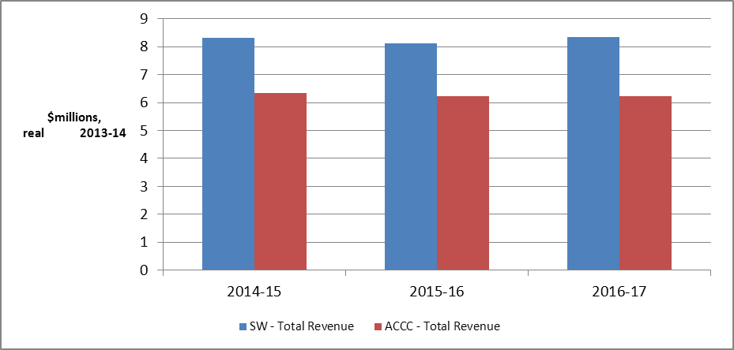
Source: ACCC analysis

Figure A14 ACCC draft decision – Revenue requirement by user and government share by component
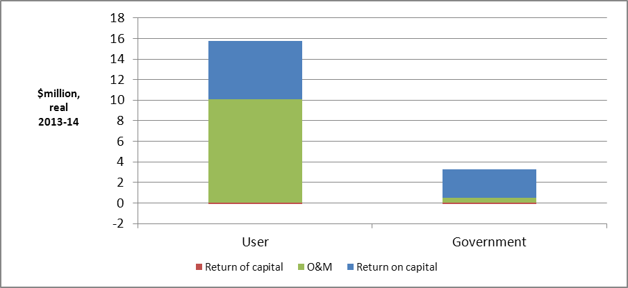
Source: ACCC analysis
What is driving State Water’s costs and charges?
The key drivers of the price reductions in the ACCC draft decision compared to the 2013-14 prices set by IPART (disregarding MDBA costs) are:
- reduction in the weighted average cost of capital (WACC)
- removal of revenue volatility allowance.
Why is the ACCC’s draft decision lower than State Water’s proposal?
The ACCC made a number of reductions to State Water’s proposal to arrive at its draft decision on Murray valley total revenue. Some of the larger adjustments are:
- non-approval of $1.77 million of State Water’s proposed step increases above base opex. Major step increases that were not approved were staff vacancy rate costs ($0.94 million) and costs associated with additional data analysis ($0.26 million) (see chapter 6)
- a reduction of $0.86 million to State Water’s proposed step increases above base opex, mainly relating to scheduled routine maintenance tasks (see chapter 6)
- a reduction of $3.12 million in capital expenditure through cuts to labour and overheads, and State-wide projects such as the Computer Aided River Management System (CARMS) (see chapter 7)
- determining a weighted average cost of capital of 7.44 per cent compared to State Water’s proposal of 8.96 per cent (see chapter 9).

Murrumbidgee valley
The Murrumbidgee valley is in southern NSW with its main river being the Murrumbidgee. Its key tributaries are the Tumut, Gudgenby, Naas, Molonglo, Queanbeyan, Cotter and Yass rivers. The Blowering Dam (capacity of 1,628,000 ML) and Burrinjuck Dam (1,026,000 ML) are the major storages in the catchment.
As shown in Table A8, the general security bulk water entitlement charge will be lower in the 2014-17 regulatory period. The high security entitlement charge and usage charge will increase slightly compared to 2013-14.
The ACCC has formed the view that State Water’s cost forecast for the regulatory period is higher than required. State Water proposed collecting total revenue of $54.6 million (in $2013–14) over the regulatory period to cover the costs of its services in the Murrumbidgee valley. Following an assessment of efficient costs, the ACCC’s considers that State Water’s total revenue for Murrumbidgee valley should be set at $46.5 million, $8.0 million lower than State Water’s proposal.
Table A8 ACCC Draft Decision – High Security, General Security and usage bulk water charges 2014-15 to 2016-17 ($ Real, 2013-14)
 | 2013-14* | 2014-15 | 2015-16 | 2016-17
High security ($/ML) | $2.64 | $2.79 | $2.78 | $2.78
General security ($/ML) | $1.41 | $1.21 | $1.21 | $1.21
Usage ($/ML delivered) | $3.34 | $3.38 | $3.37 | $3.36
* Current 2013-14 charges do not include MDBA costs for comparative purposes.
Figure A15 State Water proposed and ACCC Draft Decision total revenue
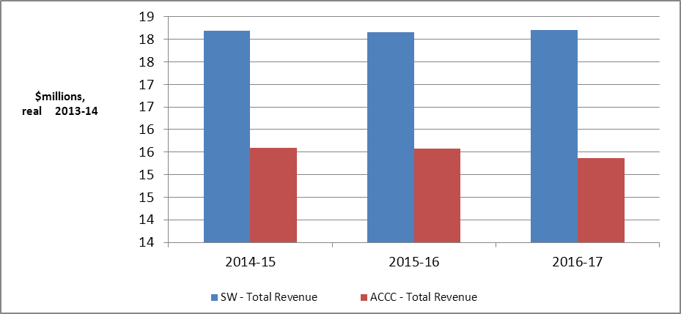
Source: ACCC analysis

Figure A16 ACCC draft decision – Revenue requirement by user and government share by component
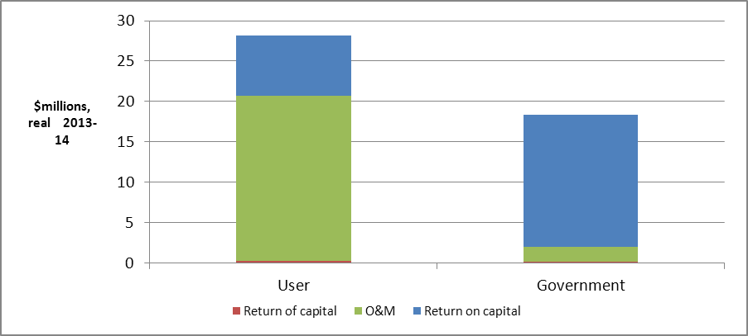
Source: ACCC analysis
What is driving State Water’s costs and charges?
The key drivers of the price change in the ACCC draft decision compared to the 2013-14 prices set by IPART (disregarding MDBA/BRC costs) are:
- the reduction in the weighted average cost of capital (WACC)
- reduction in rebates to bulk users.
These outweigh the effect of increases in:
- operating and maintenance expenditure
- depreciation, due to reduction in regulatory asset lives.
Why is the ACCC’s draft decision lower than State Water’s proposal?
The ACCC made a number of reductions to State Water’s proposal to arrive at its draft decision on Murrumbidgee valley total revenue. Some of the larger adjustments are:
- non-approval of $3.06 million of State Water’s proposed step increases above base opex. Major step increases that were not approved were staff vacancy rate costs ($1.78 million) and updating of flood manuals ($0.26 million) (see chapter 6)
- a reduction of $0.71 million to State Water’s proposed step increases above base opex, mainly relating to scheduled routine maintenance tasks (see chapter 6)
- a reduction of $3.18 million in capital expenditure through cuts to labour and overheads, and cuts to State Water-wide projects such as the Computer Aided River Management System (CARMS) (see chapter 7)
- determining a weighted average cost of capital of 7.44 per cent compared to State Water’s proposal of 8.96 per cent (see chapter 9).

Lowbidgee
The Lowbidgee catchment, which is located within the Murrumbidgee valley, will be a regulated valley from the start of the 2014-17 regulatory period. Customers in Lowbidgee hold supplementary licences only and have water delivered only when there is excess water in the Murrumbidgee valley.
Table A9 shows Lowbidgee’s bulk water entitlement and usage charges for the 2014-17 regulatory period. As this is the first time Lowbidgee will be a regulated valley, there are no 2013-14 charges to compare the ACCC’s draft decision against. Usage charges for Lowbidgee will be the same as Murrumbidgee.
The ACCC has formed the view that State Water’s cost forecast for the regulatory period is higher than required. State Water proposed collecting total revenue of $2.1 million (in $2013–14) over the regulatory period to cover the costs of its services in the Lowbidgee valley. Following an assessment of efficient costs, the ACCC’s considers that State Water’s total revenue for Lowbidgee valley should be set at $1.7 million, $0.4 million lower than State Water’s proposal. It is noted that revenue is recovered 100 per cent from users, with no State Government contribution.
Table A9 ACCC Draft Decision – High Security, General Security and usage bulk water charges 2014-15 to 2016-17 ($ Real, 2013-14)
 | 2013-14 | 2014-15 | 2015-16 | 2016-17
High security ($/ML) | n/a | n/a | n/a | n/a
General security ($/ML) | n/a | $0.71 | $0.75 | $0.80
Usage ($/ML delivered) | n/a | $3.38 | $3.37 | $3.36

Figure A17 State Water proposed and ACCC Draft Decision total revenue
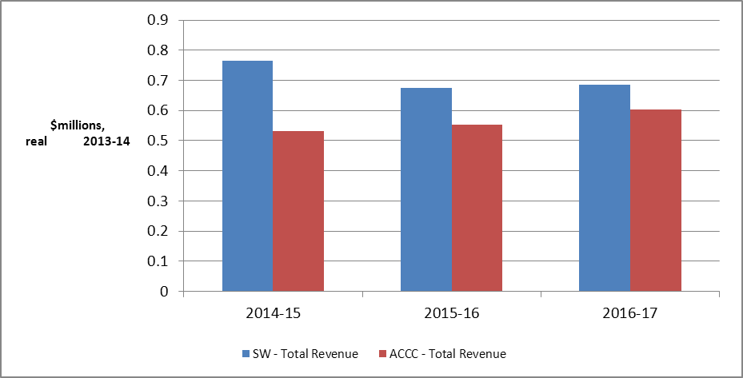
Source: ACCC analysis
Why is the ACCC’s draft decision lower than State Water’s proposal?
The ACCC made a number of reductions to State Water’s proposal to arrive at its draft decision on Lowbidgee valley total revenue. Some of the larger adjustments are:
- non-approval of $0.62 million of State Water’s proposed step increases above base opex. Major step increases that were not approved were the Lowbidgee asset audit ($0.41 million) and staff vacancy rate costs ($0.15 million) (see chapter 6)
- reduction of $0.24 million in capital expenditure through cuts to labour and overheads, and cuts to State Water-wide projects such as the Computer Aided River Management System (CARMS) (see chapter 7)
- determining a weighted average cost of capital of 7.44 per cent compared to State Water’s proposal of 8.96 per cent (see chapter 9).

Fish River Water Supply Scheme
The Fish River Water Supply Scheme (FRWSS) supplies water to the Oberon Council, Lithgow Council, the Sydney Catchment Authority, Delta Electricity and approximately 278 smaller customers. The Oberon Dam is the main storage.
The ACCC notes that charges levied for Lithgow and Oberon councils and Sydney Catchment Authority (SCA) are not regulated charges under Section 91(3) of the Water Act 2007. Accordingly the ACCC cannot determine charges for these customers, which will be regulated by IPART. The ACCC has agreed with IPART to include all Fish River charges in the ACCC’s review. IPART will review the charges for Lithgow and Oberon councils and SCA in 2014-15, and intends to use information from the ACCC’s review in its review process.
As shown in Tables A10, the ACCC’s draft decision will result in reductions in all charges for raw water. For filtered water there will be reductions in charges for minor customers, with increases for major customers.
The ACCC has formed the view that State Water’s cost forecast for the regulatory period is higher than required. State Water proposed collecting total revenue of $31.0 million (in $2013–14) over the regulatory period to cover the costs of its services in the FRWSS. Following an assessment of efficient costs, the ACCC considers that State Water’s total revenue for FRWSS should be set at $30.0 million, $1.1 million lower than State Water’s proposal. It is noted that revenue is recovered 100 per cent from users, with no State Government contribution.
Table A10 ACCC Draft Decision Fish River Water Supply Scheme - Access Charge ($ Real, 2013-14)
Raw Water | 2013-14 | 2014-15 | 2015-16 | 2016-17
Major customers (Delta, SCA, Oberon)
Access charge for minimum annual quantity (MAQ) ($/kL) | 0.38 | 0.34 | 0.34 | 0.34
Usage charge up to MAQ ($/kL) | 0.43 | 0.38 | 0.38 | 0.39
Usage charge in excess of MAQ ($/kL) | 0.81 | n.a. | n.a. | n.a.
Minor customers
Annual water service charge | 94.00* | 67.63 | 68.11 | 68.6
Annual usage up to 200kL ($/kL) | 0.85 | 0.38 | 0.38 | 0.39
Annual usage over 200kL ($/kL) | 1.33 | 0.72 | 0.72 | 0.73
Filtered Water | 2013-14 | 2014-15 | 2015-16 | 2016-17
Major customers (Delta, SCA, Oberon)
Access charge for minimum annual quantity (MAQ) ($/kL) | 0.57 | 0.65 | 0.66 | 0.66
Usage charge up to MAQ ($/kL) | 0.61 | 0.66 | 0.66 | 0.67
Usage charge in excess of MAQ ($/kL) | 1.18 | n.a. | n.a. | n.a.
Minor customers
Annual water service charge | 134.66* | 130.88 | 131.82 | 132.76
Annual usage up to 200kL ($/kL) | 1.04 | 0.66 | 0.66 | 0.67
Annual usage over 200kL ($/kL) | 1.71 | 1.31 | 1.32 | 1.33
*Converted from $/KL at MAQ = 200KL to annual format so to compare with 2014-15 to 2016-17
Figure A18 State Water proposed and ACCC Draft Decision total revenue
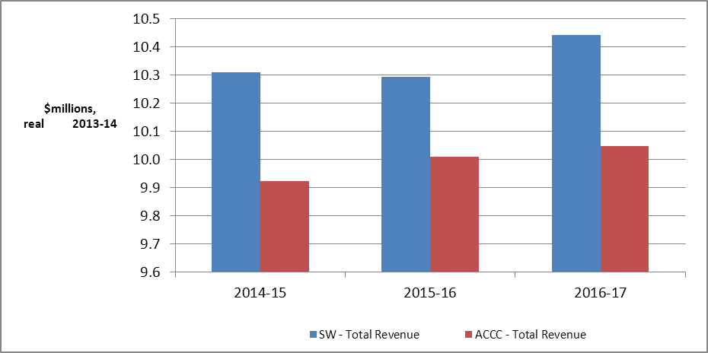
Source: ACCC analysis
What is driving State Water’s costs and charges?
The key drivers of the price reduction in the ACCC draft decision compared to the 2013-14 prices set by IPART are the reductions in
- the weighted average cost of capital (WACC)
- capital expenditure.
These outweigh the effect of increases in:
- operating and maintenance expenditure
- depreciation (return of capital) due to reduction in regulatory asset lives.
Why is the ACCC’s draft decision lower than State Water’s proposal?
The ACCC made a number of reductions to State Water’s proposal to arrive at its draft decision on Fish River total revenue. Some of the larger adjustments are:
- non-approval of $2.3 million of State Water’s proposed step increases above base opex. Major step increases that were not approved were staff vacancy rate costs ($1.02 million), chemical and energy cost increases ($0.4 million) and valve replacement costs ($0.05 million) (see chapter 6)
- a $0.51 million adjustment to State Water proposed step increases above base opex, mainly related to proposed variable costs for 2014–17 (see chapter 6)
- a $11.94 million (55.7 per cent) reduction in capital expenditure through cuts to several capex projects, including the non-approval of dam safety compliance works at Oberon Dam ($6.03 million) (see chapter 7)
- determining a weighted average cost of capital of 7.44 per cent compared to State Water’s proposal of 8.96 per cent (see chapter 9).

This page has been intentionally left blank

State Water Corporation, Pricing application to the Australian Competition and Consumer Commission for regulated charges to apply from 1 July 2014, June 2013.
The Basin water charging objectives and principles (BWCOP) are set out in Schedule 2 of the Water Act.
Appendix C is available in Attachments to ACCC Draft Decision, March 2014.
Letter from Katrina Hodgkinson MP - Minister for Primary Industries to Rod Sims Chairman ACCC – 21 November 2012.
WCIR (2010), r. 29(3).
For comparative purposes Figure 2-2 shows the IPART approved revenue requirement less MDBA & BRC costs. These costs did not form part of State Water’s 2014-17 pricing application.
Water Charge (Infrastructure) Rules 2010, Rule 29.
Water Charge (Infrastructure) Rules 2010, R.29
The ACCC’s consideration of the form of price control is at section 3.2 of this document.
In carrying out the annual revision of prices, the ACCC uses the form of price control equation that is set out in attachment 10. The price may vary due to updated entitlement and extraction volume forecasts and State Water’s ‘unders’ and overs’ account The ACCC does reopen its price determination in the annual revision.
ACCC, Pricing principles for price approvals and determinations under the Water Charge (Infrastructure) Rules 2010, July 2011 (ACCC Pricing Principles), p.51.
Further background on Fish River is set out in Appendix B to the draft decision: attachments document.
IPART’s website contains further information on its price review for certain Fish River customers. See http://www.ipart.nsw.gov.au/Home/Industries/Water/Reviews/Rural_Water/IPARTs_2015_review_of_State_Waters_prices_for_the_coastal_valleys_and_some_Fish_River_customers.
State Water, Response to the ACCC’s information request 18, Responses to questions on metering, 12-13 extractions, CARM benefits and impact of dam upgrades on water availability, 18 October 2013, p.3.
State Water forecasts that 1% of meters will fail each year for reasons not covered by warranty or insurance.
ACCC Pricing Principles, section 3.13, p.53.
ACCC Pricing Principles, p. 54.
Water Charge (Infrastructure) Rules R 29(2).
2013-14 is based on a budget estimate provided by State Water.
Water Charge (Infrastructure) Rules R 29(2)(b).
Deloitte Access Economics / Aurecon, Expenditure forecast review - State Water Corporation, Report to the ACCC under Part 6 of the Water Charge (Infrastructure) Rules 2010: Final report, 18 November 2013, p.73.
Deloitte Access Economics, final report p. 73.
Water Charge (Infrastructure) Rules 2010 (WCIR), R 29.
Forecast capex is added to the RAB, while forecast depreciation and disposals are removed from the RAB. Forecast inflation is used to index the RAB for the 2014–17 regulatory period.
The ACCC’s final decision will include an update to the actual CPI for 2013–14.
A nominal vanilla WACC is the combination of a nominal post–tax return on equity and a nominal pre–tax return on debt.
ACCC Pricing Principles, p. 26.
We have based a WACC of 7.44 per cent on market data for the debt risk premium and risk free rate from 16 December 2013 to 15 January 2014. This is an indicative averaging period of 20 business days. We will update these parameters for our final decision using an averaging period of 10–40 business days commencing as close a practically possible to the start of the regulatory period.
Our adoption of this rate is subject to the risk free rate and debt risk premium parameters being updated closer to the start of the regulatory period.
ACCC Pricing Principles, pp. 34–38.
This draft decision does not address gamma because State Water did not propose a tax building block (see attachment 1 on revenue). Typically, we would specify gamma in the WACC decision, even though it is not required to estimate the nominal vanilla WACC. Gamma would be required for calculating regulatory allowances for corporation tax.
This is relevant for nine of the ten valleys regulated by the ACCC. Lowbidgee is a new valley so it does not have an opening RAB.
Deloitte Access Economics, Final report - asset lives for State Water’s 2014 pricing proposal, 9 December 2013, p. 14–15.
The ACCC’s decision on standard and remaining asset lives is detailed in attachment 6.
Basin water charging objectives and principles (BWCOP) set out in Schedule 2 of the Water Act 2007.

