Report on the Darwin petrol market
November 2015
ISBN 978 1 922145 65 9
Australian Competition and Consumer Commission
23 Marcus Clarke Street, Canberra, Australian Capital Territory, 2601
© Commonwealth of Australia 2015
This work is copyright. In addition to any use permitted under the Copyright Act 1968, all material contained within this work is provided under a Creative Commons Attribution 3.0 Australia licence, with the exception of:
• the Commonwealth Coat of Arms
• the ACCC and AER logos
• any illustration, diagram, photograph or graphic over which the Australian Competition and Consumer Commission does not hold copyright, but which may be part of or contained within this publication.
The details of the relevant licence conditions are available on the Creative Commons website, as is the full legal code for the CC BY 3.0 AU licence.
Requests and inquiries concerning reproduction and rights should be addressed to the Director, Corporate Communications, ACCC, GPO Box 3131, Canberra ACT 2601, or publishing.unit@accc.gov.au.
Important notice
The information in this publication is for general guidance only. It does not constitute legal or other professional advice, and should not be relied on as a statement of the law in any jurisdiction. Because it is intended only as a general guide, it may contain generalisations. You should obtain professional advice if you have any specific concern.
The ACCC has made every reasonable effort to provide current and accurate information, but it does not make any guarantees regarding the accuracy, currency or completeness of that information.
Parties who wish to republish or otherwise use the information in this publication must check this information for currency and accuracy prior to publication. This should be done prior to each publication edition, as ACCC guidance and relevant transitional legislation frequently change. Any queries parties have should be addressed to the Director, Corporate Communications, ACCC, GPO Box 3131, Canberra ACT 2601, or publishing.unit@accc.gov.au.
ACCC 10/15_1025
www.accc.gov.au

Key points
Petrol prices in Darwin were significantly higher than in other capital cities
Between 2000–01 and 2010–11 Darwin motorists paid on average around 10 cents per litre (cpl) more for petrol than motorists in the five largest cities (i.e. Sydney, Melbourne, Brisbane, Adelaide and Perth). In 2011–12 the price differential between Darwin and the five largest cities began to increase, and in the two-year period 2012–13 to 2013–14 the price differential averaged over 19 cpl. Similar trends and price differentials were observed for diesel sales in Darwin.
Petrol prices in Darwin relative to Katherine also increased between 2011–12 and 2013–14, and were on average around 5 cpl higher during that period, despite the smaller size of Katherine and its more remote location. Movements in petrol prices in Alice Springs and Tennant Creek were similar to those in Darwin during this period.
The decrease in the number of independents in the Darwin market in recent years combined with weak retail competition led to higher profits
Between 2007 and 2015, the reduction in the number of independent retail sites and the associated consolidation of the Darwin retail market meant that four retailers set prices for most of the petrol sold in Darwin.
When Archer Capital became the major shareholder of Ausfuel in May 2010, it did not increase Ausfuel’s market share but it did appear to change its behaviour. Subsequent to the Archer Capital acquisition, Ausfuel became the clear leader of petrol price increases in the Darwin market. At the same time there was a lack of retailers with a discounting strategy to win market share.
This combination of factors enabled petrol retailers in Darwin to increase their margins and profits at the expense of motorists.
Net profit per site in Darwin in 2013–14 was 10 times the Adelaide average
In 2013–14 (the latest financial year data available) net profit per site in Darwin was around $1.2 million. This compares with Adelaide where net profit per site for most of the same companies in 2013-14 was between $100 000 to $200 000. Moreover, net profit per site in Darwin more than doubled between 2009–10 and 2013–14.
Looking at petrol only, and so ignoring convenience store sales, the retail net margin in Darwin in 2013–14 on a cents per litre basis was around 13 cpl, which was 11 cpl higher than in Adelaide.
The high profits in Darwin compared with other cities, such as Adelaide, are reflected in the large difference between gross indicative retail differences (GIRDs) in Darwin and Adelaide. GIRDs are the difference between retail prices and published wholesale prices (or terminal gate prices (TGPs)). GIRDs are a broad indicator of gross retail margins.
In 2013–14 the annual average GIRD in Darwin was 24.2 cpl compared with 7.1 cpl in Adelaide. Higher operating costs explain some of the higher GIRDs in Darwin relative to Adelaide. However, the majority of the difference between retail petrol prices in Darwin and Adelaide was due to higher retail profit on petrol sold in Darwin.
On a per litre of fuel sold basis (i.e. all grades of petrol, diesel and automotive LPG), retail unit net profit in Darwin was around 20 cpl in 2013–14, compared with around 3 cpl across Australia.
The increase in Darwin margins has imposed a significant cost on motorists
The increase in GIRDs for petrol in Darwin between 2011–12 and 2013–14 was costly for Darwin motorists. During that period GIRDs in Darwin were around 11 cpl higher than in the previous seven years (averaging 9.5 cpl), adding around $26 million to the petrol bill for Darwin motorists during those three years, or around $9 million per year.
In the first nine months of 2015, GIRDs for petrol in Darwin have returned to close to their previous long-term average. This has reduced costs to motorists by around $6 million for the nine-month period.
The Darwin petrol market is very concentrated
In 2013–14 four retailers—Puma Energy, Coles Express, Woolworths and United—set prices for 97 per cent of petrol sold in Darwin. Between February 2007 and May 2015, the proportion of independent retail petrol sites in Darwin decreased from 27 per cent to 8 per cent.
From mid-2010 a change occurred in the Darwin petrol market when Archer Capital became the major shareholder in Ausfuel. This was followed in March 2013 by Puma Energy’s purchase of Ausfuel.
At the import and wholesale levels, the market is also relatively concentrated. Five companies—Puma Energy, Caltex, Viva Energy, United and BP—have capacity at the Vopak import terminal (which is the only terminal in Darwin).
Puma Energy has the largest market share at the wholesale and retail levels in Darwin, has considerable distribution operations and has access to its own import supply through its ties to Trafigura, one of the world’s largest oil and mineral traders.
Higher margins and profits in Darwin are a result of weak retail competition
The ability of petrol retailers in Darwin to pass on more of the increases in TGPs than decreases in TGPs led to the significant growth in GIRDs from 2011 to October 2014. During that time only around 15 per cent of the decrease in TGPs was passed on by retailers, compared with around 35 per cent of the increase in TGPs. This reflects the absence of a sufficient number of retailers in Darwin willing to ‘chase volumes’ through discounting their prices.
The relatively weak retail competition in Darwin was due in part to the presence of a large player (Ausfuel and subsequently Puma Energy) that increased prices at its sites as a block. After Archer Capital became the major shareholder of Ausfuel in mid-2010, Ausfuel was the clear leader of petrol price increases in the Darwin market. This leadership was important to the increase in profits in petrol retailing in Darwin.
The pricing behaviour of Ausfuel and Puma Energy was accommodated by the pricing behaviours of Coles Express and Woolworths. Coles Express and Woolworths quickly followed price increases by Ausfuel and Puma Energy and typically did not lead retail fuel prices lower. Even though United’s strategy is to typically price below the market, this did not have a major effect in the Darwin market and did not appear to drive prices lower. The small number of independents in Darwin did not disrupt the behaviour of the major retailers.
Pricing behaviours have changed substantially in recent months
Since the Northern Territory Fuel Summit in October 2014, and the ACCC announcement of the Darwin market study in March 2015, retail pricing behaviour in Darwin changed. The decrease in TGPs in late 2014 and early 2015 was more than fully passed through to retail prices. As a result, monthly average GIRDs decreased by 27.9 cpl over the nine-month period from October 2014 to June 2015.
Monthly average petrol prices in Darwin in June 2015 were 134.9 cpl, which was 5.7 cpl lower than in the five largest cities (140.6 cpl). This was the first time that monthly average Darwin prices were lower than in the five largest cities since the ACCC started to regularly collect Darwin prices in January 2000.
In September 2015 Darwin motorists paid on average just over 1 cpl more for petrol than motorists in the five largest cities.
Further entry has the potential to substantially increase competitive rivalry among fuel retailers
There are three major barriers to entry into fuel retailing in Darwin. They are:
• access to fuel on competitive terms
• access to suitable sites
• the risk associated with the long-term nature of investments in petrol.
While these barriers are substantial they are not insurmountable. Caltex opened two new retail sites in Darwin in the last two years and United is also looking to establish a new retail site. It is too early to gauge the effect of Caltex’s entry on competition. In general, the effect on competition will crucially depend on the ability of the entrant to adopt a discounting strategy to win market share, and its willingness to do so. The ACCC notes the proposal by the Northern Territory Government to offer prime land for a retail petrol site to offer discounted prices.
Increased transparency and promotion of effective competition are the way forward
There are several steps that could be taken to increase transparency and promote effective competition in the Darwin market. These include:
• regular publication of GIRDs and benchmarking against other locations
• providing current retail prices to motorists
• regular reporting on market concentration
• continued monitoring by the ACCC of future merger activity in Darwin fuel markets
• promotion of effective new entrants into the market
• changing the Northern Territory Government’s fuel supply arrangements.
Background
In December 2014 the then Minister for Small Business, the Hon. Bruce Billson MP, gave the ACCC a new direction to monitor the prices, costs and profits of unleaded petroleum products in Australia for a period of three years. The new monitoring arrangements introduced by the ACCC include the preparation of regional market studies. These aim to explain why petrol prices are higher in certain regional locations and explain where money is being made in the petrol supply value chain.
The ACCC collects retail petrol prices for all capital cities and over 190 regional locations across Australia. Following extensive assessment of price and other data for these locations, the ACCC announced in March 2015 that Darwin would be the first of its regional studies.
High prices and margins do not necessarily indicate a breach of the Competition and Consumer Act
Without anti-competitive agreements or misuse of market power, pricing above cost and reasonable margins is not illegal.
The ACCC does not set petrol prices or profit margins in petrol markets, and nor is it able to restructure petrol markets or make them operate more efficiently. Its role is to promote effective competition in petrol markets where it can, to enable resources to be used efficiently and to make markets work in the interests of consumers.
Higher prices or profit margins can occur in competitive markets resulting from factors such as increasing demand, supply constraints, or cost savings from operational efficiencies or technological investment.
Markets where competition is weak or ineffective can also result in higher prices and profits at the expense of consumers. This may be the result of illegal conduct or could be the result of structural or market dynamics which are not a breach of the Competition and Consumer Act 2010 (Cth). In such circumstances the operation of the market can often improve over time through the competitive process or with policy or other changes to the business environment.
The ACCC takes action to enforce compliance with competition law which prohibits anti-competitive behaviour. This includes cartel conduct, misuse of market power and anti-competitive agreements. These behaviours can all affect prices.
Certain types of agreements can adversely affect the competitive process. Competition law prohibits agreements between competitors about price, customers, outputs and market shares, as well as supply agreements that substantially lessen competition.
By itself, having market power or a significant market share is not illegal. Concerns arise where substantial market power is used to interfere with the process of competition such as eliminating or substantially damaging a competitor, preventing the entry of a person into a market, or deterring or preventing a person from engaging in competitive conduct in a market.
It is the ACCC’s role not only to investigate breaches of the Competition and Consumer Act 2010 and take action accordingly but also to highlight where there is a need for more effective competition.

1 Petrol prices in Darwin have been significantly higher than in other capital cities

1.1 Petrol prices in Darwin have been well above average prices in Australia’s five largest cities since at least 2000 and the difference increased substantially from 2011
Between 2000–01 and 2010–11 Darwin motorists paid on average around 10 cents per litre (cpl) more for petrol than motorists in the five largest cities—see chart 1.1. This differential increased to 19.8 cpl in 2013–14.
Chart 1.1: Annual average retail petrol prices in Darwin and the five largest cities—2000–01 to 2014–15
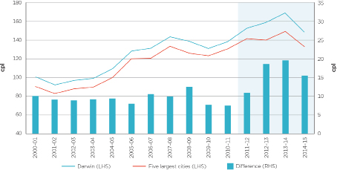
Source: ACCC calculations based on FUELtrac and Informed Sources data.
The differential between Darwin and the five largest cities began increasing in 2011–12 (see chart 1.2). In the first nine months of 2014 this difference increased to an average of 22.9 cpl.
Similar trends and price differentials were observed for diesel sales in Darwin.
Chart 1.2: Monthly average retail petrol price differentials between Darwin and the five largest cities—January 2010 to September 2015
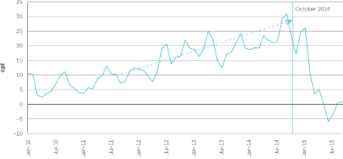
Source: ACCC calculations based on FUELtrac and Informed Sources data.

1.2 The price differential narrowed substantially from October 2014
Monthly average Darwin petrol prices fell from 173.5 cpl in September 2014 to 130.4 cpl in September 2015—a decrease of 43.1 cpl (see chart 1.3). Over the same period monthly average prices in the five largest cities fell by 13.1 cpl—from 142.4 cpl to 129.3 cpl. This included a large decrease to January 2015 followed by subsequent increases.
Darwin monthly average petrol prices fell below the average in the five largest cities for the first time since at least 2000 in June 2015. In September 2015 Darwin motorists paid on average just over 1 cpl more than motorists in the five largest cities.
A significant influence on the decrease in Darwin prices was the very steep and sustained fall in the international price of crude oil and refined petrol between October 2014 and January 2015. A number of events coincided with this decrease which contributed to the narrowing of the price differential with the five largest cities. These included the Northern Territory Government Fuel Summit in October 2014 and the ACCC announcing this regional fuel study in March 2015.
Chart 1.3: Monthly average retail petrol prices in Darwin and the five largest cities—June 2014 to September 2015
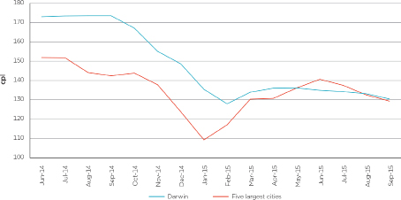
Source: ACCC calculations based on FUELtrac and Informed Sources data.
Daily average Darwin petrol prices have been relatively stable over the last six months (see chart 1.4). Between mid-March 2015 and the end of September 2015, Darwin prices were broadly within a 6 cpl range. In contrast, daily average prices in the five largest cities ranged from a low of around 124 cpl to a high of around 144 cpl—a range of 20 cpl.
Chart 1.4: Daily average retail petrol prices in Darwin and the five largest cities—September 2014 to September 2015
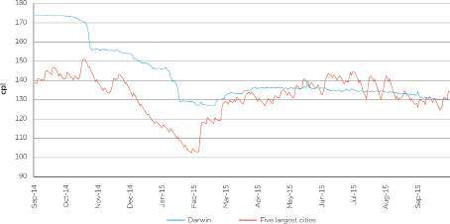
Source: ACCC calculations based on FUELtrac data.

1.3 Petrol prices in Darwin were also higher than prices in Katherine from 2011–12
From 2010–2011, Darwin petrol prices were above those in Katherine (see chart 1.5). From 2002–03 to 2010–11 average retail petrol prices in Darwin and Katherine were broadly similar. However, between 2011–12 and 2013–14 Darwin petrol prices were on average over 5 cpl above those in Katherine. That Katherine prices were lower than Darwin prices is unexpected given the smaller size of Katherine and its more remote location.
Chart 1.5: Annual average retail petrol prices in Darwin and Katherine—2000–01 to 2014–15
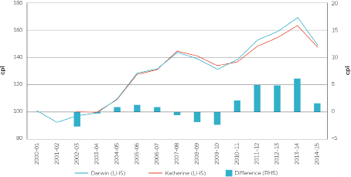
Source: ACCC calculations based on FUELtrac and Informed Sources data.
With the fall in Darwin petrol prices from October 2014, there was also a fall in the differential between Darwin and Katherine prices. In the first half of 2014–15 Darwin prices were on average over 4 cpl higher than Katherine prices. In the second half of 2014–15 they were around 1 cpl lower.

1.4 Movements in petrol prices in other locations in the Northern Territory were broadly similar to Darwin
In the Northern Territory the ACCC monitors fuel prices in Darwin and three regional locations: Alice Springs, Katherine and Tennant Creek.
Over the last 10 years, movements in the annual average retail petrol prices in Alice Springs, Katherine and Tennant Creek broadly followed movements in retail prices in Darwin.
However, unlike in Katherine, annual average retail petrol prices in Alice Springs and Tennant Creek from 2004–05 were always higher than prices in Darwin.

2 High prices in Darwin were mainly due to high retail margins and profits
Increasing retail margins on petrol in Darwin are largely responsible for the increase in the petrol price differential between Darwin and the five largest cities. This chapter presents analysis of profitability of retail sites in Darwin in relation to the rest of Australia and Adelaide. It also compares the value chain of a litre of petrol in Darwin and Adelaide.
The analysis in this chapter is largely based on site specific data provided by most retailers operating in Darwin. There are some methodological issues associated with this data, which are outlined in appendix E. Key points to note are:
• Data obtained from the sites of individual companies has been averaged across the city, and therefore the aggregate data represents an average only and could not be attributed to any individual retail site or company.
• Various types of retail sites operate in the petrol industry—such as company-owned and company-operated, franchise and commission agency—which have different operating and financial arrangements.
• The profit calculations in this chapter—apart from section 2.2—do not take account of head office costs. This information was not provided by all companies.

2.1 Profits are high in Darwin and have increased in recent years

2.1.1 Net profit per retail site in Darwin is around $1.2 million, 10 times the Adelaide average
In 2013–14, which is the latest financial year data available, retail sites in Darwin made on average around $1.2 million net profit per site. Some sites reported net profit of over $2 million. Net profit per site in Darwin was around 10 times the average in Adelaide (see chart 2.1). Chart 2.1 compares net profit per site of the four largest retailers in Darwin with the net profit per site of the three of those retailers that also operate in Adelaide.
Adelaide was chosen as a comparator because it is the smallest of the five largest cities. It has a population of around 1.1 million people and around 260 retail sites. In contrast, Darwin has a population of around 103 000 people and 39 retail sites. As with Darwin, Adelaide does not have a refinery and is dependent on petrol being imported into the city.
The high profitability of retail sites in Darwin was mainly achieved through high margins on fuel sold.
Chart 2.1: Net profit per site in Darwin and Adelaide: 2013–14
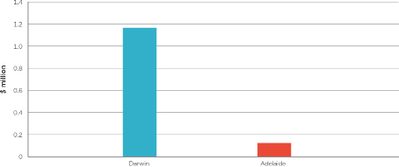
Source: ACCC calculations based on data obtained from the companies.
Notes: Darwin estimates are based on data from Coles Express, Woolworths, Puma Energy and United. Adelaide estimates are based on data from Coles Express, Woolworths and United.
The net profit per site estimates were calculated as the average of total sales revenue (fuel and convenience store) less cost of goods sold and operating costs (such as employee, energy, rent and other direct operating costs). They are based on financial template data provided by the companies.

2.1.2 Net profit per site has increased substantially over recent years
Over the period 2009–10 to 2013–14 net profit per site in Darwin increased each year. This is shown in chart 2.2, which indicates that:
• net profit per site more than doubled between 2009–10 and 2013–14
• net profit exceeded $1 million per site in 2012–13, after increasing by almost 70 per cent from 2011–12.
Chart 2.2: Net profit per site in Darwin: 2009–10 to 2013–14
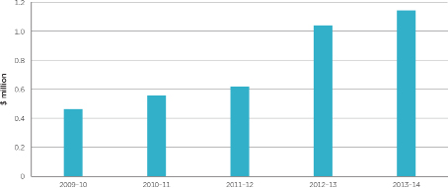
Source: ACCC calculations based on data obtained from the companies.
Notes: This chart is based on data from Coles Express, Woolworths, Puma Energy and United.
These estimates are based on the net profits reported in profit and loss statements provided by the companies. Net profit per site is broadly equal to earnings before interest and tax.

2.2 Retail unit net profit in Darwin is much higher than the Australian average
Retail unit net profit measures the overall net profit earned at retail sites (including profit made on convenience sales) per litre of fuel sold. This includes all grades of petrol, diesel and LPG. Retail unit net profit in Darwin was considerably higher than the Australian average retail unit net profit over the period 2009–10 to 2013–14 (see chart 2.3).
Chart 2.3: Annual average retail unit net profit in Darwin and Australia: 2009–10 to 2013–14
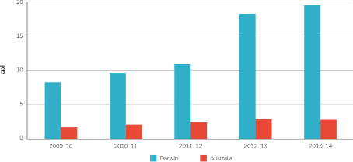
Source: ACCC calculations based on data from the companies.
Note: Darwin estimates are based on data from Coles Express, Woolworths, Puma Energy and United.
The Australia-wide estimates in this chart were published in ACCC’s 2014 petrol monitoring report (p. 154). In those figures, head office costs for fuel and non-fuel activities were deducted. To compare like with like, average head office costs across Australia each year have been deducted from the Darwin estimates. Over the five years, the estimate for head office costs across Australia ranged from 1.0 cpl to 2.2 cpl.
In 2013–14 retail unit net profit was around 20 cpl in Darwin, compared with around 3 cpl across Australia.
Over the period, retail unit net profit in Darwin compared with the Australian average retail unit net profit was:
• around five times higher between 2009–10 and 2011–12
• around six times higher in 2012–13
• around seven times higher in 2013–14.
Between 2009–10 and 2013–14 retail unit net profit increased by around 140 per cent in Darwin, compared with an increase of around 60 per cent in Australia.

2.3 Higher profits in Darwin are reflected in higher GIRDs

2.3.1 The difference in GIRDs has driven the increase in the petrol price differential between Darwin and the five largest cities
Gross indicative retail differences (GIRDs) are the difference between retail prices and published terminal gate prices (TGPs). They can be regarded as a broad indicator of gross retail margins.
TGPs are the prices at which petrol can be purchased from wholesalers in the spot market and are posted on a regular basis on the websites of the major wholesalers. While many wholesale transactions do not occur at the terminal gate, TGPs can be regarded as indicative wholesale prices.
However, TGPs reflect the price of petrol only, and exclude other retail operating costs (such as branding, transportation, labour, etc.). Furthermore, data obtained by the ACCC indicates that in both Darwin and Adelaide the average actual wholesale price paid by the major retailers is around 1–2 cpl below the average published TGPs for petrol.
As a result, GIRDs should be treated only as a useful approximate benchmark of the retail gross margin on petrol. They should not be confused with actual retail profits.
GIRDs have been increasing in the five largest cities, but have increased more rapidly in Darwin (chart 2.4). From 2004–05 to 2010–11 GIRDs on petrol sales in Darwin were on average 3.9 cpl above those in the five largest cities. They subsequently increased substantially: between 2011–12 and 2013–14 they were on average 12.8 cpl above those in the five largest cities.
Over the first nine months of 2014, GIRDs for petrol in Darwin were 19.0 cpl above those in the five largest cities. Since October 2014, this has reversed. In June 2015 the GIRDs for petrol in Darwin had fallen to 1.6 cpl—this was 9.6 cpl below the GIRDs in the five largest cities (11.2 cpl).
Similar trends and price differences were observed for diesel sales in Darwin.
Chart 2.4: Annual average petrol GIRDs in Darwin and the five largest cities—2004–05 to 2014–15
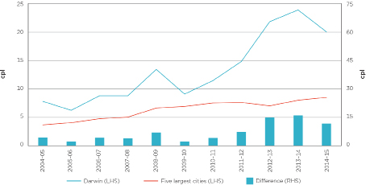
Source: ACCC calculations based on FUELtrac, Informed Sources, Australian Institute of Petroleum (AIP), BP, Caltex, Mobil, Viva Energy and WA Fuelwatch data.

2.3.2 GIRDs, profits and margins show the same trends
The net retail margin on petrol indicates the profits that retailers make on petrol sales. It is calculated by subtracting operating costs (per litre of petrol sold) at the retail level from GIRDs.
Chart 2.5 shows annual average GIRDs in Darwin and the net retail margin on petrol (in cpl on the right hand side) and the net profit per site (in millions of dollars on the left hand side) from 2009–10 to 2013–14.
Chart 2.5: Annual average petrol gross indicative retail differences, net retail margin on petrol and net profit per site in Darwin: 2009–10 to 2013–14
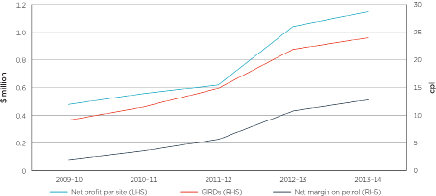
Source: ACCC calculations based on data from the companies, FUELtrac, Informed Sources and AIP.
Notes: The net profit per site estimates are from chart 2.2.
The GIRDs estimates are from chart 2.4.
The net retail margin on petrol is calculated by subtracting operating costs (per litre of petrol sold) at the retail level from GIRDs.
Movements in petrol GIRDs in Darwin over the period closely reflected movements in net profit per site:
• between 2009–10 and 2013–14 net profit per site increased by around 140 per cent compared with GIRDs which increased by around 160 per cent
• between 2010–11 and 2013–14 net profit per site increased by around 105 per cent compared with GIRDs which increased by around 110 per cent.
The net retail margin on petrol increased by a larger amount in percentage terms; however, over the period it closely followed changes in GIRDs, albeit at a lower level.
This suggests that increases in profits explain a large proportion of the increases in GIRDs in Darwin.
In 2013–14 retail sites in Darwin sold on average 2.3 million litres of petrol. Each one cent per litre increase in the net retail margin on petrol would therefore have added around $23 000 to the annual profits of an average site.

2.4 High net retail margins are the driver of high prices in Darwin
The ACCC has examined the value chain for petrol in Darwin in 2013–14 and compared it with the value chain in Adelaide. The value chain shows in broad terms the elements of the price of a litre of petrol from the price of imported refined petrol to the price of petrol at the pump (table 2.1).
Table 2.1: Petrol value chain in Darwin and Adelaide: 2013–14 (cpl)
 | Darwin | Adelaide | Difference
Retail price | 170.4 | 149.7 | 20.7
Net margin | 13 | 2 | 11
Operating costs | 9 | 4 | 5
GST—retail | 2 | 1 | 1
Terminal gate price | 146.2 | 142.6 | 3.6
GST and excise | 52 | 51 | 1
Costs and margins | 8 | 5 | 3
Import parity price | 86.7 | 86.7 | 0
Refined petrol | 82 | 82 | 0
Freight | 2 | 3 | -1
Costs and margins | 2 | 1 | 1
Quality premium | 1 | 1 | 0

Source: ACCC calculations based on data from companies monitored under the 2014 petrol monitoring program and the 2015 Darwin market study, and Informed Sources.
Notes: Darwin estimates of retail operating costs are based on data from Coles Express, Woolworths, Puma Energy and United. Adelaide estimates of retail operating costs are based on data from Coles Express, Woolworths and United.
The components of each price level have been rounded to the nearest cent. As a result, they may not sum to the totals.
‘GST—retail’ is one-eleventh of the difference between the retail price and the TGP. ‘GST and Excise’ is one-eleventh of the TGP, plus 38.14 cpl.
In 2013–14 the average retail petrol price in Darwin was 170.4 cpl and in Adelaide the average was 149.7 cpl—a difference of 20.7 cpl.
The largest contributor to the difference in retail petrol prices between Darwin and Adelaide was net retail margins. Net retail margins contributed more than half of the difference in pump prices between the two cities.
The value chain shows that in 2013–14:
• the higher retail price in Darwin was primarily due to higher net retail margins on petrol and higher retail operating costs (per litre)
• the wholesale price (represented by the published TGP) was 3.6 cpl higher in Darwin
• the imported price of refined petrol (represented by the import parity price) was the same in both cities (86.7 cpl).
These elements of the value chain are explained further below.

2.4.1 Net retail margins in Darwin are far higher than in Adelaide
The value chain highlights that the largest contributor to the high prices in Darwin is at the retail level.
The difference between retail prices and TGPs (i.e. GIRDs) in 2013–14 in Darwin was 24.2 cpl compared with 7.1 cpl in Adelaide.
Retail sites in Darwin had higher operating costs on average than sites in Adelaide. Retail sites in Darwin also sold on average a lower volume of petrol in 2013–14 than Adelaide sites. These factors (which are discussed in more detail in Section 2.5) led to higher operating costs per litre of petrol sold in Darwin.
As a result, retail operating costs in Darwin in 2013–14 were around 5 cpl higher than in Adelaide.
While the higher operating costs explain some of the higher GIRDs in Darwin relative to Adelaide, the majority of the difference between retail petrol prices in Darwin and Adelaide was due to higher net margins on petrol in Darwin.

2.4.2 Wholesale prices are higher in Darwin by around 3.5–4.0 cpl
In 2013–14, 3.6 cpl of the difference between retail petrol prices in Darwin and Adelaide was due to higher wholesale prices in Darwin.
Chart 2.6 shows that the difference between TGPs in Darwin and Adelaide has not increased in recent years to the same extent that the difference in retail prices has increased. In 2009–10 the difference between TGPs in Darwin and Adelaide was 5.4 cpl, and from 2010–11 to 2013–14 the difference was steady at 3.6 cpl to 3.8 cpl.
Chart 2.6: TGPs in Darwin and Adelaide: 2009–10 to 2013–14
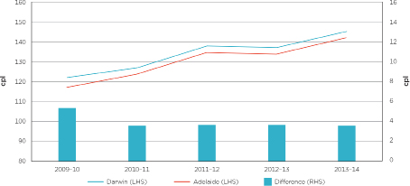
Source: ACCC calculations based on data from AIP, BP, Caltex, Mobil and Viva Energy.
Movements in wholesale petrol prices therefore do not explain increases in Darwin petrol prices relative to Adelaide (or any of the five largest cities). Retail petrol price increases in Darwin are partly driven by increases in the wholesale cost of petrol, but the changes in wholesale petrol prices do not explain all of the recent increase in retail petrol prices in Darwin.
Excluding excise (38.14 cpl) and GST at the wholesale level, the difference between the average import parity price and the average TGP in 2013–14 was around 8 cpl in Darwin and around 5 cpl in Adelaide.
Wholesalers noted that the higher TGPs in Darwin were due to higher costs such as terminal fees and a larger temperature adjustment, as well as higher wholesale margins.

2.4.3 The cost of petrol imported into Darwin or Adelaide is the same
Petrol comes into Darwin either via direct imports from overseas, or from refineries or terminals in other Australian cities. Regardless of the source, the price of petrol is based on the import parity price. Pricing according to import parity is the setting of wholesale prices of petrol at a price comparable with the cost of importing fuel into a given location in Australia. This is because Australia is a net importer of refined petrol; therefore prices must reflect international prices to attract sufficient fuel into the Australian market.
The import parity price has four broad components:
• the benchmark price of petrol
• freight
• a quality premium
• other import costs (such as wharfage and other incidental costs).
Because of its proximity to Singapore—which is the major export hub in the Asia-Pacific region—shipping costs to Darwin are lower than to Adelaide. However, other importing costs are higher for Darwin, reflecting lower volumes.
Overall, the cost of bringing petrol into Darwin is around the same as bringing petrol into Adelaide.

2.5 Lower volumes and higher costs in Darwin do not fully explain the higher retail margins

2.5.1 Operating costs are higher in Darwin but not substantially and do not explain the increase in the difference in retail prices in Darwin
Fuel retailers incur a range of operating expenses including staff costs, energy costs, site rental costs and cleaning and maintenance. Fuel retailers also must achieve a return on their investment commensurate with the risks they face and their entrepreneurship. The margins fuel retailers make on the sale of fuel and other products (such as convenience products) must cover these costs.
Based on data provided to the ACCC, average retail operating costs per site in Darwin were around $650 000 (or 12 cpl on all fuels sold) in 2013–14 and had increased at less than the inflation rate from 2011–12. Major components of operating costs were wages and site lease costs. Average operating costs per site were higher in Darwin than in Adelaide by around 10 per cent. While operating costs in Darwin were higher on average than in Adelaide, they do not explain the increasing difference in retail prices between Darwin and the five largest cities.
The ACCC estimates that operating costs contributed around 9 cpl to the average retail petrol price in Darwin in 2013–14. This was around 5 cpl higher than in Adelaide. The difference in operating costs per litre was largely due to lower sales volumes per site in Darwin.

2.5.2 Retail sites in Darwin sell lower volumes of petrol
Retail sites in Darwin on average sell much lower volumes of fuel than sites in Adelaide. In 2013–14, retail sites in Darwin sold around 40–50 per cent less petrol than sites in Adelaide (around 2.3 million litres compared with 4.5 million litres, see chart 2.7).
Chart 2.7: Average volume of fuel sold per site in Darwin and Adelaide: 2013–14
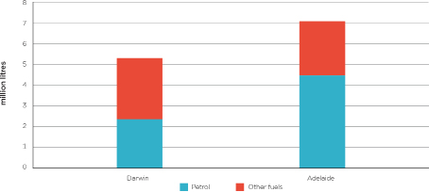
Source: ACCC calculations based on data from the companies.
Notes: Darwin estimates are based on data from Coles Express, Woolworths, Puma Energy and United. Adelaide estimates are based on data from Coles Express, Woolworths and United.
Overall average retail fuel sales per site were around 5.3 million litres in Darwin in 2013–14. This was around a quarter less than average retail fuel sales per site in Adelaide (7.1 million litres).
Generally speaking, retail sites selling higher volumes of fuel will have lower operating costs per litre of fuel sold, to the extent that the higher sales volumes do not increase costs such as wages and energy costs.

2.6 The growth in GIRDs cost motorists around $26 million between 2011–12 and 2013–14
The growth in GIRDs in Darwin has been significant for motorists. Fuel retailers in Darwin sold around 77 million litres of petrol in 2013–14. Each one cent per litre increase in gross retail margins cost motorists in Darwin around $770 000 per year.
Over the period 2011–12 to 2013–14 GIRDs for petrol in Darwin were on average almost 11 cpl above the average of the previous seven years (9.5 cpl). This added around $26 million to the petrol bill for Darwin motorists for those three years, or around $9 million per year.
In the period January to September 2015 GIRDs for petrol in Darwin have returned to close to their previous long-term average. This has reduced costs to motorists by an estimated $5.9 million over that nine-month period.

3 Darwin market structure is very concentrated

3.1 Four petrol retailers controlled prices for around 97 per cent of retail petrol volume in Darwin in 2013–14
There are currently 39 retail petrol sites in Darwin. For the purposes of this study, the ACCC has defined Darwin as the areas of Darwin, Palmerston, Howard Springs, Virginia and Humpty Doo.
In 2013–14 four retailers—Puma Energy, Coles Express, Woolworths and United—set prices for 97 per cent of petrol sold in Darwin (see chart 3.1).
Chart 3.1: Darwin retail petrol sales volumes by price setter—2013–14
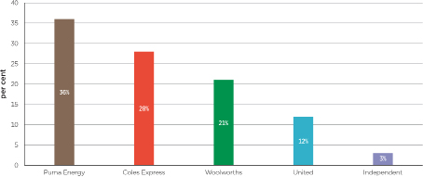
Source: ACCC calculations based on data from the companies.
This degree of concentration is relatively high. The ACCC estimates that in Adelaide in 2013–14 the four largest retailers set prices for around 80 per cent of petrol sold.
The proportion of independent retail sites in Darwin has declined since 2007—from around 27 per cent to 8 per cent (see chart 3.2).
Chart 3.2: Darwin retail petrol sites by price setter—March 2007 and May 2015
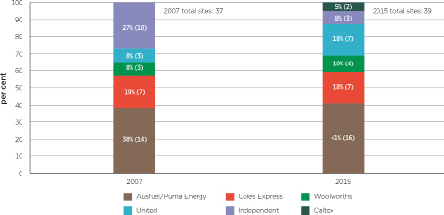
Source: ACCC calculations based on ACCC data and data from the companies.
As at May 2015 Puma Energy set retail prices at 41 per cent of retail petrol sites in Darwin. This market share gives Puma Energy the retail scale to effectively operate as a price leader in the Darwin market. Puma Energy was also the largest retailer by volume in 2013–14 with around a third of the market.

3.2 Puma Energy’s control of prices at most BP-branded retail sites is not transparent to consumers
There is a lack of transparency about the extent of price control by Puma Energy in the Darwin retail fuel market. In addition to setting prices at six Puma Energy-branded sites, Puma Energy also owns and sets the price at eight BP-branded sites, as well as one Gull and one Caltex branded site (see chart 3.3). This is not readily apparent to consumers. At other retail sites in Darwin fuel is typically sold under the respective retailer’s single banner.
Chart 3.3: Darwin retail petrol sites by brand and price setter—May 2015
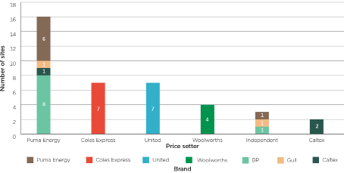
Source: ACCC calculations based on data from the companies.

3.3 Darwin supply chain is concentrated at multiple levels
The petroleum industry in Darwin operates at four key levels: importing, terminal, wholesale and retail. The current participants in the various sectors of the Darwin market are shown in chart 3.4.

Chart 3.4: Current Darwin supply chain

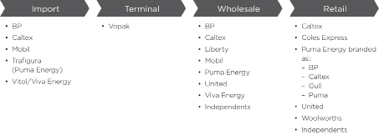
Source: ACCC based on data from the companies.

3.4 Darwin has only one import terminal
Darwin does not have a refinery. Fuel is therefore transported into Darwin, generally through the Vopak import terminal. Some fuel also comes from the Outer Harbor terminal in South Australia.
The Vopak terminal is a co-mingled facility where the fuels imported by different operators are stored in the same tanks. In 2013–14 the majority of petrol imported into the Vopak terminal came from Singapore. The remainder came from domestic refineries, such as the Kwinana refinery in Western Australia.

3.5 Puma Energy has a significant presence at the wholesale level
There are a number of wholesalers in the Darwin market. The ACCC sought information from companies about their sales at the wholesale level. There was a degree of double counting apparent, as wholesalers buy and sell from each other. However, the data indicates that Puma Energy has the largest market share and is a significant presence at the wholesale level.

3.6 Ausfuel and Puma Energy invested over time to create a viable importer-retailer

3.6.1 Ausfuel grew its wholesale, distribution and retailer network
From 1981 to 2003 Ausfuel was a local, independent fuel transport and distribution business. In 2003 Ausfuel obtained private equity backing (via AMP Capital) which enabled it to pursue growth by expanding its retailing and distribution network.
Private equity company Archer Capital became the major shareholder in Ausfuel in mid-2010. Archer Capital’s publicly stated objective was to use “Ausfuel as a vehicle for industry consolidation” with the “integration of the acquisitions creating efficiencies”. As refiner-wholesalers such as Mobil were exiting the retail market, Ausfuel took opportunities to expand its business, not only in Darwin but elsewhere, which assisted its growth. These included:
• in November 2010 Ausfuel acquired Gull Petroleum for $109 million providing Ausfuel with all of Gull’s wholesale fuel supply (including importation), access to terminal space in Western Australia, 100 Gull and Peak branded retail sites and fuel delivery
• in November 2011 Ausfuel acquired Choice Petroleum in Queensland which gave it access to another 21 retail sites and an established wholesale and distribution operation.
As a result of its acquisitions Ausfuel’s operations encompassed wholesale, distribution and retailing of fuel, becoming the largest independent fuel operator in Australia. At the time, Ausfuel was not a fuel importer. Instead it purchased wholesale supply from fuel importers and the refiner-wholesalers.

3.6.2 Global fuel company Puma Energy acquired Ausfuel in 2013
In March 2013, Puma Energy acquired Ausfuel for $625 million from Archer Capital. Puma Energy is a subsidiary of Trafigura Beheer BV, one of the world’s largest oil and mineral traders. The deal included Ausfuel’s considerable wholesale and distribution businesses in the Northern Territory and about a third of Darwin’s service stations.
The tie to Trafigura gave Ausfuel, now owned by Puma Energy, access to its own import supply. This capability and scale, combined with guaranteed downstream throughput to its retail network, gave Puma Energy the ability to circumvent the major importers into Darwin.
Puma Energy’s global reach brought major buying power to its local petrol stations. At the time, Puma Energy’s Chief Executive Pierre Eladari said, “The change in market dynamics, the closing of refineries and the growing volume of imports into Australia has opened up a great deal of opportunity for Puma Energy to invest into the Australian market.”

3.7 Other retailers have recently entered the market
Over the last 10 years United has commenced operations in the retail market in Darwin, operating at both the wholesale and retail levels. As shown in chart 3.2 United had three retail sites (8 per cent of total sites) in March 2007, which had increased to seven sites (18 per cent) by May 2015. Most of this increase was from acquiring three Mobil branded sites in June 2007. The ACCC understands that United proposes to open another site in Darwin in Parap.
In the last two years Caltex has opened two retail sites in Darwin: one at Yarrawonga in late 2013 and one at Eaton in January 2015.
In October 2014, after the Northern Territory Fuel Price Summit, the Northern Territory Government announced that it was offering prime land at the intersection of Wishart Road and Tiger Brennan Drive for a new fuel-stop offering discounted prices. It also noted that further work was underway to identify other locations that might support new fuel outlets.
After a tender process, the Northern Territory Government announced on 6 June 2015 that the Ostojic Group would develop ‘Truck Central’ as a major transport industry service centre on 16 hectares of industrial land. ‘Truck Central’ will incorporate a fuel station, 24-hour restaurant, rest/fatigue facilities and a large road train trailer parking and assembly area.
A media report in the Northern Territory News in February 2015 also noted a couple of service stations planned in Palmerston.

4 Weak retail competition in Darwin resulted in higher retail margins and profits
Competition is an important driver of petrol prices and profit margins. The high degree of transparency of petrol prices enables consumers to shop around for petrol. This can encourage some petrol retailers to ‘chase volumes’ through discounting. However, the absence of a sufficient number of retailers with a strategy to ‘chase volumes’ can result in situations where petrol prices can remain stubbornly high, even when wholesale prices are falling. Up until October 2014, this is what occurred in Darwin.

4.1 Muted responses to decreases in TGPs underpinned margin expansion in Darwin
There have been significant swings in international crude oil and refined petrol prices over the last four years, which have been reflected in TGPs. In the larger capital cities (and allowing for the price cycles that occur in those cities) retail prices tend to broadly follow movements in TGPs, both up and down.
However, in Darwin, retail prices have not been as responsive to movements in TGPs and the response in Darwin to decreases in TGPs has been muted. When TGPs were increasing, about 35 per cent of that increase was passed on in higher retail prices. When TGPs were decreasing, about 15 per cent of that decrease was passed on in lower retail prices.
Seven periods of time have been identified in the Darwin petrol market since June 2011. Each period commences at a time when TGPs started to fall. This is followed by an increase in TGPs. Table 4.1 identifies the periods and chart 4.1 shows daily median petrol prices and daily average TGPs for each period.
Table 4.1: Time periods in Darwin petrol market
Period | Dates
1 | 15 October 2011 to 11 April 2012
2 | 11 April 2012 to 17 October 2012
3 | 17 October 2012 to 21 February 2013
4 | 21 February 2013 to 8 September 2013
5 | 8 September 2013 to 5 January 2014
6 | 5 January 2014 to 5 October 2014
7 | 5 October 2014 to 1 June 2015

Chart 4.1: Daily median retail petrol prices and daily average TGPs in Darwin—1 June 2011 to 1 June 2015
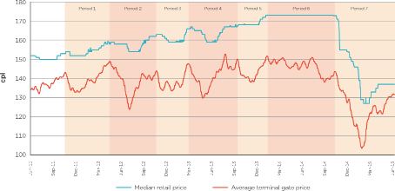
Source: ACCC calculations based on data provided by one of the companies and AIP data.
Table 4.2 separates each period into two sub-periods. The first sub-period is when TGPs were decreasing. The second sub-period is when TGPs were increasing. The change in retail prices and GIRDs are also shown in the table. The column ‘Retail/TGP’ displays the percentage of the change in TGPs in cents per litre that was passed through to retail prices.
Passing on more of the increases in TGPs than decreases led to the significant growth in GIRDs from October 2011 to October 2014. While retail prices in Darwin have been ‘sticky’ on the way up, they have been far more ‘sticky’ on the way down. This phenomenon is explained below.
The response of retail prices to movements in TGPs was muted during times when TGPs were decreasing in periods 1 to 6. For example, in period 1 TGPs decreased by 10.3 cpl between early October 2011 and late November 2011. While retail prices in Darwin also fell over the same time, they only decreased by 1.0 cpl, or 10 per cent of the decrease in TGPs. A similar pattern is evident in most of the other periods. On average around 15 per cent of the decreases in TGPs were passed through to lower retail prices in the first six periods. Period 7, after the Northern Territory Fuel Summit, is clearly different—the decrease in TGPs was more than fully passed through to retail prices.
During periods when TGPs increased, retail prices also increased and by a much greater proportion than in periods of decreasing TGPs. In period 1, for example, TGPs increased by 16.4 cpl between late November 2011 and mid-April 2012. While retail prices in Darwin also increased over the same time, they increased by 6.0 cpl, or 37 per cent. A similar pattern is evident in most of the other periods. On average around 35 per cent of the increase in TGPs was passed through in higher retail prices in the first six periods. For the last period this was around 30 per cent.
Table 4.2: Changes in retail prices and TGPs in Darwin, by time period, cents per litre
 | Period of decreasing TGP |  |  |  | Period of increasing TGP |  |  |  | Whole period
Change in: | Retail  cpl | TGP  cpl | GIRD  cpl | Retail/TGP  % | Retail  cpl | TGP  cpl | GIRD  cpl | Retail/TGP  % | Retail  cpl | TGP  cpl | GIRD  cpl
Period
1 | –1.0 | –10.3 | +9.3 | 10% | +6.0 | +16.4 | –10.4 | 37% | +5.0 | +6.1 | –1.1
2 | –4.0 | –25.3 | +21.3 | 16% | +9.0 | +20.2 | –11.2 | 45% | +5.0 | –5.1 | 10.1
3 | –4.0 | –8.6 | +4.6 | 47% | +7.0 | +12.3 | –5.3 | 57% | +3.0 | +3.7 | –0.7
4 | –3.0 | –17.9 | +14.9 | 17% | +4.5 | +20.2 | –15.7 | 22% | +1.5 | +2.3 | –0.8
5 | +0.5 | –12.1 | +12.6 | –4% | +5.0 | +13.7 | –8.7 | 36% | +5.5 | +1.6 | +3.9
6 | – | –13.5 | +13.5 | 0% | –0.2 | +5.4 | –5.6 | –4% | –0.2 | –8.1 | +7.9
7 | –43.8 | –40.0 | –3.8 | 110% | +8.0 | +28.1 | –20.1 | 28% | –35.8 | –11.9 | –23.9

Source: ACCC calculations based on data provided by one of the companies and AIP data.

4.1.1 Pricing behaviours and outcomes in Darwin changed substantially from October 2014
The reaction of retail prices in Darwin to changes in TGPs changed in October 2014.
The response of retail prices to increases in TGPs was smaller. While typically around 35 per cent of the increases in TGPs was passed through to retail prices in previous periods, this pass through was only around 30 per cent in the period since early October 2014.
This was the only period in which decreases in TGPs were fully passed through in retail prices. In each of the other periods only a fraction of the decreases in TGPs were passed through to retail prices.
As a result, GIRDs decreased by 23.9 cpl over the eight month period from early October 2014 to the end of May 2015. This is a substantial reduction in GIRDs.

4.2 No retailer regularly led prices down in Darwin
With a lack of effective competition, fuel retailers in Darwin have been able to enjoy high and increasing margins. With the exception of the period after October 2014, the competitive pressure to reduce retail prices when TGPs were decreasing has been weak in Darwin.
No one retailer has consistently led prices down. Detailed analysis of retail prices by site in Darwin has shown that there was no clear pattern with each retailer (Ausfuel and Puma Energy, Woolworths, Coles Express and United) being the first to reduce prices in some areas on some occasions.

4.3 Ausfuel and Puma Energy typically led prices up in Darwin, followed by other retailers
Detailed analysis of site-based pricing in Darwin shows that Ausfuel and Puma Energy controlled sites typically led prices up in Darwin. Ausfuel and Puma Energy controlled sites often move as a group, changing prices within a very short period of time (less than a day). Woolworths and Coles Express typically follow very soon after with United typically moving its prices up last.
For analysis purposes, Darwin was divided up into six local areas and intra-day price changes were analysed. In the example in chart 4.2, the two Ausfuel controlled sites increased prices within 10 minutes of each other on 10 August 2012, followed by Woolworths on 11 August, and Coles Express on 13 August. The two Ausfuel controlled sites then increased prices on 14 August within half an hour of each other, followed by Woolworths and the independent BP-branded site on 15 August. The two United sites had the same prices over this period.
Analysis shows that price followers are quicker to respond to price increases within local groups which have a more concentrated market structure.
Chart 4.2: Intra-day petrol price movements—by site—Nightcliff area: 9 to 17 August 2012
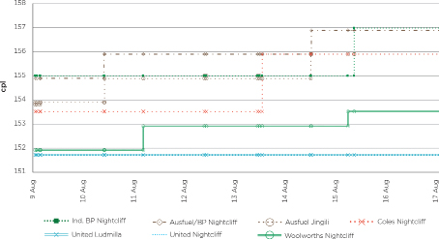
Source: ACCC calculations based on data provided by one of the companies.
Daily average prices in period 1 (i.e. 15 October 2011 to 11 April 2012) also illustrate the pattern of Ausfuel controlled sites moving prices up first, followed by Woolworths and Coles Express, with United moving last (chart 4.3).
Chart 4.3: Daily average retail petrol prices by retailer in Darwin—15 October 2011 to 11 April 2012 (period 1)
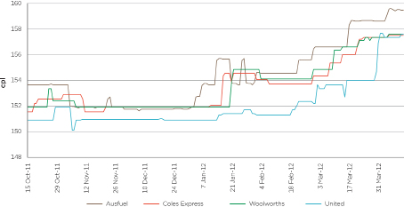
Source: ACCC calculations based on data provided by one of the companies.
It is expected that retail prices will increase during periods of rising wholesale costs. There are, however, costs to being the first retailer to move prices up. Specifically, the:
• loss of sales until other retailers follow
• possible damage to the reputation of its sites as being ‘expensive’, which in turn may adversely affect future sales.
A number of factors limited the size of these costs to Ausfuel and Puma Energy in Darwin:
• First, Ausfuel and Puma Energy had a large share of retail sites in Darwin. By moving prices up at its sites in a block, Ausfuel and Puma Energy were able to move a considerable part of the market in a short period of time. This was likely to reduce the delay until other retailers follow.
• Second, by quickly following price increases of their rivals in Darwin, Coles Express and Woolworths readily accommodated price increases by Ausfuel and Puma Energy. Again this reduced the risk to Ausfuel and Puma Energy in leading prices up.
• Third, by operating sites under a number of different brands, Ausfuel and Puma Energy could reduce the reputational damage from leading prices up.

4.4 Weak retail competition in Darwin allowed prices and margins to increase
Weak or soft competition can be self-reinforcing. So long as no major fuel retailer adopts a strategy to chase volumes through price discounting, the best strategy of other fuel retailers is likely to be the same. The behaviour of each fuel retailer ‘accommodates’ the behaviours or strategies of the other fuel retailers. While price transparency for consumers can promote competition, price transparency among fuel retailers increases the likelihood of ‘accommodating’ behaviours.
Such an outcome in Darwin is likely the result of a number of factors.
First is the dominant position of Puma Energy in Darwin fuel retailing. Puma Energy currently controls prices at over 40 per cent of sites in Darwin. Its share of the petrol sold in Darwin exceeds 35 per cent. A petrol retailer in this position gains significantly from high retail margins and has limited incentive to chase volumes by lowering its pump prices. This lack of incentive to discount is further underpinned by Puma Energy’s strong fuel card sales. As discussed in chapter 6, the ACCC understands that the Northern Territory Government has a substantial contract with Puma Energy for the supply of fuel.
Second are the behaviours of the supermarkets. In Darwin, Coles Express and Woolworths typically followed the price decreases of its local competitors. Such behaviour can, in some circumstances, drive lower prices in fuel markets. However, in the event that no other fuel retailer leads prices down, retail fuel prices can remain high. Put simply, if no fuel retailer reduces its retail fuel prices below what Coles Express and Woolworths are offering there appears to be little pressure on Coles Express and Woolworths to lower their retail fuel prices.
A significant part of the fuel offers of Coles Express and Woolworths are their shopper docket discounts. These offers enable motorists to achieve discounts on their fuel purchases so long as they make qualifying purchases from Coles or Woolworths supermarkets. These offers provide discounts to a significant number of motorists. While this is the case, Coles Express and Woolworths appear to have limited incentives to chase fuel sales by setting pump prices below their local competitors. So long as Coles Express and Woolworths price match local fuel retailers, their shopper docket offer will drive significant fuel sales.
Third, there is no clear pricing discounter in Darwin, as occurs in some other cities. Even though United’s strategy is to typically price below the market, this did not have a major effect in the Darwin market and did not appear to drive prices lower. Moreover, there are only three independent operators in Darwin with one site each: a BP-branded independent with an on-site mechanic business, a Gull-branded independent with a convenience store and cafe, and a Puma-branded independent. Even if they adopted a more aggressive pricing strategy, it seems unlikely that they would have disrupted the ‘accommodating’ behaviours of the major retailers in Darwin.
While weak competition can be persistent, such behaviours can change, especially when there is a substantial change in the environment. As noted above, the behaviours of the fuel retailers and outcomes changed in October 2014, which coincided with the Northern Territory Government’s Fuel Summit and the subsequent announcement of the ACCC’s Darwin market study. These events appear to have disrupted the ‘accommodating’ behaviours of fuel retailers in Darwin.

4.5 Ausfuel’s influence increased after Archer Capital became a major shareholder in 2010
As noted in chapter 3, Archer Capital became the major shareholder in Ausfuel in mid-2010. While the acquisition by Archer Capital did not result in any change to Ausfuel’s market share in the Darwin retail fuel market, Ausfuel became the clear leader of petrol price increases in the Darwin market. This leadership was important to the increase in the profits of petrol retailing in Darwin. Retail petrol prices in Darwin started to increase relative to the five largest cities in Australia around six months later (as shown in chart 4.4).
This is not to say that factors other than the price leadership of Ausfuel and Puma Energy did not play a role in increasing petrol margins in Darwin. The ACCC has observed increases in retail petrol margins and profits in other towns, such as Katherine, where Ausfuel and Puma Energy is not a petrol retailer. Nevertheless, Ausfuel and Puma Energy’s significant position in the Darwin retail market, combined with its price leadership, contributed to the increase in margins in Darwin.
Chart 4.4: Monthly average retail price differential between Darwin and the five largest cities—July 2007 to September 2015
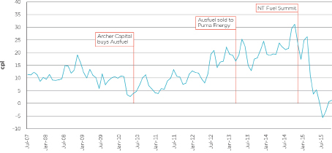
Source: ACCC calculations based on FUELtrac and Informed Sources data.

5 New entry into petrol retailing has the potential to resolve the competition problem in Darwin
In 2013–14 four petrol retailers accounted for 97 per cent of petrol sales in Darwin. This concentrated structure, combined with the lack of retailers with a discounting strategy to win market share, enabled petrol retailers in Darwin to achieve high margins and profits.
The high margins and profits have since dissipated. Since May 2015 GIRDs in Darwin have fallen to levels below those in the five largest cities. There seems little doubt that the recent public focus on fuel retailers resulting from the Northern Territory Fuel Summit and the announcement of the ACCC’s Darwin market study has, at least temporarily, altered the competitive dynamics in petrol retailing in Darwin.
A key question is whether high margins will return once the public focus on fuel retailers in Darwin wears off. Unless the structure of fuel retailing in Darwin changes, or one or more of the fuel retailers alters their pricing strategy (and seek to win market share by discounting), a return to weak competition and high margins is possible.
As noted in chapter 2, profits in fuel retailing increased substantially between 2011 and 2014. Sustained high profits, combined with an expectation they will persist, can encourage new entry. While some recent entry has occurred, it is not clear this will substantially increase competitive rivalry in petrol retailing in Darwin. There are significant barriers to entry into fuel retailing in Darwin, not least being the access to well-located sites suitable for petrol retailing. This in itself may limit the scope for new entry to prevent the weak competition observed in Darwin between 2011 and 2014 reoccurring.

5.1 There has been recent entry into Darwin retailing
Since 2013 Caltex has opened two retail sites in Darwin (Yarrawonga in late 2013 and Eaton in 2015). Caltex Eaton is a large well-located site with a substantial convenience store.
Prior to 2013 Caltex was not a retailer in Darwin. Caltex has however been a major wholesaler in Darwin for some time. This likely provided Caltex with a number of advantages when entering petrol retailing, including knowledge of the Darwin fuel sector and the ability to supply its own sites.
It will take some time for the effect of Caltex’s entry on competition in fuel retailing to be evident. However, for various reasons, since Caltex opened its second site competition among fuel retailers has been stronger. It is not possible however to attribute the recent change in the competitive dynamics in Darwin fuel retailing to the entry of Caltex. As noted above, the recent public focus on fuel retailers no doubt played a significant role in the recent fall in retail petrol margins in Darwin.
Some of the existing retailers are also keen to expand. For example, United is proposing to develop a new site on the Stuart Highway in the suburb of Parap.
Sites are expensive to develop and can be very costly to remediate. As a result, an investment in a new petrol retail site is risky and involves an assessment of the likely performance of the site over an extended period.

5.2 Retailers wishing to enter the Darwin petrol market must overcome some substantial hurdles
A retailer wishing to enter petrol retailing faces three substantial hurdles:
• access to fuel on competitive terms
• access to suitable sites
• the risk associated with the long-term nature of investments in petrol.

5.2.1 A new fuel retailer may have difficulty in acquiring fuel on competitive terms
Securing fuel supply on competitive terms is essential for any new retailer that has the intention of competing on price.
Small independent retailers without wholesale or upstream operations often have little leverage in obtaining fuel volume discounts at the wholesale level. Wholesalers in Darwin often supply an existing retail network of their own, or other retailers under a long-term agreement. To compete effectively, a potential entrant will need to secure supply on similar terms. National retailers and large chains can obtain volume-based prices or other discounts which mean their wholesale petrol costs are below the TGP. Unless a potential entrant has a substantial network of sites or has a credible threat of bypassing existing wholesalers it may find it difficult to acquire fuel on competitive terms.
A new fuel retailer will likely need scale to acquire fuel on competitive terms
There are five major wholesalers of fuel in Darwin. Each of these wholesalers has the capability of importing fuel into Darwin, including having storage contracts with Vopak. This provides a new retailer with a number of options to acquire fuel.
While this is the case, three of the major wholesalers also retail fuel in Darwin. To the extent these wholesalers see a new entrant as a competitive threat in petrol retailing, they may be reluctant to offer the entrant wholesale supply on competitive terms. While this is the case, it must be recognised that an entrant could seek to acquire fuel from Viva Energy or BP who do not have retail profits to ‘protect’.
A new fuel retailer who does not have a credible threat to supply its own retail sites may find it difficult to acquire fuel on competitive terms
A new entrant that has a credible threat to bypass current wholesalers is in the strongest position to establish a retail operation in Darwin. As noted above, the most recent entrant into fuel retailing—Caltex—has been a major wholesaler in Darwin for some time and is able to self-supply its sites.
A retailer without an existing presence in the Darwin supply chain is unlikely to be able to credibly threaten to bypass the major wholesalers, at least not until it builds substantial scale.
Importing and wholesaling fuel is a scale business. To have a credible threat of importing, a potential entrant will need the scale to make shipping its own supply worthwhile and to minimise the need to hold substantial inventories. Moreover, Vopak’s fee structure requires some scale. There are two components to the fees charged by Vopak. One is a throughput fee based on the volume of fuel which goes through the facility. The other is a fixed access fee, or capital recovery fee, which is divided and paid in equal shares by all users. This fee must be paid even if the customer does not put any volume through the facility. Therefore, proportionally, the access fee for a smaller user represents a higher fixed cost to be covered from each litre of fuel they sell.

5.2.2 Access to well-located sites suitable for petrol retailing is likely to be difficult
There are two ways in which an entrant could acquire well located sites that are suitable for petrol retailing. One is by acquiring sites from an existing retailer. The other is by developing greenfield sites.
Opportunities to establish a substantial retail presence in Darwin by purchasing sites from the incumbent retailers are likely to be limited. It is also likely to be difficult for a new retailer to establish a significant presence by developing greenfield sites. At the very least it will take many years. Developing greenfield sites is difficult for a number of reasons.
• Many well-located sites are unlikely to be suitable for fuel retailing. New sites in residential areas may cause community concern and be unsuitable for petrol retailing.
• Establishing new sites takes time (including the necessary regulatory and planning approvals) and is costly.
• Well-located sites that are suitable for petrol retailing are likely to attract the interest of existing retailers in Darwin. A bidding war for suitable sites may undermine the profitability of entry.
It is also relevant that, of all of the capital cities, Darwin has the highest number of retail sites relative to its population.

5.2.3 Investments in fuel retailing are substantial and risky
Establishing a fuel retailing business of a scale sufficient to have a significant impact on the Darwin retail market is likely to be costly and take time. Such investments are likely to involve substantial risks which ultimately make entry less attractive. A number of factors contribute to these risks.
Investments in fuel retailing are long-lived and cannot be reversed
Investment in a greenfield fuel retailing site involves a long time horizon. There can be considerable time between deciding to make the investment and generating revenues. Moreover, a significant proportion of the investment cannot be reversed. It can be very costly to remediate a site once it is operational.
New entrants will expect a competitive response from existing retailers
The Darwin retail fuel market is best described as not growing or growing slowly. Further, the number of petrol sites operating in Darwin has been stable over recent years. As a result, a new entrant’s growth would most likely come from taking sales from existing fuel retailers. This is likely to cause a competitive response.
The incentive of fuel retailers in Darwin to respond to new retailers is increased by their substantial market positions. Existing retailers have large investments to protect and deep reserves to do so. A new entrant in Darwin will compete with Coles Express and Woolworths who attract a significant portion of fuel sales though their shopper docket offers. These discounts are likely to be difficult for a new entrant to match.
The return on an investment in a new petrol retailing business will depend on profit margins and sales over the life of the investment. While a prospective investment may be commercial based on the profit margins achieved by petrol retailers in the recent past, these margins may not prevail post entry. The sharp decreases in margins since October 2014 are a case in point. The small changes in rivalry in retail fuel markets can substantially affect profitability. Uncertainty about future profitability may be an impediment to new entry in fuel retailing in Darwin.

5.3 Further entry has the potential to substantially increase competitive rivalry among fuel retailers
As noted above, it is too early to assess the likely effect of the recent entry of Caltex. The effect of new entry on competition will crucially depend on the ability of the entrant to adopt a discounting strategy to win market share, and its willingness to do so.
The ACCC notes the proposal by the Northern Territory Government to offer prime land for a retail petrol site to a retailer willing to offer discount prices. Such an offer provides a new entrant with the opportunity to overcome some of the more significant barriers to entry, and provides the scope for the retailer to be an effective competitor. This proposal is discussed further in chapter 6.

6 The key steps to take are increased transparency and promotion of competition

6.1 Recent price decreases show the way forward
From October 2014 there has been a significant decrease in Darwin retail petrol prices in both absolute terms and relative to the five largest cities. In June 2015:
• the monthly average petrol price in Darwin was 134.9 cpl, which was 5.7 cpl lower than in the five largest cities (140.6 cpl)
– this was the first time that the monthly average Darwin price was lower than in the five largest cities since the ACCC started to regularly collect Darwin prices in January 2000
• the monthly average GIRD in Darwin was 1.6 cpl, significantly below the annual average GIRD in 2014–15 of 20.3 cpl.
This decrease, and its size relative to the five largest cities, appears to have been significantly influenced by the increased scrutiny of Darwin prices by the Northern Territory Government (including through the Northern Territory Fuel Summit), the ACCC and the wider community.
The reduction in GIRDs may also have been influenced by:
• the new discount arrangement between the Automobile Association of the Northern Territory (AANT) and United
• the actual new and potential entrants into the market: a new Caltex site entered the market in January 2015 and the Northern Territory Government tendered for a greenfield site.
Apart from the members of the Organisation of Petroleum Exporting Countries, most governments have little or no influence on the international price of refined petrol. However, governments can introduce measures that may have some influence on other factors. This section outlines some actions that may be introduced to maintain the downward pressure on prices.

6.2 Increase transparency of GIRDs and retail prices
Firms may have less incentive to increase and maintain high prices if there is close scrutiny of their pricing behaviour. Ongoing monitoring and publication of margins and profits can shine a light on what is happening in the market. This may dissuade some uncompetitive market behaviour. It may also provide information—such as retail profits in Darwin are high by national standards—that may encourage new entrants into the market.

6.2.1 Regular publication of GIRDs and benchmarking against other locations
GIRDs are a broad indicator of profitability and can be compared across locations and over time. When GIRDs in one location are significantly higher than in other locations it may indicate a lack of competition.
The Northern Territory Government may wish to consider closely monitoring GIRDs in the Darwin market, relative to other locations, and publish information on GIRDs for consumers and industry participants. This could include information such as:
• chart 6.1 which shows annual average GIRDs in Darwin and the five largest capital cities since 2004–05
• chart 6.2 which shows the annual average difference between the two.
Chart 6.1: Annual average gross indicative retail differences in Darwin and the five largest cities: 2004–05 to 2014–15
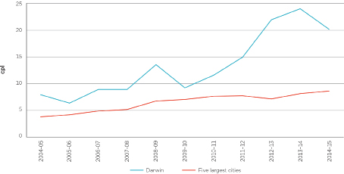
Source: ACCC calculations based on FUELtrac, Informed Sources, AIP, BP, Caltex, Mobil, Viva Energy and WA Fuelwatch data.
Chart 6.2: Difference between annual average gross indicative retail differences in Darwin and the five largest cities: 2004–05 to 2014–15
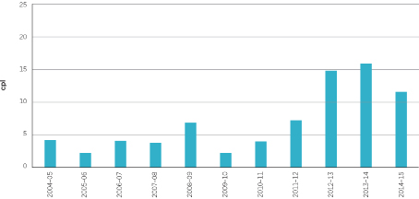
Source: ACCC calculations based on FUELtrac, Informed Sources, AIP, BP, Caltex, Mobil, Viva Energy and WA Fuelwatch data.
By making this information widely available, the Northern Territory Government and consumers can make companies accountable when GIRDs become significantly higher than usual.
GIRDs in Darwin have historically been higher than those in the five largest cities. Prior to the recent increase in GIRDs in Darwin from 2012–13 onwards, annual average GIRDs in Darwin were between 2–7 cpl higher than the GIRDs across the five largest cities.

6.2.2 Providing current retail prices to motorists
Price-sensitive motorists will often shop around for the cheapest prices. To assist them there are websites which provide the retail prices for many retail sites to consumers in Darwin. For example, the AANT website currently provides information on petrol prices at around 30 sites in Darwin.
There may be benefits for media outlets and motoring bodies such as the AANT to more actively disseminate retail pricing information to consumers to reward retailers who engage in the pricing behaviour that consumers value.

6.3 Monitor market concentration

6.3.1 Greater transparency of brand ownership and control
The brand of a retail petrol site is not necessarily an indicator of who owns and/or sets prices at the site. For example, in the Darwin retail market there are sites selling fuel under the Puma, BP, Gull, and Caltex brands which have their retail prices determined by Puma Energy. As a result, the extent of concentration of ownership in the market is not clear.
Furthermore, motorists can be unclear about the ownership of the retail site they are buying from, and may have chosen to purchase elsewhere had they known this information.
Regular collection and reporting of information by the Northern Territory Government relating to ownership of retail sites and the entity setting prices at those sites would make these relationships clearer to regulators and motorists. Chart 3.2 shows the makeup of the Darwin market by brand and price setter as at May 2015.

6.3.2 ACCC to continue to closely monitor future merger activity in the Darwin market
Since 2007 there have been changes in the ownership and operation of retail petrol sites in Darwin.
This has resulted in changes in the level of concentration as a result of:
• a reduction in the number of independent retailers either through closure or acquisition by existing retailers
• investment in new sites by major retailers (such as Caltex).
As noted in chapter 4, the acquisition of Ausfuel by Archer Capital in May 2010 was the turning point at which Ausfuel began taking a greater leadership role in petrol price increases in Darwin. This leadership played an important role in increasing petrol profits in Darwin. While the acquisition by Archer Capital resulted in a change of ownership of Ausfuel, it however had no impact on market concentration as Archer Capital did not have a presence in the Darwin retail fuel market prior to the acquisition. This represented a bare transfer of market share from Ausfuel to Archer Capital.
Similarly, the purchase of Ausfuel by Puma Energy in March 2013 had no direct impact on market concentration in petrol retailing given that Puma Energy had no retailing interests in Darwin prior to the acquisition. The acquisition did, however, enable Puma Energy to become an importer-retailer by supplying its own imported fuel to its newly acquired retail sites.
Well before the price spikes that occurred in Darwin between 2011 and 2014, it is significant to note that in March 2007 Ausfuel was the largest retail supplier with 14 (38 per cent) retail petrol sites in Darwin. Since that time, Ausfuel and then Puma Energy’s share of retail petrol sites in Darwin has increased to 16 sites (41 per cent). The ACCC has been notified by Ausfuel and Puma Energy of acquisitions that it has proposed to undertake in the Northern Territory and in other regions/states and the ACCC has conducted assessments of each of these. Of the acquisitions in Darwin, the ACCC decided not to oppose any of these on the basis that the individual acquisitions were unlikely to result in a substantial lessening of competition in petrol retailing in Darwin. The ACCC is not able to assess the cumulative impact of a series of acquisitions under section 50 of the Competition and Consumer Act 2010.
The ACCC will continue to closely monitor and assess future acquisitions in Darwin and assess whether any acquisitions are likely to substantially lessen competition. This includes acquisitions of existing sites/leases and potential sites/leases.
As noted in chapter 5, well located sites are necessary for entry to occur in petrol retailing in Darwin. It is likely there will be continuing churn in petrol retailing in Darwin, with poorly located sites closing and new, better located sites opening.

6.4 Promote effective competition

6.4.1 Promote effective entrants into the market
The Darwin petrol market is relatively concentrated, and the introduction of new players into the market may lead to increased competition.
The ACCC notes that two Caltex sites have commenced operations in Darwin over the last two years.
The ACCC is also aware of the Northern Territory Government proposal to offer prime land adjacent to the Tiger Brennan Drive and Wishart Road intersection for a new fuel-stop offering discounted prices. It was noted that:
…one of the key criteria for selecting a successful developer will be what commitments they can make to being a price leader on fuel.
While the ACCC would generally have some concerns about such government involvement in the market, it may be appropriate in some circumstances, if it is likely to lead to more effective competition.
As noted in chapter 5, this offer will provide a new entrant with the opportunity to overcome some of the more significant barriers to entry into fuel retailing and provides the scope for the new retailer to be an effective competitor.

6.4.2 Change Northern Territory Government fuel supply arrangements
The Northern Territory Government has a substantial contract with Puma Energy for the supply of fuel. This arrangement commenced in 2012 with Ausfuel and runs for five years.
The fact that the Northern Territory Government has a fuel arrangement with the largest player in the petrol market may be a contributing factor to the consolidation in the retail market. A media report in May 2015 reported the Northern Territory Corporate and Information Systems Minister commenting that government staff and fleet managers are encouraged to fill up at one of the 24 Puma-owned stations which are locked into a 6 cpl government discount.
In this context it is noted that the May 2005 inquiry into fuel prices in the Northern Territory found that the Northern Territory Government had recently entered into a three-year mandatory common use fuel card contract with BP Australia for the supply of fuel for government vehicles. It recommended:
That the Northern Territory Government consider moving away from the single tied system currently in place for government Fuel Cards and instead introduce a system that encourages government employees to shop around for the best price, thereby promoting competition in the Territory retail market.
When the current contract expires in 2017 the Northern Territory Government may wish to consider the implications on the fuel market of government fuel card arrangements.

Appendix A: Background and process
Background to the new petrol monitoring arrangements
On 9 December 2014 the then Minister for Small Business, the Hon. Bruce Billson MP, gave the ACCC a new direction to monitor the prices, costs and profits of unleaded petroleum products in Australia for a period of three years.
Instead of providing an annual report to the Minister, as occurred under the previous direction, the ACCC is to provide reports at least quarterly. The new arrangements enable the ACCC to undertake more timely and targeted monitoring and analysis of particular topics and fuel markets that are of concern to consumers.
Under these arrangements the ACCC will produce two types of reports:
• quarterly ‘macro’ reports on petrol price movements and the overall drivers of Australian fuel prices
– three of these reports—in February, May and August 2015—have already been released
• market studies that look at ‘micro’ issues in considerable depth. These will include an analysis of the price drivers of petrol in three regional markets.
Regional market studies and what they aim to achieve
The aims of the regional market studies are to:
• get to the bottom of why prices are higher in certain regional locations
• identify and explain each component of the prices paid at the bowser
• explain where money is being made in the petrol price value chain.
These studies rely on compulsory information gathering powers under Section 95ZK of the Competition and Consumer Act 2010.
While only three regional market studies are likely to be conducted in each year, each of these studies will have wider implications. The ACCC will be able to draw lessons of wider relevance to other regional markets.
Choice of Darwin
The ACCC undertook extensive assessment of relevant data to select the possible regional locations.
The ACCC collects retail petrol prices for around 190 regional locations across Australia. Two types of analyses were undertaken on this data:
• a regression analysis, which estimated prices for each regional location and then compared these with the actual prices in each location
• a ranking analysis, which ranked the regional locations against a number of criteria.
The criteria used in the ranking analysis included:
• the difference in price in each location compared with the average price in the five largest cities (i.e. Sydney, Melbourne, Brisbane, Adelaide and Perth)
• the gross indicative retail difference (GIRD) in each location
• the GIRD in each location relative to population size
• the GIRD in each location relative to nearby locations
• the variance of prices in each location.
The regression and ranking analyses were each undertaken for two time periods—one year (2013–14) and three years (2011–12 to 2013–14).
The results of the four analyses were compiled and assessed. On the basis that Darwin ranked very high overall, it was chosen as the location for the first regional market study.
The ACCC announced Darwin as the location of the first regional market study on 10 March 2015.
How the study was conducted
Data collection and analysis
The ACCC issued Section 95ZK notices to Ausfuel, BP, Caltex, Coles Express, Mobil, IOR, Liberty, Puma Energy, United, Viva Energy and Woolworths in March 2015 and April 2015 to obtain information and documents relating to the supply of petroleum products in Darwin.
This included financial and operational information about each company. The information obtained was analysed and assessed.
Consultation
The ACCC established a consultation hub on the ACCC website for any stakeholder or interested party to provide information to the market study.
In March and September 2015 ACCC staff visited Darwin to have meetings with stakeholders and to visit retail site operators.

Appendix B: Petrol prices, TGPs and GIRDs in Darwin
This appendix provides historical data on petrol prices, TGPs and GIRDs in Darwin, the five largest cities (i.e. Sydney, Melbourne, Brisbane Adelaide and Perth), Adelaide and Katherine.
Annual average retail petrol prices: 2000–01 to 2014–15
Table B1: Retail petrol prices in Darwin and selected locations—2000–01 to 2014–15—cents per litre
Year | Darwin | Five largest cities | Diff | Adelaide | Diff | Katherine | Diff
2000–01 | 101.2 | 91.0 | 10.2 | 92.8 | 8.4 | – | –
2001–02 | 92.6 | 83.4 | 9.2 | 85.5 | 7.1 | – | –
2002–03 | 97.5 | 88.5 | 9.0 | 90.4 | 7.1 | 100.1 | –2.6
2003–04 | 99.6 | 90.3 | 9.3 | 93.0 | 6.6 | 99.9 | –0.3
2004–05 | 110.1 | 100.6 | 9.5 | 103.3 | 6.8 | 109.3 | 0.8
2005–06 | 129.2 | 121.1 | 8.1 | 123.7 | 5.5 | 128.0 | 1.2
2006–07 | 132.3 | 121.6 | 10.7 | 122.4 | 9.9 | 131.4 | 0.9
2007–08 | 144.6 | 134.5 | 10.1 | 135.6 | 9.0 | 145.2 | –0.6
2008–09 | 139.8 | 127.1 | 12.7 | 128.7 | 11.1 | 141.7 | –1.9
2009–10 | 132.0 | 124.2 | 7.8 | 123.6 | 8.4 | 134.4 | –2.4
2010–11 | 139.3 | 131.7 | 7.6 | 130.0 | 9.3 | 137.2 | 2.1
2011–12 | 153.8 | 142.8 | 11.0 | 142.1 | 11.7 | 148.8 | 5.0
2012–13 | 160.1 | 141.3 | 18.8 | 140.1 | 20.0 | 155.2 | 4.9
2013–14 | 170.4 | 150.6 | 19.8 | 149.7 | 20.7 | 164.2 | 6.2
2014–15 | 149.8 | 134.1 | 15.7 | 132.4 | 17.4 | 148.2 | 1.6

Chart B1: Annual average retail petrol prices in Darwin and the five largest cities—2000–01 to 2014–15
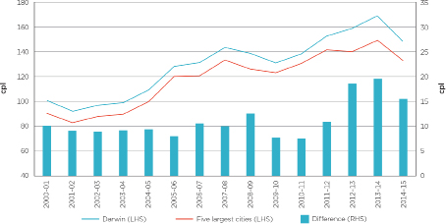
Chart B2: Annual average retail petrol prices in Darwin and Adelaide—2000–01 to 2014–15
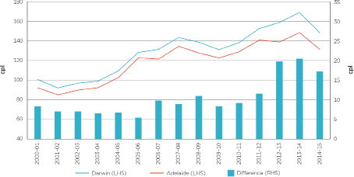
Chart B3: Annual average retail petrol prices in Darwin and Katherine—2000–01 to 2014–15
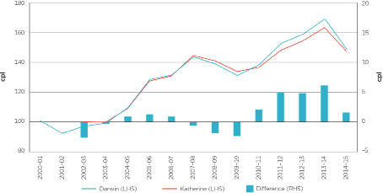
Annual average petrol TGPs: 2004–05 to 2014–15
Table B2: Annual average petrol TGPs—2004–05 to 2014–15—cents per litre
Year | Darwin | Five largest cities | Diff | Adelaide | Diff
2004–05 | 102.2 | 96.9 | 5.3 | 99.6 | 2.6
2005–06 | 122.9 | 117.0 | 5.9 | 119.7 | 3.2
2006–07 | 123.4 | 116.8 | 6.6 | 119.1 | 4.3
2007–08 | 135.7 | 129.4 | 6.3 | 131.4 | 4.3
2008–09 | 126.2 | 120.4 | 5.8 | 122.6 | 3.6
2009–10 | 122.8 | 117.2 | 5.6 | 117.4 | 5.4
2010–11 | 127.7 | 124.1 | 3.6 | 124.1 | 3.6
2011–12 | 138.8 | 135.1 | 3.7 | 135.1 | 3.7
2012–13 | 138.0 | 134.2 | 3.8 | 134.3 | 3.7
2013–14 | 146.2 | 142.5 | 3.7 | 142.6 | 3.6
2014–15 | 129.5 | 125.5 | 4.0 | 125.7 | 3.8
Chart B4: Annual average petrol TGPs in Darwin and the five largest cities—2004–05 to 2014–15
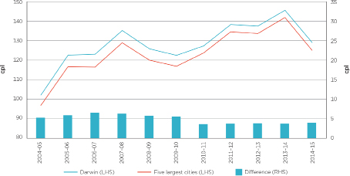
Chart B5: Annual average petrol TGPs in Darwin and Adelaide—2004–05 to 2014–15
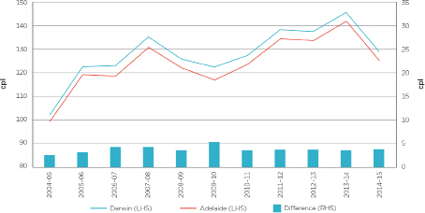
Petrol Gross Indicative Retail Differences: 2004–05 to 2014–15
Table B3: Annual average retail petrol prices, TGPs and GIRDs—2004–05 to 2014–15—cents per litre
Financial year | Retail | TGPs | GIRDs | GIRDs difference
Darwin
2004–05 | 110.1 | 102.2 | 7.9 | –
2005–06 | 129.2 | 122.9 | 6.3 | –
2006–07 | 132.3 | 123.4 | 8.9 | –
2007–08 | 144.6 | 135.7 | 8.9 | –
2008–09 | 139.8 | 126.2 | 13.6 | –
2009–10 | 132.0 | 122.8 | 9.2 | –
2010–11 | 139.3 | 127.7 | 11.6 | –
2011–12 | 153.8 | 138.8 | 15.0 | –
2012–13 | 160.1 | 138.0 | 22.1 | –
2013–14 | 170.4 | 146.2 | 24.2 | –
2014–15 | 149.8 | 129.5 | 20.3 | –
Five largest cities
2004–05 | 100.6 | 96.9 | 3.7 | 4.2
2005–06 | 121.1 | 117.0 | 4.1 | 2.2
2006–07 | 121.6 | 116.8 | 4.8 | 4.1
2007–08 | 134.5 | 129.4 | 5.1 | 3.8
2008–09 | 127.1 | 120.4 | 6.7 | 6.9
2009–10 | 124.2 | 117.2 | 7.0 | 2.2
2010–11 | 131.7 | 124.1 | 7.6 | 4.0
2011–12 | 142.8 | 135.1 | 7.7 | 7.3
2012–13 | 141.3 | 134.2 | 7.1 | 15.0
2013–14 | 150.6 | 142.5 | 8.1 | 16.1
2014–15 | 134.1 | 125.5 | 8.6 | 11.7
Adelaide
2004–05 | 103.3 | 99.6 | 3.7 | 4.2
2005–06 | 123.7 | 119.7 | 4.0 | 2.3
2006–07 | 122.4 | 119.1 | 3.3 | 5.6
2007–08 | 135.6 | 131.4 | 4.2 | 4.7
2008–09 | 128.7 | 122.6 | 6.1 | 7.5
2009–10 | 123.6 | 117.4 | 6.2 | 3.0
2010–11 | 130.0 | 124.1 | 5.9 | 5.7
2011–12 | 142.1 | 135.1 | 7.0 | 8.0
2012–13 | 140.1 | 134.3 | 5.8 | 16.3
2013–14 | 149.7 | 142.6 | 7.1 | 17.1
2014–15 | 132.4 | 125.7 | 6.7 | 13.6

Chart B6: Annual average petrol GIRDs in Darwin and the five largest cities—2004–05 to 2014–15
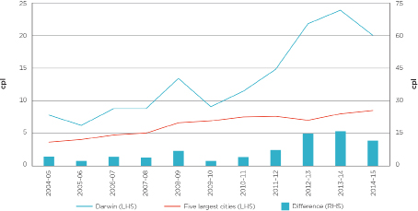
Chart B7: Annual average petrol GIRDs in Darwin and Adelaide—2004–05 to 2014–15
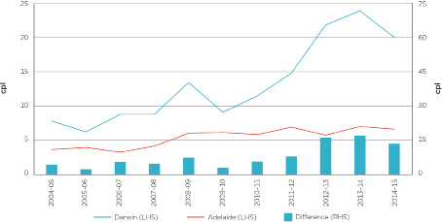

Appendix C: Diesel prices, TGPs and GIRDs in Darwin
This appendix provides historical data on diesel prices, TGPs and GIRDs in Darwin, the five largest cities, Adelaide and Katherine.
Annual average diesel retail prices: 2004–05 to 2014–15
Table C1: Retail diesel prices in Darwin and selected locations—2004–05 to 2014–15—cents per litre
Year | Darwin | Five largest cities | Diff | Adelaide | Diff | Katherine | Diff
2004–05 | 114.0 | 108.9 | 5.1 | 110.9 | 3.1 | 114.5 | -0.5
2005–06 | 134.0 | 130.3 | 3.7 | 132.4 | 1.6 | 134.3 | -0.3
2006–07 | 133.7 | 127.6 | 6.1 | 129.8 | 3.9 | 133.6 | 0.1
2007–08 | 151.4 | 147.2 | 4.2 | 149.7 | 1.7 | 153.1 | -1.7
2008–09 | 151.6 | 139.0 | 12.6 | 140.1 | 11.5 | 157.5 | -5.9
2009–10 | 132.1 | 124.5 | 7.6 | 123.8 | 8.3 | 131.9 | 0.2
2010–11 | 143.8 | 136.3 | 7.5 | 135.8 | 8.0 | 143.5 | 0.3
2011–12 | 156.6 | 147.9 | 8.7 | 148.2 | 8.4 | 156.2 | 0.4
2012–13 | 161.1 | 147.4 | 13.7 | 147.5 | 13.6 | 157.9 | 3.2
2013–14 | 172.0 | 157.8 | 14.2 | 158.0 | 14.0 | 168.1 | 3.9
2014–15 | 152.6 | 140.4 | 12.2 | 138.6 | 14.0 | 151.4 | 1.2

Chart C1: Annual average retail diesel prices in Darwin and the five largest cities—2004–05 to 2014–15
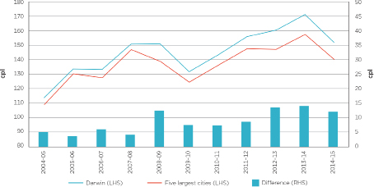
Chart C2: Annual average retail diesel petrol prices in Darwin and Adelaide—2004–05 to 2014–15
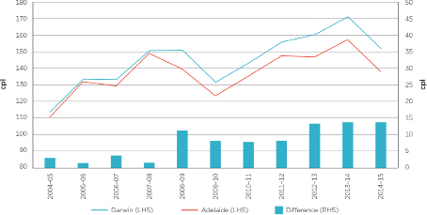
Chart C3: Annual average retail diesel prices in Darwin and Katherine—2004–05 to 2014–15
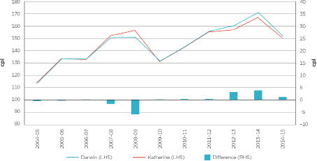
Annual average diesel TGPs: 2004–05 to 2014–15
Table C2: Annual average diesel TGPs—2004–05 to 2014–15—cents per litre
Year | Darwin | Five largest cities | Diff | Adelaide | Diff
2004–05 | 108.9 | 103.4 | 5.5 | 105.7 | 3.2
2005–06 | 129.5 | 124.0 | 5.5 | 127.3 | 2.2
2006–07 | 125.6 | 119.7 | 5.9 | 122.4 | 3.2
2007–08 | 145.0 | 139.4 | 5.6 | 141.5 | 3.5
2008–09 | 134.8 | 129.4 | 5.4 | 131.4 | 3.4
2009–10 | 120.5 | 116.2 | 4.3 | 116.3 | 4.2
2010–11 | 130.9 | 127.4 | 3.5 | 127.5 | 3.4
2011–12 | 141.6 | 138.0 | 3.6 | 138.2 | 3.4
2012–13 | 140.5 | 136.9 | 3.6 | 137.2 | 3.3
2013–14 | 150.0 | 146.3 | 3.7 | 146.7 | 3.3
2014–15 | 130.0 | 126.7 | 3.3 | 126.8 | 3.2

Chart C4: Annual average diesel TGPs in Darwin and the five largest cities—2004–05 to 2014–15
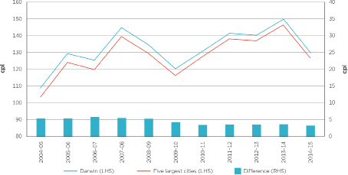
Chart C5: Annual average diesel TGPs in Darwin and Adelaide—2004–05 to 2014–15
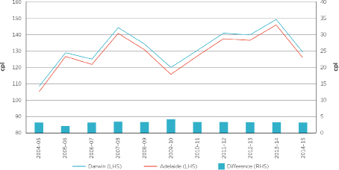
Diesel Gross Indicative Retail Differences: 2004–05 to 2014–15
Table C3: Annual average retail diesel prices, TGPs and GIRDs—2004–05 to 2014–15—cents per litre
Financial year | Retail | TGPs | GIRDs | GIRDs difference
Darwin
2004–05 | 114.0 | 108.9 | 5.1 | –
2005–06 | 134.0 | 129.5 | 4.5 | –
2006–07 | 133.7 | 125.6 | 8.1 | –
2007–08 | 151.4 | 145.0 | 6.4 | –
2008–09 | 151.6 | 134.8 | 16.8 | –
2009–10 | 132.1 | 120.5 | 11.6 | –
2010–11 | 143.8 | 130.9 | 12.9 | –
2011–12 | 156.6 | 141.6 | 15.0 | –
2012–13 | 161.1 | 140.5 | 20.6 | –
2013–14 | 172.0 | 150.0 | 22.0 | –
2014–15 | 152.6 | 130.0 | 22.6 | –
Five largest cities
2004–05 | 108.9 | 103.4 | 5.5 | –0.4
2005–06 | 130.3 | 124.0 | 6.3 | –1.8
2006–07 | 127.6 | 119.7 | 7.9 | 0.2
2007–08 | 147.2 | 139.4 | 7.8 | –1.4
2008–09 | 139.0 | 129.4 | 9.6 | 7.2
2009–10 | 124.5 | 116.2 | 8.3 | 3.3
2010–11 | 136.3 | 127.4 | 8.9 | 4.0
2011–12 | 147.9 | 138.0 | 9.9 | 5.1
2012–13 | 147.4 | 136.9 | 10.5 | 10.1
2013–14 | 157.8 | 146.3 | 11.5 | 10.5
2014–15 | 140.4 | 126.7 | 13.7 | 8.9
Adelaide
2004–05 | 110.9 | 105.7 | 5.2 | –0.1
2005–06 | 132.4 | 127.3 | 5.1 | –0.6
2006–07 | 129.8 | 122.4 | 7.4 | 0.7
2007–08 | 149.7 | 141.5 | 8.2 | –1.8
2008–09 | 140.1 | 131.4 | 8.7 | 8.1
2009–10 | 123.8 | 116.3 | 7.5 | 4.1
2010–11 | 135.8 | 127.5 | 8.3 | 4.6
2011–12 | 148.2 | 138.2 | 10.0 | 5.0
2012–13 | 147.5 | 137.2 | 10.3 | 10.3
2013–14 | 158.0 | 146.7 | 11.3 | 10.7
2014–15 | 138.6 | 126.8 | 11.8 | 10.8

Chart C6: Annual average diesel GIRDs in Darwin and the five largest cities—2004–05 to 2014–15
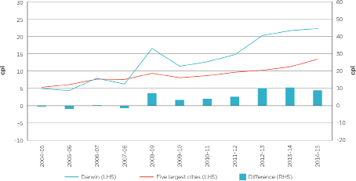
Chart C7: Annual average diesel GIRDs in Darwin and Adelaide—2004–05 to 2014–15
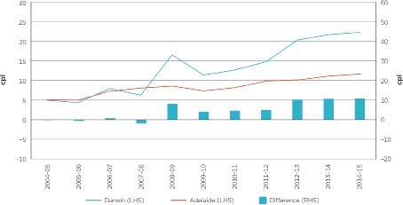

Appendix D: Petrol prices in all monitored locations in the Northern Territory
In the Northern Territory the ACCC monitors fuel prices in Darwin and three regional locations: Alice Springs, Katherine and Tennant Creek.
This appendix compares movements in annual average retail petrol prices and GIRDs in these regional locations with those in Darwin in the period 2004–05 to 2014–15.
Of these locations:
• Alice Springs is around 1500 kilometres south of Darwin and around 1500 kilometres north of Adelaide, with a population of around 24 000 people. It has 12 retail sites.
• Tennant Creek is around 1000 kilometres south of Darwin and 500 kilometres north of Alice Springs, with a population of around 3000 people. It has five retail sites.
• Katherine is around 300 kilometres south of Darwin with a population of around 6000 people. It has six retail sites.
In contrast, Darwin has a population of around 103 000 people and around 39 retail sites.
ACCC petrol monitoring has found that retail petrol prices in regional locations in Australia are typically higher than those in the capital cities, although they generally tend to follow the same overall price movements. Prices in regional locations are generally higher for a number of reasons, including:
• a lower level of local competition, often reflecting the lower number of retail sites
• lower volumes of fuel sold
• distance/location factors
• lower convenience store sales.
These factors also explain differences in petrol prices between regional locations.
Retail petrol prices
Chart D1: Annual average retail petrol prices in Darwin and Northern Territory regional locations:
2004–05 to 2014–15
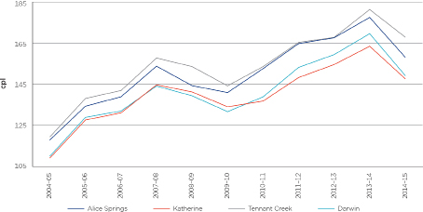
Between 2004–05 and 2014–15 (see chart D1):
• movements in annual average retail petrol prices in Alice Springs, Katherine and Tennant Creek broadly followed movements in retail prices in Darwin
– between 2009–10 and 2013–14 retail prices increased in all locations, ranging from an increase of 30 cpl in Katherine to 38 cpl in Darwin
– annual average prices in Katherine varied from being 6 cpl below Darwin prices in 2013–14 to 2 cpl above Darwin prices in 2009–10
» that Katherine prices were lower than Darwin prices is unexpected given the smaller size of Katherine and its more remote location
• annual average retail petrol prices in Alice Springs and Tennant Creek were always higher than prices in Darwin
– Alice Spring prices were between 5 cpl and 14 cpl higher than Darwin prices
– Tennant Creek prices were between 9 cpl and 19 cpl higher than Darwin prices
– however, there were some differences in movements
» in 2012–13 prices increased by around 6 cpl in Katherine and Darwin and by only around 2 cpl in Alice Springs and Tennant Creek
» in 2014–15 prices decreased by over 20 cpl in Darwin but by only 16 cpl in Katherine.
Petrol GIRDs
GIRDs are calculated by subtracting average TGPs from average retail petrol prices. The analysis uses Darwin TGPs as a proxy TGP for the Northern Territory regional locations. Actual wholesale prices in the regional locations are significantly higher compared with Darwin due to freight costs. In light of this, these GIRDs should be considered to be indicative only.
Chart D2: Annual average petrol GIRDs in Darwin and Northern Territory regional locations:
2004–05 to 2014–15
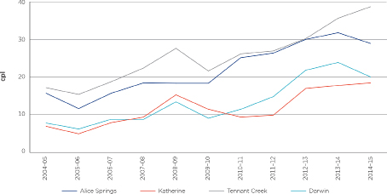
Movements in GIRDs over time have varied between locations:
• in 2014–15 GIRDs decreased in Darwin and Alice Springs, but increased in Katherine and Tennant Creek
• in 2008–09 GIRDs increased in Darwin, Katherine and Tennant Creek, but remained stable in Alice Springs
The largest annual increase in GIRDs (in cpl terms) in each location occurred at different times:
• in Darwin (7.2 cpl) and Katherine (7.1 cpl) it occurred in 2011–12
• in Alice Springs (7.0 cpl) it occurred in 2010–11
• in Tennant Creek (5.5 cpl) it occurred in 2012–13.
Table D1 shows annual average retail petrol prices in Northern Territory regional locations and the difference relative to Darwin prices over the period 2004–05 to 2014–15.
Table D1: Annual average retail petrol prices in Darwin and Northern Territory regional locations:
2004–05 to 2014–15 (cents per litre)
Year | Darwin | Alice Springs |  | Katherine |  | Tennant Creek
Year | Retail | Retail | Difference to Darwin | Retail | Difference to Darwin | Retail | Difference to Darwin
2004–05 | 110.1 | 118.1 | 8.0 | 109.2 | –0.9 | 119.6 | 9.5
2005–06 | 129.2 | 134.7 | 5.5 | 127.9 | –1.3 | 138.5 | 9.3
2006–07 | 132.3 | 139.3 | 7.0 | 131.4 | –0.9 | 142.4 | 10.1
2007–08 | 144.6 | 154.4 | 9.8 | 145.2 | 0.6 | 158.4 | 13.8
2008–09 | 139.8 | 144.8 | 5.0 | 141.7 | 1.9 | 154.2 | 14.4
2009–10 | 132.0 | 141.4 | 9.4 | 134.4 | 2.4 | 144.7 | 12.7
2010–11 | 139.3 | 153.2 | 13.9 | 137.2 | –2.1 | 154.2 | 14.9
2011–12 | 153.8 | 165.5 | 11.7 | 148.8 | –5.0 | 166.1 | 12.3
2012–13 | 160.1 | 168.4 | 8.3 | 155.2 | –4.9 | 168.6 | 8.5
2013–14 | 170.4 | 178.4 | 8.0 | 164.2 | –6.2 | 182.3 | 11.9
2014–15 | 149.8 | 158.8 | 9.0 | 148.2 | –1.6 | 168.7 | 18.9

Table D2 shows annual average GIRDs in Northern Territory regional locations and the difference relative to Darwin prices over the period 2004–05 to 2014–15.
Table D2: Annual average petrol GIRDs in Darwin and Northern Territory Regional locations:
2004–05 to 2014–15 (cents per litre)
Year | Darwin | Alice Springs | Katherine | Tennant Creek
2004–05 | 7.9 | 15.9 | 7.0 | 17.4
2005–06 | 6.3 | 11.8 | 5.0 | 15.6
2006–07 | 8.9 | 15.9 | 8.0 | 19.0
2007–08 | 8.9 | 18.7 | 9.5 | 22.7
2008–09 | 13.6 | 18.6 | 15.5 | 28.0
2009–10 | 9.2 | 18.6 | 11.6 | 21.9
2010–11 | 11.6 | 25.5 | 9.5 | 26.5
2011–12 | 15.0 | 26.7 | 10.0 | 27.3
2012–13 | 22.1 | 30.4 | 17.2 | 30.6
2013–14 | 24.2 | 32.2 | 18.0 | 36.1
2014–15 | 20.3 | 29.3 | 18.7 | 39.2

Appendix E: Financial data collection and methodology
This appendix outlines the process of collection and analysis of data for the Darwin market study and the methodology for the processing of retail financial data.
Collection
The ACCC sought information from the major fuel retailers and wholesalers operating in Darwin. Companies that owned retail sites in Darwin were asked to provide profit and loss statements for each of their retail sites in Darwin for the period 1 July 2009 to 31 March 2015. These companies were Caltex, Coles Express, Puma Energy, United and Woolworths. These retailers own and set prices at over 90 per cent of retail sites in Darwin.
The retailers were also asked to complete financial templates which provided standardised data, allowing the ACCC to analyse and compare across companies, and identify revenue and costs of petrol.
In addition, information for each company’s retail sites in Katherine and Adelaide was sought to make comparisons with the Darwin market.
Information collected under the ACCC’s 2014 petrol monitoring program was also used to compare Australia-wide retail profitability with Darwin.
Confidentiality
The information provided to the ACCC is mostly commercially sensitive and has been provided on a confidential basis. To protect confidentiality, this report presents primarily aggregated analysis of retail costs and profits.
Financial assessment methodology
Data presented in this report was collected from the fuel retailers through financial data templates and profit and loss statements for individual retail sites provided by the companies. The templates were broadly similar to those used under the ACCC’s 2014 petrol monitoring program.
Coverage
The analysis focuses on regular unleaded petrol sold at retail sites in Darwin, Katherine and Adelaide. To fully examine the retail fuel market, revenue and costs of other fuels and non-fuel products were also analysed, as well as the overall profitability of each retail site.
When calculating the average costs and profits per site in Darwin, only those sites that operated for the full financial year were included.
Cost allocation
Costs associated with the operation of a retail site cannot be directly attributed to a particular product or service. Petrol is sold jointly with other automotive fuels as well as non-fuel products, such as convenience store goods. Therefore, many costs are common to the retailing of both fuel and non-fuel products, as they are generally sold from the same premises and by the same staff.
The existence of common and joint costs means that costs must be allocated to individual products. However, as the monitored companies do not generally measure net profits by product or service, they do not allocate costs to individual products or services.
The methodology the ACCC has used to allocate common costs in this report in the retail sector is consistent with that used in previous years in the ACCC’s annual petrol monitoring reports. Firstly, gross profit by convenience store and fuel sales were used to prorate costs between these two broad activities. Secondly, costs were then split by petroleum product on the basis of the relative product volumes sold.
While the ACCC has used well accepted cost allocation rules and conventions such as using sales volumes, revenue and costs, care should be taken when interpreting data presented in this report as there is no exact way of allocating common costs.
Retail business models in Darwin
In the fuel industry, as with other industries, different companies use different business models and organisational structures and reporting systems. Types of retail businesses in Darwin include company owned and operated sites, franchisee operated sites, and commission agents.
The differences in business models and their effect on operating costs reported by the companies need to be borne in mind when considering the average costs and profits of the retail fuel market in Darwin.
Profit and loss data
Companies owning retail sites in Darwin were asked to provide profit and loss statements for each of their retail sites in Darwin for the period 1 July 2009 to 31 March 2015. This information was used to assess the profitability of retail sites in Darwin. Profit and loss information was used to calculate net profit per site and retail unit net profit—these concepts are described below.
Comparing Darwin results with the Australian retail market
The average retail unit net profit in Darwin was compared with the average retail unit net profit across Australia (see section 2.2). The latter was calculated from data provided by retailers under the ACCC’s 2014 petrol monitoring program.
In the Australia-wide figures head office costs for fuel and non-fuel activities have been deducted. To compare like with like the Australian average head office costs each year were deducted from the Darwin specific calculations. Over the five years, the estimate for head office costs across Australia ranged from 1.0 cpl to 2.2 cpl.
Financial template
Companies that owned retail sites in Darwin were asked to complete financial templates for each of their retail sites in Darwin for the period 1 July 2009 to 31 March 2015. The template sought information specific to petrol, including costs, revenue and sales volumes that was not available from the profit and loss statements. Template information was used to calculate net profit per site, retail unit net profit and net retail margins on petrol—these concepts are described below. The templates were also used to allocate retail operating costs to petrol, as outlined above.
Key performance indicators for assessing the Darwin retail market
Net profit per site
This was calculated in two ways:
• Net profit per site in section 2.1.1 was calculated based on the financial template data provided by the companies. It was calculated as the total sales revenue (fuel and convenience store) less cost of goods sold and operating costs (such as employee, energy, rent and other direct operating costs). Companies’ profit and loss data were not used to calculate net profit in section 2.1.1 because not all companies provided profit and loss statements for Adelaide in 2013–14.
• Net profit in section 2.1.2 was as reported in companies’ profit and loss statements for each site in Darwin. While there were some small differences in how net profit was calculated between companies, in general net profit broadly equates to net earnings before interest and tax, and largely excludes allocated head office costs.
Retail unit net profit
The net profit made by fuel retailers for each litre of fuel sold. That is, the overall retail net profit reported by companies divided by the total volume of fuel sold. This includes profit made on non-fuel products such as convenience store sales. Retail unit net profit reported for Australia in aggregate includes head office costs. In Darwin retail unit net profit was adjusted to account for head office costs.
Net retail margin on petrol
The net profit earned by companies on the sales of petrol only, i.e., revenue on petrol less purchases less allocated operating costs. In this report this was calculated as the average retail petrol price less the average TGP, the average operating costs allocated to petrol sales (as described earlier) and retail GST.

Appendix F: Daily retail petrol prices by major retailer
The charts in this appendix display the daily average retail petrol prices of the major retailers in Darwin over the period 15 October 2011 to 1 June 2015. Seven charts are presented, each relating to one of the periods identified in table 4.1 in chapter 4.
Chart F1: Daily average retail petrol prices by retailer, Darwin, Period 1: 15 October 2011 to 11 April 2012
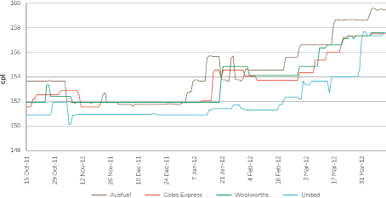
Chart F2: Daily average retail petrol prices by retailer, Darwin, Period 2: 11 April 2012 to 17 October 2012
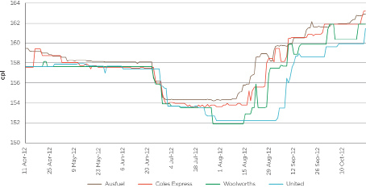
Chart F3: Daily average retail petrol prices by retailer, Darwin, Period 3: 17 October 2012 to 21 February 2013
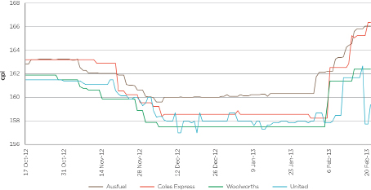
Chart F4: Daily average retail petrol prices by retailer, Darwin, Period 4: 21 February 2013 to 8 September 2013
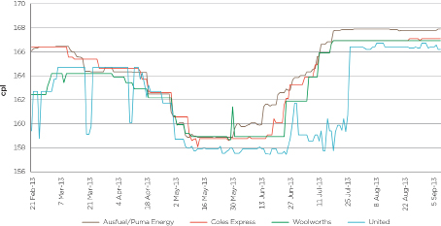
Chart F5: Daily average retail petrol prices by retailer, Darwin, Period 5: 8 September 2013 to 5 January 2014
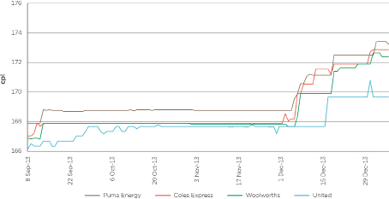
Chart F6: Daily average retail petrol prices by retailer, Darwin, Period 6: 5 January 2014 to 5 October 2014
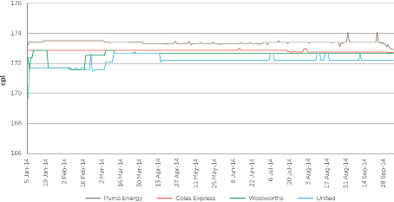
Chart F7: Daily average retail petrol prices by retailer, Darwin, Period 7: 5 October 2014 to 1 June 2015
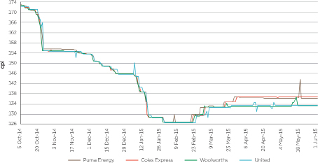

In this report ‘petrol’ means regular unleaded petrol unless otherwise specified.
Independent retail sites in this report are sites which: (a) are not owned or operated by the major retailers, and (b) whose retail prices are not determined by the major retailers. These sites may or may not trade under a major brand (e.g. BP).
Net profit per site broadly equates to earnings before interest and tax, and does not take account of head office costs.
The net margin on petrol was calculated as the annual average retail petrol price less the annual average TGP, average operating costs allocated to petrol sales, and GST at the retail level.
Retail unit net profit is the net profit made by fuel retailers for each litre of fuel sold. It includes profit made on non-fuel products (such as convenience store sales) and takes account of head office costs.
More detail on the background to the regional studies and how Darwin was chosen is included in appendix A.
The ACCC has daily average petrol prices for Darwin from 2000. Average prices for the five largest cities are for regular unleaded petrol, except for Sydney where E10 prices have been used since July 2014 instead of regular unleaded petrol.
Appendix B provides more data on petrol prices in Darwin.
Appendix C provides more data on diesel prices in Darwin.
Fuel price data for Katherine is only available from 2002–03.
Appendix D provides more data on petrol prices in other locations in the Northern Territory.
The value chain shows in broad terms the elements of the price of a litre of petrol from the price of imported refined petrol to the price of petrol at the pump.
Data on petrol GIRDs is presented in appendix B.
See appendix C.
This chart includes 36 petrol retail sites that operated for the full year in 2013–14. It excludes one Caltex site and one Coles Express site, which did not operate for the full year. It does not include the Caltex Eaton site, which only commenced operations in January 2015.
In addition, the BP Bagot Road and Gull Virginia retail sites are independently owned.
However, there is an independently owned and operated site which sells fuel under the Puma brand.
Australian Private Equity and Venture Capital Association Limited (AVCAL), Building Better Businesses 2014, http://www.avcal.com.au/documents/version/873, accessed 28 October 2015; ‘Archer leads consolidation of rival petrol players’, The Australian, 2 August 2010.
‘Investors target maturing Perth market’, WA Business News, 10 March 2011.
AVCAL, ibid.
‘Fuel company silent on high bowser prices’, Northern Territory News, 1 October 2014.
‘Swiss fill up on Gull in $625 m fuel deal’, The West Australian, 5 February 2013.
‘Trafigura subsidiary makes Australia move’, Platts Oilgram News, 5 February 2013.
‘Residents concerned about Parap development plans’, Northern Territory News, 10 May 2015, http://www.ntnews.com.au/news/northern-territory/residents-concerned-about-parap-development-plans/story-fnk0b1zt-1227349148102 accessed 6 October 2015.
Adam Giles, Chief Minister of the Northern Territory, Media release, New fuel stop to drive petrol prices down, 16 October 2014, http://newsroom.nt.gov.au/mediaRelease/10067, accessed on 3 September 2015.
Adam Giles, Chief Minister of the Northern Territory, Media release, Local company selected to develop Darwin fuel stop and transport service hub, 6 June 2015, http://newsroom.nt.gov.au/mediaRelease/12220, accessed on 6 October 2015.
‘Palmerston has shrugged off its second-rate tag to cement its reputation as one of the most vibrant and busy cities in Australia’, Northern Territory News, 12 February 2015.
To analyse which retailer or site led prices, Darwin was divided up into six local areas. For each of these areas the retail site that was the first to reduce its prices following a prolonged period of price increases was identified.
Puma Energy acquired Ausfuel on 1 March 2013.
Charts for daily prices by retailer for all seven periods are provided in appendix F.
Following undertakings given to the ACCC in December 2013, the cost of the shopper docket schemes offered by Coles and Woolworths are now wholly funded by their fuel retailing businesses.
See chart 3.1 in chapter 3.
As shown in chart 3.2 in chapter 3.
In April 2015 the AANT and United announced an offer that provided AANT members with an 8 cpl fuel discount from 15 May until 31 July and then an ongoing minimum discount of 6 cpl. The discount is only available to AANT members and applies to all 12 United sites in the Northern Territory and an independent retail site in Alice Springs. See: AANT and United media release, AANT offers United fuel discount to members, 30 April 2015, http://www.aant.com.au/Portals/2/Community/Newsroom/MR%2030April%20AANT%20%20United%20partnership%20(2).pdf, accessed 3 September 2015.
See http://www.aant.com.au/Motoring/Fuel/FuelPrices/?fuelType=2.
Adam Giles, Chief Minister of the Northern Territory, Media release, New fuel stop to drive petrol prices down, 16 October 2014, http://newsroom.nt.gov.au/mediaRelease/10067, accessed on 3 September 2015.
Ibid.
Robyn Lambley, MLA, Minister for Corporate and Information Services, Media release, Territory Company secures fuel contract, 15 October, 2012, http://newsroom.nt.gov.au/mediaRelease/7484 accessed 3 September 2015.
‘Drivers pumped as price plunges’, Northern Territory News, 29 May 2015.
Inquiry into fuel prices in the Northern Territory, May 2005, p. 32.
The Minister’s letter and direction are available from the ACCC website at https://www.accc.gov.au/system/files/Ministerial%20direction%20%26%20letter%2020–14.pdf.
ACCC media release, ACCC’s new petrol price reports, 15 January 2015, at https://www.accc.gov.au/media-release/acccs-new-petrol-price-reports.
These are available from the ACCC website at: https://www.accc.gov.au/publications/quarterly-report-on-the-australian-petroleum-industry.
ACCC media release, ACCC announces first regional petrol market study in Darwin, 10 March 2015, https://www.accc.gov.au/media-release/accc-announces-first-regional-petrol-market-study-in-darwin.
The source for all retail prices in this appendix is ACCC calculations based on FUELtrac and Informed Sources data. The sources for TGP data are: AIP, BP, Caltex, Mobil, Viva Energy and WA Fuelwatch.
Prior to 1 July 2009 the Queensland Government provided a subsidy at the retail level of 8.4 cpl (around 9.2 cpl when GST is included). For analysis of GIRDs in Brisbane in this period, TGPs in Brisbane were reduced by 9.2 cpl to put wholesale and retail prices on a consistent basis. Across the five largest cities, this reduced average TGPs by 1.8 cpl. These adjusted TGPs have been included in this table. As a result, in the period 2004–05 to 2008–09, actual TGPs in the five largest cities would be 1.8 cpl higher, and the difference between Darwin and five city average TGPs would be 1.8 cpl lower.
The source for all retail prices in this appendix is ACCC calculations based on FUELtrac and Informed Sources data. The source for TGP data are: AIP, BP, Caltex, Mobil, Viva Energy, and WA Fuelwatch.
Prior to 1 July 2009 the Queensland Government provided a subsidy at the retail level of 8.4 cpl (around 9.2 cpl when GST is included). For analysis of GIRDs in Brisbane in this period, TGPs in Brisbane were reduced by 9.2 cpl to put wholesale and retail prices on a consistent basis. Across the five largest cities, this reduced average TGPs by 1.8 cpl. These adjusted TGPs have been included in this table. As a result, in the period 2004–05 to 2008–09, actual TGPs in the five largest cities would be 1.8 cpl higher, and the difference between Darwin and five city average TGPs would be 1.8 cpl lower.
The source for all retail prices in this appendix is ACCC calculations based on FUELtrac and Informed Sources data. The source for TGP data is AIP.
Australian Bureau of Statistics, Census of Population and Housing, 2011.
ACCC, Monitoring of the Australian petroleum industry December 2014, p. xi.
The source for all data in this appendix is ACCC calculations based on data provided by one of the companies.

