Computation of Time

This document sets out the Adjudication Branch’s practice in relation to the computation of time under the Competition and Consumer Act 2010 (the Act) and the Competition and Consumer Regulations 2010 (the Regulations) in respect of:

- Authorisation – application to the Tribunal for the review of an authorisation

- Third Line Forcing notification – commencement of immunity

- Collective Bargaining notification – commencement of immunity

- 5 day deadline for validity

- Treatment of public holidays and weekends

Authorisation

Under section 101(1) of the Act, a party may make an application to the Australian Competition Tribunal (the Tribunal) for a review of a determination by the ACCC in relation to an application for an authorisation within a period of 21 days after the date of the determination.

Regulation 3(1) of the Regulations provides that where a period of time dating from a given day, act or event is prescribed by or allowed under the Regulations for doing an act or taking a proceeding, the time shall be reckoned exclusive of such a day, or of the day of the act or event, from which the time dates.

Therefore the prescribed period of 21 days is calculated exclusive of the determination date. That is, the determination date is day 0, and the first day of the prescribed period is the next day, day 1.

The issue of the treatment public holidays and weekends in calculating the time to make an application for review is explored later in this Procedure Note.

Example

- The determination is made on 4 March.

- A party has until the close of the office of the Tribunal Registrar (4pm) on 25 March to lodge a review with the Tribunal in relation to the ACCC’s determination.

- If no request for a review is lodged with the Tribunal then the determination will come into effect on 26 March.

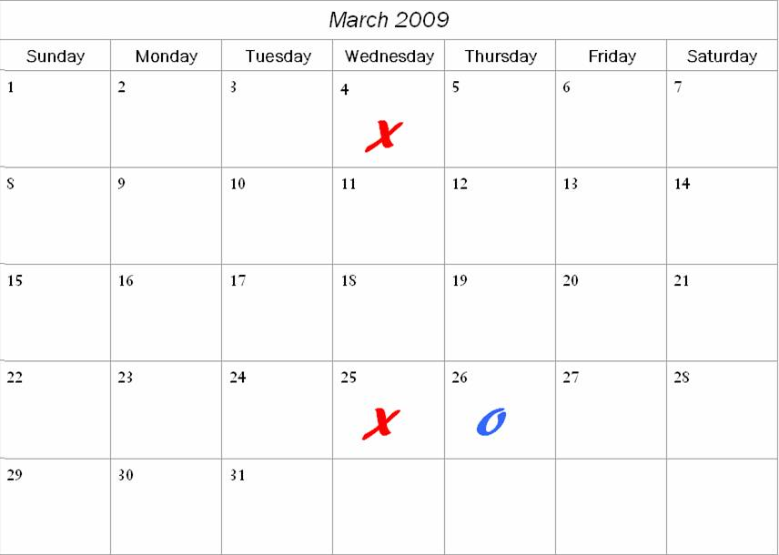

Third Line Forcing notification

Paragraph 93(7A)(a) of the Act provides where a corporation lodges a notice to the ACCC under subsection 93(1) of the Act, that notice comes into force at the end of a 14 day period that started on the day when the corporation gave the ACCC the notice.

The intention of section 93(7A)(a), given the meaning of on, is that the commencement of the prescribed period is to occur on the same day as the lodging of a notice with the ACCC. Therefore the prescribed period is calculated inclusive of the date the notification was validly lodged.

The day that the notification is validly lodged is day 1 and the ACCC has until the end of day 14 to issue a draft notice that will prevent immunity from commencing. Immunity commences on day 15.

Example

- The third line forcing notification is validly lodged on 10 March.

- The ACCC has until the end of 23 March to issue a draft notice preventing immunity commencing for the notified conduct.

- If no draft notice is issued then immunity for the notified conduct commences on 24 March.

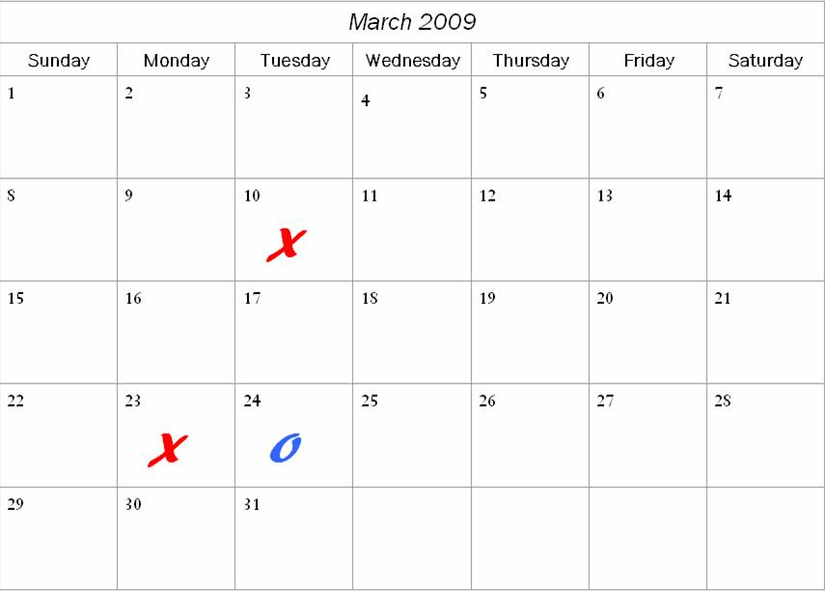

Collective Bargaining notification

Section 93AD(1)(a) of the Act provides that a collective bargaining notification comes into force at the end of the prescribed period, which is 14 days.

As with third line forcing notifications, the prescribed period is to commence on the same day as the lodging of a notification with the ACCC. Therefore, the prescribed period is calculated inclusive of the date the collective bargaining notification was validly lodged.

The day the collective bargaining notification is validly lodged is day 1 and the ACCC has until the end of day 14 to issue a draft notice that will prevent immunity from commencing. Immunity commences on day 15.

Example

- The collective bargaining notification is validly lodged on 13 March.

- The ACCC has until the end of 26 March to issue a draft notice preventing immunity commencing for the notified conduct.

- If no draft notice is issued then immunity for the notified conduct commences on 27 March.

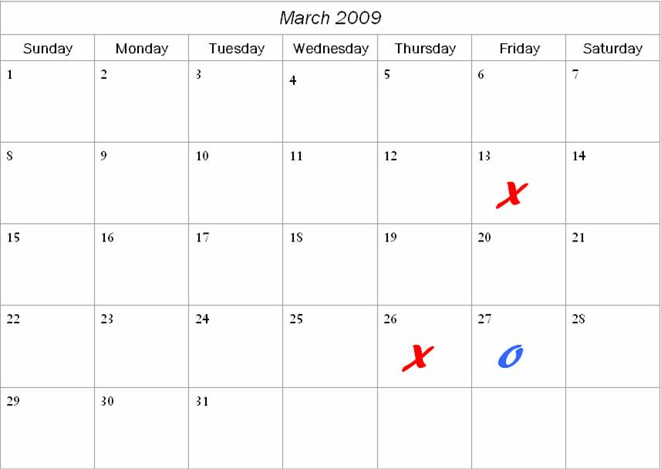

5 day deadline for validity

Sections 89(1A), 93(2B) and 93AB(10) provide the ACCC with 5 business days to give the person(s) who lodged the application for authorisation, the notification or the collective bargaining notification a written notice that the particular lodged notice is not a valid notice and the reasons for it not being valid.

Consequently, the ACCC has 5 business days, not including the date of lodgement, to consider the issue of validity.

The three divisions provide an identical definition of business day: a day that is not a Saturday, Sunday or a public holiday in the Australian Capital Territory (ACT). The Australian Public Service Holiday is not a public holiday in the ACT.

The issue of the treatment public holidays and weekends is explored in the next section of this Procedure Note.

Example 1

- The authorisation is submitted on 21 December 2009.

- As the Public Service Holiday is not an ACT public holiday, the ACCC has until the end of 30 December 2009 to give a written notice that the authorisation is not valid.

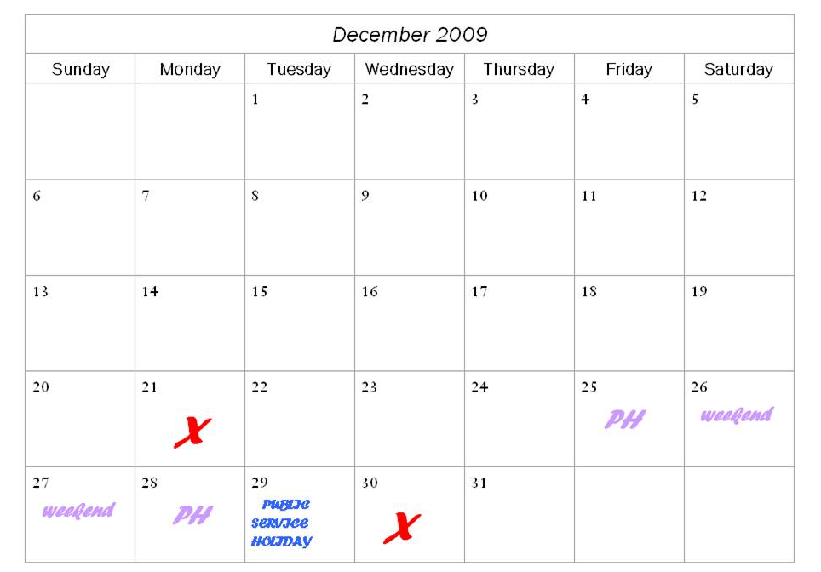

Example 2

- The notification is submitted late on Friday 31 July 2009 at the ACCC’s Sydney office.

- Monday 3 August 2009 is the Bank Holiday in Sydney and consequently the notification is not provided to Adjudication staff until Tuesday 4 August.

- The ACCC has until the end of 7 August 2009 to give a written notice that the notification is not valid.
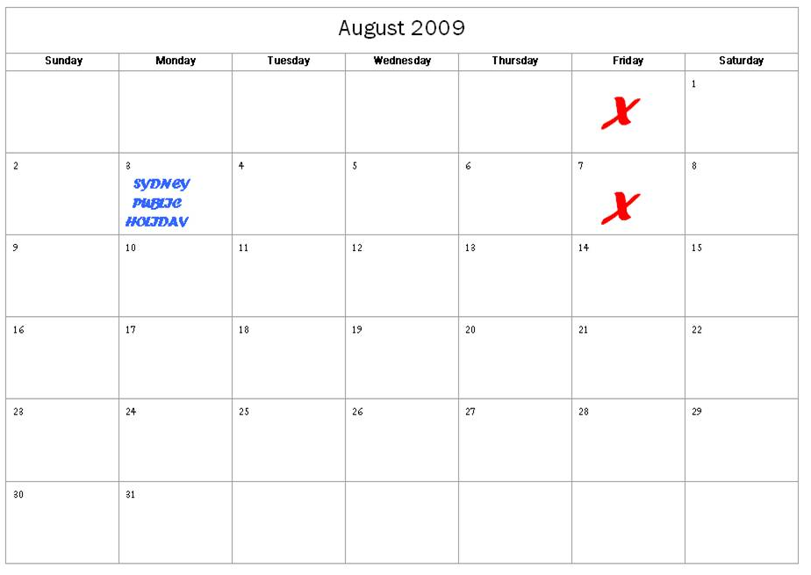

Treatment of public holidays and weekends

The relevant sections and regulations refer to ‘days’ rather than ‘business days.’ Therefore, when calculating a prescribed period the days are inclusive of weekends and public holidays. Immunity will commence on the relevant day regardless of whether it is a public holiday or a weekend.

When the end of the prescribed period falls on a weekend or public holiday

- Request for review to the Tribunal on an authorisation: Regulation 3(2) of the Regulations provides that where the time prescribed expires on a Saturday, Sunday or any day on which the Registrar of the Tribunal is closed, the act may be done on the first day following that is not a Saturday, Sunday or any day on which the office is closed. Regulation 16 provides that the office of the Registrar shall be open for business on every day, other than a Saturday, a Sunday or a day that is observed as a holiday in the Australian Public Service.

- Third line forcing notifications: As with a request for a review to the Tribunal of an authorisation, the prescribed period is determined with reference to Regulation 3(2). However, where day 14 of the exclusive dealing notification falls on a Saturday, Sunday or a public holiday and the ACCC intends to give a draft notice of revocation under s93A(2) then prudence dictates that the ACCC should give notice on the last business day before the end of the prescribed period.

- Collective bargaining notifications: Section 93AD(1)(a) of the Act sets out the prescribed period, that is, it is not provided in the Regulations. Under section 36(2) Acts Interpretation Act 1901 provides that where the last day of any period prescribed or allowed by an Act falls on a Saturday, Sunday or a public holiday, the thing may be done on the first day following which is not a Saturday, a Sunday or a public holiday . However, as with third line forcing notifications where the ACCC intends to give a draft notice of revocation then prudence dictates that is has until end of the last business day before the end of the prescribed period to give the notice.

The Australian Public Service Holiday is not recognised as a public holiday under the Act and therefore the ACCC may do a thing (i.e. issue a revocation) on this day.

Further, it is important to note when considering the deadline for a decision on validity that the ACT dates for various public holidays do not always correspond with those in other states of Australia and vice versa.

Christmas/New Year holiday period

With three public holidays, weekends and the Public Service Holiday the Christmas/New Year period is the most likely time of the year when issues with computation of time may arise.

The following three examples, while applying to the Christmas/New Year period also demonstrate how public holidays should be handled when computing time throughout the year.

Example 1 – notification commencement of immunity

- The third line forcing notification is validly lodged on 15 December.

- In theory the ACCC has until the end of 28 December to issue a draft notice preventing immunity commencing for the notified conduct.

- 25th of December is a public holiday, the 26th is a Saturday, the 27th a Sunday and the 28th is a public holiday in lieu of Boxing Day.

- Therefore the ACCC has until the end of 24 December to issue a draft notice preventing immunity commencing for the notified conduct.

- If no draft notice is issued then immunity for the notified conduct commences on 29 December.

- Note: the 29 December 2009 is the Public Service Holiday but is not recognised as a public holiday under the Act.

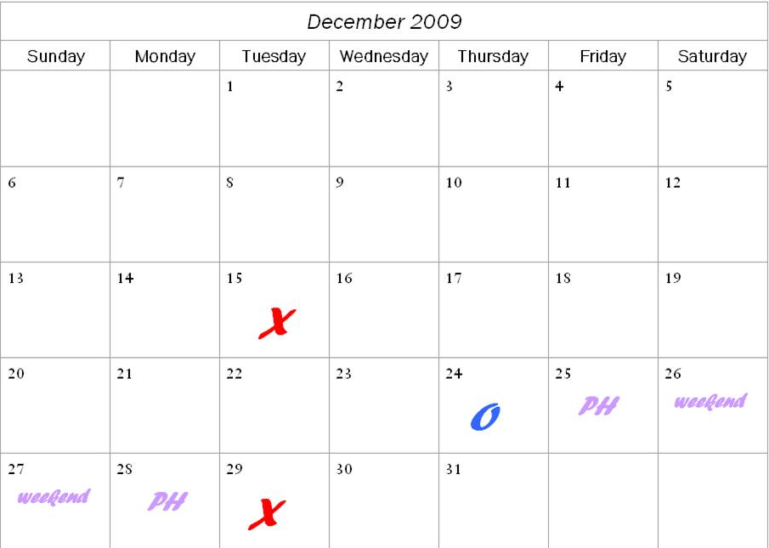
.
Example 2 – application to the Tribunal for the review of an authorisation

- The authorisation determination is made 4 December.

- As the 25th is a public holiday, the 26th is a Saturday, the 27th a Sunday and the 28th is a public holiday in lieu of Boxing Day, a party has until the close of the office of the Tribunal Registrar (4pm) on 29 December to lodge a review with the Tribunal in relation to the ACCC’s determination.

- If no request for a review is lodged with the Tribunal then the determination will come into effect on 30 December.
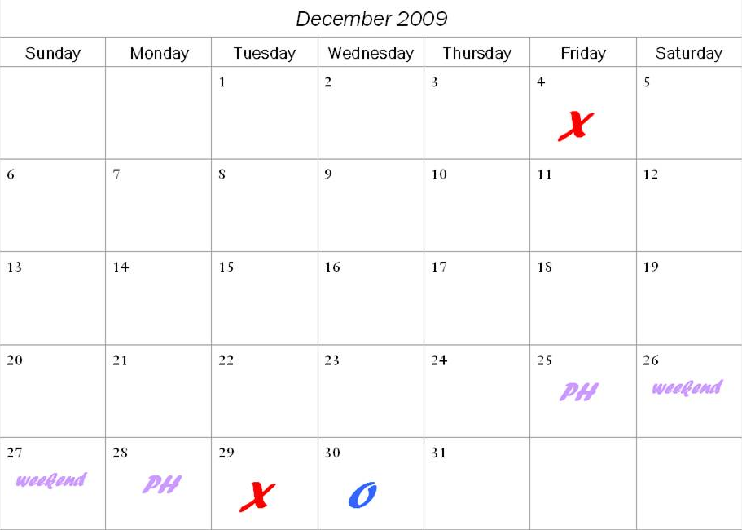

Example 3 – validity

- The notification is lodged on 23 December 2009.

- The 25th is a public holiday, the 26th is a Saturday, the 27th a Sunday, the 28th is a public holiday in lieu of Boxing Day and 1st is a public holiday. Consequently the ACCC has until the end of 4 January 2010 to give a written notice that the authorisation is not valid.

- The Public Service Holiday is the 29 December 2009 but as it is not recognised as a public holiday under the Act it is counted in the five day validity period.



