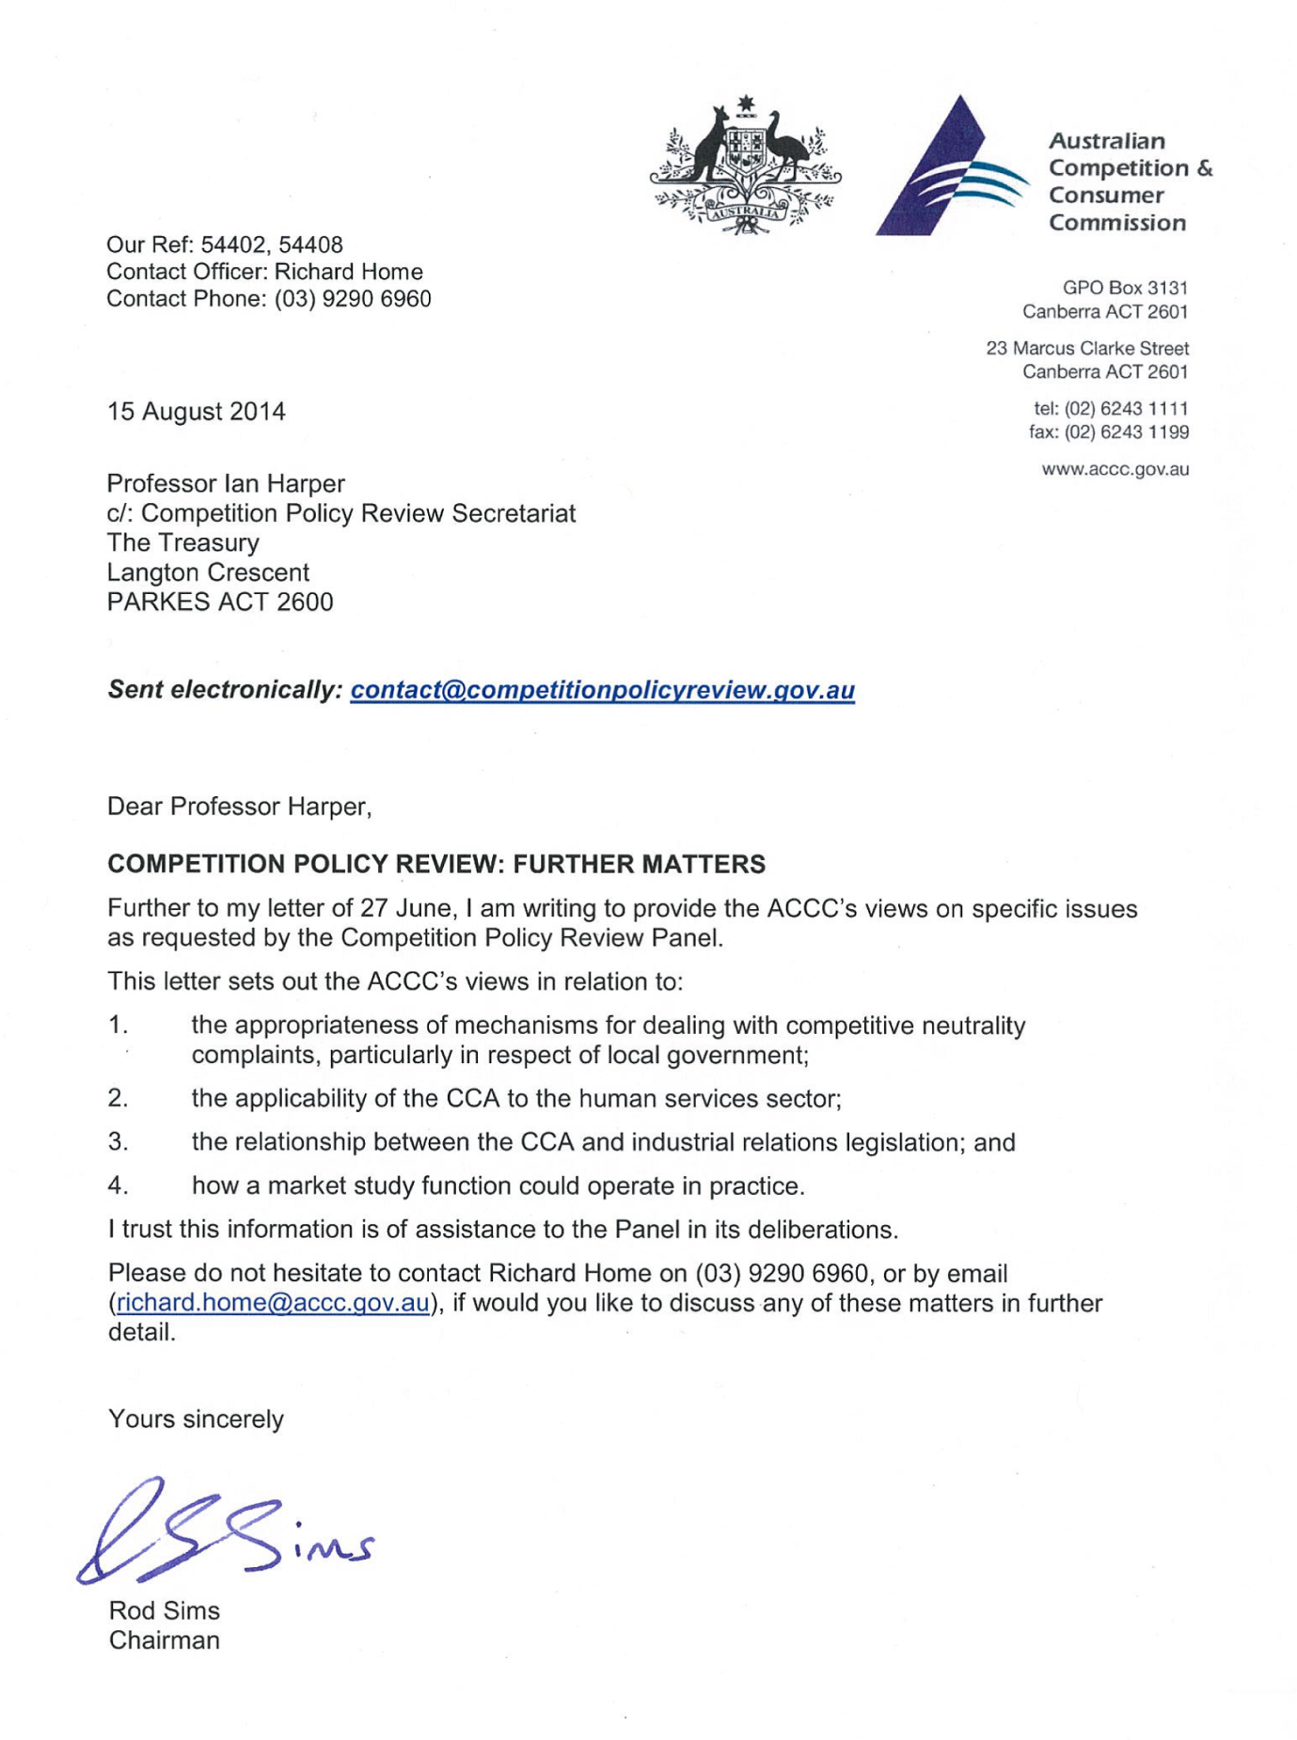

Australian Competition & Consumer Commission

Supplementary submission to the
Competition Policy Review

Further matters

15 August 2014

- Further matters
This submission provides additional information to that set out in the ACCC’s previous submissions to the Competition Policy Review, and provides some further information and comment in relation to:
- the appropriateness of mechanisms for dealing with competitive neutrality complaints, particularly in respect of local government;
- the applicability of the CCA to the human services sector;
- the relationship between the CCA and industrial relations legislation; and
- how a market study function could operate in practice.
- Competitive neutrality

An issue that has been raised in a number of submissions to the Review Panel relates to the adequacy of mechanisms for dealing with competitive neutrality complaints, particularly in respect of local governments. A related issue that has been raised is whether local governments were beneficiaries of the National Competition Policy payments initiated in the 1990s.
The ACCC notes that, while the principle of competitive neutrality under the 1995 Competition Principles Agreement does apply to local governments, Victoria, Queensland and Western Australia were the only States that provided their local government sector with part of their National Competition Policy payments to encourage reform.
In terms of the mechanisms in place to assess competitive neutrality complaints in relation to local governments, the ACCC understands that complaints are generally first dealt with by the relevant local government. If the local government is unable to resolve a complaint satisfactorily, the State or Territory government agency responsible for competitive neutrality oversight will investigate the issue. It will either dismiss the complaint or make recommendations for how the affected local government can better comply with its competitive neutrality obligations.
The ACCC understands that no jurisdiction currently provides for a formal remedy where a competitive neutrality breach occurs.
In order to assess the costs and benefits of implementing stronger enforcement mechanisms in relation to competitive neutrality it would be necessary to make judgements regarding the materiality of such issues. Given that competitive neutrality is not an issue administered by the ACCC, these complaints are not routinely made to the ACCC. Instead such complaints are made to State, Territory and Commonwealth competitive neutrality complaints bodies.
As set out in the ACCC’s submission to the Competition Policy Review dated 25 June 2014, the ACCC considers that in considering the adequacy of mechanisms for dealing with competitive neutrality complaints, Australian governments should review their competitive neutrality policies and related mechanisms in conjunction with State, Territory and Commonwealth competitive neutrality bodies. A review into, among other things, the timeliness and transparency of complaints handling and the implementation of recommendations, could promote more effective regimes.

- Applicability of the CCA to the human services sector

An issue has been raised in the context of the Competition Policy Review concerning the applicability of the CCA to the human services sector (including the health, education and disability sectors). In particular, questions have been raised about the applicability of Part IV of the CCA to the human services sector were it to be exposed to greater competition.
In the ACCC’s view, opening up the human services sector to greater competition is unlikely to raise any significant concerns in terms of coverage by Part IV of the CCA. That said (as is the case now) determining whether a particular section of the CCA applies to a specific entity is not always straightforward and requires consideration of the entity’s particular characteristics and circumstances against the relevant legal principles.
When assessing whether conduct is covered by Part IV, a relevant legal principle that would likely need to be considered is whether the entity in question (whether it be privately or publicly owned or operating on a not-for-profit basis) falls within the definition of a ‘trading corporation’ under the CCA.
The ACCC notes that whether an entity is a trading corporation is a question of fact and degree that will be answered with regard to its activities and not the purposes of its incorporation. According to this ‘activities test’, an entity will be considered a trading corporation if trading represents a substantial part of its overall corporate activities. ‘Trading' has been interpreted broadly and it is not necessary that trading activities be profitable, or even intended to be profitable, to constitute the entity as a trading corporation. Further, in regard to government-funded entities, if the trading activity does not constitute a large proportion of overall revenue, but is the largest source of revenue outside government funding and amounts to more than a modest figure it may be considered ‘substantial’ for the purposes of the activities test.
In relation to publicly owned entities, there is the further issue of crown immunity to consider and whether the entity is carrying on a business. Again, while this issue would be considered on a case by case basis, the ACCC considers that given the nature of government entities operating in the health services sector crown immunity is unlikely to apply in most cases and even if it does, the CCA is likely to apply because the entity will be carrying on a business.
Given the above, while any allegations would of course need to be considered on a case by case basis, it appears likely that most entities operating in the human services sector (whether they be privately or publicly owned or operating on a not-for-profit basis) would likely be subject to Part IV of the CCA.
- Relationship between the CCA and industrial relations legislation

Key points
From a policy perspective, the relationship between competition and industrial relations is complex. The debate on this issue is characterised by strong (and often conflicting) positions from stakeholders ranging from governments, businesses, employee organisations and consumers.
However, from a regulatory perspective, the interaction between legislation governing competition policy and legislation governing industrial relations policy is reasonably well defined. There is a broad carve out in Part IV of the CCA for conduct concerning employment related matters, such as remuneration and hours of work (section 51(2)). This carve out does not apply to a small number of provisions, including the provisions often referred to as the prohibitions on ‘secondary boycotts’. The secondary boycott related prohibitions can encompass (although they are not limited to) conduct engaged in by employee representative groups such as unions. There is a specific carve out to these prohibitions, which provides that conduct will not contravene the prohibitions where the dominant purpose is substantially related to the remuneration, conditions of employment, hours of work or working conditions (section 45DD).
The ACCC takes non-compliance with these prohibitions extremely seriously and seeks to enforce them whenever it can where the conduct is not otherwise being addressed by other regulators. However, at times there are challenges obtaining evidence, which in part may be due to limitations on the ACCC’s enforcement powers. It is notable, though, that the ACCC receives relatively few complaints about potential breaches of the secondary boycott prohibitions involving employee organisations. All are investigated - there is no lack of commitment by the ACCC to enforce the law.
‘Employment exemption’ to Part IV
Historically, in Australia (as well as many countries internationally such as the United States and the United Kingdom), competition-related matters have been subject to separate regulatory oversight from industrial-relations matters. This separation recognises that labour markets raise different issues to general markets for goods and services.
This distinction provides the rationale for the so-called ‘employment exemption’ to Part IV of the CCA set out in section 51(2). Most relevantly, section 51(2) provides an exemption from coverage of Part IV (aside from the secondary boycott prohibitions and resale price maintenance) for matters relating to the “remuneration, conditions of employment, hours of work or working conditions of employees”.
On certain occasions the ACCC investigates allegations of anti-competitive conduct which involve employee organisations. These tend to relate to interactions between such organisations and other businesses; for example, the ACCC has recently noted that it is investigating allegations of anti-competitive conduct involving Toll and the Transport Workers Union. In many cases, however, a threshold consideration is whether or not the conduct at issue falls within the ‘employment exemption’ to Part IV discussed above.
The ACCC notes, for completeness, that from time to time there may also be examples of independent contracting displacing traditional employer-employee relationships. In such circumstances there are a number of cases where the ACCC has authorised collective bargaining by groups of independent contractors.
Secondary boycotts
As noted above, one type of conduct falling outside the ‘employment exemption’ to Part IV relates to prohibitions against conduct that is generally termed a ‘secondary boycott’.
In broad terms, a secondary boycott refers to a situation where one person, in concert with a second person, impedes a third person from supplying to, or acquiring from, another person.
The secondary boycott prohibitions were inserted into the then Trade Practices Act 1974 (Cth) in 1977. These prohibitions were inserted in response to concerns raised by the 1976 Trade Practices Act Review Committee (the Swanson Committee) about the lack of protection for traders against secondary boycotts, and the Committee’s recommendation that the law provide an effective avenue of recourse for affected traders.
Prohibitions against secondary boycotts have remained in legislation governing Australian competition policy continuously since 1977, except for the period between 1993 and 1996 when the Keating government moved the prohibitions against secondary boycott conduct into industrial relations legislation.
There are a number of situations in which secondary boycotts are expressly permitted by the CCA. For example, section 45DD provides that there will not be a contravention of the ‘secondary boycott’ prohibitions where the dominant purpose for which conduct is engaged in is substantially related to employment matters – the remuneration, conditions of employment, hours of work or working conditions of relevant employees.
Other situations where the CCA provides that conduct will not contravene the ‘secondary boycott’ prohibitions are where the dominant purpose is substantially related to environmental protection or to consumer protection.
Enforcement of ‘secondary boycott’ prohibitions
The secondary boycott prohibitions can be enforced both through private actions, and through proceedings instituted by the ACCC.
While the ACCC receives relatively few complaints about potential breaches of the secondary boycott prohibitions, the ACCC carefully considers each and every complaint. In the two years from 1 July 2012 to 30 June 2014 the ACCC was contacted only nine times regarding concerns that potentially amounted to secondary boycott conduct, out of 323,835 contacts generally. Of those nine, only four related to employee organisations and all were investigated.
Issues that can make enforcement actions particularly challenging in relation to secondary boycotts include:
1. Difficulties obtaining documentary evidence
In the ACCC’s experience, secondary boycotts are often effected through verbal communication and physical actions, which are undocumented. Typically, key elements of the prohibitions – such as the requirement that there be a person acting in concert with a second person under section 45D, or that specific activities have been engaged in that impeded a third person’s acquisition or supply – will not be recorded or referenced in any written form.
Accordingly, the ACCC’s power to obtain documents and records can be of more limited assistance when investigating this type of conduct.
To the extent aspects of secondary boycott conduct are carried out through telephone communications, the ACCC does not have the power to use telecommunication intercepts to investigate potential contraventions of the secondary boycott prohibitions.
There may be occasions where other enforcement agencies obtain information relating to potential breaches of the CCA in the course of their own investigative activities. The ACCC notes that the ability to access such information could be a useful additional means of obtaining relevant evidence of secondary boycotts.

2. Lack of cooperation of witnesses
Given there is often a lack of documentary evidence of secondary boycotts, the ACCC’s ability to investigate, and then demonstrate in court, secondary boycott conduct is particularly reliant upon the cooperation of individuals involved in the conduct or who have information regarding the conduct.
In the ACCC’s experience, witnesses to secondary boycott activity are often reluctant to provide information to the ACCC, even in compulsory section 155 examinations, for fear of repercussions. Typically, individuals involved in the conduct or with information regarding the conduct have ongoing personal, business or employment relationships with those alleged to have contravened the law. Fear of repercussions can persist despite the issuing of a section 155 notice.
While section 155 provides the ACCC with an important investigative tool, it is not, in and of itself, always sufficient to ensure the ACCC can gather the necessary evidence for an enforcement action in relation to a secondary boycott. Section 155 notices do not always overcome a lack of cooperation.
3. Potential overlap between roles of ACCC and other regulators
In the ACCC’s experience, conduct the subject of a complaint to the ACCC under the secondary boycott prohibitions can also be the subject of other complaints relating to breaches of industrial relations or other legislation. Accordingly, from time to time, other regulators such as Fair Work Australia and Fair Work Building and Construction may be concurrently investigating potential breaches of legislation that they administer. In addition, a party aggrieved by a secondary boycott may also have a cause of action under common law.
In determining what enforcement action to take, the ACCC will consider whether litigation under the CCA is the most appropriate way to achieve its enforcement and compliance objectives, including whether alternative causes of action that are being pursued are likely to be sufficient to deter future offending conduct.
A related issue is that of ensuring compliance with court orders made in relation to secondary boycott conduct. The ACCC is aware that there have been occasions where allegations have been made that parties have failed to comply with court injunctions relating to secondary boycott conduct (made pursuant to legislation other than the CCA). The ACCC notes that where such non-compliance occurs this reflects broader issues of concern, potentially moving into the realm of criminal conduct.
- Market studies

The ACCC’s submission of 5 June 2014 to the Review Panel proposed a broader market study function for the ACCC to assess whether, in particular sectors, competition problems exist or not, and to support better targeted action by the ACCC or others in response. This Attachment provides further detail on how such a function could operate in practice.
1. Design of a market study function
Currently, the ACCC may conduct price inquiries under Part VIIA of the CCA. The ACCC considers that, if the following amendments were made, market studies could be conducted under Part VIIA without the need to introduce an entirely new Part to the CCA:
(a) Currently, the ACCC requires the approval of the Minister to hold a price inquiry under Part VIIA (s. 95H). The ACCC proposes that Part VIIA be amended to allow the ACCC to initiate a market study. As noted in the ACCC’s submission, the requirement for ministerial approval potentially involves the Minister in a process designed to better target ACCC enforcement or compliance action. The International Competition Network (ICN) also notes that one of the major advantages of authorities having the ability to initiate market studies themselves is that it allows them greater freedom to identify potential concerns in markets or sectors and ensure that market studies focus on the most critical issues. It also allows authorities to capitalise on their internal knowledge by collecting together information from internal sources on issues for market study.
(b) Division 3 of Part VIIA is titled ‘Price Inquiries’. Since 1983 (when the preceding Prices Surveillance Act was enacted), inquiries under these provisions have included factors that impact on price such as market structure. However, it would be preferable if the Division was retitled ‘Market Inquiries’.
(c) Currently, Division 3 provides for a price freeze during an inquiry (s. 95N) and notification of prices after receipt of the inquiry report (s. 95Q). These provisions should not apply to an ACCC-initiated inquiry. As set out in the ACCC’s submission, the ACCC is not proposing the UK market study/investigation model.
(d) Division 3 currently requires: the inquiry notice to specify the period within which the inquiry is to be completed (which can be extended) (s. 95K); and certain persons to be notified of the inquiry (ss. 95L, 95M and 95P). These provisions should also apply to ACCC-initiated inquiries. The ICN notes that setting a standard length of time is not advisable because studies vary to such a large extent, but also recommends that authorities set a timeframe for a specific inquiry due to the importance of completing a market study within a reasonable time. The effectiveness of a market study also depends upon obtaining broad stakeholder input about the way the market functions, and the draft findings and proposed outcomes.
(e) There are three additional amendments that should be made to Part VIIA which are not specific to ACCC-initiated inquiries:
- The ability to delegate ACCC functions to a member of the Commission (s. 25) should extend to Part VIIA. This would reduce the resources required to conduct inquiry hearings under Part VIIA.
- Section 95ZK should be amended so that information notices under Part VIIA may be issued to persons in addition to the relevant supplier.
- Section 155AAA (protection of information) should also apply to information obtained under Part VIIA. As an example, section 155AAA could facilitate cross agency joint market studies as occur in Europe.
As recommended by the ICN, the ACCC would also develop standardised processes for conducting market inquiries so that public resources are used to best effect. For example, the selection of a market to study would reflect the ACCC’s annual Corporate Plan and Priorities, and the possible types of outcome at the end of the inquiry. As set out in the ACCC’s submission, an inquiry could be used by the ACCC:
- as a lead-in to competition or consumer protection enforcement action when anti-competitive behaviour is suspected in a sector but the exact nature and source of the problem is unknown;
- to identify a systemic market failure (instead of ad hoc compliance action against individual firms) and to better target a response (whether, for example, through enforcement action or compliance education);
- to identify market problems where affected parties are disadvantaged and either have difficulty making a complaint to the ACCC or accessing the legal system to take private action;
- to address public interest or concern about markets not functioning in a competitive way; the market study could either confirm such concerns, and propose some solutions, or reveal them to be unfounded; or
- to fact-find to enhance the ACCC’s knowledge of a specific market or sector, particularly where a market is rapidly changing, and raises issues across the ACCC’s functions.
The type of market inquiry under Part VIIA differs from reviews conducted by other government bodies. For example, the Productivity Commission’s role is to assist governments to make better policies. In contrast, Part VIIA market inquiries would be more narrowly focused, and require granular market data such as prices, costs, margins and market share. As noted in the ACCC’s submission, the OECD has consistently raised, in its assessments of Australia’s competition policy framework, the fact that the ACCC currently does not use this type of market study to supplement its enforcement function.
2. Examples of market studies
Two examples of market studies conducted by the former UK Office of Fair Trading (OFT) are home buying and selling (2009) and bulk liquefied petroleum gas (2004).
In the home buying and selling study, the purpose of the study was to examine:
- the ability for new entrants to enter the market;
- the state of competition on price and quality between estate agents and other service providers;
- whether the existing regulatory framework provided the right level of consumer protection and also provided the right conditions for innovation and competition; and
- the relationships between estate agents and other service providers such as mortgage brokers and surveyors.
The OFT’s final report (2010) found that the market was generally working well with low barriers to entry and low concentration. However, the report identified concerns over low levels of price competition due to the lack of penetration by alternative business models, the lack of innovation by traditional estate agents, and consumers not being primarily focussed on commission rates when choosing an estate agent. The recommendations in the report included greater communication and coordination between the OFT, Ombudsmen and Trading Standards, and less onerous regulation to encourage the entry and development of new business models.
In the bulk liquefied petroleum gas (LPG) study, the OFT identified concerns with the structural features of the market, and referred the matter to the former UK Competition Commission (2004). The Competition Commission’s market investigation (2006) found high levels of concentration, high switching costs, a lack of information about switching costs and wait times, contractual restrictions on switching and high barriers to expansion by smaller suppliers. The remedies developed by the Competition Commission were directed at making it easier for customers who use LPG (e.g. for domestic heating and cooking) to switch suppliers.

Although only where the relevant business is a ‘significant’ government business activity. The CPA did not define ‘significant’. Instead, it was up to each State and Territory to decide which government and local government business activities would be subject to competitive neutrality principles.
R v Judges of Federal Court of Australia; Ex Parte Western Australian National Football League (1979) 143 CLR 190, 208 (Barwick CJ).
R v Judges of Federal Court of Australia; Ex Parte Western Australian National Football League (1979) 143 CLR 190, 208, 234 and 239; The Australian Beauty Trade Suppliers Limited v Conference and Exhibition Organisers Pty Ltd (1991) 29 FCR 68, 72; Forbes v Australian Yachting Federation (1996) ATPR 46-158. See also Australia v Metropolitan Fire and Emergency Services Board (1998) 83 FCR 346.
Hughes v Western Australia Cricket Association (1986) 19 FCR 10, 20; Shahid v Australian College of Dermatologists (2007) 72 IPR 555, 569; Quickenden v O’Connor (2001) 109 FCR 243.
R v Trade Practices Tribunal; Ex parte St George County Council (1974) 130 CLR 533. See also E v Australian Red Cross Society (1991) 99 ALR 601.
Australia v Metropolitan Fire and Emergency Services Board (1998) 83 FCR 346.
See section 2B of the CCA.
In this context, the ACCC reiterates the recommendations set out in its June 2014 submission to the Competition Policy Review regarding the ACCC’s investigative tools. The ACCC considers that the current penalties and enforcement regime for non-compliance with section 155 notices are inadequate. Further, the ACCC considers that greater protection should be available for whistle-blowers, through sanctions that deter intimidation and the creation of a third party whistle-blower regime.
In this regard, see page 2 of the transcript of 9 July 2014 of the Royal Commission into Trade Union Governance and Corruption (available at http://www.tradeunionroyalcommission.gov.au) which states that on 28 February 2013 Boral obtained interim injunctive relief against the CFMEU in the Supreme Court of Victoria restraining it from continuing the black ban in respect of a number of sites. Allegations were made to the Royal Commission that CFMEU did not comply with these injunctions. Also of relevance is that Grocon recently obtained a $1.25 million fine and indemnity costs orders against the CFMEU for contempt of court orders relating to hindering the construction work being carried out by Grocon. See Grocon & Ors v CFMEU & Ors (No. 2) [2014] VSC 134 (31 March 2014). Note that, as at the date of this submission, this decision is under appeal.
International Competition Network (Advocacy Working Group), Market Studies Good Practice Handbook (2012).
Currently, Part VIIA provides for the ACCC to summons a person to give evidence at an inquiry (s. 95S) and to issue a notice requiring the relevant supplier to give information or produce documents (s 95ZK). Section 155AAA (in Part XII) governs how the ACCC uses and discloses information but currently does not apply to information provided under Part VIIA.
See the 2008 OECD Policy Roundtable on Market Studies.

