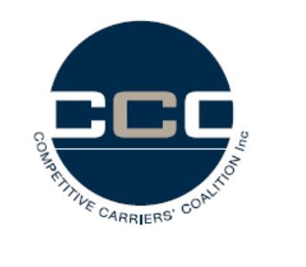

superfastbroadbandinquiry@accc.gov.au
cc: Nicole.Ross@accc.gov.au
cc: Robert.Wright@accc.gov.au

Dear Ms Ross / Mr Wright

Competitive Carriers Coalition's Submission to the Superfast Broadband Access Service Declaration inquiry

The Competitive Carriers Coalition welcomes the opportunity to provide submissions in respect of the Australian Competition and Consumer Commission's (ACCC) Draft decision in response to the "Superfast Broadband Access Service Declaration Inquiry", dated November 2015 (Draft decision).

The CCC supports the draft decision to declare SBAS.

The CCC believes superfast broadband access networks have monopoly characteristics.

Recent changes in technology and changes in NBN policy, technology and deployment plans increase the likelihood alternative networks will be built in some locations.

In the absence of effective competition, it is entirely possible the owners of these networks will not intend to offer wholesale, open access, or will offer severely discriminatory terms to alternative retailers.

The SBAS declaration is crucial to the successful transition to a structurally separated industry to address the underlying and fundamental cause of competitive weakness in Australian communications markets.

For downstream competition benefits to be realized, access to monopoly network elements, especially last mile, must be consistently regulated to the maximum extent possible.

The CCC is cautious about proposals to exempt some networks or network owners of customer classes in the absence of a rigorous competition test.

The CCC strongly urges the Commission to reconsider the approach of trying to find a proxy for developing a competition test.

The CCC considers the development of a competition test to be a core Commission role and it is unsatisfactory for the Commission to seek a necessarily compromised proxy in this situation.

The Commission observes in the discussion paper that it is open to network owners to seek location by location exemptions. It is suggested that the Competition Framework be developed by the Commission to provide guidance to access seekers and providers so as to ensure the necessary level of certainty for all in the way in which the test will be undertaken and exemptions granted.

Competitive Carriers Coalition
0438121114

