24th November 2016 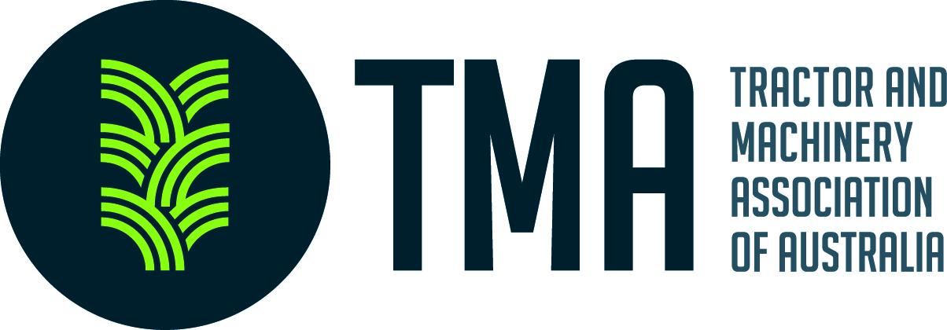
Australian Competition & Consumer Commission
Domestic Mobile Roaming Enquiry.

Submission on behalf of the agricultural machinery industry

The structure of Australian agriculture is such that it must compete against the rest of the world where in many cases subsidies are prevalent; this is where technology in the farm mechanisation industry has paid dividends.
Despite the success of technology over the last two decades, however, we are finding that we cannot keep up with the latest technology because of inadequate infrastructure revolving around the mobile phone / internet network.
Farmers in Australia are early adopters; they have embraced technology over recent years and in many cases have led the world in the acceptance of Precision Agriculture.
Australia pioneered the development of agricultural guidance using GPS technology. Australian primary producers were being guided automatically, in the paddock,way ahead of the North Americans who were still steering to light bars.
It was the expertise developed by Australians for guidance that led to nearly all the local firms, who produced this advanced technology, being bought outor partnered by multinational companies.
While the Americans were still trying to work out the best way to guide in field machines Australian had moved on to developing section ‘cut- offs’ for sprayers to help reduce the over application of chemicals.
Anecdotally, we were the first to embrace the ‘weed seeker’ technology where only the weeds were sprayed saving thousands of dollars in chemicals.
We were early adopters with the use of liquid fertiliser and developed the technology required to apply and precisely control rates.
As a country we were right up there with the adoption of CTF (controlled traffic farming) again enabled by technology and the considerable ability of the local manufactures to adopt machinery to suit.
Above are just a few examples of how technology, with farm mechanisation, has helped Australian farmers improve profitability.
The big evolution in the past has been the GPS controlled guidance but now we are moving on to remote control of equipment. GPS can guide vehicles such as tractors, combines and self-propelled sprayers but the finite control of setting and varying adjustments and the transfer of data will be done by telematics which relies on a good mobile network.
In the future information pertaining to the performance of a machine will be closely monitored and if there is anything untoward the local Dealer, or the factory many thousands of kilometres away, will be automatically alerted for corrective action. This will be done ‘online’ rather than having a technician travel many kilometres out to the farm.
This data transfer facility, particularly in rural Australia, is a matter of concern. Our mobile phone network is such that the majority of technology in the market now, and in the future, will be unable to be used, in many areas, unless there is a significant mobile coverage upgrade.
We have manufacturers developing systems where agronomists can vary application rates on speeders and sprayers from their office desk and we have, as mentioned before, technicians who can diagnose a potential problem but because of the poor (lack of cover) mobile network we are unable to use that technology in many parts of Australia.
As time goes on technology will increase and there will new products coming out which will need to be operated and controlled remotely. For example autonomous tractors, combines, sprayers will be steered by GPS but most other controls will be done over the mobile network. In the future many of the drives now done hydraulically will be activated electrically and they will probably be controlled over the mobile network too.
As we speak there is a need for ‘real time’traceability of food stuffs but again we cannot do that because of the poor network quality.
We could go on but we think this is a brief summary of where we see things in the future.
If we don’t catch up with the ability to transfer data and have good connection to the internet our farmers will be left behind their worldwide competitors.
This issue does not only apply to the primary producer but all those who operate support businesses in rural areas – any business in the country will need a lot better internet / mobile network if it is to be able to take advantage of the very latest businessprograms.
A good mobile / internet system will not only benefit primary producers trying to use the latest technology it will enhance their business operations, it will have a big impact on environmental issues (correct application of fertilisers and chemicals for example) and it will be a factor in encouraging more people to move to the country if they have access to the sorts of infrastructure available in the cities.
We are told that the mobile coverage caters for 98% of the population, unfortunately it is the 2% that are not covered who produce much of the wealth for our country.

Kind Regards
Gary Northover
Executive Director
Tractor and Machinery Association of Australia
617/434 St Kilda Road
Melbourne VIC 3004
[REDACTED]
03 9867 4289

