Monitoring of the Australian petroleum industry
Report of the ACCC into the prices, costs and profits of unleaded petrol in Australia
December 2012

ISBN 978 1 921973 36 9
Australian Competition and Consumer Commission
23 Marcus Clarke Street, Canberra, Australian Capital Territory, 2601
© Commonwealth of Australia 2012
This work is copyright. In addition to any use permitted under the Copyright Act 1968, all material contained within this work is provided under a Creative Commons Attribution 3.0 Australia licence, with the exception of:
• the Commonwealth Coat of Arms
• the ACCC and AER logos
• any illustration, diagram, photograph or graphic over which the Australian Competition and Consumer Commission does not hold copyright, but which may be part of or contained within this publication.
The details of the relevant licence conditions are available on the Creative Commons website, as is the full legal code for the CC BY 3.0 AU licence.
Requests and inquiries concerning reproduction and rights should be addressed to the Director, Internal Communication and Publishing Services, ACCC, GPO Box 3131, Canberra ACT 2601, or publishing.unit@accc.gov.au.
Important notice
The information in this publication is for general guidance only. It does not constitute legal or other professional advice, and should not be relied on as a statement of the law in any jurisdiction. Because it is intended only as a general guide, it may contain generalisations. You should obtain professional advice if you have any specific concern.
The ACCC has made every reasonable effort to provide current and accurate information, but it does not make any guarantees regarding the accuracy, currency or completeness of that information.
Parties who wish to re-publish or otherwise use the information in this publication must check this information for currency and accuracy prior to publication. This should be done prior to each publication edition, as ACCC guidance and relevant transitional legislation frequently change. Any queries parties have should be addressed to the Director, Internal Communications and Publishing Services, ACCC, GPO Box 3131, Canberra ACT 2601, or publishing.unit@accc.gov.au.
ACCC 12/12_630
www.accc.gov.au

Key points
In 2011−12 movements in the retail price of petrol in Australia continued to be driven by movements in international prices. Overall, both international refined petrol and domestic retail prices exhibited characteristic volatility and, on an annual basis, reached historically high levels. While prices in mid-2012 were off their highs of early 2012, they nevertheless remained at relatively high levels despite a weaker global economy.
International factors the key to Australian petrol prices
The main influences on Australian retail petrol prices are international prices and the exchange rate
International prices of crude oil largely drive international refined petrol prices and it is the international prices of refined petrol that drive retail petrol prices in Australia.
In the medium to long term retail prices are overwhelmingly determined by international market prices and because international prices are expressed in USD, changes in the AUD–USD exchange rate also affect domestic retail prices.
In 2011−12 average annual international prices of crude oil and refined petrol were the highest on record.
International producers of crude oil have been the major beneficiaries of higher petrol prices in recent years. From 2008−09 to 2011−12 annual average retail prices have risen 15.7 cents per litre (cpl). Of this increase, 11.8 cpl flowed to the owners of crude oil, 1.4 cpl is accounted for by taxes and 2.5 cpl accrued to Australian petrol companies.
Australian post-tax prices are low by international standards
Australian petrol prices are among the lowest in the OECD
Crude oil and refined petrol are internationally traded commodities and their prices form the basis for the setting of retail prices in most countries.
Relatively low levels of petrol taxes in Australia result in petrol prices in Australia being among the lowest in the OECD.
Key international factors
With Australia being a net importer of refined petrol, it is the international benchmark price of imports into Australia that forms the basis for prices in Australia. The most appropriate benchmark price for regular unleaded petrol (RULP) sold to Australian consumers is the price of Singapore Mogas 95 Unleaded (Mogas 95).
Australian retail petrol prices have tracked the price of Mogas 95 very closely. Between the June 2002 quarter and the June 2012 quarter, average retail prices of RULP (excluding taxes and subsidies) in Australia’s five largest capital cities increased by around 120 per cent while the price of Mogas 95 increased by around 122 per cent.
Crude oil is an internationally traded commodity and ultimately is a key driver of the price of refined petrol in the long run. Australian refineries generally pay a price for crude oil that is based on the price of Brent crude (a heavily traded crude oil marker) or Tapis crude (the crude oil marker traditionally used in the Asia-Pacific region).
In 2011−12 world crude oil prices were volatile
Crude oil prices were volatile during 2011−12 but generally moved in phases corresponding with different economic and geo-political climates:
- from July to November 2011, prices fluctuated in response to uncertainty in countries in the eurozone and to general concerns over the world economy
- from December 2011 to April 2012 international crude oil prices rose substantially as a result of increased demand due to a cold northern hemisphere winter, concerns over the effects of sanctions against Iran on global supplies and the easing of concerns about a US recession
- from April to June 2012 prices of crude oil decreased in response to evidence that the Chinese and Indian economies were slowing and that problems in the eurozone would be difficult to address
- from July to September 2012, crude oil prices rose again due to supply disruptions in the North Sea and renewed hopes for economy recovery in the US.
Despite some price reductions in April to June, 2011−12 saw the highest ever annual average crude oil prices
Average crude oil prices during 2011−12 have remained at historically high levels. The comparatively lower prices seen in June 2012 were still significantly above average prices for the previous 20 years. Average annual crude oil prices during 2011−12 were the highest on record.
Crude oil prices are likely to remain relatively high as lower-cost traditional oil fields continue to be depleted and crude oil is increasingly extracted from unconventional and more costly sources, including shale oil and tar sand deposits.
Profits
Profits in the downstream industry do not seem excessive
Consolidated profits across all products and all sectors in the downstream petroleum industry fell in 2011−12 to around $408 million, 81 per cent lower than the profit of $2.2 billion in 2010−11.
On a cents per litre basis, consolidated net profit for the downstream industry was 0.46 cpl in 2011−12, compared with 2.54 cpl the previous year. Over the last 10 years, the entire downstream petroleum industry has earned an average annual net profit of 1.82 cpl across all products sold in Australia.
On the other hand, petrol products (regular unleaded, premium unleaded and ethanol blended petrol) incurred a net loss of 0.03 cpl across all sectors in the downstream petroleum industry.
Lower industry profits in 2011−12 reflect poor financial results in the refinery and total supply sectors due to higher costs, the effects of unplanned refinery shutdowns, losses on the values of inventory holdings and losses on foreign exchange transactions.
These sectors continue to be affected by competition from more efficient refineries in the Asia-Pacific region. In 2011−12 the refinery sector incurred a loss of about $596 million. If the recent write-downs of asset values were included in profit calculations, the refining sector would have shown a loss of $2.8 billion in 2011−12.
The wholesale and retail sectors continued their recent trend of improving profits.
Domestic refining
Refinery sector facing challenges
The ACCC has found that the Australian petroleum refining sector has in general recorded comparatively low net profits and rates of return since the global financial crisis.
With domestic petrol prices set on the basis of import parity, Australian refiners (and suppliers) have little scope to pass on costs that are out of line with international best practice for refinery production.
The Australian refinery sector is facing a challenging future due to competition from the newer Asian mega refineries, as evidenced by the recent write down of the values of the Caltex and Shell refinery assets, the closure of the Shell Clyde refinery, the announced closure of the Caltex Kurnell refinery and the review of the Shell refinery in Geelong.
The long term average return on assets for the entire downstream petroleum industry has been generally comparable with other Australian industries and international downstream petroleum businesses.
Independent imports
Independent imports continued to increase
Imports by independent wholesalers continued to increase in 2011−12. Since 2007−08 independent imports have increased more than four-fold, accounting for about 30 per cent of total imports in 2011−12, compared with less than 5 per cent in 2007−08.
One of the key factors driving the growth in independent imports has been greater access to import terminals in the capital cities and to dependable sources of Australian standard refined petrol from overseas refineries.
In the past five years, at least four independent wholesalers have imported refined petrol from various overseas markets. Currently, three of the monitored independent wholesalers—Ausfuel, United and Neumann—own, or have access to, import infrastructure.
Petrol price cycles
Price cycles continue to be a concern for consumers
Petrol price cycles in the larger capital cities are of concern to many consumers due to the large price increases that can occur in a single day, and across most retail sites, on a regular basis. However, some consumers seem to take advantage of the low point in the price cycle to purchase petrol at relatively low prices.
These price cycles are not caused by changes in international benchmark prices, rather they are driven by the pricing policies of retailers. The ACCC has expressed concern with the level of coordination apparent in petrol price cycles.
The typical pattern of the petrol price cycle in recent years has been one where prices rise quickly at the outset (over one to three days) and then steadily decline over the rest of the cycle (between six and nine days); that is, they move in a ‘sawtooth’ pattern.
The duration of price cycles in the eastern capital cities has been increasing over the last few years. In 2009 the average duration of price cycles in these cities was around seven days, whereas it had increased to over 12 days by the end of the September 2012 quarter. This has made the price cycle less predictable and means that it is not as easy for consumers to take advantage of the low points in the cycle. ACCC analysis has shown that the upward phase has generally been led by BP or Caltex.
Petrol price cycles have been a feature of retail markets in Australia’s largest cities for many years. The ACCC has also found evidence of petrol price cycles in a small number of cities in the US and Canada. Evidence presented in this report suggests that the average price cycle increase in Australia is higher than in these cities in the US and Canada.
ACCC investigation into information sharing
The ACCC is progressing its investigations of the price sharing arrangements and shopper docket discounting schemes in the retail sector
The ACCC is examining price information sharing arrangements in relation to the retail petrol sector. The ACCC is concerned that such arrangements may breach the Competition and Consumer Act 2010 (the Act). In particular, the ACCC is concerned that these arrangements may lessen price competition in petrol retailing to the detriment of consumers.
These price sharing arrangements allow for the private and very frequent exchange of comprehensive retail price information between the major petrol companies. The ACCC is concerned that this allows petrol retailers to quickly signal price movements, monitor competitors’ responses, and react to them.
ACCC investigation into shopper docket discounting schemes
The ACCC is also currently examining the effects of shopper docket discounting schemes on competition and log-term consumer welfare having regard to the size (value), frequency and duration of these offers.
The ACCC’s investigations of these arrangements require a full assessment of the purposes and likely effects of the conduct and the application of the Act to any such conduct. The ACCC is yet to finalise its view as to whether information sharing and shopper docket discounting schemes in the petrol industry may contravene any provisions of the Act; both investigations are continuing.
Regional prices
Retail prices in regional locations are largely driven by international benchmark prices and the AUD–USD exchange rate, just as they are in the larger capital cities. However, prices in regional locations in Australia tend to be higher and more stable than in capital cities.
Higher regional fuel prices are generally due to structural issues such as less competition, lower volumes and higher transport costs
In many regional locations, there is a lag between movements in capital city prices and local prices. This lag arises because the turnover of petrol stocks is lower in the country than in the capital cities due to lower volume of sales in regional areas. As a result, price changes in the five largest cities take some time to be passed on to regional locations.
An example of this lag occurred in May and June 2012, when the city-country price differential increased, as prices decreased significantly in the capital cities. In Victoria, this differential was compounded by a period of substantial discounting in Melbourne, which made the city-country differential even higher.
The difference between regional petrol prices and those in the larger capital cities is principally due to the following factors in regional locations:
- a lower number of retail sites and therefore a lower level of local competition
- lower volumes of fuel sold
- distance/location factors
- lower convenience store sales.
The ACCC takes allegations of anti-competitive behaviour very seriously and will investigate and take action through the courts where appropriate
However, results of comparative analysis of regional and capital city prices need to be treated with caution. Short-term comparisons of prices in a regional location with those in a capital city can be distorted when price cycles in the capital cities have failed or the capital city is at an extreme end of its cycle.
The ACCC is aware of, and sensitive to, the concerns of motorists in regional locations about the relatively higher prices of petrol in some regional locations. The ACCC actively monitors petrol prices in around 180 locations throughout Australia and also monitors competition issues in those locations. The ACCC will continue to monitor regional Australian petrol prices and where any regional market looks to be of concern, it will not hesitate to thoroughly investigate pricing and local market dynamics.
As many regional locations have a small number of retail sites, the ACCC also pays particular attention to potential changes in ownership of retail sites in regional locations to ensure that the sale will not result in a substantial lessening of competition in that market.
The ACCC welcomes any information or evidence that local businesses or the public have in relation to changes in the ownership of retail sites in regional locations that may result in increased market concentration.
Ethanol blended petrol
Sales of ethanol blended petrol decreased in 2011−12 and, supplies of ethanol appear adequate to meet Australian demand
Ethanol is added to petrol to produce various grades of ethanol blended petrol (EBP). The most common EBP is E10, which is RULP containing up to 10 per cent ethanol. Total sales of EBP in Australia decreased in 2011−12, reversing the trend of previous years. Sales remained broadly stable in NSW but decreased significantly in Queensland and Victoria. Similarly the number of retail sites selling E10 across Australia decreased in 2011−12.
The largest volume of EBP is sold in NSW, which accounts for over 80 per cent of the Australian EBP market. This is largely the result of the ethanol mandate in that state, which from October 2011, has required that 6 per cent of the total volume of petrol sold in NSW should be ethanol.
Across all locations monitored by the ACCC in 2011−12, average RULP prices were higher than average E10 prices by around 1.8 cpl.
In previous years the ACCC has expressed concern about the supply of ethanol and that there are only three suppliers. However, in 2011−12 there appeared to be sufficient supply to meet demand. The ACCC will continue to closely monitor the market for EBP over the coming year.

Shortened terms
7-Eleven | 7-Eleven Stores Pty Ltd
AUD | Australian dollars
ABS | Australian Bureau of Statistics
ACCC | Australian Competition and Consumer Commission
AIP | Australian Institute of Petroleum
APAC | APAC biofuel consultants (a joint venture of EnergyQuest Pty Ltd and Ecco Consulting Pty Ltd)
APS | Australian Petroleum Statistics
Ausfuel | Ausfuel Group
ASX | Australian Securities Exchange
avg. | average
bl | barrel (equals 158.9873 litres)
BP | BP Australia Pty Ltd
BREE | Bureau of Resources and Energy Economics
CAD | Canadian dollars
CBA | Commonwealth Bank of Australia
CIA | Central Intelligence Agency
Caltex | Caltex Australia Ltd
Coles Express | Coles Express Pty Ltd
Coogee Chemicals | Coogee Chemicals Pty Ltd
cpl | Australian cents per litre
SEWPaC | Department of Sustainability, Environment, Water, Population and Communities
E10 | see EBP
E85 | see EBP
EBIT | earnings before interest and tax
EBP | ethanol blended petroleum, of which E10 (unleaded petrol with 10 per cent ethanol) is a common blend. E85 is a petrol blend containing 70 per cent to 85 per cent ethanol.
EUR | euros
excl. | excluding
FCAI | Federal Chamber of Automotive Industries
FFV | flex fuel vehicle
FOB | free on board
FuelCC | Fuel Consultative Committee
GIRDs | gross indicative retail differences
GL | gigalitres
GST | goods and services tax
Gull | Gull Petroleum Group (now part of Ausfuel Group)
IEA | International Energy Agency
Informed Sources | Informed Sources (Australia) Pty Ltd
IPP | import parity price/pricing
JTA | joint terminal arrangement
JV | joint venture
KBD | thousand barrels per day
KL | kilolitres (thousand litres)
LHS | left-hand side
Liberty | Liberty Oil Pty Ltd
LPG | automotive liquefied petroleum gas
mbpd | million barrels per day
MMA | McLennan Magasanik Associates Pty Ltd
Marstel | Marstel Terminals Pty Ltd
ML | megalitre (million litres)
MOC | market on close
Mobil | Mobil Oil Australia Pty Ltd
Mogas | motor gasoline
MON | motor octane number
MOPS | mean of Platts Singapore (refer to Platts in the glossary)
MTBE | methyl tertiary butyl ether (a fuel additive and octane enhancer)
na | not applicable
Neumann | Neumann Petroleum Pty Ltd
NZRC | New Zealand Refining Company
OECD | Organisation for Economic Co-operation and Development
On the Run | retail trading name of Peregrine Corporation
OPEC | Organization of the Petroleum Exporting Countries
pa | per annum
PSA | Prices Surveillance Authority
PULP | premium unleaded petrol
RBA | Reserve Bank of Australia
RBOB | Reformulated Gasoline Blendstocks for Oxygenate Blending
RET | Department of Resources, Energy and Tourism
RFS | Renewable Fuels Scheme (United States)
RHS | right-hand side
Rio Tinto | Rio Tinto Ltd
RON | research octane number
RULP | regular unleaded petrol
Saudi CP | Saudi contract price
SEP | Strasburger Enterprises (Properties) Pty Ltd
Shell | Shell Company of Australia Ltd
SMP | Sydney Metropolitan Pipeline Pty Ltd
TGP | terminal gate price
the Act | Competition and Consumer Act 2010  (formerly the Trade Practices Act 1974)
Trafigura | Trafigura Services Australia Pty Ltd
United | United Petroleum Pty Ltd
USD | United States dollars
USD/bl | United States dollars per barrel
US EIA | United States Energy Information Administration
US FTC | United States Federal Trade Commission
Vopak | Vopak Terminals Australia Pty Ltd
Woolworths | Woolworths Ltd
WSFR | Worldscale flat rate
WTI | West Texas Intermediate

Glossary

2007 ACCC petrol inquiry report | the report of the ACCC’s 2007 public inquiry into the price of unleaded petrol: Petrol prices and Australian consumers: Report of the ACCC inquiry into the price of unleaded petrol, December 2007.
2008 ACCC petrol monitoring report | the ACCC’s 2008 petrol monitoring report, Monitoring of the Australian petroleum industry: Report of the ACCC into the prices, costs and profits of unleaded petrol in Australia, December 2008.
2009 ACCC petrol monitoring report | the ACCC’s 2009 petrol monitoring report, Monitoring of the Australian petroleum industry: Report of the ACCC into the prices, costs and profits of unleaded petrol in Australia, December 2009.
2010 ACCC petrol monitoring report | the ACCC’s 2010 petrol monitoring report, Monitoring of the Australian petroleum industry: Report of the ACCC into the prices, costs and profits of unleaded petrol in Australia, December 2010.
2011 ACCC petrol monitoring report | the ACCC’s 2011 petrol monitoring report, Monitoring of the Australian petroleum industry: Report of the ACCC into the prices, costs and profits of unleaded petrol in Australia, December 2011.
automotive fuel | includes petrol, diesel and automotive LPG.
Alaska North Slope crude oil | a crude oil used as the benchmark for the acquisition cost of composite crude oil for California refineries.
barrel | a traditional measure used by the oil industry: one barrel is equivalent to 158.987 litres.
benchmark pricing | the practice of pricing to an identified crude or product price; for instance, the Tapis crude oil pricing benchmark.
biodiesel | a diesel fuel based on vegetable oil or animal fat, typically made in combination with alcohol.
Brent crude | a type of oil sourced from the North Sea and usually refined in northwest Europe. The Brent crude oil marker, also known as Brent blend, London Brent and Brent petroleum, remains the major benchmark for other crude oils in Europe and Africa.
buy–sell arrangements | arrangements between domestic refinery owners for the purchase and sale of petroleum products.
city–country differential | the difference between the average country retail price of petrol and the average city retail price of petrol.
commission agent | an arrangement whereby an agent receives a commission for selling a product owned by another; in the downstream petroleum sector a commission agent often operates a retail site owned by a petrol refiner or wholesaler.
Consumer Consultative Committee | established in 2001 by the ACCC to provide a forum for consumer representatives and the ACCC to discuss and collaboratively address consumer protection issues.
crude oil | a naturally occurring flammable liquid found in rock and other geological formations, consisting of hydrocarbons and other organic compounds. Common crude oil benchmarks include Tapis (Malaysia), which Australia has traditionally used as its benchmark, West Texas Intermediate (US) and Brent (North Sea).
diesel (automotive distillate) | fuel designed to run in diesel engines, widely used in the mining and transport sectors, as well as in some passenger motor vehicles.
distributor | a transport company that picks up petroleum products from refineries, terminals and depots for delivery to retailers and end users.
downstream | the refining, importing, distribution and marketing of petroleum products.
Dubai crude | a crude oil benchmark price used in New Zealand. A cheaper heavier crude oil sourced from the Middle East suited for the only refinery in New Zealand.
earnings before interest and tax (EBIT) | a measure of a company’s profits that excludes interest and tax expenses.
EBIT margin | EBIT divided by sales revenue.
EBP (ethanol blended petrol) | unleaded petrol that includes a proportion of ethanol (for instance, E10 is an unleaded petrol that includes up to 10 per cent ethanol).
Edmonton Par crude oil spot price | a benchmark for the price of crude oil in Canada.
Euro-Super 95 | a RON 95 grade of petrol largely sold throughout European countries.
exclusive dealing | a type of conduct prohibited in certain circumstances by section 47 of the Competition and Consumer Act 2010 which broadly speaking involves one trader imposing restrictions on another’s freedom to choose with whom, or in what or where it deals.
five largest cities | Sydney, Melbourne, Brisbane, Perth and Adelaide.
fixed costs | costs that do not vary with output.
free on board (FOB) | arrangement whereby the seller pays for transportation of goods to the port of shipment, plus loading costs, with the buyer responsible for the cost of marine freight transport, insurance, unloading and transportation from the arrival port to the final destination.
fuel | automotive, aviation, marine and other transport fuels, and non-transport fuels such as butane and heating oil.
Fuel Consultative Committee (FuelCC) | Established in 2010 by the ACCC to provide a forum for the ACCC, the fuel industry and motoring organisations to discuss fuel related issues and to assist the ACCC in undertaking its role under the Act on issues related to competition and consumer protection in the fuel industry.
fuel quality premium | additional price added to a price benchmark to reflect the higher quality of Australian-grade fuel relative to the Singapore benchmark price.
gantry | a facility used to transfer fuel products from a refinery or terminal to trucks or rail tankers.
gas | liquid petroleum gas or LPG, including automotive LPG.
gasoline crack | the difference between the price of refined petrol and the price of a barrel of crude oil, adjusted for volume differences.
gross profit | the difference between the revenue received from the sale of products and the cost of producing or purchasing them.
import parity pricing (IPP) | the setting of prices of domestically refined petrol in the wholesale market at a price comparable to the cost of importing fuel into a given location in Australia.
import terminal | a major terminal with a direct pipeline connection to a port—most fuel at import terminals is received via ship.
independent retailers | retailers (owning single or multiple sites) other than supermarket retailers and refiner-marketers. Independent retailers can sell petrol under the brand name of one of the refiner-wholesalers or under their own brand name.
Informed Sources | company that collects pricing information on various fuels and provides it to subscribers.
large independent chains | companies—other than refiner-wholesalers and supermarket chains—that import, wholesale and/or retail fuel in Australia; these include Ausfuel, United, Neumann, Liberty, 7-Eleven and On The Run.
light, sweet crude | crude oil with low viscosity (light) and relatively low levels of sulphur (sweet). These oils are preferred by refiners because of their ease of handling and relatively high yields of high-value products such as petrol, diesel and jet fuel.
major terminal | a fuel storage terminal connected to a port or a refinery by one or more pipelines. There are two broad types of major terminals—import terminals and refinery-pipeline terminals.
marginal cost | the additional cost to produce one extra unit of output.
Mean of Platts Singapore (MOPS) | the average of prices reported by Platts for Singapore traded commodities, for instance Tapis MOPS.
mogas | motor gasoline (the commonly used international term for petrol). It is used in oil markets as the benchmark for unleaded petrol in the Asia-Pacific region, including Australia.
nameplate capacity | the potential output of a refinery running at optimum utilisation.
New York Harbour conventional gasoline spot price | Platts established benchmark price for unleaded petrol in North America and Canada.
notification | a process under the Competition and Consumer Act 2010 by which a person who engages in exclusive dealing conduct may obtain prior legal protection from the application of the Act for that conduct.
oil sands | see tar sands
Oilcode | a prescribed mandatory industry code of conduct under section 51AE of the Competition and Consumer Act 2010. It regulates the conduct of suppliers, distributors and retailers in the downstream petroleum industry.
other fuels | includes kerosene, biodiesel, LPG, lead replacement and aviation fuels.
other oil-based products | includes LPG, aviation fuels, industrial and marine fuels, heating oil, fuel oil, lubricant oils, greases, basestocks and bitumen.
petrol | unleaded petrol—includes RULP (RON 91), PULP (RON 95 and above) and E10. The terms ‘unleaded petrol’ and ‘petrol’ are used interchangeably in this report.
petroleum products | any oil-based products derived from crude oil, as it is processed in oil refineries.
Platts | a provider of energy market information including price benchmarks for the oil, petrol and other energy markets.
Platts assessed price for MOPS | the mean of the high and low components of a Platts assessment for oil cargoes loading from Singapore; a free onboard price for completed deals in a particular commodity, quoted in USD.
PULP | premium unleaded petrol, such as RON 95 and above.
price support | rebate provided to a petrol retailer to compensate for periods of price discounting.
RBOB Reformulated Gasoline Blendstocks for Oxygenate Blending | a wholesale price for a base gasoline in California designed to be blended with an oxygenate to comply with environmental regulations for finished reformulated gasoline.
refining | the production of petroleum products from crude oil.
refiner margin | the petroleum product revenues received by a company, less all costs for raw materials (crude oil, catalysts etc.), product input costs and processing costs per barrel of product sold.
refiner-marketer | a company that refines, imports, wholesales and retails fuel. There are currently two refiner-marketers operating in Australia—BP and Caltex.
refiner-wholesaler | a company that refines, imports and wholesales fuel; in Australia these are BP, Caltex, Mobil and Shell.
refinery exchange | arrangements between refiner-marketers before July 2002 for the swap of a volume of product in one location for an equivalent volume in another location where they did not operate a refinery.
refinery-pipeline terminal | a major terminal with a direct or indirect pipeline connection to a refinery that supplies most of its fuel.
refinery products | fuel and other oil-based products such as lubricants and bitumen.
regional centres and country towns | around 180 regional centres and country towns which the ACCC monitors.
retail | the sale of petroleum products to the public through retail sites.
retail margin | the difference between the cost of acquiring a product from a wholesaler and the retail selling price of that product. Effectively the retailer’s gross margin.
return on assets | figure calculated by dividing net profit by total assets, expressed as a percentage, which shows how effectively a company’s assets are being used to generate profit.
return on capital employed | figure calculated by dividing net profit by the sum of total assets minus current liabilities and expressed as a percentage. This measure compares earnings with the capital invested in the company.
return on sales | figure calculated by dividing net profit by total sales, expressed as a percentage, which shows how much profit is being produced per dollar of sales.
RULP | regular unleaded petrol—RON 91; includes low-aromatic unleaded petrol.
RON | research octane number, a measure of the efficiency of petrol at resisting engine knocking. In Australia, grades of petrol typically include RON 91 (regular) and RON 95 and higher (premium grades).
Rotterdam (ARA) | Platts established benchmark price for unleaded petrol in Europe.
shopper docket | an offer to consumers to supply petrol or diesel at a reduced price if the consumer has spent a certain amount in one purchase on grocery goods or has acquired certain identified goods from a nominated supermarket or retailer.
smaller capital cities | Darwin, Hobart and Canberra.
supermarket retailer | supermarkets that sell fuel under their own name/brand.
Tapis crude | a light, sweet crude oil from Malaysia; it is used in oil markets as the benchmark for crude oil in the Asia-Pacific region, which includes Australia.
terminal | a storage facility from which fuel is received via ship and/or refinery and distributed to retailers, distributors and end users.
tar sands | naturally occurring bitumen soaked sands that can be refined to produce a range of liquid hydrocarbons.
terminal gate price (TGP) | price for a spot purchase of petrol from a terminal; used as a benchmark price; the TGP is the price a purchaser expects to pay, usually in cash, when they arrive at a wholesaler’s terminal wanting to purchase a tanker load of 30 000 litres of petrol.
terminal throughput | the annual volume received and then distributed by a refinery or terminal via truck or rail gantry.
terminal turnover | the number of times a terminal is effectively filled and emptied during a year (that is, annual throughput divided by physical capacity).
third line forcing | a form of exclusive dealing conduct prohibited by section 47 of the CCA. It involves either a supply of goods or services, or a supply at a particular price, on the condition that the purchaser acquires goods or services from a particular third party, or a refusal to supply goods or services to the purchaser because the purchaser will not agree to acquire the goods or services from the particular third party.
tight oil | a term used to describe oil embedded in low-permeable sandstone, carbonate, and shale rock.
total supply sector | the fuel industry sector that imports and exports petroleum products and purchases petroleum products from Australian refineries. This sector also imports crude oil for use by refineries.
unleaded petrol | see ‘petrol’—the terms ‘unleaded petrol’ and ‘petrol’ are used interchangeably in this report.
vertical integration | the undertaking by a single company of successive stages in the process of production and/or supply.
wholesale | the sale and movement of petroleum products from a wholesaler to other wholesalers, to retailers or to end users such as transport, agricultural and mining companies.
West Texas Intermediate (WTI) | a type of crude oil; also known as Texas Light Sweet. WTI crude is traded on the New York Mercantile Exchange. Prices have been affected by build up of excess supplies as a result of infrastructure bottlenecks at the land-locked trading hub of Cushing, Oklahoma. As a result the price of WTI is no longer a useful indicator of world demand and supply conditions for crude oil.
Worldscale | a provider of shipping freight price and other freight market information. Freight rates are quoted by ship and port combination. The freight rate for a given ship and port combination reflects market demand and the availability of shipping.

Summary
This is the fifth monitoring report into the prices, costs and profits of the Australian downstream petroleum industry since the ACCC was directed by the Minister to undertake monitoring in December 2007. This summary highlights the findings of the current report. Further in-depth analysis of each of the topics covered in this summary can be found in the relevant chapters of the report.

Australian retail petrol prices follow international benchmark prices and are influenced by the exchange rate
In previous monitoring reports, the ACCC noted that retail petrol prices were predominantly determined by the international price of refined petrol. During 2011−12, the international price of refined petrol continued to be the main determinant of Australian petrol prices.
Chart 1 displays the major downstream industry components of the average annual retail price of regular unleaded petrol (RULP) during 2011−12. The chart clearly shows the continued importance of the international price of refined petrol (Singapore Mogas 95 unleaded) in the determination of retail prices in Australia.
Chart 1 Total downstream components of the average annual retail RULP price of 142.8 cents per litre: five largest cities, 2011−12 (components are to scale)
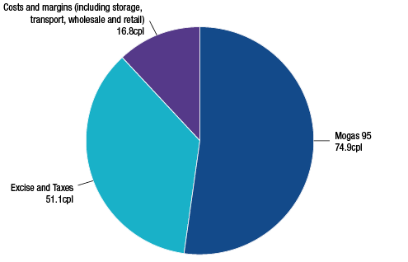
Source: ACCC calculations based on Informed Sources, Platts and RBA data, and information provided by monitored companies
Note: Costs and margins for RULP include a net loss of 0.7 cpl across all sectors of the downstream petroleum industry.
Costs and margins include components for the quality premium, freight, wharfage and other wholesale/retail costs and margins.

Australian petrol prices are among the lowest in the OECD
Retail petrol prices in Australia are still comparatively low when compared with similar countries such as those in the Organisation for Economic Co-operation and Development (OECD) (chart 2). In the June 2012 quarter, Australia had the fourth-lowest petrol prices in the OECD.
The main factor in lower petrol prices in Australia is the relatively low level of fuel taxation compared with other countries. When taxes are removed, Australian petrol prices are around the median of OECD countries.
Chart 2 Petrol prices and taxes in OECD countries: Australian cents per litre, June quarter 2012
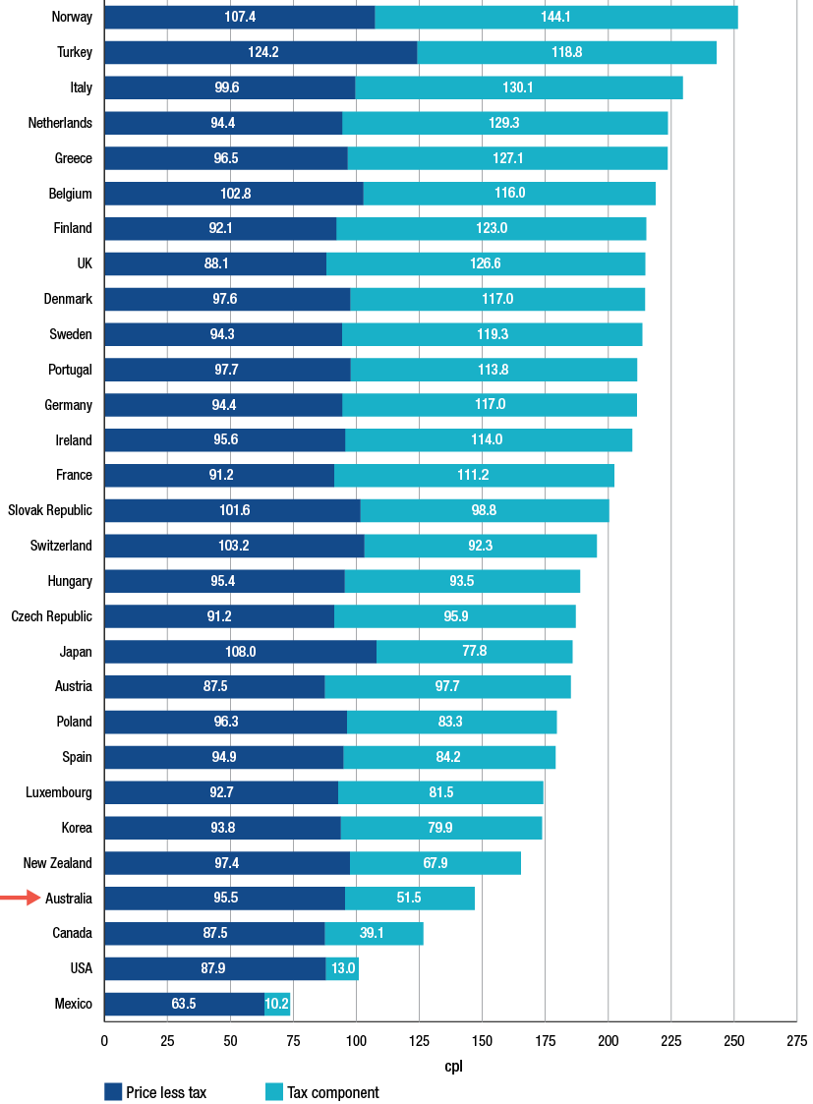
Source: Bureau of Resources and Energy Economics (BREE), Australian Petroleum Statistics; issue no. 194, September 2012
Notes: Care must be taken when making international comparisons as fuel quality standards (for example, octane rating and the content of MTBE and sulphur) for the most commonly used form of petrol in each market differ between countries.
The role of the Singapore Mogas 95 Unleaded petrol benchmark price
In Australia, as in most developed countries, domestic petrol prices are based on international benchmark prices of refined petrol. Prices in different countries are based on different international benchmarks depending on their proximity to the world’s major trading regions. The relevant benchmark for Australian petrol prices is the price of Singapore Mogas 95 Unleaded (Mogas 95), which is the price of unleaded petrol with a Research Octane Number (RON) of 95 that is loaded free on board in Singapore.
As Singapore is the regional hub for the pricing and sale of a number of petroleum products, most local Australian petroleum companies use the benchmark price of Mogas 95 as the basis for calculating the price of unleaded petrol products in Australia.
Analysis of retail prices in the largest capital cities on a seven-day rolling average basis shows that over the past five years, retail prices followed closely movements in the price of Mogas 95. The analysis shows that movements in Australian retail prices are driven by international pricing movements.
Chart 3 shows daily average retail prices over the period since July 2007 compared with the Mogas 95 benchmark.
Chart 3 Daily retail RULP prices, adjusted retail RULP prices and Mogas 95 prices:
1 July 2007 to 30 September 2012
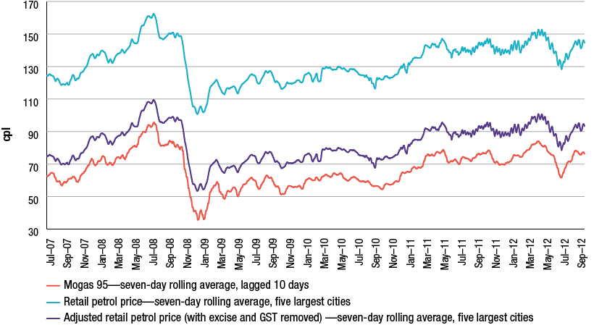
Source: ACCC calculations based on Informed Sources, Platts and RBA data
Note: The chart uses seven day rolling average retail prices in the five largest cities. The Mogas 95 benchmark has been lagged 10 days. The chart also shows adjusted retail prices where excise and GST have been removed.
Although international refined petrol benchmark prices are usually the most important influence on domestic petrol prices, other influences can also be significant. Factors such as the level of competition at the wholesale and retail levels, the amount of excise applied to petrol products, freight and quality premium costs and even petrol price cycles in some cities have a significant influence on retail prices.
Refined petrol and crude oil prices
While Australian petrol prices are linked to the price of Mogas 95, the latter is linked to world crude oil prices. The prices of crude oil and refined petrol are closely linked by virtue of the fact that in a typical refinery operation, the cost of crude oil inputs can be expected to contribute around 85 to 90 per cent of total costs.
In South East Asia, a common crude oil marker used for pricing purposes is Tapis, a Malaysian light sweet crude oil. Over the past few years, the Brent crude oil marker has also progressively become a popular benchmark. The close link between the prices of the Brent and Tapis crude oil markers and Mogas 95 is shown in chart 4.
There are times when the prices of Mogas 95 and crude oil markers can move independently from each other depending on factors that may impact on global crude oil supply and demand and the state of the regional refining industry. However, on average, there is a very close relationship between the prices of Mogas 95 and crude oil markers.
Chart 4 Weekly average prices of Mogas 95 and Brent and Tapis crude oil: 1 July 1993 to 30 June 2012
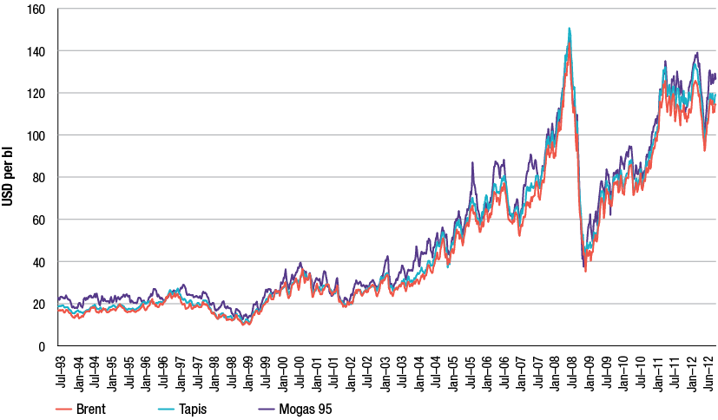
Source: ACCC calculations based on Platts data
It comes as no surprise that, given the nexus between crude oil and refined petrol prices, the surge in crude oil prices has been the principal reason for higher petrol (and diesel) prices, not just in 2011−12, but over most of the previous decade.
Crude oil prices during 2011−12
The price of a barrel of crude oil in the short term is affected by a number of factors including concerns over short-term economic growth, geo-political tensions and commodity speculation. In the longer term, the price of crude oil is influenced by international demand and supply.
In 2011−12 crude oil prices were relatively high and experienced distinct periods of variability. Crude oil prices during 2011−12 can be considered in terms of three phases:
1. During the second half of 2011, from July to November, daily Brent crude oil prices were volatile, ranging from a high of around USD 118 per barrel in early July to a low of around USD 101 per barrel in October. The main factors affecting crude oil prices included:
- uncertainty regarding the future of Greece and the eurozone
- concerns with the health of the US and emerging Asian economies.
2. The second phase was roughly from December 2011 to April 2012 when crude oil prices increased significantly. Daily Brent crude prices ranged from around USD 104 per barrel in December 2011 to a high of around USD 127 per barrel in February. Reasons for this increase included:
- easing of concerns about a possible US recession
- increased oil demand due to a cold northern winter in Europe
- supply worries due to the impending trade sanctions on Iran.
3. The third phase was from May 2012 to the end of June 2012 when daily Brent crude oil prices decreased substantially to a low of around USD 89 per barrel in mid June 2012. Reasons for the decrease included:
- ample global supplies
- the large build up of inventories in the United States with near record refinery utilisation rates
- the slowing of the Chinese and Indian economies.
4. More recently, between July and September 2012, daily Brent crude prices increased to around USD 118 per barrel. This increase was influenced by:
- supply disruptions in the North Sea
- ongoing instability in the Middle East (particularly in Syria) heightening concern over potential disruptions to supply, and
- monetary easing measures announced in the US in mid-September.
International prices high despite weak global economic conditions
Despite a generally weak global economy, and lower crude oil prices in mid-2012, average prices for the financial year 2011−12 have remained at historically high levels. Indeed, average annual prices during 2011−12 were the highest on record and have followed a strongly upwards trend, evident since 1998−99. This trend can be seen in chart 5 which presents the average of price of Brent crude oil since 1990−91.
Chart 5 Average annual price of Brent crude oil: 1990−91 to 2011−12
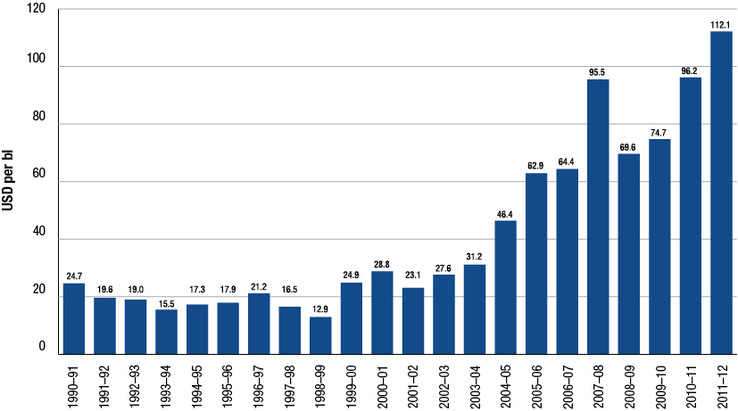
Source: ACCC calculations based on Platts data
While the development of unconventional crude oil deposits such as tar sands and shale/tight reserves may help global markets avoid future short term scarcity, they are unlikely to be so abundant and cheap to extract as to put substantial downward pressure on prices in the long term. Indeed, many future developments of unconventional deposits rely on relatively high crude oil prices to be economically viable.
As noted, crude oil prices peaked in April 2012 and then declined slightly over the course of 2011−12. Further price falls may be possible in the short term if the present uncertain global economic conditions continue. However, in the medium to long term, the price of crude oil is likely to continue to rise.
While in the short term, prices can be expected to continue to be volatile, in the absence of significant and unforseen economic circumstances, it is unlikely that prices such as USD 20 to USD 30 per barrel that existed prior to the last decade will be seen again.
Crude oil benchmarks
Both Tapis and Brent are common crude oil markers used in the Asia-Pacific region. Tapis has been the traditional crude oil marker for South-East Asia and the broader region. However, declining production of Tapis in recent years has seen the emergence of Brent as a key marker for pricing of crude oil cargoes in the region.
In theory, crude oil markers such as Tapis and Brent are to some degree, interchangeable commodities in the global market and in the medium to longer term their prices should vary little from each other, other than for quality differences.
Chart 6 presents price data for these two main crude oil markers over the past 30 years. The chart highlights two fundamental themes: one being the increase in the benchmark prices after 2000 with substantial rises over average prices for the previous decades; and the other showing how movements in the prices of the two crude oil markers appear closely correlated.
Chart 6 Average annual benchmark prices of Brent and Tapis crude oil: 1980 to 2012
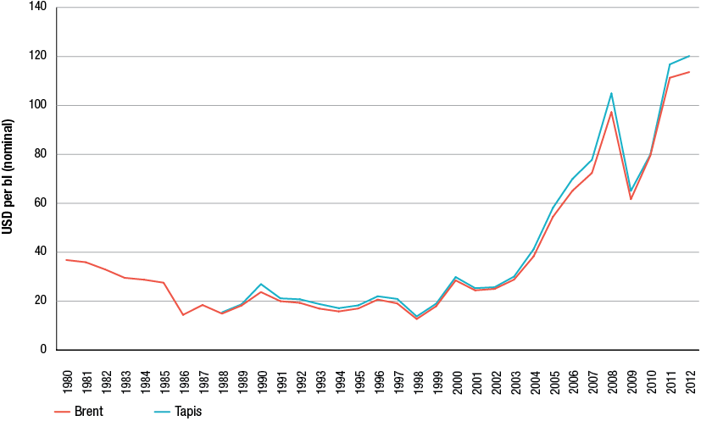
Source: Crude price data from BP Statistical review of world energy 2012
The ACCC continues to be concerned about references in the Australian media to West Texas Intermediate (WTI) when reporting crude oil price movements. The more appropriate crude oil markers for Australia are either Brent or Tapis crude oil.
For some time now, WTI prices have been distorted by the build-up of excess supplies as a result of infrastructure bottlenecks at the land-locked trading hub for WTI at Cushing, Oklahoma. Consequently, the price of WTI is no longer representative of broader global demand and supply conditions and cannot be considered a relevant crude oil marker for countries in the Asia-Pacific region.
Effect of the AUD–USD exchange rate on petrol prices
During 2011−12, the strength of the Australian dollar somewhat protected motorists from higher retail petrol prices than they otherwise may have faced. Since the highs of July 2011, the AUD–USD exchange rate has declined marginally, although it is still above recent long term averages.
Unlike in 2010−11, the exchange rate remained comparatively stable during 2011−12. Chart 7 highlights the effect of the AUD–USD exchange rate on retail petrol prices. The chart shows seven-day rolling average retail prices for the five largest cities from July 2007 to September 2012. The upper line represents what retail prices would have been if the AUD–USD exchange rate had been held constant at the lowest daily exchange rate over the period (that is, around USD 0.61 in October 2008), everything else being equal. The lower line represents what retail prices would have been if the AUD−USD exchange rate had been held constant at the highest exchange rate over the period (that is, around USD 1.11 in July 2011), everything else being equal. In between these is the actual price.
The chart shows that in 2011−12:
- retail prices were at their highest in April 2012 at around 153 cpl. The AUD–USD exchange rate was around USD 1.03 at this time. If the exchange rate had been at its minimum level at this time, retail prices would have been around 215 cpl (or 62 cpl higher)
- retail prices were at their lowest in June 2012 at around 131 cpl. The AUD–USD exchange rate was around USD 1.01 at this time. If the exchange rate had been at its maximum level at this time, retail prices would have been around 124 cpl (or 7 cpl lower)
- a strong AUD–USD exchange rate throughout most of 2011−12 protected consumers to a substantial degree from very high international refined petrol prices.
Chart 7 Seven-day rolling average retail RULP prices in the five largest cities—based on actual, minimum and maximum AUD–USD exchange rates: 1 July 2007 to 30 September 2012
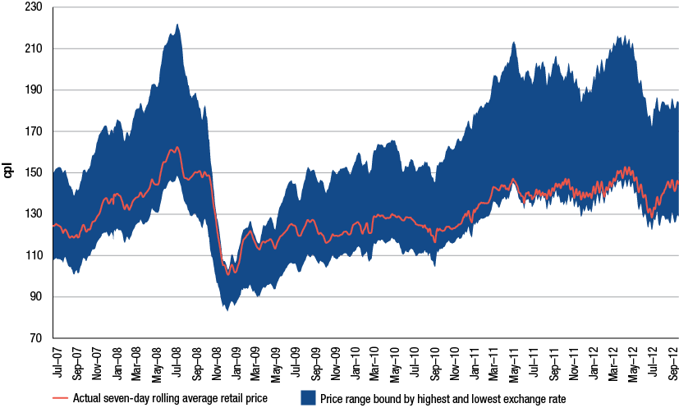
Source: ACCC calculations based on Informed Sources, Platts and RBA data

Petrol price cycles
Retail petrol price cycles continue to be a source of frustration to many motorists. However, some consumers seem to take advantage of the low point in the price cycle to purchase petrol at relatively low prices.
Petrol price cycles have been observed in a number of Australian retail petrol markets for many years. In the larger capital cities, retail petrol prices move in regular cyclical patterns, which are not reflective of movements in underlying costs, wholesale prices or international benchmark prices.
The typical pattern of the petrol price cycle in recent years has been one where prices rise quickly at the outset (over one to three days) and then steadily decline over the rest of the cycle (between six and nine days); that is, they move in a ‘sawtooth’ pattern.
The duration of price cycles in the eastern capital cities has been increasing over the last few years. In 2009 the average duration of price cycles was around seven days whereas by the end of the September 2012 quarter it had increased to over 12 days. In addition, the lowest price day in these cities has moved from Wednesdays in 2009 to other days in the week. Previously consumers could use the regularity of the price cycle to predict low-price days and purchase petrol at relatively low cost. Predicting troughs in the price cycle has become increasingly difficult. This may hinder consumers’ ability to take advantage of low-price days.
In contrast, Perth has had more predictable petrol price cycles with the duration of price cycles consistently being seven days in recent years. Unlike other states, Western Australia has fuel price regulations under which retail sites must keep their prices constant for a 24-hour period and the price at each retail site is publicly available on the FuelWatch website.
Chart 8 shows daily average petrol prices over a seven-week period during May and June 2012 and indicates the price cycles that occurred during this period.
Chart 8 Daily average RULP prices in the five largest cities: 13 May 2012 to 30 June 2012
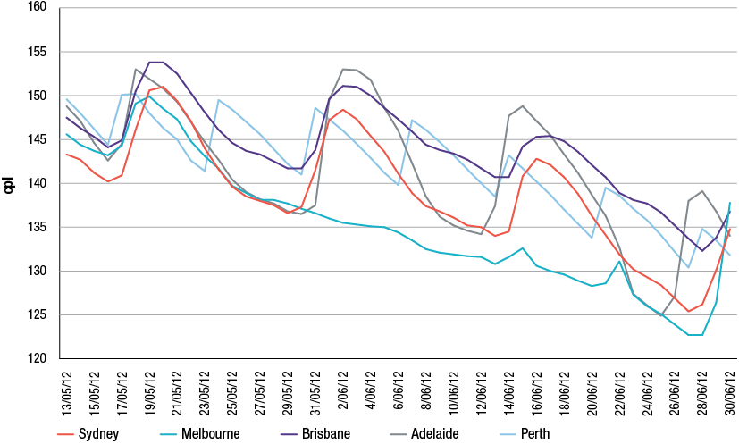
Source: ACCC based on Informed Sources data
Although not as pronounced as in previous years, the regular pattern of these cycles is clearly evident in chart 8. Also clearly evident are the failed price cycles in Melbourne (which have also occurred a number of times in other capital cities in recent years).
The regularity of price cycles and the ability to source real-time pricing data from competitors has enabled the refiner-marketers and other major retailers to understand and predict their competitors’ likely response to changes in their own behaviour.
Analysis has shown that the two refiner-marketers, that is, those integrated refiners with a presence in the retail sector, Caltex or BP have generally led the price cycle up by raising prices at several retail sites in a city by a significant amount and then waited for the market to respond. If the other major retailers respond to this move with a similar increase (which is generally the case) then the price cycle is continued. In some cases where competitors do not respond or delay in responding, the price cycle breaks down and prices can remain low for an entire week or more. The number of price cycles across the five largest cities in 2011−12 has decreased compared with 2010−11.
While they generally do not initiate the discount phase, Woolworths and a number of the independent retailers have been active in this phase of the price cycle.

Retail pricing in the petrol industry
Retail petrol price cycles in Australia are not driven by movements in underlying costs or wholesale prices. Rather, retail price cycles appear to be entirely due to the pricing policies employed by the local petrol retailers. The ACCC observed in its 2007 inquiry report that petrol price cycles do occur in some other countries but those in Australia tend to be larger in amplitude and more consistent. Data is presented in this report on price cycles in certain cities in the US and Canada. Analysis of this data suggests that price cycle increases in Australia are larger than in these cities in the US and Canada.

Information sharing arrangements in the petrol industry
The ACCC has been concerned for some time about the presence of price information sharing arrangements in relation to the retail petrol sector and their potential impact on competition. The petrol price sharing arrangements allow for the private and very frequent exchange of comprehensive retail price information between the major petrol companies. The ACCC has been concerned this allows petrol retailers to quickly signal price moves, monitor competitors’ responses and react to them.
The ACCC is concerned that such arrangements may lessen price competition in petrol retailing to the detriment of consumers.
The ACCC has acted on these concerns and announced in May 2012 that it has commenced an investigation into the competition effects of price information sharing arrangements in relation to the retail petrol sector.
The ACCC has not reached a final view on the possible effects of information sharing arrangements in the petrol industry and its investigation is continuing.

Shopper docket discounting schemes
Shopper docket discounting schemes generally offer discounts on fuel purchases based on purchases at an attached convenience store or from an associated or third-party business. Sales of petrol involving a shopper docket can account for a significant proportion of a petrol retailer’s total fuel sales.
Shopper docket discounting schemes involving petrol have been operated by the two major Australian supermarket retailers, Coles and Woolworths, for a number of years. Discounts of 4 cpl are offered on petrol purchases when a minimum amount is spent on purchases at their supermarkets, typically $30. At various times over the past 12 months, the supermarkets have had discount offers greater than 4 cpl.
In the past, other retailers such as BP, Caltex, United and other independent retailers have also conducted shopper docket discounting schemes. Some of these schemes have been linked to purchases at a local independent supermarket while others combine purchases from their convenience store with offers of fuel discounts.
While the ACCC supports initiatives that aim to provide benefits to consumers, it is necessary to assess such schemes to consider their long term effect on competition and prices. Consequently, in 2012 the ACCC commenced an investigation into the effects of shopper docket discounting schemes on competition and long term consumer welfare. The ACCC is investigating the effects of the size (value), frequency and duration of the discounts offered at retail outlets.
The ACCC has not reached a final view on the possible effects of shopper docket discount schemes and its investigation is continuing.

Retail prices over 2011−12
In 2011−12 retail petrol prices across the five largest cities were higher, but less volatile, than in 2010−11.
Average annual prices in 2011−12 were around 143 cpl, which was around 11 cpl higher than in 2010−11. Moreover, during 2011−12, retail petrol prices were at their highest levels since October 2008.
Chart 9 shows daily average retail prices, as well as seven-day rolling average prices, across the five largest cities over the period 1 July 2011 to 30 September 2012. The regular price cycle is clearly evident.
Chart 9 Daily average retail RULP prices and seven-day rolling average retail prices, five largest cities: 1 July 2011 to 30 September 2012
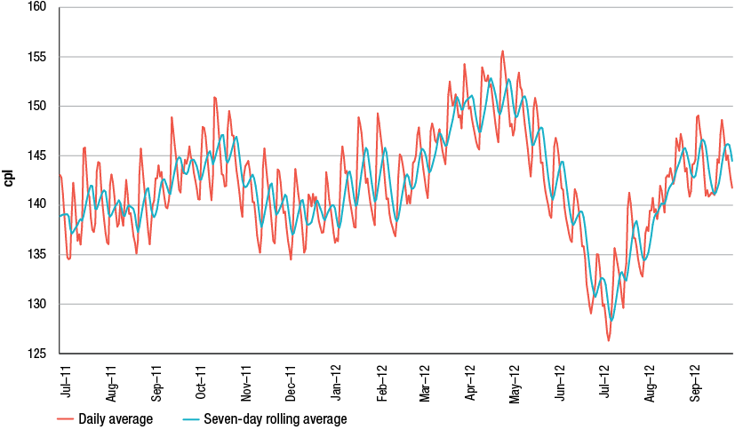
Source: ACCC calculations based on Informed Sources data
Prices varied from a low of around 128 cpl in July 2012 to a high of around 153 cpl in April 2012—a range of 25 cpl. In 2010−11 the range between the highest and lowest prices was 31 cpl.
Retail prices in regional locations
Retail prices in regional locations are largely driven by international benchmark prices and the AUD−USD exchange rate, just as they are in the larger capital cities. However, prices in regional locations in Australia tend to be higher than in capital cities. The ACCC is aware of, and sensitive to, the concerns of motorists in regional locations about the relatively higher prices of petrol in some regional locations.
Prices in regional locations are generally higher than in the capital cities for a number of reasons, including:
- lower number of retail sites and therefore a lower level of local competition
- lower volumes of fuel sold
- distance/location factors
- lower convenience store sales.
These factors also explain differences in petrol prices between regional locations. Price movements in regional locations tend to lag those in the five largest cities. Prices also tend to be more stable in regional locations than in the five largest cities. Only a very small number of regional locations have regular price cycles. These tend to be the larger population centres or locations very close to them.
Chart 10 shows daily average retail prices across all of the regional locations in Australia monitored by the ACCC and daily average retail prices in the five largest cities over the period 1 July 2011 to 30 September 2012. It can be seen that:
- prices in regional locations in aggregate broadly follow prices in the five largest cities
- regional locations in aggregate do not have retail price cycles that are evident in the five largest cities
- the difference between prices in the largest cities and in regional locations tends to widen when prices change rapidly, such as occurred in May and June 2012.
Chart 10 Daily average retail RULP prices in the five largest cities and the regional locations in aggregate: 1 July 2011 to 30 September 2012
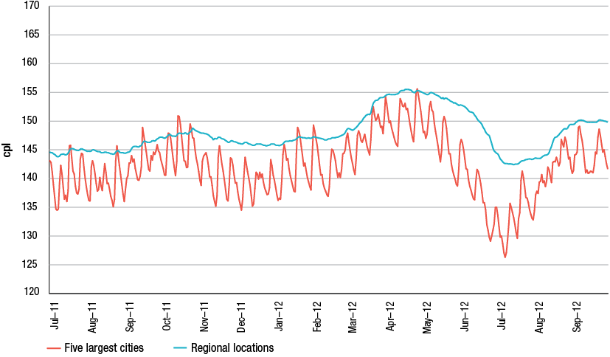
Source: ACCC calculations based on Informed Sources data

Profits
As part of the analysis of the downstream petroleum industry, the ACCC collects extensive financial data by sector from the four refiner-wholesalers and major independent wholesalers and retailers.
Financial data for the period from 2002−03 to 2011−12 was analysed and used to produce estimates on the profitability of the total downstream industry and for each sector, including total supply (which includes the refining sub-sector along with imports and buy sell transactions), wholesale and retail. The ACCC produces estimates of revenues, costs and profits for all products and also for petrol products alone (that is, regular unleaded, premium unleaded and ethanol blended petrol), on a consolidated basis for the entire downstream industry and for each sector.
During 2011−12, total consolidated profits earned by monitored companies across all products in all sectors were $408 million, compared with $2.2 billion net profit for 2010−11. The total supply sector recorded a loss of $1116 million (including losses of around $600 million from domestic refining). The wholesale and retail sectors earned net profits of around $1084 million and $400 million respectively.
On a cents per litre basis, the refinery and total supply sectors recorded losses of 1.6 cpl and 1.54 cpl, while the wholesale and retail sectors made net profits of 2.07 cpl and 2.44 cpl respectively.
The lower profits during 2011−12 partly reflect weaker results in the refinery sector. However, the other key sectors including wholesale and retail continued the trend of improved profits. Average annual total profits accruing to shareholders in the industry over the last 10 years have been around $1.45 billion per annum (see chart 11).
Chart 11 Total downstream net profit (adjusted EBIT), all products: 2002−03 to 2011−12
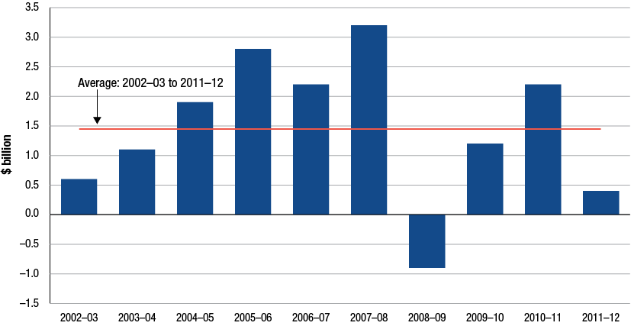
Source: ACCC analysis based on data obtained from firms monitored through the ACCC’s monitoring process
Downstream profits on petrol products are a small proportion of retail prices
The ACCC has estimated profitability per litre of petrol products (that is, regular unleaded, premium unleaded and ethanol blended petrol) sold in the entire downstream industry—this is a measure of the difference between the average revenue per litre of petrol sold and the average cost for the entire industry to purchase crude oil and process and market/sell refined petrol.
The ACCC has found that only a small proportion of the final petrol bowser price has been retained as profits by the entire downstream petroleum industry.
During 2011−12, petrol products recorded a unit net loss of 0.03 cents on each litre sold compared with a unit net profit of 2.17 cpl in 2010−11 as shown in chart 12. Over the past 10 years unit net profits earned by petrol companies from the sale of a litre of petrol averaged around 1.43 cpl for the entire downstream petroleum industry.
Chart 12 Total downstream unit net profit, petrol products (RULP, PULP and EBP) (cents per litre): 2002−03 to 2011−12
Source: ACCC analysis based on data obtained from firms monitored through the ACCC’s monitoring process
Australian refinery sector profits
The Australian petroleum refinery sector has in general, recorded comparatively low net profits and rates of return, particularly since the global financial crisis (GFC).
The refinery sector incurred losses of around $600 million during 2011−12 compared with a net profit of $348 million in 2010−11. Chart 13 shows net profit in the refinery sector since 2002−03.
The financial performance of the refinery sector in 2011−12 was adversely affected by higher costs, reflecting an increase in operating and conversion costs, the effects of unplanned refinery shutdowns, losses on the values of inventory holdings and foreign exchange transactions. If the recent refinery write downs in refinery asset values were included in profit calculations, the refining sector would have shown a loss for the year of $2.8 billion.
Chart 13 highlights two distinct phases of financial performance of the refinery sector over the past 10 years. This sector experienced higher profits in the years prior to the GFC (2002−03 to 2007−08) than in the aftermath of the GFC. Annual net profits pre-GFC averaged around $1120 million compared to the average annual post-GFC loss of $156 million. The recent write down of the value of the Caltex and Shell refinery assets (and the closure of the Shell Clyde refinery, and the announced closure of the Kurnell refinery in Sydney) are evidence of an industry that is facing an uncertain future with relatively low profits and fierce international competition from more modern refineries in the Asia-Pacific region for fuel refined to Australian standards.
Chart 13 Refinery sector net profit, all products: 2002−03 to 2011−12
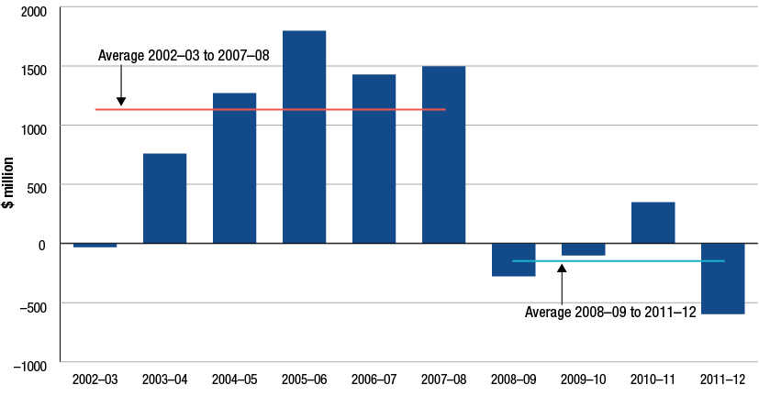
Source: ACCC calculations based on data obtained from firms monitored through the ACCC’s monitoring process

Costs
Nominal components of cost
Although petrol retailers have some discretion in determining their prices, the largest components of the pump price, the international price of refined petrol and taxes (excise and GST), are outside the control of local retailers and other petrol companies.
The two largest components of petrol, diesel and LPG prices are:
- the respective international benchmark prices for refined petrol, diesel and LPG
- GST and excise (for petrol and diesel—there is currently minimal excise imposed on LPG).
In 2011−12, international benchmark prices and taxes accounted for around 88 per cent of the average annual retail price of petrol. That is, of an annual average retail price of 142.8 cpl, 126.0 cpl is directly attributable to the cost of refined petrol and taxes (see chart 14).
For diesel, these two components also accounted for 88 per cent of the bowser price in 2011−12 (see chart 15).
For LPG, the international benchmark price and GST accounted for 79 per cent, in part reflecting the lower level of excise on LPG (see chart 16).
Other costs and margins therefore accounted for around 17 cpl of the retail price of petrol, 18 cpl for diesel and 15 cpl for LPG. This amount covers a number of costs including transport and freight, salaries, repair and maintenance, storage and terminal costs, across all sectors of the downstream petroleum industry.
Chart 14 Nominal components of Australian retail RULP prices in the five largest cities: 2011−12
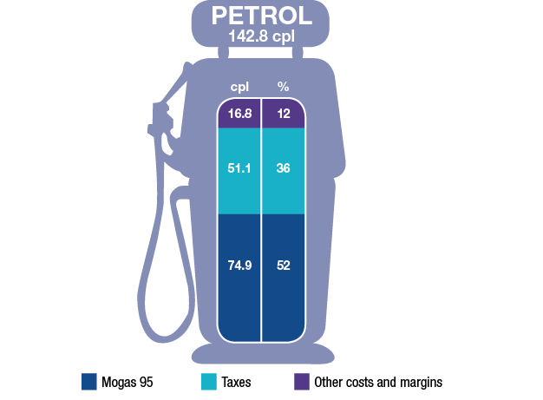
Source: ACCC calculations based on Informed Sources, Platts and RBA data
Chart 15 Nominal components of Australian retail diesel prices in the five largest cities: 2011−12
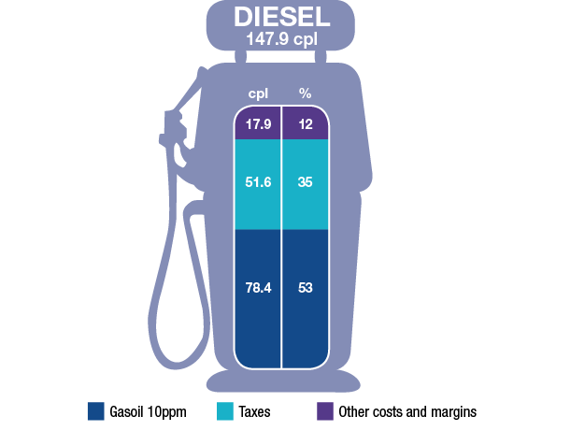
Source: ACCC calculations based on Informed Sources, Platts and RBA data
Chart 16 Nominal components of Australian retail LPG prices in the five largest cities: 2011−12
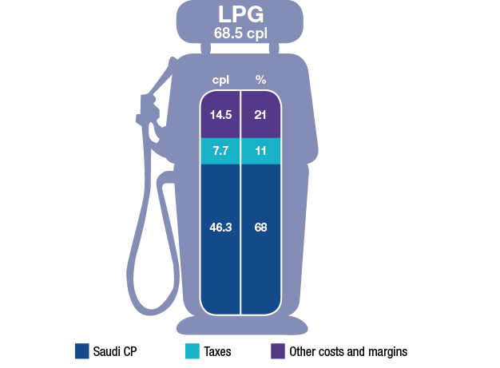
Source: ACCC calculations based on Informed Sources, LPG Australia and RBA data

Components of the pump price
Chart 17 shows a more detailed breakdown of the components of the annual average retail price of RULP across the five largest cities from 2007−08 to 2011−12.
Each bar represents the annual average retail price disaggregated into the following:
- Tapis crude oil—the benchmark for crude oil in the Asia-Pacific region (including Australia)
- excise (which is set at a constant 38.14 cpl) and GST
- gasoline crack—the difference between the price of Mogas 95 and Tapis crude oil
- wholesale costs and margins (excluding excise and GST)
- retail costs and margins (excluding GST).
Chart 17 Components of annual average retail RULP prices in the five largest cities: 2007−08 to 2011−12
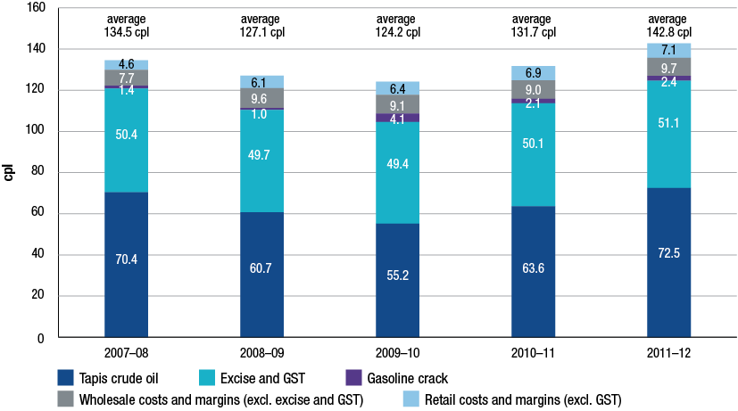
Source: ACCC calculations based on Informed Sources, Platts, RBA and WA FuelWatch data, and information provided by monitored companies
Chart 17 shows that changes in the international price of crude oil have been overwhelmingly responsible for movements in average retail petrol prices over the last five years. The components attributable to excise and GST and to the local petrol companies have been relatively stable over the period.
The price of crude oil is one of the main factors driving international refined petrol prices. Because costs associated with the exploration and development of crude oil deposits are largely fixed in the short term, it is the owners of crude oil that accrue the greatest benefits as international prices rise over time.
Between 2008−09 (when international prices began to rise in the aftermath of the GFC) and 2011−12, the average annual pump price of RULP increased by around 15.7 cpl. Most of this increase, 11.8 cpl, has flowed back to the suppliers (owners and extractors) of crude oil. By contrast, the amount flowing back to the domestic petrol companies over the same period increased by about 2.5 cpl, to cover increased operating costs in refining and in the wholesale and retail sectors. Taxes accounted for 1.4 cpl of the increase in average annual prices since 2008−09.

Conclusion: prices, costs and profits
- Movements in the international price of crude oil have driven movements in regional refined petrol prices (as reflected in the benchmark price of Mogas 95) which in turn have driven movements in Australian retail petrol prices.
- In any particular week, retail price cycles in the largest capital cities may cause divergences from the benchmark prices, depending on the phase of the price cycle.
- Total net profits for the entire downstream petroleum industry in 2011−12 were significantly down on the previous year.
- Most of the benefits from higher fuel prices in recent years have been captured by the owners and producers of crude oil.

Recent developments in the fuel industry
Ethanol blended petrol
Ethanol is added to petrol to produce various grades of ethanol blended petrol (EBP). The most common EBP is E10, which is RULP containing up to 10 per cent ethanol.
Total sales of EBP in Australia decreased in 2011−12, reversing the trend of previous years. Sales remained broadly stable in NSW but decreased significantly in Queensland and Victoria. Similarly the number of retail sites selling E10 across Australia decreased in 2011−12. The largest volume of EBP is sold in NSW, which accounts for over 80 per cent of the Australian EBP market.
Chart 18 shows EBP sales as a proportion of total petrol sales in the major states and Australia as a whole during the period 2005−06 to 2011−12. It shows that in 2011−12:
- in NSW there was a marginal increase (by 1 percentage point to 36 per cent) in the share of EBP of total petrol sales
- in Queensland there was a significant decrease (by 8 percentage points to 11 per cent)
- in Victoria there was a decrease (by 2 percentage points to 1 per cent)
- across Australia as a whole there was a decrease (by 2 percentage points to 14 per cent).
Chart 18 Ethanol blended petrol sales as a proportion of total petrol sales in the major states and Australia: 2005−06 to 2011−12
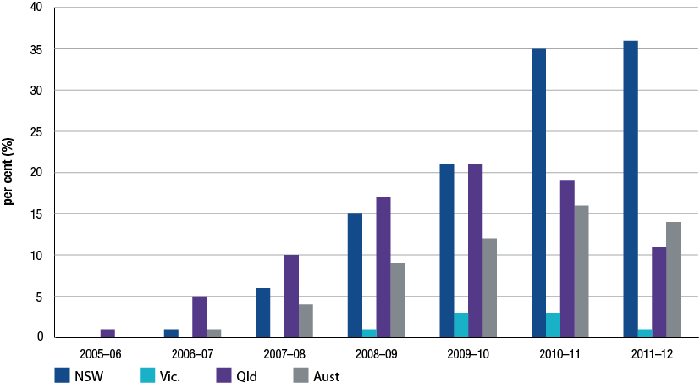
Source: ACCC calculations based on the Department of Resources, Energy and Tourism (RET) and BREE, Australian Petroleum Statistics, various issues
Across all locations monitored by the ACCC in 2011−12, average RULP prices were higher than average E10 prices by around 1.8 cpl. In previous years the ACCC has expressed concern about the supply of ethanol. However, in 2011−12 there appeared to be sufficient supply to meet demand.
There is no Australian Government mandate covering the supply of EBP in Australia. NSW is the only state government to introduce a mandate on the supply of EBP.
The NSW ethanol mandate was introduced in 2007 and required that, from 1 October 2007, 2 per cent of the total volume of petrol sold in NSW be ethanol. On 1 January 2010 the mandated level increased to 4 per cent and on 1 October 2011 it increased to 6 per cent. The final phase of the NSW mandate (i.e. requiring all RULP to be replaced with E10) was set to be introduced on 1 July 2012. However, on 31 January 2012 the NSW Government announced that it would introduce legislation to remove this requirement and that the ethanol mandate would remain at 6 per cent of total fuel sales. Legislation to this effect was passed by the NSW Parliament in May 2012.
The operation of the NSW ethanol mandate has had some significant impact on consumers:
- The mandate has reduced the availability of RULP from many retail sites but consumers have been able to source RULP from the retail sites excluded from the requirements of the legislation (retail sites are excluded if they are part of an operation of 20 or fewer sites). These retail sites comprise around 25 per cent of retail sites in NSW.
- The 2011 ACCC petrol monitoring report noted that some motorists who cannot use E10 may be forced to use PULP. The amendment to the NSW legislation means that motorists who cannot use E10 in their vehicles will now not be forced to switch to PULP.
While the review by the NSW Independent Pricing and Regulatory Tribunal into ethanol supply and demand in NSW found that supply is likely to be sufficient to meet demand, it noted that as there are only three ethanol suppliers in Australia (and one supplier provides two-thirds of total supply), supply may be unreliable if one of the suppliers is unable to produce.
In the past, the ACCC has acknowledged industry concerns about the potential impact of the ethanol mandate on supply and prices. The ACCC intends to continue to closely monitor the market for EBP in the coming year.
Refining
The structure of the domestic market continues to evolve broadly in line with international trends. Integrated refiner-marketer oil companies continue to move away from lower margin downstream activities to concentrate on oil exploration and extraction.
This year saw a number of important developments in the Australian refining industry. Generally the Australian petroleum refining industry seems to be facing a challenging future as some refiner-wholesalers reassess their refinery operations.
Prior to the GFC the refining sector in Australia was characterised by larger volume production and higher profits and rates of return than have been seen in the post-GFC period. Conditions in the pre-GFC period were characterised by:
- buoyant economic conditions and growth
- Australian fuel market being short (or shorter) on product due to the cessation of refining operations at Mobil’s Port Stanvac refinery in 2003
- difficulty in sourcing Australian standard product for importing, particularly in the Asia-Pacific region
- limited access by independent importers to import terminals.
In contrast, the post-GFC period for Australian refining is characterised by comparatively smaller production volumes and lower profits and rates of return. The reasons for this include:
- weaker economic conditions and flat growth
- the impact of large complex refineries in emerging economies, such as Jamnagar in India, with the capacity to refine petrol to Australian standards at competitive prices. Further planned openings of refineries in China and Saudi Arabia are likely to add to the availability of Australian standard petrol
- the ability of independent wholesalers to access storage capacity in import terminals and to import refined fuel at competitive prices.
In early 2012, there were seven refineries operating in Australia. By mid-2014 Australia will have five refineries in operation. Shell brought forward the closure of its Clyde refinery by nine months and closed the refinery in October 2012. Shell will convert the refinery, along with the Gore Bay terminal into an import facility. Shell has stated that the Clyde refinery was no longer regionally competitive against Asian mega-refineries. Recent media reports suggest that Shell is also considering the future of its Geelong refinery.
The Caltex review of its refinery operations saw the announcement in July that in 2014 its Sydney refinery at Kurnell will be closed permanently and turned into an import terminal. Caltex will be left operating only one refinery located in Brisbane. The announcement means that Sydney will have no refineries and all petroleum products will have to be sourced internationally or from refineries located in other states.
Evidence from Australia and overseas suggests that the Australian refinery sector may be facing a challenging future. The US Energy Information Administration noted, as refineries around the world become larger and more complex, small and older refineries (such as those still operating in Australia) will find it increasingly difficult to remain viable.
As petrol prices are set on the basis of import parity, Australian refiners have little scope to increase prices to cover domestic costs that may be out of line with international best practices. Being older and smaller than newly constructed refineries in the Asia-Pacific region, Australian refineries will continue to face a tough competitive climate in the foreseeable future.
Increase in independent imports
Imports by independent wholesalers continued to increase in 2011−12. However, due to increased import activity by the refiner-wholesalers, independent imports accounted for a slightly smaller share of total imports in 2011−12 compared with 2010−11. In 2011−12 independent imports accounted for about 30 per cent of total imports, compared with over 40 per cent in 2010−11. Independent imports have increased more than four-fold since 2007−08 when they represented less than 5 per cent of total imports.
While still relatively small, independent imports continue to provide an increasingly strong source of competitive discipline on the larger players.
One of the key factors driving the growth in independent imports has been greater access to import terminals. There has been a significant increase in the number, capacity and accessibility of independently-owned import terminals. The bulk of new investment in import terminals in the last few years has been undertaken by independent terminal owners. Reflecting this trend, refiner-wholesalers as well as smaller wholesalers/importers are increasing their use of independently-owned terminals.
In the past five years, at least four independent wholesalers have imported refined petrol from various overseas markets. Currently, three of the monitored companies—Ausfuel, United and Neumann—own, or have access to, import infrastructure.
Retail
While the retail sector was relatively stable during 2011−12 compared with previous years, some rationalisation of sites occurred. Ausfuel acquired retail sites in Queensland while 7-Eleven continued the conversion of ex-Mobil retail sites to 7-Eleven branding and convenience facilities.
Table 1 displays the current share of retail volume between the refiner-marketers, supermarkets and independent retail chains.
Table 1 Share of volume of retail petrol sales by brand: 2002−03 to 2011−12
 | BP  % | Caltex  % | Mobil  % | Shell  % | Coles Express/Shell  (co-branded)  % | Woolworths/ Caltex  (co-branded)  % | Independent retail chains  %
2002−03 | 20 | 24 | 19 | 20 | – | 10 | 6
2003−04 | 20 | 22 | 17 | 3 | 16 | 14 | 7
2004−05 | 18 | 18 | 12 | 3 | 25 | 18 | 6
2005−06 | 19 | 16 | 11 | 3 | 25 | 20 | 6
2006−07 | 19 | 16 | 11 | 3 | 22 | 22 | 7
2007−08 | 20 | 17 | 11 | 2 | 20 | 22 | 8
2008−09 | 19 | 16 | 10 | 2 | 22 | 23 | 9
2009−10 | 17 | 16 | 10 | 2 | 22 | 23 | 10
2010−11 | 19 | 18 | – | 2 | 22 | 23 | 17
2011−12 | 16 | 18 | – | 2 | 23 | 24 | 17

Source: ACCC analysis and estimates based on data obtained from firms monitored through the ACCC’s monitoring process.
Notes: Data is only for monitored companies, so does not include the total volume of retail sales in Australia.
Independent retail chains are: 7-Eleven, On The Run, and the retail operations of Neumann, United and Ausfuel. In 2002−03 Woolworths was not co-branded with Caltex. Totals may not add to 100 per cent due to rounding.
The significant increase in independent retailers’ share of retail sales in 2010−11 was due to the effects of the acquisition by 7-Eleven and On The Run of the Mobil retail network during October 2010.

Role of the ACCC
The ACCC considers that competitive markets generally provide consumers with the lowest sustainable prices. This is true for petrol products also.
The downstream petroleum industry is not regulated by the ACCC and it has no role in setting petrol prices. Petrol prices in Australia are set by market forces.
The ACCC has two broad roles in relation to the petrol industry:
1. The ACCC enforces competition and consumer protection laws across Australia
The ACCC is an independent statutory authority that administers the Competition and Consumer Act 2010 (formerly the Trade Practices Act 1974) (the Act) and other laws. The purpose of the Act is to enhance the welfare of Australians through the promotion of competition and fair trading and provision for consumer protection. These laws apply to all industry sectors, including the fuel industry.
The most relevant work of the ACCC in the fuel industry relates to its role in enforcement and compliance with the Act, assessing mergers and acquisitions and authorisations and notifications.
2. Monitoring the prices, costs and profits relating to the supply of unleaded petroleum products in the petroleum industry
In December 2007, the minister directed the ACCC to undertake monitoring of the prices, costs and profits relating to the supply of unleaded petroleum products in the Australian petroleum industry for three years to the end of 2010. On 13 May 2010, the minister subsequently extended the direction for a further year to the end of 2011. On 10 May 2011, the minister issued a further direction for the ACCC to prepare a monitoring report to the end of 2012. An additional direction issued by the Minister on 6 July 2012, means that the ACCC will be required to prepare a sixth monitoring to the end of 2013. The ACCC provides the minister with a report on its monitoring activities in December each year. A copy of the minister’s direction for 2011−12 is at appendix A.
The ACCC collects fuel prices in each capital city and around 180 regional locations. The ACCC reviews these prices and compares them with the international benchmarks. Each year, the ACCC also obtains revenue, cost and profit information from monitored petrol companies. The ACCC uses this information to compare Australian prices, revenues, costs and profits against international benchmarks. The minister has also asked the ACCC to focus on the prices of diesel and LPG.
If ACCC analysis indicates there are factors impairing competition in fuel markets it can alert the government and community to the problem, as it did with its concerns on the prices and supply of EBP.

Enforcement and compliance
Misleading conduct and false representations
Many of the contacts the ACCC received in 2011−12 about compliance with the Act related to alleged misleading and deceptive conduct and false or misleading representations. Conduct will be in breach of the Act where it misleads, deceives or is likely to mislead or deceive consumers. Such conduct may include lying to consumers, leading them to a wrong conclusion, creating a false impression or making false or inaccurate claims.
The main issues raised by consumers regarding the downstream fuel industry included the high price of fuel (around 53 per cent of all complaints), and allegations of potential compliance issues under the Act (around 23 per cent).
Price information sharing
During 2012, the ACCC commenced a formal investigation into price information sharing arrangements in relation to the retail petrol sector. The ACCC is concerned that such arrangements may be in breach of the Act. The petrol price sharing arrangements allow for the private and very frequent exchange of comprehensive retail price information between the major petrol companies.
The ACCC is concerned that the information sharing arrangements may allow petrol retailers to signal price movements, monitor competitor responses and then react to them. The ACCC’s review of these arrangements is continuing.
Petrol shopper docket discounting schemes
The ACCC is examining whether competition issues arise from the size (value), frequency and duration of discounts offered through shopper docket discounting schemes. Competition concerns arising from the increased use of shopper docket petrol vouchers, the extended periods of discounting as well as the value of the discounts have been raised with the ACCC.
While the ACCC’s 2007 inquiry into the price of unleaded petrol concluded that the introduction of shopper docket discounts offered by the major supermarket retailers appeared to have delivered a net benefit to consumers, the report also noted that the ACCC would continue to consider developments in the petrol retail sector. In particular, the ACCC noted that it would continue to monitor changes in the nature and extent of any impact of shopper docket discounting schemes on competition.
The ACCC’s 2012 review of shopper docket discounting schemes is continuing.
Business to Business dealings
The ACCC has conducted a number of investigations into fuel quality issues, including actual fuel testing at some retail locations. Further testing at these locations subsequently revealed that the fuel met required standards and no action was taken. The ACCC has also investigated fuel labelling standards at some retail sites during 2012.
During this time the ACCC assessed a number of matters; however, no allegations were able to be substantiated.
Markets in regional Australia
As part of its monitoring activities in 2011−12, the ACCC continued to actively monitor fuel prices in around 180 regional locations throughout Australia.
The ACCC uses this information to assess the competitiveness of fuel prices in regional areas. Where there is an allegation of anti-competitive conduct, it will make targeted inquiries to investigate the issue. After making inquiries, if there is information available to the ACCC that a breach of the Act is likely to have occurred, it may take legal action to enforce the Act.
Given that regional locations may only have a limited number of retail sites the ACCC pays particular attention to potential changes in ownership of service stations in regional locations to ensure that the sale would not result in a substantial lessening of competition in that particular market.
Mergers and acquisitions
Section 50 of the Act prohibits acquisitions that would have the effect, or likely effect, of substantially lessening competition in a market. The ACCC administers and enforces the merger provisions under Part IV of the Act. Over 2011−12, the ACCC completed public reviews of four fuel-related merger proposals.
Authorisations and notifications
In certain circumstances, the ACCC can grant protection from legal action for certain anti-competitive conduct where that conduct delivers an offsetting public benefit. Businesses may obtain protection from legal action by applying for an authorisation or lodging a notification with the ACCC. All authorisation applications and notifications are available on a public register and on the ACCC’s website.
Authorisations
Authorisation is a process under which protection can be provided for potential breaches of the competition provisions of the Act, except for misuse of market power, if the ACCC is satisfied the conduct delivers a net public benefit. There were no fuel-related authorisations lodged with the ACCC in 2011−12.
Exclusive dealing notifications
For certain types of conduct, including exclusive dealing, protection from legal action under the Act can also be obtained by lodging a notification with the ACCC. Exclusive dealing involves placing restrictions on the supply of goods or services such as requiring a person to purchase goods from a third-party supplier (known as third line forcing).
In 2011−12, the ACCC considered 11 fuel-related third line forcing exclusive dealing notifications, all of which were allowed. The third line forcing conduct under the notifications fell into two broad categories:
- shopper docket arrangements involving IGA supermarkets
- supply arrangements requiring the acquisition of goods or services from nominated suppliers.
Administration of the Oilcode
The Oilcode aims to regulate the conduct of suppliers, distributors and retailers in the downstream petroleum retail sector. It came into effect on 1 March 2007 as a prescribed industry code of conduct under the Act. In 2009, the Department of Resources, Energy and Tourism released its review of the Oilcode and made 11 recommendations. The recommendations were accepted by the government in 2011 and amendments came into effect on 3 July 2012. A further review of the Oilcode will be conducted in 2013.
The ACCC’s role is to ensure compliance with the Oilcode and the Act by informing downstream petroleum industry participants of their rights and obligations under the law and by enforcing the law where necessary. In 2011−12, the ACCC received one complaint and four inquiries about the Oilcode. The complaint was not pursued because there was insufficient evidence to establish a breach of the Oilcode or the Act.

Level of compliance with the Act
During 2011−12, the ACCC Infocentre received a total of 197 963 phone calls, 70 891 emails and 18 389 letters during 2011−12. Of these, just over 1300 contacts raised issues in respect of fuel. The majority of these complaints related simply to the fact that market prices were high rather than allegations of a breach of the Act. The ACCC, however, undertook a number of investigations into conduct that may breach the Act.
The ACCC will continue to monitor the operation of the petroleum industry and will take appropriate action where there is evidence of any breaches of the Act.
- Background and objectives
  - Current role of ACCC in the petrol industry
The ACCC’s main roles in the petrol industry include:
- enforcement and compliance: ensuring compliance with and enforcement of the provisions of the Competition and Consumer Act 2010 (the Act) in the petrol industry
- monitoring: including preparing annual monitoring reports as directed by the minister
- public information and education: informing the public about the petrol industry.
Under the Act, the ACCC may also be required to fulfil other specific functions including responsibilities to hold price inquiries. A full account of the ACCC’s activities in relation to the petroleum industry over 2011−12 is set out in chapter 2.
    - Enforcement and compliance
The ACCC enforces competition and consumer protection laws in the petrol industry, as it does with other sectors of the Australian economy. The ACCC pays particular attention to the operation of competition to ensure that petrol companies are complying with the Act. The Act prohibits conduct such as price fixing, predatory pricing, misleading advertising and mergers that substantially lessen competition. Since March 2007 the ACCC has also had responsibility for ensuring compliance with the Oilcode.
    - Monitoring
The ACCC monitors the prices, costs and profits of unleaded petroleum products, including regular unleaded petrol (RULP), premium unleaded petrol (PULP) and ethanol blended petrol (EBP) as well as the prices of diesel and automotive liquefied petroleum gas (LPG).
The ACCC’s monitoring activities include preparing an annual monitoring report for the government in accordance with Part VIIA of the Act.
    - Public Information and Education
As part of its role in promoting well informed markets, the ACCC provides wide-ranging information to consumers on the petrol industry. The ACCC’s website contains links to regularly updated price data, factsheets and other publications on fuel issues.
In addition, the ACCC responds to fuel enquiries from members of the public and from Commonwealth and state and territory parliamentarians.
    - Other functions
Under Part VIIA of the Act the ACCC can undertake the following functions:
- hold price inquiries
- examine proposed price rises for goods and services that have been declared by the minister
- monitor prices, costs and profits of an industry or business that the minister directs it to monitor, and reporting the results to the minister and making them publicly available.
The minister’s direction to the ACCC to monitor prices, costs and profits in the unleaded petroleum industry was issued pursuant to section 95ZE in Part VIIA of the Act.
Under section 95ZK of the Act, the ACCC can compel the provision of information and documents relevant for the ACCC’s functions under Part VIIA.
  - The 2012 Monitoring Report
This is the fifth monitoring report on the petrol industry prepared by the ACCC since the original direction by the Minister for Competition Policy and Consumer Affairs in December 2007. This report follows monitoring reports provided to the minister in December of 2008, 2009, 2010 and 2011.
    - Objectives of the Monitoring Report
The key objectives of the monitoring program derive from the minister’s letter and direction as well as the ACCC’s responsibilities under the Act. Accordingly, through the monitoring program the ACCC has sought to:
- increase the level of information available and improve consumer awareness regarding the petrol industry
- provide a description and analysis of trends in prices, costs and profits as directed by the minister
- focus on information that sheds light on those sectors of the industry where competition may be less than fully effective and on industry conduct that may warrant further consideration by the ACCC.
    - Minister’s Direction
This monitoring report (the 2012 ACCC petrol monitoring report) has been prepared in response to a direction issued on 9 May 2011, by the then Parliamentary Secretary to the Treasurer, the Hon. David Bradbury MP, to monitor the prices, costs and profits of unleaded petrol in Australia. The direction is to monitor for a period of 12 months and report to the minister by 17 December 2012. A copy of the minister’s direction is at appendix A.
This direction followed directions issued on 17 December 2007 by the then Assistant Treasurer and Minister for Competition Policy and Consumer Affairs, the Hon. Chris Bowen MP, to undertake monitoring for three years to the end of 2010, and on 13 May 2010, by the then Minister for Competition Policy and Consumer affairs, the Hon. Craig Emerson MP, to monitor for a period of 12 months to the end of 2011.
In February 2008, the minister also asked the ACCC to increase its focus on diesel and LPG prices.
On 6 July 2012, the Assistant Treasurer, the Hon. David Bradbury MP, extended the direction to the end of 2013.
    - Scope of the Monitoring report
This monitoring report follows a similar approach and framework to previous monitoring reports and again covers the three major segments of the Australian petrol industry: total supply (refining and importing), wholesaling and retailing. These are illustrated in figure 1.1.
Figure 1.1 Scope of the 2012 petrol monitoring report
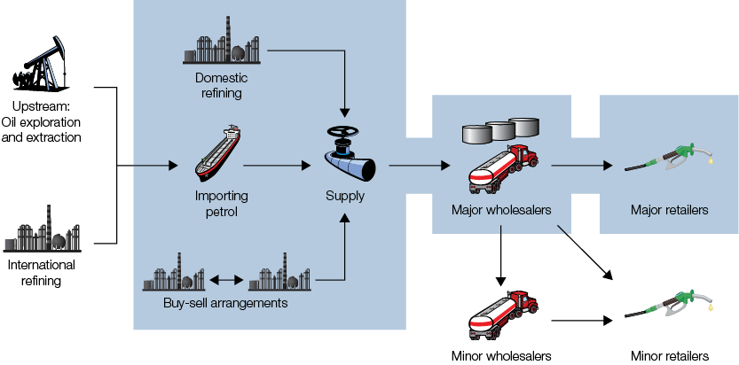
The ACCC has focussed on the Australian domestic industry and has not sought data from overseas suppliers of crude oil or refined product, domestic producers of crude oil or from minor wholesalers and retailers.
The report analyses data on wholesale and retail prices and volumes of petrol products including: RULP, PULP, EBP, LPG and diesel.
The report presents detailed cost, revenue and profitability data for the total supply (refining and import), wholesale and retail sectors. However, as with previous monitoring reports, the 2012 monitoring report also considers international factors that influenced the Australian industry, developments in the market for biofuels and the latest trends in the industry.
In addition, the 2012 monitoring report again explores Australia’s experience with wholesale and retail prices compared with other countries.
  - Data collection
    - Process
For the 2012 monitoring report, the ACCC’s approach to data collection was similar to previous monitoring reports.
Meetings with representatives from major industry participants were held during February and March 2012 to discuss the 2011 ACCC petrol monitoring report and the data requirements and monitoring processes for the 2012 monitoring program. Data templates were provided in two tranches to the refiner-marketers, independent wholesalers, importers, terminal owners/operators and retailers. Data was sought on wholesale, import and retail transactions, pricing benchmarks and financial performance. The templates sent to terminal owner/operators sought information on the operation and capacity of import terminals.
The following companies have provided information for the 2012 monitoring report:
- refiner-marketers: BP and Caltex
- refiner-wholesalers: Mobil, Shell, BP and Caltex
- supermarket chains: Coles Express and Woolworths Petrol
- independent wholesalers: Liberty, United, Ausfuel and Neumann
- independent retail chains: Ausfuel, United, Neumann, 7-Eleven and On The Run
- terminal owners/operators: Vopak, Stolthaven, Gekko, Terminals Pty Ltd and Coogee Chemicals.
The ACCC wishes to thank the companies for the information provided for this report.
    - Data issues
In 2012 the ACCC encountered a number of recurring issues in collecting and processing data. These are further explored below.
Product Coverage
While the focus of the 2012 monitoring report is on the prices, costs and profits of unleaded petrol products (RULP, PULP and EBP), these are only a subset of the products sold in the Australian downstream petroleum market. Australian refineries also produce diesel and LPG as part of a range of motoring fuel products. Some companies that supply these products to the Australian market also sell non-fuel products and services.
In order to provide broader industry context, data has also been collected on other products and services, mainly diesel, LPG and non-fuel retail sales.
Estimating costs
Measuring costs of individual products in the Australian downstream petroleum industry can be difficult.
Many costs cannot be directly attributed to a particular product or service. Often costs are common to many outputs. In some cases, it may be more efficient to produce a range of products and services jointly than it is to produce each product individually. In these cases, costs cannot be unambiguously attributed to a particular product or service.
For example, petroleum products are produced jointly as part of a suite of products. The nature of petrol refining is such that refiners find it more efficient and economical to employ refinery processes and staff to produce RULP, PULP, EBP, diesel and LPG jointly rather than individually. Similarly, in retail many costs are common to the supply of fuel and non-fuel products (and services) as they are often sold from the same premises and by the same staff.
The existence of common and joint costs means that costs must be ‘allocated’ to individual products. Australia’s refining and retail companies do not generally measure profits for individual products and services and hence do not allocate costs to each individual product.
In order for the ACCC to report on the prices, costs and profits of each petrol product, it has been necessary to collect information on the full range of petrol products in each sector. In refining, the ACCC has estimated profits for a particular petrol product by allocating refinery common and joint costs to each product. In retail, the ACCC has had to allocate total retail expenses between fuel and non-fuel items, and between the different types of fuel sold.
There is no exact way of allocating unattributable costs. While, the ACCC has used well accepted cost allocation rules and conventions such as production volumes, sales volumes and sales values, it is prudent, when interpreting data presented in this report, to be cognisant of the fact that there are no objective criteria for defining the most appropriate approach.
Cost basis
The basis used for measuring and reporting costs can have an impact on financial results. Broadly, there are two main ways of reporting financial data: on a historical cost basis, and on a current or at-market cost basis.
Most operating cost items are reported on a current cost basis as they are expensed against income in the same year that they are incurred. However, assets or long life inventories are expensed over the course of their economic lives. In an environment of relative price stability historical cost values and current cost values are likely to produce roughly approximate results. However, when prices are volatile, the measures produced by historical cost and current cost can be expected to diverge.
Some costs in the petrol industry can be volatile. The major input into the production of refined petrol—crude oil—can be subject to rapidly changing prices. Crude oil is a globally traded commodity whose price is affected by the interplay of world demand and supply conditions. The price of crude oil can change significantly between the time of purchase and the time it is used to produce refined petrol. Because the price of crude oil is an important determinant of the price of refined petrol, the use of historical cost at a time of rapidly changing prices means that refining profits are affected by timing considerations. With current cost data, the effects of changing crude prices are excluded from profit measures.
Financial data has been reported to the ACCC on a historical cost basis. As such, it is appropriate to interpret the financial results presented in this report with caution as price changes outside the control of companies can have a material impact on reported profits.
The ACCC has accepted data on a historical cost basis because not all companies typically report current costs and because historical cost reporting is consistent with Australian and international accounting standards.
Data Templates
In the petrol industry, as with other industries, different companies use different business models, organisational structures and reporting systems. Even among petrol companies that operate in the same sector, there are differences in the way they operate and report data.
Differences in company reporting structures and accounting systems can complicate comparison of data across companies.
While the ACCC has sought to use data templates that as far as possible mirror companies’ own reporting frameworks, in order to ensure that data collected in the monitoring program is comparable across companies it has been necessary to use standardised data templates.
The design and conceptual basis of the financial and transactional data templates for 2012 were largely the same as for 2011.
In 2012, data was also requested on ethanol purchases. This was prompted by on-going concerns about ethanol supplies and the impact of the cost of ethanol on the retail price of ethanol blended petrol, particularly in New South Wales. The design of the data template used to collect data on ethanol purchases reflects comments from major industry participants.
Sectoral Coverage
The sectoral coverage of the ACCC’s monitoring programme varies across sectors. The Australian downstream petroleum industry consists of four companies that own refineries (BP, Caltex, Mobil and Shell), a number of independent wholesalers/importers (Ausfuel, United, Neumann), many specialist wholesalers (including Liberty) and a large number of retailers, including the retail networks of two refining companies and the independent wholesalers/importers.
Data has been collected on the refining operations of all four refiner-wholesalers. However, as the wholesale and retail sectors include a large number of small and independent operators from which it was not possible to collect data, the coverage of the ACCC’s data collection in these sectors is less than complete. As with previous monitoring reports, data on these sectors was obtained from the four refiner-wholesalers, Liberty, United, Neumann, Ausfuel, 7-Eleven, On The Run, Coles Express and Woolworths. Retail price data for some of the smaller retailers was obtained from Informed Sources. Retail sales volumes of smaller operators can be estimated from the data provided by refiner-wholesalers on their wholesale transactions.
Time series
Data was collected from monitored companies for financial year 2011−12. This continues the time series that began for transactional data in 2007−08 and for financial data in 2002−03.
Confidentiality
Much of the information provided to the ACCC is commercially sensitive and has been provided on a confidential basis. To protect confidentiality, the analysis of costs, revenues and profits is presented in this report at an aggregate rather than a company level.
  - Previous ACCC involvement in petrol industry
The ACCC’s involvement in the petrol industry pre-dates the commencement of the present series of formal monitoring reports in 2008. The ACCC and, previously, the Trade Practices Commission and the Prices Surveillance Authority (PSA) have undertaken prices surveillance, public inquiries, informal price monitoring, and have been involved in public awareness and education activities as well as enforcement of the Act.
In 1984 the petrol industry was subject to a prices surveillance regime administered by the PSA. Under prices surveillance, the PSA, and subsequently the ACCC, established maximum wholesale prices for petrol, including freight differentials. Prices surveillance was abolished in August 1998.
Following deregulation, the ACCC continued to informally monitor the industry. Through this watching brief the ACCC was able to provide information to consumers through various ACCC publications and the ACCC website. Information collected from informal monitoring also assisted with administering the provisions of the Act and helped the ACCC prepare analyses and reports for the Australian Government and Parliament.
The ACCC’s 2007 inquiry into the petrol industry under Part VIIA of the then Trade Practices Act was triggered by concerns about a discrepancy between movements in domestic petrol prices and international petrol prices. The ACCC inquiry covered the industry structure, an assessment of competition in the industry, the determination of prices and current impediments to efficient petrol pricing and possible methods to address them. The ACCC report made a number of key findings and recommendations to the government. A summary of the ACCC’s major findings and recommendations, and the government’s response, was presented in the ACCC 2009 petrol monitoring report.
  - Report structure
The structure of the 2012 monitoring report largely reflects Australia’s downstream petrol industry structure as well as other relevant issues highlighted in the minister’s direction.
The report’s structure is as follows:
- Chapter 2 describes the ACCC’s petrol-related activities in 2011−12
- Chapter 3 presents developments in the industry structure
- Chapter 4 provides an international context for price setting in Australia in 2011−12
- Chapter 5 focuses on developments in the market for ethanol and other biofuels
- Chapter 6 assesses pricing in the wholesale sector
- Chapter 7 describes trends in the market for premium grades of petrol
- Chapter 8 outlines prices in the retail sector
- Chapter 9 focuses on retail pricing in regional locations
- Chapter 10 considers major retail pricing issues in 2011−12
- Chapter 11 presents an international perspective on petrol prices
- Chapter 12 analyses the revenue, costs and profits in downstream petroleum
- Chapter 13 analyses the revenue, costs and profits in the refining and supply sectors
- Chapter 14 analyses the revenues, costs and profits in the wholesale and retail sectors
- Chapter 15 describes broad trends in Australia’s petrol industry.

- ACCC activities related to the petroleum industry
Key points
In 2011−12, the ACCC:
- commenced a formal investigation into price information sharing arrangements in relation to the retail petrol sector
- began examining the effect of ‘shopper docket’ discounts on competition in the retail fuel market
- started working with state government regulators and industry stakeholders to develop a consistent national approach to fuel price boards
- continued to undertake its fuel monitoring activities in Australia, including in all Australian capital cities and in around 180 regional locations
- sought to improve consumer understanding about fuel issues by continuing to actively engage with stakeholders. The ACCC continued to publish daily capital city fuel price information on its website and distributed new factsheets and other publications. The ACCC also held two Fuel Consultative Committee meetings in 2012
- reviewed and allowed four fuel-related merger proposals and considered 11 fuel-related exclusive dealing notifications and allowed immunity to continue in each case. The ACCC also responded to four Oilcode-related enquiries and one complaint.

  - Introduction
The ACCC’s primary role is to enforce the Competition and Consumer Act 2010 (the Act) across the Australian economy, which includes the fuel industry. The ACCC’s activities in the fuel industry under the Act include: enforcement and compliance, mergers and acquisitions; authorisations and notifications; and administration of the Oilcode. This chapter outlines the ACCC’s activities in relation to the downstream petroleum industry over 2011−12.
  - Fuel industry and the Competition and Consumer Act 2010
In 2012, the ACCC commenced projects within the fuel industry to address concerns about possible breaches of the Act: a formal investigation into price information sharing arrangements in the retail petrol industry and an examination of the effect of ‘shopper docket’ discounts on competition in the retail fuel market. In addition, the ACCC began working with stakeholders to develop a consistent national approach to fuel price boards. These are discussed further below.
2.2.1 Enforcement and compliance
Complaints and inquiries regarding fuel
The ACCC receives information about potential breaches of the Act from a wide variety of sources. However, the most common source is complaints and enquiries originating from consumers. During 2011−12, the ACCC Infocentre received a total of 197 963 phone calls, 70 891 emails and 18 389 letters. Of these, just over 1300 contacts raised fuel-related issues.
Similar to previous years, the number of fuel-related complaints and inquiries received by the ACCC during 2011−12 moved broadly in line with movements in retail fuel prices. The ACCC has generally found that when prices increase, complaints and inquiries to the ACCC also increase. In 2011−12, the number of consumer complaints continued to respond to changing prices. While petrol prices in early 2012 were within a similar range to price levels in early 2008, there were far fewer complaints than in 2008. Complaints increased when prices rose in early 2012, which is not surprising given consumer sensitivity to rapid price rises (see chart 2.1 below).
Chart 2.1 Fuel contacts received by the ACCC by month and average fuel prices in the five largest cities: July 2007 to June 2012
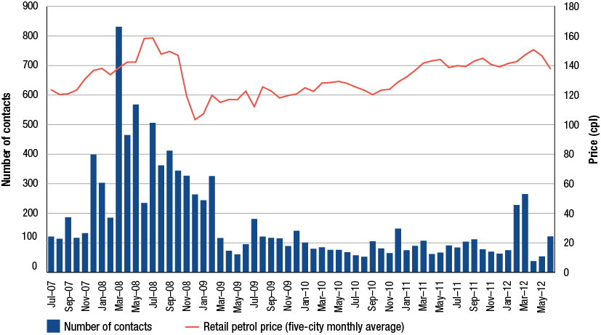
Source: ACCC and Informed Sources data
High prices
The ACCC does not set wholesale or retail fuel prices in Australia: companies set their prices according to market conditions. As detailed in chapter 8, retail fuel prices are largely driven by movements in international market prices for crude oil and refined petroleum products. Despite this, concern about high fuel prices constitutes the bulk of fuel-related complaints and enquiries to the ACCC.
In 2011−12, around 53 per cent of the complaints and enquiries received about the fuel industry related to the price of fuel being ‘too high’. Similar to 2010−11, complaints or inquiries about high prices were based on concerns about:
- differences in fuel prices between suburbs, towns or retail sites
- differences in fuel prices for one type of fuel compared to another
- the relationship between retail fuel prices in Australia and international benchmark prices.
Potential compliance issues
Around 23 per cent of complaints and inquiries received about the fuel industry related to potential compliance issues under the Act. The ACCC examined these contacts carefully and made further inquiries or assessments in respect of 25 matters.
The topics that could have raised concerns under the Act included: alleged collusion, price discrepancies between boards and fuel pumps, accuracy of fuel pumps, issues concerning ethanol blended petrol and price cycles.
2.2.2 Misleading conduct and false representations
In 2011−12, the ACCC received around 70 complaints alleging misleading and deceptive conduct and false or misleading representations. Conduct will be in breach of the Act where it misleads, deceives or is likely to mislead or deceive consumers. Such conduct may include lying to consumers, leading them to a wrong conclusion, creating a false impression or making false or inaccurate claims.
The main issues raised by consumers in 2011−12 included concerns about pricing practices, labelling on fuel pumps, advertising promotions (such as discount schemes), fuel quality claims and concerns about inaccurate fuel measurements.
2.2.3 Anti-competitive conduct
During 2011−12, the ACCC continued its focus on examining allegations of anti-competitive conduct in the retail fuel industry. Where there is information to suggest a breach of the Act may have occurred, the ACCC will investigate by making targeted inquiries. If the information available to the ACCC shows that a breach of the Act may have occurred, it may take legal action.
While most matters were addressed directly with the complainants, the ACCC identified a number of matters concerning allegations of anti-competitive conduct for further investigation over the 2011−12 financial year.
2.2.4 Price information sharing arrangements
On 3 May 2012, the ACCC announced it had commenced an investigation into price information sharing arrangements in relation to the retail petrol sector because of concerns that such arrangements may be in breach of the Act.
The petrol price sharing arrangements allow for the private and very frequent exchange of comprehensive retail price information between the major petrol companies. The ACCC is concerned that this allows petrol retailers to signal price movements, monitor competitors’ responses, and react to them.
The ACCC is concerned that these arrangements may lessen price competition in petrol retailing to the detriment of consumers. The competition provisions of the Act prohibit contracts, arrangements or understandings that have the purpose, effect or likely effect of substantially lessening competition.
2.2.5 Shopper docket discounting schemes
In its 2007 inquiry into the price of unleaded petrol, the ACCC assessed the effects of the petrol shopper docket discounting on competition and consumers. At the time, the ACCC concluded that shopper docket arrangements had no anticompetitive effect but had delivered discounts to the net benefit of consumers and promoted competition from other retailers.
While the ACCC supports initiatives that aim to provide benefits to consumers, it is necessary to assess such schemes to consider their long term effect on competition and prices. Consequently, in 2012 the ACCC commenced an assessment into whether competitive or long term consumer detriment could arise from shopper docket discounts and the size (value), frequency and duration of these offers. The ACCC is working with industry participants to gather information to assist with assessing the competitive effects of supermarket shopper docket discounting schemes.
2.2.6 Fuel price boards
There has been growing concern among competition authorities and fuel industry stakeholders about the potential for consumers to be misled by the advertising of fuel prices, in particular discounted and undiscounted prices, on road side price boards. In response to this growing concern, in 2012 the ACCC began working with state government competition authorities, motoring organisations and other industry stakeholders to develop a consistent national approach to fuel price boards.
2.2.7 The ACCC and regional engagement on fuel prices
As part of its monitoring activities, the ACCC obtains fuel price information for around 180 regional locations throughout Australia. It also engages with industry groups and members of the public to collect additional information about regional fuel pricing issues.
The ACCC uses this information to monitor regional fuel prices against relevant benchmarks to assess whether fuel prices in regional locations are justifiable. Where there is an allegation of anti-competitive conduct, it will make targeted inquires to investigate the issue. After making inquiries, if there is information available to the ACCC that a breach of the Act is likely to have occurred, it can take action to enforce the Act.
In addition, the ACCC pays particular attention to any potential changes in the ownership of retail sites in regional locations. Given many regional locations have a limited number of retail sites, the ACCC monitors such changes to ensure that the sale will not substantially lessen competition in that particular market. Further information about regional fuel prices is contained in chapter 9.
2.2.8 Mergers and acquisitions
Section 50 of the Act prohibits acquisitions that would have the effect of substantially lessening competition in a market. The ACCC administers and enforces the merger provisions under Part IV of the Act. During 2011−12 the ACCC completed a public review of four fuel-related acquisitions, the outcomes of which are summarised below.
Caltex Australia Petroleum Pty Ltd—proposed acquisition of capacity from Terminals Pty Ltd at a new Port Adelaide fuel storage terminal
Caltex Australia Petroleum Pty Ltd proposed to acquire a lease over the site of a new fuel storage terminal at Port Adelaide to be developed by Terminals Pty Ltd. On 27 January 2012, the ACCC decided to allow the merger as it was unlikely to substantially lessen competition.
The ACCC considered the proposed acquisition in the context of the market for the supply of fuel terminal services in Port Adelaide, which involved the services of fuel storage, loading (by ship) and unloading (by truck). The ACCC had regard to the fact that the supply of fuel terminal services in Port Adelaide was an important input for the wholesale supply of refined petroleum products in much of South Australia.
United Petroleum Pty Ltd—proposed acquisition of a number of Victorian petrol retail sites from Freedom Fuels Australia Pty Ltd
United Petroleum Pty Ltd proposed to acquire a number of petrol retail sites in Victoria from Freedom Fuels Australia Pty Ltd.
Initially the ACCC considered the acquisition of seven petrol retail sites in Kew, Mt Waverley, Churchill, Maffra, Newborough, Tyers and San Remo. On 6 December 2011 the ACCC decided to allow the acquisitions to proceed as United was not operating in any of the relevant local markets at the time.
Subsequently the ACCC also considered the acquisition of four other Freedom Fuel sites located in the towns of Warragul, Morwell, Traralgon and Sale in the Gippsland region of Victoria. On 16 February 2012 the allowed the acquisitions to proceed in all sites, except Warragul. United withdrew this site from its proposal following ACCC concerns that the proposed acquisition was likely to substantially lessen competition in the supply of petrol in the local market in Warragul.
Australian Fuel Distributors Pty Ltd (Ausfuel)—proposed acquisition of retail petrol sites from Munners Pty Ltd
Australian Fuel Distributors Pty Ltd (Ausfuel) proposed to acquire two retail fuel sites, BP Kununurra and BP Ord River Roadhouse from Munners Pty Ltd, located in Kununurra, Western Australian. Ausfuel operated a fuel depot located on the outskirts of Kununurra and is a distributor of fuel in and around the Kununurra region. On 12 April 2012, the ACCC decided to allow the merger to proceed as it was unlikely to substantially lessen competition.
Australian Fuel Distributors Pty Ltd (Ausfuel)—completed acquisition of Choice Petroleum
On 31 October 2011, Ausfuel acquired Choice Petroleum. Choice Petroleum had retail fuel operations, primarily in rural and regional areas of Queensland. Choice Petroleum operated 21 retail fuel sites in Queensland and also supplied fuel directly to farming and industrial customers. Ausfuel operated a wholesale fuel supply and transport business in all states of Australia excluding Tasmania. In Queensland, Ausfuel operated seven retail petrol stations and two fuel depots. On 13 March 2012 the ACCC announced that competition concerns were unlikely to arise in relation to the retail supply of fuel in any of the local markets given the lack of overlap between the retail operations of the parties.
2.2.9 Authorisations and notifications
In certain circumstances, the ACCC can grant protection from legal action for certain anti-competitive conduct where that conduct delivers an offsetting public benefit. Businesses may obtain protection from legal action by applying for an authorisation or lodging a notification with the ACCC. All authorisation applications and notifications are available on a public register and on the ACCC’s website.
Authorisations
Authorisation is a process under which legal protection can be provided for potential breaches of the competition provisions of the Act, except for misuse of market power, if the ACCC is satisfied the conduct delivers a net public benefit. There were no fuel-related authorisations lodged with the ACCC in 2011−12.
Exclusive dealing notifications
For certain types of conduct, including exclusive dealing, protection from legal action under the Act can also be obtained by lodging a notification with the ACCC. Exclusive dealing involves placing restrictions on the supply of goods or services such as requiring a person to purchase goods from a third-party supplier (known as third line forcing).
In 2011−12, the ACCC considered 11 fuel-related third line forcing exclusive dealing notifications, all of which were allowed. The third line forcing conduct under the notifications fell into two broad categories:
- shopper docket arrangements involving IGA supermarkets
- supply arrangements requiring the acquisition of goods or services from nominated suppliers.
2.2.10 Administration of the Oilcode
The Oilcode aims to regulate the conduct of suppliers, distributors and retailers in the downstream petroleum retail industry. It came into effect on 1 March 2007 as a prescribed industry code of conduct under the Act. In 2009, the Department of Resources, Energy and Tourism (RET) released its review of the Oilcode and made 11 recommendations. The recommendations were accepted by the government in 2011 and amendments came into effect on 3 July 2012, a further review of the Oilcode will be conducted in 2013.
The ACCC’s role is to ensure compliance with the Oilcode and the Act by informing downstream petroleum industry participants of their rights and obligations under the law and by enforcing the law where necessary. In 2011−12, the ACCC received one complaint and four enquiries about the Oilcode. The complaint was not pursued because there was insufficient evidence to establish a breach of the Oilcode or the Act.
  - Monitoring
In addition to the production of this monitoring report, the ACCC collected extensive fuel price information as part of its price monitoring program. The fuel price information collected by the ACCC includes:
- retail prices of petrol, diesel and automotive liquefied petroleum gas (LPG) in all Australian capital cities and in around 180 regional locations
- premium unleaded petrol (PULP) 95/96 and PULP 98 prices in all capital cities and available regional locations
- E10 petrol (regular unleaded petrol with up to 10 per cent ethanol) prices in around 60 locations across Australia
- relevant international crude oil and international refined fuel prices
- data on import, buy-sell and wholesale transactions related to petrol
- published terminal gate prices (TGPs) of the refiner-wholesalers and some independent wholesalers
- certain financial information from firms monitored under the formal monitoring program.
  - Informing consumers
While the ACCC’s primary role is to enforce the provisions of the Act, it also monitors fuel prices. On the basis of this monitoring, the ACCC seeks to educate consumers on what influences domestic retail prices by providing factsheets, information on its website and by responding to calls to its Infocentre. Throughout 2011−12, the ACCC expanded its public information activities to provide a broad range of information to consumers.
2.4.1 Public communication
In 2011−12, the ACCC updated the fuel related content on its website. The ACCC also updated its existing factsheets to better address common consumer inquiries about fuel pricing in Australia. The website is located at http://www.accc.gov.au/fuel.
The six updated factsheets available on the ACCC website in 2012 covered the following issues:
- What influences the price of unleaded petrol?
- What influences the price of automotive LPG?
- What influences the price of diesel?
- Petrol price cycles in Australia
- Fuel prices in regional Australia
- How do international factors influence petrol prices?
The ACCC continued to engage with newspapers, television, radio and internet media outlets to provide informed comment about its analysis and developments in the petroleum industry. In 2011−12 the ACCC responded to around 40 media enquiries on a variety of issues including:
- high petrol prices in regional locations compared to capital cities
- petrol prices around public holidays
- differences in fuel prices between regional locations and capital cities
- movements in LPG prices around February 2012 as a result of the demand in Europe
- questions about possible predatory pricing in the retail fuel industry.
2.4.2 Ministerial correspondence
In 2011−12, the ACCC addressed 36 pieces of correspondence from Commonwealth and state parliamentarians on fuel issues. The most common topics were:
- the level of competition in the retail fuel markets
- fuel price differentials between various (usually regional) locations
- the relationship between domestic fuel prices and relevant international benchmarks
- price differences between different fuel types.
  - Engagement with key stakeholders
In 2011−12, the ACCC continued to engage with key stakeholders, including consumers, industry and government organisations on fuel issues. The ACCC also distributed the 2011 petrol monitoring report and the summary to key stakeholders.
2.5.1 ACCC Fuel Consultative Committee
In addition to ongoing liaison with key stakeholders as part of its broader role, the ACCC formally consulted with the fuel industry and consumer groups through its Fuel Consultative Committee meetings (FuelCC).
During 2011−12, the FuelCC met on two occasions and discussed issues including availability of pricing information to consumers, state government mandates on biofuels, confusion about price cycles, fuel supply concerns, broader industry regulation and profitability of the fuel industry.
The ACCC formed the FuelCC in 2010 to:
- provide an opportunity for meaningful dialogue between the ACCC, the fuel industry and motoring organisations
- provide information to increase the ACCC’s understanding of fuel industry issues and to assist the ACCC in undertaking its role under the Act on issues related to competition and consumer protection in the fuel industry.
2.5.2 Other government bodies
As part of its broader role, the ACCC liaises and shares information in accordance with its Information Sharing Policy with the following government bodies to fulfil its functions under the Act:
- the Treasury concerning fuel pricing issues and the fuel industry broadly
- the Department of Resources, Energy and Tourism concerning the fuel industry broadly and fuel supply, including security of supply
- the Commonwealth Department of Sustainability, Environment, Water, Population and Communities in relation to the quality of fuel supplies, including allegations of contamination
- the National Measurement Institute in relation to concerns regarding trade measurement practices
- state government bodies, such as state offices of fair trading and the FuelWatch monitoring service administered by the Western Australian Government, concerning consumer protection and other related issues.
2.5.3 Consumer groups
In addition to meetings of the FuelCC and its efforts to increase consumer understanding about fuel prices, the ACCC corresponds and meets with consumer groups and motoring organisations to address concerns raised about the conduct of fuel retailers that effect consumers. In 2011−12, the ACCC continued to actively engage the motoring organisations across Australia.
Issues raised by these groups and considered by the ACCC included:
- labelling of fuel price boards at retail sites
- proposals for increasing fuel pricing information available to consumers
- cost differentials between RULP and E10
- retail price differences between metropolitan and regional areas
- allegations of anti-competitive conduct
- new and emerging issues in the fuel industry.
2.5.4 Industry associations
The ACCC regularly corresponds and meets with industry associations to address key issues in the fuel industry. Organisations that the ACCC has engaged with in 2011−12 included the Australian Automobile Association, the Australasian Convenience and Petroleum Marketers Association, the Australian Institute of Petroleum and the Biofuels Association of Australia.
- Developments in industry structure
Key points
- Australia is likely to continue to rely on imports of crude oil to supply its petrol refineries.
- The Australian refining sector faces challenges as it competes with growing refinery operations in the Asia-Pacific region. This is reflected in the closure of Shell’s Clyde refinery in October 2012, and the proposed shutting of Caltex’s Kurnell refinery in 2014.
- The availability of Australian-standard fuel from large modern refineries in the Asia-Pacific region and the expansion of Australia’s import terminal infrastructure suggest that the needs of Australia’s downstream petroleum industry can be met from imports.
- Independent wholesalers continue to be an important source of competitive pressure by importing increasing volumes of refined petrol, facilitated by increased access to imports and import terminals.
- The retailing sector consolidated during 2011−12, with specialist retailers accounting for a significant proportion of the retail market and some refiner-marketers having moved out of the sector.

  - Introduction
This chapter discusses the main features of the Australian downstream petroleum industry and highlights the latest developments in industry structure over the course of 2011−12.
Australia’s downstream petroleum industry continued to experience change in 2011−12. These developments are consistent with recent trends of rationalisation of refining and growth in import infrastructure.
More recently, the ability of Australian importers to source Australian-standard fuel from Asian refineries, in conjunction with the expansion of independently-owned import terminals, has played a significant role in shaping the structure of the total supply sector.
  - The downstream petroleum industry
Australia’s downstream petroleum industry is divided into three main sectors (figure 3.1):
- total supply—including refining and importing
- wholesale
- retail.
Figure 3.1 Crude oil and petrol flows through the Australian petroleum industry: 2011−12
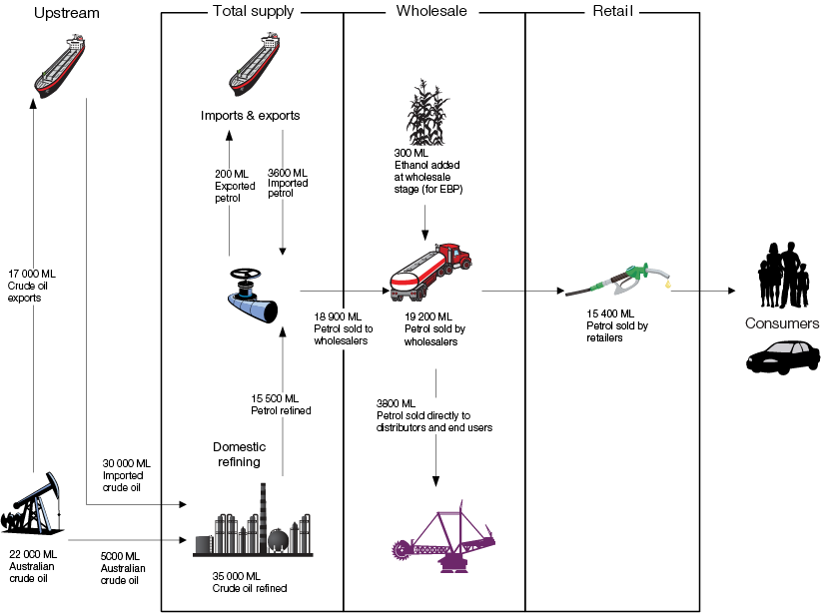
Source: Bureau of Resources and Energy Economics (BREE), Australian Petroleum Statistics, issue 191 (June 2012); ACCC estimates based on data obtained from firms monitored through the ACCC’s monitoring process; and Australian Biofuels 2012−13, APAC Biofuel Consultants
The Australian petroleum industry has evolved as a series of state-based markets, focussing on the five largest capital cities. Thus the refining, import and wholesale operations and infrastructure of petrol companies are predominantly state-based. This infrastructure is further described in the state-by-state schematics at appendix B.
This chapter first sets out the Australian context for the major input for producing petrol, crude oil. The subsequent sections outline developments in Australian refining and importing operations as well as the latest trends in the wholesale and retail sectors.
  - Crude oil inputs
As the major input into the production of petrol and other fuels, the sources and uses of crude oil play a critical role in any petroleum industry.
In Australia, there are two potential sources of crude oil:
- domestic reserves, such as those located in the North West Shelf in Western Australia and in the Gippsland Basin in Bass Strait, Victoria, and
- imports from a number of oil exporting countries.
    - Source of crude oil used in Australia
While Australia has reserves of crude oil, it is a net importer of crude oil.
Most domestic reserves are of light and sweet crude grades. Although Australian refineries are able to process these crudes, they are also able to process cheaper heavier varieties of crude oil. Because light sweet crude oil commands premium prices in international markets, Australian companies often prefer to export a large proportion of the higher quality domestic crude oil at a premium, and import heavier crudes that are not available in Australia.
The Carnarvon Basin in Western Australia accounts for around 72 per cent of total liquids production, most of which is exported. The Gippsland Basin accounts for about 24 per cent of production and while crude oil from this source is predominantly light and sweet, some is used in domestic refining due to its close proximity to refineries in Melbourne and large markets.
In 2011−12, Australia’s crude oil production was around 22 000 ML. Of this, 22 per cent was used in local refineries, while 78 per cent was exported (chart 3.1). Overall, the last 10 years have seen a decline in domestic crude oil production. According to some estimates, Australia’s crude oil production peaked in 2000. While this decline may have been one of the factors leading to an increasing need to import crude oil for domestic refining, the refinery closures outlined in this chapter should lessen future crude oil requirements.
Chart 3.1 Volumes and percentage of Australian crude oil and condensate production used domestically or exported: 2002−03 to 2011−12
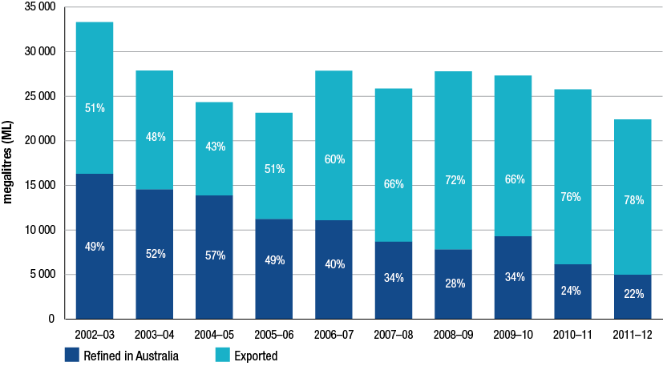
Source: Department of Resources, Energy and Tourism (RET) and BREE, Australian Petroleum Statistics, issues 107 (June 2005), 13 (June 2008), 179 (June 2011) and 191 (June 2012). Note due to data revisions by BREE chart is not comparable with previous years
    - Origin of crude oil imports
While Australia had in recent years imported crude predominantly from Asia-Pacific countries, in 2011−12 a change was evident (chart 3.2). Malaysia remained the largest source, though next were United Arab Emirates and Nigeria. There was a decline in the volume imported from Indonesia and New Zealand; and a continued decline from Vietnam, which in 2008−09 was Australia’s primary source of imports.
Chart 3.2 Major sources of crude oil imports to Australia: 2009−10 to 2011−12
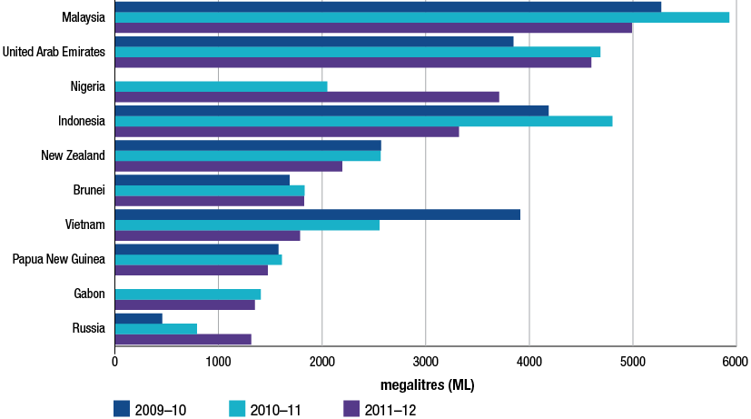
Source: RET and BREE, Australian Petroleum Statistics, issue 191 (June 2012)
  - Refining
Australia’s refining sector is experiencing a period of significant change. Currently, there are six refineries operating in Australia:
- Caltex’s Kurnell refinery in Sydney
- Caltex’s Lytton refinery in Brisbane
- BP’s Bulwer Island refinery in Brisbane
- BP’s Kwinana refinery in Perth
- Mobil’s Altona refinery in Melbourne
- Shell’s Corio refinery in Geelong.
Two refineries have closed in the last 10 years. Mobil mothballed its Port Stanvac refinery in Adelaide in 2003−04 and formally announced its closure in 2009. In September–October 2012 Shell’s Clyde refinery in Sydney progressively ceased production and is now in the process of being converted to an import terminal. In July 2012 Caltex announced its intention to close its Kurnell refinery in the second half of 2014 and also convert it to an import terminal.
In all three cases a key factor behind the decision to cease domestic refining in those locations was the competitive pressure stemming from larger and lower cost refineries in the wider Asia-Pacific region. Despite Kurnell having the second largest refining capacity in Australia behind Kwinana, Caltex claims that its relatively small size, combined with increased costs and a strong Australian currency has left the refinery at a disadvantage compared with Asian refineries.
The largest Asian refineries have the capacity to produce more than three times the output of refined petrol from the largest Australian refineries. Chapter 4 discusses the significance of Asian refining capacity in a global context.
    - Refinery capacity
Over the five years to early 2012, Australia’s refining capacity remained relatively steady, rising in small increments from 2007.
With the closure of the Shell Clyde refinery, Australian refining capacity fell by around 4990 ML pa, and when the proposed closure of Caltex’s Kurnell refinery takes effect in 2014, capacity will drop by a further 7820 ML pa.
Table 3.1 shows the change in Australia’s refinery capacity from 2007, as well as the estimated change looking ahead to the end of 2014. After Kurnell closes, Australia’s refining capacity is estimated to be around 32 620 ML pa, a reduction of close to a quarter from levels in early 2012.
Table 3.1 Refining capacity and estimated change: 2007 to 2014
 | 2007 | Jan 2012 | Oct 2012 | Dec 2014 | 2012 to 2014
 | ML per annum |  |  |  | % change
Refining capacity | 43 154 | 45 430 | 40 440 | 32 620 | -28.2

Source: Australian Institute of Petroleum and ACCC estimates
    - Refinery production
Over the 10 year period to 2011−12 production of petrol and diesel by domestic refineries has varied. While outages have affected annual volumes, overall diesel production has not kept pace with the dramatic increase in sales (chart 3.3).
During 2011−12:
- petrol production fell from 16 400 ML to 15 500 ML, representing 83.9 per cent of sales for 2011−12
- diesel production fell slightly, though remains at around 12 000 ML which is higher than for most of the past 10 years. Despite this, a significant increase in sales meant production accounted for just 52.2 per cent of sales, the lowest level of diesel self-sufficiency over the period.
Chart 3.3 Production and sales of petrol and diesel in Australia: 2002−03 to 2011−12
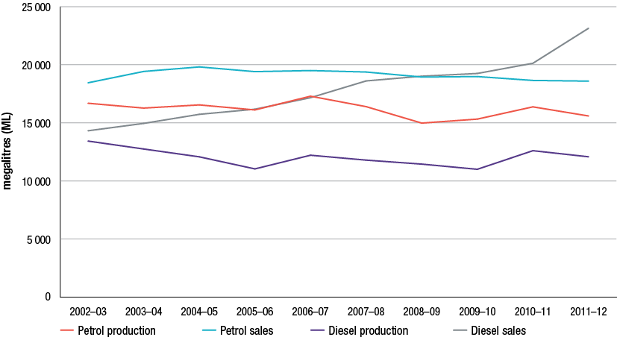
Source: ACCC analysis based on data obtained from firms monitored through ACCC’s monitoring process
    - Petrol refining market shares
Over the period from 2002−03 to 2011−12 BP, Caltex and Shell increased refinery market share, while Mobil’s share declined (chart 3.4). The most significant factor affecting shares was Mobil’s Port Stanvac refinery ceasing production in 2003−04. Looking ahead, the shares held by Shell and Caltex are expected to fall in 2012−13 and 2014−15 respectively.
Chart 3.4 Share of petrol production in Australia: 2002−03 and 2011−12
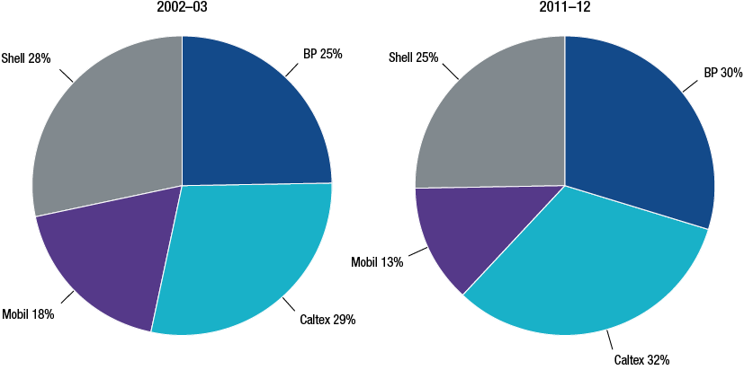
Source: ACCC analysis based on data obtained from firms monitored through ACCC’s monitoring process
    - The outlook for Australian refineries
With the planned closure of Kurnell due to take place in the second half of 2014, Caltex has reported that it is entering into a long term agreement with Chevron (a 50 per cent stakeholder of Caltex) to secure the supply of refined product at market-based prices along with associated shipping services.
The recent expansion of refining capacity in the Asia-Pacific region has improved the availability of potential imports. As these refineries increasingly are able to produce fuel in line with Australian standards, the quantity of fuel potentially suitable for marketing in Australia is greater than has been in the past.
The Department of Resources, Energy and Tourism (RET) noted in its 2012 Energy White Paper that there is significant surplus refinery capacity in Asia. This could also provide independent importers with sources of supplies.
Within Australia, access to terminals and other infrastructure associated with importing petrol is a critical factor in supporting significant growth in imports. Recent and planned expansion of independently-owned import capacity suggests that capacity may be available to cater for greater volumes. Developments are outlined in section 3.6.4 as well as in appendix C.
  - Imports and exports of refined fuel
With the recent reduction in local refining capability, Australia’s reliance on imports of refined petroleum products has become even more pronounced.
For some time now Australia has been increasingly supplementing refinery production with imports of finished product. In 2002−03 Australia’s refineries generally had the capacity to meet most domestic demand and imports of refined fuel were minimal. Ten years later imports contribute around 20 per cent of petroleum products consumed around the country.
Exports form a very minor part of the industry and are expected to diminish further over time as local refining capacity decreases. Since 2003−04 there has been a significant downward trend in petrol exports as a percentage of domestic supply.
    - Volumes of petrol and diesel imports
In 2011−12 the volume of imports changed slightly from the previous year (chart 3.5):
- after falling in the previous two years, total petrol imports increased in 2011−12, by 38.8 per cent to 3679 ML
- diesel imports continued the rising trend of the previous four years and increased by 27.2 per cent in 2011−12, to 11 230 ML.
Over the 10 years to 2011−12 increasing domestic diesel demand, combined with Australian refineries being configured with a petrol bias, has caused the volume of diesel imports to increase to be more than three times that of petrol.
Chart 3.5 Volumes of petrol and diesel imported into Australia: 2002−03 to 2011−12
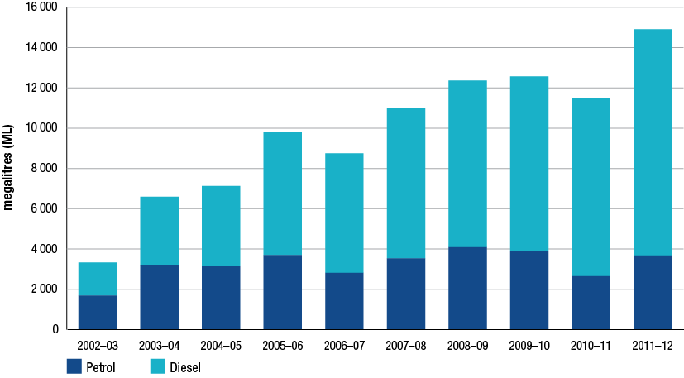
Source: RET and BREE, Australian Petroleum Statistics, issues 107 (June 2005), 13 (June 2008), 179 (June 2011) and 191 (June 2012)
In 2011−12 imports by independent wholesalers of petrol continued to grow, and accounted for around 30 per cent of total imports.
    - Sources of petrol imports
In 2011−12 the bulk of refined petrol imports (74 per cent) originated from Singapore, an international refining hub that is ideally placed to service the export market (table 3.2).
For the first time since at least 2007−08, India became a source of imports, accounting for 4 per cent of total imports. Other major sources of imports were South Korea (18 per cent) and Japan (2 per cent).
Table 3.2 Sources of petrol imports into Australia: 2007−08 to 2011−12
 | 2007−08 |  | 2008−09 |  | 2009−10 |  | 2010−11 |  | 2011−12
 | ML | % | ML | % | ML | % | ML | % | ML | %
Singapore | 3301 | 93 | 3426 | 84 | 3330 | 86 | 2101 | 79 | 2709 | 74
South Korea | 18 | 0 | 81 | 2 | 278 | 7 | 407 | 15 | 677 | 18
India | 0 | 0 | 0 | 0 | 0 | 0 | 0 | 0 | 147 | 4
Japan | 0 | 0 | 41 | 1 | 58 | 1 | 30 | 1 | 62 | 2
Taiwan | 110 | 3 | 297 | 7 | 91 | 2 | 90 | 3 | 0 | 0
Oman | 0 | 0 | 108 | 3 | 46 | 1 | 0 | 0 | 0 | 0
Other | 107 | 4 | 140 | 3 | 86 | 3 | 23 | 2 | 84 | 2
Total | 3536 | 100 | 4093 | 100 | 3889 | 100 | 2651 | 100 | 3679 | 100

Source: RET and BREE, Australian Petroleum Statistics, issues 107 (June 2005), 13 (June 2008), 179 (June 2011) and 191 (June 2012)
  - Import terminals
Import terminal infrastructure is operated around Australia by the refiner-wholesalers as well as major independent wholesalers/importers, and other independent companies specialising in terminal ownership and operation. As part of its monitoring activities, the ACCC collects detailed data on the use of and plans for major terminals from the users, owners and operators.
Historically, the majority of terminals have been owned and operated by the refiner-wholesalers. While this is still the case, there is a trend of increasing independent ownership and operation of terminals.
    - Capacity and throughput
From 2007−08 to 2011−12 there was a significant increase in both the capacity and throughput of independently-owned terminals (chart 3.6). Capacity rose by 72.3 per cent, well above the 10.6 per cent increase for refiner-wholesaler owned terminals. This trend was also evident in throughput, with a 27.4 per cent increase for independently-owned terminals, compared to a 2.8 per cent decrease for those owned by refiner-wholesalers.
Chart 3.6 Petrol capacity and throughput by type of terminal owner: 2007−08 to 2011−12
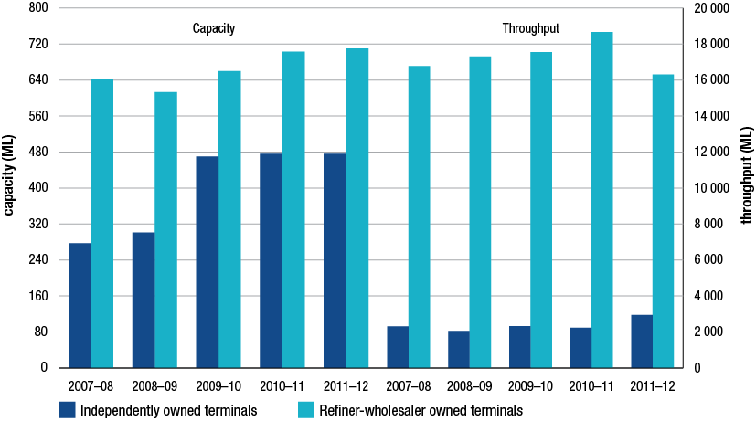
Source: ACCC analysis based on data obtained from firms monitored through ACCC’s monitoring process
Throughput of ethanol declined by 21.5 per cent in 2011−12 compared to 2010−11:
- New South Wales, which accounted for 67.5 per cent of total ethanol throughput, experienced a fall in throughput of 21 per cent compared with 2010−11.
- Queensland’s share of throughput was 22.8 in 2011−12, a 31.1 per cent decrease compared to 2010−11. It is likely that the suspension of the announced state government ethanol mandate may have contributed to a dampening of demand for ethanol in Queensland.
    - Import terminals with spare capacity
As terminals allow companies to undertake the primary functions of storing and distributing fuel supplies, having access to this key infrastructure provides companies with a strong basis for competing in the downstream industry.
There are two types of major terminals, import terminals and refinery-pipeline terminals:
- import terminals are connected to a port, which in most cases is their only source of fuel for storage and distribution
- refinery-pipeline terminals are connected to a refinery by pipeline. They may also be connected to a port, though are likely to receive most of their fuel from the refinery. Some independently-owned terminals are in this category.
As refinery-pipeline terminals have a direct link to what is usually an ongoing source of supply, they usually have a significantly higher turnover compared with import terminals. Table 3.3 shows that in 2011−12, Australia’s import terminals had an average turnover of 7.2 times compared the turnover of refinery-pipeline terminals of 28.8 times. Import terminals are also typically larger than refinery-pipeline terminals, contributing to the lower turnover.
Table 3.3 Petrol turnover by type of terminal: 2010−11 and 2011−12
 | Import terminals |  |  | Refinery-pipeline terminals
 | Capacity  ML | Throughput  ML | Turnover  times | Capacity  ML | Throughput  ML | Turnover  times
2010−11 | 691.5 | 5019.1 | 7.3 | 488.1 | 15 244.6 | 32.5
2011−12 | 689.2 | 4941.1 | 7.2 | 497.2 | 14 309.9 | 28.8
Source: ACCC analysis based on data obtained from firms monitored through ACCC’s monitoring process. Note some data may not be comparable with data in the 2011 ACCC petrol monitoring report due to data revision by one of the monitored companies
Note: Excludes Corio and Parramatta refinery-pipeline terminals (which are directly attached to refinery storage tanks and have no stand-alone storage capacity), and import terminals that exist primarily to service local mines.
Terminal access is an important aspect of independent importers’ ability to compete in the petrol industry. Table 3.4 shows the key characteristics of independently owned and refiner-wholesaler owned terminals. Data in this table shows that:
- independently-owned import terminals have significantly greater total petrol capacity than those owned by refiner-wholesalers
- the turnover at independently-owned import terminals is relatively low compared to refiner-wholesaler owned terminals, suggesting the potential availability of spare capacity for independent importers.
Table 3.4 Import terminal petrol turnover by type of ownership: 2011−12
 | Capacity  ML | Throughput  ML | Turnover  times
Independently-owned | 398.7 | 1704.1 | 4.3
Refiner-wholesaler owned | 290.5 | 3237.0 | 11.1
Australia | 689.2 | 4941.1 | 7.2
Source: ACCC analysis based on data obtained from firms monitored through ACCC’s monitoring process
Note: Excludes throughput for terminals that exist primarily to service local mines.
    - Independent imports
Independent import volumes increased by 1.9 per cent in 2011−12, following an increase of over 200 per cent in the previous year. Due to greater import activity by the refiner-wholesalers, independents accounted for a smaller share of total imports in 2011−12, about 30 per cent, compared with over 40 per cent in 2010−11. This still represents a significant increase compared to four years ago. Total volumes of independent imports have increased more than 400 per cent since 2007−08 when they represented less than 5 per cent of total imports. While still comparatively small in terms of the total wholesale market, these independent imports provide a competitive discipline on the larger players.
Two of the key factors driving the growth in independent imports have been increased international availability of Australian-standard petrol, as outlined in section 3.4.4, and greater access to import terminals. There has been a significant increase in the number, capacity and accessibility of independently-owned import terminals. Consistent with the significant new investment over the last few years by independent terminal owners, refiner-wholesalers as well as smaller wholesalers/importers are increasing their use of independently-owned import terminals.
In the past five years, at least four independent wholesalers have imported refined petrol from various overseas markets. Currently, three of the monitored companies—Ausfuel, United and Neumann—own, or have access to, import infrastructure.
    - Major developments in terminal infrastructure
Across Australia there were a number of key developments in the use, expansion and ownership of terminal infrastructure. Following is a brief description of the most significant developments in 2011−12:
- The largest development under construction is Terminals Pty Ltd’s 85 ML petrol, diesel, ethanol and biodiesel import terminal at Outer Harbour, Adelaide. Due for completion in late 2013, Caltex will use it to replace its existing Birkenhead terminal under a 25-year lease.
- At its Largs North import terminal in Adelaide, BP is building a new tank which will add 30 ML diesel capacity and is expected to be operating in August 2013.
- Mobil expanded its Birkenhead, Adelaide, import terminal with the completion of a 9 ML diesel tank.
- Caltex rebuilt its Port Hedland WA import terminal, which is now operating with a 40 ML diesel capacity.
- Neumann’s Eagle Farm, Brisbane, import terminal commissioned its pipeline extension to a deep-water port and is building a 15 ML increase in diesel capacity, with completion due in October 2013.
- In Newcastle NSW, Stolthaven Australia Pty Ltd (formerly Marstel) has commenced construction of an import terminal, initially with a 54 ML diesel storage capacity. Shell has signed a memorandum of understanding to use this terminal which will provide fuel to the Hunter Valley and north to Gunnedah.
- In May Shell opened a 0.9 ML biodiesel tank at its Newport, Melbourne, refinery-pipeline terminal, which will be used to distribute B20 diesel fuel to its commercial customers.
- Mobil has completed a two-year maintenance program at its Yarraville, Melbourne, terminal, allowing it to increase petrol capacity by 12.2 ML. This company has also converted a fuel oil tank, increasing diesel capacity by 7.9 ML.
- At its Mackay Qld terminal, Shell opened two new diesel tanks, holding a combined 38 ML. They will supply fuel to the Bowen Basin and Far North Queensland.
- Both Caltex and Shell shifted petrol and diesel throughput from their joint terminal in Fremantle to Coogee’s Kwinana terminal.
  - Wholesaling
The wholesale sector is comprised of the four refiner-wholesalers as well as large independent wholesalers including United, Neumann, Liberty and Ausfuel. A small number of other wholesale companies also operate in Australia’s petroleum industry; however, they fall out of the scope of the ACCC’s monitoring program.
    - Wholesale market share
The majority of the wholesale market is comprised of the refiner-wholesalers which account for about 90 per cent of the market monitored by the ACCC (table 3.5). Since 2005−06 there have been two significant changes in terms of market share:
- Mobil’s share has decreased from 14 per cent to 10 per cent.
- Independent wholesalers United, Neumann, Ausfuel and Liberty have expanded their presence, increasing their combined share from four to seven per cent. Ausfuel is now an established player in the wholesale sector following its acquisition of the Gull network in Western Australia in 2010 as well as continuing to expand its pre-existing operation through the Northern Territory and Queensland.
Table 3.5 Monitored companies’ share of wholesale petrol sale volumes: 2005−06 to 2011−12
 | 2005−06 % | 2006−07 % | 2007−08 % | 2008−09 % | 2009−10 % | 2010−11 % | 2011−12  %
BP | 17 | 17 | 17 | 17 | 17 | 18 | 18
Caltex | 36 | 36 | 36 | 36 | 36 | 36 | 36
Mobil | 14 | 15 | 15 | 13 | 13 | 9 | 10
Shell | 29 | 27 | 27 | 28 | 29 | 30 | 29
Independent wholesalers | 4 | 4 | 5 | 6 | 6 | 8 | 8
Source: ACCC analysis and estimates based on data obtained from firms monitored through ACCC’s monitoring process
Note: Totals may not sum to 100 due to rounding.
    - Wholesale customers
Refiner-wholesalers sell petrol in the wholesale sector to a range of different customers (table 3.6). Over the five years to 2011−12, the refiner-wholesalers’ wholesale customer base has undergone some change, particularly during 2011−12.
Specialist retailers, including independents and supermarkets, have consistently been the largest group of wholesale customers. They have increased their share of refiner-wholesalers’ wholesale sales every year since the commencement of monitoring, reaching a share of over 60 per cent in 2011−12. A factor in the growth in sales to specialist retailers has been the recent expansion of 7-Eleven’s presence in the retail sector including their acquisition of the Mobil retail network in 2010.
Following this acquisition, 7-Eleven entered into a supply agreement with Mobil to become its sole fuel supplier, which commenced in January 2012. Previously, Mobil had supplied its own retail sites. This was also a factor in the share of wholesale sales to refiner-wholesaler branded retailers, including branded independents, franchisees and company-owned businesses, falling to 27.7 per cent, compared with 35.7 per cent in 2007−08.
Table 3.6 Refiner-wholesalers’ wholesale petrol sales by type of customer: 2007−08 to 2011−12
 | 2007−08  % | 2008−09  % | 2009−10  % | 2010−11  % | 2011−12  %
Resellers and distributors | 9.8 | 9.3 | 7.2 | 8.3 | 8.7
Specialist retailers (incl supermarkets) | 50.6 | 51.3 | 53.0 | 55.3 | 60.1
Refiner-wholesalers branded retailers39 | 35.7 | 34.8 | 35.8 | 32.6 | 27.7
Other retailers | 3.9 | 4.5 | 3.9 | 3.8 | 3.5

Source: ACCC analysis and estimates based on data obtained from firms monitored through ACCC’s monitoring process
  - Retailing
The retail sector has continued to evolve from the situation of around 10 years ago when four refiner-marketers sold the majority of fuel to consumers, towards the current structure in which supermarkets and other independent chains now account for the majority of retail sales.
    - Retail market share
Table 3.7 shows the market share of retail petrol sales by brand over the 10 years to 2011−12. The share of the independent retail chains remained at around 17 per cent of petrol sales in 2011−12 after having experienced a significant increase in market share during 2010−11, primarily due to the sale of Mobil’s retail business to 7-Eleven and On The Run. BP’s share fell from 19 per cent to 16 per cent, while the supermarkets, Coles and Woolworths, rose slightly to 23 and 24 per cent respectively.
Table 3.7 Share of volume of retail petrol sales by brand: 2002−03 to 2011−12
 | BP | Caltex | Mobil | Shell | Woolworths/ Caltex  (co-branded) | Coles Express/ Shell  (co-branded) | Independent retail chains
 | % | % | % | % | % | % | %
2002−03 | 20 | 24 | 19 | 20 | 10 | – | 6
2003−04 | 20 | 22 | 17 | 3 | 14 | 16 | 7
2004−05 | 18 | 18 | 12 | 3 | 18 | 25 | 6
2005−06 | 19 | 16 | 11 | 3 | 20 | 25 | 6
2006−07 | 19 | 16 | 11 | 3 | 22 | 22 | 7
2007−08 | 20 | 17 | 11 | 2 | 22 | 20 | 8
2008−09 | 19 | 16 | 11 | 2 | 23 | 22 | 9
2009−10 | 17 | 16 | 10 | 2 | 23 | 22 | 10
2010−11 | 19 | 18 | – | 2 | 23 | 22 | 17
2011−12 | 16 | 18 | – | 2 | 24 | 23 | 17

Source: ACCC analysis and estimates based on data obtained from firms monitored through ACCC’s monitoring process
Notes: Data is only for monitored companies, so does not include the total volume of retail sales in Australia.
In 2010−11 Mobil sold its retail sites to 7-Eleven and On The Run. Independent retail chains are: 7-Eleven, On The Run, and the retail operations of Neumann, United and Ausfuel. In 2002−03 Woolworths was not co-branded with Caltex. Totals may not add to 100 per cent due to rounding.
    - Retail business types
The brand shown at a retail site gives consumers a perspective on market participants that supply fuel to that retail site. However, branding does not always equate with ownership or with the type of ownership structure of the site. In 2011−12 only 33.9 per cent of petrol retailing businesses were directly owned and operated by the company with the brand on the site (table 3.8). The majority were owned and/or operated by distributors, independent retailers, franchisees, or commission agents. Woolworths and Coles Express were the only companies that operated all the businesses on the sites displaying their brands.
Table 3.8 Percentage of monitored retail sites by brand and business operator: 2011−12a
Brand | Business operated by:b
 | Directly Owned and Operated | Distributor Owned Operations | Independent retailer | Franchiseed | Commission agentd | Total
 | % | % | % | % | % | %
BP | 7.6 | 4.5 | 15.9 | 0.4 | 0.0 | 28.3
Caltex | 1.8 | 7.6 | 2.1 | 2.0 | 6.7 | 20.4
Mobil | 0.0 | 2.2 | 0.0 | 0.0 | 0.0 | 2.2
Shell | 0.5 | 0.0 | 4.8 | 0.0 | 0.0 | 5.2
Woolworths/Caltex  (co-branded) | 11.8 | 0.0 | 0.0 | 0.0 | 0.0 | 11.8
Coles Express/Shell  (co-branded) | 12.3 | 0.0 | 0.0 | 0.0 | 0.0 | 12.3
Specialist retailers^{c} | 0.0 | 0.0 | 2.4 | 8.3 | 0.6 | 11.3
Independent wholesalers | 0.0 | 0.0 | 1.6 | 0.5 | 6.4 | 8.5
Total | 33.9 | 14.3 | 26.8 | 11.2 | 13.8 | 100.0

Source: ACCC analysis and estimates based on data obtained from firms monitored through ACCC’s monitoring process
Notes: a Data is only for monitored companies, so does not include the total number of retail sites in Australia. Data may not be comparable with data in previous monitoring reports due to site reclassifications by some monitored companies. Due to rounding some rows and columns may not equal the total.
b Sites are categorised by the operator of the business on the site, regardless of branding.
c Specialist retailers include those businesses operated by distributors, independent retail chains and other independents.
d Excludes supermarkets. Commission agents generally manage a business owned by a refiner–marketer or independent chain, and are generally compensated in the form of a commission based on the quantity of product sold. Franchisees rent a site or a number of sites and source fuel from the franchisor and brand it accordingly. They may receive price support from the franchisor (wholesaler), providing some influence over the retail prices set by the franchisee.
    - Retail site numbers
One of the most significant long term developments in the retail sector has been the decline in the number of retail sites since the 1970s (chart 3.7). It appears the trend has plateaued with the number of retail sites remaining at between 6000 and 6500 since the mid-2000s.
Chart 3.7 Number of retail sites and average annual petrol sales volume per site: 1951 to 2012
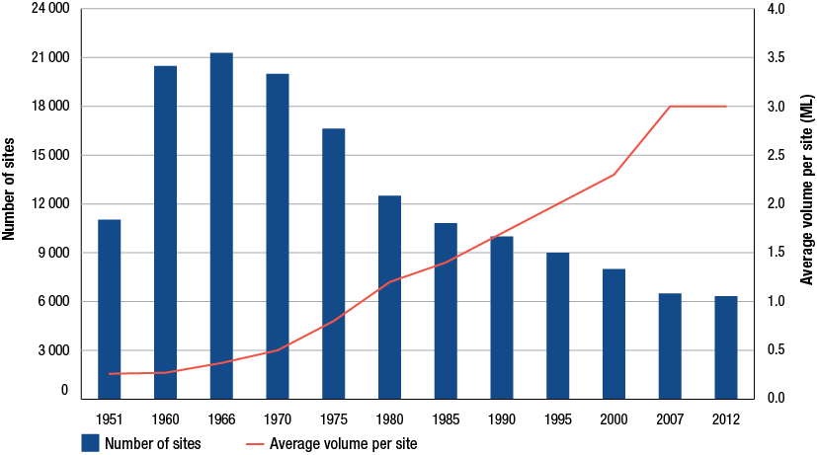
Source: Royal Commission on Petroleum, Marketing and pricing of petroleum products in Australia, fourth report, 1976, pp. 43, 57, Annexure A on Petroleum; Petroleum Information Bureau (Australia), Oil and Australia; the figures behind the facts, 1958, p. 2; Prices Surveillance Authority, National inquiry into petroleum prices, 1990, pp. 14, 17–8; ACCC, Inquiry into the petroleum products declaration, vol. 1, 1996, pp. 9, 17; 2007 ACCC petrol inquiry report, p. 78; combined with data from RET, the Bureau of Infrastructure, Transport and Regional Economics, and Informed Sources
    - Developments in the retail sector
The retail sector appeared to go through a period of relative consolidation during 2011−12 following a long period of significant change. There were no major market share changes among monitored companies.
There were some instances of entry and exit, such as Ausfuel’s purchase of the Choice Petroleum retail network in Gladstone, Queensland in November 2011.
A potentially significant development is the announcement by US warehouse retailer Costco of its intention to sell discounted petrol from its stores in Australia. Costco currently operates retail stores in Sydney, Canberra and Melbourne and is due to open a store in Brisbane. The first Costco stores slated to sell discounted petrol will be in Sydney and Brisbane. Costco is reported to be the world’s eighth largest general retailer, and had petrol sales in the US of 8.7 billion litres from 343 stores.
  - Concluding observations
Australia’s downstream petroleum industry has continued to experience significant change, which is likely to continue in the years ahead.
In 2011−12 the most pertinent developments in the industry occurred in the refining sector, largely driven by competitive pressures from Asian refineries. One refinery was closed and another was announced to be closed in two years, which would leave Australia with five petrol refineries, and none in New South Wales.
Importing refined petrol will become more important in meeting Australia’s demand for fuel. In 2011−12 imports of petrol increased by 38.8 per cent, and look likely to increase further to offset the loss of local refinery production.
In 2011−12 independent importers increased their volumes of petrol imports. While their share of total petrol imports fell slightly in 2011−12 due to higher import volumes by the refiner-wholesalers, independent importers still accounted for about 30 per cent. Increased access to import terminal infrastructure is a vital factor facilitating this trend.
Independents are also increasing their presence in the wholesale sector although the refiner-wholesalers still supply the majority of refined fuel in Australia.
In the retail sector, despite the presence of branding, refiner-wholesalers continue to reduce their involvement in retailing as specialist retailers continued to consolidate their presence.
- International context
Key points
- International crude oil prices have a strong influence on both the level of, and movements in, Australian petrol prices.
- Crude oil prices have exhibited volatility in recent years but appear to have consolidated at historically high levels.
- Despite a weakened global economy, particularly among OECD nations, 2011−12 saw the highest average crude oil prices on record.
- Strong economic activity and demand for crude oil and its refined products in developing nations, particularly for transportation, has supported high crude oil prices.
- The future balance of global oil supplies is likely to be comprised of a greater proportion on unconventional supplies, with higher costs of production likely to keep upward pressure on prices.
- Crude prices are expected to remain high, and are expected to trend higher in the medium to longer term.

  - Introduction
Previous ACCC petrol monitoring reports have highlighted the significance of crude oil prices in shaping the retail price of petrol in Australia and, indeed, around the world. As the base product used in the production of petrol, the price of crude oil heavily influences international prices of refined petrol which in turn drives changes in the retail price of petrol for Australian consumers.
Crude oil prices have shown significant volatility in recent years and appear to have consolidated at relatively high levels compared to average prices evident in the last three decades (chart 4.1).
Chart 4.1 Monthly average price of Brent crude oil: June 1984 to June 2012
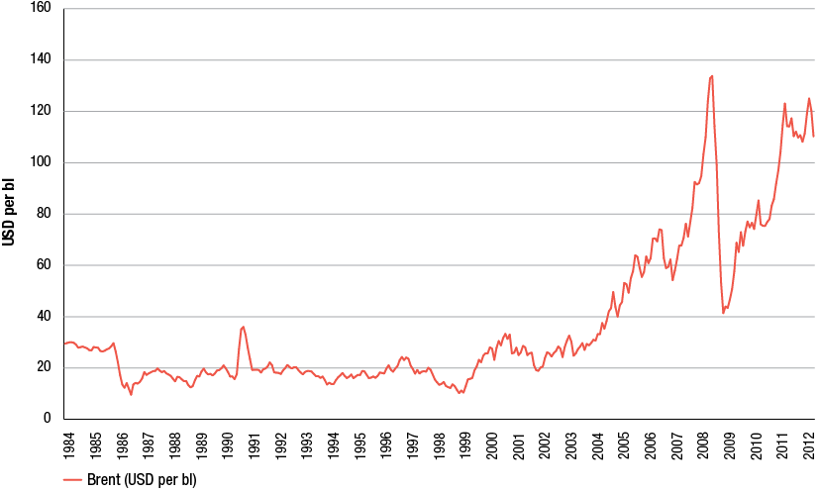
Source: ACCC calculations based on Platts data
In 2011−12 the price of crude oil continued to fluctuate at comparatively high levels although uncertainty surrounding global economic conditions led to prices weakening through the latter half of 2011−12.
This chapter explores crude oil pricing in greater detail and discusses key demand and supply factors affecting the international price of crude oil. The chapter also considers future crude oil prices and, consequently, the outlook for the price of petrol.
  - Crude oil prices
Crude oil is among the most traded commodities in the world and is the base product used to produce a range of fuels including petrol, diesel, aviation fuel and heating oil, as well as other goods such as lubricants and asphalt.
While the price of crude is influenced by a variety of factors, over time, large swings in the price of crude also reflect changes in perceptions of the state of the world economy. In the long term, economic growth is often accompanied by a greater demand for fuels. But in the short term, crude oil prices can be expected to exhibit significant volatility on the basis of market sentiment.
Chart 4.2 shows changes in the price of crude compared with changes in world annual gross domestic product (GDP) over the last 20 years.
Chart 4.2 Annual percentage change in Brent crude oil prices and global GDP: 1992 to 2012
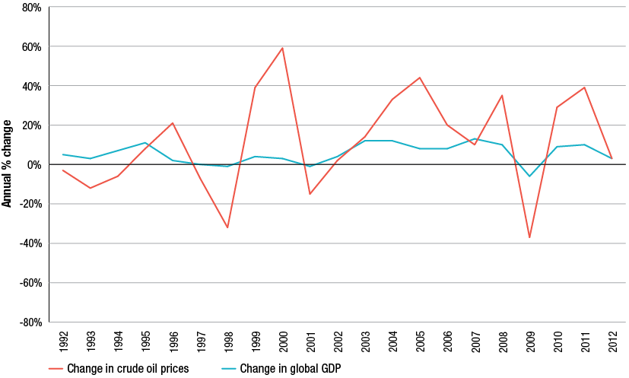
Source: ACCC calculations based on Platts and IMF data. GDP data from IMF, at http://www.imf.org/external/pubs/ft/weo/2011/01/weodata/WEOApr2011alla.xls
Notes: Data are in nominal terms.
It is evident in chart 4.2 that annual fluctuations in crude oil prices exceed fluctuations in world GDP. The data in chart 4.2 reinforces the premise that in any one year, changes in crude oil prices may not necessarily be closely linked with changes in rates of economic growth. While in the long-run world economic growth can be expected to be one of the main drivers of crude oil prices, in the short-run geopolitical and economic sentiment strongly influence prices.
    - Volatility in recent crude oil prices
For most of 2011−12 crude oil prices remained very high, fluctuating between USD 100 and USD 120 per barrel. In March 2012 Brent prices peaked for the year at just over USD 125 per barrel, but towards the end of 2011−12 prices had somewhat eased in light of renewed uncertainty in many parts of the global economy.
Concerns about economic stability in the Eurozone and the United States as well as about future growth in China and India led to oil prices subsiding to around USD 90 per barrel in June 2012.
On average, however, high crude oil prices persisted throughout the 2011−12, resulting in the highest average annual price of crude oil in history. Chart 4.3 shows that the annual average price of Brent crude oil reached a high of USD 112.1 per barrel in 2011−12.
Chart 4.3 Average annual price of Brent crude: 1990−91 to 2011−12
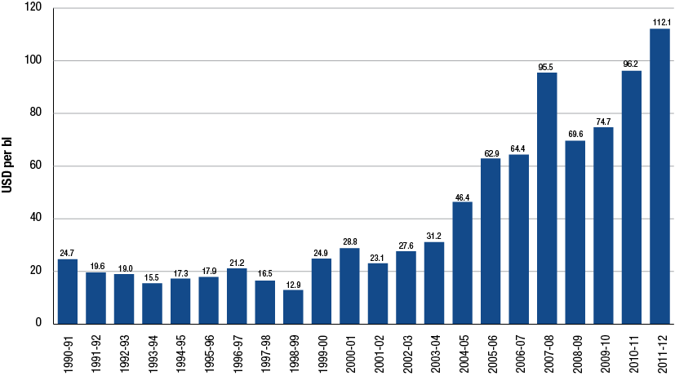
Source: ACCC calculations based on Platts data
Increases in crude oil prices have been persistent throughout the past decade. Chart 4.3 illustrates that the average annual price of crude oil has increased in almost every year since 1998−99. The only exception was 2008−09 when the price of crude oil fell in response to the global financial crisis.
As noted, higher crude oil prices have also been accompanied by a heightened level of volatility in oil pricing. Prices were most volatile in the periods leading up to and then immediately after the global financial crisis, when crude prices increased and then fell dramatically, and then also in the subsequent rebound of the world economy through 2009 and 2010.
Over the longer-term, volatility measured in terms of the range between the highest and lowest price of oil has increased. During the 1990s Brent crude oil prices ranged within a relatively narrow band, the difference averaging about USD 10 per barrel each financial year. Over the past decade however, the range of crude prices has widened, averaging about USD 37 per barrel. In 2011−12, difference between the highest and lowest price was also around USD 37 per barrel.
    - Crude oil grades and pricing behaviour
Crude oils are differentiated on the basis of their chemical properties and consistency and are generally described in terms of their ‘sweetness’ and ‘heaviness’. Crudes with relatively low sulphur content are considered to be ‘sweet’, while ‘sour’ crudes contain a higher proportion of sulphur. The consistency of different types of crude can range from a light fluid solution to a heavier waxy residue.
In general, crudes that are light and sweet are sold at a premium to sour and heavy crudes as they can be more efficiently and cheaply refined to produce larger volumes of higher value end-products such as petrol and diesel.
Among the most prominent grades of crude oil that also serve as key benchmarks for crude oil prices around the world are:
- Brent crude—a light sweet crude oil produced in the North Sea and now commonly used as a pricing marker across many regions of the world
- Dubai crude—a heavier, more sour crude oil produced in the United Arab Emirates. Its price is commonly used as a benchmark to calculate the price of exports of sour Middle East crudes to Asia
- West Texas Intermediate (WTI)—a light sweet crude oil from fields in Western Texas deliverable into Cushing, Oklahoma in the US. WTI is the major benchmark for US crude oil prices and is a deliverable grade for New York Mercantile Exchange crude oil futures contracts
- Tapis crude—a light sweet crude oil widely used as a marker in the South-East Asia region.
With the exception of the period since early 2011, the prices of all four crude oil grades have traditionally traded around a very similar level. Chart 4.4 illustrates price movements of the four prominent grades of crude oil over the 10 years to June 2012.
As expected, the lighter and sweeter crude oils (Tapis, WTI and Brent) have generally traded at a premium to the heavier Dubai grade. Being the lightest and sweetest of the four crudes, Tapis has by and large traded at the highest price. On the other hand, the price of Dubai crude has tended to be the lowest reflecting its relatively high sulphur content and heaviness.
Chart 4.4 Average weekly prices of WTI, Brent, Dubai and Tapis crudes: July 2002 to June 2012
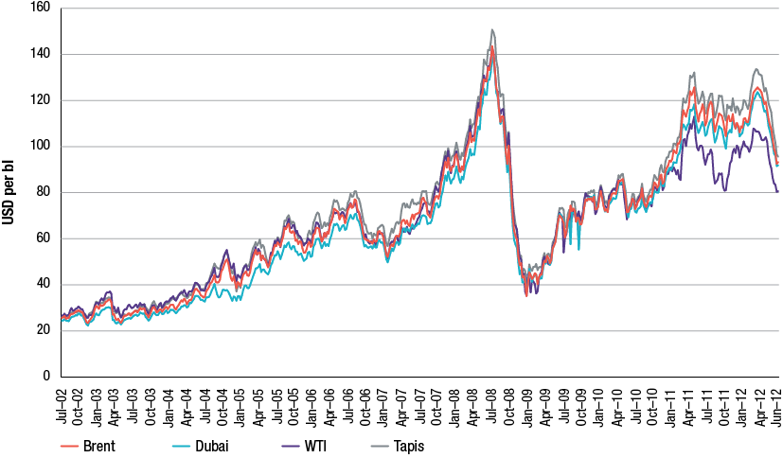
Source: ACCC calculations based on Platts data
More recently, however, the spread between the prices of the four crude markers has widened with prices of WTI becoming the lowest of the four. On average, in 2011−12 WTI traded at USD 94.8 per barrel, while Dubai, Brent and Tapis crudes traded at USD 109.0, USD 112.1 and USD 118.9 per barrel respectively.
The divergence of prices of WTI relative to other crude markers was noted in the 2011 ACCC petrol monitoring report. A culmination of several factors has led to a widening spread between the prices of WTI and other markers, including:
- a build-up of crude oil stocks at the major trading hub in land-locked Cushing, largely from strong US domestic production in conjunction with additional inflows of production from Canada
- a lack of adequate infrastructure to move supplies of crude from the Cushing hub to major refining centres.
In theory, the size of the spread between prices of WTI and other marker crudes is indicative of the high cost of moving crude oil from Cushing to the biggest US refining centres on the Gulf Coast.
In September and October 2011 the spread between WTI and Brent prices increased to well over USD 20 per barrel before narrowing to around USD 15 per barrel in May 2012 when the flow of the existing Seaway crude oil pipeline was reversed to allow oil to flow south from Cushing. However, rising US shale oil production, in conjunction with elevated Brent prices led to the spread widening to over USD 20 per barrel again in October 2012.
Further infrastructure capabilities are planned to help ease pressures at Cushing once they come online. These include expansions of the Seaway crude oil pipeline starting in early 2013, as well as the construction of the Keystone XL pipeline connecting Cushing with the Texas refining sector, expected to be in-service by late 2013.
The US Energy Information Administration’s (US EIA) baseline scenario predicts that with an increase in pipeline capacity between Cushing and the Gulf of Mexico, the price of WTI crude oil will converge with Brent prices, reaching parity by around 2016.
  - Demand for crude oil
A key long term driver of demand for crude oil is economic growth.
World demand for energy, including crude oil, is expected to increase in the medium to long term as economic growth continues, particularly among emerging economies. According to forecasts by the International Energy Agency (IEA) non-OECD economies will account for 90 per cent of growth in global energy demand over the next 25 years.
    - Crude oil consumption
Global energy demand is met in a variety of ways. Traditionally, the largest source of energy has been crude oil. Chart 4.5 shows forecast world energy consumption to 2035 for the major sources of energy: liquid fuels (including crude oil), natural gas, coal, nuclear and renewables.
As at 2008, crude oil and other liquids fuelled around 34 per cent of the world’s energy needs. According to projections by the US EIA demand for crude as an energy source will continue to grow in the future.
Chart 4.5 Annual world energy consumption, by fuel type: 1990 to 2035
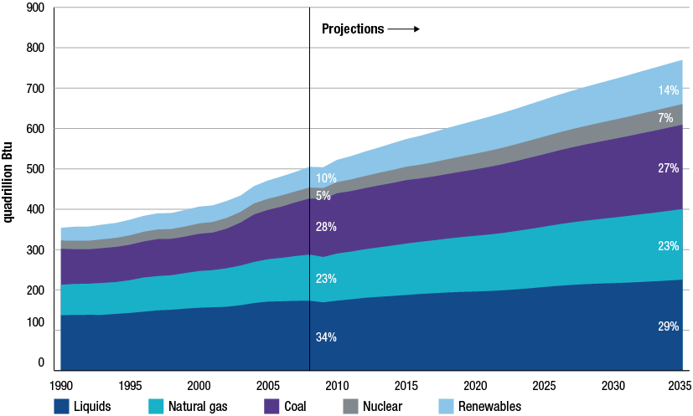
Source: US Energy Information Administration (US EIA), International Energy Outlook 2011, at http://www.eia.gov/forecasts/ieo/pdf/0484(2011).pdf
Notes: Liquids are made up of petroleum and other liquid fuels including petroleum-derived fuels and non-petroleum-derived liquid fuels, such as ethanol and biodiesel, coal-to-liquids, gas-to-liquids, petroleum coke, natural gas liquids, crude oil consumed as a fuel and liquid hydrogen (US Energy Information Administration, International energy outlook 2011, p. 25).
However, the reliance on crude oil is expected to diminish somewhat from current levels reflecting the expectation that crude prices will rise over the longer-term and encourage substitution to other energy sources. By 2035 crude and other liquid fuels are estimated to provide only 29 per cent of global energy demands.
In comparison, use of other sources of energy is expected to accelerate. Consumption of natural gas and coal is estimated to increase by about 50 per cent. Nuclear energy and renewables are projected to grow significantly with renewable sources receiving increased support and meeting around 14 per cent of world energy needs by 2035.
    - Oil demand growth
For some time now growth in oil consumption has been most prevalent in developing economies. Chart 4.6 shows projections of consumption of crude oil and other liquid fuels to 2035 in OECD and non-OECD countries. There is a clear contrast between rates of growth forecast for OECD and non-OECD regions.
Demand for crude in OECD countries has stalled, and is expected to show modest increases reflecting slow or declining population growth. In 2035 consumption is projected to reach similar levels to those seen in the mid-2000s.
In contrast, demand in non-OECD countries is estimated to grow at much higher rates driven by oil consumption in China and India, and exceed OECD levels by 2020.
Chart 4.6 Consumption of crude oil and other liquid fuels in OECD and non-OECD countries (including China and India): 1980 to 2035
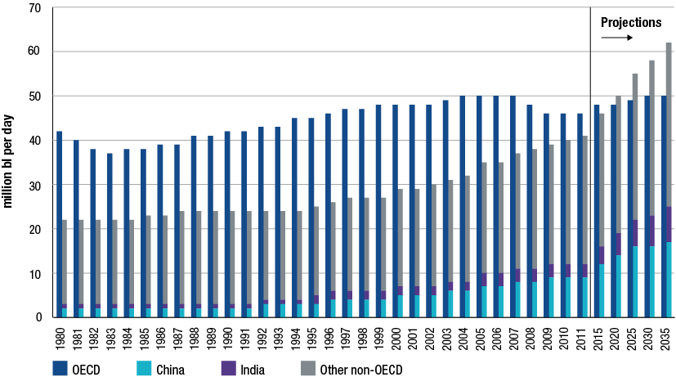
Source: US EIA, International Energy Outlook 2011, table A5, p. 162, http://www.eia.gov/cfapps/ipdbproject/iedindex3.cfm?tid=5&pid=5&aid=2&cid=CG6, CG5,CH,IN,&syid=1980&eyid=2011&unit=TBPD
Notes: Includes liquid fuels and other petroleum-derived fuels and non-petroleum derived liquid fuels, such as ethanol and biodiesel, coal-to-liquids, and gas-to-liquids, petroleum coke, natural gas liquids, crude oil consumed as fuel, and liquid hydrogen (US Energy Information Administration, International energy outlook 2011, p. 25).
It is widely expected that most of the net growth in oil consumption will occur within the transport sector of emerging economics as non-OECD car markets expand. The IEA predicts car sales in non-OECD countries to surpass those in the OECD by 2020, contributing to a doubling of the global passenger vehicle fleet by 2035.
Chart 4.7 illustrates projections of consumption of crude oil and other liquid fuels by sector to 2035 showing that the majority of growth is estimated to come from the transportation sector.
Chart 4.7 Projections of crude oil and other liquid fuel consumption by sector: 2008 to 2035
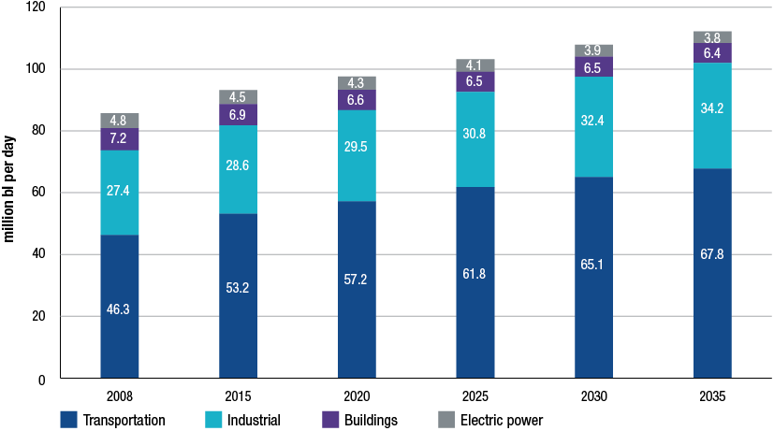
Source: US EIA, International Energy Outlook 2011, figure 33
Despite the projected long term growth, uncertainty about world economic conditions has had a dampening effect on the short term prospects for developing economies. For example, the month of April 2012 saw a dramatic slowing of economic activity in non-OECD countries, primarily in China. The IEA reported a sharp deceleration in growth in developing markets including a downturn in the use of transport fuels.
Overall, on the demand side, the US EIA expects that consumption of crude oil and other liquids markets over the longer term will be largely driven by economic activity and momentum among developing nations, as demand in OECD countries responds to higher crude oil prices.
  - Supply of crude oil
The main factors that determine the long term supply of crude oil can be grouped into three categories:
- investment and production decisions by countries that are part of the Organisation of Petroleum Exporting Countries (OPEC)
- the economics of non-OPEC supply
- the viability of other (unconventional) sources of supply.
OPEC is an inter-governmental cartel consisting of 12 oil producing and exporting nations: Algeria, Angola, Ecuador, Iran, Iraq, Kuwait, Libya, Nigeria, Qatar, Saudi Arabia, the United Arab Emirates and Venezuela. OPEC’s stated objective is ‘to coordinate and unify the petroleum policies of its Member Countries and ensure the stabilization of oil markets in order to secure an efficient, economic and regular supply of petroleum to consumers, a steady income to producers and a fair return on capital for those investing in the petroleum industry’.
The following sections discuss the sources of crude oil supplies as well as production trends of both OPEC and non-OPEC nations.
    - Oil reserves
Figure 4.1 shows the major proven crude oil reserves around the world as at January 2011. Together, OPEC countries account for just over 70 per cent of proven supplies.
Figure 4.1 Major proven crude oil reserves, billions of barrels: January 2011
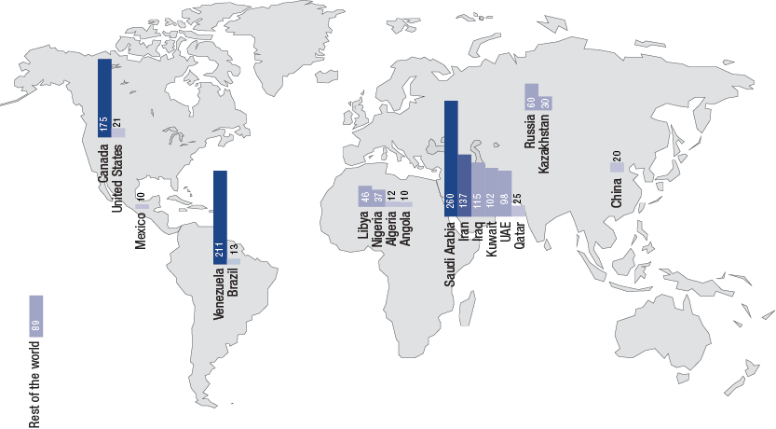
Source: US Energy Information Administration, International Energy Outlook 2011, table 5, p. 38; based on estimates by the Oil and gas journal provided to the US Securities and Exchange Commission
Notes: Proved reserves are defined by the US EIA as ‘estimated quantities that geological and engineering data indicate can be recovered in future years from known reservoirs, assuming existing technology and current economic and operating conditions’.
Around 50 per cent of the world’s proven crude oil reserves are located in the Middle East with Saudi Arabia holding the largest pool of reserves. The Americas also have sizeable reserves, largely by way of Venezuela and Canada with 14 and 12 per cent of the world total respectively. Venezuela’s reserves now include its recent Orinoco extra-heavy oil developments marking a significant increase in local oil reserves. Canadian tar sand deposits make up the majority of reserves in North America.
Recent developments in other “unproven” resources suggest the potential for sizeable growth of oil resources in some countries.
- In the US recent estimates indicate a sharp increase in recoverable volumes of shale oil. In its first official forecast of shale oil resources, the US EIA estimates US crude oil production to reach 6.7 million barrels per day (mbpd) in 2020 (the highest level since 1994) primarily as a result of continued development of shale oil resources. This is reportedly the largest new source of US supply since the offshore fields in the Gulf of Mexico, which themselves provide opportunities for further development in the short to medium-term.
- Brazil is also expected to show increases in oil supplies, largely following the discovery of significant pre-salt deposit fields in the Atlantic Ocean (located below the ocean surface underneath a layer of salt).
The extent to which these discoveries can be exploited is however uncertain, and for some fields, their viability is highly uncertain. These technically difficult, expensive and high risk projects would likely require a sustained high oil price (along with appropriate government support) to make them fully viable.
    - Major producers and exporters
In 2011 OPEC countries accounted for about 40 per cent of global crude oil production. Saudi Arabia was the largest producer with an output of 11.2 mbpd. Russia and the US were next, both producing over 10 mbpd. Chart 4.8 shows the top 30 crude oil producing countries in 2011. Australia ranks thirtieth with an output of 0.46 mbpd, down from 0.55 mbpd in the previous year.
Chart 4.8 Top 30 crude oil producing countries: 2011
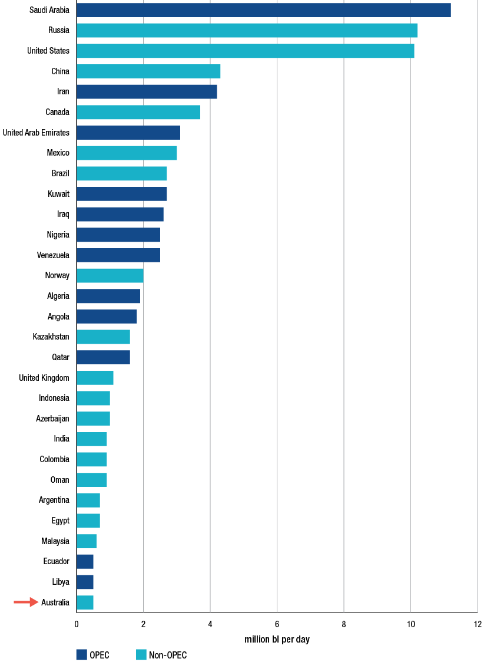
Source: US EIA, International Energy Statistics, at http://www.eia.gov/cfapps/ipdbproject/iedindex3.cfm?tid=5&pid=53&aid=1&cid=regions,ww,r1,r2,r4,CG6,CG5,CG9,&syid=1990&eyid=2010&unit=TBPD
Notes: Oil production represents total oil supply, that is, production of crude oil (including lease condensate), natural gas plant liquids, other liquids and refinery processing gains.
On average, since 1980 OPEC countries have produced about 37 per cent of global oil supplies. OPEC’s contribution to world supplies has moved over time, from 28 per cent of world production in 1985 to 42 per cent in 2008.
Forecasts on the contribution of OPEC production going forward are predominantly based on future crude oil price trends. The US EIA’s reference case suggests that OPEC members will seek to maintain a constant market share of 40 to 42 per cent of world oil production.
In-line with the notion of OPEC being a swing producer, varying output to maximise revenues, if crude oil prices move higher than anticipated OPEC may tighten supply in order to maintain prices and revenues. Similarly, in the case of lower than expected crude oil prices, OPEC producers may attempt to increase supply to maximise revenues.
Many OPEC member countries also play a key role in the export of crude oil. Chart 4.9 shows that nine of the top 12 crude oil exporting countries in 2010 were members of OPEC. Saudi Arabia is the largest exporter of crude oil supplying 6.5 mbpd to the export market.
Export volumes originating from OPEC countries have undergone some change in recent years. Iran’s export volumes have gradually declined and are set to reduce even further following US financial sanctions taking effect from the end of 2011, and the European Union banning Iranian oil imports from 1 July 2012. The measures were aimed to halt the uranium enrichment activities occurring in Iran. In response, at least in the short term, other OPEC countries such as Saudi Arabia, Iraq and Libya as well as the United States, have increased output to offset Iran’s declining supply.
Non-OPEC countries also contributed substantial crude volumes to the export market in 2010, particularly Russia, exporting 5.6 mbpd. Norway, Mexico, Canada and Kazakhstan also contributed significant crude volumes.
Chart 4.9 Major crude oil exporters: 2010
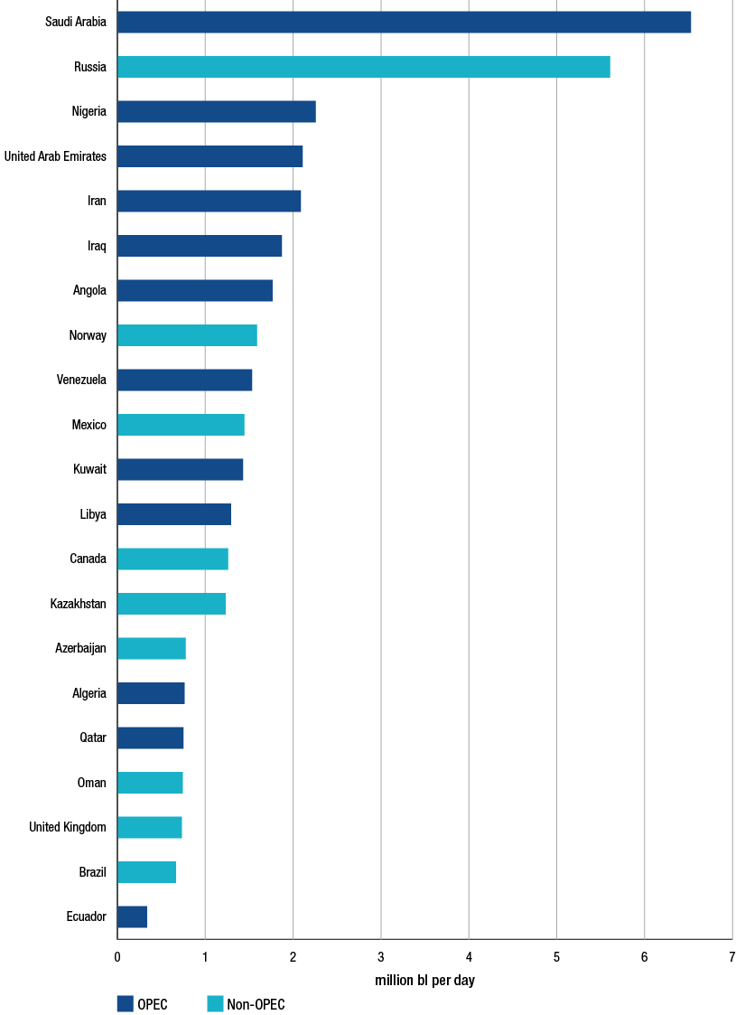
Source: US EIA, International Energy Statistics, at http://www.eia.gov/cfapps/ipdbproject/iedindex3.cfm?tid=5&pid=57&aid=4&cid=regions&syid=2009&eyid=2010&unit=TBPD
    - Conventional and unconventional sources of supply
Unconventional supplies of oil refer to a wider variety of liquid sources including tar sands, extra-heavy oil, gas to liquids and other liquids. Conventional oil fields are typically easier and cheaper to recover than unconventional sources.
The mix of conventional and unconventional crude oil used to satisfy energy demand is likely to undergo lasting change as crude oil prices continue to rise over the longer-term and relatively expensive unconventional sources become viable to extract.
Although conventional liquids account for the bulk of global production, both currently and in the forecast medium-term, the contribution from unconventional liquids is projected to more than double. Chart 4.10 shows the mix of conventional and unconventional sources of crude in 2008 as well as the US EIA’s expected composition of world fuel liquids in 2035. Unconventional liquids are estimated to contribute 11.7 per cent of world liquid fuels production by 2035, up from 4.7 per cent in 2008.
Chart 4.10 Shares of world liquid fuels production, conventional and unconventional liquids: 2008 and 2035
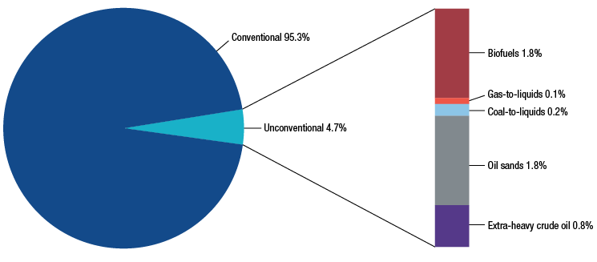
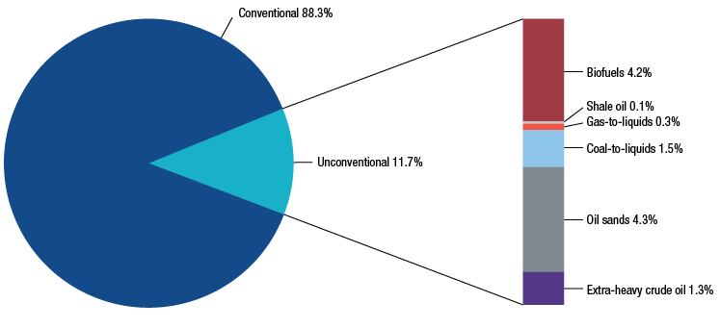
Source: US EIA, International Energy Outlook 2011, figure 28
The outlook to 2035 suggests that oil sands and biofuels remain the most prevalent unconventional sources with extra-heavy crude oil and coal-to-liquids (CTL) also increasing in use.
The vast majority of the growth in unconventional liquid supply is likely to occur in non-OPEC regions:
- Canada’s tar sands are expected to increase production by 3.3 mbpd and make up over 40 per cent of non-OPEC unconventional supplies.
- Supported by government mandates, the US is estimated to increase production of biofuels by 1.6 mbpd. Brazil is also projected to be a growth area for biofuels, increasing by 1.2 mbpd.
- China is expected to be the main producer of CTL supplies.
Venezuela’s extra-heavy oil deposits are estimated to account for most of the unconventional production in OPEC countries.
    - Future crude oil production
While projections can provide a well considered estimate about trends in crude resources going forward, the complete resource base of future oil supplies remains unclear. Estimates are likely to be continually reviewed as existing reserves are depleted, new fields are discovered and technological advancements allow greater recovery of liquids. As noted by the IEA, ‘the size of ultimately recoverable resources of both conventional and unconventional oil is a major source of uncertainty for the long term outlook for world oil production’.
The move towards greater production of oil from unconventional sources however, rests on the progression of two important themes for future oil production:
- low-cost, conventional sources of supply becoming more scarce
- crude oil prices reaching levels where the development of unconventional sources of crude becomes viable.
The 2011 ACCC petrol monitoring report canvassed the concept of ‘peak oil’—where the rate of global production of conventional oil declines and the world increasingly becomes dependent on harder-to-extract-and-refine unconventional supplies of oil.
There is concern that discoveries of new conventional oil fields are not keeping up with declining production of existing fields. It is probable that a number of nations have already experienced a high point of local crude production.
That said, some observers maintain that future increases in total supply will offset expected decreases in mature regions. In its 2011 World Oil Outlook, OPEC estimated that increases in conventional non-OPEC sources as well as steady increases in unconventional supply will more than compensate for expected conventional oil declines in regions such as North America and the North Sea.
Notwithstanding the uncertainties that lie ahead in terms of crude oil supply, the growth in unconventional sources of crude will mean higher production costs.
The production costs at which future oil supplies will be made available, although difficult to calculate exactly, are likely to be higher than those seen in the past.
  - Refining capacity
The ability to refine crude oil to produce end-products is another crucial factor contributing to the supply and price of petrol.
Asia-Pacific has quickly become the most significant region in terms of refining capacity. According to the latest BP Statistical Review of World Energy, the region expanded capacity by around 33 per cent over the 10 years to 2011 to hold over 30 per cent of world refining capacity (table 4.1).
Within the Asia-Pacific region, Australia is a relatively small player in the global refining landscape with less than 1 per cent of global capacity.
While refining capacity in the Asia-Pacific region has grown, Australian refinery capacity has declined in recent years. Over the 10 years to 2011 capacity decreased by around 9 per cent. This trend, largely driven by competitive pressures from newer, more complex and lower-cost Asian refineries, seems established with the closure of two Australian refineries since 2003 and Caltex set to close its Kurnell refinery in 2014.
Table 4.1 World refining capacity, by region: 2001, 2005 and 2011
 | 2001 | 2005 | 2011 | Change 2001 to 2011
 | Thousand bl per day |  |  | %
Asia-Pacific | 21 853 | 23 540 | 29 135 | up 33
North America | 20 183 | 20 698 | 21 382 | up 6
South and Central America | 6 246 | 6 405 | 6 590 | up 6
Europe and Eurasia | 25 162 | 24 877 | 24 570 | down 2
Middle East | 6 746 | 7 284 | 8 011 | up 19
Africa | 3 164 | 3 224 | 3 317 | up 5
World | 83 355 | 86 027 | 93 004 | up 12
Source: BP, BP Statistical Review of World Energy, June 2012, p. 16, also at http://www.bp.com/sectiongenericarticle800.do?categoryId=9037174&contentId=7068617
The surge in refining capacity in the Asia-Pacific region in the last 10 years has been propelled by China and India, where capacity has increased by about 92 per cent and 68 per cent respectively. South Korea, Singapore, Taiwan and Thailand have also increased their refining capacity in the last 10 years, albeit by a much smaller degree. Chart 4.11 illustrates the change in refining capacity between 2001 and 2011 for a number of these countries, as well as for Australia.
Chart 4.11 Refining capacity in the Asia-Pacific region, by country: 2001 and 2011
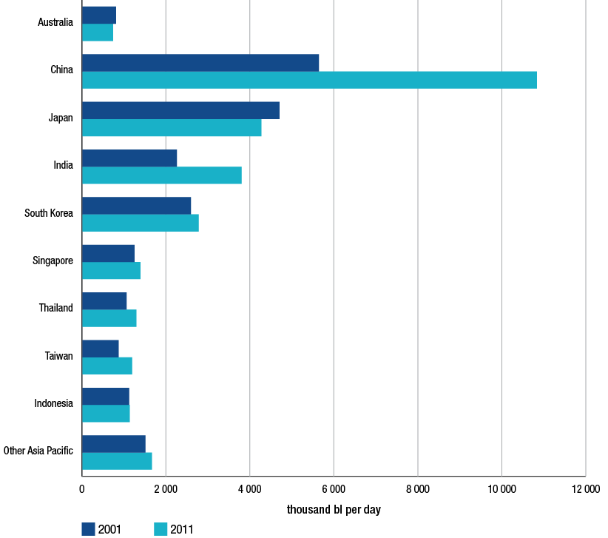
Source: BP, BP Statistical Review of World Energy, June 2012, p. 16, also at http://www.bp.com/sectiongenericarticle800.do?categoryId=9037174&contentId=7068617
The more recent trend of integrated petrol companies withdrawing from refining operations is not limited to the Australian market. Refining capacity across the Europe and Eurasia region has also declined over the 10 years to 2011.
Evidence suggests that Europe will continue to face challenges in refining. For some time now the European region has been facing overcapacity, as local fuel demand has waned as a result of unstable economic conditions. Refiners have struggled to compete against more efficient operators including the increasing capacity coming online in Asia. The UK Government has recently reported that eight European refineries have closed since 2009 and that more closures are likely.
Chapter 15 discusses the changing refining environment in further detail, as well as implications for future crude oil and petroleum supply to Australian markets.
  - Prospects for crude oil prices
The volatility seen in crude oil prices in the last few years suggests that predicting future crude oil prices is an extremely difficult task.
Table 4.2 presents various projections for crude oil prices in five year increments to 2035. The measure of oil prices is largely comparable across projections.
The spread of oil price projections also depicts the considerable level of uncertainly facing both the future supplies of crude oil and the level of global economic activity.
Table 4.2 Organisational projections of crude oil prices: 2015 to 2035
 | 2015 | 2020 | 2025 | 2030 | 2035
 | 2010 USD per bbl
US Energy Information Administration | 116.91 | 126.68 | 132.56 | 138.49 | 144.98
International Energy Agency | 106.30 | 118.10 | 127.30 | 134.50 | 140.00
Strategic Energy and Economic Research, Inc. | 94.20 | 101.57 | 107.13 | 111.26 | 121.94
Interindustry Forecasting Project at the University of Maryland (INFORUM) | 91.78 | 105.84 | 113.35 | 117.83 | 116.76
Purvin & Gertz | 98.75 | 103.77 | 106.47 | 107.37 | 107.37
Energy Ventures Analysis | 82.24 | 84.75 | 89.07 | 94.78 | 102.11
IHS Global Insight | 99.16 | 72.89 | 87.19 | 95.65 | 98.08

Source: US EIA, Annual Energy Outlook 2012 with projections to 2035, table 23, p. 105
Notes: The US EIA reports the price of low-sulphur, light crude oil, approximately the same as the WTI price widely cited in the trade press. The only series that do not report projections in WTI terms are the IEA, with prices expressed as the price of imported crude oil, and INFORUM, with prices expressed as the average US refiner acquisition cost of imported crude oil (US EIA, Annual Energy Outlook 2012 with projections to 2035, p. 105).
While there are a range of projections across the organisations represented in table 4.2, a common theme among almost all is that crude oil prices are forecast to continue to rise over the longer-term.

- Ethanol blended petrol
Key points
- Ethanol is added to petrol to produce various grades of ethanol blended petrol (EBP). The most common EBP is E10, which is regular unleaded petrol (RULP) containing up to 10 per cent ethanol.
- Total sales of EBP in Australia decreased in 2011−12, reversing the trend of previous years.
- Sales remained broadly stable in New South Wales (NSW) but decreased significantly in Queensland and Victoria.
- Similarly the number of retail sites selling E10 across Australia decreased in 2011−12.
- The largest volume of EBP is sold in NSW, which accounts for over 80 per cent of the Australian EBP market.
- This is largely the result of the NSW ethanol mandate which, from October 2011, has required that 6 per cent of the total volume of petrol sold in NSW should be ethanol.
- However, in 2011−12 only around 3.6 per cent of the volume of petrol sold was ethanol.
- The NSW Independent Pricing and Regulatory Tribunal assessed current and projected levels of ethanol supply and demand and concluded in March 2012 that there would not be enough demand for ethanol to meet the 6 per cent mandate.
- In January 2012 the NSW Government amended its ethanol mandate by removing the requirement for E10 to replace RULP from July 2012.
- Across all locations monitored by the ACCC in 2011−12, average RULP prices were higher than average E10 prices by around 1.8 cents per litre.
- In previous years the ACCC has expressed concern about the supply of ethanol. However, in 2011−12 there appeared to be sufficient supply to meet demand.
- Ethanol production capacity in Australia in 2012 is estimated to be 450 megalitres (ML).
- Ethanol demand in 2011−12 was estimated to be around 305 ML.

  - Introduction
The ACCC commenced monitoring and reporting on the price differential between regular unleaded petrol (RULP) and E10 petrol in October 2006. It first reported on the biofuels market in Australia in the 2010 ACCC petrol monitoring report. The ACCC continued to monitor developments in the biofuels market during 2011 and 2012.
The two main types of biofuel used as transport fuels in Australia are ethanol and biodiesel.
Ethanol is sometimes also referred to as ethyl alcohol, alcohol or grain spirit. Most ethanol is produced by fermenting raw materials such as sugar cane, sugar beet, molasses, wheat, grain and forest products. It is added to petrol to produce various grades of ethanol blended petrol (EBP).
In Australia, up to 10 per cent ethanol is blended with RULP to produce E10, which is the most common EBP marketed in Australia. Ethanol is also present in E85 (a fuel blend consisting of 70–85 per cent ethanol with the remainder being petrol, which may only be used in vehicles specifically built or modified to use it) and in some premium unleaded petrol (PULP), such as ‘Premium 98’ from United.
Biodiesel is derived from plant or animal feedstocks containing fatty acids such as vegetable oils and tallow. It is usually blended with petroleum-based diesel to produce fuels for diesel-powered vehicles and equipment. In Australia, biodiesel is typically used as a fuel additive in 5 per cent (B5) and 20 per cent (B20) blends.
Given its greater use by consumers, this chapter focuses primarily on EBP.
  - Ethanol blended petrol and government policy
There is no Australian Government mandate covering the supply of EBP in Australia. New South Wales (NSW) is the only state government to introduce a mandate on the supply of EBP. There were a number of regulatory developments relating to EBP in 2011−12.
    - NSW ethanol mandate
The NSW ethanol mandate was introduced in 2007 and required that, from 1 October 2007, 2 per cent of the total volume of petrol sold in NSW should be ethanol. On 1 January 2010 the mandated level increased to 4 per cent and on 1 October 2011 it increased to 6 per cent (this increase was scheduled to occur on 1 January 2011 but was deferred twice by the NSW Government).
The final phase of the NSW mandate (i.e. requiring all RULP to be replaced with E10) was set to be introduced on 1 July 2012. This would have effectively banned the sale of RULP in NSW. However, on 31 January 2012 the NSW Government announced that it would introduce legislation to remove this requirement and that the ethanol mandate would remain at 6 per cent of total fuel sales. Following this announcement there was widespread debate in the media. This debate included industry participants and motoring organisations raising concerns about the current domestic supply of ethanol not being sufficient to meet the amount of ethanol required by the 6 per cent mandate.
Subsequently, the NSW Government requested the Independent Pricing and Regulatory Tribunal (IPART) to undertake ‘an assessment of current and projected levels of ethanol supply and demand in the context of the requirement under the Biofuels Act 2007.’ IPART’s report was provided to the Premier of NSW in March 2012 and publicly released in May 2012. A summary of the main points of the report is in section 5.3.
In response to the IPART report the NSW Government released a framework which set out conditions under which exemptions from the mandate may be granted under the Biofuels Act. All applications for an exemption will be required to include a business plan that identifies future steps to increase ethanol sales, and evidence that previous business plans have been adhered to.
    - Queensland ethanol mandate
The Queensland Government had planned to introduce a 5 per cent ethanol mandate for petrol sold in Queensland by 31 December 2010. However, this was postponed on 28 October 2010 when the Queensland Government announced that it would suspend the implementation of the ethanol mandate. To date, no announcement has been made regarding the future of this mandate.
    - Excise on EBP
Transport fuels are currently subject to a fuel excise of 38.14 cents per litre (cpl). The excise applies to fuels such as petrol, diesel and EBP. However, the Ethanol Production Grants program provides full excise reimbursement to ethanol producers for ethanol produced and supplied for transport use in Australia from locally derived feedstocks. This effectively makes the ethanol component of Australian produced EBP excise free. Imported ethanol for transport purposes is subject to the excise.
    - Fuel quality and labelling standards
Following extensive stakeholder consultation, a fuel quality standard and a fuel quality information (labelling) standard for E85 automotive fuel have now been established under the Fuel Quality Standards Act 2000.
The fuel quality standard specifies the physical and chemical parameters for E85, and testing methods to determine compliance with the standard. The fuel quality information (labelling) standard sets out the labelling requirements for the sale of E85 fuel sold in Australia. The new standards came into force on 1 November 2012 and must be complied with from this date before E85 can be supplied for use in Australia.
  - IPART report
Key points of the IPART report are summarised below.
    - Ethanol supply and demand
IPART considered that there was sufficient ethanol supply to meet demand in NSW under the 6 per cent mandate, assuming ethanol sales in other states remained unchanged.
However, IPART also noted that, as there are only three ethanol suppliers in Australia (and one supplier provides two-thirds of total supply), supply may be unreliable if one of the suppliers is unable to produce. The concentrated nature of ethanol supply therefore may result in upward pressure on prices. In addition, it noted that competition from imports is unlikely because Australian Government grants effectively exempt domestic producers from excise duty.
IPART found that the market share of E10 in NSW in 2011 was 36 per cent, meaning that ethanol accounted for 3.6 per cent of petrol sales. To meet a 6 per cent mandate the E10 market share needs to be 60 per cent. However, IPART considered that there would not be enough demand for ethanol to meet the 6 per cent mandate.
Based on current market conditions, and a number of assumptions, IPART believed that the maximum possible ethanol share of petrol sales was 5.8 per cent. However, IPART considered that this was unlikely to eventuate because this estimate assumes that E10 is sold: at all petrol stations across NSW; in place of (rather than in addition to) RULP; and outside retail sites (e.g. direct to farms and mines).
The main reasons for the lack of demand for E10 identified by IPART include: the narrow price differential between E10 and RULP; community uncertainty regarding the suitability of E10; and a growing preference for PULP.
IPART noted the increasing suitability of the vehicle fleet for using E10, estimating that 73 per cent of passenger and light commercial vehicles were E10 suitable (up from 66 per cent in 2007). IPART believed that there was a lack of information about EBP in the community. It noted that a Queensland Government marketing campaign that promoted the use of EBP led to an increase in EBP sales.
    - Operational issues with the mandate
IPART identified a number of issues relating to the operation of the mandate.
- At least 25 per cent of retail sites are exempt from the requirements of the mandate as they are operated by a person operating 20 retail sites or less. This makes it more difficult for primary wholesalers to meet the 6 per cent mandate. It may also undermine the competitive position of retail sites subject to the mandate.
- The cost of supplying E10 to regional areas is high. Retail sites located in border areas could also be disadvantaged if forced to supply E10 at the expense of RULP as they would be competing with sites across the border that sell RULP.
- Approximately 15 per cent of petrol sales in NSW occur outside retail sites (e.g. direct to farms, mines and industry). If these sales were excluded from the petrol ‘base’ used to calculate the mandate, IPART estimates that EBP sales in 2011 would have increased from 36 per cent to 43 per cent.
IPART noted that exemptions have been provided to volume sellers on a case by case basis. Exemptions have been granted on the condition that volume sellers continue to take all reasonable steps to roll-out and market E10.
    - Options available to the NSW Government
IPART identified several options for the NSW Government to consider. These included:
- removing the exemption for retailers with 20 or fewer sites
- excluding sales of PULP from the petrol sales base
- excluding the sales of petrol that occur outside of retail sites (such as directly to farmers and mining companies) from the petrol sales base
- excluding sales of petrol in some NSW border regions from the petrol sales base
- strongly enforcing the mandate (IPART note that this would mean that oil companies would have to more seriously examine the option of extending the blending of ethanol to some premium products).
  - Sales of ethanol blended petrol
Chart 5.1 shows annual sales of EBP in Australia since 2005−06 and the proportion of total petrol sales represented by EBP. It highlights that:
- there was steady growth in sales of EBP between 2005−06 and 2010−11. During this period EBP increased from less than 1 per cent of total petrol sales in 2005−06 to 16 per cent in 2010−11
- in 2011−12 there was a decrease in sales of EBP and they accounted for 14 per cent of total petrol sales.
Chart 5.1 Total ethanol blended petrol sales by volume and as a proportion of total petrol sales: 2005−06 to 2011−12
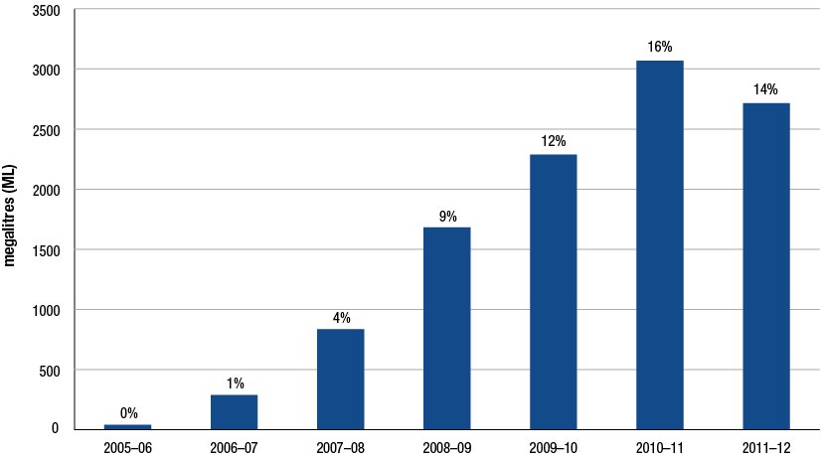
Source: ACCC calculations based on the Department of Resources, Energy and Tourism (RET) and the Bureau of Resources and Energy Economics (BREE), Australian Petroleum Statistics, various issues
There are only three states that sell EBP in any significant quantities in Australia, these are: NSW, Queensland and Victoria. Table 5.1 shows sales of EBP, RULP and PULP in these states, and the total across Australia, in 2010−11 and 2011−12.
Table 5.1 Sales of EBP, RULP and PULP in NSW, Queensland, Victoria, and Australia—2010−11 and 2011−12
 |  | NSW  ML | Vic.  ML | Qld  ML | Aust  ML
EBP | 2010−11 | 2 150 | 132 | 787 | 3 069
 | 2011−12 | 2 189 | 63 | 461 | 2 714
PULP* | 2010−11 | 1 849 | 896 | 828 | 4 267
 | 2011−12 | 2 149 | 952 | 895 | 4 735
RULP | 2010−11 | 2 160 | 3 612 | 2 515 | 11 388
 | 2011−12 | 1 774 | 3 765 | 2 718 | 11 313
Total | 2010−11 | 6 159 | 4 640 | 4 130 | 18 725
 | 2011−12 | 6 112 | 4 780 | 4 074 | 18 762

*Includes proprietary blends.
Source: ACCC calculations based on RET and BREE, Australian Petroleum Statistics, various issues
In 2011−12 sales of EBP in NSW totalled 2189 megalitres (ML), an increase of only 39 ML (or around 2 per cent) on the previous year. Data from the NSW Office of Biofuels indicates that sales of EBP have been relatively stable over the last seven quarters.
However, in Queensland, sales of EBP were 461 ML, a decrease of 326 ML (or 41 per cent) on 2010−11. In Victoria sales of EBP also decreased significantly to 63 ML in 2011−12 (a decrease of 52 per cent). The APAC biofuel consultants report Australian Biofuels 2012−13 (APAC report) noted that the decrease in demand in Queensland and Victoria was principally due to the reduction in the number of E10 outlets in those states as a consequence of ethanol shortages (partly due to natural disasters) in 2010 and early 2011, and the suspension of the proposed Queensland 5 per cent ethanol mandate.
Chart 5.2 shows sales of EBP in each major state as a proportion of total Australian EBP sales on an annual basis for the period 2005−06 to 2011−12. The chart indicates that since 2005−06 NSW’s share of national EBP sales steadily increased (from 19 per cent in 2005−06 to 81 per cent in 2011−12). Over the same period, Queensland’s share steadily decreased (from 78 per cent in 2005−06 to 17 per cent in 2011−12). Victoria’s share of national EBP sales remained broadly stable over this period (ranging between 1 per cent and 5 per cent).
Chart 5.2 Sales of EBP in the major states as a proportion of total Australian EBP sales:
2005−06 to 2011−12
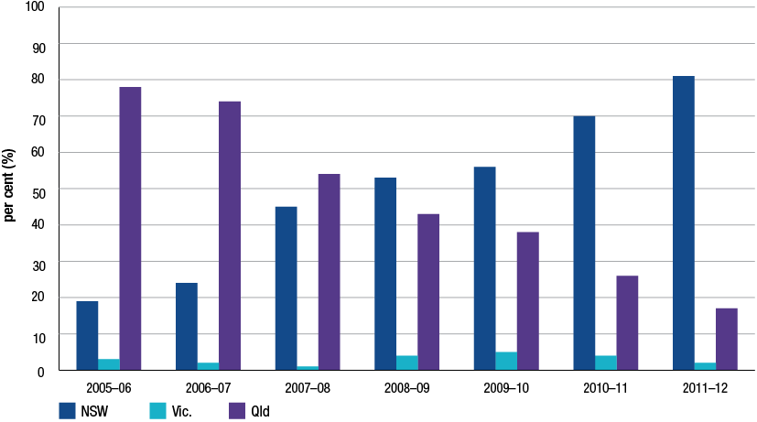
Source: ACCC calculations based on RET and BREE, Australian Petroleum Statistics, various issues
Chart 5.3 shows EBP sales as a proportion of total petrol sales in the major states during the period 2005−06 to 2011−12. It shows that in 2011−12:
- in NSW there was a marginal increase (by 1 percentage point to 36 per cent) in the share of EBP of total petrol sales
- this highlights that EBP demand in NSW appears to have broadly stabilised
- in Queensland there was a significant decrease (by 8 percentage points to 11 per cent)
- in Victoria there was a decrease (by 2 percentage points to 1 per cent).
Chart 5.3 EBP sales as a proportion of total petrol sales in the major states and Australia:
2005−06 to 2011−12
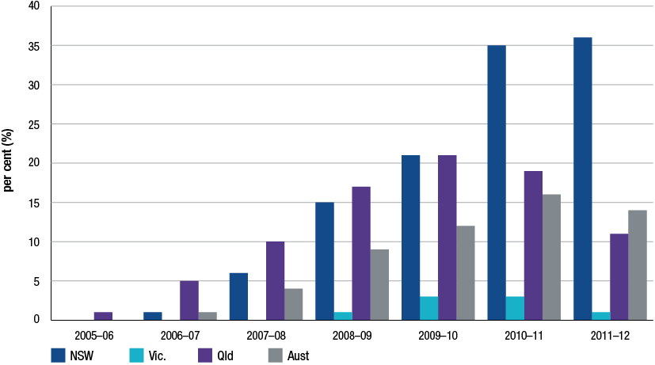
Source: ACCC calculations based on RET and BREE, Australian Petroleum Statistics, various issues
  - Retail sites selling E10 petrol
Chart 5.4 shows the average number of retail sites each month selling E10 in Australia for the period January 2007 to October 2012. The chart shows that:
- the number of retail sites selling E10 increased steadily between January 2007 (around 250 sites) and September 2010 (around 1530 sites)
- since then the number of retail sites selling E10 has declined to around 1220 sites in October 2012 (a decrease of 310 retail sites or around 20 per cent).
Chart 5.4 Number of retail sites selling E10 in Australia: January 2007 to October 2012
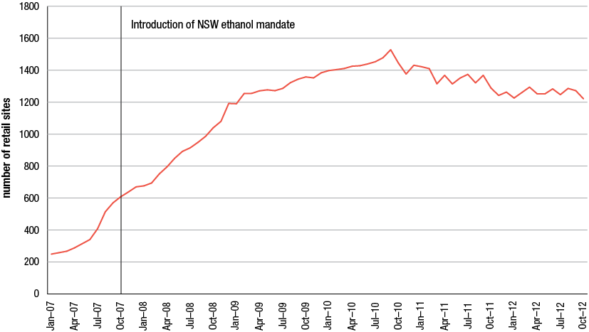
Source: ACCC calculations based on Informed Sources data
Charts 5.5 and 5.6 show the number of retail sites selling E10, RULP and E10 but not RULP (referred to as E10 only) in Sydney and Brisbane from July 2007 to October 2012.
Chart 5.5 Number of sites selling RULP, E10 and E10 only in Sydney: July 2007 to October 2012
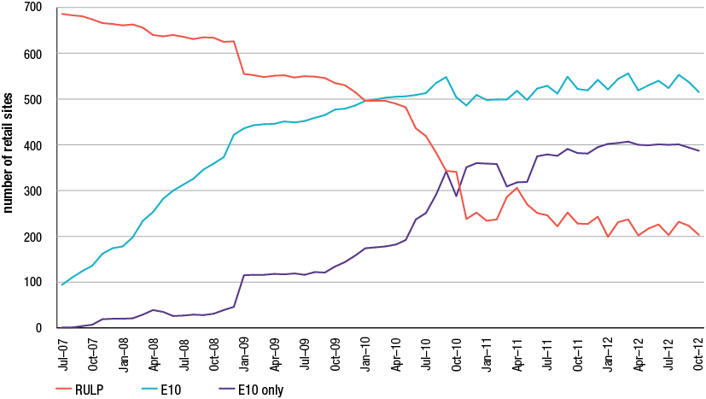
Source: ACCC calculations based on Informed Sources data
Over the last 12 months the number of retail sites selling E10 only in Sydney has remained broadly stable at around 400 sites. The numbers of retail sites selling RULP and E10 have been more volatile. Retail sites selling E10 in Sydney over the last 12 months have ranged between 500 and 560 retail sites and retail sites selling RULP have ranged between 200 and 235 retail sites.
Chart 5.6 Number of sites selling RULP, E10 and E10 only in Brisbane: July 2007 to October 2012
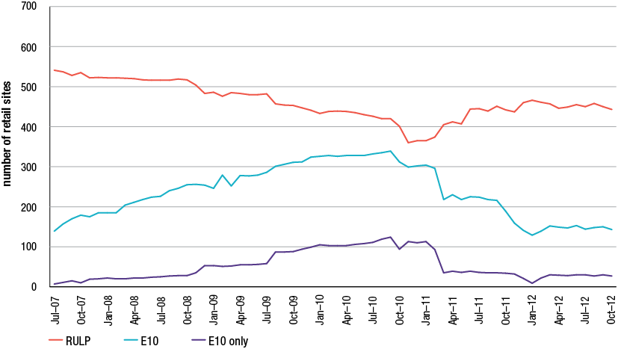
Source: ACCC calculations based on Informed Sources data
In Brisbane the number of retail sites selling E10 has decreased significantly since the peak of around 340 retail sites in September 2010. In October 2012 there were around 140 retail sites selling E10 in Brisbane—a decrease of around 200 retail sites (59 per cent). During that time a number of retailers—including BP and Coles Express—significantly reduced the number of retail sites selling E10.
  - Price differentials
The ACCC commenced monitoring and reporting on the price differential between RULP and E10 petrol in October 2006. Under this monitoring program, E10 prices are collected from various retail sites in a particular location and compared with the RULP prices at those retail sites. To be included in the analysis retail sites must sell both E10 and RULP.
Retail RULP prices have tended to be higher than E10 prices. This primarily reflects the fact that the ethanol component of E10 is effectively excise free. It may also reflect the lower energy component of ethanol compared with petrol.
Chart 5.7 shows the monthly average differential between RULP and E10 prices across all of the locations monitored by the ACCC over the period January 2007 to September 2012. It indicates that in 2011−12 average RULP prices were higher than average E10 prices by around 1.8 cpl. In the September 2012 quarter the differential increased to 2.0 cpl.
Chart 5.7 Monthly average RULP–E10 differential, all monitored locations:
January 2007 to September 2012
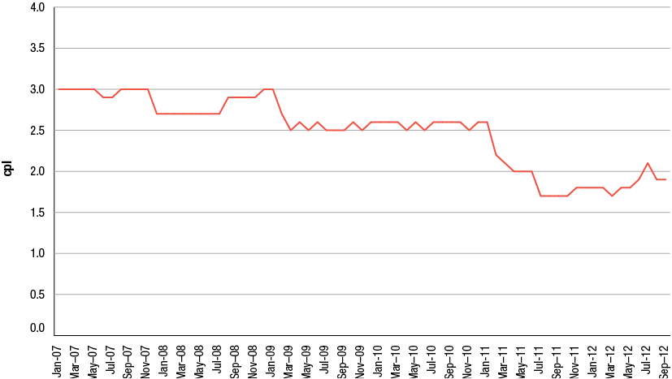
Source: ACCC calculations based on Informed Sources data
Chart 5.8 shows the annual average differential across all capital cities monitored (currently Sydney, Melbourne, Brisbane, Adelaide and Canberra) and the annual average differential across all regional locations monitored (currently comprising 16 locations in Queensland and 14 locations in NSW) for the years 2007 to 2012 (to September 2012). It shows that, over that period:
- the differential in the capital cities has been higher than the differential in regional areas in each year since 2009
- the differential in the capital cities has been greater than 2.0 cpl in all years
- the differential in the capital cities decreased from 3.0 cpl in 2009 to 2.1 cpl in 2011. In 2012 it remained the same at 2.1 cpl.
Chart 5.8 Annual average RULP–E10 differential, capital cities and regional locations: 2007 to 2012*
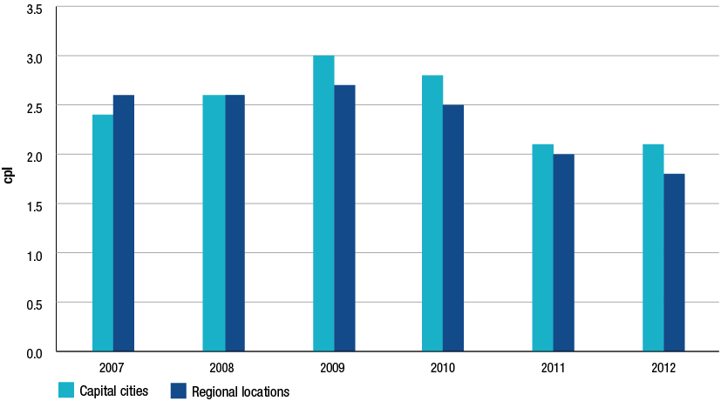
* to September 2012.
Source: ACCC calculations based on Informed Sources data
As noted in section 5.5, the number of retail sites selling both RULP and E10 has been decreasing over time—particularly in NSW. This raises questions about how meaningful it is to compare RULP and E10 prices. Given that the most widely used types of petrol in NSW are E10 and PULP (see section 5.4), IPART has suggested that the appropriate price comparison should be between those fuels.
Chart 5.9 shows monthly average differentials between PULP 95 prices and E10 prices in Sydney and Brisbane over the period July 2007 to September 2012. It also shows the monthly average differences between the differential in Sydney and the differential in Brisbane.
There are a couple of methodological points to note about this chart:
- sales of EBP accounted for 36 per cent of total petrol sales in NSW in 2011−12 and sales of PULP accounted for 35 per cent, whereas in Queensland sales of EBP accounted for only 11 per cent of total petrol sales and sales of PULP accounted for 22 per cent
- the prices are for all retail sites that sell E10 and all retail sites that sell PULP 95 in each of the cities.
Chart 5.9 Monthly average differentials between PULP 95 prices and E10 prices in Sydney and Brisbane, and the difference between the two cities, July 2007 to September 2012
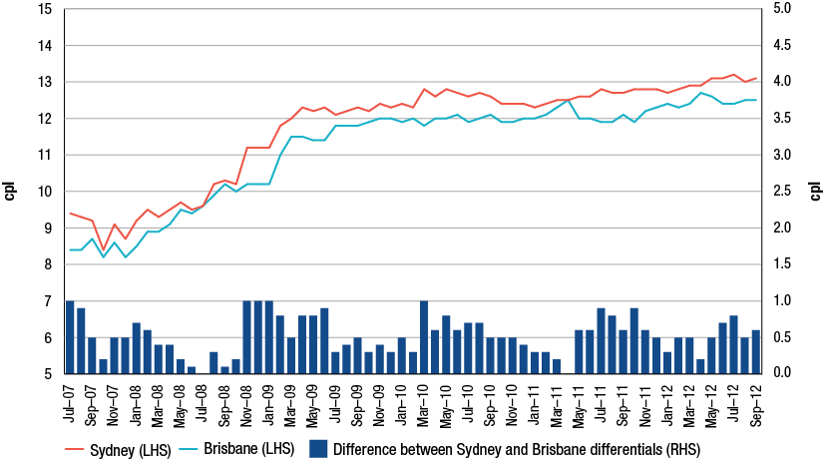
Source: ACCC calculations based on Informed Sources data
Chart 5.9 shows that:
- between July 2007 and July 2009 the PULP 95–E10 differential increased by around 3.0 to 4.0 cpl in both cities
- from mid-2009 to September 2012 the PULP 95–E10 differential has been broadly stable, increasing by less than 1.0 cpl in both cities
- the PULP 95–E10 differential in Sydney was generally higher than the PULP 95–E10 differential in Brisbane. However, the difference between the two cities was broadly stable over the entire period, with the average difference being 0.5 cpl.
There is little evidence to suggest that the introduction of the ethanol mandate in NSW has had a significant effect on the PULP 95–E10 differential in Sydney.
  - Ethanol supply and demand
In previous years the ACCC has expressed concern about the supply of ethanol. However, in 2012 there appears to be sufficient supply to meet demand. The APAC report, released in early October 2012, noted that:
Whereas in 2010−11 there was a serious shortage of ethanol to meet demand and supply could not be assured, the market is now in surplus and has been since late 2011. One producer is currently exporting surplus production to the Asian market.
According to this report, ethanol production capacity in Australia in 2012 is estimated to be 450 ML, up from 390 ML in 2011. There are currently three ethanol producers in Australia: Manildra (which produces ethanol from wheat starch); Sucrogen (which produces ethanol from molasses), and Dalby (which produces ethanol from sorghum).
The APAC report’s estimates of existing ethanol production capacity and forecast planned production capacity to 2017 are shown in table 5.2. It forecasts four new producers coming on stream between 2014 and 2017. Furthermore, the report commented that, should the market opportunity appear positive in 2015, existing producers could increase production by another 200 ML by 2016 up to an aggregate of around 700 ML (note that this additional production is not included in table 5.2).
Table 5.2 Australian ethanol production capacity (ML): 2011 to 2017
Operator | 2011 | 2012 | 2013 | 2014 | 2015 | 2016 | 2017
Manildra—Nowra, NSW | 250 | 300 | 300 | 300 | 300 | 300 | 300
Sucrogen—Sarina, Qld | 60 | 70 | 80 | 80 | 80 | 80 | 80
Dalby Biorefinery—Dalby, Qld | 80 | 80 | 80 | 90 | 90 | 90 | 90
Total from existing plants | 390 | 450 | 460 | 470 | 470 | 470 | 470
Total from planned plants |  |  |  | 215 | 510 | 590 | 590
Total from existing and planned plants | 390 | 450 | 460 | 685 | 980 | 1060 | 1060

Source: APAC biofuel consultants, Australian Biofuels 2012−13, p. 26
According to estimates in the APAC report, demand for ethanol in 2011−12 was 306 ML, a decrease of 13 ML on 2010−11. This represents a 68 per cent plant utilisation rate. As noted in section 5.4, demand for EBP in 2011−12 has been essentially flat in NSW and decreased significantly in Queensland and Victoria.
Chart 5.10 shows a number of potential supply and demand scenarios for ethanol in the years 2012−13 to 2016−17. The various scenarios on the demand side differ according to whether NSW achieves ethanol sales of 5 per cent or 6 per cent of total petrol sales, and whether an ethanol mandate is introduced in Queensland. The scenarios on the supply side are based on the production capacity of the three existing producers and the production capacity of planned producers.
These scenarios are indicative only. However, they show that:
- existing supply capacity would be sufficient to meet the increased demand associated with NSW achieving ethanol sales of 5 per cent and 6 per cent of total petrol sales in NSW (assuming that demand in Queensland and Victoria remained unchanged)
- if Queensland did introduce a 5 per cent ethanol mandate, there is likely to be sufficient planned production to meet the increased demand. Even if no new production capacity came on stream, it is likely that existing producers could increase production to fill the gap.
Chart 5.10 Estimated potential ethanol demand and supply, 2012−13 to 2016−17
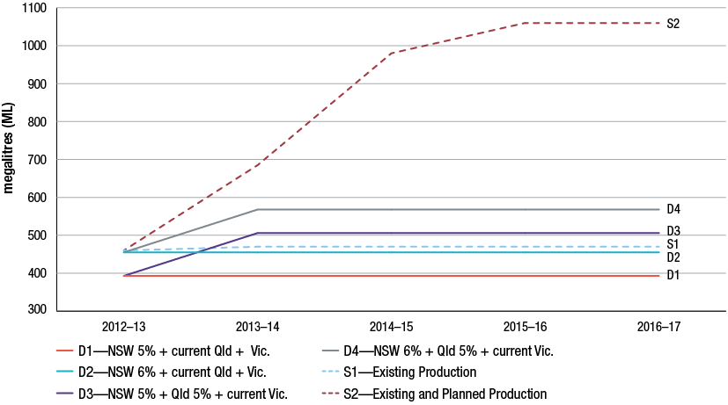
Sources: ACCC calculations based on BREE, Australian Petroleum Statistics, issue 191 June 2012 and APAC biofuel consultants, Australian Biofuels 2012−13
  - Ethanol blended petrol: consumers and competition
The ACCC has actively engaged with consumers and industry stakeholders throughout 2011−12. From this engagement, the ACCC has been informed of ongoing consumer concerns about EBP.
    - Complaints and inquiries
The ACCC continued to receive complaints about EBP in 2011−12. Around two-thirds of complaints came from NSW and around one-fifth came from Queensland.
The main issues that were brought to the ACCC’s attention in respect of EBP included concerns about:
- advertising of EBP by retailers, such as prices for RULP and EBP not being sufficiently differentiated on some roadside price boards or advertising EBP on price boards when it was not available
- labelling of EBP on retail site forecourts being absent or difficult to see
- the price difference between EBP and RULP and/or PULP
- the potential damage to vehicles caused by EBP, particularly when consumers did not realise they were purchasing EBP or were unable to purchase RULP because it had been replaced by EBP.
While most consumer complaints and inquiries do not raise concerns under the Act, the ACCC will take action where appropriate. The ACCC assessed allegations of misleading and deceptive conduct relating to the sale of EBP in 2011−12 which related to ethanol being present in fuels without appropriate labelling of the ethanol content.
    - Engagement with key stakeholders on EBP issues
During 2011−12, the Fuel Consultative Committee (Fuel CC) continued to play a role in the ACCC’s engagement with key stakeholders about ethanol and EBP. In 2011−12 the Biofuels Association of Australia joined the Fuel CC. During the meetings of the Fuel CC, members raised concerns about the following issues:
- the impact of state-based ethanol mandates, including the cost of meeting these mandates
- the price difference between E10, RULP and PULP
- the need to inform consumers more effectively about the relative value of different fuel types, particularly in relation to engine compatibility and energy content
- the increased logistical costs of handling, transporting and storing EBP to meet mandated ethanol consumption
- addressing the negative perception of EBP among some parts of the automotive industry.
The ACCC also continued to engage with stakeholders outside the Fuel CC, including liaising directly with ethanol producers, fuel retailers, industry associations, motoring organisations and government agencies regarding EBP.

- Wholesale prices
Key points
- Wholesale petrol prices in Australia are set on the basis of the import parity price (IPP).
- The IPP is calculated with reference to the international price of refined unleaded petrol plus other import costs and is a benchmark for the notional costs of importing petrol into Australia.
- The IPP has closely reflected the actual costs incurred by companies importing petrol to Australia over the five years to June 2012.
- In 2011−12, wholesale price movements continued to move in line with those of the IPP (and actual import prices).

  - Introduction
This chapter analyses petrol pricing in the wholesale sector, both at the point where it enters the sector and at the point where petrol moves into the retail sector.
Analysis focuses on wholesale pricing during 2011−12, and also builds on previous ACCC petrol monitoring reports.
  - The wholesale sector
Petrol enters the wholesale sector from domestic refineries or import terminals. There are three broad types of companies operating in the wholesale sector:
- Refiner-wholesalers: BP, Caltex, Mobil and Shell. These companies supply petrol which has been produced in domestic refineries, bought from other refiner-wholesalers through ‘buy-sell’ transactions, and imported.
- Independent wholesalers: including United, Neumann, Ausfuel (formerly Gull) and Liberty. These companies buy petrol from refiner-wholesalers and in some cases import themselves.
- Independent importers: a small number of companies import low volumes of petrol and sell directly to independent wholesalers.
In 2011−12 the refiner-wholesalers supplied most of Australia’s petrol.
- About 80 per cent of wholesale volumes were refined domestically, with the balance sourced through imports.
- Refiner-wholesalers imported around 70 per cent of total petrol imports. Independent importers accounted for the remaining 30 per cent, up from 5 per cent in 2007–08.
- Thus it is likely that the four refiner-wholesalers supplied about 95 per cent of total supplies of petrol.
Petrol is sold through the wholesale sector by refiner-wholesalers and independent wholesalers. Depending on their structure, these companies may sell/transfer to:
- their retail sites, franchisees and commission agents
- independent retailers
- independent wholesalers
- independent distributors and/or end-users such as miners, farmers and large commercial entities.
The role of the wholesale sector in the context of the flow of petrol through the industry is illustrated in figure 6.1 below.
Figure 6.1 Flow of petrol through sectors of the Australian petroleum industry
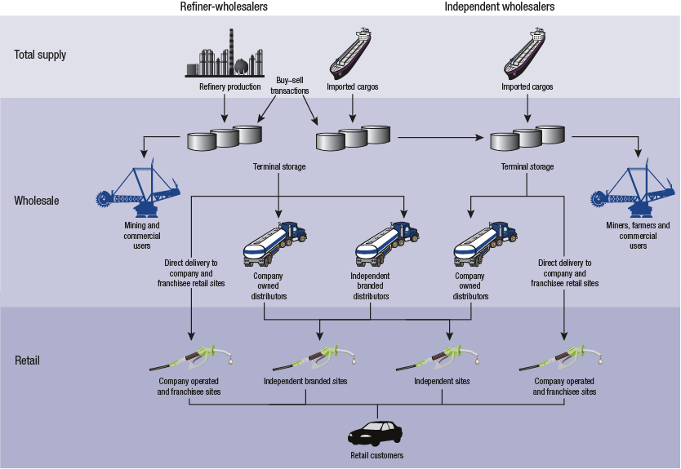
Source: ACCC
  - Wholesale price benchmarks
There are two key benchmarks used as the basis for determining wholesale prices: import parity price (IPP) and terminal gate price (TGP). Underlying both of these is the relevant international benchmark price for petrol.
    - Import parity price
The IPP is the most significant wholesale price benchmark. It is intended to reflect the cost of importing petrol. As Australia is a net importer of refined petrol, the cost of marginal supplies is the cost of imports. Refiner-wholesalers utilise a benchmark for the notional cost of importing, the IPP, as the basis for setting wholesale prices. This benchmark reflects the cost of importing petrol refined to certain specifications from and to specific locations. Therefore the IPP comprises the price of petrol in the source location refined to Australian fuel standards, plus the costs associated with transporting it to specific locations in Australia.
The IPP has three main components:
- the benchmark price of petrol at the main source of imports
- any quality premium required to account for the difference between the prices of petrol refined to Australian standards and of petrol meeting the benchmark specifications
- costs that would be incurred to import petrol, such as freight, wharfage and other incidental costs.
Singapore is the main source of petrol imported into Australia (refer table 3.2, chapter 3). The benchmark price used by the refiner-wholesalers to price regular unleaded petrol (RULP) in Australia is the Platts Singapore quote for Mogas 95 unleaded, also known as MOPS 95 (Mean of Platts Singapore for Mogas 95).
MOPS 95 is an international benchmark price subject to supply and demand factors on the global market. The Australian fuel quality standards for RULP are generally higher than the Mogas 95 specifications; therefore to reflect this difference the IPP includes a quality premium.
The common formula used to derive the IPP for RULP can be expressed as:
IPP (RULP) = Benchmark RULP price (MOPS 95) + quality premium
+ freight + insurance and loss + wharfage + other costs
The price of Mogas 95 is by far the most significant component of the IPP. In recent years Mogas 95 has represented over 90 per cent of the annual average IPP; in 2011−12 it represented 95 per cent (chart 6.1).
Chart 6.1 Components of annual average IPP for RULP in the five largest cities: 2008−09 to 2011−12
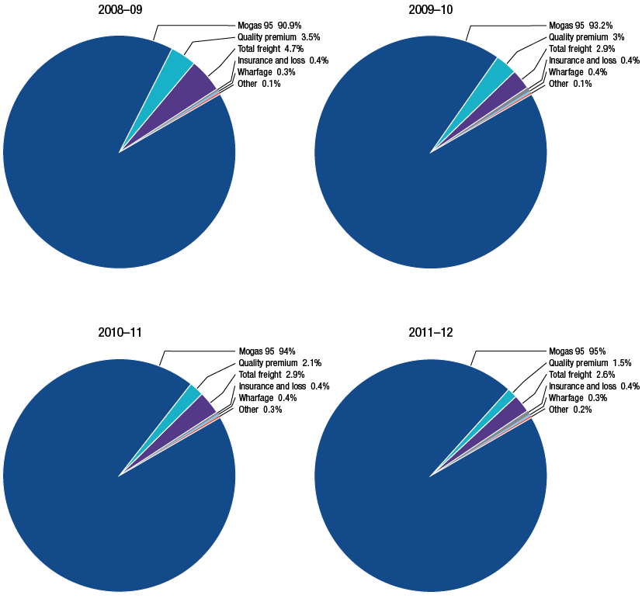
Source: ACCC analysis based on data obtained from firms monitored through the ACCC’s monitoring process
As well as being the most significant component, Mogas 95 is also the most volatile, and therefore is the key driver of changes in the IPP. Over 2011−12, the price of Mogas 95 decreased by just over 4 cpl, by contrast all the other components were virtually unchanged (chart 6.2).
Chart 6.2 Components of monthly average IPP for RULP in the five largest cities: July 2007 to June 2012
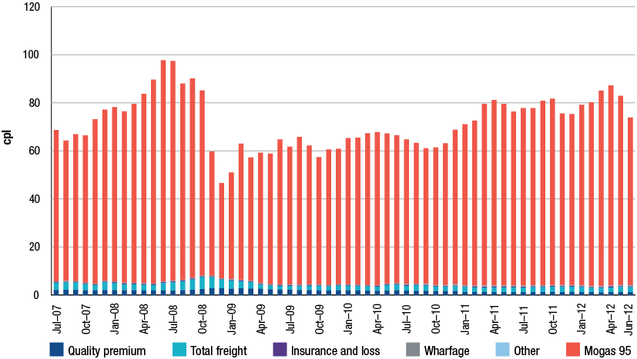
Source: ACCC analysis based on data obtained from firms monitored through the ACCC’s monitoring process
Another factor causing volatility in the IPP is that it is quoted in USD, so is subject to the fluctuations of the AUD/USD exchange rate (table 6.1). Over 2011−12, IPP was highest in April 2012 at 87.22 cpl and lowest in June 2012 at 73.93 cpl.
The size of the quality premium has fallen in recent years. The average annual quality premium was 2.01 cpl in 2007−08 but fell to 1.19 cpl in 2011−12.
Table 6.1 Components of monthly average IPP for RULP in the five largest cities: July 2011 to June 2012
 | Exchange rate | Mogas 95 | Quality premium | Total freight | Insurance and loss | Wharfage | Other | IPP
 | 1AUD = USD | cpl | cpl | cpl | cpl | cpl | cpl | cpl
Jul 11 | 1.06 | 73.92 | 1.15 | 1.98 | 0.30 | 0.26 | 0.18 | 77.36
Aug 11 | 1.05 | 73.79 | 1.16 | 2.11 | 0.30 | 0.26 | 0.19 | 77.80
Sep 11 | 1.03 | 76.77 | 1.18 | 2.11 | 0.31 | 0.26 | 0.19 | 80.82
Oct 11 | 0.99 | 77.58 | 1.23 | 2.17 | 0.31 | 0.26 | 0.19 | 81.75
Nov 11 | 1.01 | 71.43 | 1.21 | 2.13 | 0.30 | 0.26 | 0.21 | 75.54
Dec 11 | 1.00 | 71.19 | 1.23 | 2.18 | 0.29 | 0.26 | 0.21 | 75.37
Jan 12 | 1.02 | 75.15 | 1.17 | 2.09 | 0.31 | 0.26 | 0.20 | 79.18
Feb 12 | 1.06 | 76.50 | 1.14 | 1.77 | 0.32 | 0.26 | 0.19 | 80.18
Mar 12 | 1.05 | 81.37 | 1.13 | 1.80 | 0.34 | 0.26 | 0.19 | 85.09
Apr 12 | 1.03 | 83.31 | 1.15 | 1.96 | 0.35 | 0.26 | 0.19 | 87.22
May 12 | 1.00 | 78.86 | 1.18 | 2.15 | 0.33 | 0.26 | 0.19 | 82.97
Jun 12 | 0.98 | 69.89 | 1.20 | 2.09 | 0.29 | 0.26 | 0.19 | 73.93
2011−12 average | 1.02 | 74.10 | 1.19 | 2.11 | 0.30 | 0.26 | 0.19 | 78.28

Source: ACCC analysis based on data obtained from firms monitored through the ACCC’s monitoring process.
Note: The data in table 6.1, including exchange rates, is not comparable with data in chart 7.4 (PULP IPP—chapter 7) as one refiner-wholesaler calculates its PULP IPP differently. Components of chart 7.4 have been adjusted to reflect this.
Mogas 95 prices are not comparable with data in chapter 8 and the summary. Data in this table has been derived from the monitored companies.
    - IPP and actual costs of importing
There are a number of factors that will cause some monthly variations between actual costs and the IPP. These include the timing of payments, exchange rate movements and the occurrence of a relatively small number of import transactions in a given month.
For at least the past five years the actual monthly average cost of importing RULP into the five largest cities has generally reflected the IPP (chart 6.3). Over this period the difference between IPP and actual import costs has been, on average, well below 1 cpl.
Chart 6.3 Monthly average import costs and IPP for RULP in the five largest cities:
July 2007 to June 2012
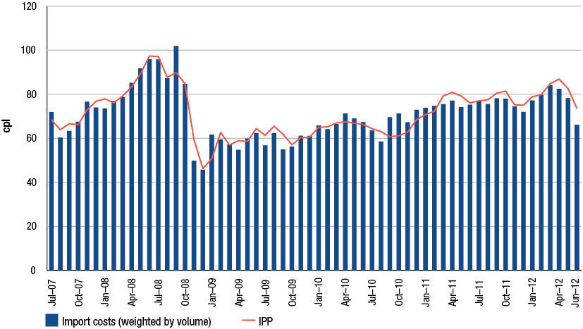
Source: ACCC analysis based on data obtained from firms monitored through the ACCC’s monitoring process
    - IPP and transactions between refiner-wholesalers
While the refiner-wholesalers have wholesale operations in most capital cities and major regional centres, they do not necessarily operate a refinery or import terminal in these locations. Where this is the case, a refiner-wholesaler has three supply options:
- use another company’s terminal to import and store petrol
- transport petrol from a refinery or terminal it owns in another location
- obtain petrol from a refinery or terminal in the local area, operated or used by a different refiner-wholesaler.
The third option is the most commonly used as it allows a refiner-wholesaler an efficient method of accessing local supplies. These are referred to as ‘buy-sell’ transactions. These occur in the supply (production and import) sector; they are pre-wholesale transactions (refer figure 6.1).
Buy-sell transactions among refiner-wholesalers are underpinned by six-monthly agreements with each other setting out the volumes they intend to buy and sell in each location. The prices in these agreements are based on the IPP; if prices were higher, a refiner-wholesaler could choose to import petrol at a lower cost. Consequently buy–sell prices and IPP track each other very closely, indicating that buy–sell prices are relatively competitive with the costs of importing (chart 6.4).
Chart 6.4 Monthly average net buy–sell prices and IPP for RULP in the five largest cities:
July 2007 to June 2012
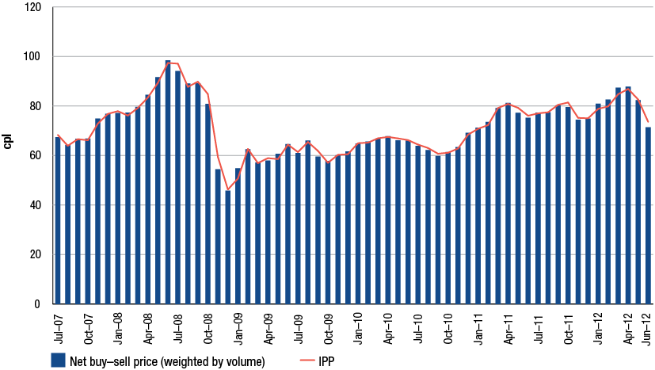
Source: ACCC analysis based on data obtained from firms monitored through the ACCC’s monitoring process
    - Terminal gate prices
Under the provisions in the Oilcode, TGPs are published daily by refiner-wholesalers and independent wholesalers for specific refineries and terminals. While they are theoretically the price for spot purchases on that day, in practice TGPs are predominantly used as the basis for wholesale transactions which occur under contracts and other pre-determined arrangements.
TGPs have four main components:
- the IPP
- taxes
- wholesale margin
- operating costs (including storage and local transportation)
The TGP formula is commonly expressed as:
TGP = IPP + excise + GST + wholesale margin + operating costs
Over the past five years IPP has been the largest component of TGP (chart 6.5). It has been the key contributor to changes in TGP; the other components have been relatively steady over the period. In early 2011−12 TGP was around 135.0 cents per litre (cpl). In April 2012 it peaked at an average of 143.3 cpl, then fell to under 130.0 cpl in June. All these changes predominantly reflect the price of the underlying benchmark product, Mogas 95.
Chart 6.5 Components of the annual average TGP for RULP in the five largest cities:
July 2007 to June 2012
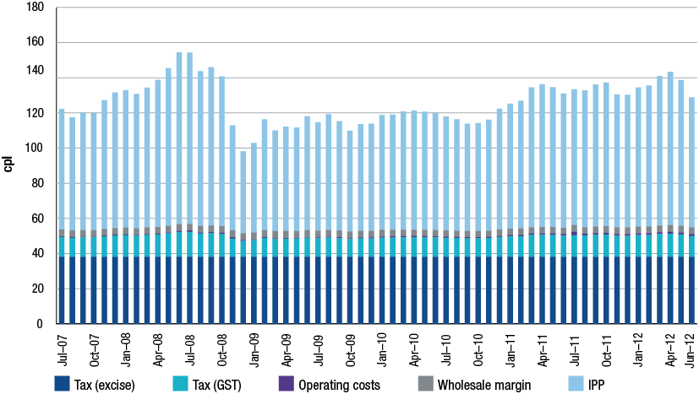
Source: ACCC analysis based on data obtained from firms monitored through the ACCC’s monitoring process
  - Relationship between wholesale prices and the benchmarks
Comparing actual wholesale prices with the IPP and TGP benchmarks provides an indication of the extent to which they reflect notional costs.
As the IPP is a pre-tax benchmark, it is appropriate to make comparisons with the ‘net’ wholesale price, which is defined as actual wholesale prices less excise and GST. As notional spot prices, TGPs include taxes and hence are compared with actual or ‘gross’ wholesale prices.
    - Wholesale prices and IPP
There has been a close relationship between average net wholesale prices and the IPP in the five largest cities over the past five years (chart 6.6). The difference between the two prices represents the average wholesale margin in these cities, as well as operating costs. The chart indicates that the average differential has remained relatively consistent over the five-year period.
Chart 6.6 Monthly average net wholesale prices and IPP for RULP in the five largest cities:
July 2007 to June 2012
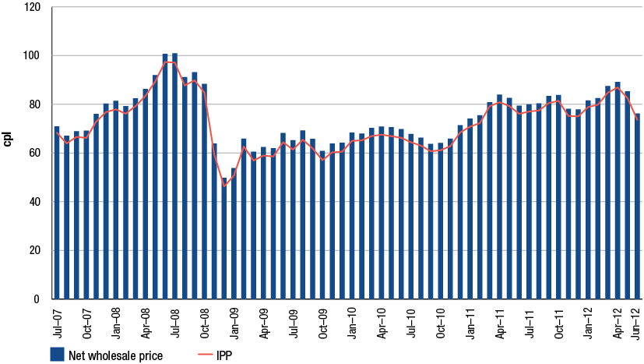
Source: ACCC analysis based on data obtained from firms monitored through the ACCC’s monitoring process
Note: Wholesale prices have been notionally adjusted to exclude excise and GST to allow a comparison with IPP, which excludes taxes.
Table 6.2 shows the differentials between net wholesale prices and the IPP for each of the five largest cities in 2011−12. Sydney (1.9 cpl) experienced the smallest differential. Most of the other cities had the same differential (2.5 cpl), with the exception of Brisbane (slightly higher at 2.6 cpl).
The differential in Sydney for 2011−12 was higher than for 2010−11, when it was 1.5 cpl. It also increased in Brisbane, (from 2.4 cpl in 2010−11), Perth (from 2.3 cpl) and Adelaide (from 2.2 cpl). Melbourne was the only city which had a lower differential compared with 2010−11, falling from 2.9 cpl.
Table 6.2 Annual average net wholesale prices and IPP for RULP in the five largest cities: 2011−12
 | Net wholesale price  cpl | IPP  cpl | Difference  cpl
Sydney | 82.0 | 80.1 | 1.9
Melbourne | 82.4 | 79.9 | 2.5
Brisbane | 82.3 | 79.7 | 2.6
Adelaide | 82.5 | 80.0 | 2.5
Perth | 81.5 | 79.1 | 2.5

Source: ACCC analysis based on data obtained from firms monitored through the ACCC’s monitoring process
Note: Wholesale prices have been notionally adjusted to exclude excise and GST to allow a comparison with IPP, which excludes taxes.
    - Wholesale prices and TGP
While it is understood that few wholesale sales are actually made at the TGP, it tends to be a benchmark price for the calculation of prices of many wholesale transactions. TGPs are therefore a useful indicator of movements in average wholesale prices.
During 2011−12 daily average gross wholesale RULP prices in the five largest cities closely followed changes in TGPs (chart 6.7). Wholesale prices generally tended to be lower than TGP in 2011−12.
Chart 6.7 Daily average wholesale prices and TGPs for RULP in the five largest cities:
July 2007 to June 2012
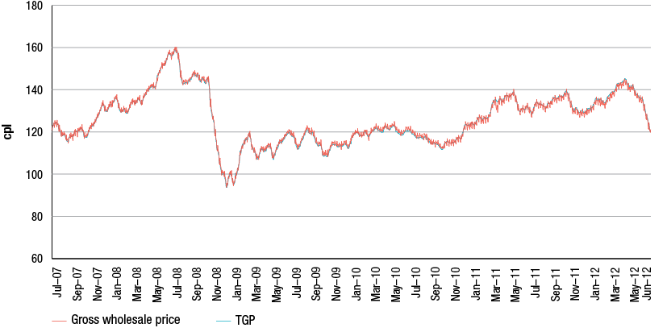
Source: ACCC analysis based on data obtained from firms monitored through the ACCC’s monitoring process
In 2011−12 the average gross wholesale prices were below TGPs in four of the five largest cities (table 6.3). This was in contrast with 2010−11, when prices were above TGP in all five capitals.
Table 6.3 Annual average gross wholesale prices and TGPs for RULP in the five largest cities: 2011−12
 | Gross wholesale price  cpl | TGP  cpl | Difference  cpl
Sydney | 134.1 | 135.2 | −1.1
Melbourne | 134.8 | 134.7 | 0.1
Brisbane | 134.6 | 134.8 | −0.2
Adelaide | 134.1 | 135.1 | −1.0
Perth | 134.9 | 135.5 | −0.6

Source: ACCC analysis based on data obtained from firms monitored through the ACCC’s monitoring process
  - Comparing wholesale and retail prices
Over the five years to June 2012 average weekly retail RULP prices in the five largest cities have closely tracked changes in both gross wholesale prices and IPP (chart 6.8). As would be expected, retail prices are above wholesale prices to account for additional costs and a margin.
The trend of an increasing differential between wholesale and retail prices noted in the 2011 ACCC petrol monitoring report appeared to be less pronounced in 2011−12, particularly in the second half of the financial year. These differentials are not measures of financial performance. Chapter 14 examines the financial performance of the wholesale and retail sectors.
Chart 6.8 Weekly average IPP, gross wholesale prices and retail prices for RULP in the five largest cities: July 2007 to June 2012
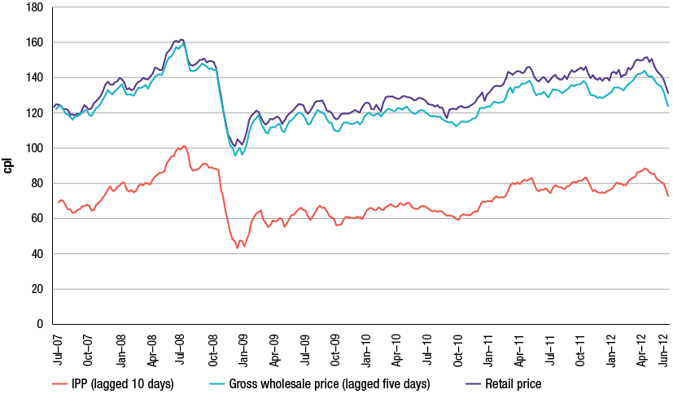
Source: ACCC analysis based on data obtained from firms monitored through the ACCC’s monitoring process
  - Observations on wholesale prices
As an internationally traded product, the wholesale price of petrol is heavily influenced by the IPP. The data analysed in this chapter indicates that over 2011−12 IPP continued to be the basis for setting wholesale prices in Australia. Movements in the IPP have reflected movements in the international price of refined petrol and generally tracked changes in the cost of importing refined petrol into Australia. This is consistent with data analysed by the ACCC since the commencement of monitoring in July 2007 showing that wholesale prices have tracked movements in the IPP which in turn have closely mirrored changes in the international benchmark price of refined petrol and import costs.
- Premium unleaded petrol
Key points
- Sales of premium unleaded petrol (PULP) continued to increase in 2011−12, particularly in NSW where sales have now overtaken sales of regular unleaded petrol (RULP).
- The increase in PULP sales in NSW seen in the last few years is likely to be primarily a result of the ethanol mandate, which has affected availability of RULP.
- Wholesale prices of PULP are set with reference to the import parity price (IPP) benchmark which is driven by the international price of PULP.
- The difference between RULP and PULP retail prices appears to be widening.
- Supplies and prices of PULP may be under pressure if demand continues to grow in line with recent trends.

  - Introduction
This chapter analyses changes in demand, supply and pricing of premium unleaded petrol (PULP).
While the focus is on developments in 2011−12, the analysis builds on that of previous ACCC petrol monitoring reports.
  - Features of premium unleaded petrol
In Australia there are two main grades of PULP:
- PULP 95: unleaded petrol with a minimum 95 RON
- PULP 98: unleaded petrol with a minimum 98 RON.
Regular unleaded petrol (RULP) has a minimum 91 RON. PULP also has a higher motor octane number and lower sulphur content compared with RULP. Cleaning agents are also often added to minimise engine wear and tear.
The higher octane, additional refining and additives of PULP may boost the performance of some engines. However, PULP is generally more costly to purchase than RULP, which must be taken into account in evaluating its relative cost effectiveness.
PULP requires a more complex refining process compared with RULP. This is primarily due to the lower sulphur content. As the desulphurisation process reduces the octane rating, PULP may require additional refining in order to achieve 95 or 98 RON. Adding a cleaning agent also requires further processing.
In contrast to RULP, which is often sold as a generic product, companies attempt to distinguish their PULP products from those of their competitors. Therefore different margins for the two grades of petrol may be expected. While different companies’ PULP products may contain the same octane level, and in some cases similar features, they are generally marketed as a company-branded retail product.
  - Demand for premium unleaded petrol
Due to a number of factors, including the NSW ethanol mandate, demand for PULP has increased over the past five years. Over the same period RULP demand decreased markedly.
    - National demand for premium unleaded petrol
In June 2012, 385 megalitres (ML) of PULP was sold in Australia, an increase from 269 ML in July 2007 (chart 7.1). Over the same period RULP sales decreased from 1,332 ML to 901 ML. Since July 2007 the volume of ethanol blended petrol (EBP) sold has risen significantly, from 43 ML to 216 ML in June 2012. However, as noted in chapter 5, on annual basis, EBP sales fell in 2011−12.
Chart 7.1 Monthly sale volumes of PULP, RULP and EBP: July 2007 to June 2012
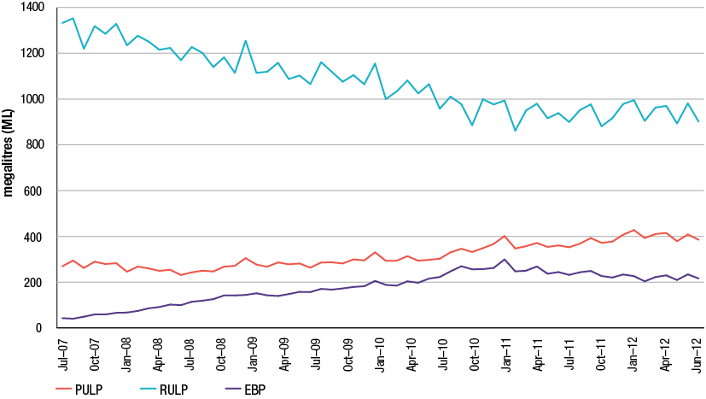
Source: Department of Resources, Energy and Tourism (RET) and Bureau of Resources and Energy Economics (BREE), Australian Petroleum Statistics, various issues
PULP products have increased their share of total petrol sales, from 17 per cent in 2007−08 to 25 per cent in 2011−12 (table 7.1). By contrast, the share of RULP fell from 79 per cent of petrol sales in 2007−08 to 60 per cent in 2011−12. EBP exhibited the most significant demand increase, primarily due to the NSW State Government ethanol mandate.
Table 7.1 Percentage and volume of annual sales of PULP, RULP and EBP: 2007−08 to 2011−12
 | PULP |  | RULP |  | EBP
 | % | ML | % | ML | % | ML
2007−08 | 17 | 3186 | 79 | 15 209 | 4 | 835
2008−09 | 17 | 3236 | 74 | 13 768 | 9 | 1682
2009−10 | 19 | 3573 | 69 | 12 841 | 12 | 2288
2010−11 | 23 | 4267 | 61 | 11 388 | 16 | 3069
2011−12 | 25 | 4735 | 60 | 11 313 | 14 | 2714
Change in percentage | -8 |  | -19 |  | -10

Source: RET and BREE, Australian Petroleum Statistics, various issues.
In 2007−08, PULP 98 sales volumes were lower than PULP 95 (chart 7.2). Over the subsequent five years demand for PULP 98 has risen faster than for PULP 95, consequently in 2011−12 there was similar demand for both grades of petrol.
Chart 7.2 Monthly wholesale sale volumes of PULP 95 and PULP 98: July 2007 to June 2012
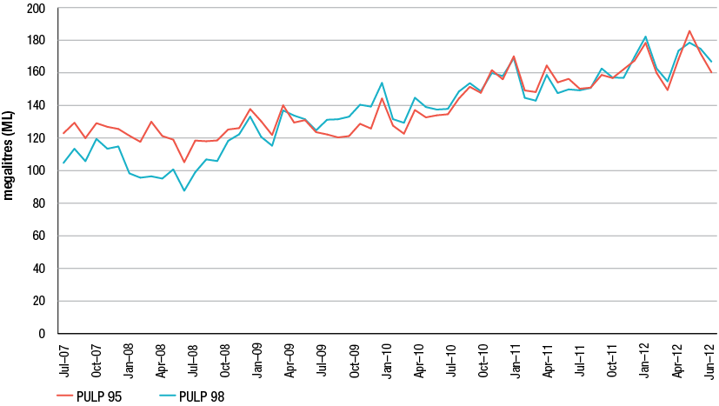
Source: ACCC analysis based on data obtained from firms monitored through the ACCC’s monitoring process
    - State demand for premium unleaded petrol
The national trend of increasing demand for PULP and declining demand for RULP has been most evident in NSW, where PULP’s share of total petrol sales has risen from 17 per cent in 2007−08 to around 35 per cent in 2011−12 (table 7.2). The other states and the Northern Territory had smaller increases in PULP sales volumes.
Table 7.2 Annual volumes and proportion of sales of RULP, PULP and total petrol (including EBP): 2007−08 to 2011−12
 |  | 2007−08 |  | 2008−09 |  | 2009−10 |  | 2010−11 |  | 2011−12
 |  | ML | % | ML | % | ML | % | ML | % | ML | %
NSW  (incl. ACT) | RULP | 4666 | 77 | 3981 | 66 | 3508 | 57 | 2160 | 35 | 1774 | 29
NSW  (incl. ACT) | PULP | 1030 | 17 | 1124 | 19 | 1316 | 22 | 1849 | 30 | 2149 | 35
NSW  (incl. ACT) | Total | 6072 |  | 5995 |  | 6112 |  | 6108 |  | 6112
Vic. | RULP | 3998 | 84 | 3684 | 82 | 3572 | 79 | 3612 | 77 | 3765 | 79
Vic. | PULP | 783 | 16 | 751 | 17 | 804 | 18 | 896 | 19 | 952 | 20
Vic. | Total | 4787 |  | 4502 |  | 4496 |  | 4685 |  | 4780
QLD | RULP | 3282 | 73 | 2855 | 66 | 2590 | 61 | 2515 | 61 | 2718 | 67
QLD | PULP | 740 | 17 | 715 | 17 | 772 | 18 | 828 | 20 | 895 | 22
QLD | Total | 4475 |  | 4296 |  | 4243 |  | 4122 |  | 4074
SA | RULP | 1139 | 86 | 1117 | 86 | 1111 | 84 | 1090 | 84 | 1060 | 83
SA | PULP | 186 | 14 | 189 | 14 | 205 | 16 | 206 | 16 | 214 | 17
SA | Total | 1325 |  | 1306 |  | 1316 |  | 1296 |  | 1275
WA | RULP | 1610 | 82 | 1629 | 81 | 1583 | 81 | 1576 | 79 | 1578 | 79
WA | PULP | 357 | 18 | 370 | 19 | 383 | 19 | 398 | 20 | 434 | 21
WA | Total | 1967 |  | 1999 |  | 1966 |  | 1987 |  | 2012
Tas. | RULP | 384 | 85 | 370 | 85 | 351 | 84 | 331 | 83 | 321 | 82
Tas. | PULP | 71 | 16 | 67 | 15 | 69 | 16 | 70 | 17 | 68 | 18
Tas. | Total | 454 |  | 437 |  | 420 |  | 401 |  | 389
NT | RULP | 131 | 87 | 133 | 86 | 126 | 85 | 104 | 83 | 97 | 81
NT | PULP | 19 | 13 | 21 | 14 | 23 | 16 | 21 | 17 | 22 | 19
NT | Total | 150 |  | 154 |  | 148 |  | 126 |  | 119

Source: RET and BREE, Australian Petroleum Statistics, various issues
Notes: ‘Total’ category includes EBP. Percentages may not add to 100 in states with EBP sales.
    - Impact of state government ethanol mandates
One of the key drivers of demand for PULP has been the NSW Government’s ethanol mandate. This has had the effect of reducing the availability of RULP in that state, as increasing volumes of RULP are mixed with ethanol to be sold as EBP, primarily E10 (RULP blended with up to 10 per cent ethanol).
As shown in chapter 5, over the five years to June 2012 the number of retail sites in Sydney selling RULP has gradually declined, generally replaced by E10. Conceivably the NSW mandates could continue to affect demand for PULP in NSW for two reasons:
- declining availability of RULP from most service stations pushing some consumers towards PULP
- consumers with older cars which cannot use EBP and cannot access RULP switching to (ethanol-free) PULP.
  - Supply of premium unleaded petrol
PULP sold in Australia is produced domestically and imported. The percentage of total sales met from imports rose significantly in 2008−09 and then plateaued in subsequent years (chart 7.3). In 2011−12 imports accounted for an estimated 24 per cent of sales.
Chart 7.3 Total and percentage of PULP sales by domestic production and imports: 2005−06 to 2011−12
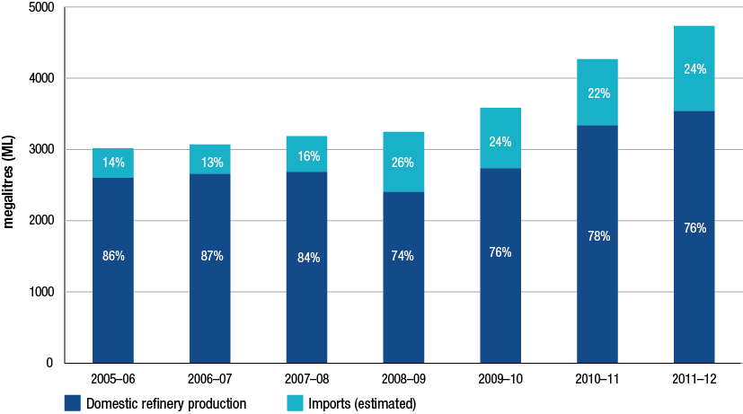
Source: ACCC analysis based on data obtained from firms monitored through the ACCC’s monitoring process; RET and BREE, Australian Petroleum Statistics, various issues
  - Premium unleaded petrol prices
As with RULP, there are two key benchmarks for determining domestic PULP prices: the import parity price (IPP) and the terminal gate price (TGP).
    - Import parity price of premium unleaded petrol
All four refiner-wholesalers calculate an IPP for PULP. Three use an IPP based on the benchmark Platts Singapore quote for refined premium petrol of RON 97 (Mogas 97). This benchmark is known as MOPS 97 (Mean of Platts Singapore for Mogas 97). The other refiner-wholesaler calculates its PULP IPP on the basis of MOPS 95 and adds a ‘PULP margin’.
The formula used by most refiner-wholesalers to derive the IPP for PULP 95 can be expressed as:
IPP (PULP 95) =
Benchmark PULP 95 price (MOPS 97) + quality premium
+ freight + insurance and loss + wharfage + other costs
Chart 7.4 shows the average monthly components of the IPP for PULP 95 over the five years to June 2012. MOPS 97 is clearly the largest component and is the main factor driving changes in the level of the IPP for PULP.
On average, the MOPS component made up over 91 per cent of the PULP IPP in 2011−12, slightly more than the previous two years due to higher benchmark prices.
Chart 7.4 Components of monthly average IPP for PULP 95 in the five largest cities:
July 2007 to June 2012
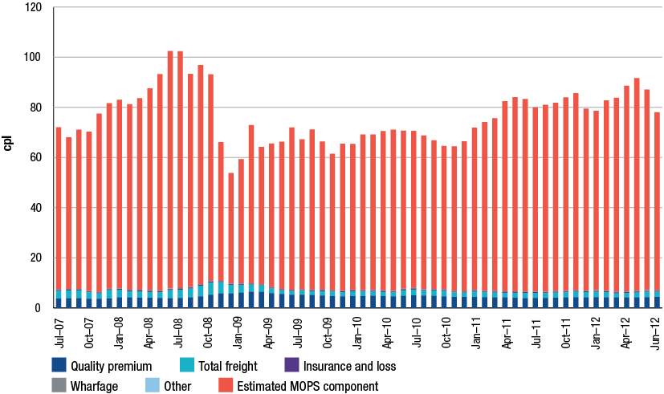
Source: ACCC analysis based on data obtained from firms monitored through the ACCC’s monitoring process.
Note: The data in chart 7.4 is not comparable with RULP IPP data in chapter 6 as one refiner-wholesaler calculates its PULP 95 IPP differently from the others. Components have been adjusted to reflect this.
    - IPP and actual costs of importing
Although IPP is a notional cost, over the past five years it has largely tracked actual costs paid by companies importing PULP into Australia (chart 7.5). While there have been some monthly variations, with actual costs above and below IPP, the average difference over the five years has been around 0.23 cpl.
Chart 7.5 Monthly average PULP 95 import costs and IPP in the five largest cities:
July 2007 to June 2012
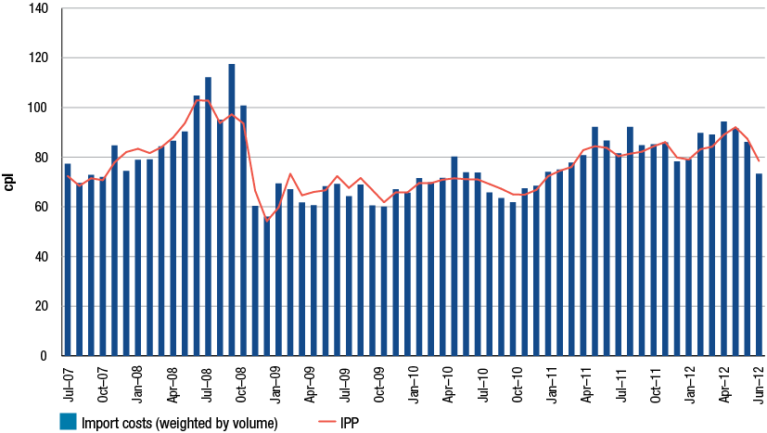
Source: ACCC analysis based on data obtained from firms monitored through the ACCC’s monitoring process
    - Comparison of the IPPs for premium and regular unleaded petrol
For most refiner-wholesalers the two key differences in the components of the IPP for PULP 95 compared to those of RULP are the benchmark prices of PULP and the quality premium.
As noted, while RULP is benchmarked against the price of Mogas 95, for PULP 95 most refiner-wholesalers use the price of Mogas 97. Over the five years to June 2012 the two benchmark prices have tracked each other very closely, with Mogas 97 priced slightly higher for most of the period (chart 7.6).
The differential between these prices has varied over the past five years. In 2011−12 the average differential was 1.7 cpl. This compares with average differentials of 1.1 cpl in 2010−11, 1.6 cpl in 2009−10, 4.4 cpl in 2008−09 and 2.6 cpl in 2007−08.
Chart 7.6 Weekly average Mogas 95 and Mogas 97 benchmark prices: July 2007 to June 2012
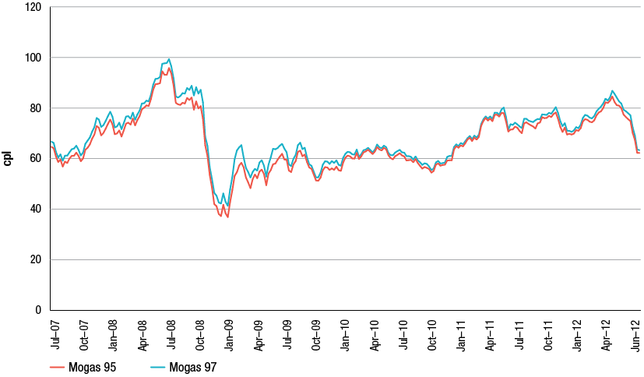
Source: ACCC calculations based on Platts and RBA data
The quality premiums for RULP and PULP primarily reflect the difference between the respective international benchmark prices for Mogas 95 and Mogas 97, and the respective prices of RULP and PULP refined to Australian standards. It also reflects differences in the relative bargaining strengths of buyers and sellers and general market conditions for the two fuels.
While the quality premiums for both products have had similar trends over the five years to June 2012, the premium for PULP 95 was clearly higher than for RULP (chart 7.7). Over the period the differential averaged 2.7 cpl which has narrowed from the five-year peak of 3.7 cpl in March 2009.
Chart 7.7 Monthly average PULP 95 and RULP quality premiums in the five largest cities:
July 2007 to June 2012
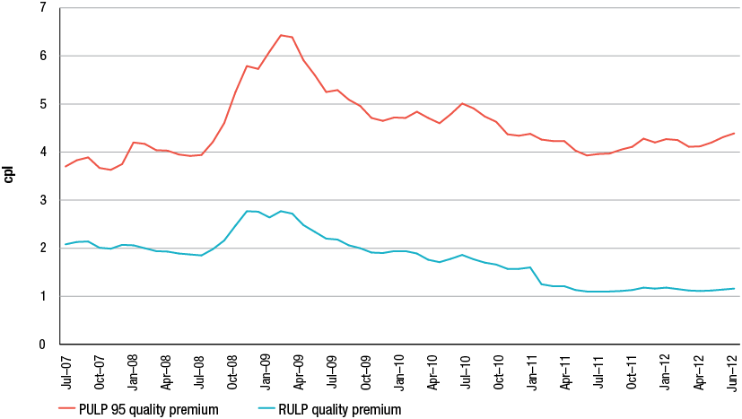
Source: ACCC analysis based on data obtained from firms monitored through the ACCC’s monitoring process
Note: The quality premium data shown in chart 7.7 has been adjusted to reflect that one refiner-wholesaler calculates its PULP 95 IPP differently from the others.
    - Wholesale prices of premium unleaded petrol
The PULP TGP represents the notional spot price of purchasing PULP from a wholesaler at the terminal gate. Similar to RULP, few PULP transactions are actually made at the terminal gate. Most transactions are negotiated in advance with prices struck slightly above or below TGP depending on volumes and additional services.
Comparing the wholesale prices paid for PULP to the IPP benchmark prices provides an indication of the extent to which wholesale prices reflect their notional import cost (chart 7.8). Over the five years to June 2012:
- average net (i.e. excluding taxes) wholesale prices for PULP 95 have closely tracked IPP for PULP
- net wholesale prices averaged about 5.15 cpl higher than the IPP
- average gross (i.e. including taxes) wholesale prices for PULP 95 and TGPs for PULP have also closely tracked each other closely
- PULP 98 wholesale prices have followed a similar trend, though this product attracts a larger premium because of the additional processing and additives required (and additional company proprietary branding).
Chart 7.8 Daily PULP average wholesale prices, IPP and TGP in the five largest cities:
July 2007 to June 2012
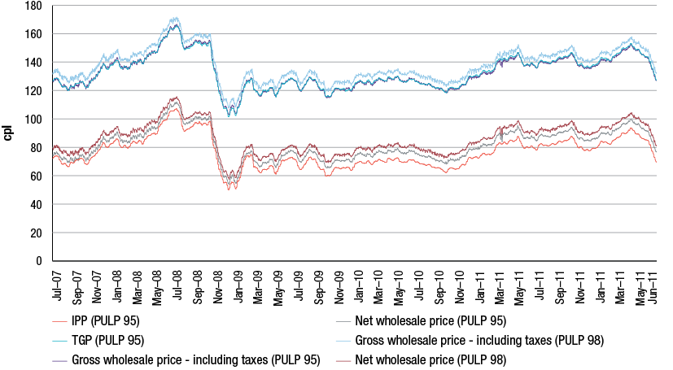
Source: ACCC analysis based on data obtained from firms monitored through the ACCC’s monitoring process
Note: The data in chart 7.8 is not comparable with RULP IPP data in chapter 6 as one refiner-wholesaler calculates its PULP 95 IPP differently from the others. Data shown have been adjusted to reflect this.
    - Retail prices of premium unleaded petrol
Retail prices of PULP have also tracked the key benchmark prices relatively closely (chart 7.9). Allowing for the cyclical nature of retail prices in Australia’s large cities, the general trend has been for retail prices to follow both the IPP and TGP benchmarks for PULP. Consistent with the trend for wholesale prices, retail prices of PULP 98 have been generally higher than PULP 95. This reflects fuel and non-fuel costs associated with the production of PULP 98 as well as a retail margin.
Chart 7.9 Daily PULP average IPP, and gross wholesale and retail prices in the five largest cities:
July 2007 to June 2012
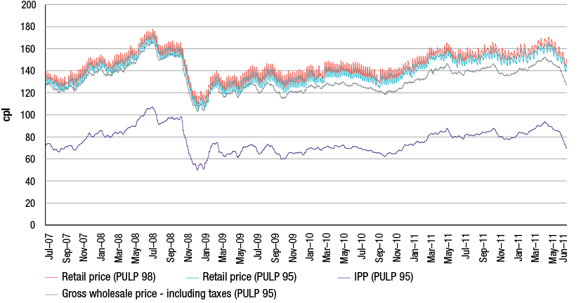
Source: ACCC analysis based on data obtained from firms monitored through the ACCC’s monitoring process, Informed Sources data
Note: The data in chart 7.9 is not comparable with RULP IPP data in chapter 6 as one refiner-wholesaler calculates its PULP 95 IPP differently from the others. Data shown have been adjusted to reflect this.
    - Comparing retail prices of premium and regular unleaded petrol
Over the five years to June 2012, the retail price differential between RULP and both PULP 95 and PULP 98 has increased (chart 7.10):
- the PULP 95—RULP differential increased from 6.2 cpl on 1 July 2007 to 10.3 cpl on 30 June 2012
- the PULP 98—RULP differential increased from 9.9 cpl on 1 July 2007 to 15.1 cpl on 30 June 2012
- by contrast the retail price differential between the two grades of PULP increased only marginally over the same period: from 3.7 cpl on 1 July 2007 to 4.8 cpl on 30 June 2012.
Chart 7.10 Differential between average daily PULP and RULP retail prices in the five largest cities, seven-day rolling averages: July 2007 to June 2012
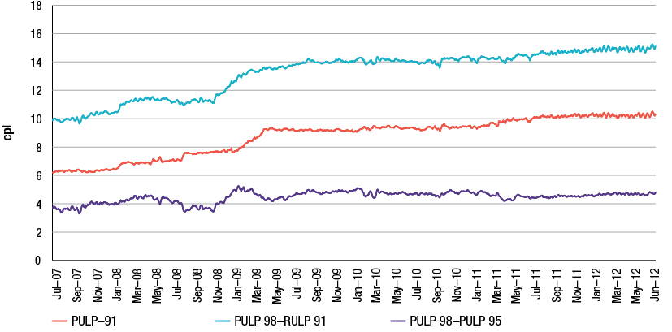
Source: ACCC analysis based on Informed Sources data
  - Key observations on premium unleaded petrol
In 2011−12, demand for PULP continued to grow in Australia, particularly in NSW where PULP sales now exceed sales of RULP.
The ethanol mandate in NSW is likely to have been the main factor responsible for the surge in demand for PULP over the last few years.
Prices of PULP in the wholesale market are established with reference to the IPP for PULP. The data for 2011−12 is consistent with established trends whereby wholesale and retail prices of PULP appear to track the PULP IPP as well as the PULP TGP closely.
While supplies of PULP continue to be met through a mix of domestic refinery production and imports, supplies and prices of PULP may be under pressure if the recent growth in PULP sales continues.

- Retail prices
Key points
- The annual average retail price of regular unleaded petrol in the five largest cities in 2011−12 was around 143 cents per litre (cpl), an increase of 11 cpl from 2010−11.
- Annual average retail petrol prices in 2011−12 were the highest on record, reflecting the persistently high international price of refined petrol throughout most of the year.
- In 2011−12 daily average retail petrol prices (on a seven-day rolling average basis) across the five largest cities ranged from a low of around 131 cpl in June 2012 to a high of around 153 cpl in April 2012—a range of 22 cpl.
- The peak price was the highest price since mid-July 2008, when prices reached their all-time high level of around 163 cpl.
- Movements in Australian retail regular unleaded petrol prices are primarily determined by movements in the international price of refined petrol (Singapore Mogas 95 Unleaded) and the AUD–USD exchange rate.
- In 2011−12 motorists were somewhat protected from higher petrol prices by the relatively strong AUD–USD exchange rate (which, for most of the year, was above parity).
- As in previous years, the international price of refined petrol, and excise and taxes, were the main components of retail petrol prices in 2011−12.

  - Introduction
This chapter primarily focuses on regular unleaded petrol (RULP) prices. However, it also examines the prices of other grades of petrol—premium unleaded petrol (PULP) 95, PULP 98, and E10 (i.e. regular unleaded petrol with up to 10 per cent ethanol)—and diesel and automotive liquefied petroleum gas (LPG).
It focuses on retail prices across the five largest cities (Sydney, Melbourne, Brisbane, Adelaide and Perth) although the three smaller capital cities (Canberra, Hobart and Darwin) are also considered. Petrol prices in regional locations are analysed in chapter 9.
While the analysis of petrol price movements in this chapter largely focuses on average prices across the five largest cities, price levels and price movements are not uniform across these cities. This is because factors specific to each city influence the extent of competition (and therefore prices).
  - Retail petrol price movements
    - Prices between July 2011 and September 2012
Chart 8.1 shows daily average retail petrol prices, and seven-day rolling average petrol prices, across the five largest cities for the period 1 July 2011 to 30 September 2012.
Chart 8.1 Daily average retail petrol prices and seven-day rolling average retail petrol prices, five largest cities: 1 July 2011 to 30 September 2012
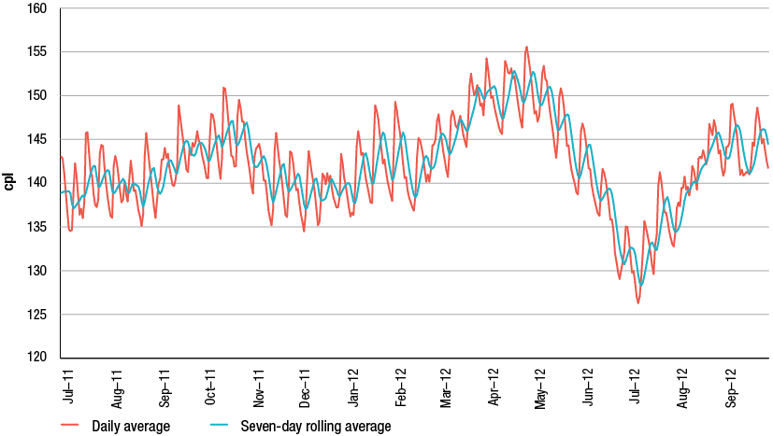
Source: ACCC calculations based on Informed Sources data
Chart 8.1 shows that:
- The period began with retail prices on a seven-day rolling average basis at around 139 cents per litre (cpl). Between July 2011 and mid-October 2011 prices increased by 8 cpl to around 147 cpl, before decreasing to around 137 cpl in early December 2011.
- From early January 2012 prices increased, reaching a peak of around 153 cpl in mid-April 2012. Prices then fell rapidly to a low of around 128 cpl in mid-July 2012 (which was the lowest price since January 2011). Prices subsequently increased by around 16 cpl to the end of September 2012 (ending the period at around 144 cpl).
- In 2011−12 the range between the highest daily average price (153 cpl in April 2012) and lowest (131 cpl in June 2012) was 22 cpl.
The average price of petrol across the five largest cities in 2011−12 was 142.8 cpl. This was 11.1 cpl higher than in 2010−11 (131.7 cpl).
    - Prices between July 2007 and September 2012
Chart 8.2 shows seven-day rolling average retail petrol prices across the five largest cities over the period 1 July 2007 to 30 September 2012.
Chart 8.2 Seven-day rolling average retail petrol prices, five largest cities:
1 July 2007 to 30 September 2012
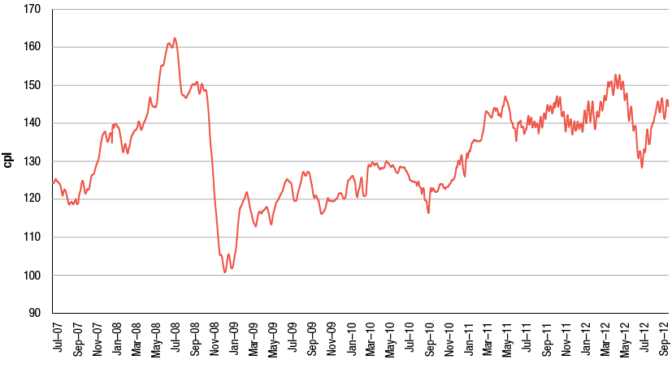
Source: ACCC calculations based on Informed Sources data
It shows that:
- Petrol prices in 2011−12 were less volatile than in 2010−11.
- The range between the highest and lowest prices in 2011−12 was 22 cpl, which was 9 cpl less than in 2010−11 (when it was 31 cpl).
- Prices in 2011−12 peaked at levels last reached in late-July 2008.
- Retail prices were at their highest in mid-July 2008 at around 163 cpl.
- The jagged appearance of the movements in petrol prices from around mid-2011 onwards reflects the significant increase in price cycle durations from this time (which has reduced the smoothing effect of using seven-day rolling averages).
- Between July 2007 and July 2008, retail prices increased rapidly (by around 38 cpl). Prices decreased substantially in the second half of 2008 (by around 62 cpl) at the time of the global financial crisis (GFC), before recovering in early 2009 and entering a period of relative stability in 2009−10.
- Between mid-September 2010 and early May 2011 prices increased by around 31 cpl, following geopolitical tensions and supply disruptions in Libya and the Middle East.
    - Prices in the three smaller capital cities
Chart 8.3 shows monthly average retail petrol prices in Canberra, Hobart and Darwin from July 2007 to September 2012, compared with prices across the five largest cities.
Chart 8.3 Monthly average retail petrol prices in Canberra, Hobart and Darwin and the five largest cities: July 2007 to September 2012
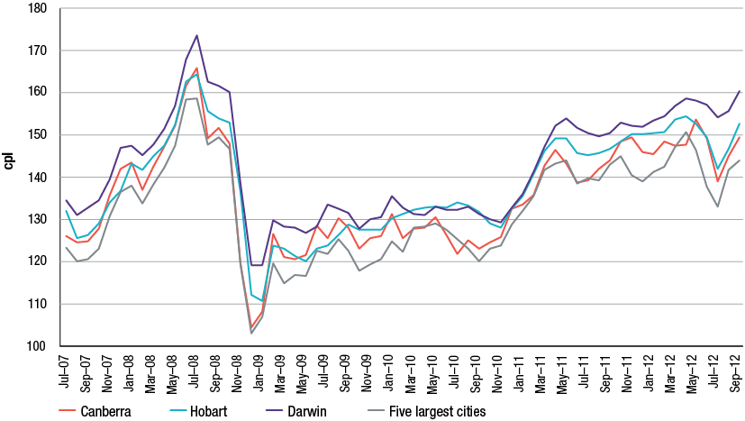
Source: ACCC calculations based on Informed Sources data
The chart shows that over this period:
- Prices in the smaller capital cities tend to follow similar trends to those in the five largest cities.
- Price relativities between the smaller capital cities and the five largest cities vary over time.
- Prices in the five largest cities are generally lower than in the three smaller capital cities.
- Prices in Darwin tend to be higher than those in Hobart and Canberra, and the five largest cities.
Factors that may be influencing the relatively higher prices in Canberra, Hobart and Darwin are similar to those outlined in section 9.3.
  - Determinants of petrol prices
Movements in retail petrol prices in Australia are primarily influenced by movements in the international price of refined petrol (which itself is driven by the price of crude oil) and the AUD–USD exchange rate.
Other influences on retail prices include the degree of competition at the wholesale and retail levels (including the regular price cycles that occur in the largest cities), the level of excise and taxes, international and domestic freight costs, the fuel quality premium (which includes a component for producing petrol to Australian fuel quality standards), and other wholesale costs and margins.
    - International price of refined petrol
The price of refined petrol in Australia is set with reference to international benchmark prices. The relevant international benchmark price for petrol in Australia is the price of refined petrol in the Asia-Pacific region, the price of Singapore Mogas 95 Unleaded (Mogas 95).
Prices between July 2011 and September 2012
Chart 8.4 shows movements in weekly average Mogas 95 prices for the period July 2011 to September 2012.
Chart 8.4 Weekly average Mogas 95 prices: July 2011 to September 2012
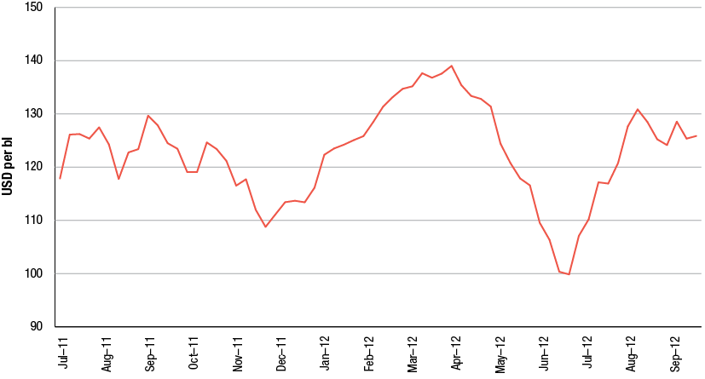
Source: ACCC calculations based on Platts data
Over the period Mogas 95 prices were influenced by several factors:
- The uncertainty around the future of Greece and the eurozone led to significant volatility in the second half of 2011.
- Concerns over a possible US recession led weekly average Mogas 95 prices to a low of around USD 109 per barrel by the end of November 2011.
- From December 2011 to April 2012, weekly average Mogas 95 prices increased by around USD 30 per barrel following easing concerns about a US recession, increased oil demand due to a cold Northern Hemisphere winter, and supply concerns due to geopolitical tensions and impending sanctions on Iran.
- Weekly average Mogas 95 prices peaked at around USD 139 per barrel in early April 2012, its highest level since mid-2008.
- Subsequently, weekly average Mogas 95 prices decreased significantly by around USD 39 per barrel (28 per cent) between early-April 2012 and late-June 2012 to around USD 100 per barrel. The decrease was influenced by ample global supplies and renewed economic concerns about a number of European countries.
- Between July 2012 and September 2012, weekly average Mogas 95 prices increased by around USD 26 per barrel (26 per cent) to around USD 125 per barrel. This increase was influenced by supply disruptions in the North Sea, on-going instability in the Middle East (particularly in Syria) heightening concern over potential disruptions to supply, and monetary easing measures announced in the US in mid-September 2012.
Prices between July 2007 and September 2012
Chart 8.5 shows movements in monthly average Mogas 95 prices for the period July 2007 to September 2012.
Chart 8.5 Monthly average Mogas 95 prices: July 2007 to September 2012
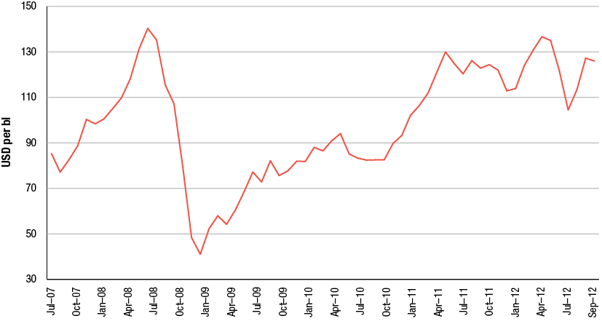
Source: ACCC calculations based on Platts data
Monthly average Mogas 95 prices reached a record high in July 2008 at around USD 140 per barrel. As a result of the GFC, prices subsequently decreased sharply to around USD 40 per barrel in December 2008, a decrease of around USD 100 per barrel (over 70 per cent).
Prices steadily increased from early 2009 through to 2012. In May 2012 prices reached around USD 137 per barrel, the second-highest monthly average price on record (behind July 2008).
Despite the volatility, monthly average Mogas 95 prices were persistently high throughout 2011−12. The yearly average Mogas 95 price was around USD 123 per barrel, the highest level on record.
Refined petrol and crude oil prices
The price of crude oil is the major determinant of Mogas 95 prices. However, like the prices of most internationally traded commodities, the price of Mogas 95 is also determined by global and regional supply and demand conditions.
Mogas 95 generally trades at a premium to Tapis crude oil. However, at times Mogas 95 may be cheaper than Tapis crude oil (such as in November and December 2011) when demand for refined petrol is relatively low compared with demand for crude oil. Conversely, the premium can be large when demand for refined petrol is relatively high compared with demand for crude oil.
Chart 8.6 shows the close relationship between Mogas 95 prices and Tapis crude oil prices in the period July 2011 to September 2012. While Mogas 95 prices and Tapis crude oil prices generally moved in a similar fashion over the year, the differential between weekly average Mogas 95 prices and Tapis crude oil prices varied from a low of around USD –7 per barrel (in November 2011) to a high of around USD 14 per barrel (in August 2012).
Chart 8.6 Weekly average Mogas 95 and Tapis crude oil prices: July 2011 to September 2012
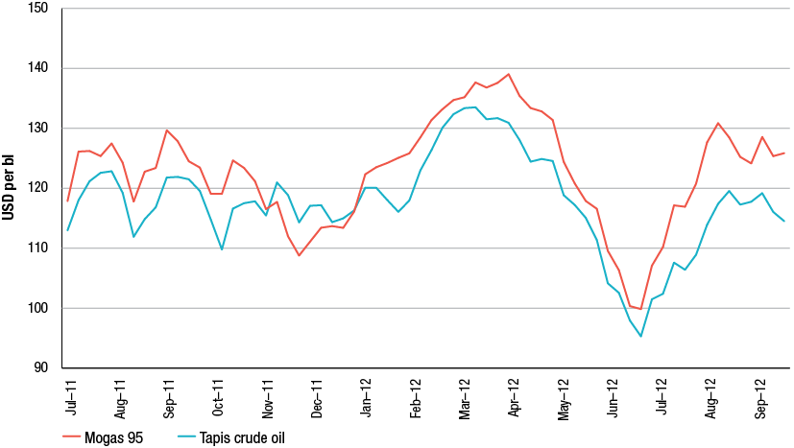
Source: ACCC calculations based on Platts data
    - AUD–USD exchange rate
The AUD–USD exchange rate is an important influence on domestic retail prices because the international benchmark prices of refined petrol are set in US dollars.
Chart 8.7 shows movements in the daily AUD–USD exchange rate between 1 July 2011 and 30 September 2012. The Australian dollar fluctuated within a USD 0.16 range during 2011−12, from a record high of around USD 1.11 in late July 2011 to a low of around USD 0.95 in early October 2011. Despite this volatility, the AUD–USD exchange rate remained above parity for most of 2011−12 (81 per cent of days).
Chart 8.7 Daily average AUD–USD exchange rates: 1 July 2011 to 30 September 2012
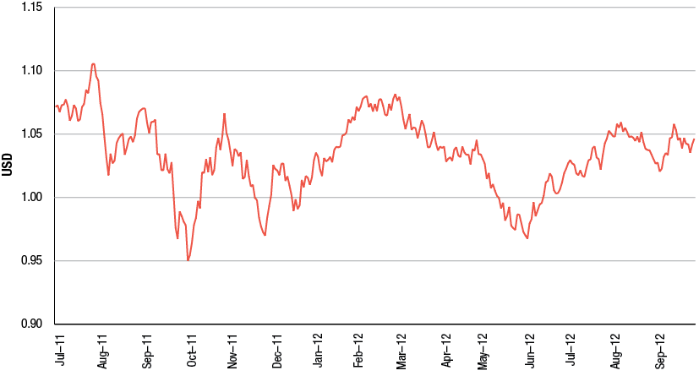
Source: RBA data
The average AUD–USD exchange rate in 2011−12 was USD 1.03, compared with USD 0.99 in 2010−11 and USD 0.91 for the five-year period 2007−08 to 2011−12.
Over the period 1 July 2007 to 30 September 2012 the lowest daily AUD–USD exchange rate was around USD 0.61 on 28 October 2008 and the highest daily exchange rate was around USD 1.11 on 27 July 2011.
Influence of the AUD–USD exchange rate in 2011−12
Chart 8.8 shows the importance of the AUD–USD exchange rate on retail petrol prices in Australia.
The red line shows actual seven-day rolling average retail prices across the five largest cities from 1 July 2011 to 30 September 2012. The upper line shows what retail prices would have been if the AUD–USD exchange rate was held constant at the lowest daily exchange rate over this period (i.e. around USD 0.61), everything else being equal. The lower line shows what retail prices would have been if the AUD–USD exchange rate was held constant at the highest daily exchange rate over this period (i.e. around USD 1.11), everything else being equal.
Chart 8.8 Seven-day rolling average retail petrol prices in the five largest cities—based on actual, minimum and maximum AUD–USD exchange rates over the period: 1 July 2007 to 30 September 2012
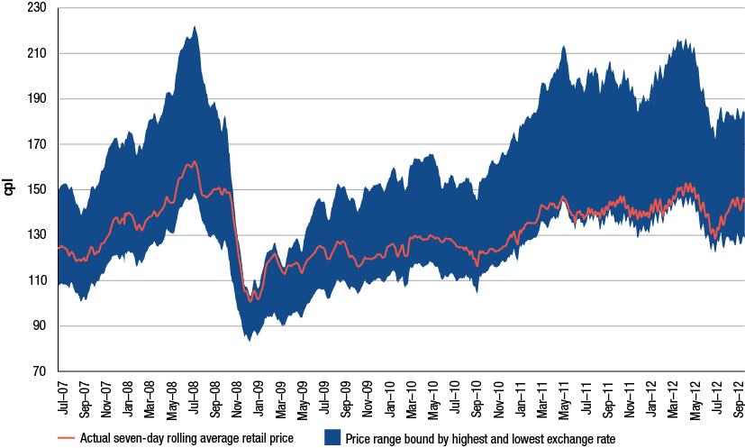
Source: ACCC calculations based on Informed Sources, Platts and RBA data
The chart indicates that in 2011−12:
- Retail prices were at their highest in April 2012 at around 153 cpl. The AUD–USD exchange rate was around USD 1.03 at this time. If the exchange rate had been at its five-year minimum level at this time, retail prices would have been around 215 cpl (or 62 cpl higher).
- Retail prices were at their lowest in June 2012 at around 131 cpl. The AUD–USD exchange rate was around USD 1.01 at this time. If the exchange rate had been at its five-year maximum level at this time, retail prices would have been around 124 cpl (or 7 cpl lower).
- A strong AUD–USD exchange rate throughout most of 2011−12 protected consumers to a substantial degree from very high international refined petrol prices.
In 2011−12, the annual average retail price was around 143 cpl and the annual average AUD–USD exchange rate was around USD 1.03.
- If the exchange rate had instead been at the five-year minimum level throughout 2011–2012 (USD 0.61), the annual average retail price would have been around 200 cpl (or 57 cpl higher).
- If the exchange rate had been at the five-year maximum level throughout 2011–2012 (USD 1.11), the annual average retail price would have been around 137 cpl (or 6 cpl lower).
This analysis shows how a strong AUD generally protected consumers from the very high international petrol prices seen throughout 2011−12.
    - Retail petrol prices compared with Mogas 95 prices
Chart 8.9 shows seven-day rolling average retail petrol prices in the five largest cities, and Mogas 95 prices (lagged by 10 days), over the period 1 July 2011 to 30 September 2012. For comparison purposes, it also shows adjusted retail prices (which have excise and GST removed).
Chart 8.9 Seven-day rolling average retail petrol prices, adjusted retail prices and Mogas 95 prices: 1 July 2011 to 30 September 2012
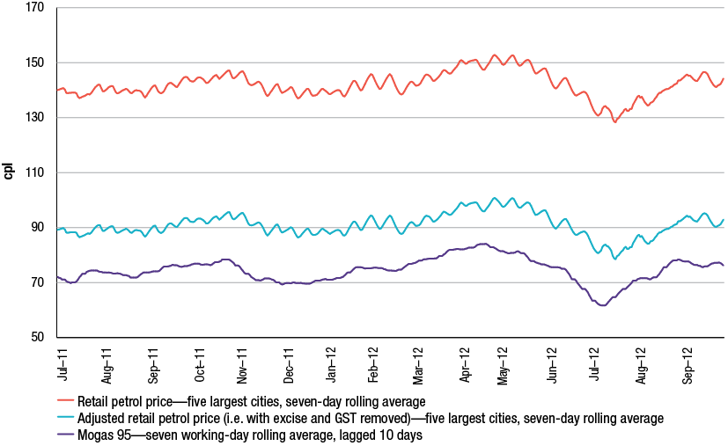
Source: ACCC calculations based on Informed Sources, Platts and RBA data
The chart shows that in the period 1 July 2011 to 30 September 2012 retail prices in the five largest cities have closely followed movements in Mogas 95 prices in AUD terms. This demonstrates that changes in domestic retail prices are overwhelmingly driven by changes in the international price of refined petrol.
Chart 8.10 shows the daily differential between seven-day rolling average adjusted retail petrol prices in the five largest cities and seven-day rolling average Mogas 95 prices (lagged by 10 days) in Australian cents per litre over the period 1 July 2011 to 30 September 2012. Excise and GST have been removed from the retail price.
The differential between adjusted domestic retail prices and international refined petrol prices is influenced by a range of other factors, including changes in the fuel quality premium, freight costs, wholesale and retail costs, and the level of local competition.
Chart 8.10 Daily differential between seven-day rolling average adjusted retail petrol prices in the five largest cities and Mogas 95 prices: 1 July 2011 to 30 September 2012
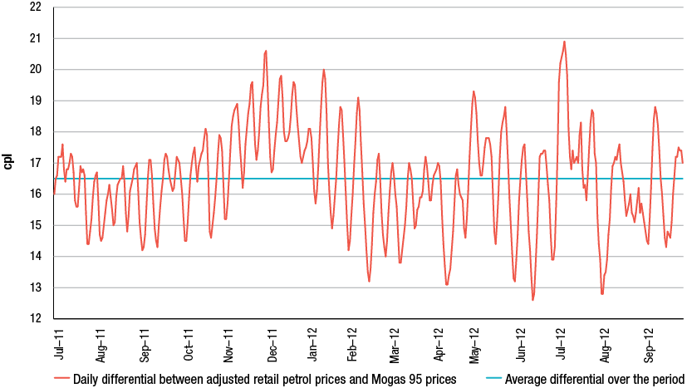
Source: ACCC calculations based on Informed Sources, Platts and RBA data
Between 1 July 2011 and 30 September 2012 the average daily differential between adjusted retail prices and Mogas 95 prices was 16.5 cpl.
Chart 8.10 shows that the differential between Australian retail prices and the price of Mogas 95 moves up and down rapidly as a result of the influence of price cycles. Over the medium term, the differential varies around the average for the period. Therefore, comparisons between domestic retail prices and international benchmark prices should not solely focus on the differential on a particular day but consider the trend of the differential over a longer period of time.
  - Components of retail petrol prices
There are three broad components of the retail price of petrol: the international refined petrol price, domestic taxes (excise and GST) and other costs and margins at the wholesale and retail levels.
Chart 8.11 shows the components of the annual average retail petrol price across the five largest cities in 2011−12. The two largest components of the pump price—Mogas 95 and taxes—accounted for 88 per cent of the price of petrol. These components are largely outside the control of the local petrol retailers.
Chart 8.11 Components of annual average retail petrol price in the five largest cities: 2011−12
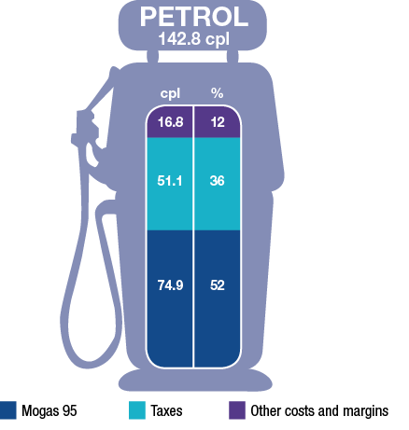
Source: ACCC calculations based on Informed Sources, Platts and RBA data
The proportions of the annual average price in 2011−12 represented by each of Mogas 95, taxes, and other costs and margins were broadly similar to those in 2010−11. In 2011−12 the cost of refined petrol (Mogas 95) represented 52 per cent of the annual average price of a litre of petrol (an increase of 2 percentage points from 2010−11).
Chart 8.12 shows a more detailed breakdown of the components of the annual average retail petrol prices across the five largest cities from 2007−08 to 2011−12. Each bar represents the annual average retail price disaggregated into the following:
- Tapis crude oil—the benchmark for crude oil in the Asia-Pacific region (including Australia)
- excise (which is set at a constant 38.14 cpl) and GST
- gasoline crack—the difference between the prices of Mogas 95 and Tapis crude oil
- wholesale costs and margins (excluding excise and GST)
- retail costs and margins (excluding GST).
Chart 8.12 Components of annual average retail petrol prices in the five largest cities: 2007−08 to 2011−12
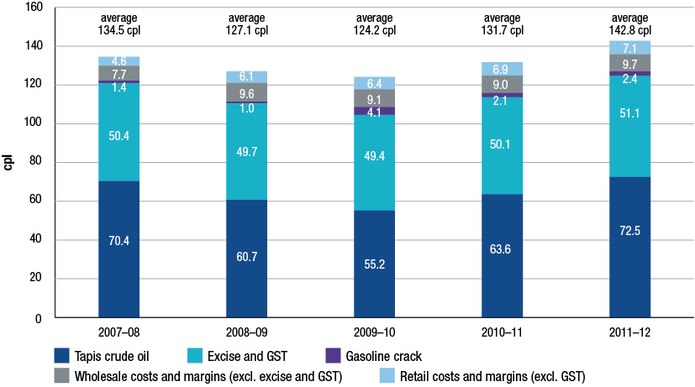
Source: ACCC calculations based on Informed Sources, Platts, RBA and WA FuelWatch data, and information provided by the monitored companies
The chart shows that, over the last five years:
- the price of Tapis crude oil has been the largest component of the retail price of petrol
- wholesale and retail costs and margins (excluding GST) have remained broadly stable over the last four years
- the annual average price of Tapis crude oil in 2011−12 was the highest over the five-year period.
  - Gross indicative retail differences for petrol
Gross indicative retail differences are calculated by subtracting average terminal gate prices (TGPs) from average retail petrol prices.
TGPs are the prices at which petrol can be purchased from wholesalers in the spot market and are posted on a regular basis on the websites of the major wholesalers. Not all wholesale transactions are at TGPs—some will be at higher prices and some will be at lower prices, depending on the specific commercial arrangements. Therefore, TGPs can be regarded as indicative wholesale prices. Furthermore, TGPs reflect the price of petrol only, and exclude other retail operating costs (such as branding, transportation, labour, etc.).
As a result, gross indicative retail differences should be treated as a useful approximate benchmark only for the difference between wholesale and retail prices. They should not be confused with actual retail profits.
Table 8.1 shows annual gross indicative retail differences in the five largest cities, in both nominal and real terms, from 2007−08 to 2011−12.
Table 8.1 Annual average retail petrol prices, terminal gate prices and gross indicative retail differences, five largest cities: 2007−08 to 2011−12
 | Average retail  price | Average TGP | Gross indicative retail difference | Gross indicative retail difference (real)
 | cpl | cpl | cpl | cpl
2007−08 | 134.5 | 129.4 | 5.1 | 5.1
2008−09 | 127.1 | 120.4 | 6.7 | 6.5
2009−10 | 124.2 | 117.2 | 7.0 | 6.6
2010−11 | 131.7 | 124.1 | 7.6 | 7.0
2011−12 | 142.8 | 135.1 | 7.7 | 6.9

Source: ACCC calculations based on Informed Sources, ABS, WA FuelWatch and information provided by the monitored companies
Table 8.1 shows that gross indicative retail differences:
- increased by 0.1 cpl in 2011−12 to 7.7 cpl, the highest difference over the last five years. In real terms, the difference decreased by 0.1 cpl in 2011−12
- have been broadly stable over the last four years in real terms (moving within a 0.5 cpl range).
  - Other grades of petrol
    - Retail prices of the different petrol grades
The retail prices of the different grades of unleaded petrol—RULP, PULP 95 and 98, and E10—tend to move in a similar manner.
Chart 8.13 shows monthly average retail prices for these four grades of petrol in the five largest cities from July 2007 to September 2012.
Chart 8.13 Monthly average retail prices of RULP, PULP 95, PULP 98 and E10 in the five largest cities:
July 2007 to September 2012
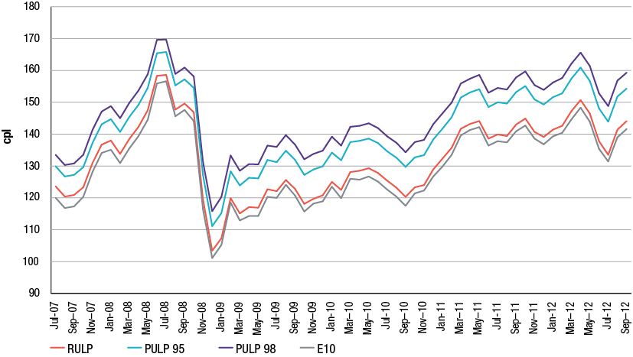
Source: ACCC calculations based on Informed Sources data
Retail prices of the different grades of petrol move in a similar manner because they are all set according to international refined petrol benchmark prices (which primarily move in line with changes in the price of crude oil). However, the price differentials between the various types of petrol vary over time. For example, retailers will generally set the price of PULP at a fixed premium to RULP. They will then adjust this premium from time to time reflecting changes in international benchmark differentials, local supply and demand factors, and other factors.
In 2011−12 the average differential between RULP and PULP 95 prices across the five largest cities was 10.2 cpl. This was an increase of 0.6 cpl from the difference in 2010−11. The average differential between RULP prices and PULP 98 in 2011−12 was 14.8 cpl, which was also an increase of 0.6 cpl from the difference in 2010−11. The average differential between RULP and E10 prices in 2011−12 was 2.2 cpl (no change from 2010−11).
For a discussion of the markets for E10 and PULP, including movements in average retail prices, see chapters 5 and 6 respectively.
    - Components of retail PULP 95 prices
Chart 8.14 shows the components of the annual average retail PULP 95 price across the five largest cities in 2011−12.
Chart 8.14 Components of annual average retail PULP 95 price in the five largest cities: 2011−12
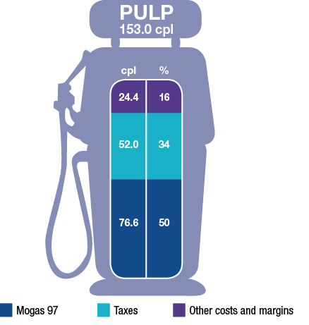
Source: ACCC calculations based on Informed Sources, Platts and RBA data
The proportions of the annual average price in 2011−12 represented by each of Singapore Mogas 97 Unleaded (Mogas 97, the appropriate international benchmark for PULP), taxes, and other costs and margins were broadly similar to those in 2010−11.
In 2011−12 the cost of Mogas 97 represented 50 per cent of the average price of a litre of PULP 95 (an increase of 3 percentage points from 2010−11).
Other costs and margins (excluding excise and GST) for PULP 95 in 2011−12 (24.4 cpl) were higher than for RULP (16.8 cpl). In part, this reflects a higher fuel quality premium for PULP 95 relative to RULP, as well as other related costs. This difference (7.6 cpl) was the same as in 2010−11.
  - Diesel and LPG prices
    - Diesel and LPG prices compared with petrol prices
Retail prices of petrol, diesel and LPG generally move in line with their respective international benchmark prices, which are influenced by different supply and demand factors.
The appropriate international benchmark price for diesel is the price of Singapore Gasoil with 10 parts per million sulphur content (Gasoil 10 ppm). International demand for diesel is different from that for petrol, in part because of diesel’s off-road, industrial and electricity generation uses. However, both petrol and diesel are refined from crude oil and their prices will tend to follow broadly similar movements over the long term.
The appropriate benchmarks for LPG are the Saudi Aramco Contract Prices for propane and butane (Saudi CP). These prices only change once a month, at the start of each month. International LPG prices only very loosely move in line with international refined petrol or diesel prices.
Chart 8.15 shows monthly average retail petrol, diesel and LPG prices in the five largest cities from July 2007 to September 2012.
Chart 8.15 Monthly average retail prices of petrol, diesel and LPG in the five largest cities:
July 2007 to September 2012
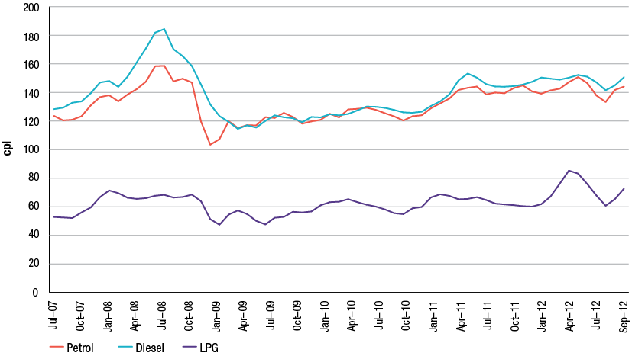
Source: ACCC calculations based on Informed Sources data
The chart shows that:
- Over the period, petrol and diesel prices broadly moved in line with each other (generally following movements in the price of crude oil).
- Diesel prices were higher than petrol prices between July 2007 and February 2009 and generally higher from January 2011. This reflected relatively high demand for diesel compared with petrol during those periods, particularly from China and India.
- LPG prices were significantly lower than petrol and diesel prices.
- A major reason for this is that excise is imposed on petrol and diesel at a rate of 38.14 cpl, whereas prior to 1 December 2011 there was no excise on LPG. From that date excise was imposed on LPG at a rate of 2.5 cpl. The rate of excise increased to 5.0 cpl on 1 July 2012.
- The rate of excise imposed on LPG is scheduled to increase in annual increments of 2.5 cpl to a final rate of 12.5 cpl by 1 July 2015.
    - Diesel prices
Retail diesel prices compared with Gasoil prices
Chart 8.16 shows seven-day rolling average retail diesel prices in the five largest cities and Gasoil 10 ppm prices over the period 1 July 2011 to 30 September 2012. Retail diesel prices broadly followed movements in Gasoil 10 ppm prices throughout the period.
Chart 8.16 Seven-day rolling average retail diesel prices in the five largest cities and Gasoil 10 ppm prices: 1 July 2011 to 30 September 2012
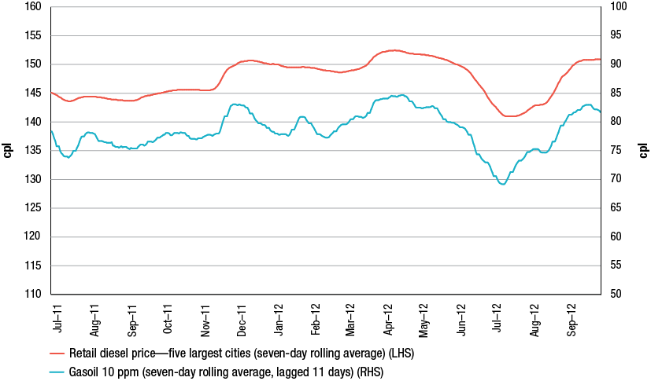
Source: ACCC calculations based on Informed Sources, Platts and RBA data
Components of diesel prices
Chart 8.17 shows the components of the annual average retail price of diesel across the five largest cities in 2011−12.
Chart 8.17 Components of annual average retail diesel price in the five largest cities: 2011−12
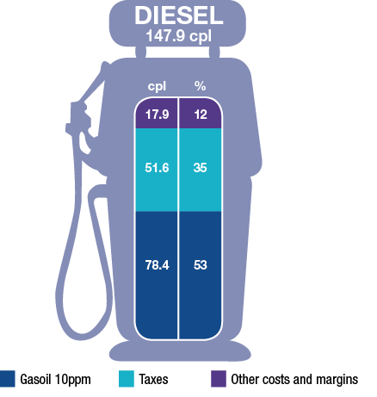
Source: ACCC calculations based on Informed Sources, Platts and RBA data
The international price of refined diesel (Gasoil 10 ppm) accounted for more than half of the average price of diesel in 2011−12. The proportion of the average pump price represented by other costs and margins in 2011−12 (12 per cent) remained the same as in 2010−11.
    - LPG prices
Retail LPG prices compared with the Saudi CP benchmarks
Chart 8.18 shows seven-day rolling average retail LPG prices in the five largest cities and monthly Saudi CP benchmarks over the period 1 July 2011 to 30 September 2012. As the Saudi CP benchmarks only change at the start of each month, the relationship between movements in the international benchmark prices and retail prices for LPG is somewhat different from petrol and diesel.
Chart 8.18 Seven-day rolling average retail LPG prices in the five largest cities and monthly Saudi CP benchmarks: 1 July 2011 to 30 September 2012
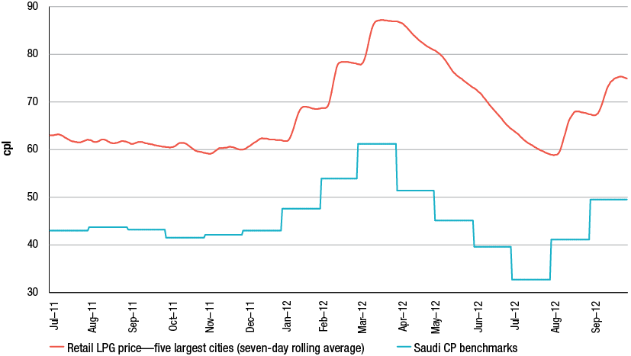
Source: ACCC calculations based on Informed Sources, RBA and LPG Australia data
The chart shows that LPG retail prices broadly tracked movements in the international benchmark prices over the period.
The Saudi CP benchmarks reached an all-time high of 61.2 cpl in March 2012, as a result of high demand for heating fuels and geopolitical tensions in Iran. However, demand fell away moving into the Northern Hemisphere summer, and benchmark prices subsequently fell to a low of 32.7 cpl in July 2012. Saudi CP benchmarks increased to 49.5 cpl in September 2012 as South Korea, Japan and China increased their propane stocks ahead of the northern winter.
Components of LPG prices
Chart 8.19 shows the components of the annual average retail price of LPG across the five largest cities in 2011−12.
Chart 8.19 Components of annual average retail LPG price in the five largest cities: 2011−12
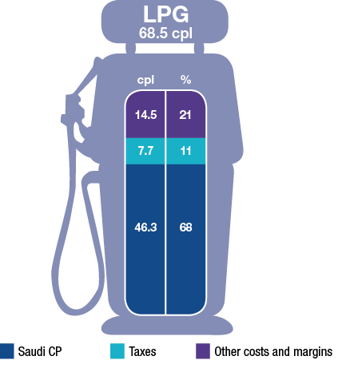
Source: ACCC calculations based on Informed Sources, LPG Australia and RBA data
Over two-thirds of the average price of LPG in 2011−12 was accounted for by the Saudi CP benchmarks. The proportion of the price accounted for by other costs and margins in 2011−12 (21 per cent) was broadly the same as last year (20 per cent).
Other costs and margins make up a relatively larger proportion of the retail price for LPG compared with those for petrol and diesel, because of higher transportation and storage costs for LPG, and the low rate of excise imposed on LPG.

- Retail prices in regional locations
Key Points
- Movements in retail petrol prices in regional locations are largely driven by changes in international refined petrol prices and the AUD–USD exchange rate, just as they are in the five largest cities.
- However, the extent to which petrol prices in each regional location are influenced by changes in international refined petrol prices varies between locations, depending on the specific characteristics of each regional location.
- Petrol prices in regional locations are generally higher than in the five largest cities for a number of reasons, including:
- lower number of retail sites and therefore a lower level of local competition
- lower volumes of fuel sold
- distance/location factors
- lower convenience store sales.
- These factors also explain differences in petrol prices between regional locations.
- Movements in petrol prices in regional locations—both up and down—tend to lag those in the five largest cities.
- Petrol prices in regional locations tend to be more stable than in the five largest cities. Only a very small number of regional locations have regular petrol price cycles. These tend to be regional locations close to major population centres and/or on major highways.

  - Introduction
This chapter examines retail petrol prices in regional locations in Australia and the city–country price differential.
In 2009−10 the ACCC significantly increased its focus on regional locations by increasing the number of regional locations included in the ACCC’s fuel price monitoring program from around 110 locations to around 150 locations.
The ACCC’s coverage was further expanded in 2011−12, with the number of regional locations included in the fuel price monitoring program increasing to around 180 locations.
  - Petrol prices in regional locations
    - Prices in aggregate
Retail petrol prices in regional locations in Australia are typically higher than those in the capital cities, although they generally follow the same overall price movements. Furthermore, in many regional locations there is a lag between movements in capital city prices and local prices. This lag arises because the turnover of petrol stocks is generally lower in the country than in the capital cities due to lower volume of sales in regional areas. As a result, price changes in the five largest cities take some time to be passed on to regional locations. This lag occurs both when prices are increasing and when they are decreasing.
Chart 9.1 shows daily average retail prices across all the monitored regional locations in Australia and daily average retail prices in the five largest cities (i.e. Sydney, Melbourne, Brisbane Adelaide and Perth). It can be seen that:
- Prices in the regional locations in aggregate broadly follow prices in the five largest cities.
- Regional locations in aggregate do not have the regular retail price cycles that are evident in the five largest cities.
Chart 9.1 Daily average petrol prices in the five largest cities and the regional locations in aggregate:
1 July 2011 to 30 September 2012
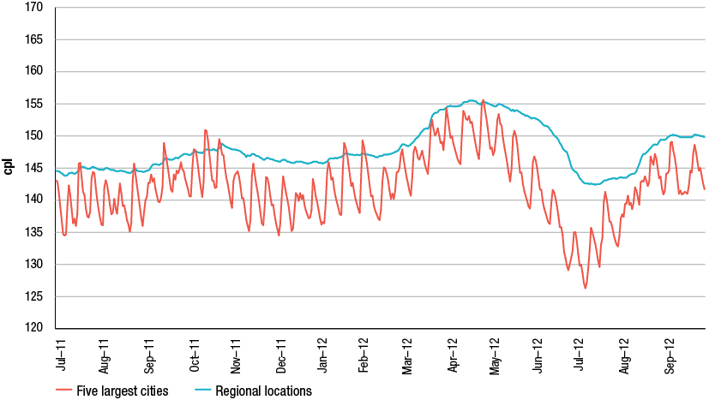
Source: ACCC calculations based on Informed Sources data
    - Prices in each of the states and the Northern Territory
Charts 9.2 to 9.8 show daily average retail petrol prices for the monitored regional locations in aggregate in each state and the Northern Territory, along with the relevant capital city prices, from 1 July 2011 to 30 September 2012.
The charts show that:
- Apart from the fluctuations associated with regular price cycles in most of the capital cities, prices in regional locations, on average, have generally followed movements in prices in their respective capital cities.
- In states with capital cities that have regular price cycles, the city-country price differential varies significantly on a daily basis.
- There were times when the city-country price differentials were larger than usual. These are particularly evident when there are periods of discounting in the capital cities.
- For example, there was a period of substantial discounting in Melbourne in May and June 2012. The average city-country price differential in May and June 2012 was 10.4 cents per litre (cpl), compared with an average differential of 3.0 cpl for the remaining 10 months of 2011−12.
- Prices in regional locations in Western Australia and the Northern Territory, where many locations are a long way from a refinery and import terminals, are significantly higher than those in Perth and Darwin, respectively. Conversely, in Tasmania, where distances from terminals are smaller, prices in regional locations are relatively close to those in Hobart.
Chart 9.2 Daily average petrol prices in Sydney and New South Wales regional locations:
1 July 2011 to 30 September 2012
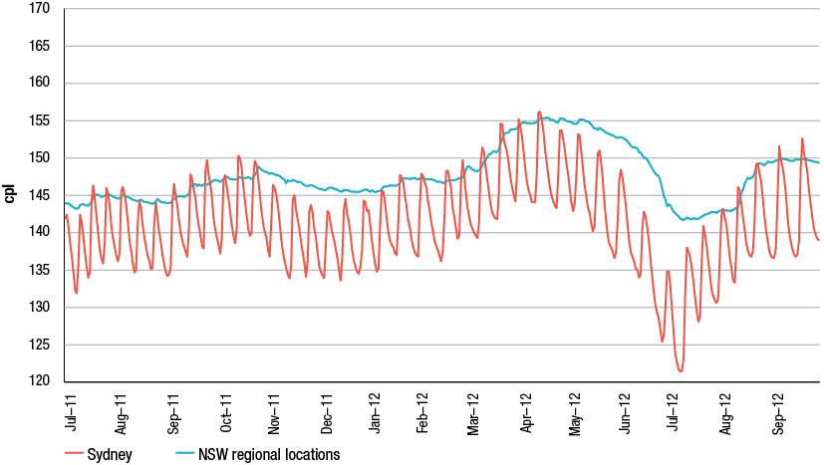
Source: ACCC calculations based on Informed Sources data
Chart 9.3 Daily average petrol prices in Melbourne and Victorian regional locations:
1 July 2011 to 30 September 2012
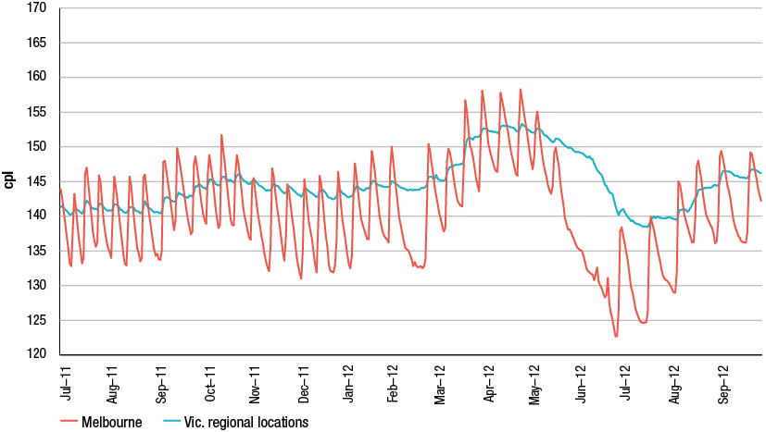
Source: ACCC calculations based on Informed Sources data
Chart 9.4 Daily average petrol prices in Brisbane and Queensland regional locations:
1 July 2011 to 30 September 2012
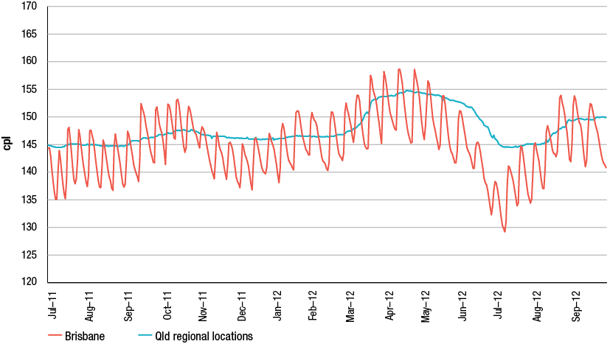
Source: ACCC calculations based on Informed Sources data
Chart 9.5 Daily average petrol prices in Adelaide and South Australian regional locations:
1 July 2011 to 30 September 2012
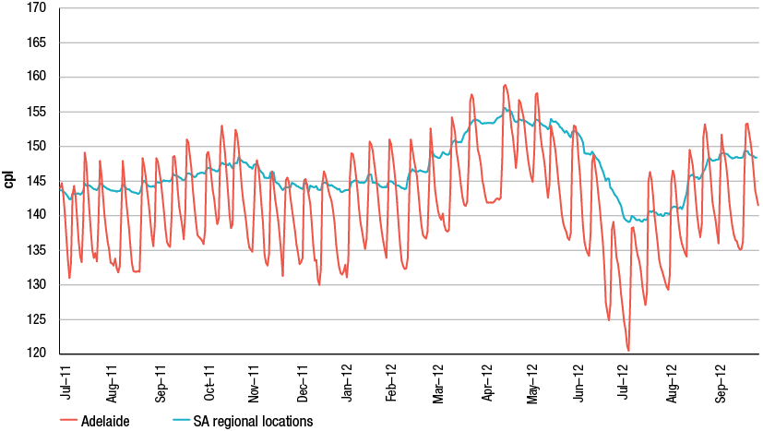
Source: ACCC calculations based on Informed Sources data
Chart 9.6 Daily average petrol prices in Perth and Western Australian regional locations:
1 July 2011 to 30 September 2012
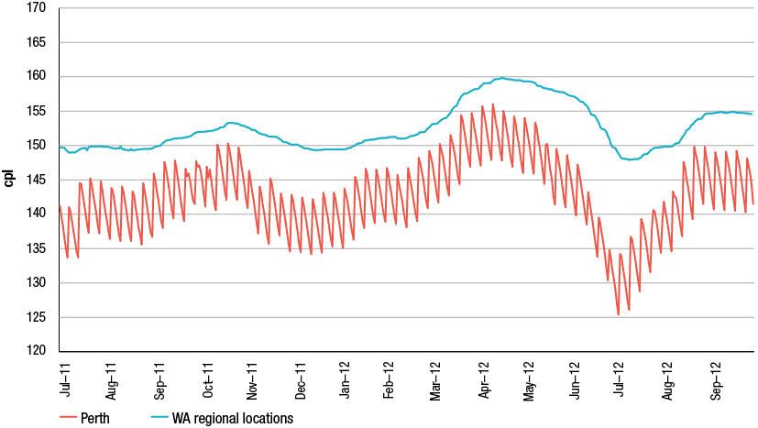
Source: ACCC calculations based on Informed Sources data
Chart 9.7 Daily average petrol prices in Hobart and Tasmanian regional locations:
1 July 2011 to 30 September 2012
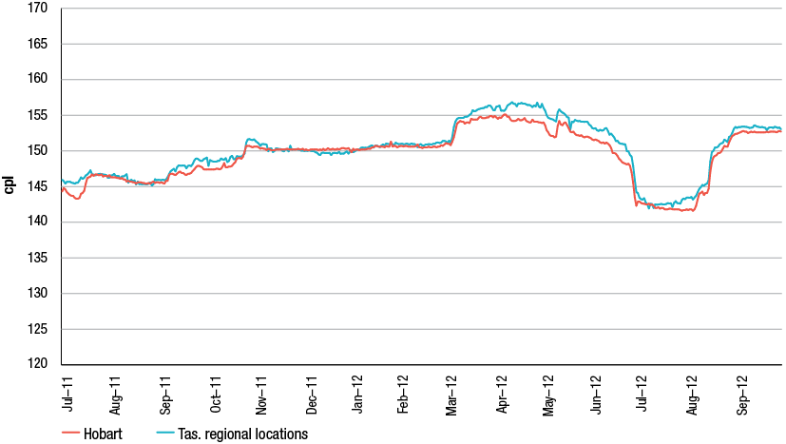
Source: ACCC calculations based on Informed Sources data
Chart 9.8 Daily average petrol prices in Darwin and Northern Territory regional locations:
1 July 2011 to 30 September 2012
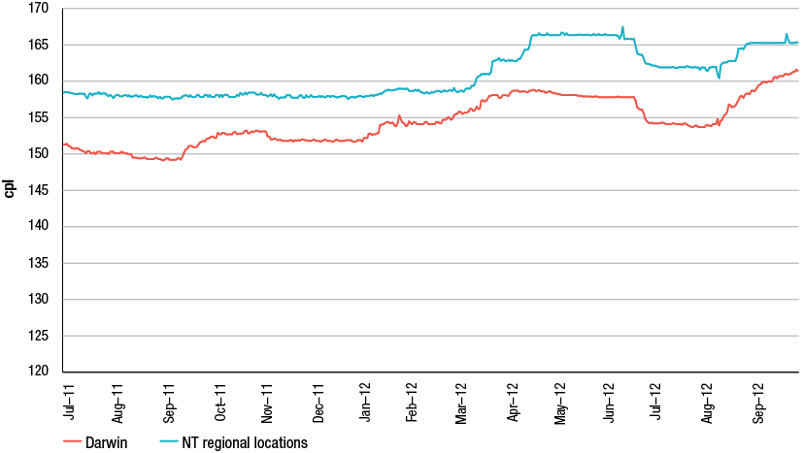
Source: ACCC calculations based on Informed Sources data
    - Price differentials over time
The city–country price differential varies between states and over time. Table 9.1 provides data on annual average price differentials between the capital city and regional locations for each state and the Northern Territory. It also shows two aggregate indicators of the city–country price differential: five-city and eight-city.
Table 9.1 Annual average petrol price differentials between the capital city and the monitored regional locations for each state and the Northern Territory: 2010−11, 2011−12 and 10-year average
State/Territory | 2010−11  cpl | 2011−12  cpl | 10-year avg.  cpl
NSW | 3.5 | 6.1 | 5.0
Vic. | 1.0 | 4.1 | 3.7
Qld | 1.8 | 2.6 | 3.4
SA | 4.5 | 5.2 | 4.4
WA | 10.6 | 9.4 | 11.9
Tas. | −0.1 | 0.6 | 0.2
NT | 8.9 | 6.4 | 6.5
Aggregate indicators
5-city | 4.1 | 5.5 | 5.4
8-city | 2.3 | 2.7 | 2.9
Source: ACCC calculations based on Informed Sources data
When comparing city–country price differentials over time it needs to be remembered that the number of regional locations included in the ACCC’s fuel price monitoring program has increased over this period.
2011−12 compared with 2010−11
Table 9.1 shows that in 2011−12, compared with 2010−11:
- the city-country price differential increased in New South Wales, Victoria, Queensland, South Australia and Tasmania
- there was a decrease in the city-country price differential in Western Australia and the Northern Territory. The largest decrease was in the Northern Territory (2.5 cpl)
- the five-city price differential increased by 1.4 cpl and the eight-city price differential increased by 0.4 cpl.
2011−12 compared with the 10-year average
Table 9.1 shows that in 2011−12, compared with the 10-year average:
- the city-country price differential was higher in New South Wales, Victoria, South Australia and Tasmania, and was lower in Queensland, Western Australia and the Northern Territory
- the five-city price differential was higher, while the eight-city price differential was lower.
  - Influences on prices in regional locations
Movements in retail petrol prices in regional locations are largely driven by changes in international refined petrol prices and the AUD–USD exchange rate, just as they are in the five largest cities. However, prices are generally higher in regional locations. A number of factors contribute to these higher prices and they are outlined below. The influence of these factors varies significantly from location to location. This means that there may be substantial differences in prices between specific regional locations.
    - Lower number of retail sites and therefore a lower level of local competition
In general, the degree of competition in a market will be greater if there are a large number of sellers. Therefore, everything else being equal, the higher the number of retail sites in a location, the greater the level of competition.
Smaller populations in regional locations generally have fewer vehicles, and therefore less retail sites, compared with the larger cities. Often this results in less competition in regional locations. In small country towns with a small number of retail sites there may be little incentive to reduce prices. This is because competitors will also quickly reduce their prices and the net result is the same volume of petrol sold at each retail site but with a lower margin.
    - Lower volumes of fuel sold
The volume of fuel sold at any particular retail site can significantly influence the price. Generally, the greater the volume of fuel sold the lower the price.
Certain costs of running a retail site (such as rent and maintenance) may be fixed irrespective of the volume of fuel sold. However, retail sites in regional locations generally sell lower volumes of fuel than retail sites in larger cities because they have comparatively fewer customers. Retail sites with higher volume sales can spread their fixed costs over this greater volume, which reduces the unit cost of supplying their fuel compared with retail sites with lower volumes of sales.
    - Distance/location factors
It generally costs more to deliver fuel to regional locations than it does to the largest capital cities. In regional locations, fuels need to be moved further from the fuel terminals, leading to higher freight costs. Additional storage costs may also be necessary if the fuel is stored in a local storage facility before being supplied to retail sites.
Regional locations which are situated along a major highway may have lower prices due to increased competition. This is because they may sell higher volumes due to the passing traffic on the highway, and may also have lower delivery and storage costs.
    - Lower convenience store sales
The margin on convenience store sales is usually significantly higher than on fuel sales. In the five largest cities convenience store sales generally make a greater contribution to the overall returns of a retail site than they do in regional locations. These retail sites can remain profitable on much lower margins on fuel sales. As a result, upward pressure is put on retail petrol prices in retail sites with lower convenience store sales, such as in regional locations.
    - Lags in price movements in regional locations
Price movements in regional locations generally lag behind movements in the five largest cities. This is due in part to a lower volume of sales in these locations, and hence slower replenishment of fuel stocks by wholesalers and retailers. Consequently, prices in regional locations often take more time to reflect changes in international prices than those in the five largest cities.
Chart 9.9 shows monthly average petrol prices in the five largest cities, regional locations in aggregate, and the monthly average price of Mogas 95 in Australian cents per litre in the period July 2011 to September 2012.
Chart 9.9 Monthly average retail petrol prices in the five largest cities and regional locations in aggregate, and Mogas 95 prices in Australian cents per litre: July 2011 to September 2012
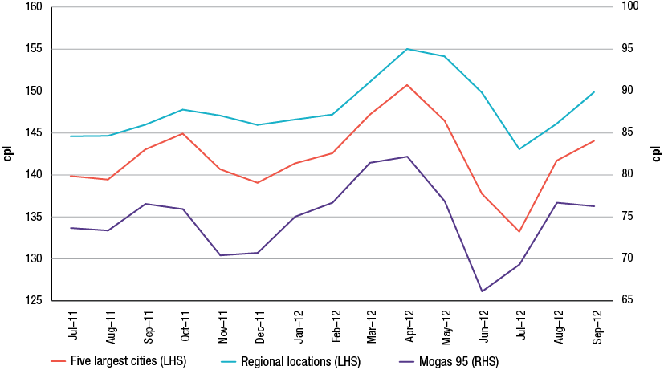
Source: ACCC calculations based on Informed Sources, Platts and RBA data
One example of the lag is during the period November 2011 to February 2012:
- monthly average Mogas 95 prices troughed in November 2011, but retail prices in the five largest cities and in regional locations did not trough until a month later
- between November 2011 and January 2012, Mogas 95 prices increased by 4.6 cpl; however, between December 2011 and February 2012 retail prices in the five largest cities increased by only 3.5 cpl and in regional locations they increased by only 1.2 cpl.
Another example is the period April 2012 to June 2012:
- monthly average Mogas 95 prices peaked in April 2012 and subsequently decreased by 16.1 cpl over the next two months
- over the same period, average monthly prices in the five largest cities decreased by 13.0 cpl; however, average prices across regional locations decreased by only 5.2 cpl.
  - Price movements can vary among regional locations
While retail petrol prices in regional locations at an aggregate level broadly follow movements in retail prices in the five largest cities—and hence international refined petrol prices—with a lag, at the individual regional location level there can be quite distinct differences in the extent to which retail petrol prices in regional locations follow movements in international refined petrol prices.
In a number of regional locations retail petrol prices closely follow movements in international refined petrol prices, whereas in others retail petrol prices have only a minimal relationship with movements in international refined petrol prices. There are other regional locations where retail petrol prices broadly follow movements in international refined petrol prices. Examples of these three types of regional locations are presented below.
    - Case studies
Keith
Keith is a small town located in South Australia, around 230 kilometres (km) south-west of Adelaide. It has a population of around 2000 people and five retail sites selling petrol.
Chart 9.10 shows seven-day rolling average retail petrol prices in Keith and seven-day rolling average Mogas 95 prices lagged 10 days from 1 July 2011 to 30 September 2012.
Chart 9.10 Seven-day rolling average retail petrol prices in Keith and Mogas 95 prices in Australian cents per litre: 1 July 2011 to 30 September 2012
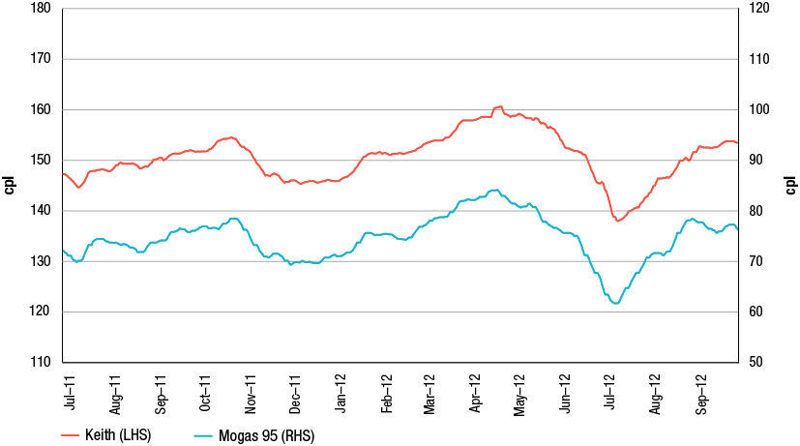
Source: ACCC calculations based on Informed Sources, Platts and RBA data
The chart shows that retail prices in Keith closely followed movements in Mogas 95 prices for the entire period.
Karratha
Karratha is located in the north-west of Western Australia, around 1500 km north of Perth. It has a population of around 14 000 people and five retail sites selling petrol.
Chart 9.11 shows seven-day rolling average retail petrol prices in Karratha and seven-day rolling average Mogas 95 prices lagged 10 days from 1 July 2011 to 30 September 2012.
Chart 9.11 Seven-day rolling average retail petrol prices in Karratha and Mogas 95 prices in Australian cents per litre: 1 July 2011 to 30 September 2012
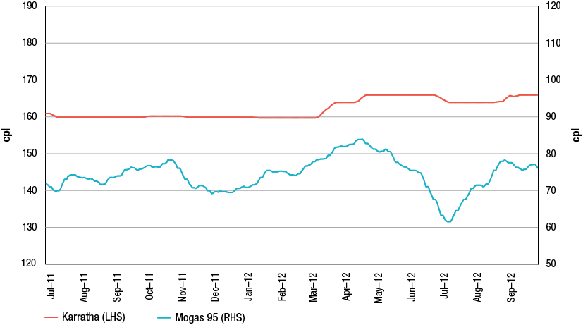
Source: ACCC calculations based on Informed Sources, Platts and RBA data
Retail petrol prices in Karratha remained largely unchanged between July 2011 and March 2012, despite movements in Mogas 95 prices during that period. They subsequently increased by around 6.0 cpl in two stages before becoming relatively stable again from early April 2012. The chart shows that between July 2011 and September 2012 retail prices in Karratha had only a minimal relationship with movements in international refined petrol prices.
Warrnambool
Warrnambool is located in Victoria, around 250 km south-west of Melbourne. It has a population of around 32 000 people and 12 retail sites selling petrol.
Chart 9.12 shows seven-day rolling average retail petrol prices in Warrnambool and seven-day rolling average Mogas 95 prices lagged 10 days from 1 July 2011 to 30 September 2012.
Chart 9.12 Seven-day rolling average retail petrol prices in Warrnambool and Mogas 95 prices in Australian cents per litre: 1 July 2011 to 30 September 2012
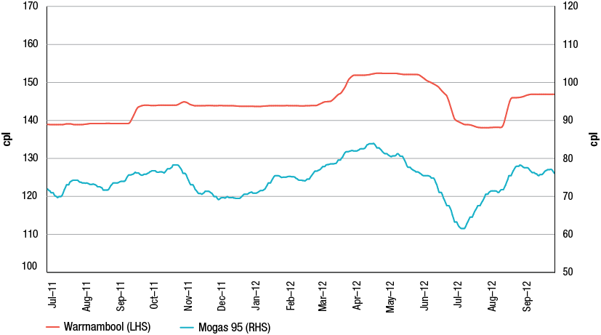
Source: ACCC calculations based on Informed Sources, Platts and RBA data
Between July 2011 and September 2012, retail prices in Warrnambool moved broadly in line with Mogas 95 prices. However, there were periods when movements in Warrnambool prices did not correspond with movements in Mogas 95 prices. For example, between late October 2011 and March 2012, Mogas 95 prices decreased by around 9.0 cpl before increasing by around the same amount. In contrast, retail prices in Warrnambool during this time remained constant.
    - Differences in price movements in regional locations
The factors that influence the extent to which retail petrol prices in specific regional locations follow international refined petrol prices were described in section 9.3.
For example, the number of retail sites in the specific regional location is likely to be an important factor. Keith has one retail site for every 400 people whereas Karratha has one retail site for every 2800 people. Warrnambool has one retail site for every 2667 people.
Similarly, the distance of the specific regional location from the capital city, and whether it is on a major highway, are likely to be relevant factors. Keith is located on the main highway between Melbourne and Adelaide and is around 230 km from Adelaide. Karratha, on the other hand, is situated 1500 km from Perth in a remote area. Warrnambool is around 250 km from Melbourne and is located on a fairly busy highway.
This analysis demonstrates that when comparing petrol prices between regional locations, it needs to be borne in mind that every regional location will tend to have particular factors that influence petrol prices to varying degrees. Furthermore, these influences can change over time.
  - Price cycles in regional locations
Regular price cycles are a prominent feature of petrol prices in Australia’s five largest cities (see chapter 10). Petrol price cycles also sometimes occur in Canberra, but not in Hobart or Darwin.
This section examines the extent to which there were petrol price cycles in regional locations in calendar year 2011. Daily average petrol prices in all of the regional locations included in the ACCC’s fuel price monitoring program were analysed and classified according to the number of price cycles that occurred.
    - Methodology
A petrol price cycle is a movement in price from the trough to a peak to a subsequent trough. A price cycle was considered to have occurred if the following criteria were met:
- the increase in price from the trough to the peak was 3 per cent or more of the trough price
- the decrease in price to the subsequent trough was also 3 per cent or more of the initial trough price.
To ensure that the price cycles in regional locations were of a broadly regular pattern—similar to those in the five largest cities—an additional criterion was applied:
- the decrease in price from the peak to the subsequent trough must have occurred within three weeks of the peak being reached.
The daily price movements in the regional locations were assessed and locations were classified into three broad categories according to the number of price cycles in the year. These categories were:
- Regular price cycles: these regional locations had 20 or more price cycles during 2011.
- Occasional price cycles: these regional locations had between six and 19 price cycles during 2011.
- No or few price cycles: these regional locations had five price cycles or less during 2011.
A degree of judgement was required when setting the criteria for this analysis. Note that:
- Price cycle increases are calculated from daily average prices in each regional location. This means that the actual increase in price at any individual retail site in the regional location may vary from the average price cycle increase.
- Prices in some regional locations may appear to move in a similar pattern to a price cycle; however, unless they met the criteria above these price movements were not counted as price cycles.
    - Analysis
Of the 173 regional locations analysed:
- Eight regional locations (5 per cent) had regular petrol price cycles. These were:
- Geelong, Seymour, Wallan, and Koo Wee Rup in Victoria; Moss Vale, Singleton and Tweed Heads South in New South Wales; and Gawler in South Australia.
11 regional locations (6 per cent) had occasional petrol price cycles. These were:
- Newcastle, Wollongong, Central Coast, Narrabri, Forster and Goulburn in New South Wales; Blackall in Queensland; Keith in South Australia; Wynyard and Sorell in Tasmania, and Corryong in Victoria.
- 154 regional locations (89 per cent) had no or few petrol price cycles. Of these:
- 124 regional locations (72 per cent of the total number of regional locations analysed) had no price cycles at all in 2011
- 16 regional locations (9 per cent) had only one price cycle in 2011.
    - Comparison with 2010 analysis
A comparison with the analysis of price cycles in regional locations in 2010 (which is described in chapter 10 of the 2011 ACCC petrol monitoring report) shows that:
- Five of the eight locations that had regular petrol price cycles in 2010 also had regular cycles in 2011. These were: Geelong, Seymour, Moss Vale, Singleton and Gawler.
- The other three regional locations that had regular petrol price cycles in 2011—Wallan, Koo Wee Rup and Tweed Heads South—were locations that were added to the ACCC’s fuel price monitoring program in 2011.
- There were four regional locations that had regular petrol price cycles in 2010 but not in 2011. These were: Wollongong, Newcastle, Queanbeyan and Bulahdelah in New South Wales.
- In 2011 all four of these regional locations had a greater number of price cycles for E10 petrol than for regular unleaded petrol. It may be that the steady move from selling regular unleaded petrol to selling E10 petrol in New South Wales, as a result of the ethanol mandate, has had an influence on the number of petrol price cycles in these locations.
    - Common features of the regional locations with regular price cycles
Some common features of the eight regional locations with regular petrol price cycles in 2011 are that they are either a major population centre (such as Geelong) or are close to major population centres and/or on major highways:
- Moss Vale is close to Wollongong, on the Illawarra Highway and close to the Hume Highway.
- Singleton is close to Newcastle and on the New England Highway.
- Seymour is relatively close to Melbourne and on the Hume Highway.
- Koo Wee Rup is close to Melbourne and on the South Gippsland Highway.
- Wallan is close to Melbourne and on the Hume Highway.
- Tweed Heads South is relatively close to Brisbane, and on the Pacific Highway.
- Gawler is close to Adelaide and near the Sturt Highway.
Generally, when petrol price cycles failed in the capital city, they also failed in the associated regional location. This suggests that retail petrol prices in these regional locations may be set on a similar basis to those in the five largest cities.

- Retail pricing analysis
Key points
- In 2011 and 2012 petrol price cycles in the four eastern mainland capital cities—Sydney, Melbourne, Brisbane and Adelaide—were characterised by considerable variability:
- The day of the week on which price cycles peaked and troughed changed with almost every price cycle.
- The duration of price cycles gradually increased to be over 12 days by September 2012.
- Perth was the exception to this pattern: it had stable price cycles (with each price cycle lasting seven days), and the day of the week on which price cycles peaked and troughed generally did not change.
- As in previous years, price cycle increases before public holidays in 2011−12 were on average no larger than the price increases in other weeks of the year.
- Analysis of data from January 2008 indicates that during periods of significant volatility in international benchmark prices and wholesale prices, retail petrol prices in Australia tend not to move—either up or down—by the same magnitude as wholesale prices.

  - Introduction
This chapter provides detailed analysis on a number of retail pricing issues. These include the regular petrol price cycles that occur in Australia’s largest cities and the relationship between changes in wholesale prices and retail prices.
  - Price cycles
Price cycles are a prominent feature of petrol prices in Australia’s largest cities. They occur only at the retail level; wholesale prices do not exhibit similar cyclical movements. Petrol price cycles are of concern to some consumers due to the large price increases that occur in a single day, and across most retail sites, on a regular basis. On the other hand, many consumers take advantage of the low point in the price cycle to purchase petrol at relatively low prices.
A petrol price cycle is a movement in price from a trough to a peak to a subsequent trough. The ACCC defines a price cycle as having occurred when the increase in price from the trough to the peak is 3 per cent or more of that trough price, and the decrease in price to the subsequent trough is also 3 per cent or more of the initial trough price. A price cycle increase is the increase in price from the initial trough to the peak. The duration of the price cycle is the number of days from the initial trough to the subsequent trough.
Chart 10.1 shows the elements of a petrol price cycle in Sydney in September 2011.
Chart 10.1 Elements of a petrol price cycle, Sydney: 9 September to 27 September 2011
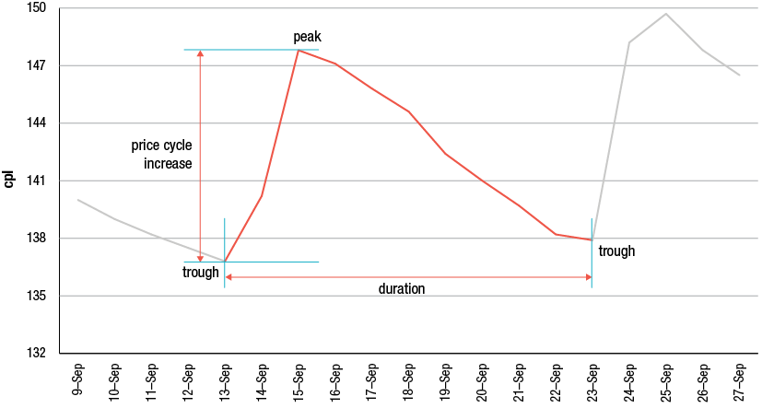
Source: ACCC analysis based on Informed Sources data
Detailed analysis of petrol price cycles was undertaken in previous ACCC petrol monitoring reports. This chapter extends that analysis to the end of September 2012. In particular, it considers the following elements of petrol price cycles in the five largest cities (Sydney, Melbourne, Brisbane, Adelaide and Perth):
- average price cycle increases
- the days of the week on which prices peak and trough
- the duration of price cycles
- the regularity (or otherwise) of price cycles
- consumer buying patterns during the price cycles
- the size of price cycle increases before public holidays.
  - Data on price cycles
Price cycle increases are calculated from daily average prices in each city. This means that the actual increase in price at any individual retail site in that city can vary from the average price cycle increase for the city.
There are three main influences on the size of price cycle increases:
- changes in wholesale prices—price cycle increases tend to be higher than average when underlying wholesale prices are increasing and lower than average when underlying wholesale prices are decreasing
- the extent of discounting before the price cycle increase
- the overall price level—for example, the absolute magnitude of the price cycle increase when prices are around 150 cents per litre (cpl) is likely to be higher than when prices are around 100 cpl.
Data on the number of price cycles and average price cycle increases in the five largest cities for the period 1 January 2011 to 30 September 2012 is shown in table 10.1.
Table 10.1 Average price cycle increase in cents per litre and as a percentage of average price, and number of price cycles—five largest cities: 2011 and 2012
 | Sydney | Melbourne | Brisbane | Adelaide | Perth
Average price cycle increase (cpl)
2011 | 9.5 | 11.4 | 8.8 | 13.7 | 8.1
2012 | 11.9 | 13.2 | 10.4 | 15.8 | 8.2
Price cycle increase as per cent of average annual price (%)
2011 | 6.8 | 8.2 | 6.2 | 9.8 | 5.8
2012 | 8.4 | 9.4 | 7.1 | 11.1 | 5.7
Number of price cycles
2011 | 42 | 42 | 39 | 37 | 52
2012 | 22 | 17 | 22 | 21 | 39

Source: ACCC analysis based on Informed Sources data
In 2011 the average price cycle increase was largest in Adelaide (13.7 cpl) and smallest in Perth (8.1 cpl). In 2012 average price cycle increases were greater than 10 cpl in all cities except Perth. As in 2011, Adelaide had the largest average price cycle increase (15.8 cpl) in 2012 and Perth had the smallest (8.2 cpl). As a percentage of annual average prices, the average price cycle increases were larger in 2012 compared with 2011 in all cities except Perth.
In 2011 Perth had a price cycle every week of the year, while the number of price cycles in the other cities was 42 or less. This was largely due to the longer duration of price cycles in recent years in the four eastern capital cities, and was also influenced by a number of price cycle failures.
In 2012 Perth again had a price cycle every week. The number of price cycles in the other cities was 22 or fewer over the 39-week period. In Melbourne, there were only 17 price cycles, reflecting a large increase in the duration of price cycles that occurred in the period, as well as three failed price cycles.
Table 10.1 shows that compared with the four eastern cities, Perth had more predictable price cycles with smaller average price cycle increases in both 2011 and 2012. Unlike other states, Western Australia has fuel price regulations under which retail sites must keep their prices constant for a 24-hour period and the price at each retail site is publicly available on the FuelWatch website. As a result of these arrangements, petrol retailers may adopt different pricing strategies from those employed in the eastern cities.
  - Peaks and troughs by day of the week
This section examines the days of the week on which price cycles peaked and troughed in 2011 and 2012 and discusses the changes that have occurred.
    - Number of peaks and troughs by day of the week
Prior to 2010, price cycle peaks and troughs generally occurred on the same day each week. However, in 2011 and 2012 the troughs and peaks have varied over the week in the four eastern cities, reflecting the longer duration of price cycles. The converse is true for Perth: price cycles have became more regular and predictable in 2011 and 2012 compared with previous years.
Table 10.2 shows the number of troughs and peaks (and percentage of the annual total) on each day of the week in each of the five largest cities in 2011 and 2012.
Table 10.2 Number of troughs and peaks (and percentage of annual total) in petrol prices on each day of the week, five largest cities: 2011 and 2012
 | Mon | Tue | Wed | Thu | Fri | Sat | Sun | Total
Sydney
Trough
2011 | 6 (14%) | 2 (5%) | 5 (12%) | 8 (19%) | 16 (38%) | 1 (2%) | 4 (10%) | 42
2012 | 4 (17%) | 4 (17%) | 5 (22%) | 1 (4%) | 5 (22%) |  |  | 23
Peak
2011 | 9 (21%) | 2 (5%) | 2 (5%) | 7 (17%) | 5 (12%) | 5 (12%) | 12 (29%) | 42
2012 | 3 (14%) |  | 1 (5%) | 5 (23%) | 3 (14%) | 6 (27%) | 4 (18%) | 22
Melbourne
Trough
2011 | 6 (14%) | 3 (7%) | 4 (10%) | 7 (17%) | 13 (31%) | 5 (12%) | 4 (10%) | 42
2012 | 1 (6%) | 3 (17%) | 6 (33%) | 1 (6%) | 4 (22%) | 1 (6%) | 2 (11%) | 18
Peak
2011 | 6 (14%) | 3 (7%) | 5 (12%) | 5 (12%) | 7 (17%) | 6 (14%) | 10 (24%) | 42
2012 | 3 (18%) | 2 (12%) | 1 (6%) | 2 (12%) | 3 (18%) | 2 (12%) | 4 (24%) | 17
Brisbane
Trough
2011 | 7 (18%) | 4 (10%) | 2 (5%) | 8 (21%) | 14 (36%) | 4 (10%) |  | 39
2012 | 5 (23%) | 2 (9%) | 6 (27%) | 3 (14%) | 4 (18%) | 1 (5%) | 1 (5%) | 22
Peak
2011 | 6 (15%) | 3 (8%) | 3 (8%) | 5 (13%) | 5 (13%) | 4 (10%) | 13 (33%) | 39
2012 | 4 (18%) | 1 (5%) | 1 (5%) | 4 (18%) | 3 (14%) | 5 (23%) | 4 (18%) | 22
Adelaide
Trough
2011 | 7 (19%) | 3 (8%) | 4 (11%) | 8 (22%) | 12 (32%) | 1 (3%) | 2 (5%) | 37
2012 | 1 (5%) | 3 (14%) | 6 (27%) | 2 (9%) | 4 (18%) |  | 6 (27%) | 22
Peak
2011 | 3 (8%) |  | 4 (11%) | 7 (19%) | 2 (5%) | 10 (27%) | 11 (30%) | 37
2012 | 1 (5%) | 3 (14%) | 6 (29%) | 2 (10%) | 4 (19%) |  | 5 (24%) | 21
Perth
Trough
2011 |  |  | 52 (100%) |  |  |  |  | 52
2012 |  |  | 39 (100%) |  |  |  |  | 39
Peak
2011 |  |  |  | 51 (98%) | 1 (2%) |  |  | 52
2012 |  |  |  | 36 (92%) | 3 (8%) |  |  | 39

Source: ACCC analysis based on Informed Sources data
The table shows that in the four eastern cities:
- with a few exceptions, price cycle peaks and troughs occurred every day of the week in 2011
- in 2011 the trough occurred most often on a Friday and the peak most often on a Sunday
- in 2012 the most common trough day was Wednesday, while the most common peak day varied across the cities.
In Perth:
- the price cycle trough always occurred on a Wednesday in 2011 and 2012
- the price cycle peak occurred on all but one Thursday in 2011 and all but three Thursdays in 2012. On the other four occasions the peak occurred on a Friday.
    - Changes in days of the week of peaks and troughs
Charts 10.2 to 10.11 identify the day of the week on which each price cycle peak and trough occurred in each of the five largest cities in the period 1 January 2011 to 30 September 2012. Each square in the charts depicts a peak (in light blue) or a trough (in dark blue) during each price cycle.
The charts highlight that in 2011 and 2012—with the exception of Perth—there has been no consistent pattern for peak and trough days.
In the four eastern cities, the following trends can broadly be seen:
- Price cycles were around seven days in duration in January to March 2011. At this time the peak and trough occurred around the same time each week for several weeks at a time.
- From April to June 2011, price cycles were around eight days in duration. The peak and trough days generally moved through the week.
- Since mid-2011 price cycle durations have gradually increased but durations have not been consistent. As a result, peak and trough days have been very unpredictable for consumers.
On the other hand, in Perth peak and trough days have been very predictable throughout 2011 and 2012. They have not moved through the week, as they have in the four eastern cities.
The stability of the weekly price cycle in Perth is a relatively recent phenomenon. Price cycles were largely absent in Perth for nearly a year prior to March 2009 and before that price cycles were around fourteen days in duration. In contrast, price cycles in all four eastern cities were generally seven days in duration prior to mid-2010. The duration of price cycles is considered in more detail in section 10.5.
Chart 10.2 Day of peak, Sydney: 1 January 2011 to 30 September 2012
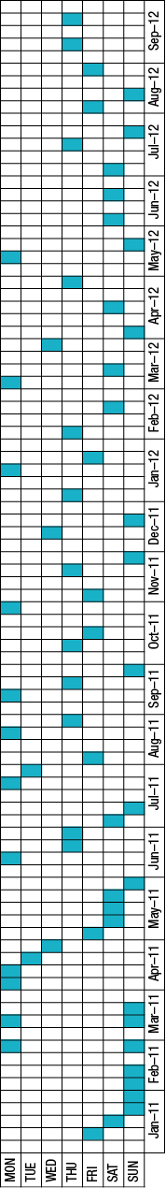
Chart 10.3 Day of trough, Sydney: 1 January 2011 to 30 September 2012
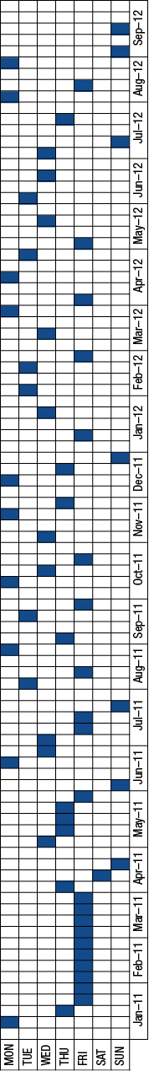
Chart 10.4 Day of peak, Melbourne: 1 January 2011 to 30 September 2012
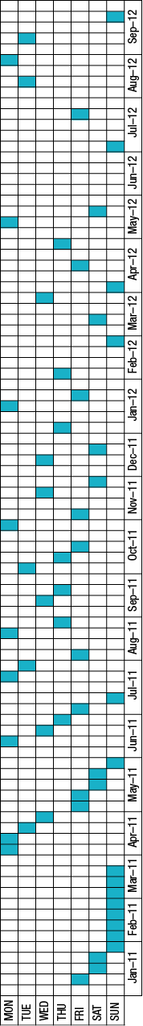
Chart 10.5 Day of trough, Melbourne: 1 January 2011 to 30 September 2012
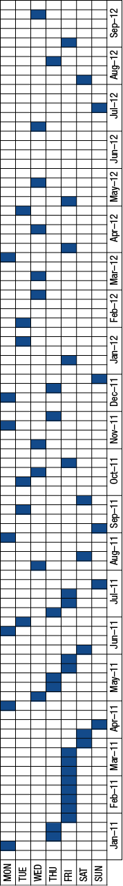
Chart 10.6 Day of peak, Brisbane: 1 January 2011 to 30 September 2012
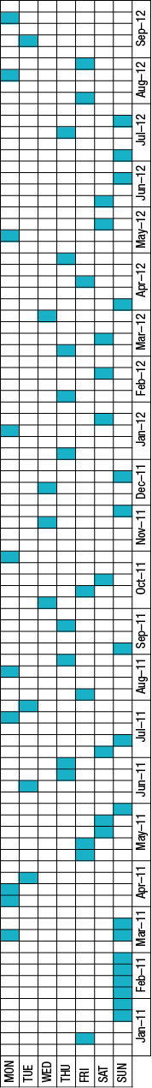
Chart 10.7 Day of trough, Brisbane: 1 January 2011 to 30 September 2012
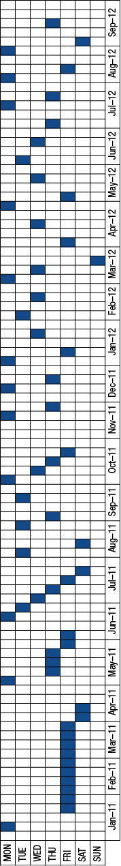
Chart 10.8 Day of peak, Adelaide: 1 January 2011 to 30 September 2012
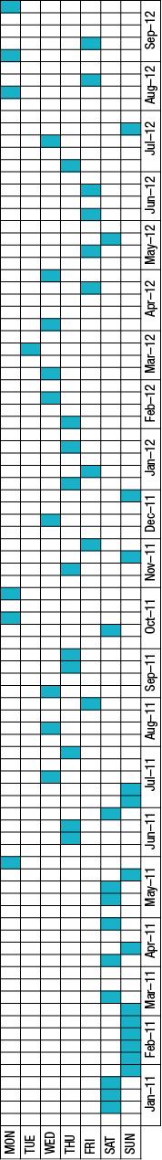
Chart 10.9 Day of trough, Adelaide: 1 January 2011 to 30 September 2012
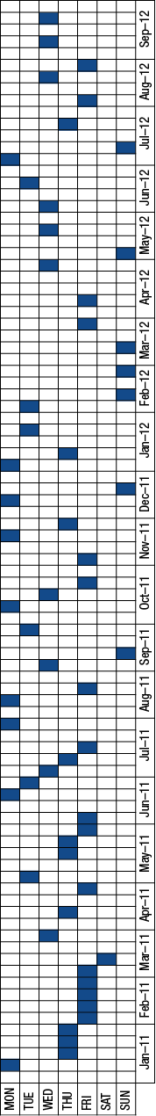
Chart 10.10 Day of peak, Perth: 1 January 2011 to 30 September 2012
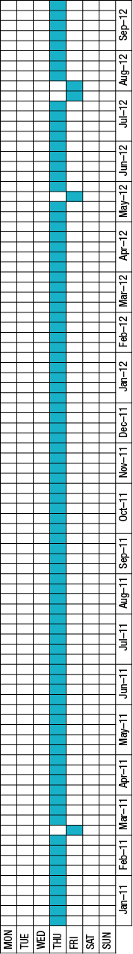
Chart 10.11 Day of trough, Perth: 1 January 2011 to 30 September 2012
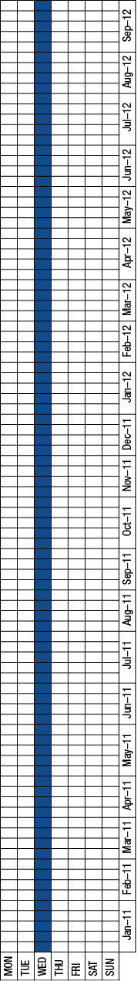
Source: ACCC analysis based on Informed Sources data
Note: Each light blue square depicts the peak of a price cycle and each dark blue square depicts the trough of a price cycle.
  - Duration of price cycles
A feature of petrol price cycles in recent years has been the increase in the duration of price cycles in Sydney, Melbourne, Brisbane and Adelaide, while price cycle durations in Perth have remained largely unchanged. This section analyses the duration of regular price cycles in the five largest cities between the March 2009 quarter and the September 2012 quarter.
    - Methodology
As noted in section 10.2, a price cycle is a movement in price from the trough to a peak to a subsequent trough. The duration of a price cycle is therefore the number of days between the two troughs.
This analysis of price cycle durations excludes the influence of the failed price cycles (as defined in section 10.6) that occurred in these cities during this time. Failed price cycles can have a significant effect on the duration of price cycles. In the event of a failed price cycle, the duration of the price cycle immediately preceding or succeeding it will be much larger than it otherwise would have been. These longer price cycles have been removed from the analysis. With the influence of failed price cycles removed it is possible to observe a more illustrative trend of how price cycle durations have changed since January 2009.
    - Analysis
Tables 10.3 to 10.7 show the quarterly and annual average duration of regular price cycles in the five largest cities between the March 2009 quarter and the September 2012 quarter. They also show the average number of days from trough to peak and the average number of days from peak to trough.
Charts 10.12 to 10.16 show the duration of each regular price cycle in the five largest cities during this period.
Table 10.3 Quarterly and annual average price cycle duration, trough–peak duration and peak–trough duration, Sydney: March 2009 to September 2012 quarter
 | Average cycle duration | Average duration  trough–peak | Average duration  peak–trough
Mar 2009 | 7.0 | 1.2 | 5.8
Jun 2009 | 7.0 | 1.8 | 5.2
Sep 2009 | 7.0 | 2.0 | 5.0
Dec 2009 | 7.0 | 2.0 | 5.0
2009 | 7.0 | 1.8 | 5.2
Mar 2010 | 7.0 | 2.1 | 4.9
Jun 2010 | 7.4 | 2.1 | 5.3
Sep 2010 | 8.0 | 2.2 | 5.8
Dec 2010 | 7.3 | 1.9 | 5.4
2010 | 7.4 | 2.1 | 5.3
Mar 2011 | 7.3 | 2.4 | 4.8
Jun 2011 | 8.2 | 2.3 | 5.9
Sep 2011 | 9.6 | 2.7 | 6.9
Dec 2011 | 10.6 | 2.8 | 7.8
2011 | 8.8 | 2.5 | 6.2
Mar 2012 | 12.0 | 2.7 | 9.3
Jun 2012 | 12.5 | 3.3 | 9.3
Sep 2012 | 12.1 | 3.6 | 8.6
2012 | 12.2 | 3.2 | 9.0

Source: ACCC analysis based on Informed Sources data
Chart 10.12 Duration of price cycles, Sydney: January 2009 to September 2012
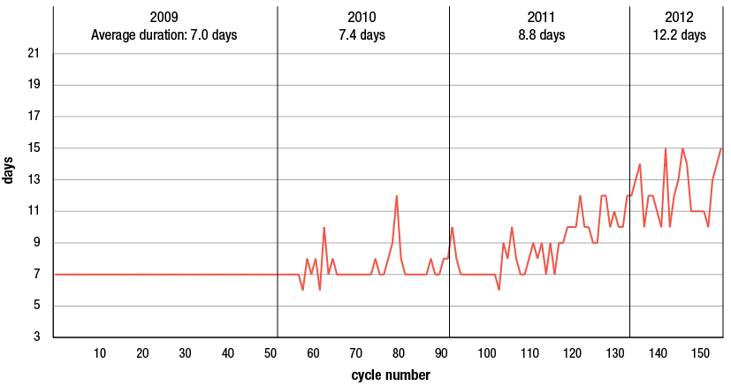
Source: ACCC analysis based on Informed Sources data
Table 10.4 Quarterly and annual average price cycle duration, trough–peak duration and peak–trough duration, Melbourne: March 2009 to September 2012 quarter
 | Average cycle duration | Average duration  trough–peak | Average duration  peak–trough
Mar 2009 | 7.0 | 1.4 | 5.6
Jun 2009 | 7.0 | 2.0 | 5.0
Sep 2009 | 7.0 | 2.0 | 5.0
Dec 2009 | 7.0 | 2.0 | 5.0
2009 | 7.0 | 1.8 | 5.2
Mar 2010 | 6.9 | 2.0 | 4.9
Jun 2010 | 7.2 | 1.8 | 5.3
Sep 2010 | 7.7 | 2.0 | 5.7
Dec 2010 | 7.3 | 1.6 | 5.6
2010 | 7.3 | 1.9 | 5.4
Mar 2011 | 7.4 | 2.2 | 5.3
Jun 2011 | 8.1 | 1.8 | 6.3
Sep 2011 | 9.6 | 2.3 | 7.3
Dec 2011 | 10.4 | 2.3 | 8.1
2011 | 8.8 | 2.1 | 6.6
Mar 2012 | 12.4 | 3.0 | 9.4
Jun 2012 | 11.8 | 2.3 | 9.5
Sep 2012 | 16.2 | 4.0 | 12.2
2012 | 13.7 | 3.2 | 10.5

Source: ACCC analysis based on Informed Sources data
Chart 10.13 Duration of price cycles, Melbourne: January 2009 to September 2012
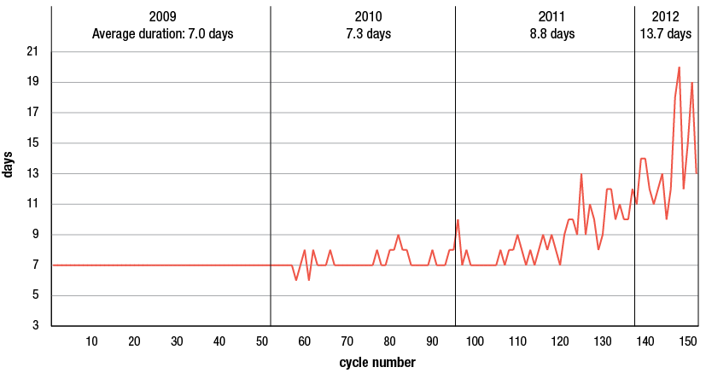
Source: ACCC analysis based on Informed Sources data
Table 10.5 Quarterly and annual average price cycle duration, trough–peak duration and peak–trough duration, Brisbane: March 2009 to September 2012 quarter
 | Average cycle duration | Average duration  trough–peak | Average duration  peak–trough
Mar 2009 | 7.0 | 1.8 | 5.2
Jun 2009 | 6.9 | 2.0 | 4.9
Sep 2009 | 7.1 | 2.0 | 5.1
Dec 2009 | 7.0 | 2.0 | 5.0
2009 | 7.0 | 2.0 | 5.0
Mar 2010 | 7.0 | 2.1 | 4.9
Jun 2010 | 7.2 | 2.0 | 5.2
Sep 2010 | 7.6 | 1.9 | 5.7
Dec 2010 | 7.3 | 1.9 | 5.4
2010 | 7.2 | 2.0 | 5.3
Mar 2011 | 7.1 | 2.2 | 4.9
Jun 2011 | 8.0 | 2.4 | 5.6
Sep 2011 | 9.8 | 2.6 | 7.2
Dec 2011 | 9.9 | 2.4 | 7.4
2011 | 8.6 | 2.4 | 6.2
Mar 2012 | 12.0 | 2.9 | 9.1
Jun 2012 | 12.9 | 3.0 | 9.9
Sep 2012 | 12.0 | 3.4 | 8.6
2012 | 12.3 | 3.1 | 9.2

Source: ACCC analysis based on Informed Sources data
Chart 10.14 Duration of price cycles, Brisbane: January 2009 to September 2012
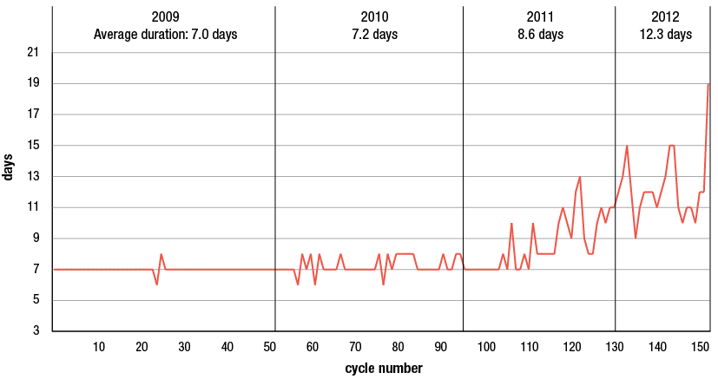
Source: ACCC analysis based on Informed Sources data
Table 10.6 Quarterly and annual average price cycle duration, trough–peak duration and peak–trough duration, Adelaide: March 2009 to September 2012 quarter
 | Average cycle duration | Average duration  trough–peak | Average duration  peak–trough
Mar 2009 | 7.0 | 1.0 | 6.0
Jun 2009 | 7.0 | 1.0 | 6.0
Sep 2009 | 7.0 | 1.5 | 5.5
Dec 2009 | 7.0 | 2.0 | 5.0
2009 | 7.0 | 1.4 | 5.6
Mar 2010 | 7.0 | 2.4 | 4.6
Jun 2010 | 7.2 | 2.2 | 5.0
Sep 2010 | 7.3 | 2.4 | 4.9
Dec 2010 | 7.4 | 2.2 | 5.2
2010 | 7.2 | 2.3 | 4.9
Mar 2011 | 7.6 | 2.1 | 5.4
Jun 2011 | 7.4 | 2.3 | 5.1
Sep 2011 | 10.0 | 2.6 | 7.4
Dec 2011 | 11.8 | 3.1 | 8.6
2011 | 9.2 | 2.5 | 6.6
Mar 2012 | 13.0 | 3.2 | 9.8
Jun 2012 | 12.3 | 2.7 | 9.7
Sep 2012 | 13.0 | 3.0 | 10.0
2012 | 12.8 | 2.9 | 9.8

Source: ACCC analysis based on Informed Sources data
Chart 10.15 Duration of price cycles, Adelaide: January 2009 to September 2012
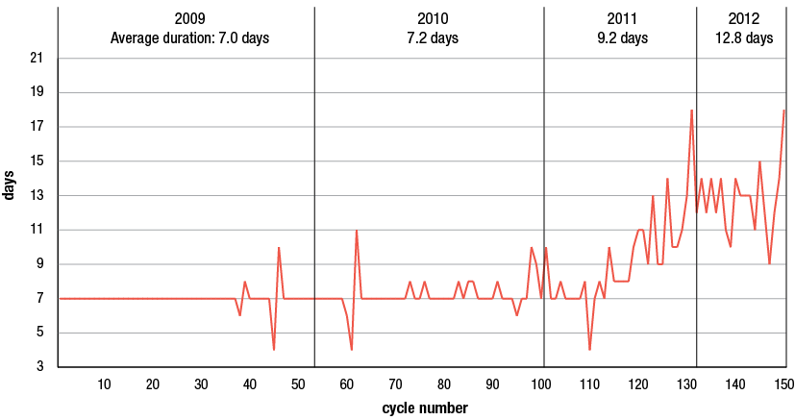
Source: ACCC analysis based on Informed Sources data
Table 10.7 Quarterly and annual average price cycle duration, trough–peak duration and peak–trough duration, Perth: March 2009 to September 2012 quarter
 | Average cycle duration | Average duration  trough–peak | Average duration  peak–trough
Mar 2009 | 8.0 | 4.5 | 3.5
Jun 2009 | 7.0 | 3.0 | 4.0
Sep 2009 | 7.0 | 3.0 | 4.0
Dec 2009 | 6.9 | 2.7 | 4.2
2009 | 7.0 | 3.0 | 4.0
Mar 2010 | 7.1 | 3.3 | 3.9
Jun 2010 | 7.0 | 2.0 | 5.0
Sep 2010 | 7.0 | 1.9 | 5.1
Dec 2010 | 7.1 | 1.9 | 5.2
2010 | 7.0 | 2.2 | 4.9
Mar 2011 | 7.0 | 1.1 | 5.9
Jun 2011 | 7.0 | 1.0 | 6.0
Sep 2011 | 7.0 | 1.0 | 6.0
Dec 2011 | 7.0 | 1.0 | 6.0
2011 | 7.0 | 1.0 | 6.0
Mar 2012 | 7.0 | 1.0 | 6.0
Jun 2012 | 7.0 | 1.1 | 5.9
Sep 2012 | 7.0 | 1.2 | 5.8
2012 | 7.0 | 1.1 | 5.9

Source: ACCC analysis based on Informed Sources data
Chart 10.16 Duration of price cycles, Perth: March 2009 to September 2012
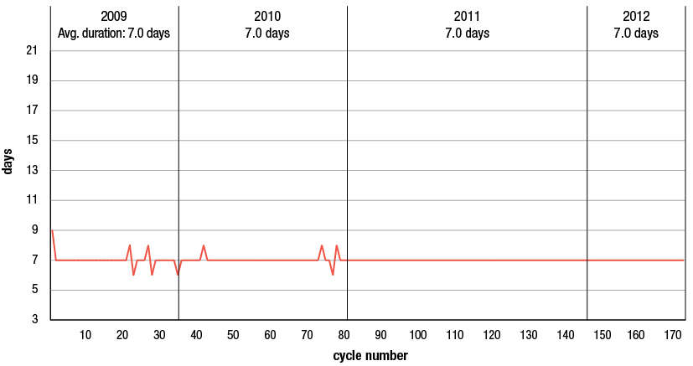
Source: ACCC analysis based on Informed Sources data
Change in price cycle durations
In the four eastern cities:
- In 2009 the duration of price cycles was always seven days in Sydney and Melbourne and generally seven days in Brisbane and Adelaide. The average annual price cycle duration was seven days in each city.
- In 2010 the duration of price cycles became more variable, with price cycles more frequently being longer than seven days. The average annual price cycle duration was over seven days in each city.
- In 2011 there was a noticeable increase in the average duration of price cycles in the September 2011 quarter in all four cities. It increased from around seven or eight days to around 10 days. The average annual price cycle duration was close to nine days in each city.
- In the first three quarters of 2012 the average quarterly durations continued to increase. The average price cycle duration in the first three quarters of 2012 was over 12 days in each city.
- Overall, between the March 2009 and September 2012 quarters, average quarterly price cycle durations increased by five days or more.
- In all cities the average duration in the March 2009 quarter was seven days. By the September 2012 quarter this had increased to around 12 days in Sydney and Brisbane, around 13 days in Adelaide and around 16 days in Melbourne.
In contrast, in Perth average quarterly price cycle durations between the March 2009 and September 2012 quarters remained largely constant at seven days. The duration of price cycles was largely seven days in 2009 and 2010 and always seven days in subsequent years.
Change in trough–peak and peak–trough durations
In the four eastern cities:
- In 2009 each city generally had seven day price cycles, and the average trough to peak duration was around two days and the average peak to trough duration was around five days.
- By the first three quarters of 2012 these cities generally had 12-day price cycles and the average trough to peak duration was around three days (an increase of one day) and the average peak to trough duration was around nine to 10 days (an increase of four to five days).
- While the duration of price cycles has increased between the March 2009 and September 2012 quarters, the proportion of time in the trough to peak movement (around 20–30 per cent) and in the peak to trough movement (around 70–80 per cent) has not materially changed.
The story is different in Perth, which generally had seven day price cycles over the whole period. In 2009 the average trough to peak duration was three days and the average peak to trough duration was four days. By the first three quarters of 2012 the average trough to peak duration was around one day (a decrease of two days) and the average peak to trough duration was around six days (an increase of two days).
- The proportion of time in the trough to peak movement in Perth decreased from around 43 per cent in 2009 to around 16 per cent in 2012.
- This indicates that the shape of the price cycle in Perth has changed substantially since 2009.
    - Factors that may have contributed to the change in the price cycle
The 2010 ACCC petrol monitoring report noted that the ACCC had sought the views of the major petrol retailers in September 2010 about reasons for the change in the pattern of the price cycle in 2010. Factors identified by a number of retailers included:
- an increase in the degree of retail price competition
- some retailers had been delaying price increases until later in the week in order to increase their market share.
The report also noted that the ACCC’s decision in late 2009 to oppose the sale of Mobil’s retail assets to Caltex may also have led to a greater degree of uncertainty in the industry.
In January 2012 the ACCC again sought the views of the major petrol retailers about reasons for the change in the pattern of the price cycles. The same factors identified in September 2010 were also mentioned in January 2012. Other factors identified were:
- changes in the pricing behaviour of the supermarkets (such as remaining at the bottom of the price cycle longer and increased use of shopper dockets with a value greater than 4.0 cpl)
- a greater sensitivity among consumers of high petrol prices.
If some retailers delay putting up their prices, other retailers respond to this delay in the current and subsequent price cycles. Over time, this can lead to the movement through the week of trough and peak days of the price cycle and a longer duration of price cycles. It may also increase uncertainty in the market and lead to a degree of instability with retailers unsure about the behaviour of the market and the response of competitors.
  - Regularity of price cycles
This section analyses price cycles in 2011 and 2012 to determine the extent to which there have been regular, failed and truncated price cycles.
Regular cycles
The typical pattern of the petrol price cycle in the five largest cities in recent years has been one where prices increase quickly at the outset (over one to three days) and then steadily decrease over the rest of the cycle (between six and nine days); that is, they move in a ‘sawtooth’ pattern. This is classified as a ‘regular’ price cycle. During regular price cycles, most market participants increase prices within a few days of each other. Generally, a small number of retailers increase their prices first and the rest of the market follows.
Irregular cycles
There are a number of price cycles that could be considered to be irregular. These can be classified as ‘failed’ or ‘truncated’ price cycles. These types of price cycles are often associated with relatively lower prices, ostensibly due to strong price competition between retailers.
Failed and truncated price cycles can occur because some market participants do not increase prices at the time that might be expected during a regular price cycle. This can lead to price cycles taking longer to occur (or not occur at all), or to a collapse in the price cycle (as those retailers that increased their prices first notice that the rest of the market has not followed them, and subsequently they decrease their prices).
    - Methodology
Price cycles have been classified into three broad categories:
- Regular: this is a price cycle which meets the 3 per cent definition (referred to in section 10.2), where the peak occurs at a time when a peak might have been expected, and where the regular sawtooth pattern is apparent.
- Truncated: this is a price cycle which meets the 3 per cent definition, where the peak occurs at a time when a peak might have been expected, but the typical sawtooth pattern is shortened (that is, there is a return to a lower price within one or two days of the trough to peak movement). Generally, the price cycle increase is significantly lower than might have been expected.
- Failed: this is where there is a small (or no) increase in price, at a time when an increase might have been expected, and the magnitude of the price increase (if any) does not meet the 3 per cent definition.
    - Example of regular and failed price cycles
Chart 10.17 shows daily average retail petrol prices in the five largest cities for the period 13 May to 30 June 2012. There were regular and failed price cycles during this period.
The chart indicates that:
- Price cycles in Sydney, Brisbane, Adelaide and Perth were broadly regular in pattern.
- In Melbourne (the aqua line in the chart) there were two failed cycles.
- The average duration of price cycles in Sydney, Brisbane and Adelaide was almost twice that of the price cycles in Perth.
Chart 10.17 Daily average petrol prices in the five largest cities: 13 May 2012 to 30 June 2012
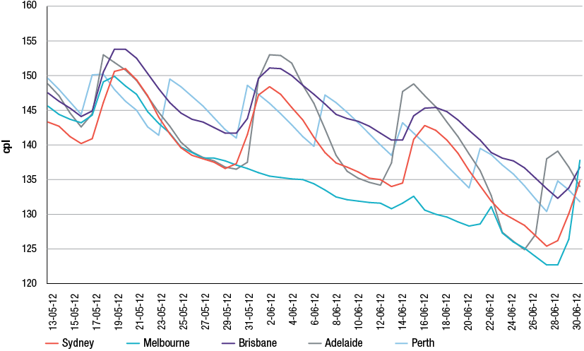
Source: ACCC based on Informed Sources data
    - Classification of price cycles in 2011 and 2012
Table 10.8 indicates the classification of price cycles in the five largest cities in 2011 and 2012.
Table 10.8 Classification of price cycles in the five largest cities: 2011 and 2012
 | Sydney | Melbourne | Brisbane | Adelaide | Perth | Total
Regular
2011 | 40 | 42 | 39 | 35 | 52 | 208
2012 | 22 | 17 | 22 | 21 | 39 | 121
Truncated
2011 | 2 | – | – | 2 | – | 4
2012 | – | – | – | – | – | –
Failed
2011 | – | – | 3 | 6 | – | 9
2012 | – | 3 | – | 2 | – | 5

Source: ACCC analysis based on Informed Sources data
In 2011 and 2012:
- there were 14 failed price cycles
- Adelaide had six failed price cycles in 2011 and Brisbane had three
- in 2012 only two cities had failed price cycles: Melbourne (three) and Adelaide (two)
- there were four truncated price cycles in 2011: two each in Adelaide and Sydney
- no truncated price cycles occurred in any city in 2012
- altogether there were a total of 18 failed and truncated price cycles in the five largest cities in the period.
- more than half of these occurred in Adelaide (two truncated and eight failed cycles)
- Perth had regular price cycles every week during the period.
The occasions in the second half of 2011 and the first half of 2012 when failed price cycles occurred in Sydney, Melbourne, Brisbane and Adelaide can be seen in the charts at appendix G.
  - Consumer buying patterns during the price cycle
This section provides information on the volume of retail petrol sales and the average price of petrol by day of the week in the five largest cities in 2011−12.
In Perth, the cheapest day of the week to buy petrol was always Wednesday, and the most expensive day was almost always Thursday. Therefore, consumers in Perth had the opportunity to take advantage of petrol price cycles by buying relatively cheap petrol on Wednesday each week.
In contrast, in the four eastern cities, the days of the week on which price cycles peaked and troughed varied from week to week in 2011−12. As noted in section 10.5.2 the average duration of price cycles in these cities was over 12 days in 2012. Therefore, there were many weeks which had neither a peak nor a trough.
    - Average petrol sales and volumes by day of the week by city
Chart 10.18 shows the percentage of average sales volumes and average retail petrol prices by day of the week in 2011−12 in the five largest cities in aggregate.
Chart 10.18 Average petrol sales volumes and prices by day of the week, five largest cities: 2011−12
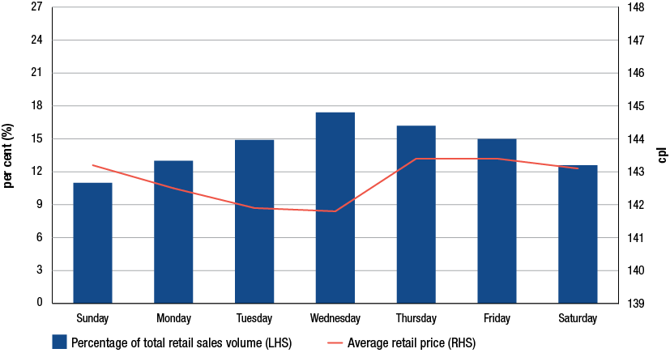
Source: ACCC calculations based on Informed Sources, and information provided by the monitored companies
There was a smaller variation in average retail prices from day to day over the week in 2011−12 compared with the previous year—1.6 cpl in 2011−12 compared with 3.4 cpl in 2010−11.
There was also a slightly more uniform pattern of sales volumes over the week in 2011−12—they ranged from a low of 11 per cent (on Sunday) to a high of 17 per cent (on Wednesday) in 2011−12, compared with a range of 10 per cent to 18 per cent in 2010−11.
The flattening in the shape of sales volumes and prices over the week reflects the increasing duration of petrol price cycles in the eastern capital cities in 2011−12. This is evident from charts 10.19 to 10.22, which show the percentage of average sales volumes and average retail petrol prices by day of the week in 2011−12 in each of the eastern capital cities.
Chart 10.19 Average petrol sales volumes and prices by day of the week, Sydney: 2011−12
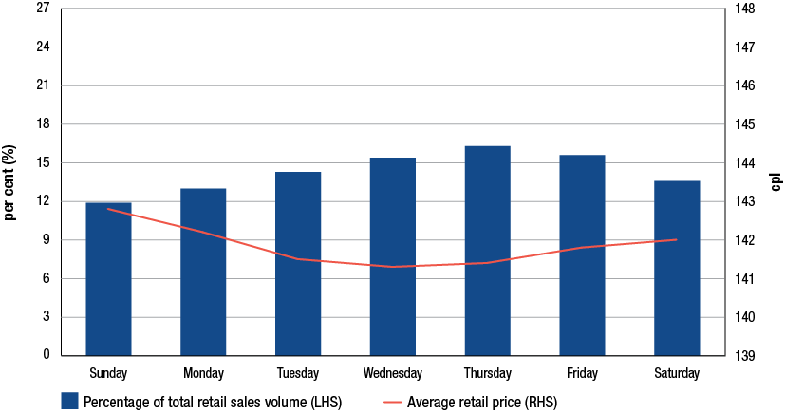
Source: ACCC calculations based on Informed Sources, and information provided by the monitored companies
Chart 10.20 Average petrol sales volumes and prices by day of the week, Melbourne: 2011−12
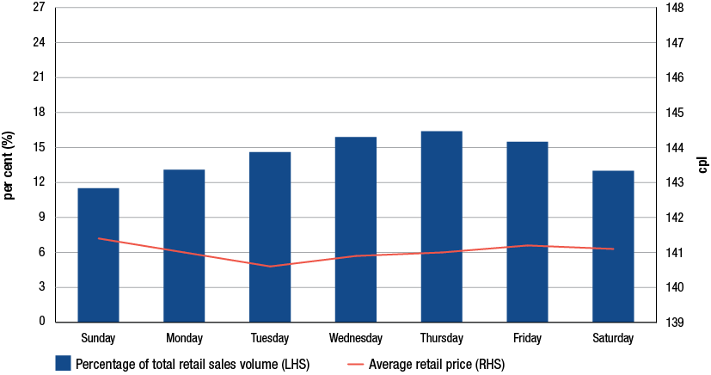
Source: ACCC calculations based on Informed Sources, and information provided by the monitored companies
Chart 10.21 Average petrol sales volumes and prices by day of the week, Brisbane: 2011−12
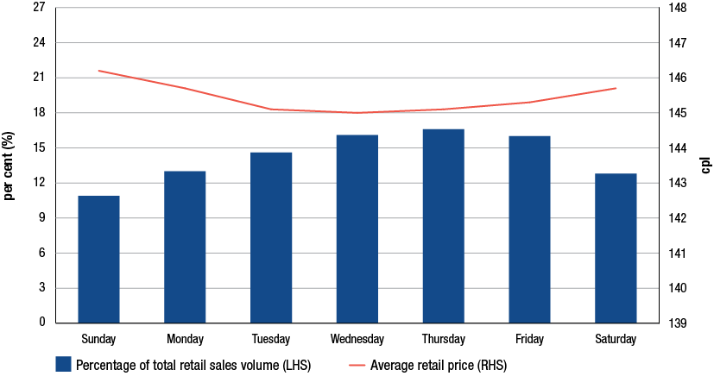
Source: ACCC calculations based on Informed Sources, and information provided by the monitored companies
Chart 10.22 Average petrol sales volumes and prices by day of the week, Adelaide: 2011−12
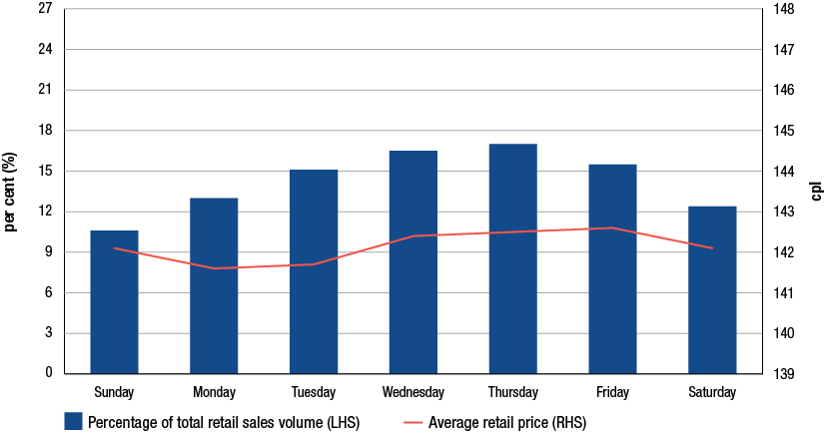
Source: ACCC calculations based on Informed Sources, and information provided by the monitored companies
In contrast to the eastern capital cities, Perth—which has regular seven-day petrol price cycles—exhibited a clear inverse relationship between average prices and sales volumes over the week (see chart 10.23). The variation in average retail prices from day to day over the week was 7.8 cpl—from a high of 147.0 cpl on Thursday to a low of 139.2 cpl on Wednesday. The variation in sales volumes ranged from 23 per cent (on Wednesday) to around 9 per cent on Sunday.
Chart 10.23 Average petrol sales volumes and prices by day of the week, Perth: 2011−12
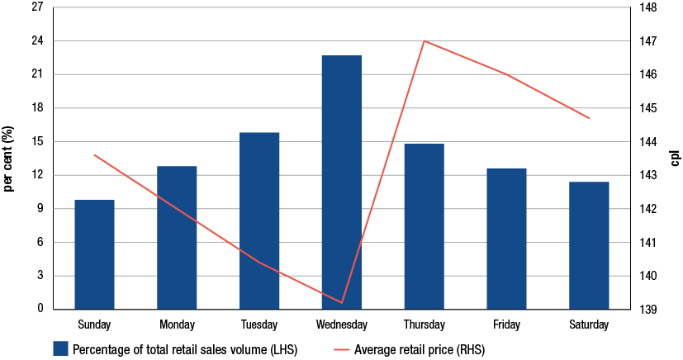
Source: ACCC calculations based on Informed Sources, and information provided by the monitored companies
    - Average petrol sales and volumes over a two-month period
Daily average petrol prices and daily volumes of petrol sold in Adelaide and Perth were analysed over a two-month period to see how consumers responded to price levels during each price cycle.
Chart 10.24 shows daily average petrol sales (as a percentage of total sales for the period) and average retail petrol prices in Adelaide for the period 1 February to 31 March 2012. During this period, the duration of each price cycle in Adelaide varied from 13 to 14 days.
Chart 10.24 Daily average petrol sales volumes and prices, Adelaide: 1 February to 31 March 2012
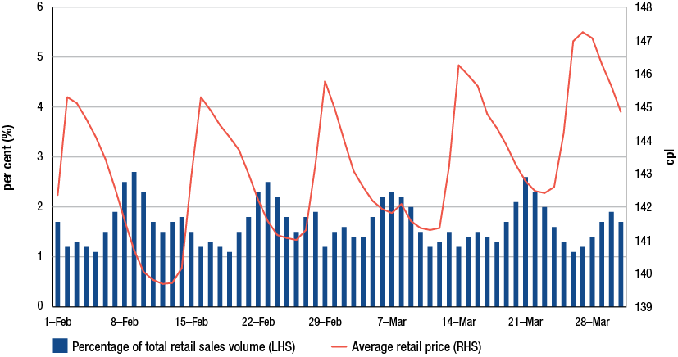
Source: ACCC calculations based on Informed Sources, and information provided by the monitored companies
The chart shows that:
- there was a broadly inverse relationship between price levels and volumes of petrol sold
- however, the highest volumes sold occurred on average three days before the trough of the price cycle
- there were lower volumes of petrol sold at the peak of the price cycle and a few days thereafter
- this pattern of buying shows that while consumers in Adelaide tended to purchase higher volumes on the cheaper days of the price cycle, they tend to purchase petrol before the trough price. This suggests that the longer and more variable price cycles in Adelaide have made it difficult for consumers to pick the cheapest days to buy petrol.
Chart 10.25 shows daily average petrol sales (as a percentage of total sales for the period) and average retail petrol prices in Perth for the period 1 February to 31 March 2012. In contrast to Adelaide, the duration of each petrol price cycle was always seven days. The cheapest day was always Wednesday and the most expensive day was always Thursday.
Chart 10.25 Daily average petrol sales volumes and prices, Perth: 1 February to 31 March 2012
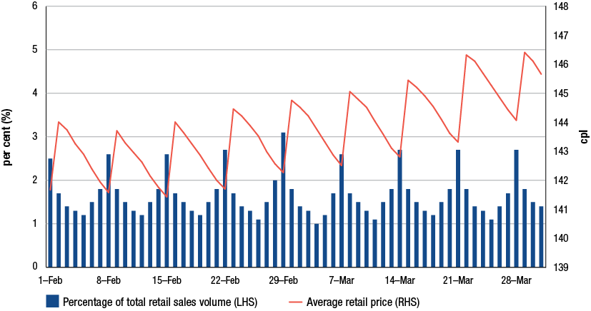
Source: ACCC calculations based on Informed Sources, and information provided by the monitored companies
The chart shows that:
- the highest volumes of petrol sold always occurred on the cheapest day of the price cycle (i.e. Wednesday)
- the lowest volume of petrol sold was on Sunday. Higher volumes of petrol were sold on Thursday and Friday, despite average prices on these days being relatively higher than on the weekend
- the predictable nature of price cycles in Perth (combined with elements of the FuelWatch system, such as retail prices being fixed for 24 hours and prices at each site being publicly available on the FuelWatch website) make it easier for consumers to purchase petrol on the cheapest day of the price cycle each week.
  - Price cycle increases and public holidays
It is often claimed that retail petrol prices always increase before public holidays. These price increases are not surprising given the regularity of petrol price cycle increases in the five largest cities. It is also often claimed that the price increases before public holidays are always higher than the price cycle increases when there is no public holiday.
The 2011 ACCC petrol monitoring report examined petrol price increases before public holidays in each of the five largest cities for the period January 2007 to June 2011. It found that during this period the average price cycle increase before public holidays was equal to or above the annual average price cycle increase less than half (45 per cent) of the time.
As noted in section 10.3 there are three main influences on the size of price cycle increases: changes in wholesale prices, the extent of discounting before the price cycle increase and the overall price level. These factors are not influenced by the timing of public holidays.
Analysis of price cycle increases has been updated to cover the five and a half year period January 2007 to June 2012. In each of the years 2007 to 2011, and the first half of 2012, the price cycle increase before a public holiday was compared with the relevant yearly average price cycle increase (or half yearly in the case of 2012). The results are shown in table 10.9. Charts showing price cycle increases and public holidays in the five largest cities in 2011−12 are provided in appendix G.
Table 10.9 shows that during this period the price cycle increases before public holidays were equal to or above the yearly average price cycle increase less than half (48 per cent) of the time.
Table 10.9 Number (and percentage) of price cycle increases before public holidays for the five largest cities: January 2007 to June 2012
 | Total | Greater than or equal to calendar year average | Less than calendar year average | Less than calendar year maximum
Sydney | 39 | 19 (49%) | 20 (51%) | 39 (100%)
Melbourne | 41 | 17 (41%) | 24 (59%) | 39 (95%)
Brisbane | 42 | 19 (45%) | 23 (55%) | 41 (98%)
Adelaide | 41 | 28 (68%) | 13 (32%) | 39 (95%)
Perth | 35 | 13 (37%) | 22 (63%) | 34 (97%)
Total | 198 | 96 (48%) | 102 (52%) | 192 (97%)

Source: ACCC analysis based on Informed Sources data
The table shows that:
- a majority of price cycles before public holidays had smaller price increases than the yearly average price cycle increase
- in Sydney, Melbourne, Brisbane and Perth, price cycle increases before public holidays were below the yearly average price cycle increase more than half of the time
- in Adelaide price cycle increases before public holidays were equal to or above the yearly average price cycle increase around two-thirds of the time
- in Melbourne and Adelaide, there were two occasions when the price cycle increase before a public holiday was the highest price cycle increase for the year. In Brisbane and Perth there was one occasion and in Sydney there were none.
The results from this analysis are consistent with the conclusions from previous ACCC monitoring reports and show that there is little evidence to support the claim that price cycle increases before public holidays are always higher than the price cycle increases when there is no public holiday.
  - Relationship between changes in wholesale prices and retail prices
The ACCC has noted many times that the main determinant of retail prices in Australia is the international benchmark price of refined petrol, which in Australia’s case is the price of Mogas 95. Movements in Mogas 95 prices are first reflected in movements in domestic wholesale prices (i.e. terminal gate prices, or TGPs) and then in retail prices.
There is usually a time lag between changes in TGPs and changes in retail prices; i.e. retailers do not necessarily pass on changes in TGPs straight away. This may reflect the stage in the petrol price cycle when TGPs change, and also that some retail sites may not need to purchase petrol immediately when TGPs change. The ACCC has found that there is generally a lag of five days between changes in TGPs and changes in retail prices.
The relationship between changes in TGPs and changes in retail prices is broadly stable over time. However, in the short term it can vary due to the influence of a number of factors. These include:
- the extent to which there is extended discounting at the retail level in particular markets
- the magnitude of the change in TGPs.
These factors are considered further below.
    - Periods of extended discounting
Chart 10.26 shows daily average retail petrol prices in Melbourne for the three month period 10 April to 10 July 2012 and daily average TGPs lagged five days.
Chart 10.26 Daily average retail prices and daily average terminal gate prices lagged five days, Melbourne: 10 April to 10 July 2012
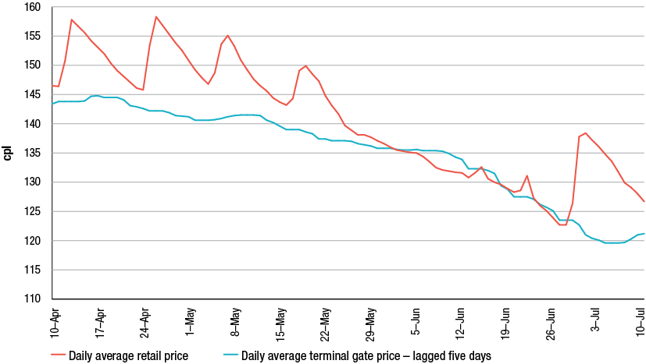
Source: ACCC analysis based on Informed Sources, BP, Caltex, Mobil and Shell data
During this period there were two failed price cycles in Melbourne. As a result of this extended discounting, the decrease in retail prices in Melbourne was greater than the decrease in TGPs over that period. Between May and June 2012 monthly average TGPs (lagged by five days) decreased by around 10 cpl whereas monthly average retail prices in Melbourne decreased by around 15 cpl.
This indicates that the state of the market needs to be considered when the relationship between TGPs and retail prices (and gross indicative retail differences—GIRDs—which are the difference between the two series) is being examined.
    - Magnitude of the change in terminal gate prices
The size of the change in TGPs also appears to be an influence on the relationship between TGPs and retail prices.
The ACCC has analysed monthly changes in TGPs and retail prices in the five largest cities over the four and a half year period from January 2008 to June 2012. The analysis found that large changes in average monthly TGPs (i.e. changes in TGPs of 5.0 cpl or more per month) led to a less than commensurate change in retail prices. This applied to both increases and decreases in TGPs.
In the 54 months between January 2008 and June 2012 there were 14 months when the change in average monthly TGPs was 5.0 cpl or more. These months are shown in table 10.10, along with the change in retail prices in the month and the difference between the two.
Table 10.10 Changes in monthly average TGPs equal to or greater than 5.0 cpl, changes in monthly average retail prices and the difference, five largest cities: January 2008 to June 2012
Month | Change in TGPs  cpl | Change in retail prices  cpl | Difference  cpl
May 2008 | 6.4 | 4.9 | 1.5
Jun 2008 | 9.7 | 11.3 | −1.6
Aug 2008 | −12.3 | −11.8 | −0.5
Nov 2008 | –25.4 | –25.0 | −0.4
Dec 2008 | −19.3 | −18.9 | −0.4
Feb 2009 | 15.0 | 13.6 | 1.4
Mar 2009 | –5.0 | –3.9 | −1.1
Jun 2009 | 6.3 | 6.0 | 0.3
Oct 2009 | –6.4 | –5.9 | −0.5
Dec 2010 | 5.5 | 5.0 | 0.5
Mar 2011 | 6.9 | 5.9 | 1.0
Nov 2011 | –6.3 | –4.1 | –2.2
Mar 2012 | 5.0 | 4.7 | 0.3
Jun 2012 | –8.2 | −9.2 | 1.0

Source: ACCC analysis based on Informed Sources, BP, Caltex, Mobil, Shell and WA FuelWatch data
Of the 14 months when monthly average TGPs changed by 5.0 cpl or more:
- there were an equal number of months (seven each) when prices decreased and when prices increased
- there were 12 occasions when the change in monthly average retail prices was smaller than the change in average monthly TGPs. Six of these were when prices increased and six were when prices decreased
- the change in average monthly retail prices in June 2008 (an increase of 11.3 cpl) was greater than the change in average monthly TGPs (an increase of 9.7 cpl). This may have been influenced by price cycle failures in the previous month causing higher than usual increases in retail prices in June 2008
- the change in average monthly retail prices in June 2012 (a decrease of 9.2 cpl) was greater than the change in average monthly TGPs (a decrease of 8.2 cpl). This is likely to have been influenced by the price cycle failures in Melbourne in June 2012.
This analysis suggests that retail prices, in the short run, are slow to reflect large changes in TGPs. This applies equally to increases and decreases. This can have the effect of increasing GIRDs when TGPs decrease by large amounts, and decreasing GIRDs when TGPs increase by large amounts. The analysis highlights the importance of examining changes in GIRDs over a longer time period.
- Petrol pricing: an international perspective
Key points
- Australia’s experience with petrol prices is not unique.
- Similar to Australia, retail petrol prices in other countries closely track movements in relevant international benchmark prices and are influenced by movements in their exchange rates against the USD.
- Crude oil prices and taxes account for the majority of the retail price of petrol in other countries:
- Movements in crude oil prices drive changes in international refined petrol prices and ultimately domestic retail prices, while fuel taxes largely determine different price levels in different countries.
- There is evidence of retail petrol price cycles in some overseas markets in Canada and the US.
- Excluding the impact of taxes, retail petrol prices in a number of countries, including Australia, are broadly similar.
- Including taxes, Australia had the fourth lowest retail prices in the OECD in 2011−12.

  - Introduction
The key themes regarding the behaviour and composition of petrol prices in Australia can be described in three main points:
- Retail prices generally reflect international market prices of both crude oil and refined petrol benchmarks. Retail prices are also influenced by changes in the AUD–USD exchange rate.
- The final pump price that consumers pay is largely made up of the international price of refined petrol and taxes.
- In the very short term, retail prices in the large capital cities typically fluctuate in a cyclical pattern, changing frequently over the course of a week.
This chapter considers how this experience compares with other countries around the world.
To provide continuity with the analysis presented in the 2011 ACCC petrol monitoring report this chapter considers how Australia’s experience compares with the petrol pricing experience in five other countries:
- Canada
- United States (US)
- New Zealand
- Germany
- United Kingdom (UK).
Located across three regions of the world, these five countries provide a useful yardstick for examining Australia’s experience with petrol prices.
Similar to Australia, each of these countries are members of the Organisation for Economic Co-operation and Development (OECD) and have petroleum operations in both upstream and downstream sectors.
  - Determinants of petrol prices around the world
Over the medium to longer term, Australian retail petrol prices are largely driven by movements in the international benchmark price of refined petrol, which is used to set prices in Australia.
Singapore Mogas 95 Unleaded (Mogas 95) is the refined petrol benchmark product traded in the Singapore market, the largest petrol-trading centre in the Asia-Pacific region, which forms the basis for setting refined regular unleaded petrol prices in Australia. The price of Mogas 95 is affected by demand and supply conditions for refined petrol in the Asia-Pacific region. It is also driven by changes in the price of crude oil.
Chapter 8 highlighted the influence of international market prices as well as movements in the AUD–USD exchange rate in determining the retail price of petrol in Australia.
Just as they do in Australia, international benchmark prices of crude oil and refined petrol also play a major role in determining petrol prices in other countries. Benchmark prices are developed in major trading regions all over the world, including:
- Singapore (Asia)
- New York (North America)
- Rotterdam (Europe).
The markets in which these benchmarks are used are generally located in relatively close proximity to these major trading hubs.
Taxation also plays a significant role in determining the level of petrol prices both in Australia and overseas. As the level of tax applied to the sale of petrol varies from country to country, the overall price level also varies.
    - Influence of crude oil and petroleum benchmark prices
Movements in Australian retail regular unleaded petrol (RULP) prices are displayed in chart 11.1. Retail prices are shown alongside wholesale, refined petrol and crude oil prices over the five years to June 2012.
The price of crude oil and refined petrol are key drivers of retail prices, with changes in the price of these base products closely reflected by retail prices.
Chart 11.1 Weekly movements in crude oil, refined petrol, wholesale and retail prices for RULP in Australia: July 2007 to June 2012
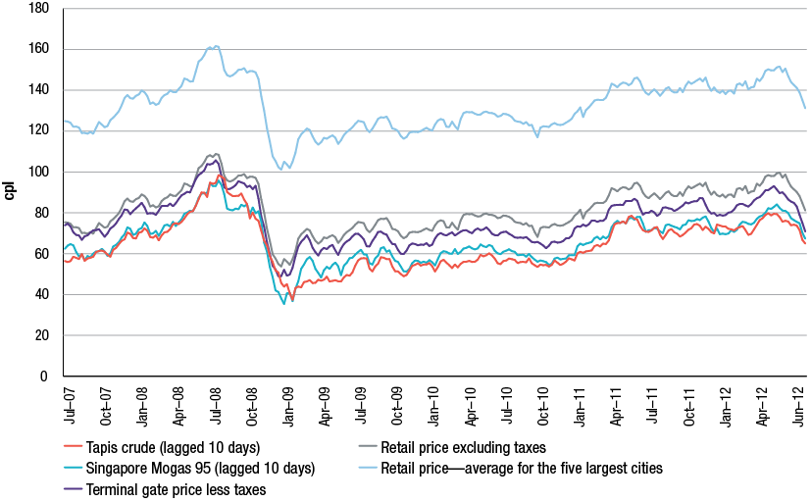
Source: ACCC calculations based on data from Informed Sources, Platts, RBA and information provided by monitored companies
Canada
In Canada retail petrol prices are also affected by similar determinants. Chart 11.2 shows movements in crude oil and refined petrol benchmark prices applicable to the Canadian market as well as wholesale prices and retail prices with and without taxes.
Traditionally, Edmonton Par crude has been the appropriate crude benchmark for a number of locations in the Canadian market. Recently the price of Edmonton crude has traded at a discount compared with other types of crude. Similar to the recent behaviour of WTI prices, continued pipeline constraints in the US Midwest have meant that Canadian Par crude derived from the tar sands production has also experienced difficulties in finding a market, leading to significant discounting.
However, movements in the local benchmark price of refined petrol, the price of gasoline at New York Harbour, are very closely reflected in both wholesale and retail prices.
Chart 11.2 Weekly movements in crude oil, refined product benchmarks, wholesale and retail prices for regular unleaded gasoline in Canada: July 2007 to June 2012
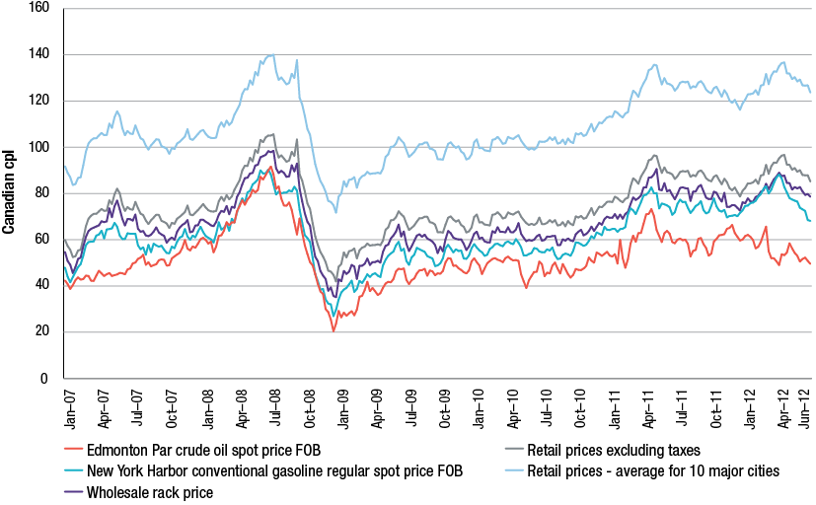
Source: ACCC calculations based on data from US Energy Information Administration (US EIA), Bank of Canada and MJ Ervin & Associates
Note: Retail prices are an average of a weekly observed Tuesday price across 10 major Canadian cities. Wholesale prices reflect a snapshot of wholesale prices at a particular point in time and at specific locations. Full data collection methodology on wholesale and retail prices is available at: http://kentmarketingservices.com/dnn/PetroleumPriceData/Methodology.aspx.
United States—California
Movements in retail petrol prices in California also suggest a similar relationship with the relevant international benchmark prices.
Alaska North Slope crude oil is used as the benchmark for the acquisition cost of composite crude oil for California refineries. In terms of a refined petrol benchmark, the Los Angeles Reformulated Gasoline Blendstocks for Oxygenate Blending (RBOB) price represents a benchmark price for the base petrol that suits the Californian market.
Chart 11.3 shows the relevant international benchmarks compared with wholesale and retail prices of regular branded petrol across California.
Chart 11.3 Weekly movements in crude oil, refined product benchmarks, wholesale and retail prices for regular petrol in California: July 2007 to June 2012
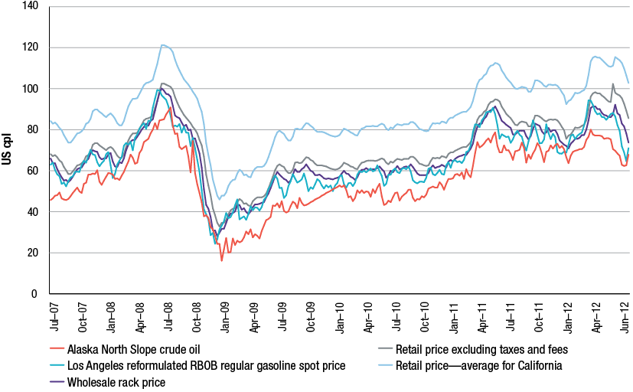
Source: ACCC calculations based on data from US EIA and the California Energy Commission
Note: Retail prices are weekly prices collected by the US EIA. Wholesale prices reflect the average of 13 unbranded and 13 branded wholesale prices at various wholesale fuel loading racks around California. This average price is for the same day as US EIA’s weekly average gasoline price. Full data collection methodology on wholesale prices is available at: http://energyalmanac.ca.gov/gasoline/margins/index.php#terms.
New Zealand
The experience in the geographically closest developed country to Australia, New Zealand, is also very similar to Australia’s experience with petrol prices. Chart 11.4 shows the relationship between retail petrol prices and wholesale, refined product and crude oil benchmarks in New Zealand.
As in Australia, the appropriate refined petrol benchmark in New Zealand is Mogas 95. Prices in New Zealand are established with reference to the ‘importer cost’ which is conceptually similar to the notional import cost or import parity price in Australia. The importer cost is also based on the price of Mogas 95. Dubai crude is the most relevant crude oil benchmark price in New Zealand as the only refinery in New Zealand is suited to cheaper heavier crude than is the case for Australian refineries.
Chart 11.4 Weekly movements in crude oil, refined product benchmarks, wholesale and retail prices for regular petrol in New Zealand: July 2007 to June 2012
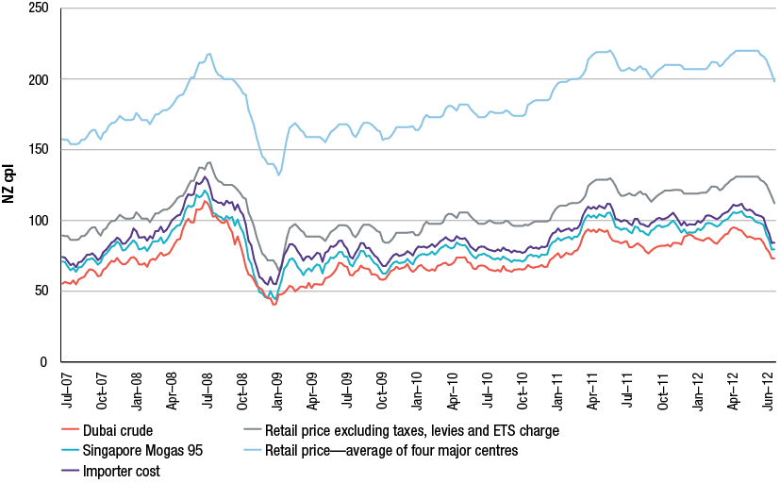
Source: ACCC calculations based on data from Platts, RBA, and the New Zealand Ministry of Business, Innovation and Employment, see http://www.med.govt.nz/sectors-industries/energy/liquid-fuel-market/weekly-oil-price-monitoring (Crown copyright)
Note: Retail prices are based on more than 90 per cent of total petrol transactions across all major centres.
Germany
From a European standpoint, retail petrol prices also closely track relevant international benchmark prices.
Germany is Europe’s biggest motor fuel market. Chart 11.5 shows German retail prices of Euro-Super 95, a 95 RON grade of petrol, as well as crude oil and refined petrol benchmark prices over the five years to June 2012. This particular grade of fuel is a higher standard than Australia’s RULP, but is nevertheless one of the most commonly used types of fuel across the European market.
Crude oil and refined petrol benchmark prices applicable to most European countries differ to those affecting the Australian market, but the relationship with retail prices remains very similar. Brent crude oil is the dominant oil benchmark in Europe and the most applicable international benchmark price of refined petrol is the average price of Mogas 95 in the Antwerp/Rotterdam/Amsterdam region.
Chart 11.5 Weekly movements in crude oil, refined product benchmarks and retail prices for Euro-Super 95 petrol in Germany: July 2007 to June 2012
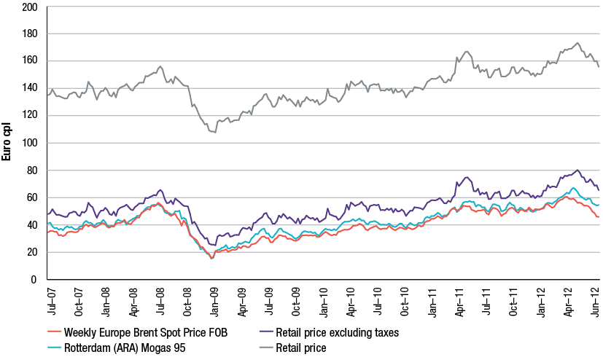
Source: ACCC calculations based on data from US EIA, Bloomberg, US Federal Reserve Bank, European Commission
Note: Retail prices are the average of a weekly observed Monday price. Prices are collected from five oil companies which cover most of the market. A small number of prices represent a calculated average of the preceding and following weeks as prices were not collected in some weeks. Full data collection methodology is available at: http://ec.europa.eu/energy/observatory/oil/bulletin_en.htm.
United Kingdom
Chart 11.6 tracks retail prices of Euro-Super 95 petrol with crude and refined petrol benchmarks in the UK.
Chart 11.6 Weekly movements in crude oil, refined product benchmarks and retail prices for Euro-Super 95 petrol in the UK: July 2007 to June 2012
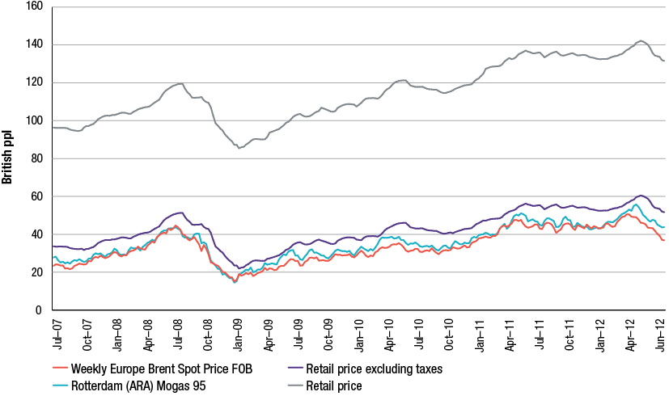
Source: ACCC calculations based on data from US EIA, Bloomberg, US Federal Reserve Bank, European Commission
Note: Retail prices represent a weekly observed Monday price. Prices are collected from five oil companies and two supermarkets which cover the majority of the market. A small number of prices represent a calculated average of the preceding and following weeks as prices were not collected in some weeks. Full data collection methodology is available at: http://ec.europa.eu/energy/observatory/oil/bulletin_en.htm.
One notable difference between the characteristics of petrol prices in Germany, the UK and many other parts of Europe compared with Australia, is the amount of tax applied to the price of fuel. European countries generally impose higher taxes on fuel, making it relatively more expensive than in Australia.
The components of petrol prices are examined in more detail in the following section, but despite the differences in fuel taxation retail petrol prices in the countries considered in this chapter follow movements in relevant international benchmark prices.
    - Influence of exchange rate changes on prices
Just as changes in the value of the AUD against the USD has an impact on retail petrol prices in Australia, changes in other exchange rates against the USD have a similar influence on petrol prices in those countries. Since international benchmark prices are largely set in USD, the price of petrol is susceptible to local exchange rate movements against the USD.
Chapter 8 describes the impact of movements in the AUD–USD exchange rate on Australian retail petrol prices. Chart 8.8 illustrates the Australian case over the five years to June 2012, showing what retail prices would have been if the AUD–USD exchange rate was held constant at the highest or lowest daily rate over the last five years, all else being equal. Overall, the relatively high value of the AUD in recent years, reaching almost USD 1.11 in July 2011, has led to lower retail petrol prices in Australia than otherwise may have been the case.
A similar effect is evident in the behaviour of petrol prices in Canada, where a higher value of the Canadian dollar (CAD) against the USD has contributed to lower Canadian petrol prices.
Chart 11.7 shows the actual retail price of petrol in Canada as well as the price had the CAD–USD rate been held constant at the highest or lowest daily rate over the five years to June 2012, all else being equal. During this period the value of the CAD against the USD ranged from a high of about USD 1.08 in November 2007 to USD 0.77 in March 2009.
Chart 11.7 Weekly retail price movements of regular petrol in Canada based on actual and five year minimum and maximum CAD–USD exchange rates: July 2007 to June 2012
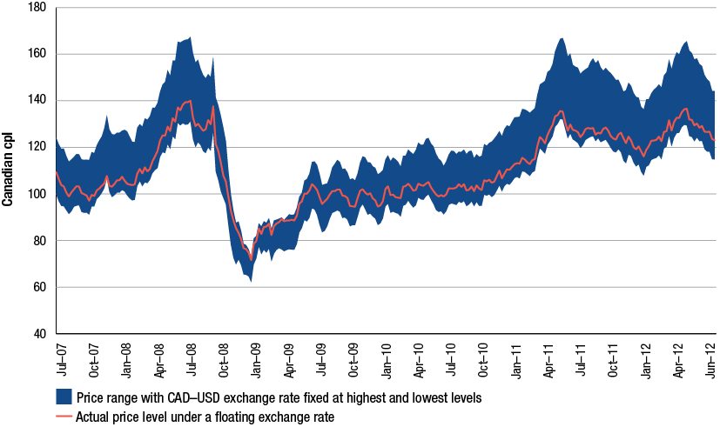
Source: ACCC calculations based on data from US EIA, US Federal Reserve Bank, Natural Resources Canada
Over the same period, the value of the Euro (EUR) against the USD has ranged from a peak of almost USD 1.60 just prior to the Global Financial Crisis (GFC) in April 2008, to a low of around USD 1.20 in June 2010 and again in June 2012. Chart 11.8 shows actual retail petrol prices in Germany as well as what the price of petrol would have been had the highest or lowest EUR–USD exchange rate been held constant over the five years to June 2012, all else being equal.
In contrast to the Australian and Canadian cases, where in particular the AUD has remained at relatively strong levels against the USD in recent years, the EUR–USD rate has not shown the same pattern. The value of the EUR has on many occasions weakened against the USD, largely through economic uncertainty in the Eurozone, and has as a result had less favourable effects on German petrol prices than the Australian and Canadian currencies have had on their domestic petrol prices.
During 2012, the weaker EUR–USD rate, in conjunction with higher crude oil prices, has put upward pressure on fuel prices across Europe and led to Germany’s average petrol pump price reaching an all time high in August 2012, surpassing the previous high seen in April 2012.
Chart 11.8 Weekly retail price movements of Euro-Super 95 petrol in Germany based on actual and five-year minimum and maximum EUR–USD exchange rates: July 2007 to June 2012
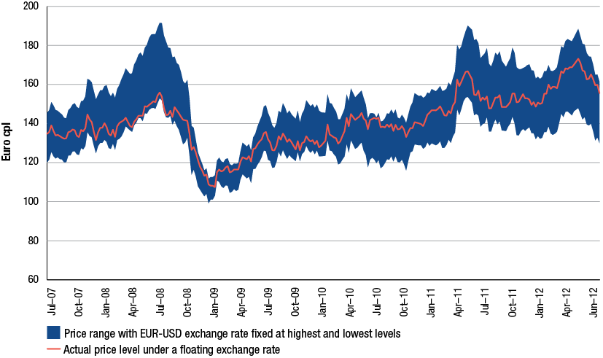
Source: ACCC calculations based on data from Bloomberg, US Federal Reserve Bank, European Commission
  - Components of petrol prices
The composition of Australian petrol prices is covered in detail in chapters 6 and 8. Essentially, the retail price of petrol in Australia is a combination of:
- the cost of crude oil
- taxes
- other costs and margins in the refinery, wholesale and retail sectors.
Chart 11.9 provides the components of annual average Australian retail RULP prices over the seven years to 2011−12. The cost of crude oil represents the largest component, followed by taxes, which together account for the bulk of the price of RULP in Australia. In 2011−12 the average price of RULP was the 142.8 cpl, the highest on record, with the cost of crude oil contributing over 50 per cent.
Chart 11.9 Australian components of retail RULP prices across the five largest cities: 2005−06 to 2011−12
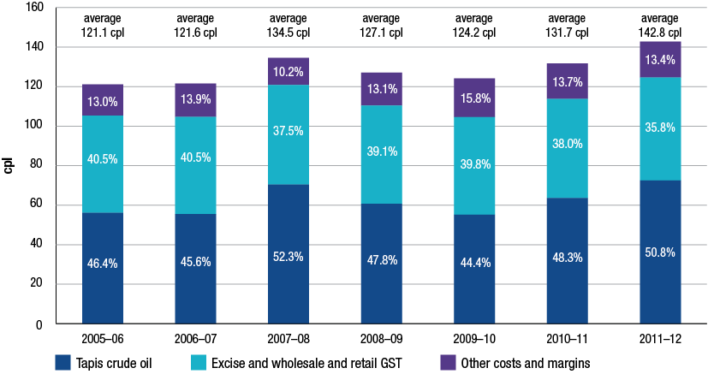
Source: ACCC calculations based on data from Informed Sources, Platts, RBA, WA FuelWatch data and information provided by monitored companies
Note: Annual averages are calculated from daily data.
The cost of crude oil and taxes also appear to make up the majority of the price of petrol in other countries, although their specific contribution varies from country to country. Charts 11.10 and 11.11 show the components of petrol prices in Canada and Germany respectively from 2005−06 to 2011−12.
Chart 11.10 Canadian components of retail regular unleaded gasoline prices in 10 major cities:
2005−06 to 2011−12
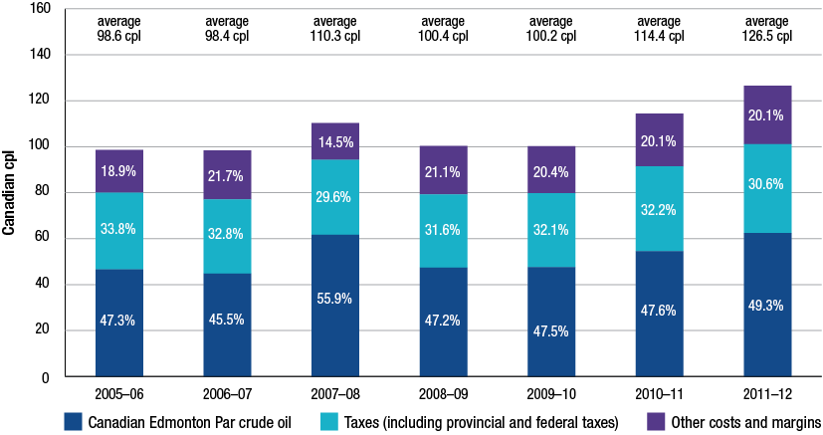
Source: ACCC calculations based on data from MJ Ervin & Associates
Note: Annual averages are calculated from monthly data.
Chart 11.11 Components of retail Euro-Super 95 petrol prices in Germany: 2005−06 to 2011−12
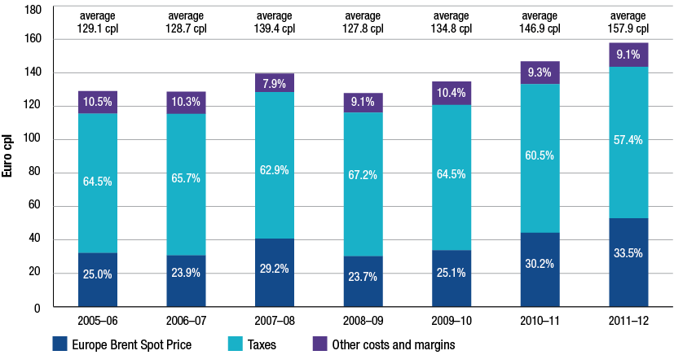
Source: ACCC calculations based on data from US EIA, US Federal Reserve Bank and the European Commission
Note: Annual averages are calculated from weekly data.
Similar to Australia, the cost of crude oil also represents the largest component of the retail pump price in Canada, while taxes also contribute a significant portion of the final price.
In Germany the final pump price shows a slightly different mix of components. Taxes account for the largest component of retail prices, contributing over 57 per cent of the retail price in 2011−12, reflecting higher fuel taxation regimes throughout most of Europe. Because of the larger tax component in European countries, the cost of crude oil represents a relatively smaller but substantial component of the retail price.
Despite the differences in the level of fuel taxes across Australia, Canada and Germany, a number of features are common across these countries:
- the cost of crude oil and taxes make up the bulk of the price of petrol
- taxes are relatively stable over time leaving movements in petrol prices largely driven by changes in the cost of crude oil
- in 2011−12 the average price of petrol in each country reached their highest levels.
    - Petrol price components around the world in 2011−12
Chart 11.12 shows the components of average retail prices for 2011−12 across the six countries considered in this chapter after all prices have been converted to AUD.
While the final retail price of petrol differs in each country, the key driver of these differences is the level of taxation applied to the price of petrol.
Chart 11.12 Components of annual average retail petrol prices in Australia, California, Canada, New Zealand, Germany and the UK on an Australian cpl basis: 2011−12
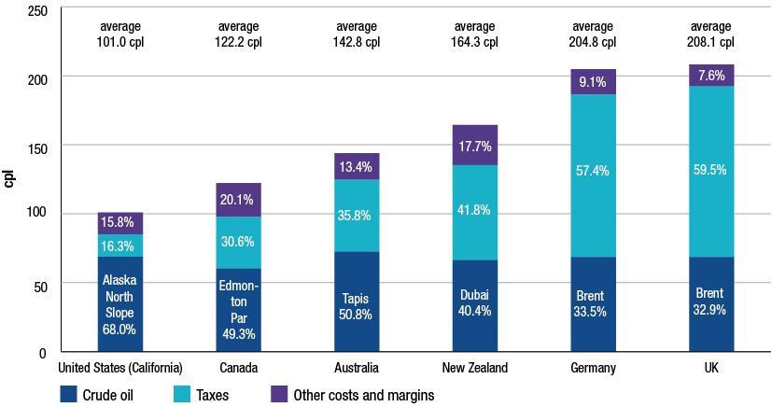
Source: ACCC calculations based on data from RBA, Informed Sources, Platts, California Energy Commission, MJ Ervin & Associates, US EIA, European Commission, information provided by the monitored companies and the New Zealand Ministry of Business, Innovation and Employment, see http://www.med.govt.nz/sectors-industries/energy/liquid-fuel-market/weekly-oil-price- monitoring (Crown copyright)
Note: Fuel types shown in this chart are those described throughout section 11.2.1 and vary from country to country. The basis of weekly retail prices shown varies across countries. Details of retail price data collection methodologies can be found in notes to charts 11.1 to 11.6.
As a variety of crude oil benchmarks are adopted in different parts of the world, the exact crude component applicable to local retail markets also differ. In Australia, the crude component is based on Tapis crude oil, which trades at a small premium to many other types of crude due to its light and sweet properties. Other heavier crudes such as Dubai and Edmonton Par generally trade at a slight discount.
Nevertheless, even when adjusting for exchange rate movements and converting foreign prices to AUD, the size of the crude oil component is largely similar across these countries.
  - Petrol price cycles: overseas evidence
The regular petrol price cycles evident in the five largest capital cities, as well as a small number of regional locations across Australia, have a significant impact on day-to-day prices. Chapter 10 discusses Australia’s experience with petrol price cycles in detail, showing that retail petrol prices can cycle by 15 cpl or more over the course of a week.
Evidence from overseas indicates that these short-term cyclical movements in petrol prices are not limited to Australian markets.
The 2011 ACCC petrol monitoring report noted similar, but not identical, cyclical petrol price movements in a number of German cities where fuel prices regularly moved up and down a number of times within a week. A number of studies have also identified petrol price cycles in other countries, including in the US, Canada and Norway.
Chart 11.13 shows an index of price movements of regular grade petrol in two cities in North America: Indianapolis in the US Midwest and Montreal in Canada. The chart covers a 12-month period to the end of March 2012 where prices move in the familiar sawtooth pattern associated with price cycles, although not at the same frequency.
Chart 11.13 Index of daily average prices of regular grade petrol in Indianapolis and Montreal:
1 April 2011 to 31 March 2012
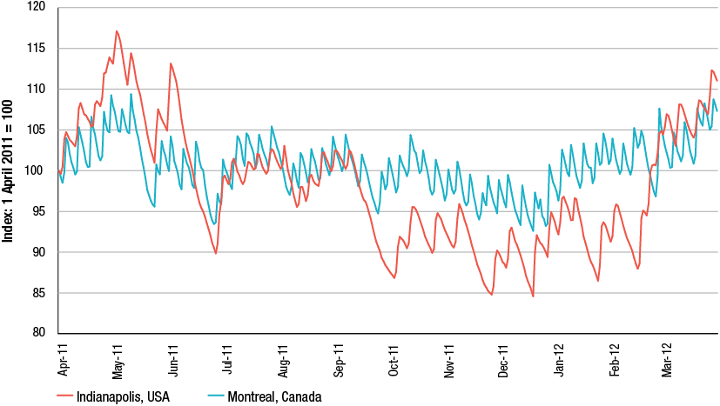
Source: Oil Price Information Service (OPIS)
In Indianapolis, price changes appear to be less regular, but more pronounced. This may result from lower fuel taxes applied in the US, with retail petrol prices therefore reflecting volatility in crude oil and petroleum benchmark prices to a greater extent.
Price movements in Montreal appear to be more regular and bear a closer resemblance to those in the large Australian cities. Chart 11.14 compares changes in daily average retail prices in Montreal and Sydney over the same period.
Chart 11.14 Index of daily average prices of regular grade petrol in Montreal and Sydney:
1 April 2011 to 31 March 2012
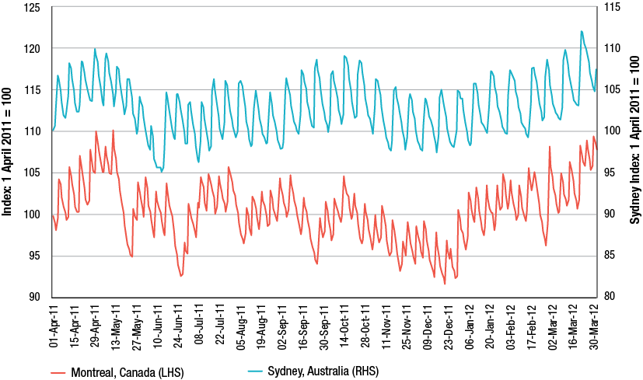
Source: OPIS and Informed Sources
While day-to-day petrol price movements and cycling behaviour seen in Montreal shows a similarity with that observed in Sydney, the extent of price movements differs. The Sydney price cycles appear, on average, to be more regular and exhibit larger amplitudes compared with those in Montreal.
  - Australian petrol prices compared to other countries
The Bureau of Resources and Energy Economics (BREE) publishes a ranking of Australia’s petrol, diesel and LPG prices relative to prices of other countries in the OECD. Chart 11.15 shows the retail price of petrol among countries in the OECD both including and excluding the tax component.
The chart shows that Australia has the fourth lowest petrol prices in the OECD.
Chart 11.15 Petrol prices and taxes in OECD countries: June quarter 2012
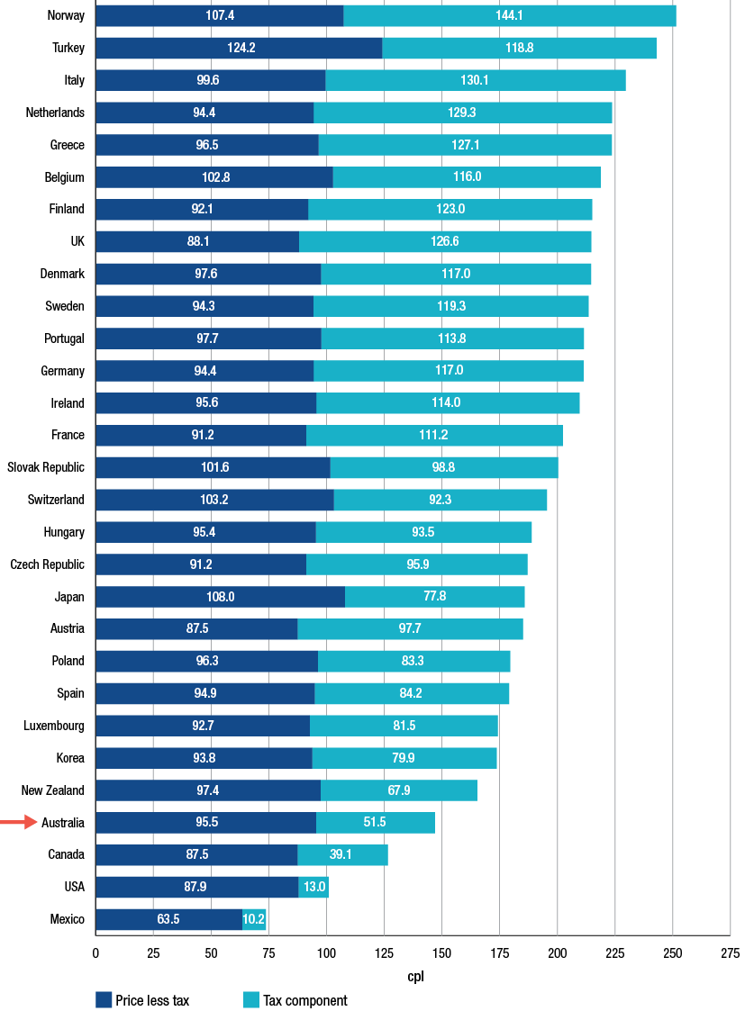
Source: BREE, Australian Petroleum Statistics, issue no.194, September 2012
Similarly, the price of diesel and LPG in Australia also compares well with other OECD countries. Charts 11.16 and 11.17 shows that Australian retail diesel prices are the fifth lowest in the OECD while LPG prices are the lowest in the OECD.
Chart 11.16 Diesel prices and taxes in OECD countries: June quarter 2012
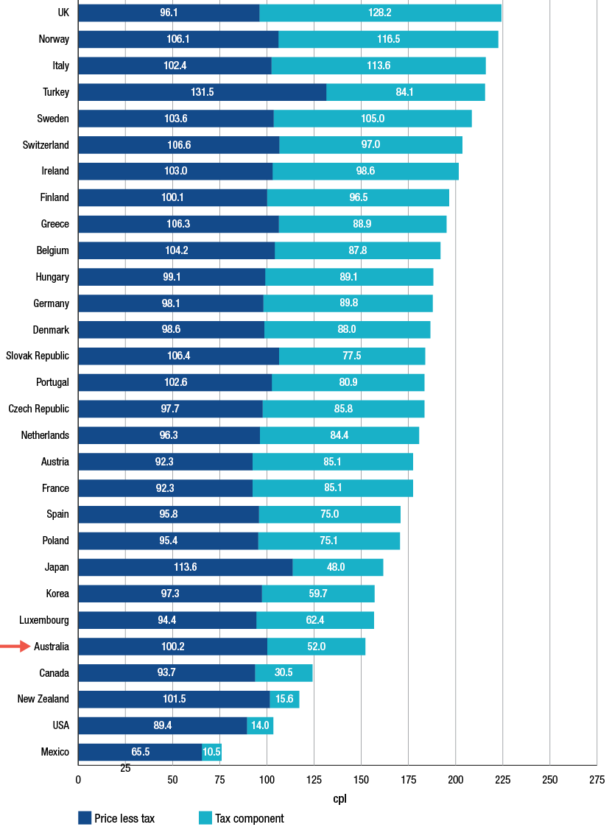
Source: BREE, Australian Petroleum Statistics, issue no. 194, September 2012
Chart 11.17 LPG prices and taxes in OECD countries: June quarter 2011
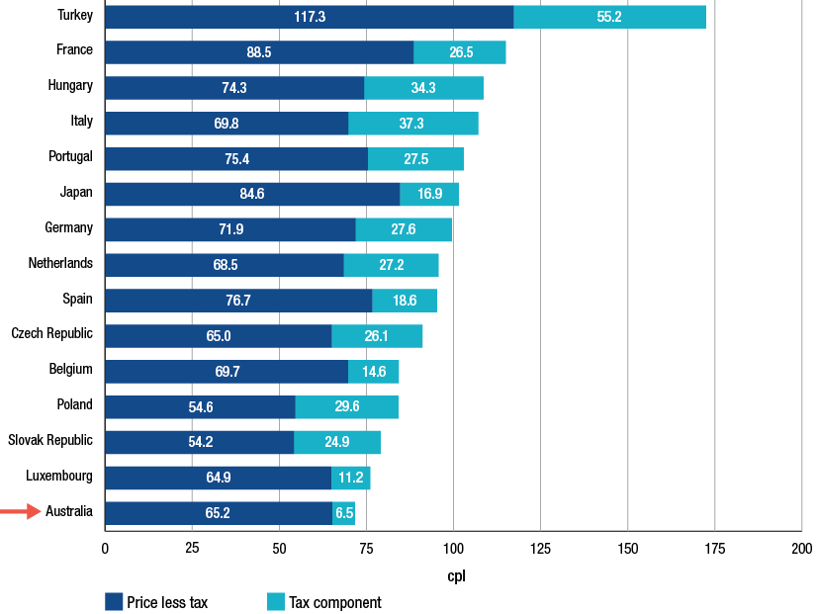
Source: BREE, Australian Petroleum Statistics, issue no. 194, September 2012
  - Conclusions
Australia’s experience in petrol pricing is in many respects not unique. A number of fundamental elements of the Australian petrol pricing experience are also seen in Canada, the US, New Zealand, Germany and the UK:
Retail petrol prices appear to be driven by and track movements in relevant international crude oil and petroleum benchmark prices.
Changes in the exchange rate of local currencies against the USD appear to have an effect on retail prices. While this has continued to benefit Australian motorists in 2011−12, exchange rate influences do not appear to have been uniform across all the countries considered in this chapter.
The price of crude oil and taxes make up the majority of the final retail petrol price.
Price cycles and other day-to-day movements in retail petrol prices are also evident in a small number of overseas markets. Evidence suggests that there are forms of price cycles in some Canadian and US cities as well as in Germany, although Australian price cycles appear be more regular and have a larger amplitude.
Taxes on fuel prices largely differentiate the level of retail petrol prices in countries highlighted in this analysis, while movements in crude oil and petroleum benchmark prices are key drivers of weekly, monthly and annual changes in retail prices.
While the behaviour and composition of petrol prices in Australia is similar to countries considered in this chapter, in 2011−12 Australia had the fourth lowest retail petrol prices, the fifth lowest diesel prices, and the lowest LPG prices in the OECD, principally due to lower taxation on fuel.

- Financial performance of the downstream petroleum industry
Key points
- Profits for the Australian downstream petroleum industry are volatile and in 2011−12 fell by 81 per cent to $408 million or 0.46 cents per litre.
- This compares with a net profit of $2171 million or 2.54 cpl in 2010−11.
- The industry sold 90 billion litres of petroleum products in 2011−12, earning $79 billion in revenue.
- In 2011−12 petrol products (that is, RULP, PULP and EBP) recorded a loss of $9.5 million, down 101 per cent from 2010−11.
- Regular unleaded fuels recorded a loss of $167 million, compared with a profit of $289 million in 2010−11.
- Premium unleaded fuels earned a profit of $213 million in 2011−12, compared with a profit of $450 million in 2010−11.
- EBP products lost $56 million in 2011−12 after a profit of $68 million the previous year.
- Diesel profits were $8 million in 2011−12, compared with a $764 million profit in 2010−11.
- Sectoral profitability was mixed during 2011−12:
- The total supply sector recorded a loss of $1116 million (within the total supply sector, the refinery sector recorded a net loss of $596 million, down 271 per cent from the previous year).
- The wholesale sector earned a net profit of $1084 million during 2011−12.
- The retail sector earned a net profit of $440 million in 2011−12.

  - Introduction
This chapter reports on the consolidated revenues, costs and profits of the entire Australian downstream petroleum industry. The Australian downstream petroleum industry consists of three sectors: total supply (of which the refinery sector is a sub-sector), wholesale and retail. The revenues, costs and profits of individual sectors are assessed in chapters 13 and 14.
As well as reporting total revenues, costs and profits of the industry, this chapter also reports on the revenues, costs and profits associated with the supply of individual petrol products, as specified by the Minister’s direction of 9 May 2011. Petrol products include regular unleaded petrol (RULP), premium unleaded petrol (PULP) and ethanol blended petrol (EBP). Financial data is collected on a historical cost basis on established templates by product and by sector. Section 12.9 provides details of the ACCC’s data collection process and methodology.
  - Overview of financial performance of the downstream petroleum industry
Key observations on revenues, costs and profits across all products and industry sectors in the entire downstream petroleum industry for 2011−12 include:
- total revenue for the industry was $79 billion, up 17 per cent on the previous year
- total sales volumes were 90 billion litres representing an increase of 5 per cent on the previous year
- total net profits (adjusted EBIT) for the industry decreased by 81 per cent to $408 million relative to the previous year. Unit net profits were 0.46 cents per litre (cpl), a fall of 82 per cent on the previous year.
Key observations on revenues, costs and profits associated with petrol products (that is RULP, PULP and EBP), for 2011−12 include:
- total revenue on petrol products was $33 billion, up 14 per cent on the previous year
- total sales volume of petrol products was 37 billion litres representing an increase of 1 per cent on the previous year
- net profits on petrol products for the industry decreased by 101 per cent to a loss of $9.5 million. Unit net petrol losses were 0.03 cpl.
Table 12.1 shows sales volumes, revenues and net profits for the total downstream industry, for all products, for petrol products and for diesel.
Table 12.1 Sale volumes, revenues and net profits in the downstream petroleum industry:
2011−12 and average for 2002−03 to 2011−12
 |  | 2011−12 | 2002−03 to 2011−12 average
All products | Sale volumes (ML) | 89 581 | 79 925
All products | Total revenue ($ million) | 79 246 | 55 357
All products | EBIT ($ million) | 408 | 1 452
All products | Unit EBIT (cpl) | 0.46 | 1.82
Petrol products  (RULP, PULP and EBP) | Sales volumes (ML) | 37 430 | 36 314
Petrol products  (RULP, PULP and EBP) | Total revenue ($ million) | 32 506 | 24 359
Petrol products  (RULP, PULP and EBP) | EBIT ($ million) | −9.5 | 518
Petrol products  (RULP, PULP and EBP) | Unit EBIT (cpl) | −0.03 | 1.43
Diesel | Sales volumes (ML) | 35 305 | 27 195
Diesel | Total revenue ($ million) | 29 969 | 18 957
Diesel | EBIT ($ million) | 8 | 638
Diesel | Unit EBIT (cpl) | 0.02 | 2.42

Source: ACCC calculations based on data obtained from firms monitored through the ACCC’s monitoring process
Revenues and profits on diesel have traditionally been a significant contributor to overall industry revenues and profits. However, during 2011−12, while diesel revenue grew 22 per cent to $30 billion, diesel profits declined by 99 per cent to $8 million. In 2011−12 diesel products contributed 2 per cent to total industry profits after having contributed 35 per cent of total profits in 2010−11.
  - Revenues, costs and profits in the downstream industry: all products
This section details the revenues, costs and profits associated with all petroleum related activities in the Australian downstream petroleum industry.
The downstream petroleum industry derives its income from a variety of sources. These include the refining of crude oil into automotive fuels and other products; revenue from the on-selling of these refined products to the commercial sector; revenue from the on-selling of fuel to the public; and revenue from selling products at convenience stores (attached to retail sites).
    - Revenues and costs, all products
Chart 12.1 shows total revenues and costs for all products and services and for all monitored firms for the period 2002−03 to 2011−12.
Chart 12.1 Downstream industry revenues and costs, all products: 2002−03 to 2011−12
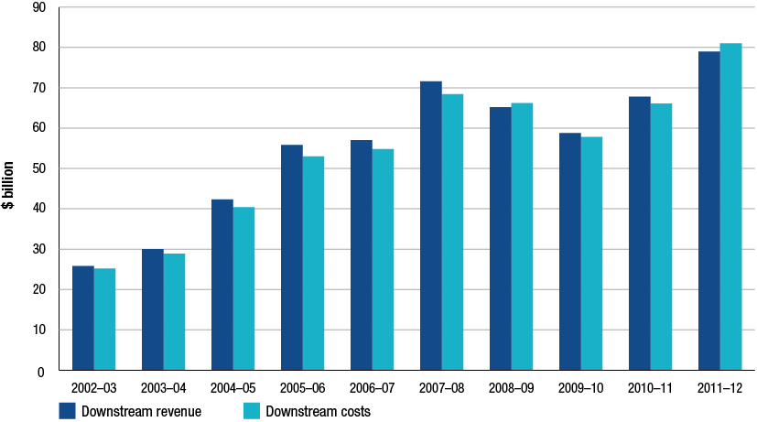
Source: ACCC calculations based on data obtained from firms monitored through the ACCC’s monitoring process
Note: Included in total costs are all expenses including impairment, amortisation and profit or loss on the sale of assets. These items are excluded from net profit calculations.
Key observations on total industry revenue and costs for 2011−12 include:
- total revenues and costs increased to around $79 billion and $81 billion respectively. These increases are largely associated with higher prices for petroleum products sold and with increases in total volumes sold of around 4.7 per cent
- total revenues reported for 2011−12 exceed the levels seen prior to the global financial crisis (GFC)
- unit revenue and unit costs for 2011−12 were 88.5 cpl and 90.5 cpl respectively.
    - Total and unit net profits, all products
Total net profits
One of the key performance indicators used to monitor the profitability of the downstream petroleum industry has been adjusted EBIT in aggregate and as a unit measurement. Further detail on this KPI and others used in the three financial chapters can be found in section 12.9.
Adjusted EBIT measures profits from the operating performance of monitored firms. This profitability measure can be volatile due to the variable effects of changing prices of crude oil and refined petrol and also changes in the AUD–USD exchange rate (see section 12.9.1).
As adjusted EBIT measures profits associated with the operating performance of monitored firms, it excludes costs and revenues associated with activities that are one-off and not part of their normal business operations. The most relevant expense exclusion from adjusted EBIT has been impairment costs associated with a re assessment of the future earnings potential of refinery assets. Thus, the 2011−12 profit data excludes Caltex’s write down of the value of its refinery assets with a $1.5 billion impairment expense charge and also Shell’s $638 million impairment charge against its Geelong refinery. Both Caltex and Shell have reported these charges as a loss of value of their refinery assets due to the effects of competition from more efficient refineries in the Asia-Pacific region.
Chart 12.2 shows net profit, or adjusted EBIT, for all products for all monitored firms from 2002−03 to 2011−12.
Chart 12.2 Downstream industry net profit, all products: 2002−03 to 2011−12
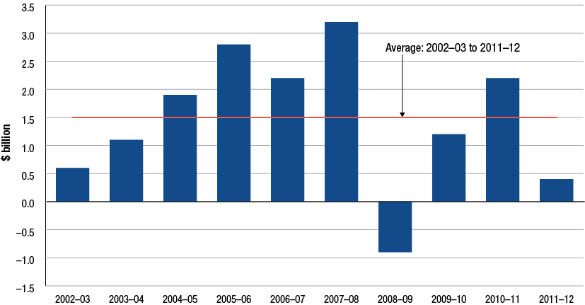
Source: ACCC calculations based on data obtained from firms monitored through the ACCC’s monitoring process
Key observations on total industry net profit for 2011−12 include:
- adjusted EBIT for the entire downstream petroleum industry was $408 million, representing a decrease of 81 per cent from profits earned in 2010−11.
- this result was affected by losses of around $600 million in the refinery sector.
- the refiner-wholesalers’ contributed no profits to the downstream industry’s 2011–12 profits (after contributing 85 per cent of total profits in 2010−11). The refiner-marketers recorded a net loss in 2011−12 of $3.3 million. Businesses only operating in the retail sector increased their share of total net profits to 78 per cent, compared with 13 per cent the previous year.
Unit net profit
Unit net profit is derived by dividing total net profit by total volume. This measure is presented in terms of cents per litre (cpl). Key observations on unit net profit for the entire downstream industry include:
- average unit net profit for 2011−12 was 0.46 cpl, down from the 2010−11 unit net profit of 2.54 cpl
- an analysis of unit net profit by type of company in 2011−12 shows the refiner-wholesalers with negative 0.01 cpl, independent wholesalers with 2.28 cpl and firms with only a presence in the retail sector with 2.58 cpl
- the average annual unit net profit for the downstream industry from 2002−03 to 2011−12 has been around 1.8 cpl.
Chart 12.3 displays unit net profit for all monitored companies for the period 2002−03 to 2011−12.
Chart 12.3 Downstream industry unit net profit, all products: 2002−03 to 2011−12
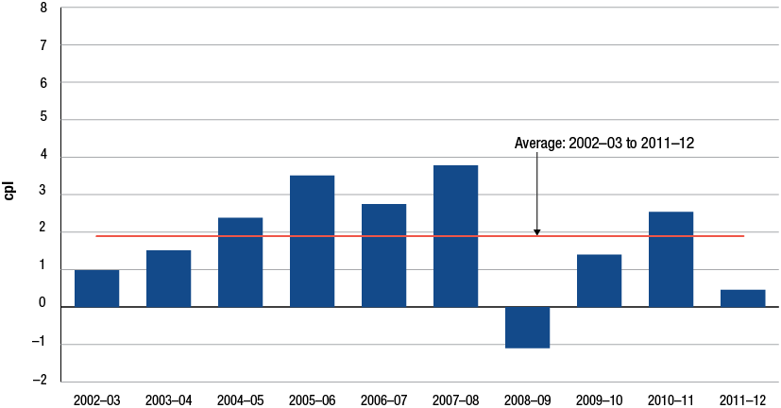
Source: ACCC calculations based on data obtained from firms monitored through the ACCC’s monitoring process
    - Other key performance indicators
The ACCC utilises a number of other profit KPIs to assess the performance of the downstream petroleum industry. Established and common accounting measures to assess profitability and included in this analysis are return on sales (adjusted EBIT divided by total sales), return on assets (adjusted EBIT divided by total adjusted assets) and capital expenditure. For further information on these KPIs see Box 12.1 at the end of this chapter. Note that recent substantial write downs of values of refinery assets by two of the monitored companies have impacted total industry asset values and return on assets.
Key observations regarding these profit KPIs for the downstream industry during 2011−12 include:
- return on sales (RoS) decreased to 0.5 per cent (down from 3.2 per cent in the previous year).
- refiner-wholesalers recorded the lowest RoS with negative 0.01 per cent. The independent wholesalers’ RoS was 2.4 per cent while RoS for those companies with only a retail presence was also 2.4 per cent.
- average RoS for the period 2002−03 to 2011−12 was 2.6 per cent.
- return on assets (RoA) for the industry decreased to 1.96 per cent (down from the 10.3 per cent in the previous year).
- the largest RoA by type of firm was earned by those companies with only a retail presence with a RoA of 24 per cent. The refiner-wholesalers’ RoA was negative 0.02 per cent and independent wholesalers’ RoA was 12.6 per cent.
- average RoA for the period 2002−03 to 2011−12 was 8.7 per cent.
Chart 12.4 displays these profit KPIs for the period 2002−03 to 2011−12.
Chart 12.4 Downstream industry return on sales and return on assets, all products: 2002−03 to 2011−12
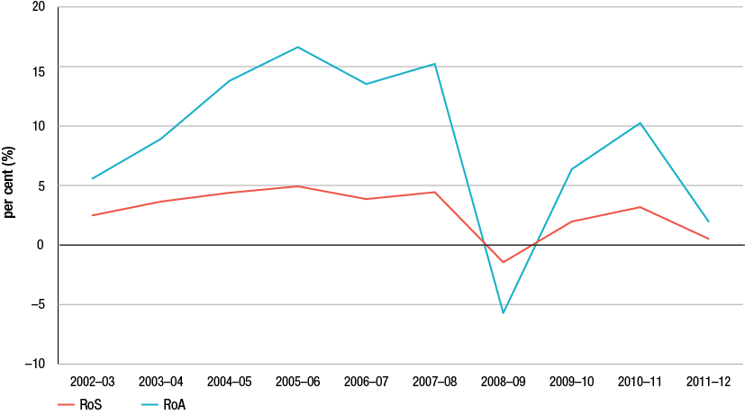
Source: ACCC analysis based on data obtained from firms monitored through the ACCC’s monitoring process
Chart 12.5 presents total annual industry capital expenditure and compares this to total adjusted EBIT for the years 2002−03 to 2011−12. Key observations from chart 12.5 include:
- total capital expenditure for 2011−12 was around $1.1 billion or approximately 2.8 times adjusted EBIT
- capital expenditure levels have ranged from a low of $467 million in 2002−03 to a high of $1.28 billion in 2007−08
- average annual capital expenditure from 2002−03 to 2011−12 has been around $923 million per year or about 64 per cent of EBIT per year.
Chart 12.5 Downstream industry capital expenditure and adjusted EBIT, all products: 2002−03 to 2011−12
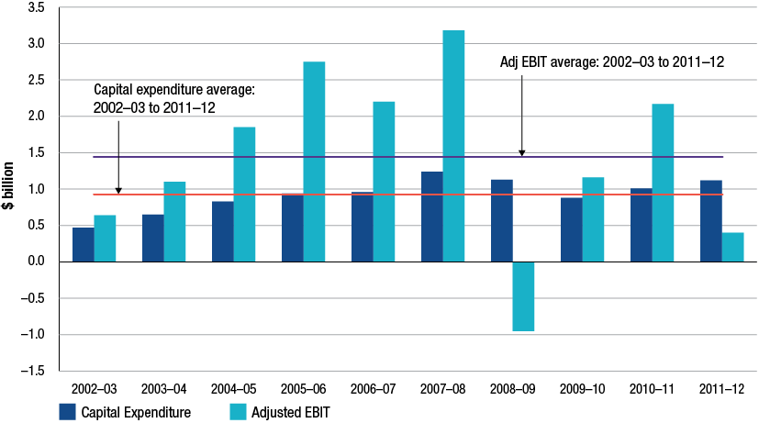
Source: ACCC analysis based on data obtained from firms monitored through the ACCC’s monitoring process
  - Revenues, costs and profits in the downstream industry: petrol products
As per the minister’s direction of 9 May 2011, the ACCC has reported on the revenues, costs and profits of petrol products. This section presents KPIs on petrol products for the downstream petroleum industry. As noted, petrol products are RULP, PULP and EBP.
The methodology used to allocate expenses and estimate individual product profits is discussed in section 12.9.
    - Revenues and costs, petrol products
Chart 12.6 shows the total revenues and costs of petrol for all monitored firms for the years 2002−03 to 2011−12. Key observations on total industry revenue and costs relating to petrol products include:
- total revenue on petrol products increased 14 per cent in 2011−12 to $32.5 billion while total costs increased by 20 per cent to $33.5 billion
- this increase in revenues is largely due to increased prices for petrol products and an increase in volumes of 0.8 per cent. Increases in total costs are due to higher purchase prices and higher operating/conversion costs.
Chart 12.6 Downstream industry revenues and costs, petrol products: 2002−03 to 2011−12
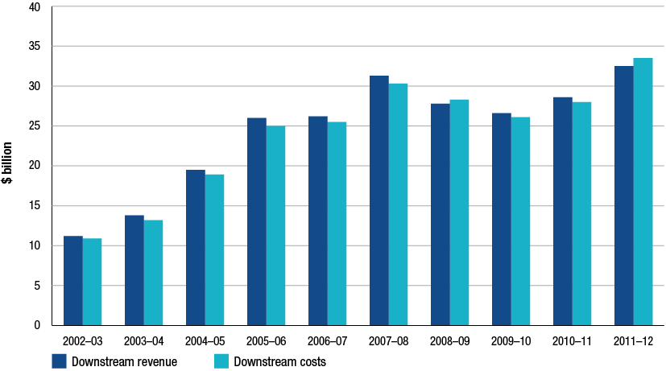
Source: ACCC calculations based on data obtained from firms monitored through the ACCC’s monitoring process
    - Total and unit net profits, petrol products
Total net profits
Chart 12.7 displays net profit on petrol products for all monitored companies, for the years 2002−03 to 2011−12. Key observations on industry petrol profits include:
- petrol products recorded a net loss of $9.5 million in 2011−12, after earning net profits of $807 million in 2010−11
- the average annual petrol profit over the time series has been around $518 million.
Chart 12.7 Downstream industry net profit (adjusted EBIT), petrol products: 2002−03 to 2011−12
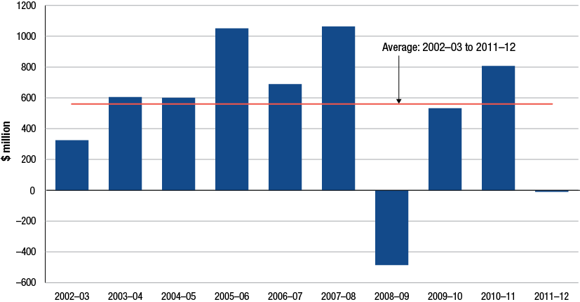
Source: ACCC calculations based on data obtained from firms monitored through the ACCC’s monitoring process
Unit net profit
Chart 12.8 displays unit net profit for petrol products for all monitored companies from 2002−03 to 2011−12. Key observations from the chart include:
- unit net losses for petrol products in the downstream industry was −0.03 cpl in 2011−12 compared with a unit net profit of 2.18 cpl in 2010−11
- average annual unit net profit for petrol products over the time series has been estimated to be around 1.4 cpl.
Chart 12.8 Downstream industry unit net profit, petrol products: 2002−03 to 2011−12
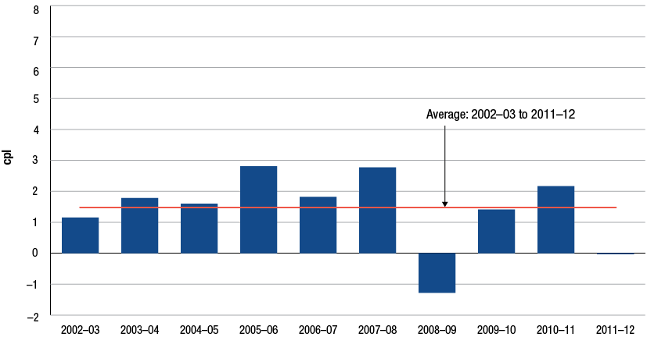
Source: ACCC calculations based on data obtained from firms monitored through the ACCC’s monitoring process
    - Motorist’s perspective profits, petrol products
Due to complexities associated with the way that data is collected and reported in a conventional accounting framework, it is not possible to arrive at a precise measure of profits contributed by motorists. The ‘motorist’s perspective’ profit is an estimate of profit contributed by motorists to the industry with each litre of petrol purchased. It is calculated by estimating each sector’s (total supply, wholesale and retail) profit or loss taking into account the revenues and costs in that particular sector. The motorist’s perspective KPI was introduced in 2009 to provide a consumer’s perspective to average profit that motorists would pay at the retail level for each litre of petrol products purchased.
KPIs discussed in previous sections present financial KPIs such as adjusted EBIT and return on assets derived from data based on standard Australian accounting principles. These KPIs represent financial results for all activities and for petrol products alone from the firm’s or shareholder’s perspective. These KPIs also reflect the results of transactions between petrol companies and all of their customers. This includes overseas purchasers, other refiner-wholesalers, wholesalers, commercial customers and retail customers and motorists.
The accounting system developed for the ACCC petrol monitoring programme was designed to capture data for companies operating in different sectors of the industry, as though each sector was a stand-alone enterprise. Some of these firms are integrated into different sectors. Furthermore, some of the firms transact internally across sectors. This means that a given volume of petrol may feature in the final results more than once.
The motorist’s perspective profit is a measure of the sum of the unit net profits in each sector as a stand-alone business. This measure ignores inter-sector volume transfers.
Chart 12.9 displays unit net profit from a motorist’s perspective from 2002−03 to 2011−12. Key observations from the chart include:
- in 2011−12, unit net profit from a motorist’s perspective was 1.2 cents per litre, down 72 per cent from 2011−12
- the average annual motorist’s perspective unit net profit over the time series was around 2.4 cents per litre.
Chart 12.9 Motorist’s perspective—downstream industry unit net profits, petrol products:
2002−03 to 2011−12
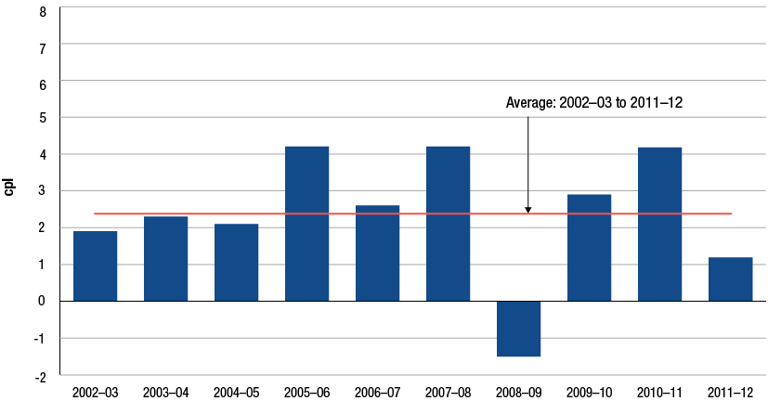
Source: ACCC calculations based on data obtained from firms monitored through the ACCC’s monitoring process
    - Unit net profits by fuel type
Unit net profit in cents per litre has been estimated for each product type. Section 12.9.4 describes the methodology used for splitting costs by product and the caveats on this measure.
Chart 12.10 displays estimates of average unit net profit by fuel type for the years 2005−06 to 2010−11. Key observations from the chart include:
- premium unleaded fuels earned an estimated average annual unit net profit of 3.6 cpl over the time period
- diesel was on average the second most profitable product over the period with average annual unit net profit of 2.5 cpl
- EBP had the lowest average product profitability with an average annual unit net profit of less than half of one cpl.
Chart 12.10 Downstream industry average annual unit net profit, by fuel type: 2005−06 to 2011−12
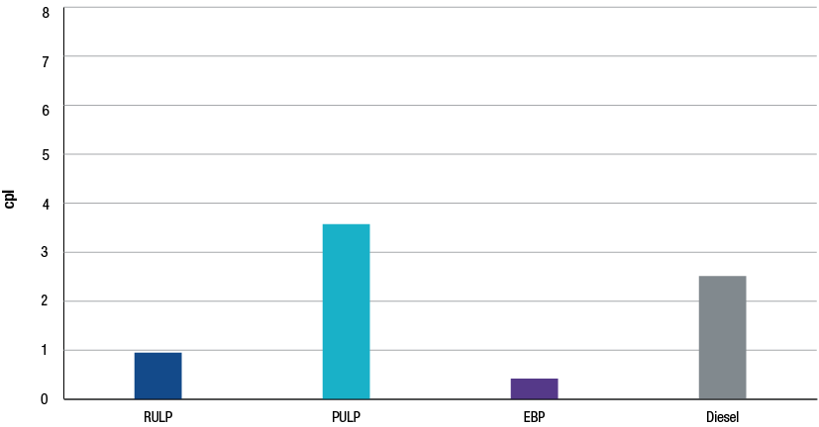
Source: ACCC calculations based on data obtained from firms monitored through the ACCC’s monitoring process
  - Profits by sector: all products
As noted in the introduction to this chapter, the ACCC assesses the downstream industry in its totality and by sector. These sectors include total supply (that is refining, imports and buy sell transactions), wholesale and retail. This section assesses and compares rates of profitability in these sectors. Further detailed financial information on these sectors is presented in chapters 13 and 14.
    - Sectoral net profits, all products
The ACCC collects data for all operations and by sector from the monitored companies. Some companies do not structure their accounts in accordance with the ACCC’s sectoral split. This may mean that in some cases internal allocations and accounting arrangements (especially for the integrated firms) can affect the profit results of individual sectors.
Total net profit by sector is provided in chart 12.11. Key observations from the chart include:
- during 2011−12, the wholesale sector earned net profits of $1.1 billion. Wholesale has been the most profitable sector of the Australian downstream industry in each of the past four financial years
- the retail sector earned $440 million during 2011−12, up 17 per cent from 2010−11
- the refinery sector recorded a loss of $596 million during 2011−12 which is consistent with the trend of low or negative profitability in this sector evident since the GFC. Profitability in the refinery sector has been characterised by contrasting trends over the time series. In terms of net profit, the refinery sector has gone through two distinct phases over the past 10 years, notably a relatively profitable period prior to the GFC and a considerably less profitable period post GFC. Average refiner profits prior to the GFC were $1119 million, in contrast with average profits of negative $156 million since the GFC
- an analysis of inter-sectoral trends on average profitability over the time series shows that the wholesale sector has had the highest average profit of $712 million. The refinery sector was on average the second most profitable sector with $609 million. Note that this refinery average is slightly biased by the relatively high pre-GFC profits.
Chart 12.11 Downstream industry net profits by sector, all products: 2002−03 to 2011−12
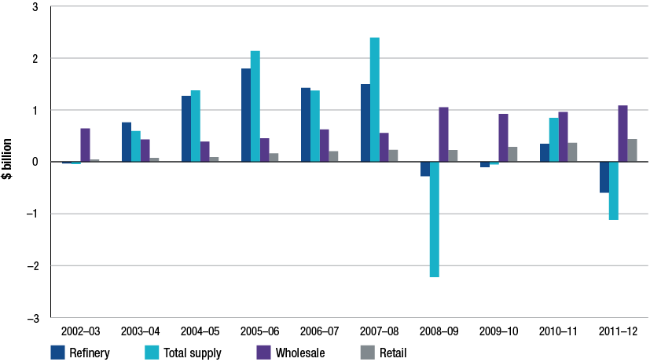
Source: ACCC calculations based on data obtained from firms monitored through the ACCC’s monitoring process
Note: Refinery is a sub-sector of total supply.
    - Sectoral variation with average profit, all products
This section considers each sector’s net profit for 2011−12 relative to its long term annual average.
Chart 12.12 displays the difference between the sectoral profit or loss for 2011−12 from its long term average. For instance, the chart shows that the refining sector’s 2011−12 net profit is $1205 million less than its long term average of $609 million.
Other observations from the chart include:
- the entire downstream petroleum industry recorded a net profit for 2011−12 which was around $1043 million below its long term average
- as was the case in 2010−11, wholesale had the largest net profit differential relative to its long term average. During 2011−12, this was $373 million greater than its long term average
- the retail sector’s net profit for 2011−12 was $228 million above its long term average.
Chart 12.12 Downstream industry—2011−12 net profit by sector relative to the average from 2002−03 to 2011−12
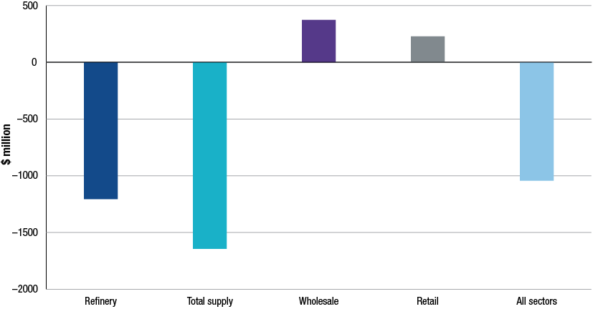
Source: ACCC calculations based on data obtained from firms monitored through the ACCC’s monitoring process
Note: Refinery is a sub-sector of total supply.
    - Sectoral unit net profits, all products
Sectoral unit net profits increased in two sectors during 2011−12. Unit net profit by sector is presented in chart 12.13. Key observations from the chart include:
- during 2011−12 the retail sector had the highest unit net profit with 2.4 cpl, up from 2.1 cpl in 2010−11
- the wholesale sector had the second largest unit net profit in 2011−12 with 2.1 cpl, compared with 2.0 cpl in 2010−11
- average annual unit net profits over the time series show that the refinery sector had the highest unit net profit with 1.6 cpl. This is largely due to the above average annual profits that the refinery sector was earning prior to the GFC
- the retail sector on average had the second lowest average annual unit net profits over the time series with 1.47cpl.
Chart 12.13 Downstream industry unit net profits by sector, all products: 2002−03 to 2011−12
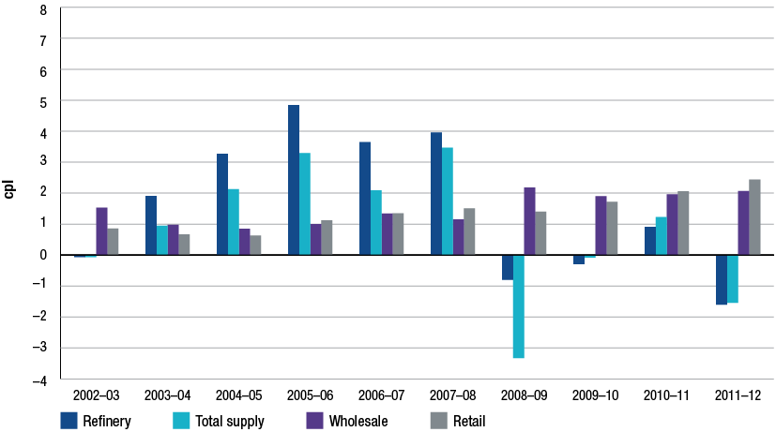
Source: ACCC calculations based on data obtained from firms monitored through the ACCC’s monitoring process
Note: Refinery is a sub-sector of total supply.
  - Profits by sector: petrol products
Section 12.5 detailed profit KPIs for all products by sector. This section provides profit KPIs on petrol products alone that are manufactured and/or sold by monitored companies. Petrol products include RULP, PULP and EBP. Further detailed financial information on these products is presented in chapters 13 and 14.
    - Sectoral net profits, petrol products
Chart 12.14 displays net profit on petrol products for each sector. Key observations from the chart include:
- the retail sector recorded the largest net profit from petrol products with $239 million, up 32 per cent from 2010−11. The retail sector also recorded the largest net petrol profits in 2008−09 when the industry as a whole incurred overall losses of almost one billion dollars
- the wholesale sector had the second largest net profit from petrol products with $159 million during 2011−12, but was down 19 per cent from 2010−11
- an analysis of average annual profits over the time series shows that total supply had the largest annual average profit with $393 million per annum. The wholesale sector on average had the lowest average profits from petrol products with $40 million per annum.
Chart 12.14 Downstream industry, net profits by sector, petrol products: 2002−03 to 2011−12
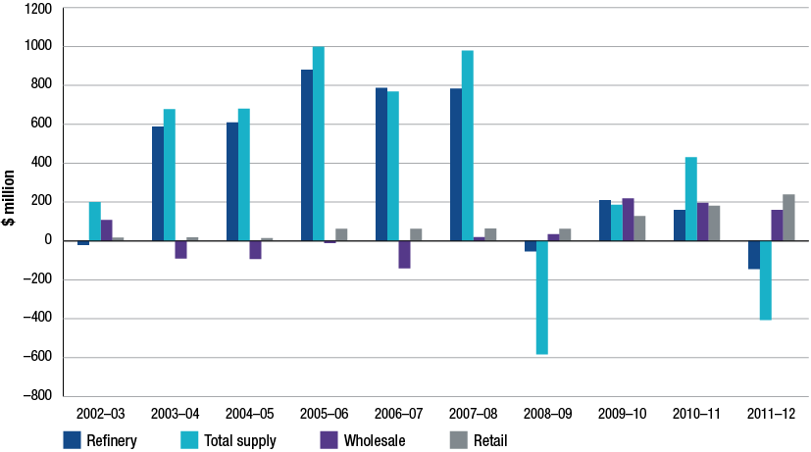
Source: ACCC calculations based on data obtained from firms monitored through the ACCC’s monitoring process
Note: Refinery is a sub-sector of total supply.
    - Sectoral unit net profits, petrol products
This section presents unit net profits by sector. The results are displayed in chart 12.15. Key observations from this chart include:
- the retail sector achieved the largest unit profit on petrol products for 2011−12 with a unit net profit of 1.9 cpl (up 30 per cent on 2010−11)
- the wholesale sector earned 0.9 cpl on petrol products during 2011−12, down 19 per cent on 2010−11
- since 2002−03 the refinery sector achieved the highest average annual unit net profit with 2.4 cpl. Profits earned prior to the GFC were higher than in the post GFC years
- the wholesale sector has the lowest average annual unit net profit over the time series with 0.2 cpl.
Chart 12.15 Downstream industry, unit net profits by sector, petrol products: 2002−03 to 2011−12
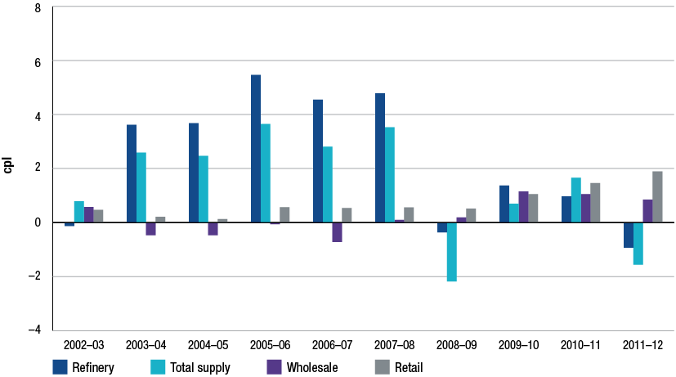
Source: ACCC calculations based on data obtained from firms monitored through the ACCC’s monitoring process
Note: Refinery is a sub-sector of total supply.
  - Comparison of the profitability of the downstream petroleum industry with other industries
As part of its assessment of the profitability of the downstream petroleum industry, the ACCC has compared KPIs for the petroleum industry against other Australian industries.
The benchmark used in previous monitoring reports was the Australian Securities Exchange’s top 200 companies by market capitalisation (ASX200). The same (updated) benchmark has been used for this year’s analysis. The ASX200 is represented by a wide range of industry groups and thus provides a meaningful comparison for the downstream petroleum industry.
A summary of the results of this comparative analysis shows that return on sales (RoS) is relatively low when compared to other Australian industries. This is not unexpected in an industry such as the downstream petroleum industry which is a high-volume and low-margin industry.
Return on assets (RoA) is slightly above the average for the ASX200. Recent writedowns of values of refinery assets by two of the monitored companies have affected the overall result for RoA.
    - Australian comparison: return on sales
The ACCC has calculated rates of return on sales (RoS) for the downstream petroleum industry and for industry groupings derived from the ASX200. The data are an average for the period 2002−03 to 2011−12 and thus present a snapshot of industry profitability over a relatively lengthy period of time. As was the case for many other Australian industries, the downstream petroleum industry was impacted by the GFC.
Chart 12.16 presents average annual rate of RoS for the period 2002−03 to 2011−12. Key observations from the chart include:
- over the period the average annual rate of RoS for the downstream petroleum industry is the lowest among all industry grouping over the time series
- the average RoS for the downstream petroleum industry between 2002−03 and 2011−12 was approximately 2.6 per cent, compared to the ASX average of 18 per cent
- the Australian Bureau of Statistics’ all industry average RoS for all industries for a similar period was 13.3 per cent
- the industry grouping with the average RoS closest to the downstream petroleum industry RoS was ‘Food and Staples Retailing’ with 5.62 per cent.
Comparisons of RoS data for the petroleum industry with other industries should be treated with caution. As noted, the petroleum industry is a high-volume low-margin industry. Firms in this type of industry will generally have a lower RoS than firms in other industries. Furthermore, as the petroleum industry is characterised by volatile prices of both inputs and outputs, the value of sales can be affected by changing price levels with minimal impact on profits.
Chart 12.16 Comparison of return on sales for the downstream petroleum industry, ASX average and ASX top 10 GICS industry groupings (excluding financial and media sectors):
2002−03 to 2011−12 average
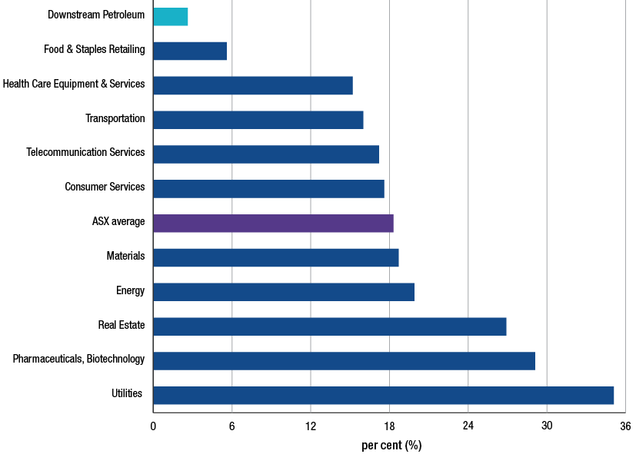
Source: ACCC calculations based on data obtained from firms monitored through the ACCC’s monitoring process and Bloomberg
Note: The list of companies in the ASX200 is as at 1 October 2012. The list of companies is less than 200: for the specific industries, companies with RoS of more than 70 per cent (positive and negative) in any year have been excluded; Caltex has also been excluded. Not all companies have data for all years. Some companies report on a calendar-year or other financial-year basis. Industries are grouped using the Global Industry Classification Standard (GICS) and include at least two companies.
Industry groupings used in the chart above differ from those presented in the 2011 ACCC petrol monitoring report due to changes in their capitalisation aggregates. The list of groupings represented in the chart is from the current top 10 GICS groupings by market capitalisation that were derived from the reduced ASX200 sample. Revisions to historical data and to the composition of the ASX200 mean that comparisons with data in the comparable chart in the 2011 ACCC petrol monitoring report should be treated with caution.
    - Australian comparison: return on assets
This section compares the Australian downstream petroleum industry’s average rates of return on assets (RoA) with the RoA for a number of industry groupings derived from the ASX200.
RoA is a more appropriate profitability KPI than RoS with which to compare firms across industries. Nevertheless, there are a number of caveats concerning this KPI for this industry, including:
- RoA may be influenced by asset evaluation methodologies and accounting depreciation rates
- over the past two years, the downstream petroleum industry has been characterised by large write downs of asset values and impairment charges against four refineries
- some Australian refineries may have assets with an older age profile than the average for other industries. All else equal, this may have the effect of inflating RoA measures in the downstream petroleum industry relative to other industries
- in the Australian refinery sector, the value of assets is not market-based as refinery assets are not generally traded in a liquid market. This complicates comparisons of RoA data with industries where asset values are market-based.
Chart 12.17 presents RoA for the period 2002−03 to 2011−12 and compares the downstream petroleum industry to selected ASX200 industry groupings. Key observations from the chart include:
- over the time series, the average RoA for the Australian downstream petroleum industry was around the median compared to the selected industry groupings. The average RoA for the Australian downstream petroleum industry was around 8.7 per cent while the ASX200 average was 10 per cent
- industry groupings including real estate, utilities, materials, energy and pharmaceuticals had lower rates of return than the downstream petroleum industry.
Chart 12.17 Comparison of average return on assets for the downstream petroleum industry, ASX average and ASX top 10 GICS industry groupings (excluding financial and media sectors):
2002−03 to 2011−12 average
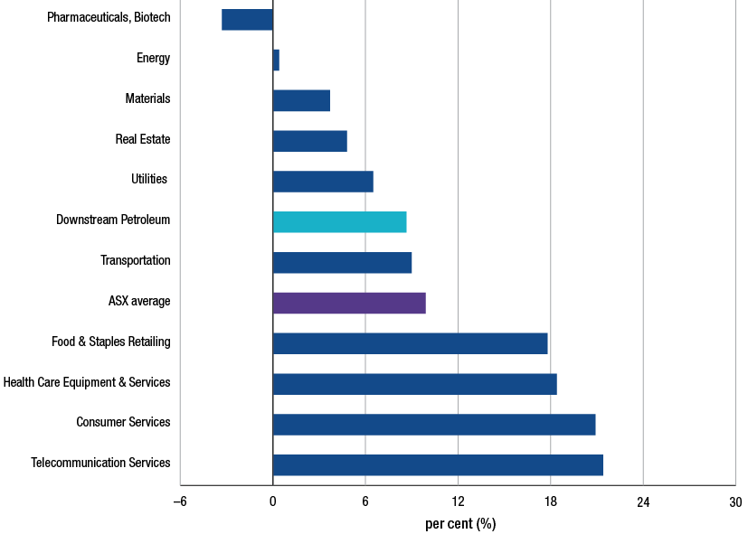
Source: ACCC calculations based on data obtained from firms monitored through the ACCC’s monitoring process, and Bloomberg
Note: The list of companies in the ASX200 is as at 1 October 2012. The list of companies is less than 200: For the specific industries, companies with RoA of more than 70 per cent (positive and negative) in any year have been excluded; Caltex has also been excluded. Not all companies have data for all years. Some companies report on a calendar-year or other financial-year basis. Industries are grouped using the Global Industry Classification Standard (GICS) and include at least two companies.
Industry groupings used in the chart above differ from those presented in the 2011 ACCC petrol monitoring report due to changes in their capitalisation aggregates. The list of groupings represented in the chart is from the current top 10 GICS groupings by market capitalisation that were derived from the reduced ASX200 sample. Revisions to historical data and to the composition of the ASX200 mean that comparisons with data in the comparable chart in the 2011 ACCC petrol monitoring report should be treated with caution.
  - Comparison of the profitability of the Australian downstream petroleum industry with international downstream petroleum companies
The previous section found that the Australian downstream petroleum industry had lower return on sales and comparable return on assets relative to a number of selected Australian industries. This section compares the Australian downstream petroleum industry with overseas downstream petroleum companies.
In the following sections return on sales (RoS) and return on assets (RoA) are used to compare companies in the Australian downstream petroleum industry with similar overseas companies.
A comparative analysis of these KPIs with overseas companies suggests that firms in the Australian downstream petroleum industry earn less on sales than overseas companies, but have similar returns on assets.
    - International comparison: return on sales
RoS for the Australian and international downstream petroleum companies are presented in chart 12.18. RoS is presented yearly and as an average for the period from 2002−03 to 2011−12. Key observations from the chart include:
- the Australian downstream petroleum industry average RoS was just over 2.6 per cent while the average RoS for overseas companies was 3.9 per cent
- for most years, the Australian downstream petroleum industry’s RoS has been below that of comparable overseas firms
- the largest difference between the two groupings occurred in 2008−09 when average RoS for the Australian companies was negative 1.5 per cent compared to 2.0 per cent for international firms.
Chart 12.18 Comparison of rates of return on sales for the downstream petroleum industry in Australia and overseas: 2002−03 to 2011−12
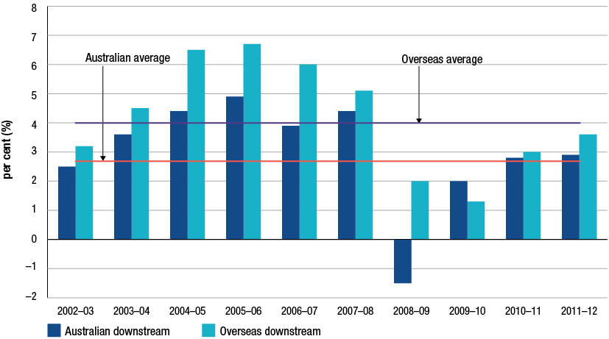
Source: ACCC calculations based on data obtained from firms monitored through the ACCC’s monitoring process, Bureau van Dijk Orbis database, Bloomberg, annual reports and Onesource
Note: Not all companies have data for all years. Overseas companies report on various annual bases. For example, year 2009 has been taken as 2009−10.
The selection of an overseas company was based on the following criteria: the company had to be based in an OECD country; be non–government owned; and have annual turnover greater than USD 10 million. Companies were also screened on the basis of their activity profile to ensure comparability with Australian downstream petroleum companies. That is, they had to derive their income from the refining and marketing of petroleum products. Major international refiner-marketers with large upstream activities such as Exxon Mobil, British Petroleum and Chevron, were excluded from the sample. A company was also excluded if it had significant non-petroleum related secondary activities such as chemical manufacturing or gas related activities. The screening process reduced the size of the sample from more than 70 companies to 29 companies.
    - International comparison: return on assets
Data for return on assets (RoA) for Australian and comparable international companies are presented in chart 12.19. As was the case for RoS, RoA is presented yearly and as an average for the period 2002−03 to 2011−12. The caveats discussed in section 12.7.2 regarding asset valuation also apply in respect of data presented in chart 12.19. In particular, it is likely that Australian refineries have an older asset age profile than some of the refineries included in the international sample. This complicates comparisons of rates of RoA with international companies.
Key observations from chart 12.19 include:
- the Australian downstream petroleum industry’s average RoA was slightly higher than for comparable overseas petroleum companies with RoA of 8.7 and 8.1 per cent respectively
- the Australian downstream petroleum industry achieved a higher RoA for all years except 2008−09
- the largest difference in RoA occurred in 2008−09 when the Australian industry earned an average RoA of negative 5.7 per cent compared with the overseas companies average RoA of positive 5.3 per cent.
Chart 12.19 Comparison of return on assets for the downstream petroleum industry in Australia and overseas: 2002−03 to 2011−12
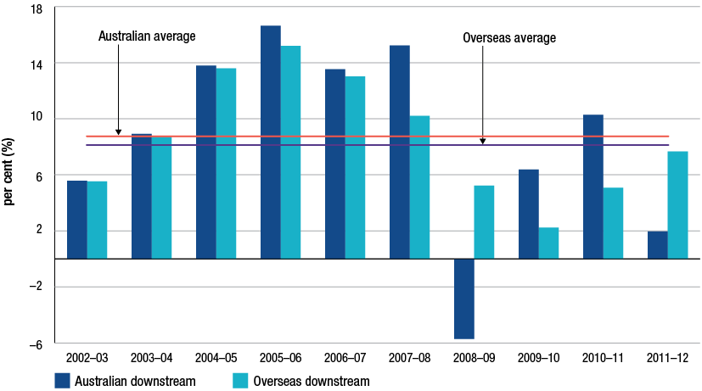
Source: ACCC calculations based on data obtained from firms monitored through the ACCC’s monitoring process, Bureau van Dijk Orbis database, Bloomberg, annual reports and Onesource
Note: Not all companies have data for all years. Overseas companies report on various annual bases. For example, year 2009 has been taken as 2009−10.
The selection of an overseas company was based on the following criteria: the company had to be based in an OECD country; be non–government owned; and have annual turnover greater than USD 10 million. Companies were also screened on the basis of their activity profile to ensure comparability with Australian downstream petroleum companies. That is, they had to derive their income from the refining and marketing of petroleum products. Major international refiner-marketers with large upstream activities such as Exxon Mobil, British Petroleum and Chevron, were excluded from the sample. A company was also excluded if it had significant non-petroleum related secondary activities such as chemical manufacturing or gas related activities. The screening process reduced the size of the sample from more than 70 companies to 29 companies.
  - Methodology note for assessing profitability in the Australian downstream petroleum industry
    - Data variability
Monitoring of the Australian downstream petroleum industry over the last five years has shown that the financial performance of the industry, particularly at the refinery and total supply levels is affected by many factors and can be volatile. Financial performance can also be affected by one-off events.
The operating performance of the downstream petroleum industry is affected by the behaviour of prices of its key inputs and outputs, that is, crude oil and refined petrol products. Crude oil and refined petrol are globally traded commodities and their prices are subject to considerable volatility. As transactions for these commodities are undertaken in USD, changes in the AUD–USD exchange rate can also affect financial outcomes expressed in Australian currency.
At any one time the refinery production and distribution process may involve significant holdings of inventories of both crude and refined products. Changes in commodity prices and the AUD–USD exchange rate can impact on the values of inventory holdings.
The effects of changes in the values of inventory holdings and foreign exchange transactions are reflected in the adjusted earnings before interest and tax (EBIT) data. Only the effects of foreign exchange transactions are reported separately to the ACCC as part of the monitoring of the total supply sector, which is the sector with the greatest exposure to foreign currency fluctuations.
Financial performance can also be affected by one-off events such as impairment charges resulting from re-assessments of assets’ future earnings potential. These costs have been reported separately to the ACCC but as they are not associated with monitored firms’ normal business operations they have been excluded from the calculation of adjusted EBIT.
    - Data collection process
Data presented in all financial chapters was collected from monitored firms through financial data templates established in consultation with the companies. The templates are comprehensive and collect data on revenues and cost of goods sold by product. Monitored companies include: the four refiner-wholesalers, Mobil, Caltex, BP and Shell; independent wholesalers including Neumann Petroleum, United Petroleum, Ausfuel and Liberty Oil; and retailers including 7-Eleven, On the Run, Coles Express and Woolworths Petrol.
    - Data collection methodology
Historical and replacement cost measures
Data collected from monitored companies is on a historical cost basis (as was the case for the past four ACCC petrol monitoring reports). Historical cost accounting records all revenues, costs and profits at the actual or original cost of the transaction. With rising oil prices this can mean companies can earn profits simply because of prices rising between the time the product was purchased and then sold.
Replacement cost on the other hand is a popular measure used in the oil industry by those participants who usually have a refinery operation. This measure excludes the impact of changes in the price of oil and refined products which are seen as external factors impacting profits outside the control of management. By excluding these movements, replacement cost provides a better understanding of actual management performance.
The ACCC collects data based on historical costs for a number of reasons. These include the fact that not all monitored companies report on a replacement cost basis, historical cost accounting is consistent with Australian standards, and finally, it allows the ACCC to compare monitored companies with other Australian and overseas industries.
Long-term perspective in data collection
As noted, crude oil and petroleum prices have traditionally been volatile. As data is collected on a historical cost basis, reported profits can produce large movements in time of substantial price changes. Because of this volatility, the ACCC have collected financial data going back to the 2002−03 financial year so as to provide a long term perspective. In a number of charts, the ACCC have averaged the KPI over this time series so as to smooth out the historical cost profits.
    - Estimation of profits by product or service type
Many costs in the petroleum industry are shared or common among different products. This means that estimating profits by product requires some estimation of individual product costs. The methodology the ACCC has adopted to allocate common costs in the 2012 monitoring report is consistent with that used in previous monitoring reports. Product volumes have been used as a proxy for splitting common costs. The assumption is that costs indirectly associated with refining or selling petrol and other products tend to be proportional to the volumes of these products. This methodology has also been used in respect of the total supply (including refining) and wholesale sectors.
The allocation of costs in the retail sector differs slightly due to the convenience store activities. In the retail sector, common costs are first allocated on the basis of gross profit on petroleum sales and on convenience sales. Costs estimated for petroleum product activities are then further allocated to individual products on the basis of their respective sales volumes.
    - Key performance indicators for assessing the profitability and performance of the downstream petroleum industry
Box 12.1 Key performance indicators
Gross profit: Gross profit is a measure of profit calculated by deducting the costs of goods or services sold from sales revenues. In refining, those costs can include the purchase of crude or refined product, direct labour and factory overheads included in the manufacturing (refining) process and the cost of delivering it to the customer (usually a wholesaler). Note that the gross indicative differences used in the analysis of retail prices (see chapter 8) are based on international benchmark prices for crude oil and refined products, notional import parity prices, published terminal gate prices and average retail prices. As such, they differ from the estimates provided in chapters 12, 13 and 14 which are based on financial information provided directly by the monitored companies.
Gross margin: Gross margin is the ratio of gross profit to sales and indicates how much is left from each dollar of sales after costs of goods sold have been subtracted.
Adjusted EBIT (net profit): EBIT is a common accounting measure of profit and measures the total returns to the firm before interest incomes or expenses and taxes are taken into account. The ACCC uses an adjusted EBIT profit measure. Adjusted EBIT excludes non-operating incomes, amortisation, impairment charges, and profits or losses on sales of fixed assets. This provides a consistent measure of profits from petrol activities and the petroleum industry rather than of total profits of the monitored companies.
Adjusted EBIT to sales (return on sales): The ratio of adjusted EBIT relative to sales revenue calculates the extent to which profit is earned from each dollar of revenue after deducting all relevant operating costs, other than interest and tax.
Return on adjusted total assets (return on assets): The ratio of adjusted EBIT to total assets calculates the extent to which profit is earned relative to assets used in the business. Total assets have been adjusted to exclude deferred tax assets as they are not relevant to an after-tax profit assessment. Intangibles are excluded since those values have not been consistently provided by the monitored companies, and usually arise from the acquisition of other companies (as opposed to growth solely by increasing sales). It is expressed as a percentage of total assets.

- Financial performance of the refinery and total supply sectors
Key points
Refining
- During 2011−12, the Australian refinery sector recorded a net loss of $596 million, or negative 1.6 cents per litre on the sale of all products.
- The refining sector’s total revenue for 2011−12 was $28.9 billion earned on sales of 37.2 billion litres.
- Petrol products recorded a net loss of $145 million in the refinery sector, down on the profit for 2010−11 of $159 million
- among the petrol products, regular unleaded petrol recorded a loss of $231 million in 2011−12
- premium unleaded petrol earned a net profit of $87 million during 2011−12.
Total supply
- The total supply sector recorded a net loss of $1.1 billion during 2011−12, or negative 1.5 cents per litre on all products.
- The total supply sector’s total revenue for 2011−12 was $57 billion earned on sales of 72 billion litres.
- Petrol products recorded a loss of $407 million in 2011−12, compared to profits of $430 million in 2010−11.

  - Introduction
This chapter reports on the financial performance of the Australian refinery and total supply sectors of the downstream petroleum industry for the year ended 30 June 2012.
While the closure of the Shell Clyde refinery in September 2012 reduced the number of refineries operating in Australia to six, the data presented in this chapter is for the financial performance of the seven refineries operating as at 30 June 2012. The refinery sector as at 30 June 2012 consisted of seven refineries operating in all mainland capitals except Adelaide. Each refinery produces a suite of petroleum products from crude oil. The refining environment in Australia, particularly post global financial crisis (GFC) is facing a challenging future with fierce international competition.
For the purposes of financial reporting and monitoring, the refinery sector is considered a sub sector of total supply. The total supply sector includes refining, importing and buy-sell transactions among the refiner-wholesalers.
  - Overview of financial performance in the refinery and total supply sectors
Key observations on revenues, costs and profits in the refinery sector for 2011−12 include (table 13.1):
- total revenue for the refinery sector was $28.9 billion, up 10 per cent on 2010−11. Total petrol revenue was $12.4 billion, up 8 per cent on 2010−11
- the refinery sector recorded a loss of $596 million, compared with a profit of $348 million in 2010−11. The manufacture and sale of petrol products, that is regular unleaded petrol (RULP), premium unleaded petrol (PULP) and ethanol blended petrol (EBP), incurred a loss of $145 million.
Key observations on revenues, costs and profits in the total supply sector for 2011−12 include:
- total revenue for the total supply sector was $57 billion, up 17 per cent from 2010−11. Total petrol revenue was $21 billion, up 14 per cent
- the total supply sector incurred a loss of $1.1 billion, down from the previous year. The net loss on petrol products was $407 million.
Table 13.1 Sales and profits in the refinery and total supply sectors: 2011−12 and average from 2002−03 to 2011−12
 |  |  | 2011−12 | 2002−03 to 2011−12  average
Refinery sector | All products | Sale volumes (ML) | 37 247 | 37 926
Refinery sector | All products | EBIT ($ million) | –596 | 609
Refinery sector | All products | Unit EBIT (cpl) | −1.6 | 1.61
Refinery sector | Petrol | Sales volumes (ML) | 15 591 | 16 156
Refinery sector | Petrol | EBIT ($ million) | −145 | 380
Refinery sector | Petrol | Unit EBIT (cpl) | −0.93 | 2.35
Refinery sector | Diesel | Sales volumes (ML) | 12 078 | 12 043
Refinery sector | Diesel | EBIT ($ million) | 27 | 466
Refinery sector | Diesel | Unit EBIT (cpl) | 0.22 | 3.87
Total supply sector | All products | Sale volumes (ML) | 72 328 | 66 236
Total supply sector | All products | EBIT ($ million) | −1 116 | 528
Total supply sector | All products | Unit EBIT (cpl) | −1.54 | 0.81
Total supply sector | Petrol | Sales volumes (ML) | 26 090 | 26 647
Total supply sector | Petrol | EBIT ($ million) | –407 | 393
Total supply sector | Petrol | Unit EBIT (cpl) | −1.56 | 1.47
Total supply sector | Diesel | Sales volumes (ML) | 31 191 | 24 769
Total supply sector | Diesel | EBIT ($ million) | –244 | 438
Total supply sector | Diesel | Unit EBIT (cpl) | −0.78 | 1.77

Source: ACCC calculations based on data obtained from firms monitored through the ACCC’s monitoring process
  - Refinery sector: revenues, costs and profits for all products
The refinery sector derives its income from the production and sale of petroleum products. An assessment of the Australian refinery sector over the period 2002−03 to 2011−12 indicates vastly different results in the years leading up to the GFC compared with the years since the GFC:
- the first period from 2002−03 to 2007−08 (prior to the GFC) is characterised by rising volume production, strong profits and rates of return on sales and assets
- the post GFC period, from 2008−09 to the present, is characterised by smaller production volumes, comparatively lower profits and rates of return
- possible reasons for the deterioration in the financial performance of the refinery sector since the GFC include weak economic conditions and intense competition from recently constructed large and complex Asian refineries.
    - Refinery sector: revenues and costs, all products
Within the challenging refining environment outline above, the Australian refining sector increased revenues in 2011−12 but also suffered substantial losses. Chart 13.1 shows the total revenues and costs for all refineries in Australia.
Chart 13.1 Refinery sector revenues and costs, all products: 2002−03 to 2011−12
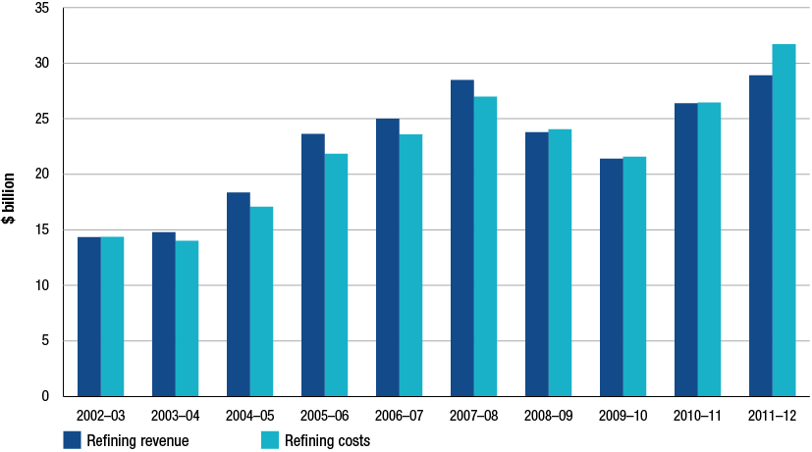
Source: ACCC calculations based on data obtained from firms monitored through the ACCC’s monitoring process
Notes: Refining costs include impairment expenses for the years 2010−11 and 2011−12.
Key observations on refinery revenues and costs for 2011−12 include:
the refinery sector’s total revenue and costs increased to $28.9 and $31.7 billion respectively. The overall increases were associated with higher international prices for refined products sold
- total volume produced and sold was around 37.2 billion litres, 2.5 per cent down on 2010−11 and 680 megalitres (ML) below the long term average. This volume reduction was reflected in the refinery utilisation rates which decreased from 88 to 82 per cent
- unit revenue was 77.6 cpl, up 12 per cent from 2010−11 and unit costs were 85.1 cpl, up 23 per cent from 2010−11
- excluding the impairment expenses, unit costs for 2011−12 were 79.2 cpl, up 16 per cent on the previous year.
    - Refinery sector: total and unit net profits, all products
Total net profits
The key profitability measure used to assess the refinery sector is net profit or adjusted EBIT. As outlined in chapter 12, this measure excludes a number of items. The main expense item excluded from this performance indicator and of relevance to the refinery sector is impairment charges. Both Caltex and Shell have announced over the past 12 months impairment write-downs at three of their four refineries. The adjusted earnings before interest and tax (EBIT) items presented in this chapter, as well as in chapters 12 and 14, exclude impairment costs. Chart 13.2 displays net profit for all refineries from 2002−03 to 2011−12.
Key observations on refinery net profit for 2011−12 include:
- the refinery sector net loss for 2011−12 was $596 million compared with a profit of $348 million in 2010−11. The result in the refinery sector was affected by losses on valuations of inventory holdings including foreign exchange losses, lower volumes, higher operating costs and the effects of unscheduled shutdowns
- the refinery sector is also continuing to be under pressure from import competition. Caltex and Shell have publicly stated that their refineries are relatively small and competitively disadvantaged against the more modern and efficient refineries in the Asia-Pacific region. The post-GFC financial results for the refinery sector reported by the ACCC in its monitoring reports support this position. In the past four years, the refinery sector has returned a profit only once
- chart 13.2 clearly shows contrasting financial results over two distinct periods over the past 10 years. In the years prior to the GFC, 2002−03 to 2007−08, the refinery sector had relatively strong profits with an average annual net profit of $1,119 million compared an average loss of $156 million per annum in the years since the GFC
- Not surprisingly, the 2011−12 result for the refinery sector is substantially below the long term annual average net profit of $609 million.
Chart 13.2 Refinery sector net profit, all products: 2002−03 to 2011−12
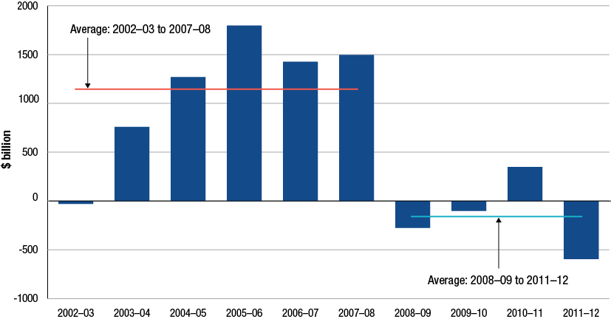
Source: ACCC calculations based on data obtained from firms monitored through the ACCC’s monitoring process
Unit net profit
This section presents data on unit net profits across all refinery products. Unit profits are calculated by dividing total net profits by total output volumes expressed in litres. Unit net profit for the refinery sector is presented in chart 13.3. Key observations from the chart include:
- the refining sector made a unit net loss of around 1.6 cpl in 2011−12, compared with a unit net profit of 0.91 cpl in 2010−11
- the average annual unit net profit over the time series was around 1.6 cpl
- splitting the periods into pre and post GFC shows that the average annual unit net profit prior to the GFC was 2.9 cpl compared to −0.4 cpl in the post GFC period.
Chart 13.3 Refinery sector unit net profit, all products: 2002−03 to 2011−12
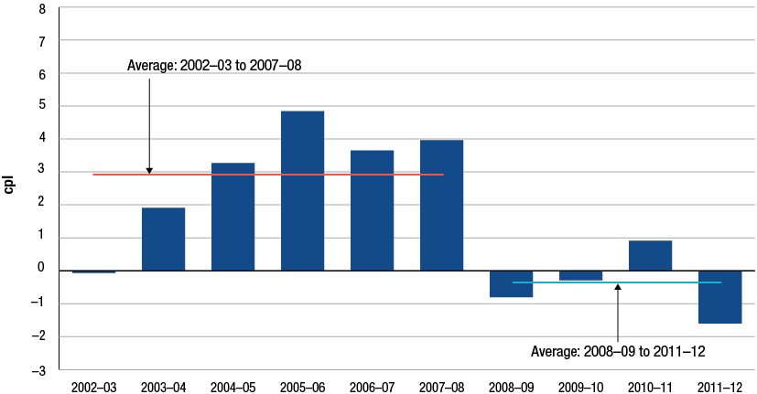
Source: ACCC calculations based on data obtained from firms monitored through the ACCC’s monitoring process
    - Refinery sector: other key performance indicators, all products
Although net profit is the key KPI for the refinery sector, there are a number of other KPIs used by the ACCC to assess the performance of this sector. These include return on sales (RoS) and return on assets (RoA). This report also considers capital expenditure relative to total profits. For further details on these KPIs, see section 12.9.5. The write down of the value of three refineries during 2011−12 has reduced the overall refinery asset base which, all things remaining the same, will affect the final calculation of the KPI for 2011−12. Chart 13.4 shows these KPIs for the period 2002−03 to 2011−12.
Key observations regarding these profit KPIs for the refinery sector include:
- RoS decreased from positive 1.32 per cent in 2010−11 to negative 2.06 per cent in 2011−12
- the average RoS for the entire time series was a positive 2.7 per cent
- RoS sales at each refinery ranged from a low of negative 8.4 per cent to a high of positive 1.1 per cent in 2011−12
- contrasting the pre and post-GFC periods shows RoS averaging 5.4 per cent pre-GFC and negative 0.6 per cent in the post-GFC period.
- RoA for the refinery sector was around negative 12 per cent for 2011−12, down from positive 4.6 per cent in 2010−11. Note that the absence of liquid markets for refinery assets and the different asset valuation methodologies can influence RoA data:
- the average annual RoA for the time series was around 9.6 per cent
- pre-GFC RoA averaged around 19 per cent, while post-GFC RoA averaged negative 2.3 per cent.
Chart 13.4 Refinery sector return on sales and return on assets, all products: 2002−03 to 2011−12
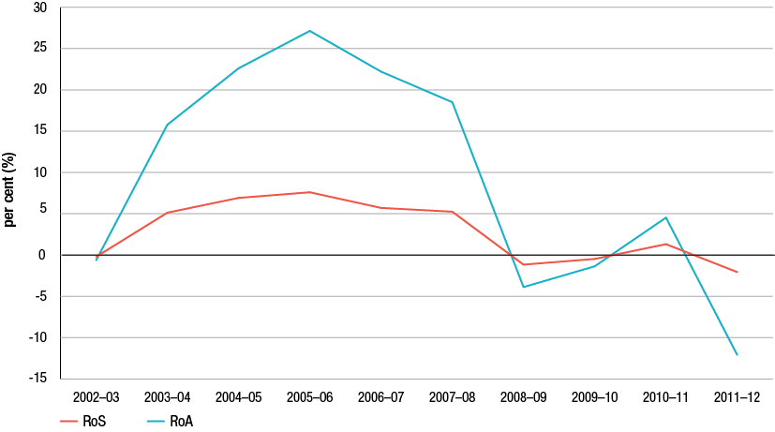
Source: ACCC calculations based on data obtained from firms monitored through the ACCC’s monitoring process
Chart 13.5 presents capital expenditure and adjusted EBIT for the refinery sector over the time series. Key observations regarding capital expenditure and adjusted EBIT for the refinery sector include:
- total capital expenditure during 2011−12 was around $447 million
- capital expenditure over the past 10 years has averaged around $481 million per year or about, on average, 79 per cent of yearly net profit
- post-GFC capital expenditure has averaged of $451 million per annum compared to $500 million per annum in the years prior to the GFC.
Chart 13.5 Refinery capital expenditure and adjusted EBIT, all products: 2002−03 to 2011−12
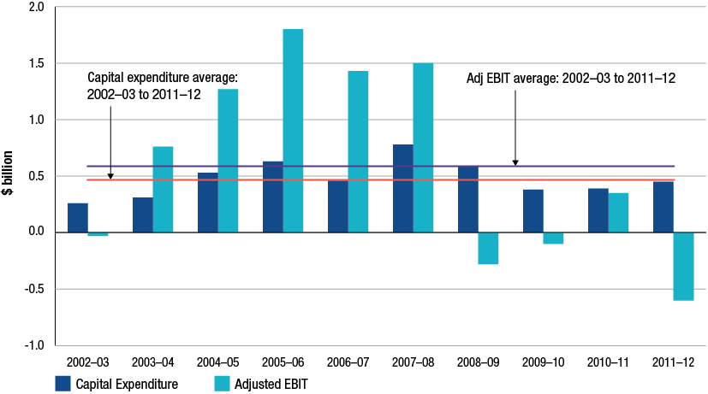
Source: ACCC calculations based on data obtained from firms monitored through the ACCC’s monitoring process
  - Refinery sector: revenues, costs and profits—petrol products
Section 13.3 assessed total revenues, costs and profits in the Australian refinery sector. As required under the minister’s direction, the ACCC is also directed to report on the revenues, costs and profits associated with the manufacture and sale of petrol products. This section presents KPIs on the refinery sector’s petrol products, that is, RULP and PULP.
The methodology for the estimation of costs and derivation of profits associated with petrol products is outlined in section 13.13.
    - Refinery sector: revenues and costs, petrol products
Chart 13.6 displays the revenues and costs associated with the production and sale of petrol products in the refinery sector. Key observations from the chart include:
- total petrol revenues and costs continued to grow and were around $12.4 billion and $13.5 billion respectively during 2011−12
- the increase in petrol revenues is largely due to increases in prices of petrol products
- total petrol volume produced and sold by Australian refineries was around 15.6 billion litres representing a decrease of around 4.8 per cent relative to 2010−11. This volume decrease was due to reduced RULP volumes, down 8 per cent from 2010−11.
Chart 13.6 Refinery sector, revenues and costs, petrol products: 2002−03 to 2011−12
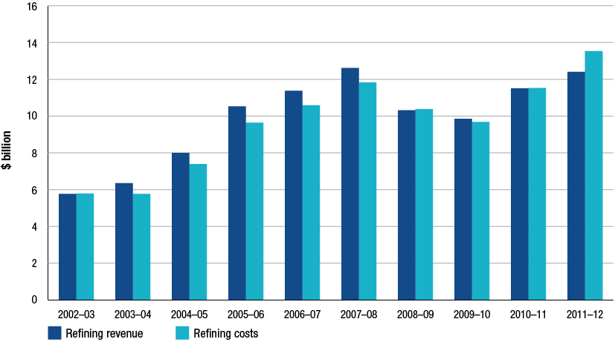
Source: ACCC calculations based on data obtained from firms monitored through the ACCC’s monitoring process
    - Refinery sector: total and unit net profit, petrol products
Total net profits
Chart 13.7 displays net profit on petrol products for all Australian refineries from 2002−03 to 2011−12.
Key observations on total refinery petrol net profits include:
- in 2011−12 petrol products recorded a net loss of $145 million, compared with a net profit of $159 million in 2010−11
- the key product driver of this loss was RULP which incurred a loss of $231 million during 2011−12. In contrast, PULP 95 and 98 earned profits during 2011−12
- the average yearly profit for petrol products over the time series has been around $380 million.
Chart 13.7 Refinery sector net profit, petrol products: 2002−03 to 2011−12
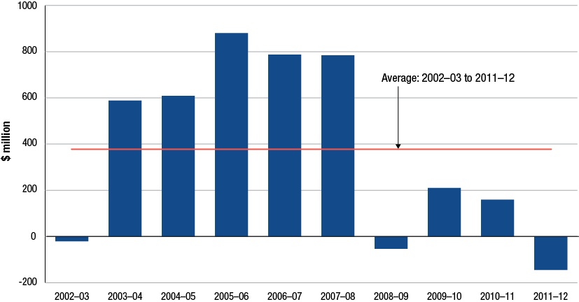
Source: ACCC calculations based on data obtained from firms monitored through the ACCC’s monitoring process
Unit net profit
Refinery unit net profits for petrol products are presented in chart 13.8. Observations from the chart include:
- refinery petrol products incurred a net loss of 0.93 cpl in 2011−12, down from a positive net profit of around one cent per litre the previous year
- average unit net profit for petrol over the time series has been estimated to be around 2.4 cpl.
Chart 13.8 Refinery sector unit net profit, petrol products: 2002−03 to 2011−12
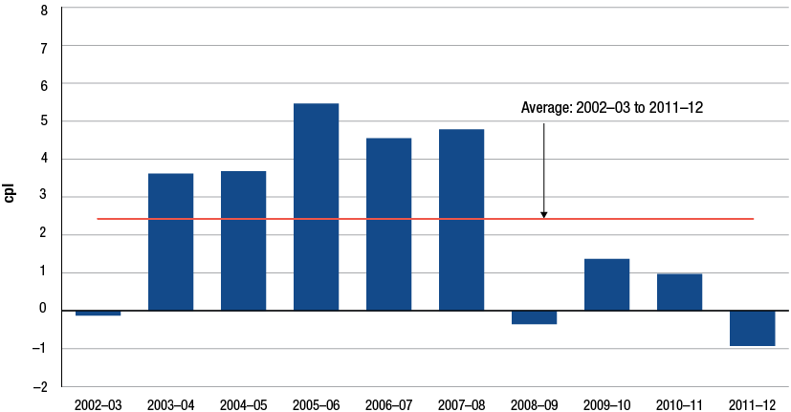
Source: ACCC calculations based on data obtained from firms monitored through the ACCC’s monitoring process
    - Refinery sector: comparison between unit RULP, PULP and diesel net profits
The previous section assessed petrol revenues and profits for the refinery sector. This section assesses the refinery sector’s unit net profits for RULP, PULP and diesel. Chart 13.9 provides a comparison of unit RULP, unit PULP and unit diesel net profits from 2002−03 to 2011−12.
Key observations from a comparison of unit net profits for these individual products include:
- PULP average unit net profits over the time series have been greater than both RULP and diesel. The average annual unit net profits for PULP, diesel and RULP were 5.4, 3.9 and 1.7 cpl respectively
- during 2011−12, PULP unit net profits were the largest with 2.4 cpl, while diesel earned 0.22 cpl and RULP negative 1.92 cpl
- since 2006−07, PULP on average has earned a margin over RULP of 5.3 cpl, highlighting the comparatively greater profitability of refining premium fuels relative to regular unleaded petrol
- the largest divergence among these three products occurred in 2007−08 when diesel earned 13.4 cpl, while RULP unit net profit was 3.8 cpl
- post-GFC, RULP unit net profits averaged negative 0.71 cpl compared to PULP with positive 4.4 cpl.
Chart 13.9 Refinery sector unit net profits, RULP, PULP and diesel: 2002−03 to 2011−12
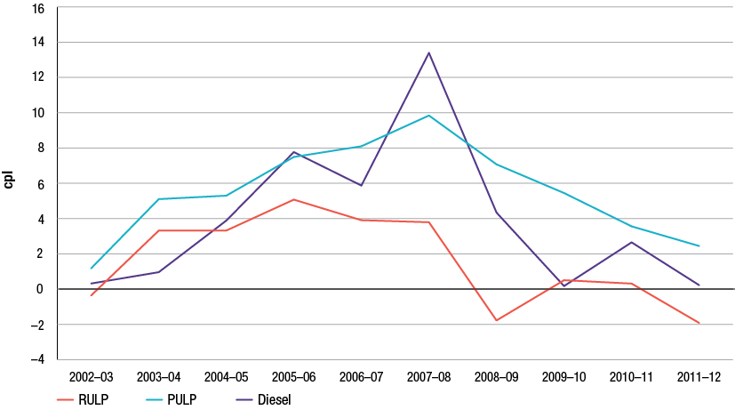
Source: ACCC calculations based on data obtained from firms monitored through the ACCC’s monitoring process
  - Refinery capacity utilisation rates
The refinery utilisation rates are KPIs that attempt to show the extent to which a refinery’s name plate capacity has been used to process crude oil into the various petroleum products.
The ACCC has used data provided by Australian refineries to derive refinery capacity utilisation rates. Utilisation rates are based around an imaginary 365 day operating efficiency mark (that in reality is rarely reached). Operating issues such as planned and unplanned maintenance or upgrades, natural disasters such as the Queensland floods of 2011, and industrial disputes can affect utilisation rates.
Chart 13.10 displays the total Australian refinery utilisation rates for the period 2002−03 to 2011−12.
Chart 13.10 Refinery sector capacity utilisation rates: 2002−03 to 2011−12
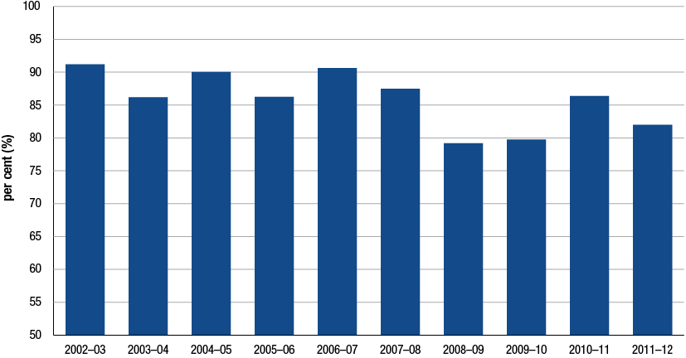
Source: ACCC calculations based on data obtained from firms monitored through the ACCC’s monitoring process; and AIP Downstream Petroleum reports, various issues
Key observations on Australian refinery utilisation rates include:
- the Australian refinery sector’s combined utilisation rate decreased from 88 per cent in 2010−11 to 82 per cent in 2011−12
- generally over the time series, the overall utilisation rate has fluctuated between 80 and 90 per cent
- in the last 10 years, the highest utilisation rate occurred in 2002−03 when, on average, refineries operated at 91.2 per cent of capacity.
  - Refinery sector: comparison of KPIs with other industries in Australia
In chapter 12, the financial performance of selected groupings from the ASX200 was compared with the Australian downstream petroleum industry. In this section, KPIs including RoS and RoA are used to compare the refinery sector against other manufacturing firms in the ASX200.
    - Australian manufacturing industry comparison: return on sales, all products
The Australian refinery sector’s RoS from 2002−03 to 2011−12 is presented in chart 13.11 and compared with selected manufacturing units in the ASX200. The data in chart 13.11 is an average over the time series for all groupings.
Chart 13.11 Average return on sales for the refinery sector and other manufacturing industries in the ASX200: 2002−03 to 2011−12
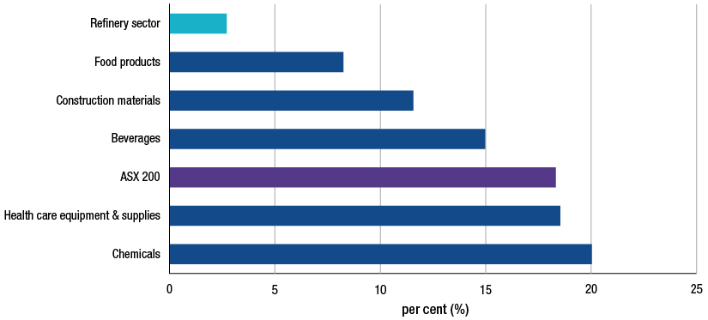
Sources: ACCC calculations based on data obtained from firms monitored through the ACCC’s monitoring process and Bloomberg
Notes: The list of companies in the ASX200 is as at 1 October 2012. The list of companies is less than 200: For the specific industries, companies with RoA of more than 70 per cent (positive and negative) in any year have been excluded; Caltex and non-manufacturing companies have also been excluded. Not all companies have data for all years. Some companies report on a calendar-year or other financial-year basis. Industries are grouped using the Global Industry Classification Standard (GICS) and include at least two companies. Revisions to historical data and to the composition of the ASX200 mean that comparisons with data in the comparable chart in the 2011 ACCC petrol monitoring report should be treated with caution.
Key observations on the chart include:
- Australian refineries have the lowest average annual RoS of any grouping with around 2.7 per cent.
- the ASX average RoS of 18 per cent was substantially above the refinery sector RoS.
- Refining is regarded as a high-volume and low-margin activity. Companies in these types of industries rely on volumes to earn adequate returns and will generally have lower returns on sales than firms in a low-volume high-margin industry.
    - Australian manufacturing industry comparison: return on assets, all products
The Australian refinery sector’s average annual RoA from 2002−03 to 2011−12 is presented in chart 13.12 and is compared with selected manufacturing units in the ASX200. Although RoA is a more accurate measure of profitability for a firm in a low-margin, high-turnover industry, it has limitations.
As noted in section 12.7.2, the absence of liquid markets for refinery assets and different asset valuation methodologies and depreciation rates can influence RoA data. Further to this, the Australian downstream industry has seen four significant write downs of the value of refinery assets in 2010−11 and 2011−12. Although the write down in costs is excluded from adjusted EBIT, these write downs have had the effect of reducing the value of total assets and subsequently increase the value of RoA. Differences in age profiles across assets also complicate comparisons of RoA for different firms.
Key observations from a comparison of average refinery RoA with other manufacturing industries include:
- average annual RoA for the refinery sector was around 9.6 per cent which is comparable to the ASX200 average of 10 per cent for the time series
- the only grouping to have a lower average annual RoA than the refinery sector was the beverages grouping with an average RoA of 8.7 per cent.
Chart 13.12 Average return on assets for the refinery sector and other manufacturing industries in the ASX200: 2002−03 to 2011−12
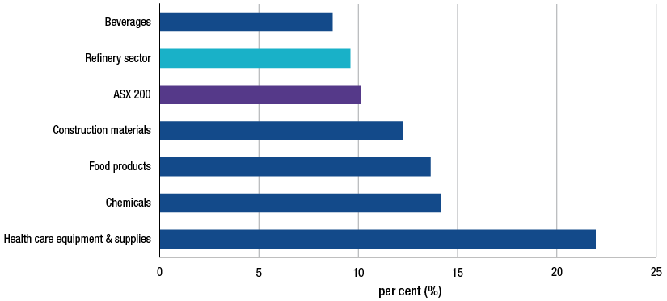
Sources: ACCC calculations based on data obtained from firms monitored through the ACCC’s monitoring process. Bloomberg and Bureau van Dijk Orbis database
Notes: The list of companies in the ASX200 is as at 1 October 2012. The list of companies is less than 200: For the specific industries, companies with RoA of more than 70 per cent (positive and negative) in any year have been excluded; Caltex and non-manufacturing companies have also been excluded. Not all companies have data for all years. Some companies report on a calendar-year or other financial-year basis. Industries are grouped using the Global Industry Classification Standard (GICS) and include at least two companies. Revisions to historical data and to the composition of the ASX200 mean that comparisons with data in the comparable chart in the 2011 ACCC petrol monitoring report should be treated with caution.
  - Total supply sector
This section assesses the revenue, costs and profits associated with the total supply sector. The total supply sector covers the following activities:
- total refinery operations (the refinery sector is a sub-sector of total supply)
- imports of refined products such as RULP and PULP (and some exports)
- purchase and coordination of crude imports for the refinery sector
- transactions between the refiner-wholesalers through buy-sell arrangements.
Before assessing the revenues, costs and profits of the total supply sector the following caveats must be taken into consideration:
- although all refiner-wholesalers have supply activities, not all have a separate total supply sector. Of those refiner-wholesalers that do not have a total supply sector, imports may be within the refinery operations while buy-sell transactions may be incorporated within the wholesale sector
- this variation by company on the location of certain activities prompted the ACCC to adopt the concept of a separate total supply sector to bring consistency to the sectoral analysis. This decision was taken in consultation with the industry
- those companies that did have a total supply sector did not necessarily operate it as a separate cost centre
- achieving consistency in sectoral reporting meant some companies were required to make allocations not normally undertaken in their internal accounting systems.
  - Total supply sector: revenues, costs and profits—all products
In the total supply sector, revenues are earned from the sale of locally refined crude oil, the sale of imported refined product and refined petrol purchased and sold through buy-sell transactions. As this sector (which includes refining) has the greatest exposure to international price movements due to the importation of crude and refined product, the resultant price volatility can impact overall revenues, costs and ultimately profits.
    - Total supply: revenues and costs, all products
Revenues and costs in the total supply sector are displayed in chart 13.13 over the period 2002−03 to 2011−12. Key observations from the chart include:
- in 2011−12 total revenues and costs increased to $57 billion and $60 billion respectively, 17 and 25 per cent higher than 2010−11 respectively
- total volumes increased by 5.2 per cent to 72.3 billion litres during 2011−12. Driving this increase were diesel volumes which increased 11 per cent. PULP products increased 14 per cent (off a relatively smaller base) while RULP volumes decreased 0.1 per cent.
Chart 13.13 Total supply sector revenues and costs, all products: 2002−03 to 2011−12
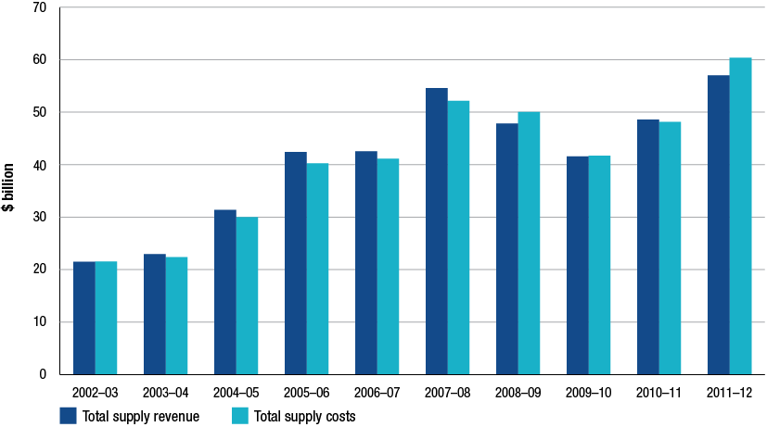
Source: ACCC calculations based on data obtained from firms monitored through the ACCC’s monitoring process
    - Total supply sector: total and unit net profits, all products
Total net profits
The ACCC has derived a net profit measure for the total supply sector. The caveats outlined in section 13.8 should be used in conjunction with any assessment of total supply net profits. Chart 13.14 presents net profit from 2002−03 to 2011−12.
Key observations on 2011−12 net profits for the total supply sector include:
- total supply recorded a net loss of $1.1 billion during 2011−12, compared with a profit of $0.85 billion in 2010−11
- the total supply sector has experienced net losses in three out of the past four years, with the largest loss of $2.2 billion occurring in 2008−09
- total supply’s average annual profit for the entire time series was around $528 million.
Chart 13.14: Total supply sector net profit, all products: 2002−03 to 2011−12
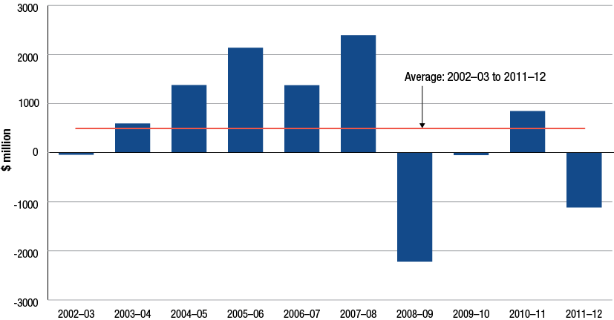
Source: ACCC calculations based on data obtained from firms monitored through the ACCC’s monitoring process
Unit net profit
Total supply unit net profits are presented in chart 13.15. In 2011−12 total supply recorded a net loss of 1.5 cpl compared with a profit of 1.2 cpl in 2010−11. Average annual unit net profit in the total supply sector for the years 2002−03 to 2011−12 was 0.80 cpl.
Chart 13.15 Total supply sector unit net profit, all products: 2002−03 to 2011−12
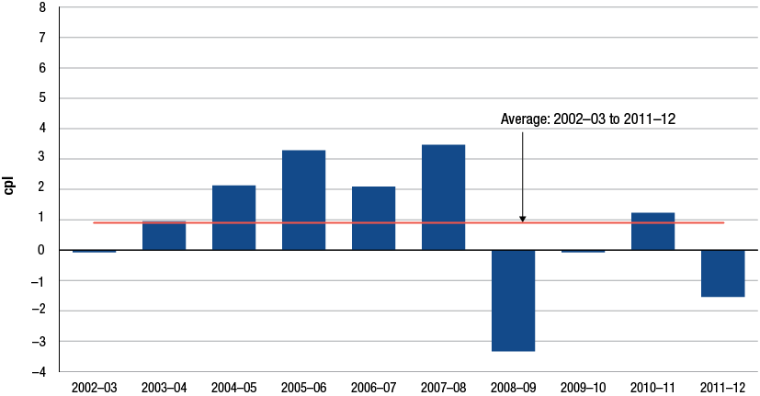
Source: ACCC calculations based on data obtained from firms monitored through the ACCC’s monitoring process
  - Total supply sector: revenues, costs and profits—petrol products
This section discusses the total supply sector’s revenue, costs and profits from petrol products. Petrol products include RULP, PULP and EBP, however little EBP is traded at the total supply level as EBP is normally blended with RULP in the wholesale sector. The caveats discussed in section 13.7 on the sectoral allocation of data should be considered carefully when assessing petrol profits in the total supply sector.
    - Total supply sector: revenues and costs, petrol products
Chart 13.16 presents total sales and expenses for petrol products manufactured and sold in the total supply sector. Key observations on petrol sales and costs include:
- in 2011−12 total petrol revenue and costs increased to $20.8 billion and $22.2 billion respectively
- total petrol volumes increased to 26 090 ML, representing an increase of one per cent on 2010−11. RULP volumes decreased by 0.1 per cent while PULP volumes increased 14 per cent (off a smaller base).
Chart 13.16 Total supply sector revenues and costs, petrol products: 2002−03 to 2011−12
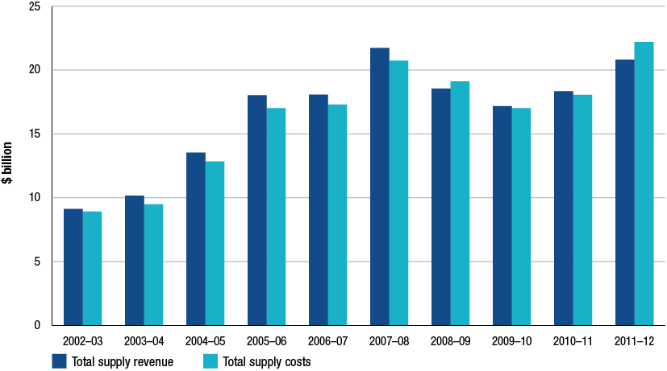
Source: ACCC calculations based on data obtained from firms monitored through the ACCC’s monitoring process
    - Total supply: total and unit net profit, petrol products
Chart 13.17 presents the ACCC’s estimates of net profit on petrol products for the total supply sector. Key observations from this chart include:
- net profit in the total supply sector for petrol products fell from $430 million in 2010−11 to a loss of $407 million in 2011−12
- the long term annual average for petrol net profits is around $393 million.
Chart 13.17 Total supply sector net profit, petrol products: 2002−03 to 2011−12
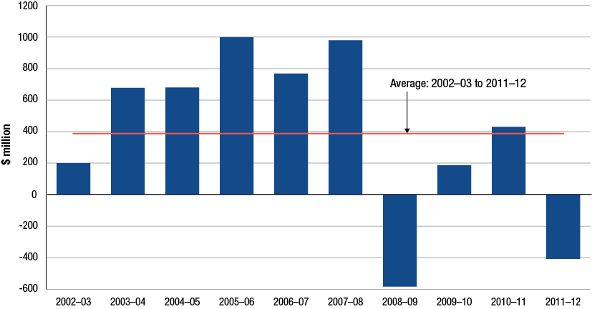
Source: ACCC calculations based on data obtained from firms monitored through the ACCC’s monitoring process
Data on unit net profit for petrol products in the total supply sector is presented in chart 13.18. Petrol products recorded a unit net loss of 1.6 cpl during 2011−12, down from a unit net profit of 1.66 cpl in 2010−11.
Chart 13.18 Total supply sector unit net profit, petrol products: 2002−03 to 2011−12
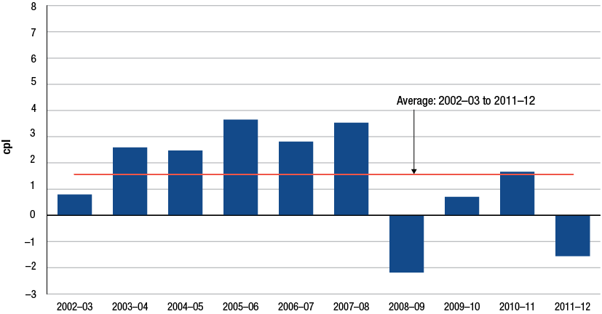
Source: ACCC calculations based on data obtained from firms monitored through the ACCC’s monitoring process
    - Total supply sector: comparison of unit RULP, PULP and diesel net profits
The previous section discussed petrol revenues and profits. This section assesses the profitability of the two fuels that make up petrol products RULP and PULP in the total supply sector and compares them with diesel.
Chart 13.19 displays the unit net profits for RULP, PULP and diesel over the time series. Key observations on these products’ unit net profits include:
- all three products recorded net unit losses during 2011−12 in difference to 2010−11 when all were profitable
- RULP recorded the largest unit net loss with 1.2 cpl, slightly below PULP which had a unit net loss of 1.1 cpl. Diesel’s unit net loss was 0.8 cpl
- diesel recorded the largest average annual unit net profit over the time series with 1.8 cpl.
Chart 13.19 Total supply sector unit net profits, RULP, PULP and diesel: 2002−03 to 2011−12
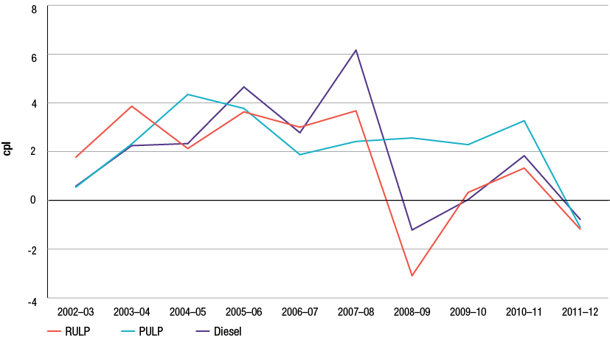
Source: ACCC calculations based on data obtained from firms monitored through the ACCC’s monitoring process
  - Total supply sector: product mix
In terms of volumes the total supply sector is the largest sector in the Australian downstream petroleum industry. Assessing changes in this sector’s product volume mix provides some clarity on levels of and changes in Australian demand for various products. Chart 13.20 presents an index commencing from 2002−03 displaying changes in product volume for RULP, PULP and diesel.
Key observations on the changes in product volume mix include:
during 2011−12, PULP experienced the largest percentage increase from the previous year with 24 per cent
- RULP continued its long term decline with volumes decreasing 1 per cent compared with 2010−11. The chart clearly shows the decline in volumes of RULP, decreasing by around 22 per cent since 2002−03
- on the other hand, PULP has increased substantially since 2002−03 with an increase of around 101 per cent (albeit off a substantially smaller base than RULP).
Chart 13.20 Total supply sector, change in volumes of RULP, PULP and diesel (index): 2002−03=100
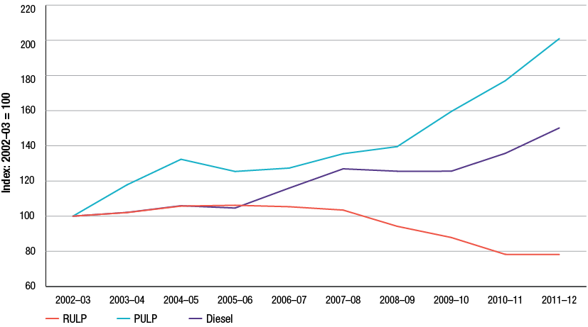
Source: ACCC calculations based on data obtained from firms monitored through the ACCC’s monitoring process
Further discussion of recent changes in product volume mix in the Australian downstream petroleum industry is presented in section 15.6.
  - Total supply sector: foreign exchange gains and losses
The total supply sector in the ACCC’s model of the Australian downstream petroleum industry is the sector that coordinates the purchasing (and sale) of domestic and imported crude oil and processed product. Because of this exposure to the international market, this sector has the highest exposure to foreign currency gains and losses as the oil market largely settles in USD.
Chart 13.21 displays foreign exchange gains and losses for the period 2006−07 to 2011−12. Key observations on foreign exchange gains and losses include:
- during 2011−12, the total supply sector experienced losses in foreign exchange transactions for the first time since 2008−09
- foreign exchange transactions resulted in net losses of $217 million in 2011−12 compared with gains of $385 million in 2010−11.
Chart 13.21 Total supply sector, foreign exchange gains and losses: 2006−07 to 2011−12
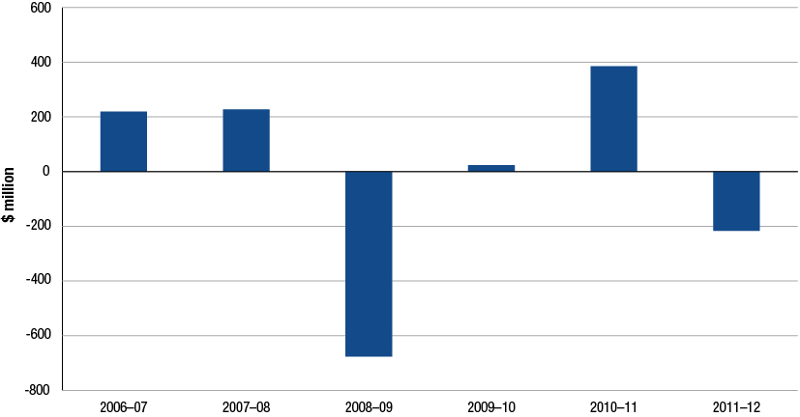
Source: ACCC calculations based on data obtained from firms monitored through the ACCC’s monitoring process
  - Methodology note
The assessment of the downstream petroleum industry is based on data included total company returns for each monitored company and also company returns by sector.
For the purposes of this monitoring program the ACCC segmented the industry into four broad sectors. Three of these sectors including refining, wholesaling and retailing directly align with the Australian and New Zealand Standard Industrial Classification 2006 (ANZSIC06). The ANZSIC06 classes are Petroleum and Coal Product Fuel Manufacturing class 1701, Petroleum Product Wholesaling class 3321 and Fuel Retailing class 4000. Note that comparisons with Australian Bureau of Statistics industry data may be misleading due to the scope of monitored units compared to all Australian units that operate in those sectors and also due to the allocation of activities to total supply. The total supply sector used by the ACCC to monitor the Australian downstream petroleum industry does not directly align to any ANZSIC class.
While Australian refineries report revenues by product, it is often not possible to measure costs by product. This means that total costs must be allocated to individual products. Cost allocation is complicated by the fact that different petroleum products are produced from the same barrel of oil and using the same refining facilities. Some companies have not provided cost splits for these reasons. As outlined in section 12.1, the ACCC has used sales volumes to prorate costs across products so that costs and profits can be estimated for each type of product.

- Financial performance of the wholesale and retail sectors
Key points
Wholesale
- During 2011–12, the wholesale sector recorded a net profit of $1084 million, or 2.07 cents per litre on total revenue of $44.9 billion and total sales volumes of 52 billion litres.
- Profits for petrol products (that is, RULP, PULP and EBP) were $159 million down 19 per cent on 2010-11.
- Premium fuels were the main contributor with net earnings of $165 million in
2011–12.
- Other products, including lubricants, were the largest contributor to total wholesale net profits earning $519 million in 2011–12.
Retail
- The retail sector recorded a net profit of $440 million during 2011–12, or 2.44 cents per litre, on total revenue of $19.7 billion and total fuel volumes of 18.1 billion litres.
- Profits from petrol products were $239 million, up 32 per cent from 2010–11.
- Premium fuels were the largest contributor to petrol profits with $121 million earned in 2011−12.
- Convenience store sales earned a total net profit of $171 million, on total revenues of $3.02 billion.

  - Introduction
This chapter reports on the financial performance of the wholesale and retail sectors in the Australian downstream petroleum industry.
The wholesale sector is comprised of the four refiner-wholesalers and a number of independent wholesalers who either source petroleum products locally from one of the refiner-wholesalers or other wholesalers or through direct imports.
Companies from which wholesale financial data has been collected for this monitoring report include the four refiner-wholesalers, Liberty, Ausfuel, Neumann and United. The refiner-wholesalers account for the majority of total wholesale sales.
The Australian retail sector is comprised of the retail operations of refiner-marketers the supermarkets some independent wholesalers a number of large independent retailers and a large number of smaller independent owner operators.
For the purposes of this monitoring report financial data is presented in respect of the retail operations of Caltex, BP, Coles, Woolworths, United, Neumann, Ausfuel, 7-Eleven and On the Run. Mobil no longer operates in the retail sector while Shell has a small number of re-fueller sites that also sell to the public.
  - Overview of the financial performance in the wholesale and retail sectors
Key observations on revenues costs and profits in the wholesale sector for 2011−12 include (table 14.1):
- total revenue for the wholesale sector was $44.9 billion up 18 per cent from 2010−11. Total petrol revenue was $15.8 billion, up 12 per cent.
- total profit for the wholesale sector was $1 084 million, up 12 per cent from the previous year. Petrol net profit was $159 million, down 19 per cent.
Table 14.1 Sale volumes and net profits (EBIT) in the wholesale sector: 2011−12 and the average from 2002−03 to 2011−12
 |  | 2011−12 | 2002−03 to 2011−12 average
All products | Sale volumes (ML) | 52 455 | 47 049
All products | EBIT ($ million) | 1 084 | 712
All products | Unit EBIT (cpl) | 2.07 | 1.51
Petrol products | Sales volumes (ML) | 18 590 | 19 113
Petrol products | EBIT ($ million) | 159 | 40
Petrol products | Unit EBIT (cpl) | 0.85 | 0.21
Diesel | Sales volumes (ML) | 23 138 | 17 847
Diesel | EBIT ($ million) | 196 | 154
Diesel | Unit EBIT (cpl) | 0.85 | 0.86
Other products  (incl. lubricants and engine oils) | Sales volumes (ML) | 1 371 | 1 634
Other products  (incl. lubricants and engine oils) | EBIT ($ million) | 519 | 456
Other products  (incl. lubricants and engine oils) | Unit EBIT (cpl) | 37.80 | 27.90

Source: ACCC calculations based on data obtained from firms monitored through the ACCC’s monitoring process
Key observations on revenues costs and profits in the retail sector for 2011−12 include (table 14.2):
- total revenue for the retail sector was $19.7 billion up 16 per cent from 2010−11. Total petrol revenue was $11.9 billion up, 15 per cent on the previous year
- total profit for the retail sector was $440 million, up 23 per cent compared with 2010−11. Petrol net profit was $239 million, up 32 per cent
- convenience store share of total profits was 39 per cent, remaining unchanged from 2010−11.
Table 14.2 Sale volumes and net profits (EBIT) in the retail sector: 2011−12 and the average from 2005−06 to 2011−12
 |  | 2011−12 | 2005−06 to 2011−12 average
All products | Sale volumes (ML) | 18 054 | 16 176
All products | EBIT ($ million) | 440 | 273
All products | Unit EBIT (cpl) | 2.44 | 1.69
Petrol products | Sales volumes (ML) | 12 607 | 11 869
Petrol products | EBIT ($ million) | 239 | 114
Petrol products | Unit EBIT (cpl) | 1.89 | 0.96
RULP | Sales volumes (ML) | 7 231 | 8 260
RULP | EBIT ($ million) | 88 | 57
RULP | Unit EBIT (cpl) | 1.22 | 0.69
PULP | Sales volumes (ML) | 3 157 | 2 306
PULP | EBIT ($ million) | 121 | 47
PULP | Unit EBIT (cpl) | 3.82 | 2.03
EBP | Sales volumes (ML) | 2 219 | 1 303
EBP | EBIT ($ million) | 30 | 10
EBP | Unit EBIT (cpl) | 1.35 | 0.76
Diesel | Sales volumes (ML) | 4 209 | 3 006
Diesel | EBIT ($ million) | 56 | 58
Diesel | Unit EBIT (cpl) | 1.34 | 1.93
Convenience stores | Revenue ($ million) | 3016 | 2 391
Convenience stores | EBIT ($ million) | 171 | 113

Source: ACCC calculations based on data obtained from firms monitored through the ACCC’s monitoring process
Note: The time period for average convenience store revenue and EBIT is 2006−07 to 2011−12.
  - Wholesale sector: revenues, costs and profits
The wholesale sector derives its income from the purchasing and reselling of petroleum products and lubricants to retail and commercial customers. As was the case in the refinery sector the financial performance of the wholesale sector since 2002−03 can also be analysed in terms of two reasonably distinct periods:
- the first period, the years prior to the global financial crisis (GFC) from 2002−03 to 2007−08, is characterised by lower volumes (on average 45 327 megalitres (ML) compared to 49 632 ML for the post-GFC period 2008−09 to 2011−12) and lower average annual net profits ($515 million compared to post-GFC $1 006 million)
- between the two periods, the change in volumes was around 9 per cent compared with the change in net profit of 95 per cent
- the change between the two periods is related to the performance of the refiner-wholesalers in this sector rather than any structural or economic conditions as was the case in the refinery sector
- since 2002−03 the refiner-wholesalers have on average sold around 95 per cent of all volume and have earned around 98 per cent of total net profit.
    - Wholesale sector: revenues and costs, all products
In 2011−12 revenues and costs in the wholesale sector increased relative to those recorded in the previous 12 months. Chart 14.1 shows total revenues and costs for the monitored firms in the wholesale sector.
Chart 14.1 Wholesale sector revenues and costs, all products: 2002−03 to 2011−12
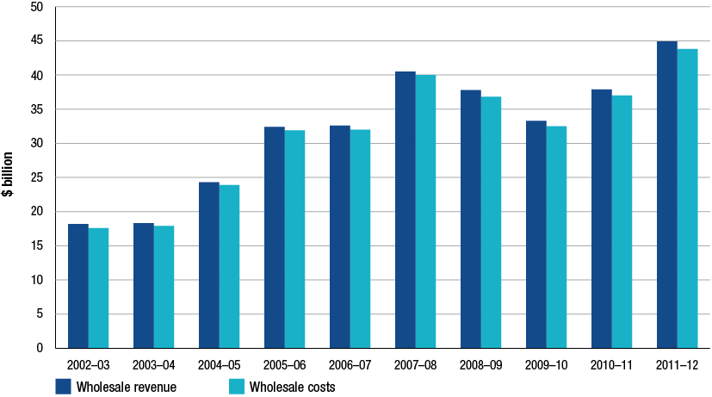
Source: ACCC calculations based on data obtained from firms monitored through the ACCC’s monitoring process
Key observations on wholesale sector revenues and costs for 2011−12 include:
- total revenue and costs increased to $44.9 billion and $43.8 billion respectively. This growth was associated with increased volumes and prices for fuel products sold and purchased
- total volume traded in 2011−12 was around 52 billion litres which is about five billion litres higher than the long term average
- unit revenues and unit costs for 2011−12 were 85.6 and 83.5 cents per litre (cpl) respectively.
    - Wholesale sector: total and unit net profits, all products
Total net profits
The key measure for profitability used by the ACCC to assess financial performance is net profit or adjusted earnings before interest and tax (EBIT). Chart 14.2 presents net profit data for the wholesale sector.
Key observations on wholesale sector net profit for 2011−12 include:
- net profit was $1 084 million representing an increase of 12 per cent on 2010−11
- since the GFC the wholesale sector’s financial performance has improved and is now the most profitable sector in the Australian downstream petroleum industry
- the 2011−12 net profit is $373 million above the long term average of $712 million.
Chart 14.2 Wholesale sector net profit, all products: 2002−03 to 2011−12
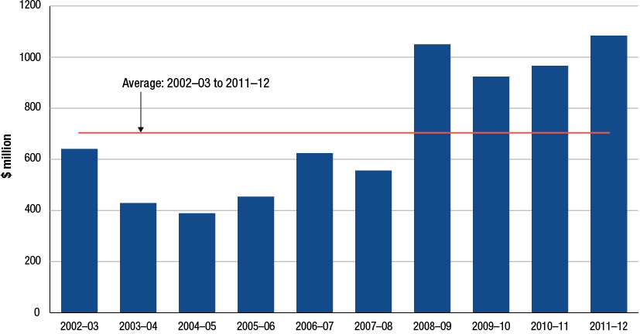
Source: ACCC calculations based on data obtained from firms monitored through the ACCC’s monitoring process
Unit net profit
Consistent with the definition used in previous chapters unit net profit is defined as total profits divided by total volumes. Unit net profit for the wholesale sector is presented in chart 14.3. Key observations from this chart include:
- unit net profit for the wholesale sector was around 2.07 cpl in 2011−12 up 6 per cent from the previous year
- the average annual unit net profit from 2002−03 to 2011−12 was around 1.5 cpl
- unit net profits since the GFC have improved relative to the period before the GFC. Prior to 2008−09, the average annual unit net profit was 1.1 cpl compared to 2.0 cpl since 2008−09.
Chart 14.3 Wholesale sector unit net profit, all products: 2002−03 to 2011−12
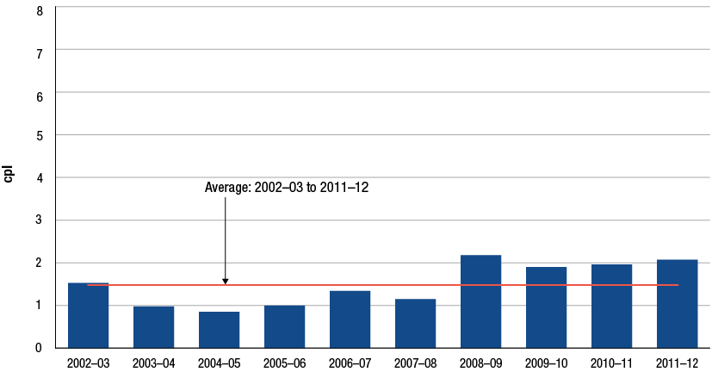
Source: ACCC calculations based on data obtained from firms monitored through the ACCC’s monitoring process
    - Wholesale sector: other key performance indicators
The ACCC uses other key performance indicators to assess industry or sectoral profitability. These include return on sales (RoS) and return on assets (RoA). For further details on these KPIs refer to section 12.9.5.
Chart 14.4 presents RoS and RoA for the period 2002−03 to 2011−12. Key observations regarding these profit key performance indicators for the wholesale sector include:
- return on sales was 2.4 per cent in 2011−12 down from 2.6 per cent in 2010−11. The decrease is due to a smaller rise in profits than revenues
- the average RoS over the time series was around 2.2 per cent
- during 2011−12, the refiner-wholesalers average RoS was around 2.5 per cent compared to around 1.3 per cent for independent wholesalers
- the average for the time series was 2.3 per cent for the refiner-wholesalers and 1 per cent for the independent wholesalers.
- return on assets for the wholesale sector was around 15.6 per cent in 2011−12 down from 18.5 per cent in 2010−11. An increase in the wholesale sector asset base of 33 per cent resulted in a lower RoA despite higher profits
- the average RoA for the entire time series was 13.5 per cent
- average RoA during the pre-GFC years was 10 per cent compared to the post-GFC RoA of 19 per cent.
Chart 14.4 Wholesale sector return on sales and return on assets, all products: 2002−03 to 2011−12
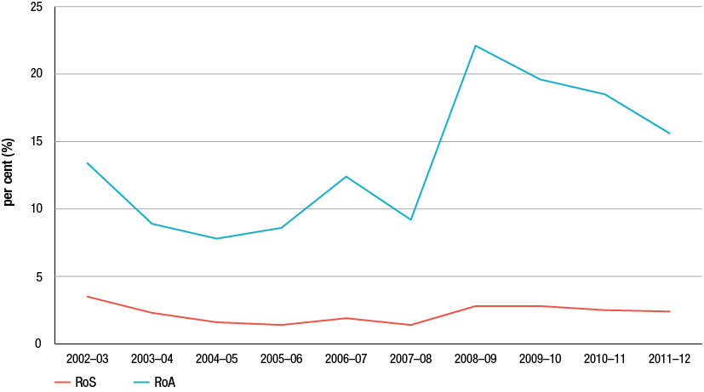
Source: ACCC calculations based on data obtained from firms monitored through the ACCC’s monitoring process
As discussed in previous chapters there are a number of caveats pertaining to data on return on sales and return on assets that should be taken into account when analysing these KPIs. Return on sales is affected by a firm’s cost structure. Generally firms with operations that have significant fixed costs rely on volumes to produce adequate returns and will therefore tend to have a lower return on sales. Return on assets is affected by approaches to measuring asset values, the allocation of corporate assets across sectors and asset age profiles.
  - Wholesale sector: revenues, costs and profits—petrol products
Section 14.3 assessed total revenues, costs and profits in the wholesale sector. As required under the minister’s direction the ACCC is also directed to report on the revenues costs and profits associated with petrol products that is RULP, PULP and EBP. This section presents financial performance KPIs on these products.
Monitored companies do not provide cost data for individual products. To estimate costs for each product the ACCC has allocated total costs on the basis of product volume splits. The methodology used by the ACCC for the allocation of costs and derivation of profits on petrol products is outlined in section 14.10.
    - Wholesale sector: revenues and costs, petrol products
Chart 14.5 shows data on total revenues and costs associated with the sale of petrol products in the wholesale sector from 2002−03 to 2011−12. Key observations from this chart include:
total revenue and costs on petrol products increased to $15.8 billion and $15.7 billion respectively in 2011−12
- total petrol sale volumes decreased by 0.3 per cent during 2011−12 continuing the trend of generally declining petrol sales since 2004−05. EBP volumes decreased 17 per cent while PULP volumes increased by 16 per cent from 2010−11.
Chart 14.5 Wholesale sector revenues and costs, petrol products: 2002−03 to 2011−12
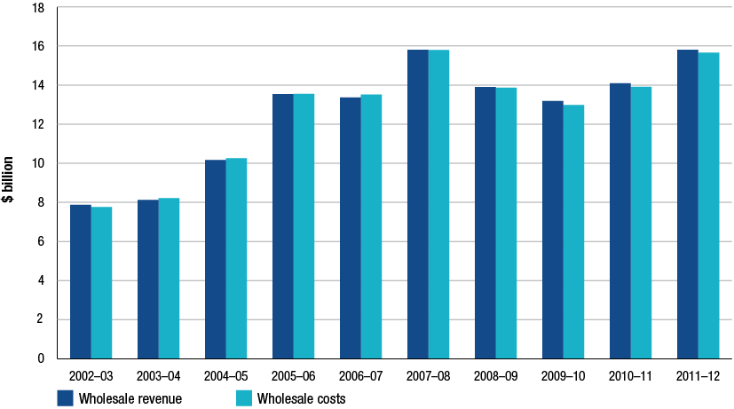
Source: ACCC calculations based on data obtained from firms monitored through the ACCC’s monitoring process
    - Wholesale sector: total and unit net profits, petrol products
Total net profits
Chart 14.6 displays net profit on petrol products sold in the wholesale sector from 2002−03 to 2011−12.
Key observations on wholesale petrol profits include:
- total profits on petrol products during 2011−12 were $159 million representing a decrease of around 19 per cent relative to 2010−11
- the main driver of increased profits in recent years has been PULP which on average has contributed 80 per cent of petrol net profit over the past three years.
Chart 14.6 Wholesale sector net profit, petrol products: 2002−03 to 2011−12
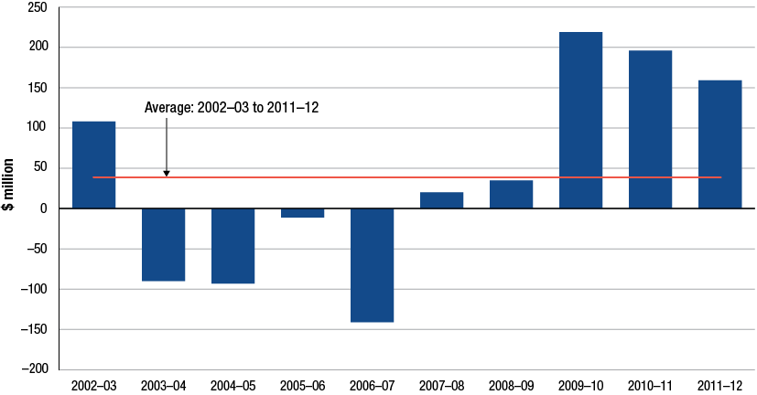
Source: ACCC calculations based on data obtained from firms monitored through the ACCC’s monitoring process
Unit net profit
Data on unit net profit for petrol products in the wholesale sector over the 10 years to 2011−12 are presented in chart 14.7. Key observations from this chart include:
- unit net profit for petrol products decreased to 0.85 cpl during 2011−12 representing a fall of 19 per cent from 2010−11
- over the past three financial years petrol unit net profit has averaged around one cent per litre, driven mainly by earnings from PULP
- since 2002−03 average annual unit net profit for petrol has been estimated to be around 0.21 cents per litre.
Chart 14.7 Wholesale sector unit net profit, petrol products: 2002−03 to 2011−12
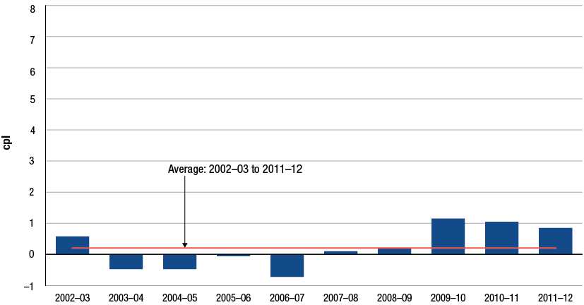
Source: ACCC calculations based on data obtained from firms monitored through the ACCC’s monitoring process
    - Wholesale sector: comparison of unit net profit for RULP, PULP, EBP and diesel
The previous section discussed profits for petrol products as a group. This section presents profitability data on RULP, PULP, EBP and diesel sold in the wholesale sector by monitored companies. Chart 14.8 presents individual profitability data for these four products from 2003−04 to 2011−12.
Key observations for unit net profits for each product include:
- during 2011−12, PULP products recorded the largest unit net profit with 3.4 cpl while RULP recorded the lowest result with a unit net loss of 0.5 cpl
- in 2011−12 RULP continued to account a decreasing share of total volumes representing 21 per cent of total volumes. PULP volumes on the other hand have increased their share of total volumes, contributing about 9 per cent of total volumes in 2011−12
- diesel unit net profits were 0.9 cpl during 2011−12. Diesel during 2011−12 contributed around 44 per cent to total wholesale fuel volumes
- over the entire time series, PULP has recorded the highest average annual unit net profits with around 2.4 cpl. Diesel averaged around 0.86 cpl while RULP has recorded an average annual loss of 0.34 cpl.
Chart 14.8 Wholesale sector unit net profits, RULP, PULP, EBP and diesel: 2003−04 to 2011−12
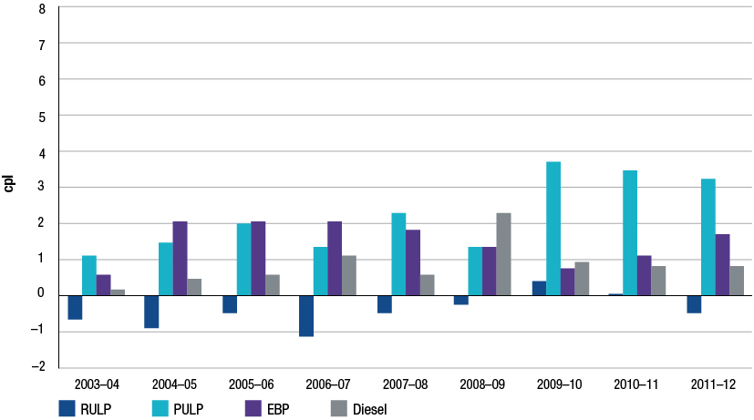
Source: ACCC calculations based on data obtained from firms monitored through the ACCC’s monitoring process
Note: The financial year 2002−03 has been excluded from the chart due to data inconsistencies in the reporting of EBP splits.
  - Retail sector: revenues, costs and profits
The retail sector in Australia is in transition. Refiner-wholesalers have greatly reduced their direct presence in the retail sector and the industry has seen the emergence of specialist retailers such as the supermarkets, and other independent retail operators such as 7-Eleven and On The Run as well as the continued consolidation of the retail operations of the major independent wholesalers, Neumann, United and Ausfuel. The ACCC’s monitoring programme for the retail sector does not cover single site and small multiple-site retailers.
Revenues and profits in the retail sector are derived from the sale of petroleum products and non-fuel products and services to the public. Sales of non-fuel products and services have become increasingly important for overall profitability in the retail sector. Some of these services include normal convenience store sales, car and animal wash services, franchised businesses within the convenience store and other traditional services such as the hire of trailers, gas bottle exchange and ATM services. Convenience store margins and profits are assessed in section 14.9.
Business models used in the retail sector vary greatly. Retail operations include refiner-marketer owned and operated sites, commission agent sites, franchise sites, independent but refiner-wholesaler branded sites, alliances between supermarket chains and refiner-wholesalers and various large and small independent owned and operated sites.
    - Retail sector: revenues, costs and volumes, all products and services
The general trends evident in the last few years have been observed again during 2011−12. Chart 14.9 displays total revenues and costs in the retail sector over the period 2005−06 to 2011−12. Key observations on retail revenues costs and volumes include:
- during 2011−12, total revenues and costs increased to $19.7 billion and $19.3 billion respectively. This growth was largely driven by higher fuel prices, some volume growth and possibly some increased market share at the expense of small non-monitored retailers.
- unit revenues for 2011−12 were $1.09 per litre (up 12 per cent on 2010−11) and $1.07 per litre for costs (up 11 per cent on 2010−11)
- during 2011−12, total sector volumes increased to 18.1 billion litres up 3.5 per cent on 2010−11. Total sales volumes by monitored retail companies have increased annually since 2005−06.
- RULP volumes increased for the first time since 2006−07, up by 2.6 per cent to 7.2 billion litres in 2011−12. However, RULP’s contribution to total volumes has fallen in the last few years, from 63 per cent of all retail fuel sales in 2005−06, to 40 per cent in 2011−12
- EBP sales volumes decreased by 11 per cent in 2011−12 to 2.2 billion litres. EBP’s share of total retail sales volumes decreased from 14 per cent in 2010−11 to 12 per cent in 2011−12.
Chart 14.9 Retail sector total revenues and costs, all products and services: 2005−06 to 2011−12
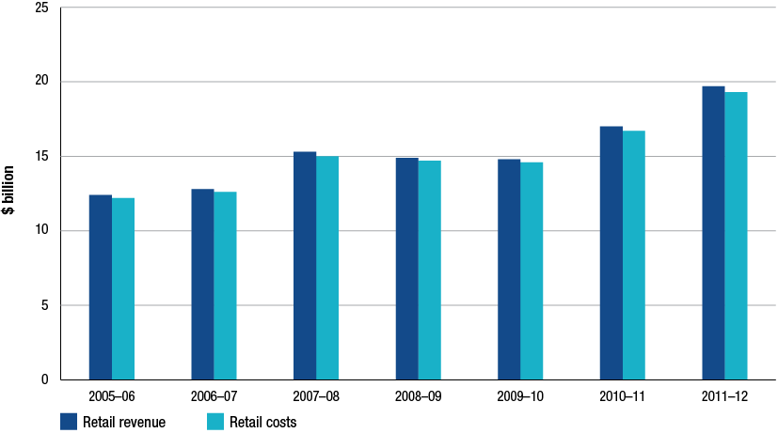
Source: ACCC calculations based on data obtained from firms monitored through the ACCC’s monitoring process
    - Retail sector: total and unit net profits, all products and services
Total net profits
In the retail sector, net profit includes profits from the sale of fuel and from convenience store products and services. Chart 14.10 presents data on total net profits from 2005−06 to 2011−12.
Key observations on retail net profits include:
- profit results for 2011−12 continued the general trend of rising profit (apart from 2008−09) reaching $440 million in 2011−12. This represents an increase of 23 per cent on 2010−11.
- the average net profit over the period 2005−06 to 2011−12 was $273 million.
Chart 14.10 Retail sector total net profit, all products and services: 2005−06 to 2011−12
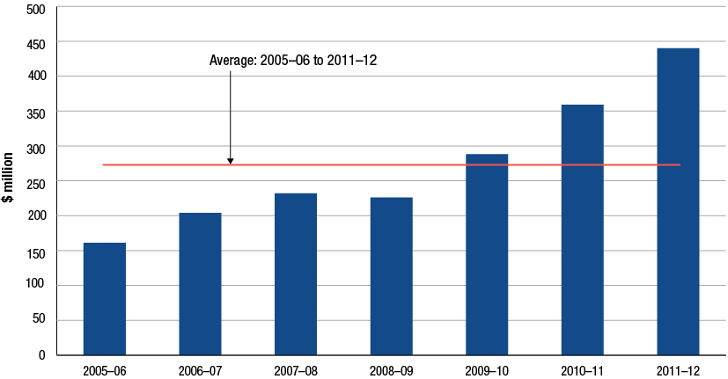
Source: ACCC calculations based on data obtained from firms monitored through the ACCC’s monitoring process
Unit net profit
Unit net profit for the retail sector is presented in chart 14.11. In previous monitoring reports, the ACCC has presented unit net profit for the retail sector which included convenience store profits. For 2011−12, the profitability analysis for the retail sector has been refined to allow unit net profit to be calculated exclusive of convenience store profits.
Key observations from chart 14.11 include:
- unit net profit from all products and services, including convenience store sales, during 2011−12 was around 2.4 cpl, up 18 per cent on 2010−11
- unit net profit from fuel sales only was 1.5 cpl during 2011−12, and thus accounted for just over half of total unit net profits
- in the period 2005−06 to 2011−12 average annual unit net profit, including convenience store profits, was around 1.7 cpl while average annual unit net profit from fuel sales only was around one cent per litre.
Chart 14.11 Retail sector unit net profit, all petroleum products and convenience store products and services: 2005−06 to 2011−12
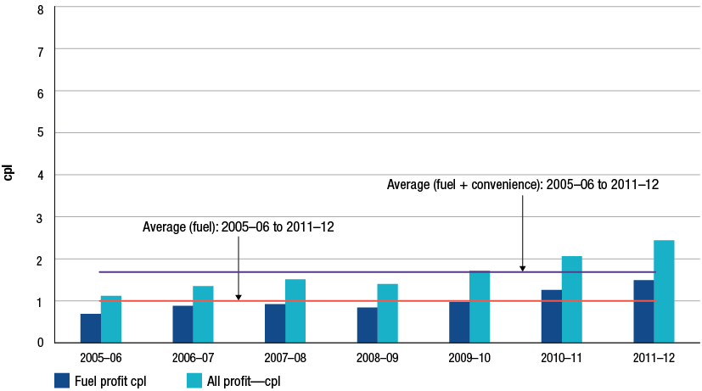
Source: ACCC calculations based on data obtained from firms monitored through the ACCC’s monitoring process
    - Retail sector: other key performance indicators
The ACCC uses a number of other financial KPIs to assess the retail sector. These include return on sales (RoS) and return on assets (RoA). Data on capital expenditure relative to total net profits is also presented. The discussion in section 12.9.5 provides further details on these KPIs.
Chart 14.12 displays these profit KPIs for the period 2002−03 to 2011−12. Key observations regarding these profit KPIs for the retail sector include:
- return on sales increased slightly to 2.2 per cent in 2011−12, up from 2.1 per cent in 2010−11.
- RoS for specialist retailers was 2.37 per cent while independent wholesalers with a retail presence recorded a RoS of 3.07 per cent.
- the average annual RoS for the entire time series was around 1.7 per cent.
- return on assets for the retail sector was around 14.7 per cent in 2011−12, up from 13.4 per cent in 2010−11.
- during 2011−12 RoA was 12.4 per cent for independent wholesalers and about 24 per cent for specialist retailers.
- the average annual RoA for the time series was around 12.0 per cent.
Chart 14.12 Retail sector return on sales and return on assets, all petroleum products and convenience store products and services: 2002−03 to 2011−12
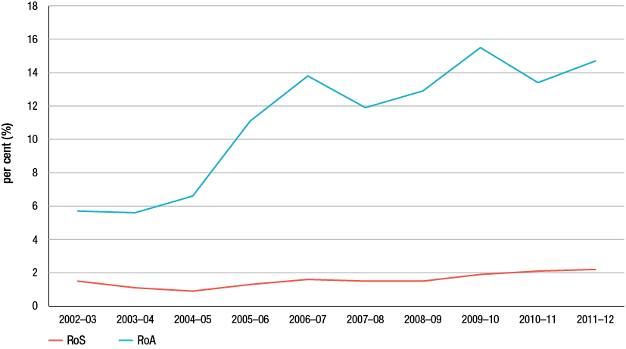
Source: ACCC calculations based on data obtained from firms monitored through the ACCC’s monitoring process
As discussed in section 14.3.3, there are a number of caveats pertaining to data on return on sales and return on assets that should be taken into account when analysing these KPIs. Return on sales is affected by a firm’s cost structure. This means that firms with significant fixed costs rely on volumes to produce adequate returns and will tend to have low returns on sales. Return on assets is affected by different approaches to valuing assets, the allocation of assets across relevant sectors and the asset age profiles.
Chart 14.13 presents capital expenditure and adjusted EBIT in the retail sector over the seven years to 2011−12. Key observations from this chart include:
- total capital expenditure was $201 million in 2011−12, or around 46 per cent of the sector’s net profit for the year
- average annual capital expenditure over the past seven years has been around $169 million per year, averaging about 62 per cent of annual net profit.
Chart 14.13 Retail capital expenditure and adjusted EBIT, all petroleum products and convenience store products and services: 2005−06 to 2011−12
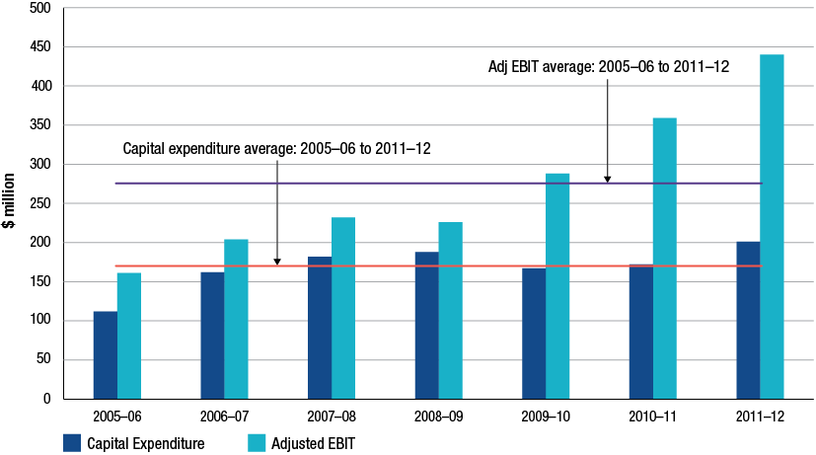
Source: ACCC calculations based on data obtained from firms monitored through the ACCC’s monitoring process
    - Retail sector: total net profits per retail site, all products and services
Profitability measures discussed in sections 14.5.2 and 14.5.3 related to total profits earned by all monitored retail businesses. This section presents profitability measures by retail site, including estimates of the share of profits earned on convenience store products and services by site. When assessing net profit per site, it is necessary to note that the monitored companies have different ownership and profit-sharing arrangements:
- the operators of individual retail sites are not always the owners of those sites
- in some cases the retail site will be managed by staff who either work for a wage, a commission or for a share of profits under a profit-sharing arrangement with the owner
- some of the monitored companies have franchisee arrangements where profit sharing exists on convenience stores and/or fuel sales.
For further details on the methodology used to calculate convenience store profits refer to section 14.10.
Chart 14.14 presents data on retail sector profitability per site from 2009−10 to 2011−12. Key observations from this chart include:
- total net profit by site in 2011−12 was around $145 000, representing an increase of about 12 per cent on 2010−11
- convenience store profit was around $57 000, per site also increasing 12 per cent from 2010−11.
Chart 14.14 Retail sector estimated total and convenience store net profit per site: 2009−10 to 2011−12
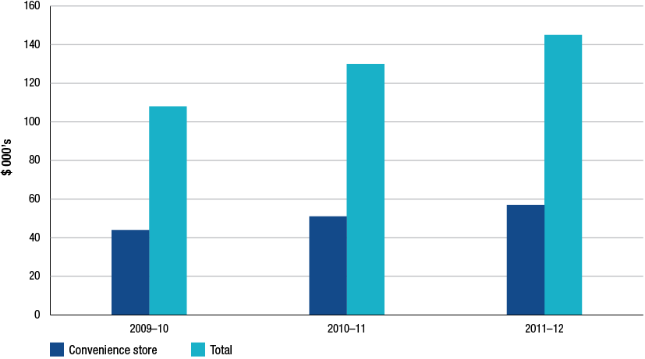
Source: ACCC estimates based on data obtained from firms monitored through the ACCC’s monitoring process
Notes: Data is not comparable to that presented in the 2011 ACCC petrol monitoring report due to some monitored companies changing how they classify and report site ownership types.
  - Retail sector: revenues, costs and profits—petrol products
The previous sections discussed revenues, costs and profits for all fuel sales and convenience store sales and other services. As required under the minister’s direction this section reports on the revenues, costs and profits in the retail sector associated with sales of petrol products. This section presents KPIs on the sale of petrol products including RULP, PULP and EBP. Refer to section 14.11 for further details on the methodology used to allocate costs to individual products.
    - Retail sector: revenues and costs, petrol products
Chart 14.15 displays revenues and costs associated with the sale of petrol products in the retail sector from 2005−06 to 2011−12. Key observations from this chart include:
- total revenues and costs on petrol products grew in 2011−12 to $11.87 billion and $11.64 billion respectively
- total petrol sales volumes increased 1.7 per cent during 2011−12. While RULP volumes have generally been declining since 2006−07, in 2011−12 they increased by 2.6 per cent.
Chart 14.15 Retail sector revenues and costs, petrol products: 2005−06 to 2011−12
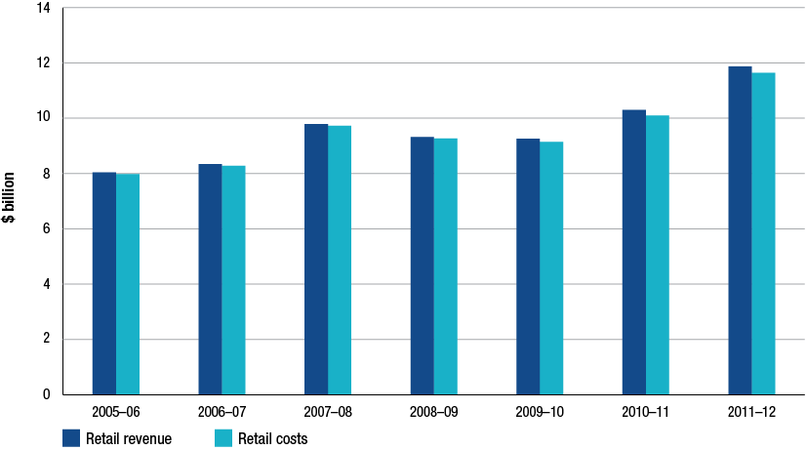
Source: ACCC calculations based on data obtained from firms monitored through the ACCC’s monitoring process
    - Retail sector: total and unit net profits, petrol products
Total net profits
Total retail net profit earned by monitored firms on petrol products during 2011−12 was around $239 million, up about 32 per cent from 2010−11. Annual average net profit for petrol products since 2005−06 has been around $114 million.
Unit net profit
Chart 14.16 shows unit net profit for monitored firms in the retail sector over the seven years to 2011−12. Key observations from this chart include:
- unit net profit for petrol products was around 1.9 cpl in 2011−12, representing an increase of 30 per cent on 2010−11
- average annual unit net profit from 2005−06 to 2008−09 was around 0.5 cpl compared to 1.5 cpl for the three years to 2011−12.
Chart 14.16 Retail sector unit net profit, petrol products: 2005−06 to 2011−12
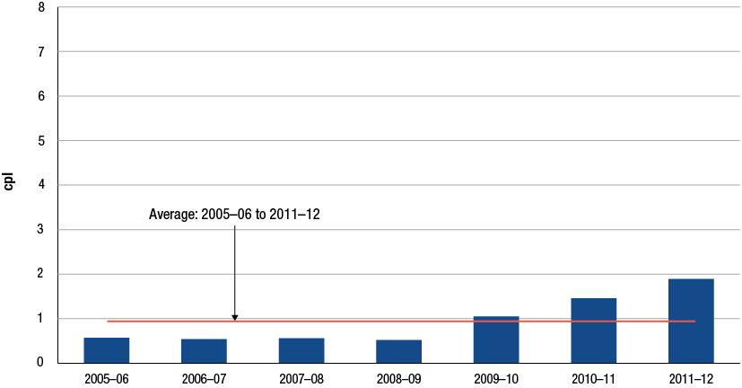
Source: ACCC calculations based on data obtained from firms monitored through the ACCC’s monitoring process
Unit net RULP profit
Chart 14.17 displays unit net profit for RULP products only for monitored firms in the retail sector over the seven years to 2011−12. Key observations from this chart include:
- unit net profit for RULP was 1.2 cpl in 2011−12, increasing from 0.8 cpl in 2010−11
- returns on PULP account for the majority of the increase in petrol net profits during 2011−12 (see section 14.6.3).
Chart 14.17 Retail sector unit net profit, RULP products: 2005−06 to 2011−12
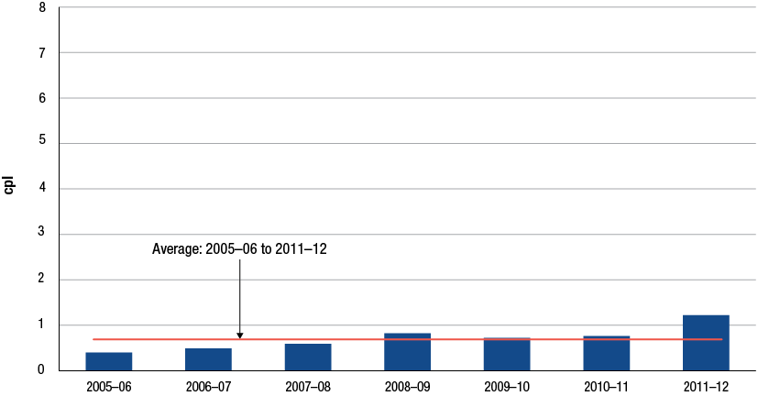
Source: ACCC calculations based on data obtained from firms monitored through the ACCC’s monitoring process
    - Retail sector: petrol and diesel unit net profits
This section assesses the profitability of each petrol product, that is, RULP, PULP and EBP. The profitability of these products is then compared to diesel profits earned by the monitored companies in the retail sector. Chart 14.18 compares the profitability of these four individual products from 2005−06 to 2011−12.
Key observations for unit net profits for these products include:
- PULP unit net profit for 2011−12 was around 3.8 cpl, the largest net profit of any retail petroleum product. PULP volumes increased 10 per cent on 2010−11
- diesel unit net profits were around 1.3 cpl in 2011−12. Diesel volumes recorded the largest increase of any fuel type during 2011−12 with a 14.3 per cent rise on 2010−11
- RULP unit profits were the lowest among all retail fuel types, earning 1.2 cpl during 2011−12
- over the entire time series the average annual unit net profit for PULP products was 2.03 cpl, while diesel averaged around 1.93 cpl, RULP 0.69 cpl and EBP around 0.76 cpl.
Chart 14.18 Retail sector unit net profits, RULP, PULP, EBP and diesel: 2005−06 to 2011−12
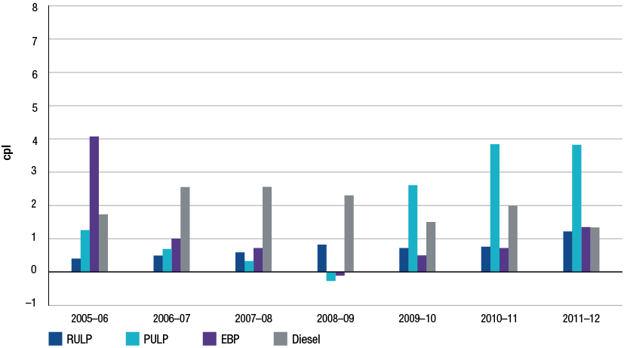
Source: ACCC calculations based on data obtained from firms monitored through the ACCC’s monitoring process
  - Comparison of the profitability of the retail sector with other Australian retail industries
The previous sections have discussed revenues cost and profits for monitored firms in the retail sector.
This section compares the financial performance of monitored firms in the retail sector relative to other selected Australian retail industries. The ACCC has used data for the Australian Securities Exchange’s top 200 (ASX200) businesses by market capitalisation to compile profitability KPIs for selected Australian retailing businesses.
    - Retail sector: Australian comparison—return on sales
The ACCC has calculated return on sales for the retail sector and for retail businesses that are included in the ASX200. The results are an average for the period 2002−03 to 2011−12 and therefore represent results over a decade of activity in the Australian retail sector.
Chart 14.19 shows the average RoS for the period 2002−03 to 2011−12 for the retail petroleum sector and for other selected Australian retailing businesses. Caveats relating to RoS discussed in section 14.5.3 should be taken into account when considering these data.
Key observations for RoS include:
- over the past 10 years the Australian retail petroleum sector average annual RoS was around 1.68 per cent
- the selected retail units from the ASX200 have an average annual return of 7.18 per cent.
Chart 14.19 Comparison of average annual return on sales for the Australian retail petroleum sector and ASX200 retailers: 2002−03 to 2011−12
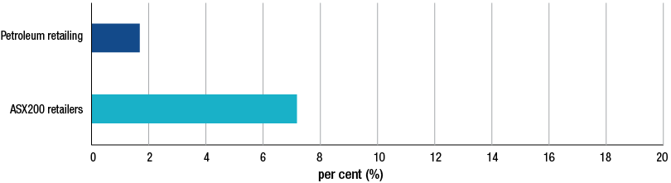
Source: ACCC calculations based on data obtained from firms monitored through the ACCC’s monitoring process; Bloomberg and Bureau van Dijk Orbis database
Notes: Calculations of RoS of more than 70 per cent (positive and negative) in any year for any company have been excluded. Not all companies have data for all years. Some companies report on a calendar-year or other financial-year basis. Revisions to historical data and to the composition of the ASX200 mean that comparisons with data in the comparable chart in the 2011 ACCC petrol monitoring report should be treated with caution.
    - Retail sector: Australian comparison—return on assets
This section compares the RoA in the Australian retail petroleum sector with other selected Australian retail businesses.
The caveats noted in sections 12.7.2 and 13.6.2 with regard to using RoA for the downstream petroleum industry should be noted when comparing data for RoA across firms in different industries. Returns on assets are affected by approaches to measuring asset values and different asset age profiles. In the case of firms operating in multiple sectors of the Australian downstream petroleum industry, the allocation of assets to retail operations can also affect RoA. Retail business models based on different approaches to asset ownership can also impact RoA values and comparisons.
Chart 14.20 presents average RoA for the period 2002−03 to 2011−12. Key observations from this chart include:
- the retail petroleum sector average RoA was 12.01 per cent.
- the average return for the selected retail businesses from the ASX200 was 16.76 per cent.
Chart 14.20: Comparison of average annual return on assets for the domestic retail petroleum sector and ASX200 retailers: 2002−03 to 2011−12
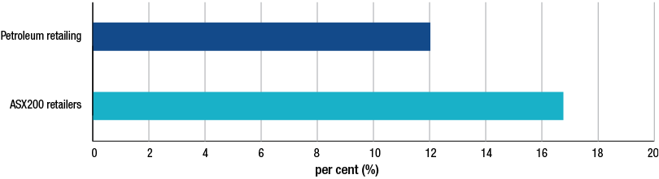
Source: ACCC calculations based on data obtained from firms monitored through the ACCC’s monitoring process; Bloomberg and Bureau van Dijk Orbis database
Note: Calculations of RoA of more than 70 per cent (positive and negative) in any year for any company have been excluded. Not all companies have data for all years. Some companies report on a calendar-year or other financial-year basis. Revisions to historical data and to the composition of the ASX200 mean that comparisons with data in the comparable chart in the 2011 ACCC petrol monitoring report should be treated with caution.
  - International comparative analysis: the profitability of the Australian retail petroleum sector and international petroleum retailers
This section benchmarks the profitability of monitored firms in the Australian petrol retail sector against international firms whose predominant activity is petrol retailing. Data for RoS and RoA are used to compare Australian firms against comparable overseas firms. Around 22 international companies were selected for the comparison sample.
    - Retail sector: international comparison—return on sales
Chart 14.21 displays RoS for the Australian petrol retail sector and overseas petrol retail companies.
The data in chart 14.21 shows that the RoS between the two groups is broadly comparable and highlights that the fuel retail sector is a low-margin, high-volume industry. The Australian average annual RoS for the period 2002−03 to 2011−12 was 1.68 per cent compared to around 1.70 per cent for the international units.
Chart 14.21: Average annual return on sales for the Australian retail petroleum sector and international retail petroleum sector: 2002−03 to 2011−12
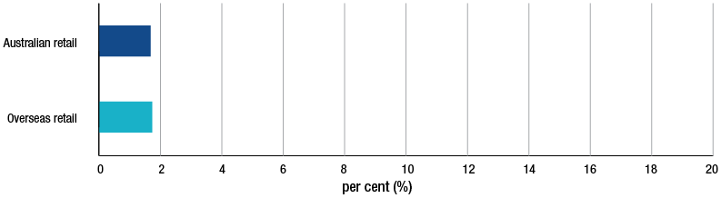
Sources: ACCC calculations based on data obtained from firms monitored through the ACCC’s monitoring process; Bloomberg and Bureau van Dijk Orbis database and Onesource database and individual company annual returns
Notes: Not all companies have data for all years. Some companies report on a calendar year or other annual basis.
The selection of an overseas company was based on the following criteria: it had to be based in an OECD country; be non-government owned; and have annual turnover greater than USD 10 million. Companies were also screened on the basis of their activity profile to ensure comparability with Australian downstream petroleum companies. That is they had to derive their income from the refining and marketing of petroleum products. Major international refiner-marketers with large upstream activities such as Exxon Mobil British Petroleum and Chevron were excluded from the sample. A company was also excluded if it had significant non-petroleum related secondary activities such as chemical manufacturing or gas related activities. Calculations are based on a sample of 22 international retailers.
    - Retail sector: international comparison—return on assets
Chart 14.22 displays RoA for the Australian retail petrol sector and for the same overseas petrol retail businesses presented in section 14.8.1.
The caveats outlined in section 14.7.2 regarding comparisons of rates of return on assets across firms and industries also apply in respect to data presented in this section.
The average annual RoA for the Australian petroleum retail sector during the period 2002−03 to 2011−12 was 12.01 per cent compared to the international average of 8.63 per cent.
Chart 14.22: Average annual return on assets of the Australian retail petroleum sector and international retail petroleum sector: 2002−03 to 2011−12
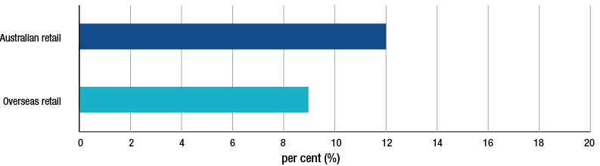
Sources: ACCC calculations based on data obtained from firms monitored through the ACCC’s monitoring process; Bloomberg and Bureau van Dijk Orbis database and Onesource database and individual company annual returns
Notes: Not all companies have data for all years. Some companies report on a calendar year or other annual basis.
The selection of an overseas company was based on the following criteria: it had to be based in an OECD country; be non-government owned; and have annual turnover greater than USD 10 million. Companies were also screened on the basis of their activity profile to ensure comparability with Australian downstream petroleum companies. That is they had to derive their income from the refining and marketing of petroleum products. Major international refiner-marketers with large upstream activities such as Exxon Mobil British Petroleum and Chevron were excluded from the sample. A company was also excluded if it had significant non-petroleum related secondary activities such as chemical manufacturing or gas related activities. Calculations are based on a sample of 22 international retailers.
  - Retail sector: the importance of convenience store sales
Petrol retailing in Australia (and overseas) includes a proportion of revenues and profits derived from sales of non-fuel products at convenience stores and services such as hiring equipment and washing facilities. The introduction of canopy sites located in car parks of supermarkets retailing petrol is another recent feature of the retail convenience store market.
This section considers the significance of convenience store sales and profitability in the petrol retail sector. As noted in section 14.5, monitored retail companies have a wide variety of business models which can affect convenience store profits. In some cases a profit sharing arrangement exists with the franchisee while in others a third party operates the convenience store and shares petrol profits. A more conventional business model may exist in other cases where all convenience store revenues and profits are to the account of the owner of the site.
    - Retail sector: convenience store gross profits and margins
This section analyses gross margins for retailing both fuel and convenience store products.
Gross margins are calculated by subtracting the cost of goods (purchases and usually transport costs in the retail sector) from revenue. Gross margins are typically expressed as a percentage of revenue. This provides a percentage measure that highlights the core profitability of a company before operating expenses are deducted. The gross margin represents the proportion of each revenue dollar that a retailer retains after deducting the direct costs associated with the sale of the good. The higher the percentage the more a firm retains from each sales dollar.
Gross margins for petroleum and convenience store sales are presented in chart 14.23 over the period 2006−07 to 2011−12. Key observations regarding gross margins in the retail sector include:
- convenience store sales have the largest gross margin of any product sold at retail petrol sites. The gross margin in 2011−12 was 32 per cent, consistent with gross margins achieved over the time series.
- in contrast, diesel gross margins were around 7.6 per cent during 2011−12 and petrol margins were around 7.9 per cent.
Chart 14.23 Retail sector gross margins for petrol, diesel, automotive LPG and convenience store sales: 2006−07 to 2011−12
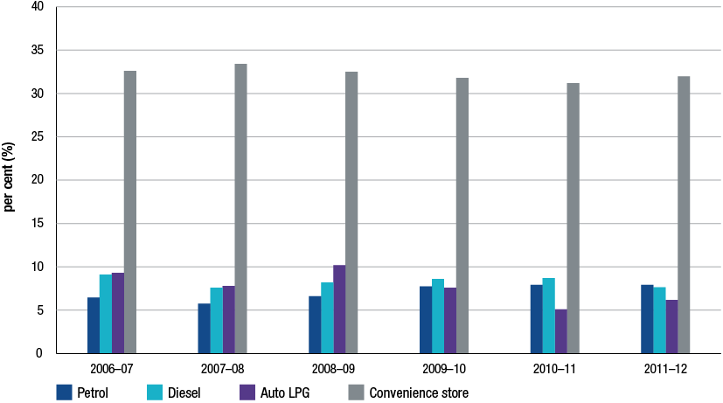
Source: ACCC analysis based on data obtained from firms monitored through the ACCC’s monitoring process
The ACCC has noted in previous monitoring reports the trend towards new and imaginative ways of increasing convenience store sales and profits. For example, some petrol retailers have adopted a business model whereby franchised and/or independently run and operated businesses operate from within the convenience store site.
    - Retail sector: convenience store net profits
This section assesses the profitability of convenience store products and services compared with fuel sales. The methodology for allocating costs among individual retail products and services is outlined in section 14.10.
Chart 14.24 presents net profit for convenience and fuel sales in the retail sector. Key observations from the chart include:
- in 2011−12 convenience store net profit accounted for around 39 per cent of total retail profits. During 2011−12, total convenience store profits increased 23 per cent to $171 million.
- apart from 2006−07 when convenience store profits were around 35 per cent of total net profits, convenience store profits as a share of total profits has averaged around 40 per cent over the time series
- net profit from petrol sales has increased from 30 per cent of total profits in 2006−07 to around 54 per cent for 2011−12
- for the past three years, retailers have on average, incurred losses on the sale of LPG.
Chart 14.24 Retail sector total net profit for petrol, diesel, automotive LPG and convenience store sales: 2006−07 to 2011−12
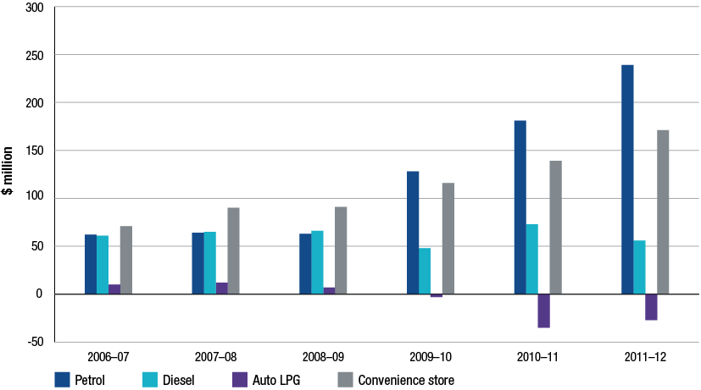
Source: ACCC analysis based on data obtained from firms monitored through the ACCC’s monitoring process
  - Methodology note
Wholesale allocations
The data presented for the Australian wholesale sector includes imports by independent wholesalers. It was not methodologically possible to allocate these imports to the total supply sector as with the refiner-wholesalers’ imports. The revenues and costs associated with these volumes are included in the independents’ wholesale financial data.
The assessment of revenues in the wholesale sector is complicated by the provision of price support. Price support is a mechanism used by some fuel suppliers to provide assistance to linked retailers during times of heavy price discounting (normally at the trough of a retail price cycle). Among other things, price support allows the supplier to partly control or influence the setting of prices for certain products at certain retail sites. For the purposes of assessing revenues, price support has been deducted from each product’s sales revenue.
Retail sector sample
The ACCC’s monitoring program does not encompass the entire retail sector, due to the very large number of small businesses. The ACCC has collected data from retail businesses operated by the refiner-marketers, major independent wholesalers and importers, supermarkets and the larger specialist retailers. The retail sector is also comprised of many single and multi-site independent retail site owners
Data has been collected from the following larger retail sector businesses:
refiner-marketers BP and Caltex
large independent chains On the Run, 7-Eleven, United Petroleum, Ausfuel and Neumann Petroleum
- supermarkets Coles Express and Woolworths Petrol.
As such, the ACCC considers that the scope of the monitoring program is sufficiently wide to capture a significant proportion of retail outlets.
Convenience store profit calculation
To calculate convenience store profits, the ACCC has adjusted the methodology that is used in the refinery, total supply and wholesale sectors. While sales and purchases by type of product in the retail sector can be measured without difficulty estimating net profits is complicated by the presence of common costs.
In order to calculate net profits by product, common costs were allocated through a two-stage process. Firstly, gross profit by convenience store and fuel sales were used to prorate costs between these two broad activities. Secondly, costs were then split by product on the basis of the relative product volumes sold.

- Key trends in Australia’s petroleum industry
Key points
- After record average crude oil prices in 2011−12, evidence suggests that despite a weak global economy (and prospects of new additions to oil reserves), oil prices may remain higher over the longer term as a result of:
- increasing demand, particularly from industrializing Asia
- continuing depletion of low cost conventional sources of crude oil and
- increasing use of more expensive less conventional sources of crude oil.
- The nature of the supply of petrol to Australia is undergoing changes as the local refining industry faces strong competition from larger, more modern refineries in the Asia-Pacific region. The recently announced refinery closures in Sydney are evidence of the challenges faced by Australia’s refinery sector.
- Imports of petrol are set to increase further and are likely to contribute an increasing share of total petrol sales in line with the expansion of Australia’s import infrastructure.
- Independent importers’ ability to compete against established petrol companies has improved with greater range of supply options and access to import terminals.
- The refiner-wholesalers continue scaling back their presence in downstream operations while specialist retailers are consolidating their presence in Australia’s evolving retail sector.
- Australia’s experience with petrol prices has similarities with that of some other countries.

  - Industry trends
Key trends that have emerged in Australia’s downstream petroleum industry in recent years are continuing to have a significant impact in all sectors of the industry.
The most significant trends affecting petrol markets include:
- rising prices of crude oil
- the impact on established refineries of new and large refineries in the Asian region
- the establishment/growth of independent importers with access to secure sources of refined petrol and to domestic markets for their imported fuel
- withdrawal of refiner-wholesalers from the retail sector and emergence of specialist petrol retailers
- integrated petrol companies refocussing away from downstream to upstream operations.
Australia’s experience is not alone in this regard. Similar trends are affecting the structure of petroleum industries in other developed countries.
  - Crude oil: the outlook for costs, supply and prices
Costs and prices of petrol products in Australia, and around the world, are ultimately driven by changes in the price of crude oil. Chapter 4 describes the international context behind crude oil price movements over time and highlights the relatively steep increases in crude oil prices in recent years.
In 2011−12 the average annual price of Brent crude oil was USD 112 per barrel, the highest on record. This comes at the end of a rising trend over the past decade where, with the exception of the fallout in 2008−09 after the global financial crisis (GFC), average crude oil prices have increased steadily since 1999.
    - Production costs
While crude oil prices are influenced by a wide range of factors impacting on demand and supply conditions, one of the key factors is the cost of production.
All else equal, as the cost associated with the exploration and development of crude oil reserves increases, prices can be expected to rise. Although there are significant reserves of low-cost oil in easily accessible reservoirs, these are being steadily depleted and the discovery of additional low-cost resources is becoming increasingly scarce. This means that supplies are likely to continue to be supplemented by crude from unconventional sources, where oil extraction is more difficult and more costly.
Higher crude oil prices have improved the viability of unconventional sources which can only be accessed by the application of advanced technologies to discover and exploit oil deposits. The 2011 ACCC petrol monitoring report presented an oil production cost schedule based on estimates of the International Energy Agency (IEA) showing that with the price of Brent at around USD 110 per barrel (as has been the case during most of 2012), a number of more advanced and costly production methods appear feasible (including extraction from very deep water, tar sands, bitumen, oil shales, enhanced oil recovery and coal/gas to oil conversions). Some of these sources of oil were discussed in chapter 4.
    - Advances in global crude oil supplies
Examples of unconventional sources of crude oil where commercial viability has improved in recent years include shale oil reserves in the US and the tar sand deposits in Canada.
In the US there has been significant capital invested in developing shale oil deposits, particularly in North Dakota and Texas. Growth in these areas has come relatively quickly, and to some extent, outpaced local infrastructure capabilities.
Although still under assessment in terms of their achievable output, reports suggest that these deposits, and the crude that may be extracted from them, may have the potential to affect the supply picture in the US. In part because of the contribution to crude oil supplies by shale oil deposits, US imports of crude oil have fallen from 60 per cent of total consumption in 2005 to about 45 per cent in 2011. Recent reports suggest that the growth in supply from oil shale reserves has the potential to continue to allow the US to reduce its reliance on imports.
Another potentially significant source of unconventional supplies of crude oil are tar sands. A prominent source of tar sand deposits is located in Alberta, Canada. These vast deposits make up about 98 per cent of Canada’s oil reserves but have only recently become technically and economically recoverable. Depending on the method of extraction, the cost of oil sands production can range from around USD 40−100 per barrel, making production viable but still somewhat sensitive to oil price movements.
With tar sands production contributing over half of Canadian oil output in 2011 the US Energy Information Administration (US EIA) considers Canada’s tar sands a significant contributor in supporting future oil supplies.
    - Future crude oil prices
Oil price forecasts are subjects to dramatic swings based on economic sentiment, hopes for technological breakthroughs, new discoveries and global and local geopolitical tension.
Members of OPEC reportedly consider USD 100 per barrel to be an ‘acceptable’ price of Brent crude oil in the current circumstances, and that any price higher is a reflection of market sentiment rather than fundamentals.
Data in table 4.2 in section 4.6 shows a range of projections for crude oil prices particularly looking towards the medium to long term. The US EIA and IEA predict oil prices continuing to rise towards USD 140 per barrel (at current prices) by 2035.
With continued global economic growth, particularly in energy intensive Asian economies as well as increased use of more costly and unconventional sources of oil, high prices are likely to persist.
  - Refining facing challenges
In the next few years Australia will reduce its domestic refining activities and concomitantly source an increasing proportion of its refined petrol through imports. The recent closure of Shell’s Clyde refinery and the announced closure of Caltex’s Kurnell refinery and review of Shell’s Geelong refinery are evidence of a sector with an uncertain future.
The reduction of local refining capacity translates directly to an increased need for imported products, which will be facilitated by the planned conversion of the Clyde and Kurnell refineries into import terminals. Currently petrol imports account for around 20 per cent of sales and are likely to contribute an increasing share of Australia’s future fuel supplies.
Refinery closures and the shift towards an increased reliance on petrol imports are closely linked to competitive pressures facing the global refining industry. Both Shell and Caltex noted that a major factor behind their decision to close their refinery facilities was the fierce competition from larger Asian refineries.
    - Competition from refineries overseas
For some time output from newly constructed large and complex refineries in a number of developing countries has led to surplus refining capacity in the Asia-Pacific region.
Asian refiners equipped to produce fuel to Australian standards are able to compete directly against Australian refineries. A number of Asian refineries are more efficient and larger than those in Australia, providing them with greater economies of scale and lower unit costs. In addition, some of the new Asian refineries are highly complex, meaning that they can process cheaper lower quality oil, offer lower prices and produce high-quality products.
Table 15.1 compares four Australian refineries against some of the larger refineries in the Asia-Pacific region. The table shows the year refining operations began, the complexity rating and the capacity of each refinery. Complexity is measured by the Nelson complexity index which provides insight into replacement costs and rates the ability of a refinery to add value to crude. A higher rating means the refinery can add greater value when processing a barrel of oil.
Table 15.1 Selected refineries in the Asia-Pacific region
Country | Refinery | Year operations began | Nelson complexity index | Capacity  (bpd) | Status
Australia | Shell, Clyde | 1926 | n/a | 86 000 | Closed
Australia | Caltex, Kurnell | 1956 | n/a | 135 500 | Announced to close
Australia | BP, Kwinana | 1955 | 7.6 | 143 000
Australia | BP, Bulwar Island | 1965 | 7.3 | 102 000
Singapore | Exxon Mobil Jurong | 1965 | n/a | 605 000
South Korea | S-Oil, Onsan | 1980 | n/a | 580 000
South Korea | GS-Caltex, Yeosu | 1969 | n/a | 775 000 | Expansions planned
South Korea | SK Energy, Ulsan | 1964 | n/a | 840 000
India | Reliance Jamnagar | 1999 | 11.3 | 660 000
India | Reliance Jamnagar (expansion) | 2008 | 14.0 | 580 000

Source: Company websites
The Reliance complex in Jamnagar is the largest refining facility in the world and is capable of processing low-cost heavy and sour crudes to produce high-quality fuel products. South Korea has significant refining capacity and is expected to remain a leading refiner in the region, with significant exports to surrounding countries. Australian imports of petrol from South Korea have increased from 18 megalitres (ML) in 2007−08 to 676 ML in 2011−12.
In comparison, Australia’s refineries are relatively small and aged. Even Australia’s largest refinery, Kwinana, appears small compared with many of the large regional refineries and one of Australia’s newer refineries, at Bulwer Island, is now over 45 years old. Also, it is possible that other operating and maintenance costs, such as labour and energy costs, are also higher in Australia than other countries in Asia.
Data presented in chapter 13 indicates in addition to losses on inventory holdings and foreign exchange transactions, refineries also faced an increase in conversion and operating costs (excluding crude oil purchases) of around $400 million during 2011−12. With prices of refinery outputs set on the basis of import parity prices, which are in turn established with reference to international benchmark prices for refined petrol, Australian refiners have little scope to raise prices to cover domestic costs that are out of line with international best practice for refinery production.
While Australia’s refineries have been maintained to high standards through new investment and refinery upgrades over time, recent decisions taken by Shell and Caltex indicate difficulties in justifying continued funding of these expenditures.
It is likely that the Australian refinery sector will continue to face a challenging future.
    - Shutdowns and rationalisation of refining assets
Data presented in chapter 13 illustrates the modest profitability of Australia’s refining sector, particularly in the period following the GFC.
In addition to the Clyde and Kurnell closures, Shell has also been reported to have some doubt about the future of their Geelong refinery in the face of strong international competition and cheap shipping. Shell reported that the future of the refinery is ‘borderline’ and may be impacted when the further capital investment is required to maintain reliability. As the Geelong refinery requires imports of crude to feed production, a switch to directly importing petrol is not a big jump, according to Shell, commenting that there is no structural reason to keep the facility operating.
Refineries in other OECD countries appear to be experiencing challenges with some facing a similar fate as those in Australia.
In the UK, the government has recently acknowledged that refineries are increasingly coming under competitive pressure from other refineries in Europe and across Asia. In May 2012 administrators announced the closure of the Coryton refinery near London. It was subsequently announced that the facility will be converted into an import and storage terminal.
Refining assets in Japan are also under review with the decision to close Cosmo Oil’s 140 000 barrels per day (b/d) Sakaide refinery in West Japan, again, due to competition from newer and more advanced refineries.
The longer-term rationalisation of refineries has been a common trend around the world for some time:
In 1985 there were almost 200 refineries operating in the US. By the start of 2012 the number of operating US refineries had fallen to 134.
- The number of refineries across Europe has also fallen over time. In the UK, for example, of the 19 major refineries in 1975 only seven were operating in 2012.
  - The impact of independent importers and retailers
Another key trend which has been evident for some time is the evolving nature of the market structure and of industry players in Australia’s downstream petroleum industry. There have been two key shifts in the industry:
- independent wholesalers have become more active importers of fuel in Australia as a result of improved access to terminal infrastructure and more overseas supplies of Australian standard fuel
- specialist retailers including the supermarkets have increased their presence in the retail sector.
    - Independent imports
A number of independent wholesalers have now become significant importers of petrol, making up around 30 per cent of total petrol imports in 2011−12. This has changed from a position in 2007−08 when independent wholesalers only imported about 5 per cent of total petrol imports. As noted, the increased availability of Australian-standard fuel from the Asia-Pacific region and improved access to import terminal infrastructure have been key factors underpinning the growth of independent imports into Australia.
Over the five years to 2011−12 there has been significant change in Australia’s import terminal infrastructure. While traditionally most terminals have been owned and operated by the refiner-wholesalers, independents have been very active in this sector, accounting for almost all of the net growth in import terminal capacity and throughput since 2007−08. Chart 15.1 shows that independent import terminal capacity has grown by around 50 per cent while their throughput has increased by over 90 per cent.
Independents have invested in expanding capacity at key import terminals around Australia in recent years, including in Sydney (Vopak), and also refinery-pipeline terminals with import capacity, including in Brisbane (Neumann) and Perth (Coogee Chemicals).
Construction of additional terminal infrastructure is also underway including Terminal Pty Ltd’s 85 ML import terminal in Adelaide, and Stolthaven’s import terminal in Newcastle estimated to hold about 54 ML of diesel.
Chart 15.1 Change in capacity and throughput of petrol at import terminals by type of owner:
2007−08 to 2011−12
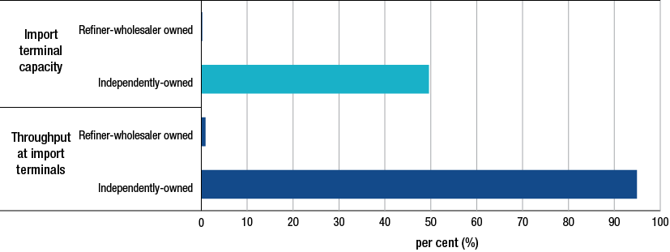
Source: ACCC analysis based on data obtained from firms monitored through the ACCC’s monitoring process
With a much greater presence in importing and access to terminal infrastructure, independents appear to be well placed to cater for the anticipated increase in imported fuel.
    - Retail
The most significant development in the retail sector in recent years has been the continued expansion of specialist retailers such as 7-Eleven and On The Run and the major supermarkets, Coles and Woolworths. These retailers contributed around 60 per cent of branded retail sales in 2011−12.
The expansion of these retailers has brought with it a greater focus on petrol sites combined with a convenience shopping experience. Numerous retail sites nationally now offer not only a selection of fuel or automobile related goods but also an on-site mini supermarket intending to provide motorists with a ‘one stop shop’ for both fuel and other grocery goods.
Profitability results discussed in chapter 14 indicate that sales of convenience and grocery products significantly contribute to retail earnings, with the margins on convenience products higher than those traditionally earned on fuel and related goods.
As with developments in the refinery sector, there is evidence that Australia’s experience in the retail sector is not unique. For example, in the United Kingdom the number of supermarket-owned and operated retail petrol sites has continued to increase while several oil companies have exited the retail market with the result that the total number of retail petrol sites is in decline. According to the United Kingdom Petroleum Industry Association (UKPIA), in 2011 supermarkets owned 16 per cent of retail petrol sites but accounted for almost 39 per cent of retail sales.
    - Attractive returns upstream
One of the consequences of the deterioration of the outlook for refining and the successful entry of specialist retailers has been the move by many integrated companies away from downstream businesses in order to concentrate on the pursuit of more attractive returns in upstream activities.
Data presented in previous ACCC monitoring reports has illustrated the difference in returns generated by integrated oil companies from upstream and downstream operations, with upstream operations clearly achieving consistently higher earnings and rates of return on assets. As crude oil prices rise, production of crude, particularly from low-cost conventional sources, is increasingly profitable and returns from upstream activities become more attractive.
In addition to the recent closing of a refinery in Australia, Shell largely withdrew from petrol retailing in 2003 when it entered into an alliance with Coles Supermarkets. Mobil has had a similar strategy of downstream retrenchment. Mobil ceased refinery operations at Port Stanvac in Adelaide in 2003 and exited the retail market when its retail network was sold to 7-Eleven and On The Run in 2010.
Overseas, companies such as ConocoPhilips, BP and Royal Dutch Shell have already taken steps to streamline their operations. After announcing its intention to divide its upstream and downstream businesses last year, ConocoPhilips split its refineries, pipelines and chemicals division into a separate company in April 2012.
Consistent with this trend, in January 2012, Exxon Mobil announced it was selling 99 per cent of its Japanese refining operations to a joint-venture partner and divesting its controlling interest in its Japanese subsidiary.
  - Australia’s petrol pricing experience is not unique
Chapter 11 compares Australia’s petrol pricing experience with that observed in five other developed countries, highlighting that the experience of motorists in other countries has similarities with the experience of Australian motorists. Evidence on the behaviour and composition of petrol prices in Australia, Canada, California (US), New Zealand, Germany and the UK indicates that in each country:
- petrol prices closely reflected movements in the relevant international benchmark prices for refined petrol in their respective regions
- changes in the value of currencies against the USD affected retail prices as international benchmark prices in all regions are determined in USD
- the cost of crude oil plus fuel taxes made up the majority of the price of petrol, though their specific contribution varies from country to country.
Once the impact of local taxes is excluded, retail petrol prices in each country track a similar path. Chart 15.2 shows how pre-tax petrol prices in Australia, Canada, California, New Zealand, Germany and the UK have ranged within a band over the five years to June 2012.
Chart 15.2 Range of weekly retail petrol prices excluding taxes across Australia, Canada, California, New Zealand, Germany and the United Kingdom: July 2007 to June 2012
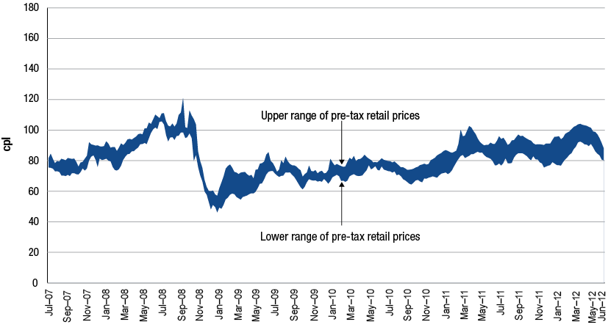
Source: Informed Sources, MJ Ervin, Californian Energy Commission, New Zealand Ministry of Economic Development, European Commission, RBA
The tendency for petrol prices to move in a regular cycle in the larger Australian cities has also been observed in a small number of overseas markets. Section 11.4 illustrates the day-to-day movements of petrol prices in Indianapolis and Montreal, two North American cities where petrol prices are shown to move in the familiar sawtooth pattern seen in Australia. Evidence of cyclical price movements has also been noted in Germany.
While the concept of petrol price cycles is not unique to the larger Australian cities, the characteristics of the price cycles occurring in Australia appear slightly different to other parts of the world in terms of the frequency and the amplitude of the cycles.
  - Australia’s fuel mix
An interesting feature of petrol markets in Australia in the last several years has been the change in product mix in retail sales.
Chart 15.3 shows the stark change in Australia’s retail fuel diet between 2005−06 and 2011−12. The share of regular unleaded petrol (RULP) has decreased from over 60 per cent to about 40 per cent in 2011−12. On the other hand sales of premium unleaded petrol (PULP), diesel and ethanol blended petrol (EBP) have become a greater proportion of the total market over the last few years.
Chart 15.3 Australia’s retail product mix: 2005−06 and 2011−12
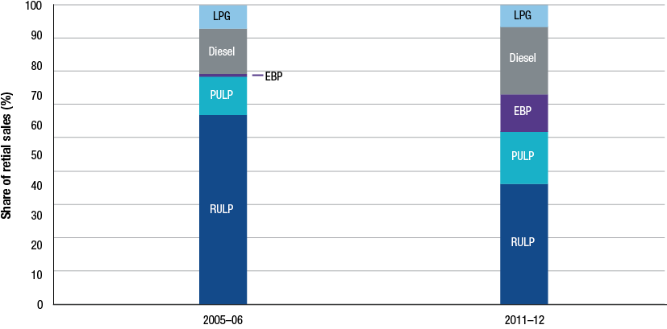
Source: ACCC calculations based on data obtained from firms monitored through the ACCC’s monitoring process
Two key factors that have contributed to this swing in product mix include the changing nature of the vehicle fleet and the NSW Government mandate on EBP sales.
Australia’s vehicle fleet has evolved from being predominantly powered by petrol to now include a greater proportion of vehicles taking diesel fuel. According to the Motor Vehicle Census conducted by the Australian Bureau of Statistics (ABS) the proportion of registered vehicles that use petrol has dropped from 89 per cent in 2001 to just over 81 per cent in 2012. This trend has gained momentum in recent years with the number of registered passenger vehicles using diesel more than doubling since 2007.
- The New South Wales Government’s ethanol mandate is another factor affecting sales of EBP, RULP and PULP. Data in chapter 5 shows that a number of retail sites in Sydney have ceased selling RULP over the last five years, generally replacing it with E10. The NSW mandate has also contributed to the increased demand for PULP as some consumers switch fuels due to the lack of availability of RULP. The NSW ethanol mandate required 2 per cent of the total volume of petrol sold in NSW to be ethanol from October 2007. This had increased to 6 per cent by October 2011.
    - Alternative transport fuels
Developments in alternatives to conventional hydrocarbon fuels were discussed in detail in the 2010 ACCC petrol monitoring report. These alternatives include natural gas, hydrogen, biofuels and electric powered vehicles.
To a large degree, consumer acceptance of alternative fuels hinges on the affordability of current transport arrangements and the extent that crude oil prices push up the price of petrol.
The IEA has been proactive in setting out steps to reduce the reliance on oil for transportation, with a longer term view to halving fuel used for road transport in under 40 years.
  - Carbon pricing
On 1 July 2012 the Australian Government’s price on carbon became effective. The carbon price would not apply to fuel purchased for passenger and light commercial vehicles.
Companies could potentially pass on the carbon price they are exposed to, although it appears to have had a negligible effect on retail prices.
  - Conclusions
The key trends that have shaped the industry over the last few years, and have continued in 2011−12, include:
- Record high average crude oil prices in 2011−12. Forecasts over the longer term suggests that despite a weaker global economy high oil prices are likely to persist due to depletions in conventional sources of crude and increased use of more costly unconventional sources.
- Supply of petrol to Australia is undergoing lasting change with the closure of the Clyde refinery in October 2012, and the announced closure of the Kurnell refinery in 2014. The refining industry is likely to continue to face strong competition from newer and larger refineries in the Asian region.
- With challenges in domestic refining, imports of petrol are set to contribute a greater proportion of petrol sales, underpinned by expansion of import infrastructure.
- Independent wholesalers have consolidated their position in the industry and have investments in import capabilities.
- Large oil companies all over the world have been scaling back their presence in downstream operations in light of more attractive returns from upstream operations.
- In Australia, specialist retailers such as 7-Eleven and On the Run are consolidating their presence in Australia’s evolving retail sector.
- Australia’s experience with petrol prices, with the price of crude oil and taxes making up the majority of retail prices and international benchmark prices and currency exchange rates driving changes in retail prices, has similarities with that of some other countries.
- The mix of fuels sold at the retail level has undergone significant change since 2005−06. PULP, diesel and EBP have all become much more important in Australia’s fuel mix, as the share of RULP sold has fallen to contribute less than half of retail fuel sales.

Appendix A: Minister’s letter and direction
Letter and direction to the ACCC from the Parliamentary Secretary to the Treasurer establishing the formal monitoring of the prices, costs and profits of unleaded petrol in Australia—2012
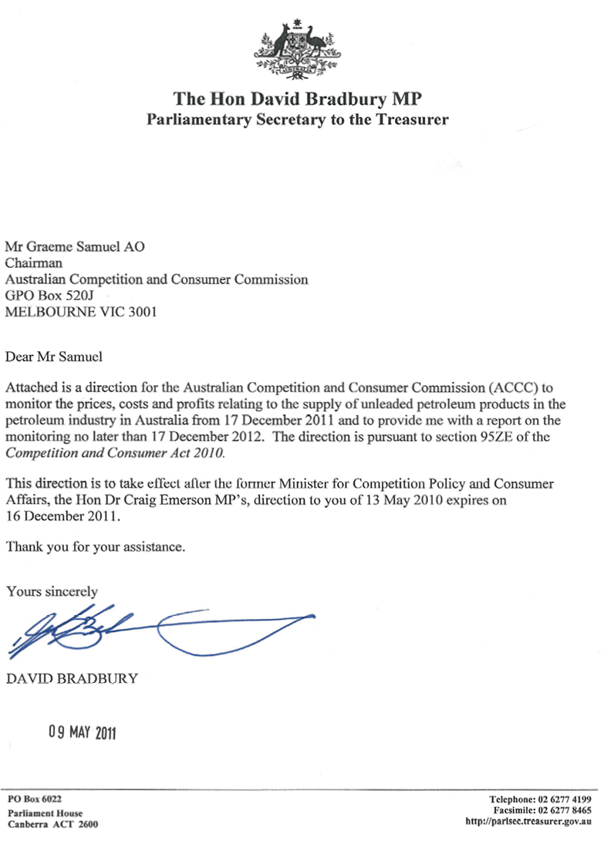
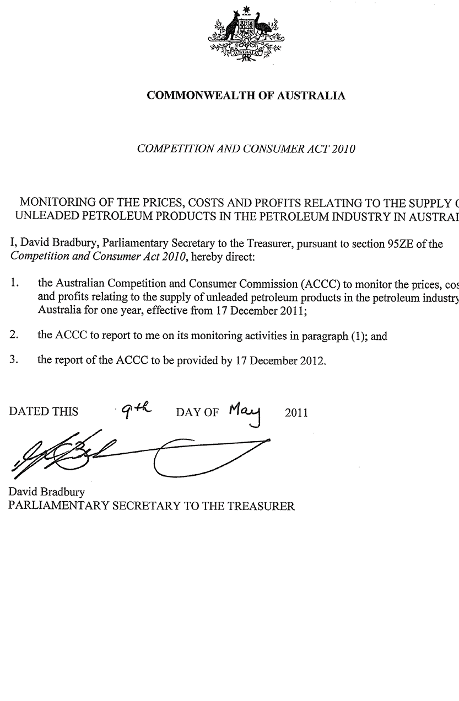

Appendix B: Major infrastructure schematics
Figure B.1 New South Wales oil flow schematic
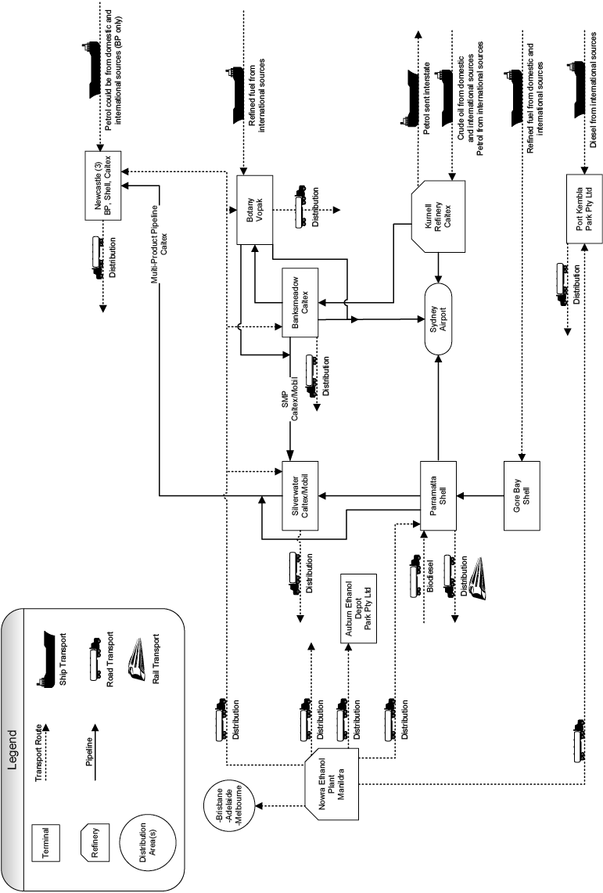
Source: Prepared by the ACCC and RLMS Pty Ltd.
Figure B.2 Queensland oil flow schematic
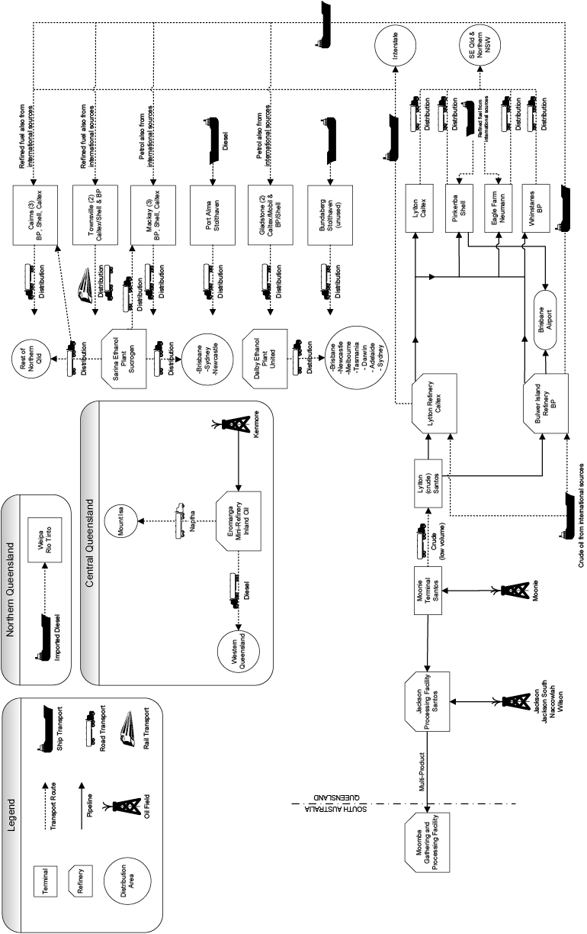
Source: Prepared by the ACCC and RLMS Pty Ltd.
Figure B.3 Victoria and Tasmania oil flow schematics
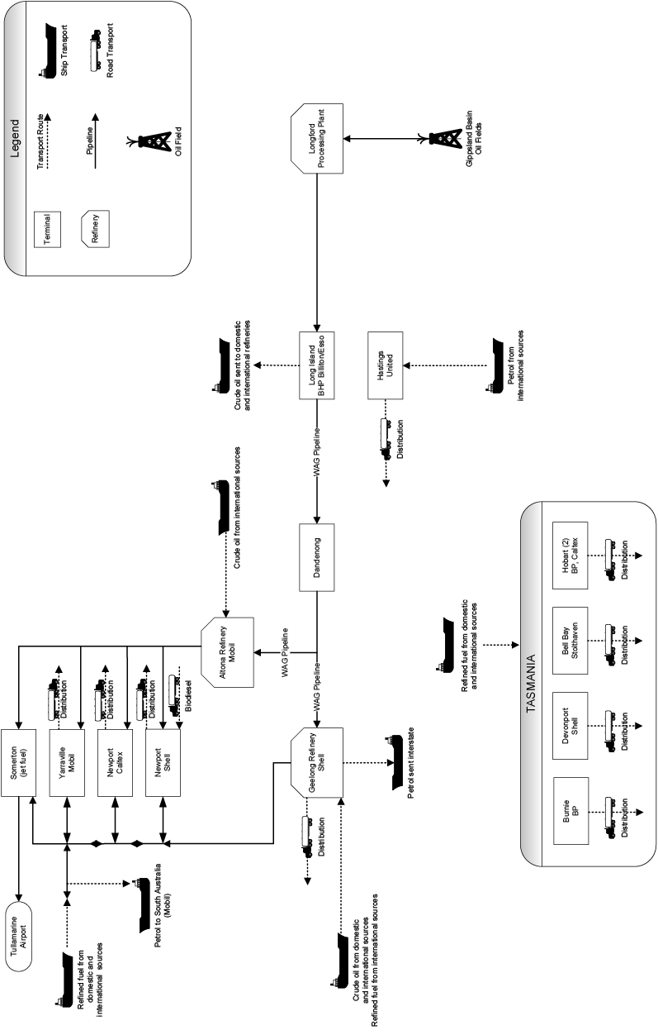Source: Prepared by the ACCC and RLMS Pty Ltd.
Figure B.4 Western Australia, Northern Territory and South Australia oil flow schematics
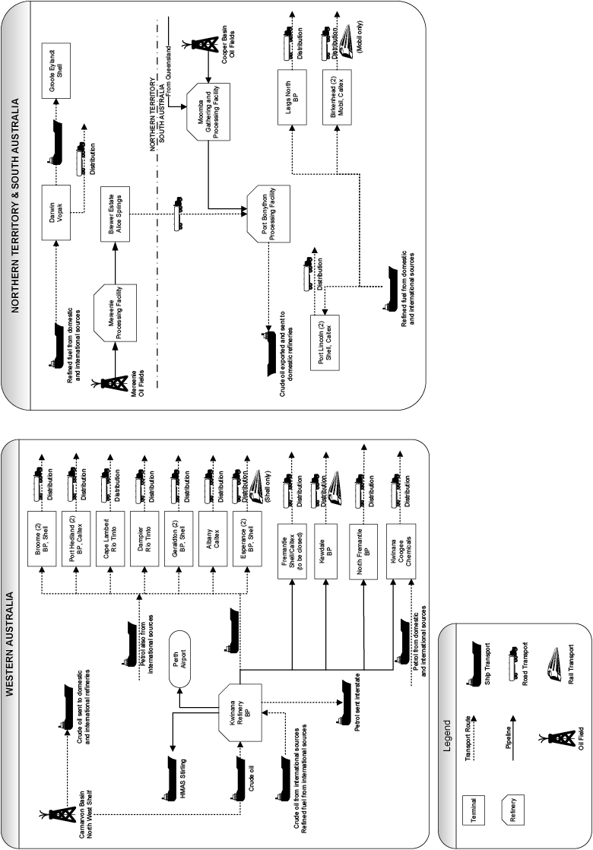
Source: Prepared by the ACCC and RLMS Pty Ltd.

Appendix C: Major Australian terminals
Table C.1 Major terminals: New South Wales
Location | Owner(s) | Operator | User(s)  (type of arrangement) | Import access
Banksmeadow (Sydney) | Caltex | Caltex | Caltex  Mobil (minor) | Indirectly through Kurnell refinery or Vopak Botany by pipeline.
Parramatta (Sydney) | Shell | Shell | Shell  BP (JTA) | Directly via Gore Bay terminal.
Silverwater (Sydney) | Caltex/ Mobil (SMP)197 | Mobil | Caltex  Mobil | Indirectly through Kurnell refinery or Vopak Botany then via pipeline.
Botany (Sydney) | Vopak | Vopak | BP, Mobil, Shell and independent wholesalers (co-mingled leases) | Direct from Port Botany.
Botany (Sydney) | Terminals Pty Ltd | Terminals Pty Ltd | Independent wholesaler (lease) | Direct from Port Botany. No petrol throughput, primarily diesel.
Newcastle | BP | BP | BP  Mobil (minor) | Direct from Port of Newcastle. Indirect through Sydney terminals and/or refineries.
Newcastle | Caltex | Caltex | Caltex  Mobil (minor) | Indirect through Sydney terminals and/or refineries.
Newcastle | Shell | Shell | Shell  Mobil (JTA) | Indirect through Sydney terminals and/or refineries.
Port Kembla | Park Pty Ltd | Park Pty Ltd | Park Pty Ltd  Manildra | Direct from Port Kembla.

Table C.2 Major terminals: Northern Territory
Location | Owner(s) | Operator | User(s)  (type of arrangement) | Import access
Darwin | Vopak | Vopak | BP, Caltex, Shell and independent wholesaler (co-mingled leases) | Direct from Port Darwin.

Table C.3 Major terminals: Queensland
Location | Owner(s) | Operator | User(s)  (type of arrangement) | Import access
Lytton (Brisbane) | Caltex | Caltex | Caltex | Indirect through Lytton refinery.
Pinkenba (Brisbane) | Shell | Shell | Shell | Direct from own port. Indirect through both Brisbane refineries.
Whinstanes (Brisbane) | BP | BP | BP  Mobil (JTA) | Indirect through Bulwer Island refinery. Import by Mobil not allowed under current JTA.
Eagle Farm (Brisbane) | Neumann | Neumann | Neumann  Independent wholesalers (hosted) | Direct from own port. Indirect through both Brisbane refineries.
Bundaberg | Stolthaven | Stolthaven | Unused | Direct from port.
Cairns | BP | BP | BP  Mobil (hosted) | Direct from port.
Cairns | Caltex | Caltex | Caltex | Direct from port.
Cairns | Shell | Shell | Shell | Direct from port.
Gladstone | BP/Shell | BP | BP  Shell | Direct from port.
Gladstone | Caltex/ Mobil | Caltex | Caltex  Mobil | Direct from port.
Mackay | BP | BP | BP  Mobil (hosted)  Caltex (minor) | Direct from port.
Mackay | Caltex | Caltex | Caltex | Direct from port.
Mackay | Shell | Shell | Shell  Caltex (minor) | Direct from port.
Port Alma | Stolthaven | Stolthaven | None currently | Direct from port.
Townsville | BP | BP | BP  Mobil (hosted) | Direct from port.
Townsville | Caltex/ Shell | Shell | Caltex  Shell | Direct from port.
Weipa | Rio Tinto | BP | BP | Direct from port. Serves local mines, primarily diesel throughput.

Table C.4 Major terminals: South Australia
Location | Owner(s) | Operator | User(s)  (type of arrangement) | Import access
Birkenhead (Adelaide) | Caltex | Caltex | Caltex | Direct from port.
Birkenhead (Adelaide) | Mobil | Mobil | Mobil  Shell (JTA)  Caltex (minor) | Direct from port.
Largs North (Adelaide) | BP | BP | BP  Caltex (minor) | Direct from port.
Port Lincoln | Caltex | Caltex | Caltex | Direct from port.
Port Lincoln | Shell | Shell | Shell  Mobil (hosted)  BP (minor) (hosted) | Direct from port.

Table C.5 Major terminals: Tasmania
Location | Owner(s) | Operator | User(s)  (type of arrangement) | Import access
Hobart | BP | BP | BP  Caltex (minor) (hosted)  Mobil (minor) (hosted) | Direct from port.
Hobart | Caltex | Caltex | Caltex  Shell (hosted) | Direct from port.
Bell Bay | Stolthaven | Stolthaven | Independent wholesaler (leased) | Direct from port.
Burnie | BP | BP | BP  Caltex (minor) (hosted) | Direct from port.
Devonport | Shell | Shell | Shell  Caltex (JTA) | Direct from port.

Table C.6 Major terminals: Victoria
Location | Owner(s) | Operator | User(s)  (type of arrangement) | Import access
Newport (Melbourne) | Caltex | Caltex | Caltex | Direct from Holden Dock.
Newport (Melbourne) | Shell | Shell | Shell | Direct from Holden Dock.
Yarraville (Melbourne) | Mobil | Mobil | Mobil  BP (JTA) | Direct from Holden Dock.
Coode Island (Melbourne) | Terminals Pty Ltd | Terminals Pty Ltd | Third party (lease) | Direct from port. No petrol throughput; has ethanol capacity.
Corio (Geelong) | Shell | Shell | Shell  Caltex | Indirect through refinery. Terminal is truck gantry at Geelong refinery.
Hastings | United | United | United | Direct from port.

Table C.7 Major terminals: Western Australia
Location | Owner(s) | Operator | User(s)  (type of arrangement) | Import access
Fremantle (Perth) | Shell/ Caltex | Shell | Caltex  Shell | Indirect through Kwinana refinery.  Terminal is being closed down.
Kewdale (Perth) | BP | BP | BP  Caltex (hosted) | Indirect through Kwinana refinery.
North Fremantle (Perth) | BP | BP | BP | Indirect through Kwinana refinery. Minimal petrol throughput.
Kwinana (Perth) | Coogee | Coogee | Caltex, Mobil, Shell, and independent wholesalers (hosted) | Direct from port.
Albany | Caltex | Caltex | Caltex | Direct from port.
Broome | BP | BP | BP  Caltex (minor) (hosted) | Direct from port.
Broome | Shell | Shell | Shell | Direct from port.
Cape Lambert | Rio Tinto | BP | BP | Direct from port. Serves local mines, primarily diesel throughput.
Dampier | Rio Tinto | BP | BP | Direct from port. Serves local mines, primarily diesel throughput.
Esperance | BP | BP | BP | Direct from port.
Esperance | Shell | Shell | Shell  Caltex (hosted) | Direct from port.
Geraldton | BP | BP | BP  Caltex (hosted) | Direct from port.
Geraldton | Shell | Shell | Shell  Caltex (hosted) | Direct from port.
Port Hedland | BP | BP | BP  Caltex | Direct from port.
Port Hedland | Caltex | Caltex | Caltex | Direct from port. No petrol throughput.

Appendix D: E10 price monitoring
This appendix presents information on the ACCC’s E10 price monitoring in the period October 2011 to September 2012.
E10 is regular unleaded petrol which includes up to 10 per cent ethanol. The prices monitored are those for regular unleaded petrol (RULP) and E10. The monitoring excludes premium unleaded petrol that contains ethanol and E85. E10 prices are collected from various retail sites in a particular location and compared with the RULP prices at those retail sites. To be included in this analysis retail sites must sell both E10 and RULP.
Nine regional locations that were included in last years’ report have dropped out of the monitoring program this year. Seven of these locations are in New South Wales and two in Queensland. In addition, two regional locations in New South Wales and one in Queensland have not had any price data available for the last 6 months. Three locations (two in Queensland and one in New South Wales) were added to the monitoring program this year.
The decrease in the number of locations in New South Wales included in the E10 monitoring program is a result of the ethanol mandate in that state (as retail sites move to sell E10 and cease selling RULP).
Methodological issues relating to the collection and reporting of this price data are discussed at the end of this appendix.

Monthly and quarterly aggregates
Table D1 shows monthly and quarterly average differentials between RULP and E10 prices across all of the locations included in the ACCC’s E10 price monitoring program for the period October 2011 to September 2012.
Table D1 Monthly and quarterly average RULP-E10 differentials: October 2011 to September 2012—all locations monitored
Month | Differential  cpl
October 2011 | 1.7
November 2011 | 1.8
December 2011 | 1.8
Average | 1.8
January 2012 | 1.8
February 2012 | 1.8
March 2012 | 1.7
Average | 1.8
April 2012 | 1.8
May 2012 | 1.8
June 2012 | 1.9
Average | 1.8
July 2012 | 2.1
August 2012 | 1.9
September 2012 | 1.9
Average | 2.0

Table D1 shows that the monthly average differential between RULP and E10 prices across all the locations in the ACCC’s E10 price monitoring program was broadly stable over most of the period, with a slight increase in the last quarter.
Capital cities and regional locations
Table D2 shows monthly average RULP and E10 prices and the differential for the capital cities and regional locations in aggregate. The table covers the period October 2011 to September 2012.
Table D2 Monthly and quarterly average RULP and E10 prices and the differential:
October 2011 to September 2012—broad aggregates
Location | Month | RULP  cpl | E10  cpl | Differential  cpl
Capital cities | October 2011 | 145.4 | 143.3 | 2.1
Capital cities | November 2011 | 142.1 | 140.0 | 2.1
Capital cities | December 2011 | 140.0 | 137.9 | 2.1
Capital cities | Average | 142.5 | 140.4 | 2.1
Capital cities | January 2012 | 142.0 | 139.9 | 2.1
Capital cities | February 2012 | 143.3 | 141.3 | 2.0
Capital cities | March 2012 | 146.7 | 144.6 | 2.1
Capital cities | Average | 144.0 | 141.9 | 2.1
Capital cities | April 2012 | 149.6 | 147.4 | 2.2
Capital cities | May 2012 | 147.2 | 145.1 | 2.1
Capital cities | June 2012 | 139.4 | 137.3 | 2.1
Capital cities | Average | 145.4 | 143.3 | 2.1
Capital cities | July 2012 | 134.0 | 131.8 | 2.2
Capital cities | August 2012 | 141.8 | 139.6 | 2.2
Capital cities | September 2012 | 144.4 | 142.2 | 2.2
Capital cities | Average | 140.1 | 137.9 | 2.2
Regional locations | October 2011 | 145.1 | 143.4 | 1.7
Regional locations | November 2011 | 144.3 | 142.5 | 1.8
Regional locations | December 2011 | 143.1 | 141.3 | 1.8
Regional locations | Average | 144.2 | 142.4 | 1.8
Regional locations | January 2012 | 143.8 | 142.1 | 1.7
Regional locations | February 2012 | 144.5 | 142.8 | 1.7
Regional locations | March 2012 | 148.9 | 147.2 | 1.7
Regional locations | Average | 145.7 | 144.0 | 1.7
Regional locations | April 2012 | 153.2 | 151.6 | 1.6
Regional locations | May 2012 | 152.5 | 150.8 | 1.7
Regional locations | June 2012 | 147.7 | 145.8 | 1.9
Regional locations | Average | 151.1 | 149.4 | 1.7
Regional locations | July 2012 | 141.2 | 139.1 | 2.1
Regional locations | August 2012 | 144.5 | 142.6 | 1.9
Regional locations | September 2012 | 146.9 | 145.0 | 1.9
Regional locations | Average | 144.2 | 142.2 | 2.0

Specific locations
Tables D3 and D4 show the same data as in table D2 for each of the 35 locations across Australia included in the monitoring program in the period October 2011 to September 2012. Table D3 includes five capital cities and table D4 includes 30 regional locations (14 in New South Wales and 16 in Queensland).
Table D3 Monthly and quarterly average RULP and E10 prices and the differential: October 2011 to September 2012—capital cities
Location | Month | RULP  cpl | E10  cpl | Differential  cpl
Sydney | October 2011 | 143.4 | 141.2 | 2.2
Sydney | November 2011 | 139.9 | 137.6 | 2.3
Sydney | December 2011 | 138.4 | 136.1 | 2.3
Sydney | Average | 140.6 | 138.3 | 2.3
Sydney | January 2012 | 140.3 | 138.1 | 2.2
Sydney | February 2012 | 143.0 | 140.9 | 2.1
Sydney | March 2012 | 145.6 | 143.4 | 2.2
Sydney | Average | 143.0 | 140.8 | 2.2
Sydney | April 2012 | 148.9 | 146.7 | 2.2
Sydney | May 2012 | 143.8 | 141.6 | 2.2
Sydney | June 2012 | 136.3 | 134.0 | 2.3
Sydney | Average | 143.0 | 140.8 | 2.2
Sydney | July 2012 | 130.8 | 128.3 | 2.5
Sydney | August 2012 | 140.4 | 137.9 | 2.5
Sydney | September 2012 | 142.4 | 140.0 | 2.4
Sydney | Average | 137.9 | 135.4 | 2.5
Melbourne | October 2011 | 142.9 | 140.7 | 2.2
Melbourne | November 2011 | 138.9 | 136.7 | 2.2
Melbourne | December 2011 | 136.9 | 134.7 | 2.2
Melbourne | Average | 139.6 | 137.4 | 2.2
Melbourne | January 2012 | 139.2 | 137.1 | 2.1
Melbourne | February 2012 | 138.5 | 136.4 | 2.1
Melbourne | March 2012 | 144.9 | 142.6 | 2.3
Melbourne | Average | 140.9 | 138.7 | 2.2
Melbourne | April 2012 | 151.5 | 148.7 | 2.8
Melbourne | May 2012 | 145.2 | 142.8 | 2.4
Melbourne | June 2012 | 130.6 | 128.4 | 2.2
Melbourne | Average | 142.4 | 140.0 | 2.5
Melbourne | July 2012 | 131.2 | 129.0 | 2.2
Melbourne | August 2012 | 138.3 | 136.0 | 2.3
Melbourne | September 2012 | 141.8 | 139.3 | 2.5
Melbourne | Average | 137.1 | 134.8 | 2.3
Brisbane | October 2011 | 148.0 | 146.1 | 1.9
Brisbane | November 2011 | 143.3 | 141.4 | 1.9
Brisbane | December 2011 | 141.5 | 139.6 | 1.9
Brisbane | Average | 144.3 | 142.4 | 1.9
Brisbane | January 2012 | 144.3 | 142.4 | 1.9
Brisbane | February 2012 | 145.4 | 143.5 | 1.9
Brisbane | March 2012 | 149.6 | 147.6 | 2.0
Brisbane | Average | 146.4 | 144.5 | 1.9
Brisbane | April 2012 | 151.8 | 149.7 | 2.1
Brisbane | May 2012 | 147.4 | 145.5 | 1.9
Brisbane | June 2012 | 141.9 | 140.0 | 1.9
Brisbane | Average | 147.0 | 145.1 | 2.0
Brisbane | July 2012 | 136.4 | 134.5 | 1.9
Brisbane | August 2012 | 144.5 | 142.5 | 2.0
Brisbane | September 2012 | 146.3 | 144.2 | 2.1
Brisbane | Average | 142.4 | 140.4 | 2.0
Adelaide | October 2011 | 143.7 | 141.5 | 2.2
Adelaide | November 2011 | 139.1 | 136.8 | 2.3
Adelaide | December 2011 | 137.0 | 134.7 | 2.3
Adelaide | Average | 139.9 | 137.7 | 2.3
Adelaide | January 2012 | 140.2 | 137.9 | 2.3
Adelaide | February 2012 | 141.0 | 138.8 | 2.2
Adelaide | March 2012 | 145.7 | 143.6 | 2.1
Adelaide | Average | 142.3 | 140.1 | 2.2
Adelaide | April 2012 | 148.3 | 146.0 | 2.3
Adelaide | May 2012 | 145.9 | 143.6 | 2.3
Adelaide | June 2012 | 139.0 | 136.7 | 2.3
Adelaide | Average | 144.4 | 142.1 | 2.3
Adelaide | July 2012 | 132.4 | 130.0 | 2.4
Adelaide | August 2012 | 140.7 | 138.4 | 2.3
Adelaide | September 2012 | 142.2 | 139.8 | 2.4
Adelaide | Average | 138.4 | 136.1 | 2.4
Canberra | October 2011 | 148.8 | 147.1 | 1.7
Canberra | November 2011 | 149.4 | 147.7 | 1.7
Canberra | December 2011 | 146.1 | 144.4 | 1.7
Canberra | Average | 148.1 | 146.4 | 1.7
Canberra | January 2012 | 145.8 | 144.0 | 1.8
Canberra | February 2012 | 148.8 | 147.0 | 1.8
Canberra | March 2012 | 147.6 | 145.9 | 1.7
Canberra | Average | 147.4 | 145.6 | 1.8
Canberra | April 2012 | 147.6 | 145.9 | 1.7
Canberra | May 2012 | 153.8 | 152.1 | 1.7
Canberra | June 2012 | 149.3 | 147.6 | 1.7
Canberra | Average | 150.2 | 148.5 | 1.7
Canberra | July 2012 | 139.1 | 137.3 | 1.8
Canberra | August 2012 | 144.9 | 143.1 | 1.8
Canberra | September 2012 | 149.5 | 147.8 | 1.7
Canberra | Average | 144.5 | 142.7 | 1.8

Table D4 Monthly and quarterly average RULP and E10 prices and the differential:
October 2011 to September 2012—regional locations
Location | Month | RULP  cpl | E10  cpl | Differential  cpl
New South Wales regional locations
Albury | October 2011 | 135.5 | 134.0 | 1.5
Albury | November 2011 | 135.5 | 134.0 | 1.5
Albury | December 2011 | 135.5 | 134.0 | 1.5
Albury | Average | 135.5 | 134.0 | 1.5
Albury | January 2012 | 135.5 | 134.0 | 1.5
Albury | February 2012 | 138.9 | 137.4 | 1.5
Albury | March 2012 | 142.9 | 141.4 | 1.5
Albury | Average | 139.1 | 137.6 | 1.5
Albury | April 2012 | 149.9 | 148.4 | 1.5
Albury | May 2012 | 149.9 | 148.4 | 1.5
Albury | June 2012 | 145.9 | 144.4 | 1.5
Albury | Average | 148.6 | 147.1 | 1.5
Albury | July 2012 | 137.8 | 136.3 | 1.5
Albury | August 2012 | 140.2 | 138.7 | 1.5
Albury | September 2012 | 142.9 | 141.4 | 1.5
Albury | Average | 140.3 | 138.8 | 1.5
Bathurst | October 2011 | 142.6 | 141.0 | 1.6
Bathurst | November 2011 | 145.9 | 144.4 | 1.5
Bathurst | December 2011 | 145.9 | 144.4 | 1.5
Bathurst | Average | 144.8 | 143.3 | 1.5
Bathurst | January 2012 | 145.9 | 144.4 | 1.5
Bathurst | February 2012 | 146.3 | 144.8 | 1.5
Bathurst | March 2012 | 151.2 | 149.7 | 1.5
Bathurst | Average | 147.8 | 146.3 | 1.5
Bathurst | April 2012 | na | na | na
Bathurst | May 2012 | na | na | na
Bathurst | June 2012 | na | na | na
Bathurst | Average | na | na | na
Bathurst | July 2012 | na | na | na
Bathurst | August 2012 | na | na | na
Bathurst | September 2012 | na | na | na
Bathurst | Average | na | na | na
Bulahdelah | October 2011 | 141.2 | 139.4 | 1.8
Bulahdelah | November 2011 | 140.6 | 138.9 | 1.7
Bulahdelah | December 2011 | 138.5 | 136.8 | 1.7
Bulahdelah | Average | 140.1 | 138.4 | 1.7
Bulahdelah | January 2012 | na | na | na
Bulahdelah | February 2012 | na | na | na
Bulahdelah | March 2012 | na | na | na
Bulahdelah | Average | na | na | na
Bulahdelah | April 2012 | na | na | na
Bulahdelah | May 2012 | na | na | na
Bulahdelah | June 2012 | na | na | na
Bulahdelah | Average | na | na | na
Bulahdelah | July 2012 | na | na | na
Bulahdelah | August 2012 | na | na | na
Bulahdelah | September 2012 | na | na | na
Bulahdelah | Average | na | na | na
Central Coast | October 2011 | 144.8 | 143.0 | 1.8
Central Coast | November 2011 | 146.0 | 144.2 | 1.8
Central Coast | December 2011 | 142.7 | 140.9 | 1.8
Central Coast | Average | 144.5 | 142.7 | 1.8
Central Coast | January 2012 | 140.9 | 139.1 | 1.8
Central Coast | February 2012 | 143.6 | 141.7 | 1.9
Central Coast | March 2012 | 146.8 | 145.0 | 1.8
Central Coast | Average | 143.8 | 141.9 | 1.8
Central Coast | April 2012 | 151.8 | 149.3 | 2.5
Central Coast | May 2012 | 151.2 | 148.5 | 2.7
Central Coast | June 2012 | 143.9 | 139.5 | 4.4
Central Coast | Average | 149.0 | 145.8 | 3.2
Central Coast | July 2012 | 132.7 | 127.1 | 5.6
Central Coast | August 2012 | 142.6 | 139.1 | 3.5
Central Coast | September 2012 | 144.0 | 140.6 | 3.4
Central Coast | Average | 139.8 | 135.6 | 4.2
Dubbo | October 2011 | 142.7 | 141.2 | 1.5
Dubbo | November 2011 | 142.7 | 141.2 | 1.5
Dubbo | December 2011 | 142.7 | 141.2 | 1.5
Dubbo | Average | 142.7 | 141.2 | 1.5
Dubbo | January 2012 | 142.7 | 141.2 | 1.5
Dubbo | February 2012 | 142.7 | 141.2 | 1.5
Dubbo | March 2012 | 147.5 | 146.0 | 1.5
Dubbo | Average | 144.3 | 142.8 | 1.5
Dubbo | April 2012 | 154.2 | 152.7 | 1.5
Dubbo | May 2012 | 154.3 | 152.8 | 1.5
Dubbo | June 2012 | 152.2 | 150.7 | 1.5
Dubbo | Average | 153.6 | 152.1 | 1.5
Dubbo | July 2012 | 144.8 | 143.3 | 1.5
Dubbo | August 2012 | 145.1 | 143.6 | 1.5
Dubbo | September 2012 | 146.9 | 145.4 | 1.5
Dubbo | Average | 145.6 | 144.1 | 1.5
Inverell | October 2011 | na | na | na
Inverell | November 2011 | na | na | na
Inverell | December 2011 | na | na | na
Inverell | Average | na | na | na
Inverell | January 2012 | na | na | na
Inverell | February 2012 | na | na | na
Inverell | March 2012 | 150.0 | 148.5 | 1.5
Inverell | Average | 150.0 | 148.5 | 1.5
Inverell | April 2012 | 153.0 | 152.0 | 1.0
Inverell | May 2012 | 152.0 | 151.0 | 1.0
Inverell | June 2012 | 147.4 | 146.4 | 1.0
Inverell | Average | 150.8 | 149.8 | 1.0
Inverell | July 2012 | 140.1 | 139.1 | 1.0
Inverell | August 2012 | 144.0 | 143.0 | 1.0
Inverell | September 2012 | 148.8 | 147.8 | 1.0
Inverell | Average | 144.3 | 143.3 | 1.0
Kempsey | October 2011 | 147.2 | 145.7 | 1.5
Kempsey | November 2011 | 146.1 | 144.4 | 1.7
Kempsey | December 2011 | 145.9 | 144.3 | 1.6
Kempsey | Average | 146.4 | 144.8 | 1.6
Kempsey | January 2012 | 146.7 | 145.2 | 1.5
Kempsey | February 2012 | 147.0 | 145.5 | 1.5
Kempsey | March 2012 | 150.1 | 148.5 | 1.6
Kempsey | Average | 147.9 | 146.4 | 1.5
Kempsey | April 2012 | na | na | na
Kempsey | May 2012 | na | na | na
Kempsey | June 2012 | 148.8 | 147.1 | 1.7
Kempsey | Average | 148.8 | 147.1 | 1.7
Kempsey | July 2012 | 143.0 | 141.5 | 1.5
Kempsey | August 2012 | 141.5 | 140.0 | 1.5
Kempsey | September 2012 | 138.2 | 136.5 | 1.7
Kempsey | Average | 140.9 | 139.3 | 1.6
Moruya | October 2011 | 151.7 | 149.7 | 2.0
Moruya | November 2011 | 150.7 | 149.0 | 1.7
Moruya | December 2011 | 147.7 | 146.3 | 1.4
Moruya | Average | 150.0 | 148.3 | 1.7
Moruya | January 2012 | 149.0 | 147.6 | 1.4
Moruya | February 2012 | 150.0 | 148.4 | 1.6
Moruya | March 2012 | 155.2 | 153.8 | 1.4
Moruya | Average | 151.4 | 149.9 | 1.5
Moruya | April 2012 | na | na | na
Moruya | May 2012 | 156.1 | 154.5 | 1.6
Moruya | June 2012 | 149.0 | 147.6 | 1.4
Moruya | Average | 152.6 | 151.1 | 1.5
Moruya | July 2012 | 141.6 | 140.0 | 1.6
Moruya | August 2012 | 149.0 | 147.8 | 1.2
Moruya | September 2012 | na | na | na
Moruya | Average | 145.3 | 143.9 | 1.4
Moss Vale | October 2011 | 146.2 | 144.8 | 1.4
Moss Vale | November 2011 | 144.0 | 142.5 | 1.5
Moss Vale | December 2011 | 139.9 | 138.4 | 1.5
Moss Vale | Average | 143.4 | 141.9 | 1.5
Moss Vale | January 2012 | 146.6 | 145.1 | 1.5
Moss Vale | February 2012 | 147.9 | 146.4 | 1.5
Moss Vale | March 2012 | 150.7 | 149.2 | 1.5
Moss Vale | Average | 148.4 | 146.9 | 1.5
Moss Vale | April 2012 | 151.1 | 149.6 | 1.5
Moss Vale | May 2012 | 152.0 | 150.5 | 1.5
Moss Vale | June 2012 | 141.7 | 140.2 | 1.5
Moss Vale | Average | 148.3 | 146.8 | 1.5
Moss Vale | July 2012 | 137.0 | 135.5 | 1.5
Moss Vale | August 2012 | 146.2 | 144.8 | 1.4
Moss Vale | September 2012 | 152.6 | 151.1 | 1.5
Moss Vale | Average | 145.3 | 143.8 | 1.5
Newcastle | October 2011 | 146.2 | 143.8 | 2.4
Newcastle | November 2011 | 145.5 | 143.0 | 2.5
Newcastle | December 2011 | 142.5 | 140.0 | 2.5
Newcastle | Average | 144.7 | 142.3 | 2.5
Newcastle | January 2012 | 143.4 | 140.8 | 2.6
Newcastle | February 2012 | 144.1 | 141.6 | 2.5
Newcastle | March 2012 | 149.2 | 146.7 | 2.5
Newcastle | Average | 145.6 | 143.0 | 2.5
Newcastle | April 2012 | 154.0 | 151.7 | 2.3
Newcastle | May 2012 | 151.2 | 148.7 | 2.5
Newcastle | June 2012 | 140.8 | 138.3 | 2.5
Newcastle | Average | 148.7 | 146.2 | 2.4
Newcastle | July 2012 | 133.0 | 129.8 | 3.2
Newcastle | August 2012 | 142.8 | 140.6 | 2.2
Newcastle | September 2012 | 146.6 | 144.5 | 2.1
Newcastle | Average | 140.8 | 138.3 | 2.5
Taree | October 2011 | 147.6 | 145.4 | 2.2
Taree | November 2011 | 146.4 | 144.2 | 2.2
Taree | December 2011 | 144.8 | 143.3 | 1.5
Taree | Average | 146.3 | 144.3 | 2.0
Taree | January 2012 | 146.5 | 144.9 | 1.6
Taree | February 2012 | 147.1 | 145.6 | 1.5
Taree | March 2012 | 151.8 | 150.3 | 1.5
Taree | Average | 148.5 | 146.9 | 1.5
Taree | April 2012 | 155.9 | 154.4 | 1.5
Taree | May 2012 | 153.7 | 152.2 | 1.5
Taree | June 2012 | 145.9 | 144.3 | 1.6
Taree | Average | 151.8 | 150.3 | 1.5
Taree | July 2012 | 141.9 | 140.4 | 1.5
Taree | August 2012 | na | na | na
Taree | September 2012 | na | na | na
Taree | Average | 141.9 | 140.4 | 1.5
Tweed Heads | October 2011 | 148.6 | 147.4 | 1.2
Tweed Heads | November 2011 | 143.8 | 142.6 | 1.2
Tweed Heads | December 2011 | 141.5 | 140.4 | 1.1
Tweed Heads | Average | 144.6 | 143.5 | 1.2
Tweed Heads | January 2012 | 144.8 | 143.7 | 1.1
Tweed Heads | February 2012 | 147.5 | 146.3 | 1.2
Tweed Heads | March 2012 | 149.1 | 148.1 | 1.0
Tweed Heads | Average | 147.1 | 146.0 | 1.1
Tweed Heads | April 2012 | 152.0 | 150.9 | 1.1
Tweed Heads | May 2012 | na | na | na
Tweed Heads | June 2012 | na | na | na
Tweed Heads | Average | 152.0 | 150.9 | 1.1
Tweed Heads | July 2012 | na | na | na
Tweed Heads | August 2012 | na | na | na
Tweed Heads | September 2012 | na | na | na
Tweed Heads | Average | na | na | na
Tweed Heads South | October 2011 | 148.2 | 146.6 | 1.6
Tweed Heads South | November 2011 | 143.2 | 141.4 | 1.8
Tweed Heads South | December 2011 | 141.3 | 139.5 | 1.8
Tweed Heads South | Average | 144.2 | 142.5 | 1.7
Tweed Heads South | January 2012 | 143.7 | 142.0 | 1.7
Tweed Heads South | February 2012 | 146.8 | 145.1 | 1.7
Tweed Heads South | March 2012 | 148.0 | 146.3 | 1.7
Tweed Heads South | Average | 146.2 | 144.5 | 1.7
Tweed Heads South | April 2012 | 150.8 | 149.1 | 1.7
Tweed Heads South | May 2012 | 148.2 | 146.4 | 1.8
Tweed Heads South | June 2012 | 141.7 | 140.0 | 1.7
Tweed Heads South | Average | 146.9 | 145.2 | 1.7
Tweed Heads South | July 2012 | 136.0 | 134.3 | 1.7
Tweed Heads South | August 2012 | 146.9 | 145.1 | 1.8
Tweed Heads South | September 2012 | 149.7 | 147.9 | 1.8
Tweed Heads South | Average | 144.2 | 142.4 | 1.8
Wollongong | October 2011 | 146.9 | 144.1 | 2.8
Wollongong | November 2011 | 146.1 | 142.6 | 3.5
Wollongong | December 2011 | 144.3 | 140.6 | 3.7
Wollongong | Average | 145.8 | 142.4 | 3.3
Wollongong | January 2012 | 146.1 | 143.2 | 2.9
Wollongong | February 2012 | 147.4 | 144.3 | 3.1
Wollongong | March 2012 | 150.2 | 148.1 | 2.1
Wollongong | Average | 147.9 | 145.2 | 2.7
Wollongong | April 2012 | 153.2 | 151.4 | 1.8
Wollongong | May 2012 | 151.2 | 149.2 | 2.0
Wollongong | June 2012 | 143.6 | 140.2 | 3.4
Wollongong | Average | 149.3 | 146.9 | 2.4
Wollongong | July 2012 | 138.7 | 134.0 | 4.7
Wollongong | August 2012 | 145.3 | 142.8 | 2.5
Wollongong | September 2012 | 146.3 | 143.7 | 2.6
Wollongong | Average | 143.4 | 140.2 | 3.3
Queensland regional locations
Bowen | October 2011 | 145.9 | 143.9 | 2.0
Bowen | November 2011 | 145.9 | 143.9 | 2.0
Bowen | December 2011 | 145.9 | 143.9 | 2.0
Bowen | Average | 145.9 | 143.9 | 2.0
Bowen | January 2012 | 145.9 | 143.9 | 2.0
Bowen | February 2012 | 145.9 | 143.9 | 2.0
Bowen | March 2012 | 150.0 | 148.0 | 2.0
Bowen | Average | 147.3 | 145.3 | 2.0
Bowen | April 2012 | 154.3 | 152.3 | 2.0
Bowen | May 2012 | 154.9 | 152.9 | 2.0
Bowen | June 2012 | 152.5 | 150.5 | 2.0
Bowen | Average | 153.9 | 151.9 | 2.0
Bowen | July 2012 | 146.9 | 144.4 | 2.5
Bowen | August 2012 | 147.5 | 145.0 | 2.5
Bowen | September 2012 | 149.9 | 147.4 | 2.5
Bowen | Average | 148.1 | 145.6 | 2.5
Bundaberg | October 2011 | na | na | na
Bundaberg | November 2011 | na | na | na
Bundaberg | December 2011 | na | na | na
Bundaberg | Average | na | na | na
Bundaberg | January 2012 | na | na | na
Bundaberg | February 2012 | 143.9 | 141.9 | 2.0
Bundaberg | March 2012 | 148.0 | 146.0 | 2.0
Bundaberg | Average | 146.0 | 144.0 | 2.0
Bundaberg | April 2012 | 151.7 | 149.7 | 2.0
Bundaberg | May 2012 | 152.0 | 149.7 | 2.3
Bundaberg | June 2012 | 147.4 | 145.1 | 2.3
Bundaberg | Average | 150.4 | 148.2 | 2.2
Bundaberg | July 2012 | 141.6 | 139.6 | 2.0
Bundaberg | August 2012 | 143.8 | 141.8 | 2.0
Bundaberg | September 2012 | 144.9 | 142.9 | 2.0
Bundaberg | Average | 143.4 | 141.4 | 2.0
Cairns | October 2011 | 146.4 | 144.7 | 1.7
Cairns | November 2011 | 145.9 | 144.3 | 1.6
Cairns | December 2011 | 145.9 | 144.3 | 1.6
Cairns | Average | 146.1 | 144.4 | 1.6
Cairns | January 2012 | 145.9 | 144.3 | 1.6
Cairns | February 2012 | 146.0 | 144.5 | 1.5
Cairns | March 2012 | 150.3 | 148.7 | 1.6
Cairns | Average | 147.4 | 145.8 | 1.6
Cairns | April 2012 | 154.9 | 153.3 | 1.6
Cairns | May 2012 | 155.3 | 153.7 | 1.6
Cairns | June 2012 | 152.7 | 151.1 | 1.6
Cairns | Average | 154.3 | 152.7 | 1.6
Cairns | July 2012 | 147.1 | 145.5 | 1.6
Cairns | August 2012 | 147.2 | 145.5 | 1.7
Cairns | September 2012 | 148.8 | 147.1 | 1.7
Cairns | Average | 147.7 | 146.0 | 1.7
Childers | October 2011 | 146.1 | 144.6 | 1.5
Childers | November 2011 | 144.1 | 142.6 | 1.5
Childers | December 2011 | 143.2 | 141.6 | 1.6
Childers | Average | 144.5 | 142.9 | 1.5
Childers | January 2012 | 144.4 | 142.8 | 1.6
Childers | February 2012 | 144.9 | 143.4 | 1.5
Childers | March 2012 | 150.0 | 148.4 | 1.6
Childers | Average | 146.4 | 144.9 | 1.6
Childers | April 2012 | 154.7 | 153.1 | 1.6
Childers | May 2012 | 153.6 | 152.1 | 1.5
Childers | June 2012 | 148.1 | 146.6 | 1.5
Childers | Average | 152.1 | 150.6 | 1.5
Childers | July 2012 | 140.3 | 138.6 | 1.7
Childers | August 2012 | 144.6 | 143.1 | 1.5
Childers | September 2012 | 148.1 | 146.5 | 1.6
Childers | Average | 144.3 | 142.7 | 1.6
Dalby | October 2011 | 143.8 | 142.3 | 1.5
Dalby | November 2011 | 142.7 | 141.2 | 1.5
Dalby | December 2011 | 142.3 | 140.8 | 1.5
Dalby | Average | 142.9 | 141.4 | 1.5
Dalby | January 2012 | 142.4 | 140.9 | 1.5
Dalby | February 2012 | 142.4 | 140.8 | 1.6
Dalby | March 2012 | 148.4 | 146.9 | 1.5
Dalby | Average | 144.4 | 142.9 | 1.5
Dalby | April 2012 | 154.5 | 152.9 | 1.6
Dalby | May 2012 | 154.1 | 152.6 | 1.5
Dalby | June 2012 | 152.1 | 150.6 | 1.5
Dalby | Average | 153.6 | 152.0 | 1.5
Dalby | July 2012 | 145.1 | 143.6 | 1.5
Dalby | August 2012 | 145.6 | 144.1 | 1.5
Dalby | September 2012 | 148.0 | 146.5 | 1.5
Dalby | Average | 146.2 | 144.7 | 1.5
Gladstone | October 2011 | 145.2 | 143.2 | 2.0
Gladstone | November 2011 | 143.0 | 141.0 | 2.0
Gladstone | December 2011 | 141.9 | 139.9 | 2.0
Gladstone | Average | 143.4 | 141.4 | 2.0
Gladstone | January 2012 | 141.6 | 139.6 | 2.0
Gladstone | February 2012 | 142.6 | 140.6 | 2.0
Gladstone | March 2012 | 148.9 | 146.8 | 2.1
Gladstone | Average | 144.4 | 142.3 | 2.0
Gladstone | April 2012 | na | na | na
Gladstone | May 2012 | na | na | na
Gladstone | June 2012 | na | na | na
Gladstone | Average | na | na | na
Gladstone | July 2012 | na | na | na
Gladstone | August 2012 | na | na | na
Gladstone | September 2012 | na | na | na
Gladstone | Average | na | na | na
Gympie | October 2011 | na | na | na
Gympie | November 2011 | 145.4 | 143.3 | 2.1
Gympie | December 2011 | 143.7 | 141.7 | 2.0
Gympie | Average | 144.6 | 142.5 | 2.1
Gympie | January 2012 | 143.8 | 141.8 | 2.0
Gympie | February 2012 | 143.7 | 141.7 | 2.0
Gympie | March 2012 | 150.4 | 148.4 | 2.0
Gympie | Average | 146.0 | 144.0 | 2.0
Gympie | April 2012 | 155.3 | 153.3 | 2.0
Gympie | May 2012 | 154.3 | 152.3 | 2.0
Gympie | June 2012 | 145.7 | 143.7 | 2.0
Gympie | Average | 151.8 | 149.8 | 2.0
Gympie | July 2012 | 139.0 | 137.0 | 2.0
Gympie | August 2012 | 144.2 | 142.2 | 2.0
Gympie | September 2012 | 148.4 | 146.4 | 2.0
Gympie | Average | 143.9 | 141.9 | 2.0
Hervey Bay | October 2011 | 145.5 | 144.2 | 1.3
Hervey Bay | November 2011 | 144.5 | 143.1 | 1.4
Hervey Bay | December 2011 | 143.3 | 141.9 | 1.4
Hervey Bay | Average | 144.4 | 143.1 | 1.4
Hervey Bay | January 2012 | 143.1 | 141.6 | 1.5
Hervey Bay | February 2012 | 143.1 | 141.7 | 1.4
Hervey Bay | March 2012 | 147.9 | 146.5 | 1.4
Hervey Bay | Average | 144.7 | 143.3 | 1.4
Hervey Bay | April 2012 | 151.4 | 150.0 | 1.4
Hervey Bay | May 2012 | 151.6 | 150.1 | 1.5
Hervey Bay | June 2012 | 146.8 | 145.3 | 1.5
Hervey Bay | Average | 149.9 | 148.5 | 1.5
Hervey Bay | July 2012 | 140.9 | 138.6 | 2.3
Hervey Bay | August 2012 | 143.3 | 141.4 | 1.9
Hervey Bay | September 2012 | 146.9 | 145.5 | 1.4
Hervey Bay | Average | 143.7 | 141.8 | 1.9
Ingham | October 2011 | 143.5 | 141.4 | 2.1
Ingham | November 2011 | 143.0 | 141.0 | 2.0
Ingham | December 2011 | 142.9 | 140.9 | 2.0
Ingham | Average | 143.1 | 141.1 | 2.0
Ingham | January 2012 | 143.2 | 141.2 | 2.0
Ingham | February 2012 | 143.4 | 141.4 | 2.0
Ingham | March 2012 | 149.1 | 147.1 | 2.0
Ingham | Average | 145.2 | 143.2 | 2.0
Ingham | April 2012 | 154.3 | 152.3 | 2.0
Ingham | May 2012 | 154.9 | 152.9 | 2.0
Ingham | June 2012 | 152.9 | 150.9 | 2.0
Ingham | Average | 154.0 | 152.0 | 2.0
Ingham | July 2012 | 146.9 | 144.9 | 2.0
Ingham | August 2012 | 146.8 | 144.8 | 2.0
Ingham | September 2012 | 148.8 | 146.8 | 2.0
Ingham | Average | 147.5 | 145.5 | 2.0
Mackay | October 2011 | 144.2 | 142.8 | 1.4
Mackay | November 2011 | 142.9 | 141.6 | 1.3
Mackay | December 2011 | 142.9 | 141.6 | 1.3
Mackay | Average | 143.3 | 142.0 | 1.3
Mackay | January 2012 | 142.9 | 141.7 | 1.2
Mackay | February 2012 | 143.0 | 141.5 | 1.5
Mackay | March 2012 | 147.4 | 145.8 | 1.6
Mackay | Average | 144.4 | 143.0 | 1.4
Mackay | April 2012 | 152.9 | 151.3 | 1.6
Mackay | May 2012 | 153.1 | 151.5 | 1.6
Mackay | June 2012 | 150.0 | 148.4 | 1.6
Mackay | Average | 152.0 | 150.4 | 1.6
Mackay | July 2012 | 142.7 | 140.9 | 1.8
Mackay | August 2012 | 142.9 | 140.9 | 2.0
Mackay | September 2012 | 145.8 | 143.8 | 2.0
Mackay | Average | 143.8 | 141.9 | 1.9
Maryborough | October 2011 | 145.7 | 144.7 | 1.0
Maryborough | November 2011 | 144.3 | 143.3 | 1.0
Maryborough | December 2011 | 142.9 | 141.9 | 1.0
Maryborough | Average | 144.3 | 143.3 | 1.0
Maryborough | January 2012 | 143.4 | 142.4 | 1.0
Maryborough | February 2012 | 143.3 | 142.4 | 0.9
Maryborough | March 2012 | 148.2 | 147.2 | 1.0
Maryborough | Average | 145.0 | 144.0 | 1.0
Maryborough | April 2012 | na | na | na
Maryborough | May 2012 | 151.5 | 150.5 | 1.0
Maryborough | June 2012 | na | na | na
Maryborough | Average | 151.5 | 150.5 | 1.0
Maryborough | July 2012 | na | na | na
Maryborough | August 2012 | na | na | na
Maryborough | September 2012 | na | na | na
Maryborough | Average | na | na | na
Rockhampton | October 2011 | 149.1 | 147.4 | 1.7
Rockhampton | November 2011 | 149.6 | 147.9 | 1.7
Rockhampton | December 2011 | 149.9 | 148.3 | 1.6
Rockhampton | Average | 149.5 | 147.9 | 1.7
Rockhampton | January 2012 | 148.5 | 146.5 | 2.0
Rockhampton | February 2012 | 148.5 | 146.5 | 2.0
Rockhampton | March 2012 | 151.0 | 149.0 | 2.0
Rockhampton | Average | 149.3 | 147.3 | 2.0
Rockhampton | April 2012 | 153.9 | 151.9 | 2.0
Rockhampton | May 2012 | 153.4 | 151.4 | 2.0
Rockhampton | June 2012 | 149.9 | 148.2 | 1.7
Rockhampton | Average | 152.4 | 150.5 | 1.9
Rockhampton | July 2012 | 144.6 | 143.2 | 1.4
Rockhampton | August 2012 | 146.0 | 144.3 | 1.7
Rockhampton | September 2012 | 151.0 | 149.3 | 1.7
Rockhampton | Average | 147.2 | 145.6 | 1.6
Toowoomba | October 2011 | 141.2 | 139.6 | 1.6
Toowoomba | November 2011 | 141.1 | 139.4 | 1.7
Toowoomba | December 2011 | 139.4 | 137.7 | 1.7
Toowoomba | Average | 140.6 | 138.9 | 1.7
Toowoomba | January 2012 | 138.8 | 137.1 | 1.7
Toowoomba | February 2012 | 139.0 | 137.3 | 1.7
Toowoomba | March 2012 | 143.9 | 142.2 | 1.7
Toowoomba | Average | 140.6 | 138.9 | 1.7
Toowoomba | April 2012 | 151.2 | 149.5 | 1.7
Toowoomba | May 2012 | 151.7 | 150.0 | 1.7
Toowoomba | June 2012 | 147.3 | 145.6 | 1.7
Toowoomba | Average | 150.1 | 148.4 | 1.7
Toowoomba | July 2012 | 140.3 | 138.6 | 1.7
Toowoomba | August 2012 | 139.6 | 137.9 | 1.7
Toowoomba | September 2012 | 145.4 | 143.7 | 1.7
Toowoomba | Average | 141.8 | 140.1 | 1.7
Townsville | October 2011 | 142.8 | 140.7 | 2.1
Townsville | November 2011 | 142.3 | 140.2 | 2.1
Townsville | December 2011 | 141.6 | 139.5 | 2.1
Townsville | Average | 142.2 | 140.1 | 2.1
Townsville | January 2012 | 141.9 | 139.8 | 2.1
Townsville | February 2012 | 142.1 | 140.0 | 2.1
Townsville | March 2012 | 148.0 | 145.8 | 2.2
Townsville | Average | 144.0 | 141.9 | 2.1
Townsville | April 2012 | 151.8 | 149.7 | 2.1
Townsville | May 2012 | 151.2 | 149.1 | 2.1
Townsville | June 2012 | 148.8 | 146.7 | 2.1
Townsville | Average | 150.6 | 148.5 | 2.1
Townsville | July 2012 | 143.7 | 141.2 | 2.5
Townsville | August 2012 | 144.7 | 142.0 | 2.7
Townsville | September 2012 | 146.0 | 143.4 | 2.6
Townsville | Average | 144.8 | 142.2 | 2.6
Warwick | October 2011 | 143.8 | 142.3 | 1.5
Warwick | November 2011 | 143.7 | 142.2 | 1.5
Warwick | December 2011 | 143.7 | 142.2 | 1.5
Warwick | Average | 143.7 | 142.2 | 1.5
Warwick | January 2012 | 143.7 | 142.2 | 1.5
Warwick | February 2012 | 143.3 | 141.8 | 1.5
Warwick | March 2012 | 147.8 | 146.3 | 1.5
Warwick | Average | 144.9 | 143.4 | 1.5
Warwick | April 2012 | 151.3 | 149.8 | 1.5
Warwick | May 2012 | 151.3 | 149.8 | 1.5
Warwick | June 2012 | 148.0 | 146.5 | 1.5
Warwick | Average | 150.2 | 148.7 | 1.5
Warwick | July 2012 | 138.4 | 136.9 | 1.5
Warwick | August 2012 | 142.2 | 140.7 | 1.5
Warwick | September 2012 | 145.1 | 143.4 | 1.7
Warwick | Average | 141.9 | 140.3 | 1.6
Whitsunday | October 2011 | na | na | na
Whitsunday | November 2011 | na | na | na
Whitsunday | December 2011 | na | na | na
Whitsunday | Average | na | na | na
Whitsunday | January 2012 | 142.2 | 140.6 | 1.6
Whitsunday | February 2012 | 142.6 | 141.1 | 1.5
Whitsunday | March 2012 | 146.8 | 145.2 | 1.6
Whitsunday | Average | 143.9 | 142.3 | 1.6
Whitsunday | April 2012 | 151.4 | 149.9 | 1.5
Whitsunday | May 2012 | 150.1 | 148.5 | 1.6
Whitsunday | June 2012 | 149.3 | 147.8 | 1.5
Whitsunday | Average | 150.3 | 148.7 | 1.5
Whitsunday | July 2012 | 145.2 | 143.6 | 1.6
Whitsunday | August 2012 | 145.8 | 144.3 | 1.5
Whitsunday | September 2012 | 147.7 | 146.2 | 1.5
Whitsunday | Average | 146.2 | 144.7 | 1.5

Methodology
Coverage
The ACCC obtains petrol price data from Informed Sources. Informed Sources price monitoring involves sampling. Informed Sources currently monitors fuel prices at around 4200 retail sites in Australia. There are currently around 6300 retail sites in Australia. Therefore, the Informed Sources monitoring covers two thirds of the total number of retail sites. All of the capital cities and most of the major regional centres are included in the Informed Sources price monitoring, as are a representative sample of other regional locations.
Informed Sources collects E10 price data from all states and territories, except Western Australia where E10 is not commercially available.
As at early October 2012 Informed Sources collected E10 prices from around 1220 retail sites across Australia. Of this total, around 35 per cent of these retail sites are included in the locations covered in this appendix.
The number of locations included in the E10 monitoring program in 2012 has decreased from last year (from 41 to 35 locations) primarily because retail sites in New South Wales are increasingly selling E10 and not selling RULP.
Locations that were included in last year’s report but which have since dropped out of the E10 monitoring program are Armidale, Coffs Harbour, Goulburn, Gunnedah, Lismore, Muswellbrook and Tamworth in New South Wales; and Ayr and Roma in Queensland. Three locations—Bulahdelah and Bathurst in New South Wales and Gladstone in Queensland—have not had any price data available for the last six months.
Locations that have been added to the E10 monitoring program this year are Inverell in New South Wales; and Bundaberg and Whitsunday in Queensland.
Data collection
Informed Sources obtains daily average E10 and RULP prices for the locations included in this appendix. The monthly averages are derived from the daily average prices. E10 prices collected are for regular E10. They do not include premium unleaded petrol that contains ethanol or E85.
The daily E10 price for these locations is the average price at retail sites selling E10 that are monitored by Informed Sources. The daily RULP price is the average price at those retail sites. Therefore, the average RULP price for a particular location included in this report may be different from the overall average RULP price in that location.
Locations are only included in the tables where Informed Sources obtains daily E10 prices from two or more retail sites in that location. This is to ensure the robustness of the price data.
Daily price data is only included in the monthly average where both E10 and RULP prices for that day are available. To derive a monthly average price, daily average prices need to be available for at least 14 days in that month.
Informed Sources may exclude data from some retail sites which sell E10 in these locations where it has concerns about the robustness and accuracy of the E10 or RULP price data.
In some locations there are significant variations in the monthly price differential between RULP and E10. These variations are influenced by factors such as the specific retail sites included in the monitoring each month and changes to the pricing policies at retail sites.

Appendix E: Gross indicative retail differences
This appendix provides data on gross indicative retail differences (subsequently referred to as ‘differences’) for petrol. These differences are calculated by subtracting average terminal gate prices (TGPs) from average retail prices.
Differences for the five largest cities in aggregate were discussed in chapter 8. This appendix provides differences for each of the cities individually. These are shown annually for the period 2007−08 to 2011−12 in both nominal and real terms, and monthly for 2011−12.
It is important to remember that these differences are a useful benchmark only and they should not be confused with actual profits.
Sydney
Average annual petrol retail prices, TGPs and differences in Sydney for 2007−08 to 2011−12 are presented in table E.1. The differences are also calculated in real terms relative to 2007−08 prices. The information is presented on a monthly basis for 2011−12 in table E.2.
Table E.1 Average annual petrol retail prices, TGPs and differences, Sydney: 2007−08 to 2011−12
 | Average retail price  cpl | Average TGP  cpl | Difference  cpl | Difference (real)  cpl
2007–08 | 136.3 | 131.3 | 5.0 | 5.0
2008–09 | 128.2 | 122.1 | 6.1 | 5.9
2009–10 | 123.4 | 117.0 | 6.4 | 6.1
2010–11 | 131.7 | 124.1 | 7.6 | 7.0
2011–12 | 141.9 | 135.2 | 6.7 | 6.0
Average difference |  |  | 6.4 | 6.0
The average annual difference over the five years was 6.4 cpl. It ranged from a low of 5.0 cpl in 2007−08 to a high of 7.6 cpl in 2010−11.
Table E.2 Average monthly petrol retail prices, TGPs and differences, Sydney: July 2011 to June 2012
 | Average retail price  cpl | Average TGP  cpl | Difference  cpl
July 11 | 139.3 | 132.2 | 7.1
August 11 | 139.3 | 132.8 | 6.5
September 11 | 142.0 | 136.2 | 5.8
October 11 | 143.4 | 137.3 | 6.1
November 11 | 139.9 | 130.8 | 9.1
December 11 | 138.5 | 130.5 | 8.0
January 12 | 140.5 | 134.7 | 5.8
February 12 | 143.2 | 135.8 | 7.4
March 12 | 145.9 | 141.1 | 4.8
April 12 | 149.3 | 143.4 | 5.9
May 12 | 144.4 | 138.8 | 5.6
June 12 | 136.7 | 128.9 | 7.8
Average annual difference |  |  | 6.7

The monthly difference over the year ranged from a low of 5.6 cpl in May 2012 to a high of 9.1 cpl in November 2011.
Melbourne
Average annual petrol retail prices, TGPs and differences in Melbourne for 2007−08 to 2011−12 are presented in table E.3. The differences are also calculated in real terms relative to 2007−08 prices. The information is presented on a monthly basis for 2011−12 in table E.4.
Table E.3 Average annual petrol retail prices, TGPs and differences, Melbourne: 2007−08 to 2011−12
 | Average retail price  cpl | Average TGP  cpl | Difference  cpl | Difference (real)  cpl
2007–08 | 136.3 | 130.7 | 5.6 | 5.6
2008–09 | 129.9 | 121.8 | 8.1 | 7.9
2009–10 | 125.3 | 116.7 | 8.6 | 8.2
2010–11 | 131.6 | 123.6 | 8.0 | 7.4
2011–12 | 141.1 | 134.7 | 6.4 | 5.8
Average difference |  |  | 7.3 | 7.0

The average annual difference over the five years was 7.3 cpl. It ranged from a low of 5.6 cpl in 2007−08 to a high of 8.6 cpl in 2009−10.
Table E.4 Average monthly petrol retail prices, TGPs and differences, Melbourne: July 2011 to June 2012
 | Average retail price  cpl | Average TGP  cpl | Difference  cpl
July 11 | 139.3 | 131.6 | 7.7
August 11 | 138.9 | 132.3 | 6.6
September 11 | 142.2 | 135.6 | 6.6
October 11 | 143.1 | 136.7 | 6.4
November 11 | 139.2 | 130.2 | 9.0
December 11 | 137.4 | 130.0 | 7.4
January 12 | 139.8 | 134.1 | 5.7
February 12 | 139.1 | 135.2 | 3.9
March 12 | 145.5 | 140.7 | 4.8
April 12 | 151.8 | 142.9 | 8.9
May 12 | 145.5 | 138.2 | 7.3
June 12 | 130.6 | 128.3 | 2.3
Average annual difference |  |  | 6.4

The monthly difference over the year ranged from a low of 2.3 cpl in June 2012 to a high of 8.9 cpl in November 2011 and April 2012.
Brisbane
Average annual petrol retail prices, TGPs and differences in Brisbane for 2007−08 to 2011−12 are presented in table E.5. The differences are also calculated in real terms relative to 2007−08 prices. The information is presented on a monthly basis for 2011−12 in table E.6.
Table E.5 Average annual petrol retail prices, TGPs and differences, Brisbane: 2007−08 to 2011−12
 | Average retail price  cpl | Average TGP  cpl | Difference  cpl | Difference (real)  cpl
2007–08 | 128.4 | 122.0 | 6.4 | 6.4
2008–09 | 122.5 | 112.8 | 9.7 | 9.3
2009–10 | 126.3 | 116.9 | 9.4 | 8.8
2010–11 | 133.7 | 123.8 | 9.9 | 9.0
2011–12 | 145.4 | 134.8 | 10.6 | 9.4
Average difference |  |  | 9.2 | 8.6

Note: TGPs were adjusted downwards before 2009−10 to reflect the Queensland Government retail fuel subsidy of around 9.2 cpl (including GST).
The average annual difference over the five years was 9.2 cpl. It ranged from a low of 6.4 cpl in 2007−08 to a high of 10.6 cpl in 2011−12.
Table E.6 Average monthly petrol retail prices, TGPs and differences, Brisbane: July 2011 to June 2012
 | Average retail price  cpl | Average TGP  cpl | Difference  cpl
July 11 | 141.2 | 131.9 | 9.3
August 11 | 141.7 | 132.5 | 9.2
September 11 | 145.0 | 135.9 | 9.1
October 11 | 148.2 | 137.0 | 11.2
November 11 | 143.7 | 130.2 | 13.5
December 11 | 141.9 | 129.9 | 12.0
January 12 | 144.7 | 134.2 | 10.5
February 12 | 145.8 | 135.2 | 10.6
March 12 | 150.1 | 140.7 | 9.4
April 12 | 152.6 | 143.1 | 9.5
May 12 | 148.2 | 138.6 | 9.6
June 12 | 142.3 | 128.6 | 13.7
Average annual difference |  |  | 10.6

The monthly difference over the year ranged from a low of 9.1 cpl in September 2011 to a high of 13.7 cpl in June 2012.
Adelaide
Average annual petrol retail prices, TGPs and differences in Adelaide for 2007−08 to 2011−12 are presented in table E.7. The differences are also calculated in real terms relative to 2007−08 prices. The information is presented on a monthly basis for 2011−12 in table E.8.
Table E.7 Average annual petrol retail prices, TGPs and differences, Adelaide: 2007−08 to 2011−12
 | Average retail price  cpl | Average TGP  cpl | Difference  cpl | Difference (real)  cpl
2007–08 | 135.6 | 131.4 | 4.2 | 4.2
2008–09 | 128.7 | 122.6 | 6.1 | 5.9
2009–10 | 123.6 | 117.4 | 6.2 | 5.9
2010–11 | 130.0 | 124.1 | 5.9 | 5.4
2011–12 | 142.1 | 135.1 | 7.0 | 6.3
Average difference |  |  | 5.9 | 5.5

The average annual difference over the five years was 5.9 cpl. It ranged from a low of 4.2 cpl in 2007−08 to a high of 7.0 cpl in 2011−12.
Table E.8 Average monthly petrol retail prices, TGPs and differences, Adelaide: July 2011 to June 2012
 | Average retail price  cpl | Average TGP  cpl | Difference  cpl
July 11 | 139.7 | 132.1 | 7.6
August 11 | 137.5 | 132.8 | 4.7
September 11 | 142.5 | 136.2 | 6.3
October 11 | 144.2 | 137.3 | 6.9
November 11 | 140.1 | 130.5 | 9.6
December 11 | 138.5 | 130.3 | 8.2
January 12 | 140.4 | 134.5 | 5.9
February 12 | 142.0 | 135.6 | 6.4
March 12 | 146.0 | 141.0 | 5.0
April 12 | 148.6 | 143.5 | 5.1
May 12 | 146.5 | 138.9 | 7.6
June 12 | 139.8 | 129.0 | 10.8
Average annual difference |  |  | 7.0

The monthly difference over the year ranged from a low of 4.7 cpl in August 2011 to a high of 10.8 cpl in June 2012.
Perth
Average annual petrol retail prices, TGPs and differences in Perth for 2007−08 to 2011−12 are presented in table E.9. The differences are also calculated in real terms relative to 2007−08 prices. The information is presented on a monthly basis for 2011−12 in table E.10.
Table E.9 Average annual petrol retail prices, TGPs and differences, Perth: 2007−08 to 2011−12
 | Average retail price  cpl | Average TGP  cpl | Difference  cpl | Difference (real)  cpl
2007–08 | 135.8 | 131.6 | 4.2 | 4.2
2008–09 | 126.2 | 122.7 | 3.5 | 3.4
2009–10 | 122.3 | 118.2 | 4.1 | 3.9
2010–11 | 131.5 | 124.8 | 6.7 | 6.2
2011–12 | 143.3 | 135.4 | 7.9 | 7.1
Average difference |  |  | 5.3 | 5.0

The average annual difference over the five years was 5.3 cpl. It ranged from a low of 3.5 cpl in 2008−09 to a high of 7.9 cpl in 2011−12.
Table E.10 Average monthly petrol retail prices, TGPs and differences, Perth: July 2011 to June 2012
 | Average retail price  cpl | Average TGP  cpl | Difference  cpl
July 11 | 139.9 | 132.7 | 7.2
August 11 | 139.9 | 133.2 | 6.7
September 11 | 143.6 | 136.5 | 7.1
October 11 | 145.6 | 137.6 | 8.0
November 11 | 140.5 | 131.0 | 9.5
December 11 | 139.1 | 130.5 | 8.6
January 12 | 141.4 | 134.6 | 6.8
February 12 | 142.9 | 135.8 | 7.1
March 12 | 148.4 | 141.2 | 7.2
April 12 | 151.3 | 143.7 | 7.6
May 12 | 147.7 | 139.0 | 8.7
June 12 | 139.4 | 129.2 | 10.2
Average annual difference |  |  | 7.9

The monthly difference over the year ranged from a low of 6.7 cpl in August 2011 and January 2012 to a high of 10.2 cpl in June 2012.

Appendix F: Retail fuel prices in regional locations
The ACCC monitors fuel prices in around 180 regional locations across Australia. Average annual regular unleaded petrol, diesel and automotive LPG retail prices in these locations in 2011−12 are shown in table F.1.
Table F.1 Average regular unleaded petrol, diesel and automotive LPG retail prices in regional locations in cents per litre: 2011−12
Location | RULP | Diesel | LPG |  | RULP | Diesel | LPG
New South Wales
Albury | 140.8 | 148.7 | 70.4 | Lithgow | 143.3 | 150.0 | 68.8
Armidale | n/a | 155.9 | 80.6 | Merimbula | 150.0 | 152.8 | 84.6
Ballina | n/a | 151.2 | 79.5 | Mittagong | n/a | 154.2 | 74.5
Batemans Bay | n/a | 156.2 | 89.9 | Moama | 147.2 | 149.4 | 74.1
Bathurst | 146.7 | 152.1 | 79.9 | Moree | 151.1 | 152.5 | 87.8
Bega | 153.3 | 156.6 | 94.0 | Moruya | 150.7 | 154.6 | 84.7
Broken Hill | 148.5 | 153.6 | 80.3 | Moss Vale | 148.1 | 152.2 | 70.3
Bulahdelah | 142.9 | 151.9 | 79.7 | Mudgee | 153.1 | 156.2 | 83.2
Buronga | 146.8 | 149.7 | 75.8 | Murwillumbah | 147.1 | 151.9 | 77.1
Casino | 145.5 | 151.4 | 79.6 | Muswellbrook | 149.3 | 152.6 | 75.4
Central Coast | 144.8 | 151.0 | 70.1 | Narrabri | 151.9 | 155.3 | 90.0
Coffs Harbour | 148.6 | 151.4 | 78.5 | Newcastle | 145.7 | 149.7 | 72.4
Cooma | 153.4 | 159.7 | 91.8 | Nowra | 147.4 | 150.2 | 76.7
Cootamundra | 151.7 | 156.3 | 85.0 | Nyngan | n/a | 157.1 | 94.0
Cowra | n/a | 151.2 | n/a | Orange | 147.7 | 153.9 | 83.2
Deniliquin | 150.5 | 152.3 | 84.0 | Parkes | 147.9 | 151.4 | 85.3
Dubbo | 146.7 | 150.0 | 81.5 | Port Macquarie | 149.2 | 155.0 | 82.2
Forbes | 148.6 | 151.8 | 86.7 | Queanbeyan | 147.7 | 148.9 | 75.0
Forster | 149.7 | 153.1 | 78.1 | Singleton | 146.2 | 151.4 | 79.1
Gilgandra | 148.5 | 151.8 | 92.6 | Tamworth | 148.9 | 153.9 | 79.6
Glen Innes | n/a | 149.9 | 78.3 | Taree | 146.3 | 149.2 | 65.8
Goulburn | n/a | 148.9 | 73.8 | Temora | 150.7 | 153.6 | 85.3
Grafton | 148.1 | 151.3 | 80.0 | Tumut | 149.8 | 155.4 | 82.1
Griffith | 147.7 | 152.3 | 80.7 | Tweed Heads South | 145.2 | 147.6 | 68.9
Gundagai | 146.2 | 148.6 | 81.2 | Ulladulla | n/a | 150.1 | 78.3
Gunnedah | 147.7 | 151.0 | 82.6 | Wagga Wagga | 147.8 | 151.7 | 78.1
Hay | 150.2 | 152.0* | 82.0 | Wauchope | 146.7 | 152.3 | 83.3
Inverell | 148.2 | 151.0 | n/a | Wellington | 151.7* | 155.0 | 79.3
Jerilderie | 149.9 | 149.3 | 81.9 | West Wyalong | 151.4 | 156.1 | 87.6
Kempsey | 148.1 | 153.5 | 77.3 | Wollongong | 146.7 | 150.4 | 72.6
Leeton | 147.4 | 151.4 | 81.0 | Woolgoolga | 148.3 | 151.2 | n/a
Lismore | 145.9 | 150.4 | 76.7 | Yass | 150.6 | 153.0 | 78.4
Northern Territory
Alice Springs | 165.5 | 168.5 | 97.9 | Tennant Creek | 166.1 | 173.3 | n/a
Katherine | 148.8 | 156.2 | 98.3
Queensland
Atherton | 147.6 | 153.7 | n/a | Innisfail | 147.5 | 154.5 | n/a
Ayr | 145.4 | 150.2 | 81.7 | Kingaroy | 146.9 | 151.4 | 73.6
Biloela | 149.2 | 152.9 | n/a | Longreach | 156.2 | 159.0 | n/a
Blackall | 157.1 | 158.7 | 100.5 | Mackay | 143.4 | 150.3 | 84.4
Blackwater | 149.2 | 151.7 | n/a | Mareeba | 148.1 | 154.7 | 91.4
Bowen | 148.5 | 149.7 | 87.4 | Maryborough | 146.0 | 149.4 | 85.0
Bundaberg | 145.8 | 150.0 | 81.3 | Miles | 156.2 | 155.5 | 85.3
Cairns | 148.4 | 155.5 | 89.1 | Moranbah | 152.9 | 155.3 | n/a
Charters Towers | 150.7 | 152.5 | 89.4 | Mt Isa | 152.9 | 155.6 | 84.3
Childers | 146.3 | 149.9 | 81.5 | Rockhampton | 149.0 | 152.7 | 88.5
Dalby | 145.5 | 149.1 | 82.2 | Roma | 149.6 | 151.7 | 90.2
Emerald | 148.0 | 151.3 | 84.9 | Toowoomba | 141.8 | 149.4 | 71.8
Gladstone | 146.1 | 151.1 | 80.2 | Townsville | 145.0 | 147.6 | 84.2
Goondiwindi | 149.2 | 150.4 | 80.6 | Tully | 149.0 | 153.4 | n/a
Gympie | 147.4 | 148.7 | 82.1 | Warwick | 145.3 | 147.9 | 78.9
Hervey Bay | 145.6 | 149.4 | 84.1 | Whitsunday | 140.0 | 148.3 | 83.4
Ingham | 145.7 | 147.8 | 88.6 | Yeppoon | 148.3 | 151.4 | n/a
South Australia
Bordertown | 149.1 | 152.4 | 81.3 | Murray Bridge | 143.8 | 150.1 | 72.9
Ceduna | 153.4 | 154.1 | 81.9 | Naracoorte | 146.2 | 150.2 | 74.5
Clare | 144.9 | 147.9 | 77.2 | Port Augusta | 142.9 | 149.4 | 72.2
Coober Pedy | 163.2 | n/a | 99.9 | Port Lincoln | 147.8 | 153.3 | 69.2
Gawler | 142.4 | 149.3 | 68.4 | Port Pirie | 145.3 | 148.4 | 77.8
Kadina | 145.5 | 148.5 | 77.7 | Renmark | 143.1 | 150.4 | 76.4
Keith | 151.4 | 153.2 | 82.7 | Tailem Bend | 147.3 | 150.5 | 83.4
Loxton | 148.2 | 151.1 | 79.5 | Victor Harbour | 145.2 | 149.8 | 68.7
Mt Gambier | 145.8 | 151.8 | 75.8 | Whyalla | 146.3 | 151.7 | 73.3
Tasmania
Burnie | 150.1 | 153.2 | 83.4 | Queenstown | 156.0 | 157.6 | n/a
Devonport | 149.4 | 154.0 | 82.0 | Smithton | 151.4 | 154.2 | 85.8
Huonville | 150.3 | 155.1 | 84.2 | Sorell | 147.2 | 152.4 | 82.8
Launceston | 149.4 | 152.2 | 79.2 | Ulverstone | 149.9 | 153.4 | 83.1
New Norfolk | 150.1 | 154.4 | 84.6 | Wynyard | 152.7 | 154.9 | 83.8
Victoria
Ararat | 143.6 | 147.1 | 63.3 | Leongatha | 148.2 | 150.8 | 73.4
Bairnsdale | 141.7 | 146.0 | 68.6 | Mildura | 147.7 | 148.5 | 77.0
Ballarat | 142.3 | 148.3 | 67.5 | Moe | 142.6 | 147.6 | 67.7
Benalla | 147.4 | 151.0 | 74.8 | Morwell | 143.6 | 145.8 | 70.7
Bendigo | 143.9 | 149.5 | 70.3 | Portland | 147.7 | 148.3 | 77.0
Cobram | 146.7 | 148.8 | 74.6 | Sale | 144.0 | 147.8 | 72.0
Colac | 146.7 | 149.6 | 66.7 | Seymour | 142.2 | 149.7 | 64.3
Corryong | 152.1 | 156.0 | n/a | Shepparton | 145.5 | 149.1 | 71.1
Echuca | 147.2 | 149.5 | 73.9 | Swan Hill | 147.8 | 150.3 | 77.4
Euroa | 145.9 | 147.4 | 71.6 | Traralgon | 143.3 | 148.0 | 69.8
Geelong | 140.8 | 147.4 | 63.6 | Wallan | 142.4 | 148.2 | 64.7
Hamilton | 147.9 | 150.6 | 72.8 | Wangaratta | 146.5 | 150.3 | 71.5
Horsham | 146.9 | 150.3 | 73.7 | Warrnambool | 144.9 | 149.1 | 73.8
Koo Wee Rup | 141.5 | 145.5 | 65.1 | Wodonga | 142.7 | 149.7 | 72.7
Kyabram | 145.6 | 149.2 | 71.3 | Yarrawonga | 147.2 | 148.8 | 73.8
Lakes Entrance | 146.3 | 151.0 | 72.3
Western Australia
Albany | 148.8 | 153.2 | 100.2 | Esperance | 150.7 | 156.3 | 103.2
Boulder | 153.1 | 156.8 | 96.3 | Geraldton | 153.1 | 155.3 | 88.5
Bridgetown | 149.2 | 153.4 | 91.3 | Kalgoorlie | 152.0 | 155.9 | 93.3
Broome | 167.4 | 167.2 | 111.6 | Karratha | 161.5 | 163.1 | 102.3
Bunbury | 141.5 | 150.1 | 76.3 | Majimup | 149.5 | 153.4 | 93.4
Busselton | 146.2 | 151.3 | 83.9 | Mount Barker | 150.2 | 154.9 | 102.5
Carnarvon | 158.6 | 165.3 | 104.2 | Port Hedland | 160.1 | 160.2 | 103.4
Collie | 147.7 | 153.0 | 90.9 | Waroona | 148.0 | 150.9 | 89.3
Dongara | 158.2 | 158.8 | 100.3

Appendix G: Petrol price cycles and public holidays in the five largest cities
Charts G.1 to G.10 show daily average retail prices for regular unleaded petrol for the second half of 2011 and the first half of 2012 in each of the five largest cities. They also identify the price increase of each price cycle during the period and the dates of public holidays. The charts also provide information on the average, minimum and maximum price cycle increases in 2011 and the first half of 2012.
Chart G.1 Sydney, daily average retail prices—price cycles and public holidays:
1 July to 31 December 2011
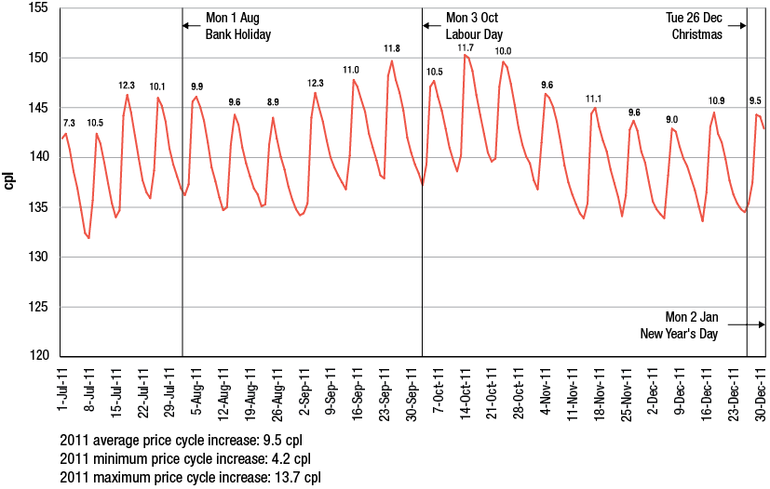
Chart G.2 Sydney, daily average retail prices—price cycles and public holidays:
1 January to 30 June 2012
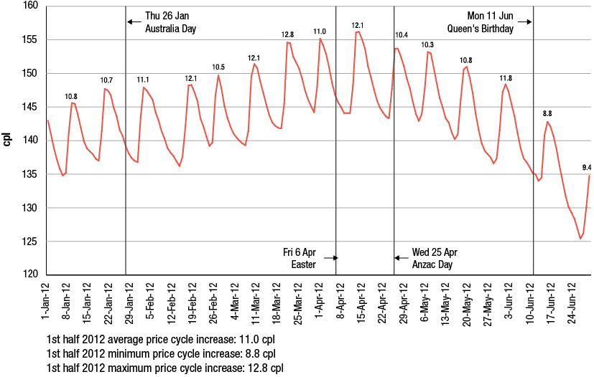
Chart G.3 Melbourne, daily average retail prices—price cycles and public holidays:
1 July to 31 December 2011
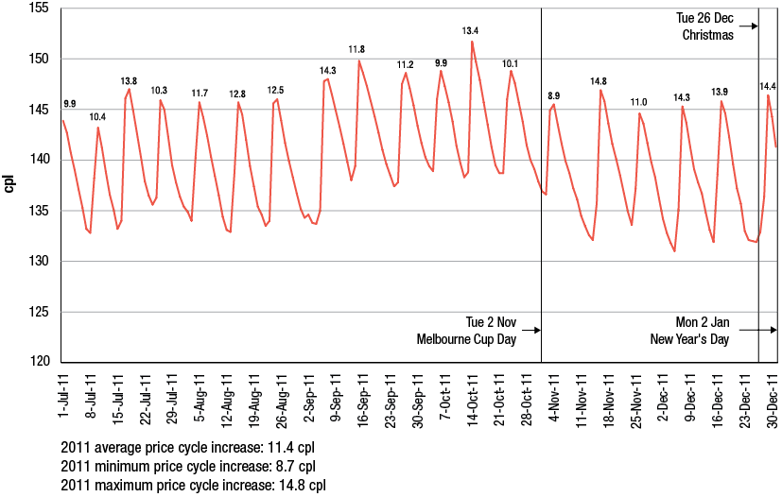
Chart G.4 Melbourne, daily average retail prices—price cycles and public holidays:
1 January to 30 June 2012
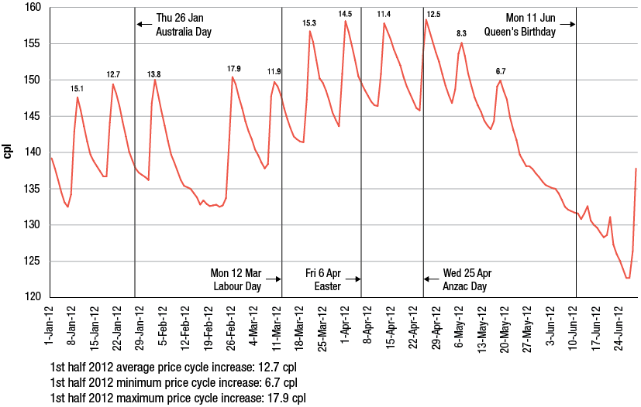

Chart G.5 Brisbane, daily average retail prices—price cycles and public holidays:
1 July to 31 December 2011
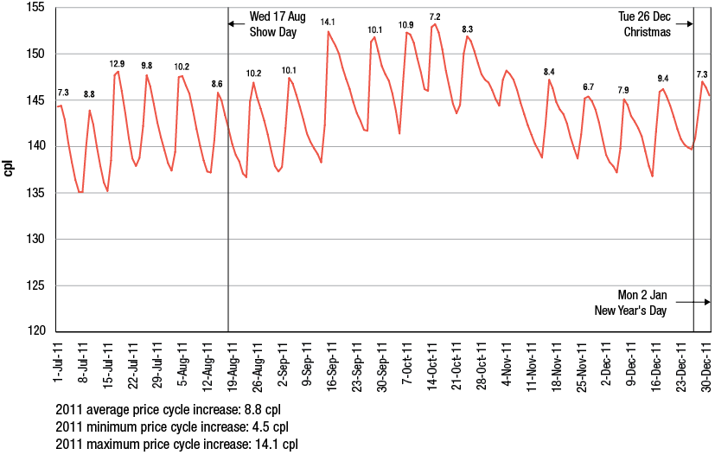
Chart G.6 Brisbane, daily average retail prices—price cycles and public holidays:
1 January to 30 June 2012
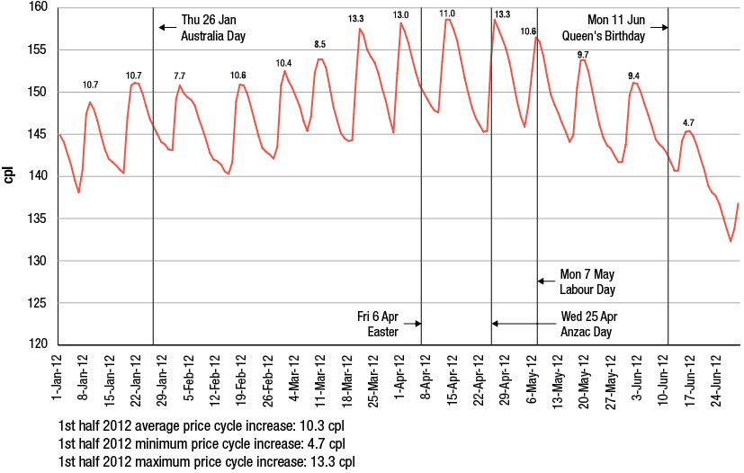

Chart G.7 Adelaide, daily average retail prices—price cycles and public holidays:
1 July to 31 December 2011
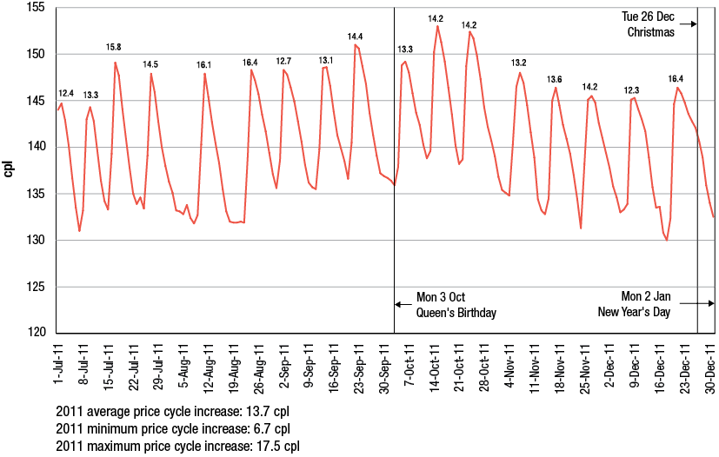
Chart G.8 Adelaide, daily average retail prices—price cycles and public holidays:
1 January to 30 June 2012
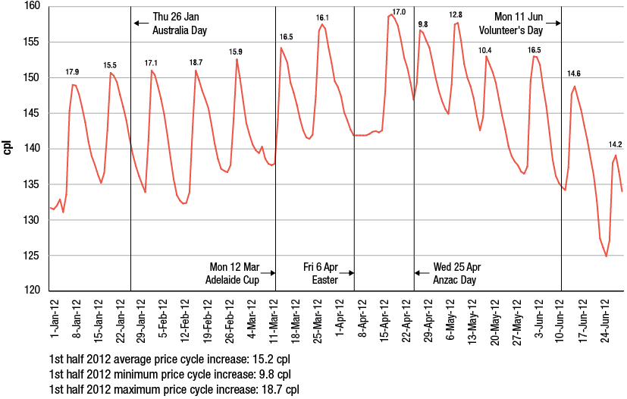
Chart G.9 Perth, daily average retail prices—price cycles and public holidays:
1 July to 31 December 2011
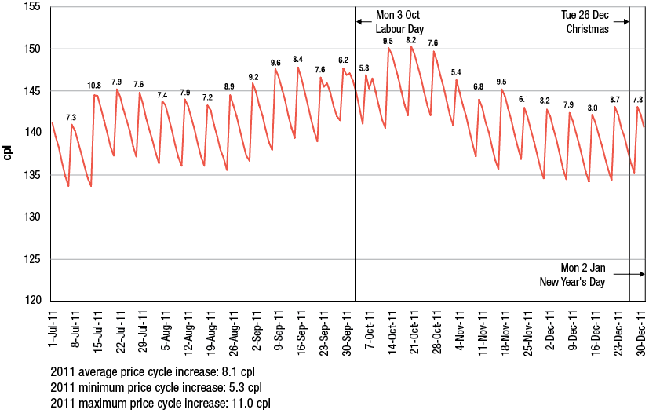
Chart G.10 Perth, daily average retail prices—price cycles and public holidays:
1 January to 30 June 2012
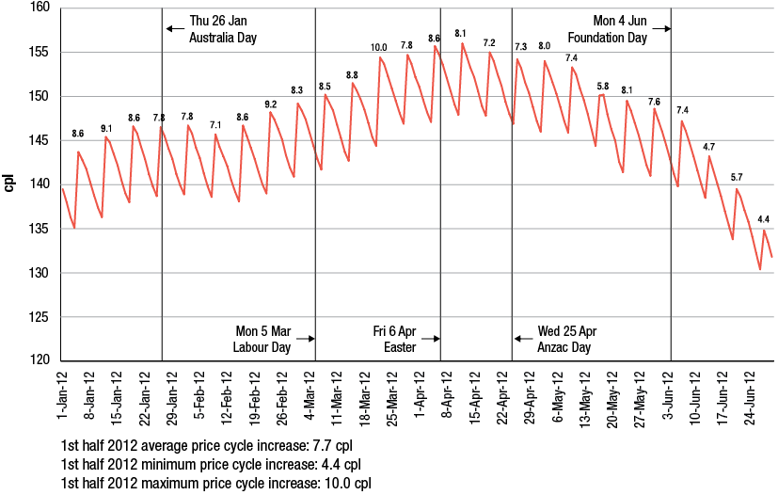

ACCC contacts
ACCC Infocentre: business and consumer inquiries: 1300 302 502
Website: www.accc.gov.au
Translating and Interpreting Service: call 13 1450 and ask for 1300 302 502
TTY users phone: 1300 303 609
Speak and Listen users phone 1300 555 727 and ask for 1300 302 502
Internet relay users connect to the NRS (see www.relayservice.com.au and ask for 1300 302 502)
ACCC addresses
National office
23 Marcus Clarke Street
Canberra ACT 2601
GPO Box 3131
Canberra ACT 2601
Tel: 02 6243 1111
Fax: 02 6243 1199
New South Wales
Level 20, 175 Pitt Street
Sydney NSW 2000
GPO Box 3648
Sydney NSW 2001
Tel: 02 9230 9133
Fax: 02 9223 1092
Victoria
Level 35, The Tower
360 Elizabeth Street
Melbourne Central
Melbourne Vic 3000
GPO Box 520
Melbourne Vic 3001
Tel: 03 9290 1800
Fax: 03 9663 3699
Queensland
Brisbane
Level 24, 400 George Street
Brisbane Qld 4000
PO Box 12241
George Street Post Shop
Brisbane Qld 4003
Tel: 07 3835 4666
Fax: 07 3835 4653
Townsville
Suite 2, Level 9
Suncorp Plaza
61–63 Sturt Street
Townsville Qld 4810
PO Box 2016
Townsville Qld 4810
Tel: 07 4729 2666
Fax: 07 4721 1538
South Australia
Level 2, 19 Grenfell Street
Adelaide SA 5000
GPO Box 922
Adelaide SA 5001
Tel: 08 8213 3444
Fax: 08 8410 4155
Western Australia
3rd floor, East Point Plaza
233 Adelaide Terrace
Perth WA 6000
PO Box 6381
East Perth WA 6892
Tel: 08 9325 0600
Fax: 08 9325 5976
Northern Territory
Level 8, National Mutual Centre
9−11 Cavenagh St
Darwin NT 0800
GPO Box 3056
Darwin NT 0801
Tel: 08 8946 9666
Fax: 08 8946 9600
Tasmania
Level 2, 70 Collins Street
Cnr Collins and Argyle Streets
Hobart Tas 7000
GPO Box 1210
Hobart Tas 7001
Tel: 03 6215 9333
Fax: 03 6234 7796

Bureau of Resources and Energy Economics (2012), Australian Petroleum Statistics, issue number 194, September 2012.
A seven-day rolling average price is the average of the current day’s price and the prices on the six previous days. In the case of retail prices it is the average of calendar days but in the case of Mogas 95 it is the average of working days (i.e. Monday to Friday). The refiner-wholesalers use a rolling average for Mogas 95 prices when determining their wholesale prices.
Tight oil refers to liquid oil embedded in low-permeable sandstone, carbonate, and shale rock (US Energy Information Administration, Annual Energy Outlook 2012, p. 95).
A petrol price cycle is a movement in price from a trough to a peak to a subsequent trough. See chart 10.1 in chapter 10. The ACCC defines a price cycle as having occurred when the increase in price from the trough to the peak is 3 per cent or more of that trough price, and the decrease in price to the subsequent trough is also 3 per cent or more of the initial trough price. A price cycle increase is the increase in price from the initial trough to the peak. Petrol price cycles are discussed in more detail in chapter 10.
A failed petrol price cycle occurs when there is a small (or no) increase in price, at a time when an increase might have been expected, and the magnitude of the price increase (if any) does not meet the 3 per cent definition of a price cycle (noted in the previous footnote).
‘Refiner-marketers’ is the traditional term referring to the four integrated fuel companies (BP, Shell, Caltex and Mobil) which used to refine, wholesale and retail fuel in the Australian market. While BP and Caltex continue to directly retail fuel, Mobil and Shell, while still marketing proprietary fuels, have effectively withdrawn from direct retailing. Given its historical use, the term refiner-marketer is used throughout this report to refer to the two companies that are still integrated from refining to retailing, BP and Caltex. The other two companies, Mobil and Shell are in involved refining and wholesaling. As these four companies account for all of refining output and the vast majority of wholesale sales, as a group they are referred in this report as ‘refiner-wholesalers’.
The ACCC’s 2007 inquiry into the price of unleaded petrol reported that around 60 per cent of fuel sold at Woolworths’ service stations involved a shopper docket. ACCC (2007), Petrol prices and Australian consumers: Report of the ACCC inquiry into the price of unleaded petrol, December, p. 181 http://www.accc.gov.au/content/index.phtml/itemId/790921
The specific regional locations monitored by the ACCC in each state and the Northern Territory are listed in appendix F. It also provides average annual prices for RULP, diesel and LPG in 2011−12 for each regional location.
Note that these profits have been reported on a historical cost basis.
Sector by sector profits may not equate to consolidated profits as they reflect the performance of each sector acts as a stand-alone enterprise. In practice, some companies are integrated across sectors and transact internally between sectors. Consolidated profits take into account these transactions.
Note that prior to July 2009, the Queensland Government provided a subsidy at the retail level of 8.4 cpl (around 9.2 cpl when GST is included). Therefore, terminal gate prices prior to July 2009 in Brisbane have been reduced by 9.2 cpl to put the wholesale and retail prices on a consistent basis.
Independent Pricing and Regulatory Tribunal (2012), Ethanol supply and demand in NSW—Other Industries—Final Report, March 2012, p. 4.
Shell Media Release (2011), ‘Shell to cease refining at Clyde’, 27 July http://www.shell.com.au/home/content/aus/aboutshell/media_centre/news_and_media_releases/archive/2011/clyde_cease_refining_27072011.html http://www.caltex.com.au/Media%20Items/ASX%20-%20Caltex%20Announces%20Supply%20Chain%20Restructure.pdf.
See Australian Financial Review: Shell’s Geelong refinery in doubt, 18 September 2012, p 19; and Competitiveness Key: Baillien, 19 September 2012, p. 4.
Caltex Media Release (2012), ‘Caltex announces supply side restructuring’, 26 July http://www.caltex.com.au/Media%20Items/ASX%20-%20Caltex%20Announces%20Supply%20Chain%20Restructure.pdf.
US Energy Information Administration, (2012), Annual Energy Outlook, p. 44.
Further information is available on the Department of Resources, Energy and Tourism website, at http://www.ret.gov.au/resources/fuels/petroleum_refining_and_retail/downstream_petroleum_legislation/oilcode_review/Pages/OilcodeReview.aspx
‘Refiner-marketers’ is the traditional term referring to the four integrated fuel companies (BP, Shell, Caltex and Mobil) which used to refine, wholesale and retail fuel in the Australian market. While BP and Caltex continue to directly retail fuel, Mobil and Shell, while still marketing proprietary fuels, have effectively withdrawn from direct retailing. Given its historical use, the term refiner-marketer is used throughout this report to refer to the two companies that are still integrated from refining to retailing, BP and Caltex. The other two companies, Mobil and Shell are in involved refining and wholesaling. As these four companies account for all of refining output and the vast majority of wholesale sales, as a group they are referred in this report as ‘refiner-wholesalers’.
ACCC, Monitoring of the Australian petroleum industry, December 2009, p 6.
Further information is available on the Department of Resources, Energy and Tourism website, at http://www.ret.gov.au/resources/fuels/petroleum_refining_and_retail/downstream_petroleum_legislation/oilcode_review/Pages/OilcodeReview.aspx
US Energy Information Administration, at http://www.eia.gov/countries/cab.cfm?fips=AS
See Australian Petroleum Production and Exploration Association, at: http://www.appea.com.au/oil-a-gas-in-australia/oil.html
Condensate is defined in the Excise Act 1901 as either (a) liquid petroleum, that is, a mixture of hydrocarbons that is produced from gas wells and that is liquid at standard temperature and pressure after recovery in surface preparation facilities, or (b) another substance that is derived from gas associated with oil production and that is liquid at standard temperature and pressure.
For additional information on the refineries refer to chapter 4 and the 2009 petrol monitoring report, pp. 25–6.
Caltex Australia ASX/Media release, Caltex announces supply chain restructuring, 26 July 2012.
BP Statistical Review of World Energy, June 2011; historical data at http://www.bp.com/sectionbodycopy.do?categoryId=7500&contentId=7068481
Caltex Australia ASX/Media release, Caltex announces supply chain restructuring, 26 July 2012, p. 2.
Department of Resources, Energy and Tourism, Energy White Paper 2012: Australia’s Energy Transformation, October 2012, p. 126.
Major terminals are defined as terminals which have a pipeline connection to a port and/or refinery. They are the point at which fuel which has been refined in Australia or imported is stored, distributed or sold by refiner-wholesalers and importers.
Throughput refers to how intensely a terminal is used, measured by the annual volume of product that goes through the terminal’s truck and/or rail gantries.
Turnover refers to the number of times a terminal is effectively emptied and filled in the year.
It is important to note that some independently-owned terminals may be the subject of exclusive leasing arrangements.
For more information on the factors driving the growth in independent imports refer 2011 ACCC petrol monitoring report, chapter 4.
Appendix C lists all major terminals on a state-by-state basis.
Shell Company of Australia Limited (2012), New Shell BioDiesel 20 facility launched at Newport Terminal, 29 May
Shell Company of Australia Limited (2012), Shell builds more tankage to supply Bowen Basin demand, 31 July
Some volumes are not reported to the ACCC as wholesale transactions; hence understate the market share of independent wholesalers. Accordingly the ACCC has made adjustments to the data to reflect this.
See “7-Eleven Announces Sole Fuel Supply Agreement With Mobil”, 7-Eleven, 7 June 2011, at http://7eleven.com.au/media-centre/article/7-eleven-announces-sole-fuel-supply-agreement-with-mobil
Consistent with the definition in the Summary (see footnote 6), the term ‘refiner-wholesalers’ is used to refer to the four major petrol companies that are involved in refining as well as wholesaling activities. While only BP and Caltex are integrated from refining to retailing, Mobil and Shell are involved in wholesaling and through their wholesale activities have branding arrangements with certain retailers.
Refer chapter 4, 2011 ACCC petrol monitoring report for more analysis of the decline in retail site numbers since the 1970s: http://www.accc.gov.au/content/index.phtml/itemId/1020827
See Ausfuel media release of 22 November 2011 at: http://www.ausfuel.com.au/images/stories/final_mr_choice_acquisition_nov_11.pdf.
See “Costco wants its cut of cut-price petrol”, The Age, Monday 27 August 2012, at http://www.theage.com.au/business/costco-wants-its-cut-of-cutprice-petrol-20120826-24ufq.html?skin=text-only
Crudes with a sulphur content of less than 0.5 per cent are typically considered to be ‘sweet’.
The American Petroleum Industry gravity index is used to measure the consistency of crudes, or the extent to which it floats on water.
Reuters, at http://glossary.reuters.com/index.php/Dubai_Crude
Reuters, at http://glossary.reuters.com/index.php/WTI
US Energy Information Administration (US EIA), Short-Term Energy Outlook: Market Prices and Uncertainty Report July 2012, 10 July 2012, p. 2.
Platts, Oilgram News—Volume 90, Number 201, 10 October 2012, p. 12.
Seaway Crude Pipeline Company, at http://seawaypipeline.com/
US EIA, Country Analysis Brief: Canada, September 2012, p. 10.
US EIA, Annual Energy Outlook 2012, pp. 23-4.
IEA, World Energy Outlook 2011 Factsheet © OECD/IEA, p. 1.
US EIA, International Energy Outlook 2011, p. 28.
IEA, World Energy Outlook 2011 Factsheet © OECD/IEA, p. 3.
IEA, Oil Market Report © OECD/IEA, 13 June 2012, pp. 5−11.
US EIA, Annual Energy Outlook 2012, p. 72.
US EIA, Annual Energy Outlook 2012, p. 23.
OPEC Mission Statement, at http://www.opec.org/opec_web/en/about_us/23.htm
US EIA, International Energy Outlook 2011, p. 38.
Unproved resources are ‘additional volumes estimated to be technically recoverable without consideration of economics or operating conditions, based on the application of current technology’. (US EIA, Annual Energy Outlook 2012, p. 56).
Also referred to as tight oil. Tight oil refers to liquid oil embedded in low-permeable sandstone, carbonate, and shale rock (US EIA, Annual Energy Outlook 2012, p. 95).
Reuters, at http://www.reuters.com/article/2012/06/25/energy-data-eia-idUSL2E8HPCNO20120625
US EIA, International Energy Outlook 2011, p. 33.
Ibid.
US EIA, Annual Energy Outlook 2012, p. 24.
US EIA, International Energy Outlook 2011, p. 36.
Platts, Oilgram News Extra, 29 June 2012.
IEA, at http://www.iea.org/aboutus/faqs/oil/ © OECD/IEA
US EIA, International Energy Outlook 2011, p. 36.
US EIA, International Energy Outlook 2011, p. 37.
US EIA, International Energy Outlook 2011, p. 36.
IEA, World Energy Outlook 2010 - Executive Summary © OECD/IEA, p. 6.
ACCC, Monitoring of the Australian Petroleum Industry—Summary 2011, p. 18.
OPEC, World Oil Outlook 2011, p. 10.
Platts, Oilgram News—Volume 90, Number 122, 21 June 2012, p. 4.
US EIA, Annual Energy Outlook 2012 with projections to 2035, p. 105.
Major characteristics of the market for ethanol and EBP in Australia were outlined in chapter 6 of the 2011 ACCC petrol monitoring report.
See NSW Government Office of Biofuels, Biofuels in New South Wales, at: http://www.biofuels.nsw.gov.au/, accessed 15 October 2012.
The Hon Barry O’Farrell MP, Premier of NSW and Minister for Western Sydney, Media release, 31 January 2012, Regular unleaded petrol to be retained in NSW, at: http://www.biofuels.nsw.gov.au/__data/assets/pdf_file/0011/168572/Ethanol_Unleaded_Petrol_31_1_12pg.pdf, accessed 15 October 2012.
Independent Pricing and Regulatory Tribunal, Ethanol supply and demand in NSW—Other Industries—Final Report, March 2012, at: http://www.ipart.nsw.gov.au/Home/Industries/Other/Reviews/Ethanol/Review_of_Ethanol_Supply_and_Demand_in_NSW/23_May_2012_-_Released_Final_Report/Final_Report_-_Ethanol_supply_and_demand_in_NSW_-_March_2012, accessed 15 October 2012.
The Hon Andrew Stoner, Deputy Premier of NSW and Minister for Regional Infrastructure and Services and the Hon Chris Hartcher, Minister for Resources and Energy, Media release, 23 May 2012, NSW Government releases E10 exemption framework, at: http://www.biofuels.nsw.gov.au/__data/assets/pdf_file/0004/171085/Stoner-Hartcher_med_rel_-_E10_exemption_framework.pdf, accessed 15 October 2012.
The Honourable Andrew Fraser, Treasurer and Minister for Employment and Economic Development, Media release, 28 October 2010, Ethanol mandate suspended at: http://statements.qld.gov.au/Statement/Id/72283, accessed 15 October 2012.
Australian Government Department of Sustainability, Environment, Water, Population and Communities, Ethanol E85 fuel quality and fuel quality information standards, at: http://www.environment.gov.au/atmosphere/fuelquality/standards/ethanol-e85.html, accessed 15 October 2012.
NSW Government Office of Biofuels, Ethanol results achieved - period 1 April - 30 June 2012, at: http://www.biofuels.nsw.gov.au/__data/assets/pdf_file/0006/172914/Results_Page.pdf, accessed on 15 October 2012.
APAC biofuel consultants, Australian Biofuels 2012−13, p. 3.
The data in charts 5.4 to 5.6 is based on the number of retail sites selling RULP, E10, and E10 only for which Informed Sources has price data.
Additional information on the RULP-E10 price differential for each of the locations included in the ACCC’s monitoring, and a description of the methodology used, is at appendix D.
Note that the RULP-E10 price differentials in the ‘capital cities’ aggregate are the average across all retail sites selling E10 in the five capital cities. Similarly, the differentials in the ‘regional locations’ aggregate is the average across all retail sites selling E10 in the NSW and Queensland regional locations. This is different from the RULP-E10 differentials shown in chart 5.7 which calculates the differential for each monitored location first and then averages them across locations. In other words, the differentials in chart 5.8 are site-weighted and the differentials in chart 5.7 are location-weighted.
IPART Ethanol supply and demand in NSW–Other industries–Final Report, March 2012, p. 50.
APAC biofuel consultants, Australian Biofuels 2012–13, p. 25.
Ibid, p. 26.
Ibid, p. 35. This estimate is based on funding provided under the Ethanol Production Grant scheme in 2011–12. See Australian Government Department of Resources, Energy and Tourism, Reporting of Grants—12 October 2012, pp. 34–35; at: http://www.ret.gov.au/Department/Documents/reporting-grants/reporting-grants12.10.2012.pdf, accessed 15 October 2012. The estimate is higher than the implied volume of ethanol (272 ML) in 2011–12 in EBP data from the Australian Petroleum Statistics (which is shown in table 5.1).
In section 5.3.1 it was noted that IPART considers that there would not be enough demand in NSW for ethanol to meet the 6 per cent mandate.
Estimated potential ethanol supply is based on Australian ethanol nameplate capacity reported in the APAC report for existing producers (S1) and for existing producers and planned producers (S2). Estimated potential ethanol demand is based on sales data in BREE’s Australian Petroleum Statistics, issue 191 June 2012 and RET Ethanol Production Grant data. Ethanol demand forecasts are based on 2011–12 sales volumes for RULP, PULP and EBP.
The Fuel CC is described in section 2.5.1.
Buy–sell transactions allow refiner-wholesalers to purchase large volumes of petrol in some cities and regional centres where they do not operate a refinery or import terminal (refer 6.3.3 below).
Refer chapter 3 for more information.
A more extensive analysis of IPP is available in chapter 6 of the 2009 ACCC petrol monitoring report and in: The method and basis of the setting of the import parity price for unleaded petrol and diesel in Australia by McLennan, Magasanik and Associates, available from the ACCC website: http://www.accc.gov.au/content/item.phtml?itemId=906685&nodeId=a1d61acd4d02faf7ffd66f0970aecbf4&fn=Petrol%20and%20Diesel%20IPP%20Report%20-%20MMA.pdf.
RON is a rating of a fuel’s resistance to auto-ignition to the fuel after being tested in an engine simulating road conditions where pure iso-octane has a rating of 100.
MON is a similar rating to RON but with the fuel being tested in an engine simulating conditions of greater stress. Refer Fuel Standard (Petrol) Determination 2001, compilation prepared 28 June 2008.
The rationale behind using these benchmarks and their importance in determining prices is explained in chapter 6.
Only one refiner-wholesaler calculates an IPP for PULP 98.
The price for PULP 95 (i.e. 95 RON) has been based on Mogas 97 (i.e. 97 RON) as the Australian fuel standard for PULP 95 has traditionally been tighter than that for the Singapore product. Refer report prepared for the ACCC by McLennan, Magasanik and Associates: http://www.accc.gov.au/content/item.phtml?itemId=906685&nodeId=a1d61acd4d02faf7ffd66f0970aecbf4&fn=Petrol%20and%20Diesel%20IPP%20Report%20-%20MMA.pdf
Note the IPP excludes taxes, so is compared with the net wholesale price. As TGPs include taxes they are compared with the gross wholesale price.
References to petrol in this chapter are to regular unleaded petrol (RULP) unless otherwise specified.
A seven-day rolling average price is the average of the current day’s price and the prices on the six previous days. In the case of retail prices it is the average of calendar days but in the case of Mogas 95 it is the average of working days (i.e. Monday to Friday). Traditionally, the ACCC has used a seven-day rolling average to smooth out the influence of the regular petrol price cycles in the larger capital cities on price movements. In recent years this has been less effective as the duration of price cycles in the larger capital cities has been increasing beyond seven days (see chapter 10). The refiner-wholesalers use a rolling average for Mogas 95 prices when determining their wholesale prices.
As noted in chapter 4, Australian refiner-wholesalers are increasingly using Brent crude oil as the appropriate international benchmark price.
These are the daily RBA 4.00 pm closing rates. See: http://www.rba.gov.au/statistics/frequency/exchange-rates.html .
Mogas 95 prices are lagged by 10 days, as there is generally around a one- to two-week lag between changes in international prices and changes in retail prices in the five largest cities. This is because of the averaging formula used by refiners in Australia when setting their wholesale prices and there is a lag between changes in wholesale prices and retail prices. The lag may be more pronounced during times of significant price volatility.
The average differential in 2011−12 was 16.5 cpl. This is slightly lower than the ‘Other costs and margins’ component in the petrol bowser in chart 8.11 (16.8 cpl). This is because there are differences in the way these estimates have been calculated: there is a 10-day lag in the Mogas 95 data in chart 8.10, whereas no lag is used in chart 8.11. Furthermore, seven-day rolling average prices are used in chart 8.10, whereas annual data is used in chart 8.11.
Prior to July 2009 the Queensland Government provided a subsidy at the retail level of 8.4 cpl (around 9.2 cpl when the impact of the GST is included). Therefore, wholesale prices in Brisbane prior to July 2009 have been reduced by 9.2 cpl to put the wholesale and retail prices on a consistent basis.
Chapter 14 presents data on retail profits derived from financial data provided by the monitored companies.
The ABS All Groups Consumer Price Index for Sydney, Melbourne, Brisbane, Adelaide and Perth was used to deflate the differences to 2007–2008 prices. Source: Australian Bureau of Statistics, 6401.0 Consumer Price Index, Australia, Tables 1 and 2. CPI: All Groups, Index Numbers and Percentage Changes, at: http://www.abs.gov.au/AUSSTATS, accessed 8 October 2012.
E10 prices in the chart are for four capital cities and do not include Perth, as E10 is not sold in Western Australia.
Prior to 1 January 2009 the international benchmark for diesel used by Australian refiners was Gasoil 50 ppm.
All references to petrol in this chapter are to regular unleaded petrol (RULP) unless otherwise specified. The city-country price differential for each state and the Northern Territory is the difference between the arithmetic average of prices in each regional location in the state and Northern Territory and the average capital city price.
The specific regional locations in each state and the Northern Territory which are monitored by the ACCC are listed in appendix F, which also provides average annual retail prices for petrol, diesel and automotive LPG in 2011−12 for each regional location.
Note that there are no prices available for locations in the Australian Capital Territory other than Canberra.
The five-city city-country price differential is the difference between the arithmetic average of prices in the monitored regional locations in the six states and the Northern Territory and the arithmetic average price in the five largest cities (Sydney, Melbourne, Brisbane, Adelaide and Perth). The eight-city city-country price differential is the difference between the arithmetic average of prices in the monitored regional locations in the six states and the Northern Territory and the arithmetic average price in the eight capital cities (the five largest cities plus Canberra, Hobart and Darwin).
The source for population and retail site data in the three case studies is: Australian Bureau of Statistics, 2010 Estimated Resident Population data provided on a consultancy basis to the ACCC, and Informed Sources data.
In charts 9.10 to 9.12 retail prices are shown on the left hand side of the chart and Mogas 95 prices are shown on the right hand side of the chart (with different starting and ending values). This is done to show clearly the relative movements in the price series.
See the diagram in section 10.2.
While around 180 regional locations are included in the fuel price monitoring program there are times when price data is not available in a particular regional location for all of the year. In 2011 there were 173 regional locations for which petrol price data was sufficiently available to analyse the extent of petrol price cycles.
All references to petrol in this chapter are to regular unleaded petrol (RULP). All references to the year 2012 are to the period 1 January 2012 to 30 September 2012.
The number of price cycles in a year is recorded as the number of peaks that occurred in that year. When comparing data across these cities, some locally specific factors need to be considered. For example, in Sydney, the number of retail sites selling regular unleaded petrol has been declining since October 2007 following the introduction of an ethanol mandate in New South Wales (see section 5.5).
See section 10.6 for a description of failed price cycles.
There were a total of 38 failed price cycles in these cities between January 2009 and September 2012. In Sydney, six price cycles failed in 2010. In Melbourne, four price cycles failed in 2010 and three in 2012. In Brisbane, one cycle failed in 2009, three in 2010 and three in 2011. In Adelaide, two cycles failed in 2010, six in 2011 and two in 2012. In Perth, four price cycles failed in both 2009 and 2010. The failed cycle in Brisbane in 2009 occurred in the first week of the year and affected the duration of the last price cycle in 2008. It had no influence on price cycle durations in 2009.
The sum of the average trough to peak duration and the average peak to trough duration may not equal the average price cycle duration due to rounding.
See ACCC, Monitoring of the Australian petroleum industry, December 2010, p. 180.
See ACCC, Monitoring of the Australian petroleum industry, December 2011, pp. 225–6.
In the eastern capital cities, a price cycle increase before a public holiday has been defined as having occurred within the week up to and including the day of the public holiday in the years 2007 to 2010, and within two weeks in 2011 and 2012. The methodology was modified this year to reflect the increasing duration of price cycles since late-2010. In Perth, a price cycle increase before a public holiday has been defined as having occurred within two weeks up to and including the day of the public holiday prior to 2009 and within one week subsequently. The price increase before (or on) the New Year’s Day public holiday is compared with the average price cycle increase for the previous year. This is because the price increase usually occurs in the last week of the previous year.
In the analysis daily average TGPs were lagged by five days and then averaged over the month. Seven-day rolling average retail prices were used (to smooth out the effects of price cycle movements) and averaged over the month.
ACCC, Monitoring of the Australian petroleum industry, December 2011, pp. 229–62.
Further background regarding the petroleum industry in each of these countries is provided in the 2011 ACCC petrol monitoring report.
Natural Resources Canada, Review of issues affecting the price of crude oil, October 2010, p. 15.
Natural Resources Canada, Fuel Focus: Understanding Gasoline Markets in Canada and Economic Drivers Influencing Prices, Volume 7, Issue 8, 4 May 2012, p. 5.
California Energy Commission, at http://energyalmanac.ca.gov/gasoline/margins/index.php
Gasoline is required to be blended with oxygenates to meet local environmental standards in California.
Importer cost is based on the Singapore benchmark petrol price plus an estimated quality premium and an assessment of the importation costs of freight, insurance, losses, and wharfage.
Platts, Oilgram News, Volume 90, Number 165, 21 August 2012, p. 9.
Rotterdam is the largest European port for the import of crude oil. German refining and importing companies base their prices on the relevant benchmark prices in Rotterdam.
Platts, Oilgram News, Volume 90, Number 165, 21 August 2012, p. 9.
ACCC, Monitoring of the Australian petroleum industry, December 2011, pp. 247–8.
Care must be taken when making international comparisons as fuel quality standards (for example, octane rating and the content of MTBE and sulphur) for the most commonly used form of petrol in each market may differ between countries.
The terms net profit and adjusted EBIT are used interchangeably throughout the chapter.
Caltex (2012), 2011 Preliminary Final Report, Results for announcement to the market, 27 February, http://www.caltex.com.au/Media%20Items/ASX%20Announcement%20- %202011%20Preliminary%20Final%20Report%20and%202011%20Financial%20Report.pdf. See also Chambers, M (2012), Shell units shed $495 million after huge refinery write-down, in The Australian newspaper, 11 May 2012.
Note that if impairment expenses had been included in the profit derivation, the overall industry result would have been a loss of $1.82 billion.
Inventory valuation changes occur when a company purchases a product for on-selling and the market price of the product either increases or declines by the time the product is sold. In companies which report data on a replacement cost basis, the difference between the purchase and sell price is recorded as an inventory gain or loss in the company’s accounts. Generally, those companies which report on a historical cost basis do not record inventory gains or losses. Data for the ACCC petrol monitoring program has been provided on a historical cost basis and thus does not include separate data on inventory valuation changes.
Total industry volume is derived after the elimination of intra-company transfers.
In an ideal sense, the best way to conceptualise the motorist’s perspective profit is to think of an imaginary litre of petrol that makes its way through a company operating in the three sectors of the petrol industry and finally into the tank of the motorist. As that litre flows through the industry, from one sector to the next, margins are accumulated. For instance, if at total supply the margin per litre made by the industry is 2 cents per litre (cpl), then in wholesale, the industry makes 3 cpl and finally in retail, 1.5 cpl, the litre that the motorist finally puts in his car has a total margin of 6.5 cents on it.
Note that retail unit net profits are derived from total retail profits, which include convenience store profits.
A number of companies have been excluded from the ASX200 due to missing data, excessively high or low rates of return or because they are in the group of monitored companies. Further information can be found in notes under the respective charts.
The Australian Securities Exchange use Standard and Poor’s Global Industry Classification Standard (GICS) rather than the Australian and New Zealand Industrial Classification (ANZSIC) system. Because of this, the ACCC have adopted Standard and Poor’s Global Industry Groupings.
Australian Bureau of Statistics, (2011), Australian Industry, 2010−11, 2009−10, 8155.0, data cubes & Australian Industry, 2005−06, 8155.0, data cube Note that the ABS data excludes general government and banking / insurance industries. Time series covers 2002−03 to 2010−11 http://www.abs.gov.au/AUSSTATS/abs@.nsf/DetailsPage/8155.02010−11?OpenDocument http://www.abs.gov.au/AUSSTATS/abs@.nsf/DetailsPage/8155.02005−06
Note that upstream petroleum companies or those with a presence in both upstream and downstream activities have been excluded from the sample of units. Upstream businesses generally earn significantly higher profits compared to downstream companies. See chapter 16 in the 2011 ACCC petrol monitoring report for a discussion of profits in upstream petroleum industries.
Caltex (2012), 2011 Preliminary Final Report, Results for announcement to the market, 27 February, http://www.caltex.com.au/Media%20Items/ASX%20Announcement%20-%202011%20Preliminary%20Final%20Report%20and%202011%20Financial%20Report.pdf Chambers, M (2012), ‘Shell units shed $495 million after huge refinery write-down’, in the Australian newspaper, 11 May 2012.
Note that if all expenses are included (including impairment expenses), unadjusted EBIT in the refinery sector for 2011−12 would have been a loss of $2.8b.
Caltex (2012), Press Release, ‘Kurnell decision the right one for Caltex’ future’, 27 August 2012 http://www.caltex.com.au/LatestNews/Pages/NewsItem.aspx?ID=13323
EBP is not blended in the refinery sector and not considered in the calculation of petrol profits for this sector.
Note that the ABS’ return on sales for ANZSIC division C for a comparable time series was half the ASX value at 9.4 per cent, Australian Bureau of Statistics, (2011), Australian Industry, 2010−11, 8155.0, data cube & Australian Industry, 2005−06, 8155.0, data cube Note that the ABS data excludes general government and banking / insurance industries. Time series covers 2002−03 to 2009−10 http://www.abs.gov.au/AUSSTATS/abs@.nsf/DetailsPage/8155.02010−11?OpenDocument http://www.abs.gov.au/AUSSTATS/abs@.nsf/DetailsPage/8155.02005−06
Buy-sell arrangements are bilateral arrangements between domestic refiners to supply those refiners with refined product where they do not have a refinery. For example, BP does not have a refinery in Victoria. But by having buy-sell agreements with one of the Victorian refineries, BP can supply refined petrol in Victoria.
Note that if all expenses including impairment costs were included in the EBIT calculation, the total loss for the total supply sector would have been $3.3 billion during 2011−12.
Note that the smaller independent owner operators are excluded from the scope of monitored firms operating in the retail sector.
These Shell sites are not included in the monitoring of the retail sector.
ACCC (2011), Monitoring of the Australian petroleum industry—Report of the ACCC into the prices, costs and profits of unleaded petrol in Australia, December 2011, p. 39.
Refer to table 3.8 for a breakdown of retail sites by branding and type of business operator.
The majority of data presented in this retail section covers the period from 2005–06 to the present. Only selected data is presented for the years 2002–03 and 2003–04. Structural changes in the retail sector during 2002–03 and 2003–04 mean that data for this period is not comparable with data for later years. Where data are expressed as ratios, such as RoS and RoA, the analysis extends to 2002–03.
Note that the time series for convenience store profits can only be calculated from 2006-07 onwards.
In real terms, the price of crude oil has reached levels not seen for over 100 years. See BP Statistical Review of World Energy, June 2012, p. 15.
ACCC, Monitoring of the Australian Petroleum Industry, December 2011, p. 363.
Oil and Gas Journal, North American energy independence possible, House panel told, 24 September 2012, pp. 24–5.
US Energy Information Administration, Short-Term Energy Outlook, September 2012, p. 5.
US Energy Information Administration, Annual Energy Outlook 2012, June 2012, p. 2.
US Energy Information Administration, Country Analysis Brief: Canada, September 2012, p. 3.
Ibid., p. 4.
Wall Street Journal, Gulf OPEC producers want Brent at $100/barrel, 25 September 2012, at http://www.marketwatch.com/story/gulf-opec-producers-want-brent-oil-at−100barrel-2012−09-25
Shell media release, Date of Clyde Conversion Confirmed, 7 June 2012. See http://www.shell.com.au/home/content/aus/aboutshell/media_centre/news_and_media_releases/2012/date_for_clyde_conversion_07062012.html
Caltex ASX Media Release, Caltex announces supply chain restructuring, 26 July 2012, p. 1. See http://www.caltex.com.au/LatestNews/Pages/NewsItem.aspx?ID=13315
See Australian Financial Review: Shell’s Geelong refinery in doubt, 18 September 2012, p 19; and Competitiveness Key: Baillien, 19 September 2012, p 4.
Shell media release, Date of Clyde Conversion Confirmed, 7 June 2012; op cit. Caltex ASX Media Release, Caltex announces supply chain restructuring, 26 July 2012; op cit.
Reliance, see http://www.ril.com/html/business/types_refinery.html
US Energy Information Administration, Country analysis brief; South Korea, October 2011, p. 5.
See Australian Financial Review, Shell’s Geelong refinery in doubt, 18 September 2012; op cit.
Platts Oilgram News, UK concedes refining sector is struggling to compete, volume 90, number 122, 21 June 2012, p. 1.
Platts Oilgram News, Cosmo to shut 140,000 b/d Sakaide refinery in 2013, volume 90, number 171, 29 August 2012, p. 3.
See US Energy Information Administration, at http://www.eia.gov/dnav/pet/PET_PNP_CAP1_A_(NA)_8OO_COUNT_A.htm
United Kingdom Petroleum Industry Association (UKPIA), UKPIA Statistical review 2012, June 2012, p. 16.
As noted in section 3.6.4 Caltex has a 25-year lease to use the Adelaide terminal, while Shell has signed a memorandum of understanding to use the Newcastle terminal.
UKPIA, UKPIA Statistical review 2012, June 2012, pp. 33–4.
ACCC, Monitoring of the Australian Petroleum Industry, December 2011, pp. 365–7.
Forbes, As ConocoPhillips Spins Off Refining Assets, Think Twice Before Buying The New Phillips 66, 30 April 2012, at http://www.forbes.com/sites/christopherhelman/2012/04/30/as-conocophillips-spins-off-refining-assets-should-you-own-the-new-phillips-66/
The Wall Street Journal, Exxon Mobil to Unload Its Subsidiary in Japan, 30 January 2012, at http://online.wsj.com/article/SB10001424052970204740904577190232442544166.html
ACCC, Monitoring of the Australian Petroleum Industry, December 2011, pp. 247–8.
ABS, Motor Vehicle Census, 9309.0, 31 January 2012, p. 6.
ACCC, Monitoring of the Australian Petroleum Industry, December 2010, pp. 278–80.
IEA, IEA plots path to halving fuel used for road transport in under 40 years, News release, 19 September 2012, at http://www.iea.org/newsroomandevents/pressreleases/2012/september/name,31383,en.html
The source for tables in this appendix is ACCC analysis based on data obtained from firms monitored through the ACCC’s monitoring process. Major terminals are defined as terminals which have a pipeline connection to a port and/or refinery.
Sydney Metropolitan Pipeline (SMP) is a Caltex/Mobil (60/40) joint venture which also owns the pipeline from Banksmeadow terminal to Silverwater terminal.
E10 price monitoring quarterly reports for the December 2006 quarter and the March, June and September 2007 quarters are available from the ACCC website. Information from October 2007 to September 2011 was included in past ACCC petrol monitoring reports. The source for all data in this appendix is ACCC and Informed Sources. Note that some figures in the tables may not add exactly due to rounding. Where data is not available it is identified in the tables as ‘na’.
These are identified in the methodological section at the end of this appendix.
The New South Wales ethanol mandate is described in section 5.2.1 of chapter 5.
The average monthly price in the ‘capital cities’ aggregate is the average of all prices from retail sites selling E10 in the five capital cities (i.e. Sydney, Melbourne, Brisbane, Adelaide and Canberra); and similarly the average monthly price in the ‘regional locations’ aggregate is the average of all prices from retail sites selling E10 in New South Wales and Queensland regional locations.
To be included in this appendix, locations needed to have price data for at least three months over the period October 2011 to September 2012.
All references to petrol in this appendix are to RULP.
Sources for the data in this appendix are: ACCC, Informed Sources, BP, Caltex, Mobil, Shell, WA FuelWatch, and Australian Bureau of Statistics.
The ABS All Groups Consumer Price Index for Sydney, Melbourne, Brisbane, Adelaide and Perth was used to deflate the respective retail differences. Source: Australian Bureau of Statistics, 6401.0 Consumer Price Index, Australia, Tables 1 and 2. CPI: All Groups, Index Numbers and Percentage Changes, at: http://www.abs.gov.au/AUSSTATS, accessed 8 October 2012.
For a price to be included in the table it had to meet a number of quality thresholds. In general, there had to be a price observation on at least 75 per cent of days over the year, with no break in price data of more than 30 consecutive days. In cases where this threshold was not met, a price has still been included in the table if there was an even spread of missing data observations which would mean that a broadly reliable average price could be estimated. Prices in the latter category have been identified with an asterisk (*) and a degree of caution is required in using the prices of these locations. For comparison purposes, the average annual RULP retail prices in the capital cities in 2011−12 were: Sydney 141.9 cpl, Melbourne 141.1 cpl, Brisbane 145.4 cpl, Adelaide 142.1 cpl, Perth 143.3 cpl, Canberra 146.8 cpl, Hobart 149.8 cpl and Darwin 153.8 cpl. The sources for all prices in this appendix are ACCC and Informed Sources.
Source for all charts: ACCC calculations based on Informed Sources data.
Similar charts for the period January 2007 to June 2011 are available in past ACCC petrol monitoring reports.

